16__SUB-QUERY():

Q1) Find the name of the employee who has the highest salary.

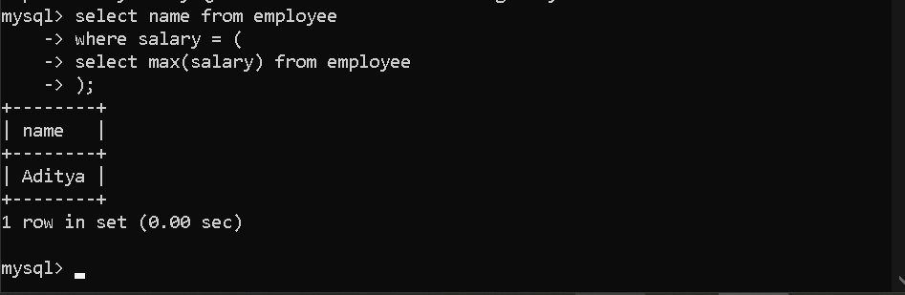

Q2) Find the name of employees whose salary is equal to 360000.



Q3) Find the names of employees whose salary is greater than the average salary.

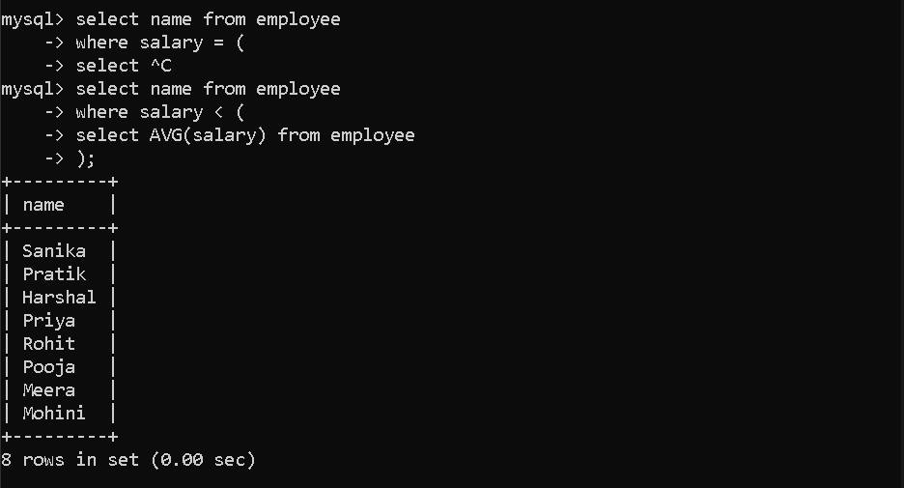

Q4) Find the names of employees who work in the HR department.

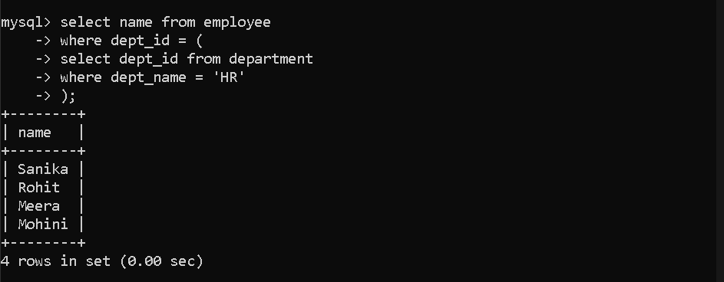

Q5) Find the department name where the employee with the highest salary works.

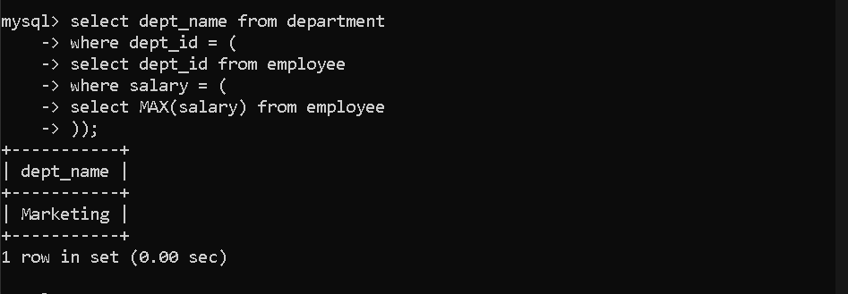

Q6) Find the names of employees who work in departments located in Pune.

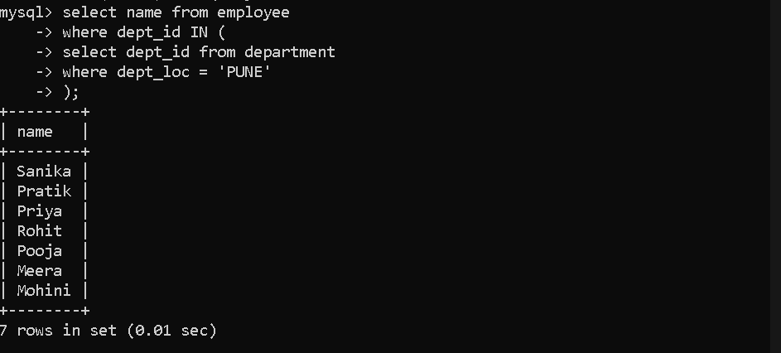

Q7) Count the number of employees in each city and department.

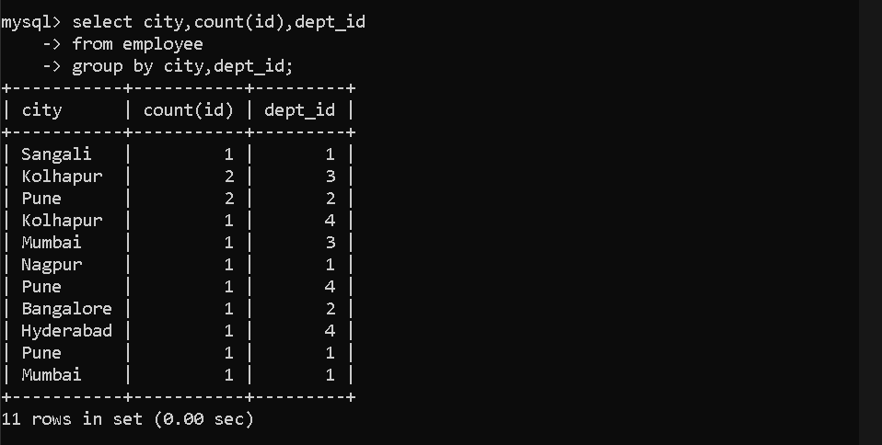

Q8) Display department ID, city, and number of employees grouped by city and department.

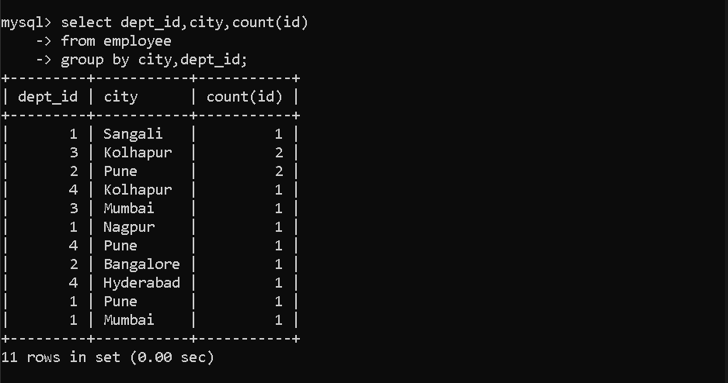

Q9) Display department ID, city, and number of employees sorted by department ID.

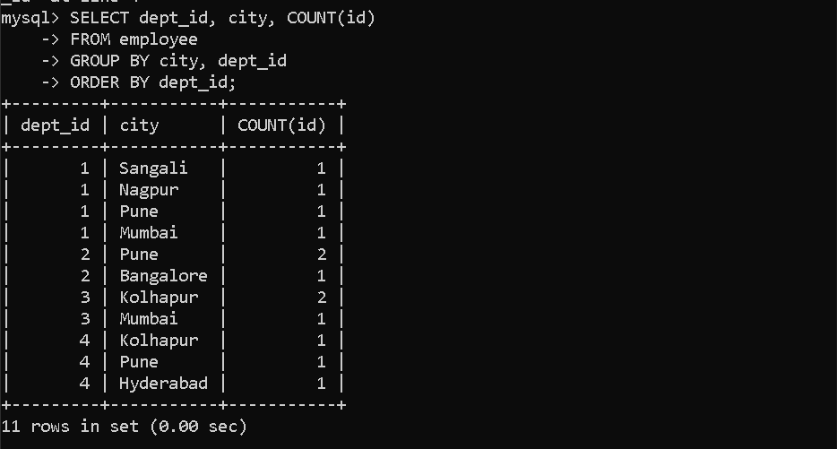

Q10) Find the name of the employee with the highest salary using ORDER BY and LIMIT.

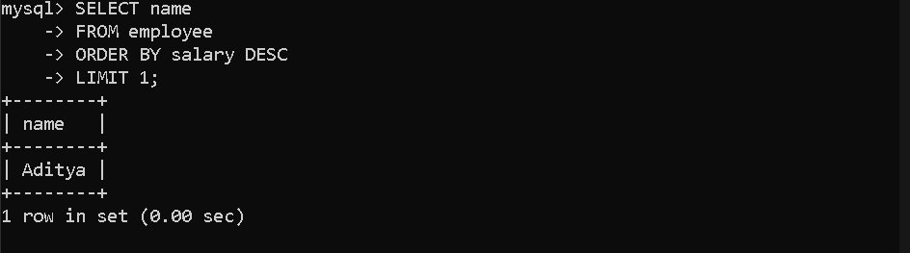

Q11) Find the maximum salary in the employee table.

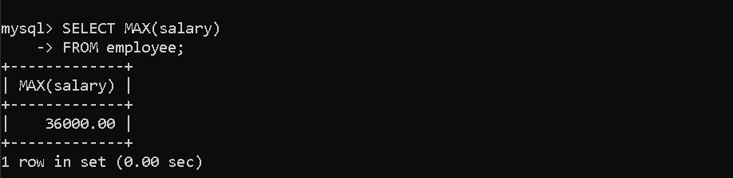

Q12) Find the names of employees whose salary is equal to the maximum salary using a subquery.

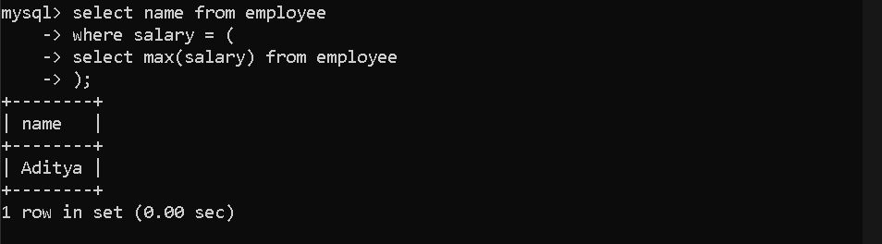

Q13) Find the names of employees whose salary is greater than the average salary using a subquery.

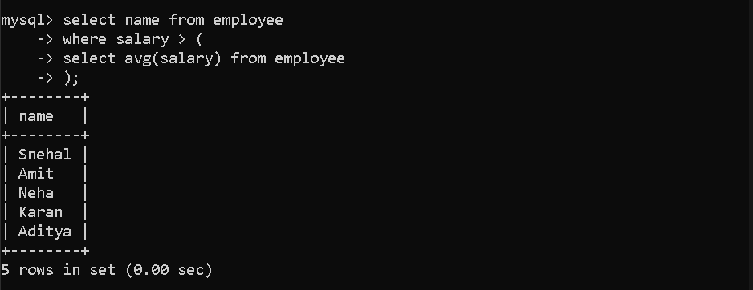

Q14) Find the names of employees who belong to the department named "HR".



Q15) Find the department name of the employee who has the highest salary.



Q16) Find the names of employees who work in departments located in Pune using IN.


