17__AGGREGATE() and FUNCTIONS() :

Subquery
- Find the name, salary, and age of employees who work in the IT department.
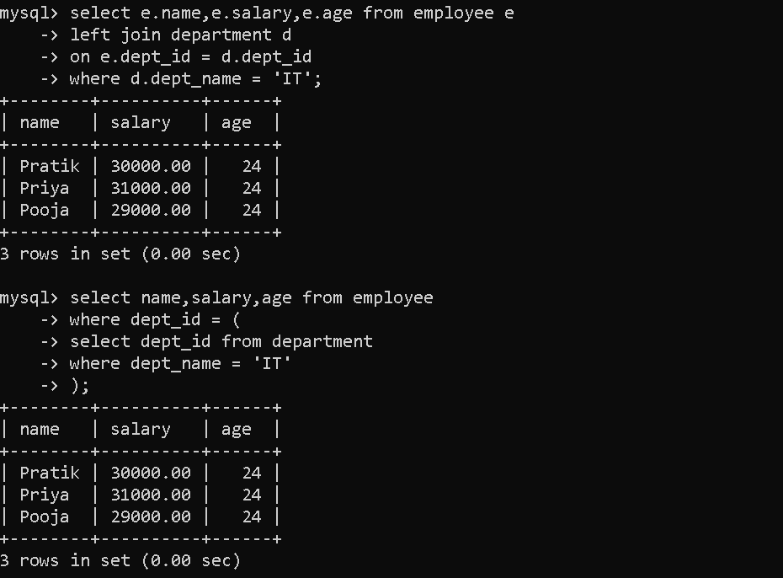

LIKE Operator (Pattern Matching)
- Find employees whose name starts with S.
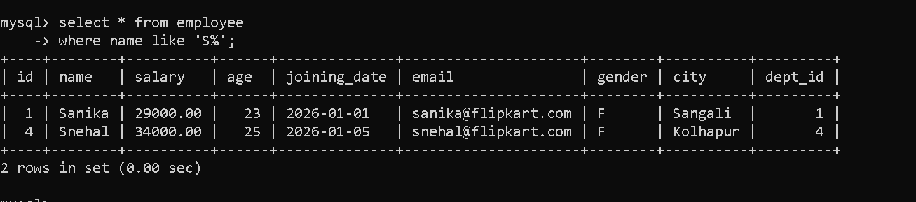
- Find employees whose name ends with a.
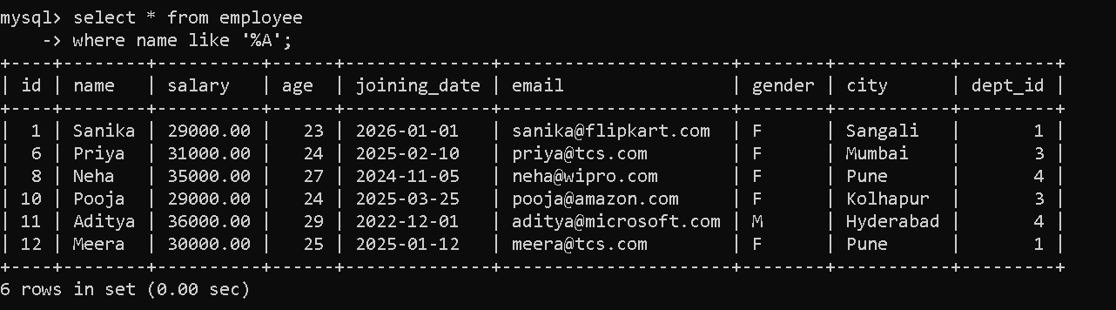
- Find employees whose name contains a anywhere.
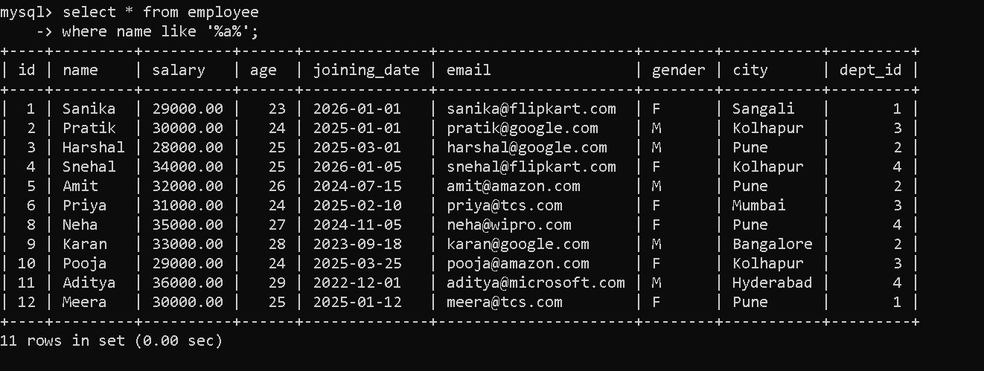
- Find employees whose name contains n.
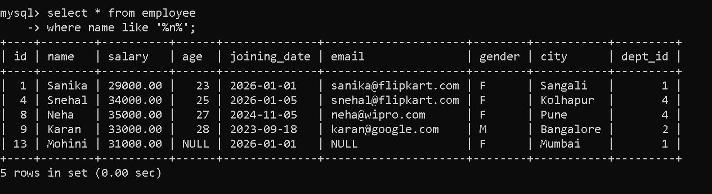
- Find employees whose second letter is a.
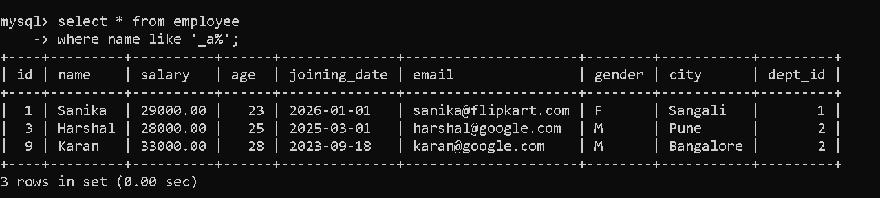
- Find employees whose name matches pattern %a_.
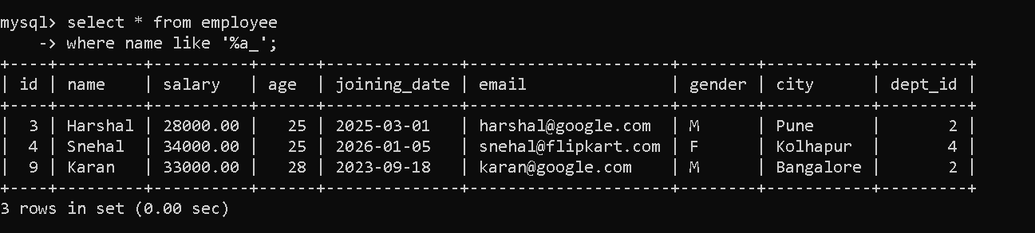
- Find employees whose email belongs to google.com.
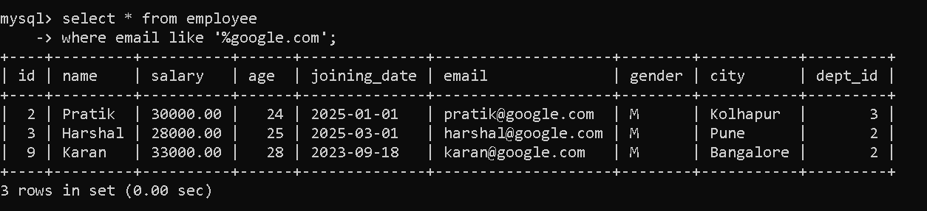
- Display name and email of employees whose email belongs to google.com.
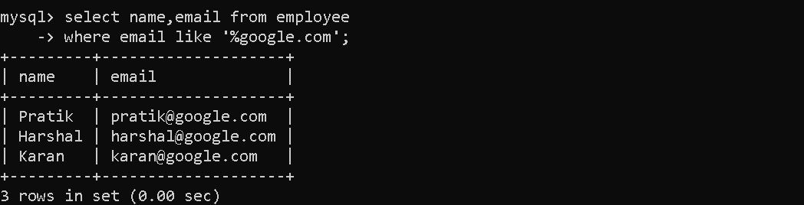
- Find employees whose name matches pattern p_a%.
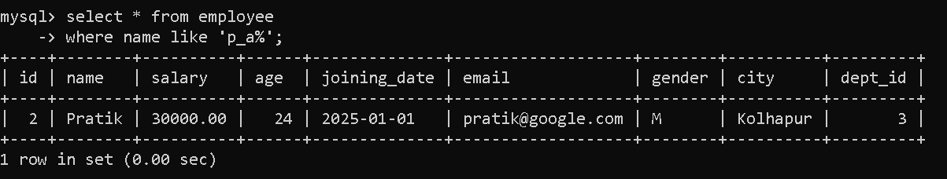

String Functions
- Find the length of string "Virat Kohli".
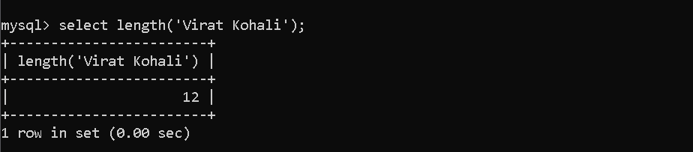
- Display employee names along with length of their names.
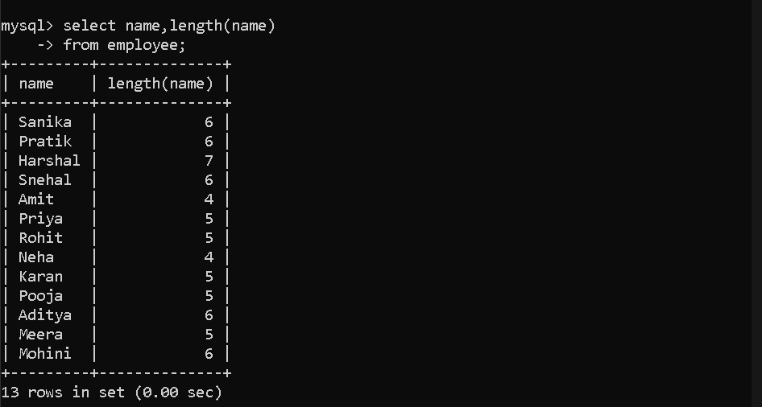
- Display employee names along with length of age values.
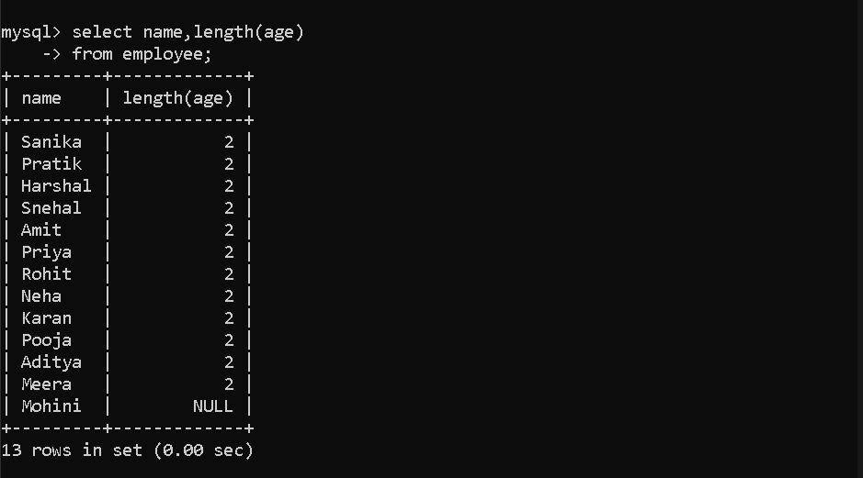
- Remove spaces from both sides of a string.
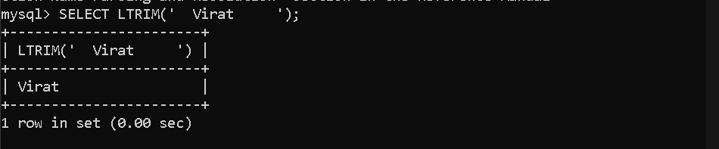
- Remove spaces from the left side of a string.

- Remove spaces from the right side of a string.

- Replace word SQL with MySQL in string.
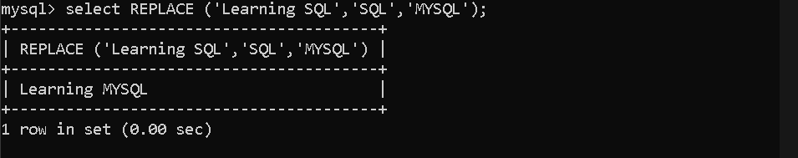
- Find the position of MySQL in string.
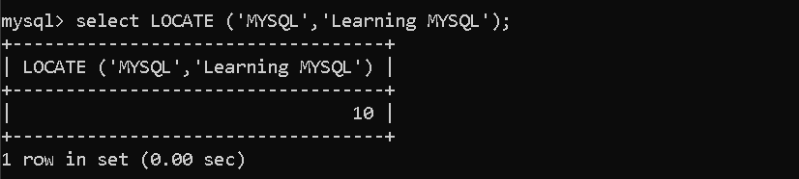
- Extract first 5 characters from a string.
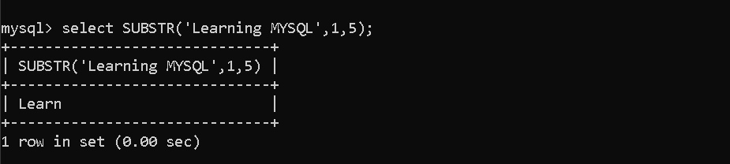
- Extract characters starting from position 5 for length 8.
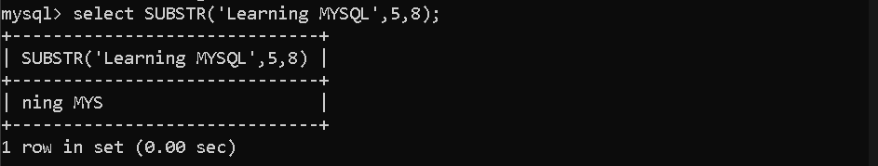

Number Functions
- Round the number 10.54.
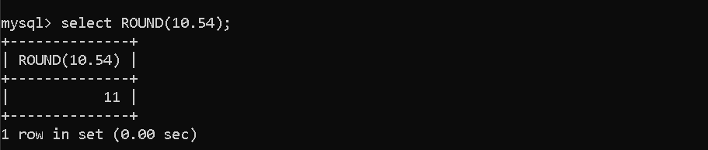
- Round the number 10.44.
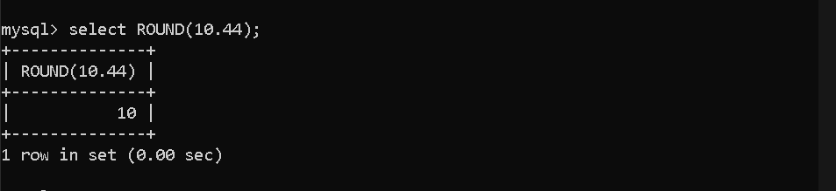
- Find the ceiling value of 10.44.
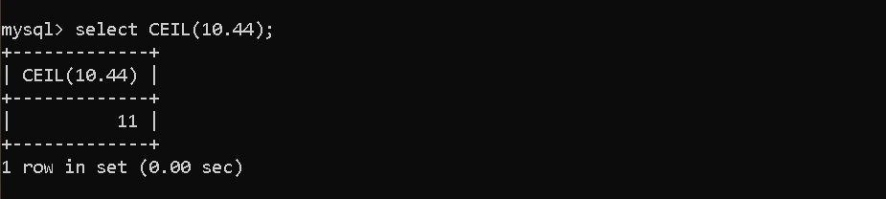
- Find the floor value of 10.74.
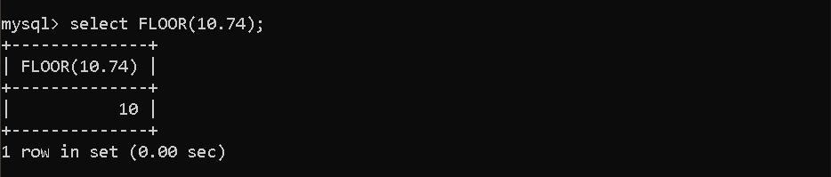
- Find remainder when 10 is divided by 2.
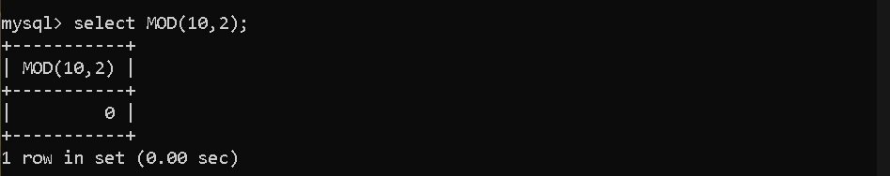
- Find remainder when 10 is divided by 3.
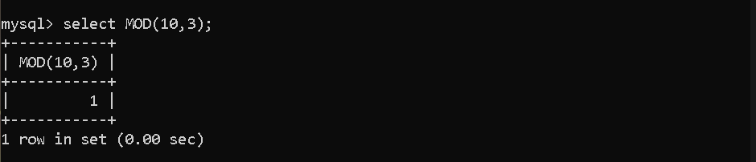
- Find square root of 64.
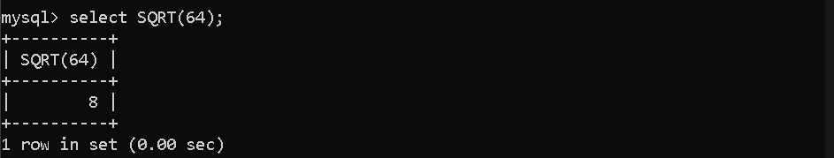
- Find value of 2 power 3.
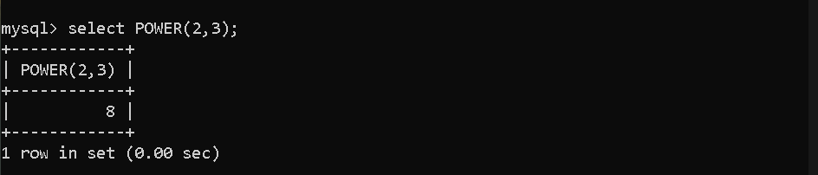
- Find absolute value of -10.
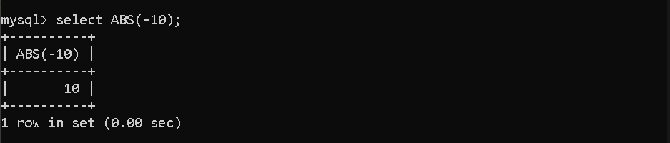

Aggregate + Number Functions
- Find the average salary of employees.
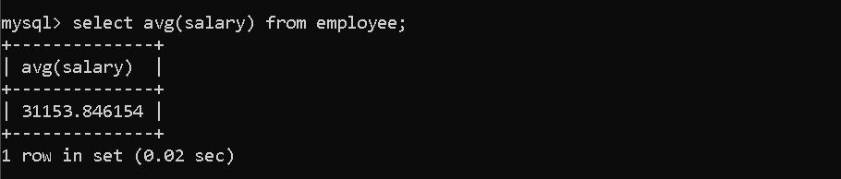
- Find the rounded average salary of employees.
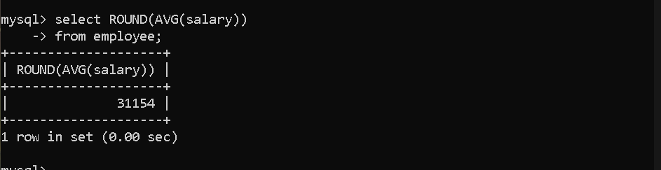
- Find the floor value of average salary.
