20__JOINS() and GROUP_BY() :

Q1) Display employee name, age, salary, and department name using INNER JOIN.

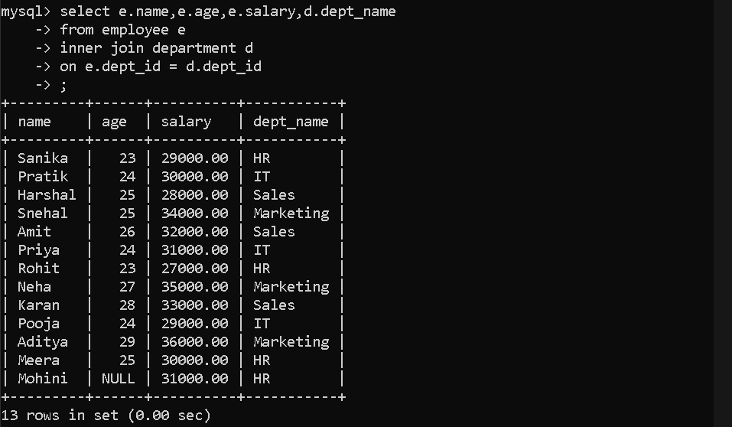

Q2) Display employee name, age, salary, and department name for employees whose salary is between 30000 and 35000.

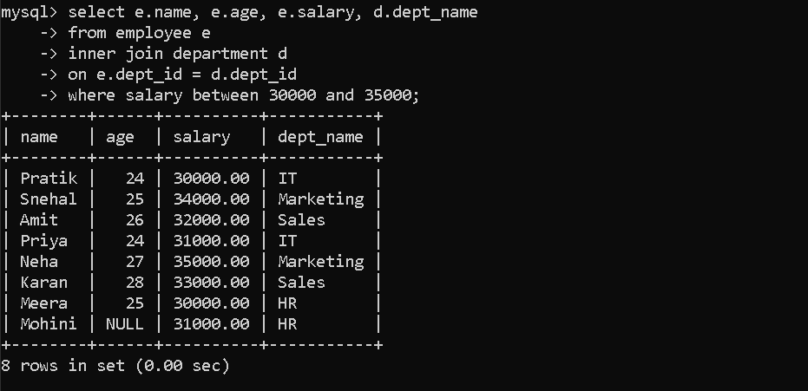

Q3) Display all employees who joined in the year 2025.

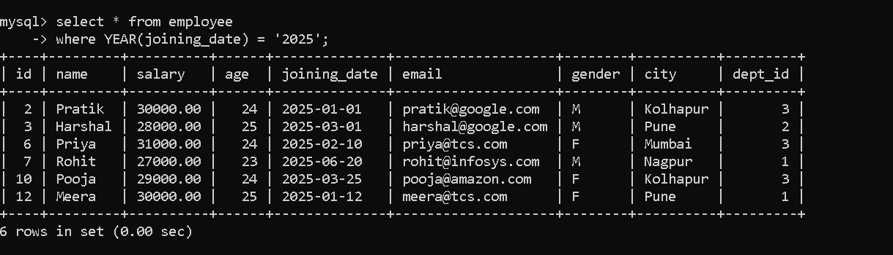

Q4) Display department name and number of employees in each department using INNER JOIN.

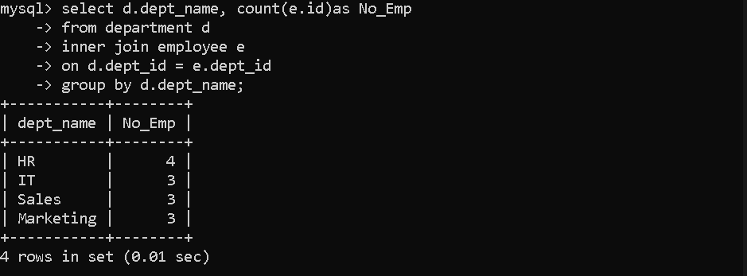

Q5) Write a general syntax for INNER JOIN between two tables.

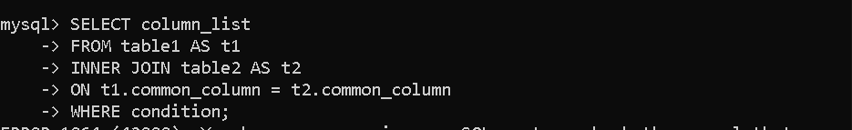

Q6) Display employee name and department name using INNER JOIN.

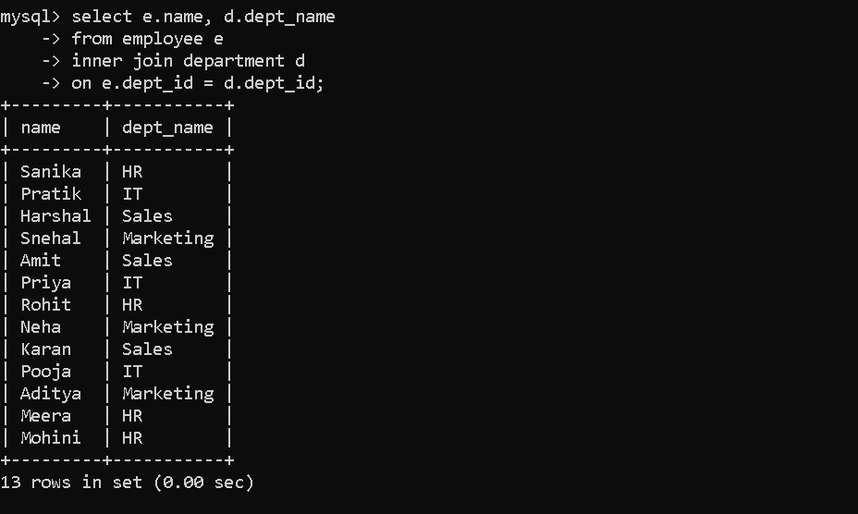

Q7) Insert a new department record with department_id = 5, department name "Accounts", and location "Gujrat".

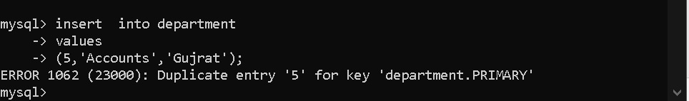

Q8) Display employee name and department name for employees who live in Pune.

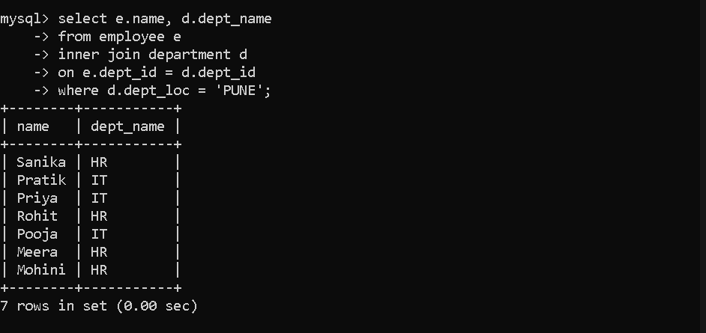

Q9) Display employee name and department name where employee city is equal to department location.

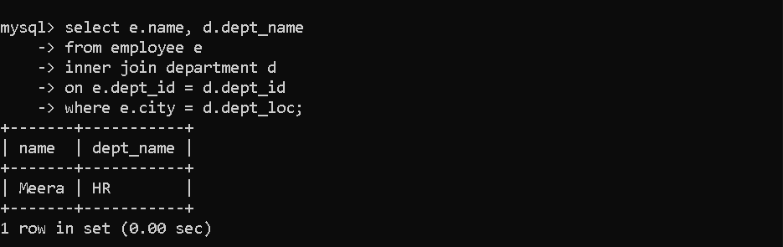

Q10) Display the current year using SQL function.

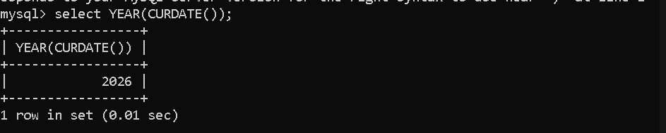

Q11) Display the current month using SQL function.



Q12) Display the current day using SQL function.

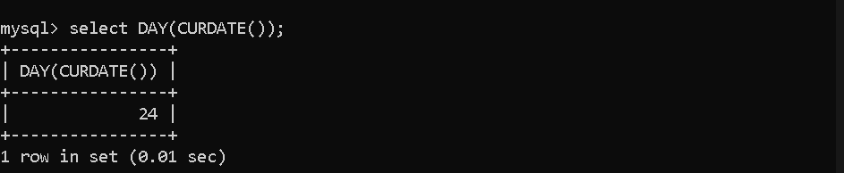

Q13) Display department name and number of employees in each department grouped by department name.

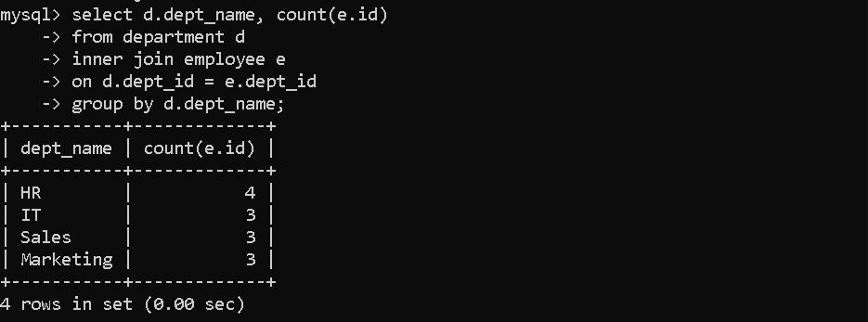

Q14) Display department location and number of employees in each department.

