20__JOINS() and GROUP_BY() and HAVING() :

HAVING + GROUP BY
- Find the department names where the minimum salary of employees is greater than or equal to 20000.
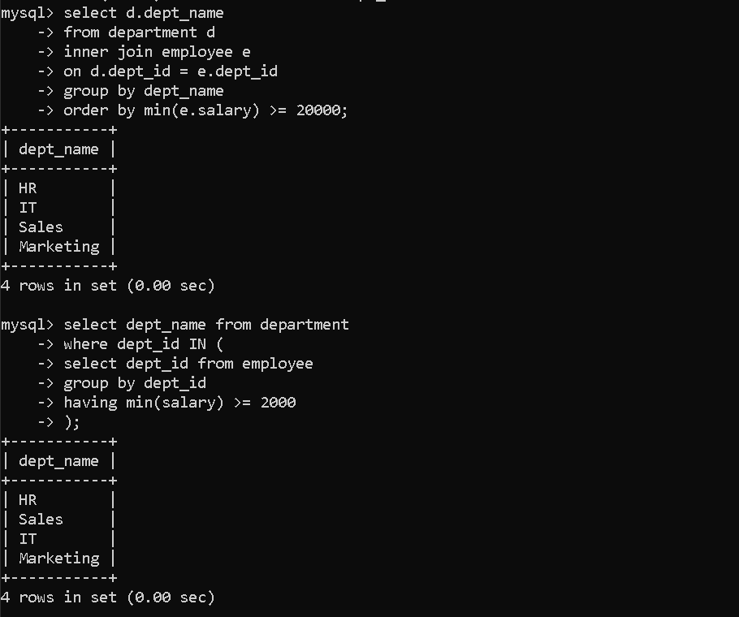
- Find the department names that have at least 3 employees.
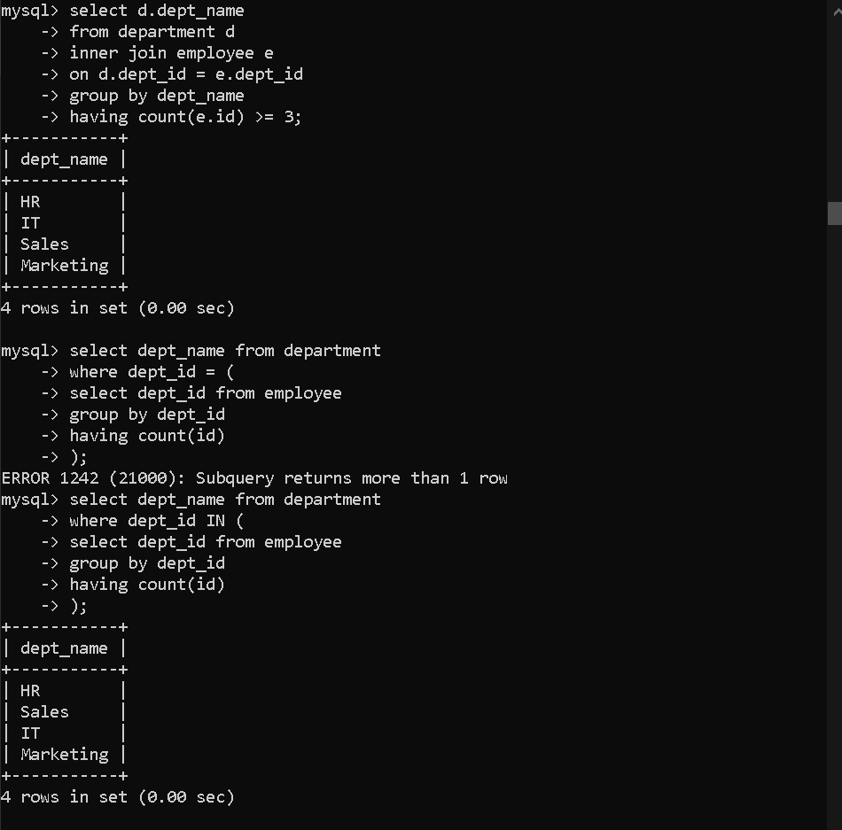
- Display department name along with maximum and minimum salary for departments not located in Pune.
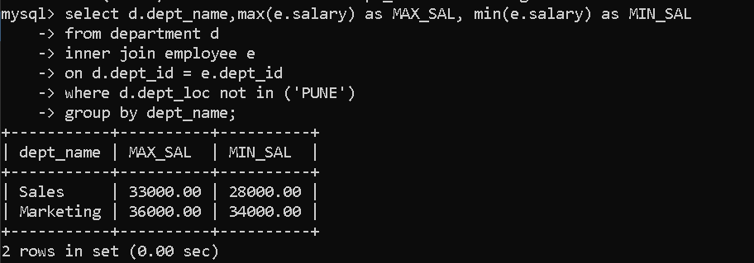
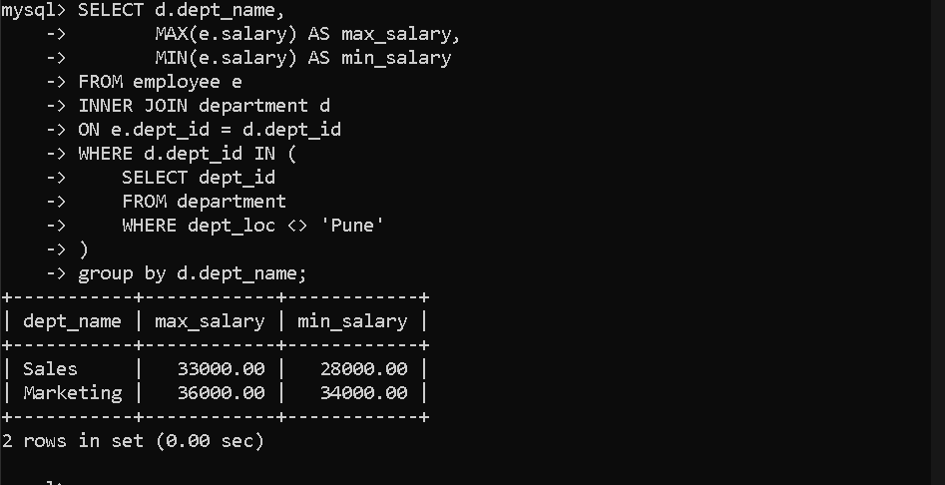

Subquery — NOT IN
- Find the departments that do not have any employees assigned to them.
This is a very common interview question
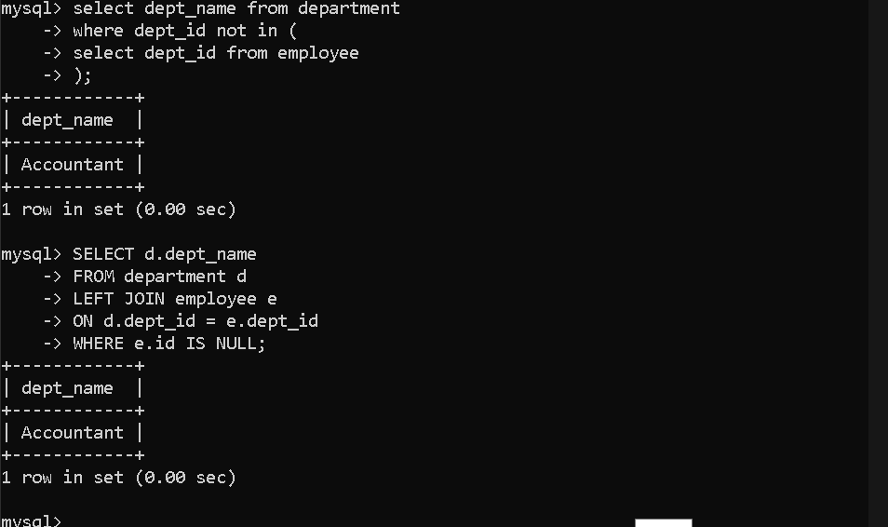

JOIN Concepts
- Display employee name and department name using LEFT JOIN.
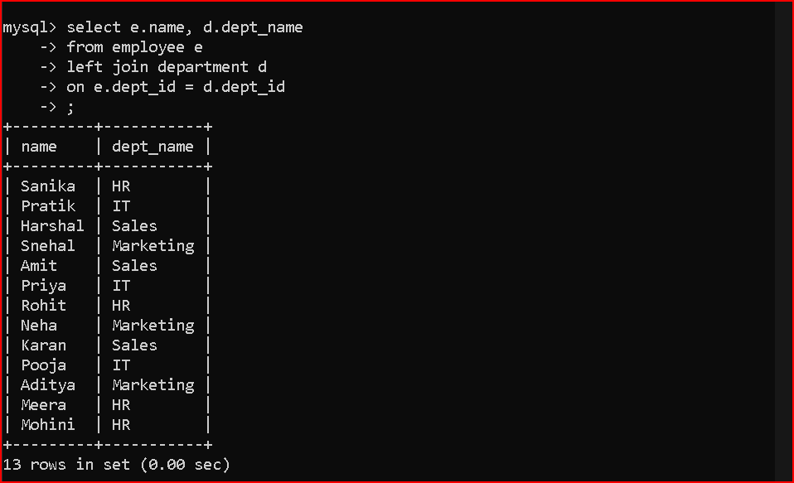
- Display department names even if no employees exist in that department.
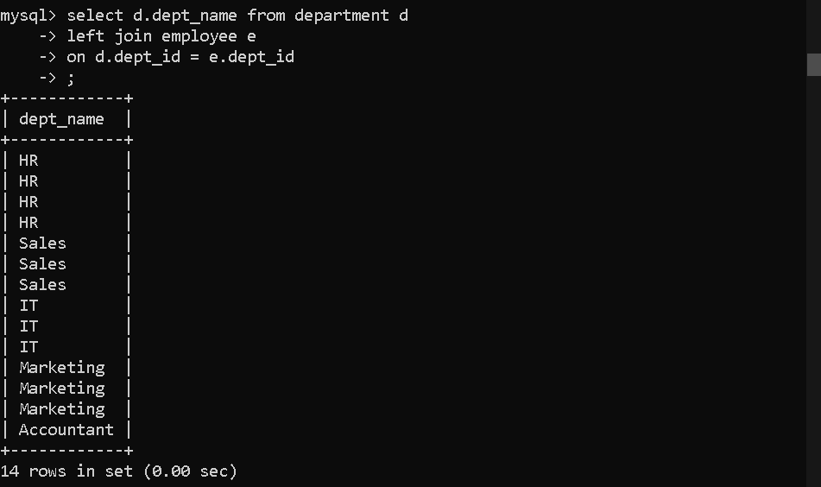
- Display employee names even if they are not assigned to any department.


- Explain the difference between LEFT JOIN and RIGHT JOIN with an example query.
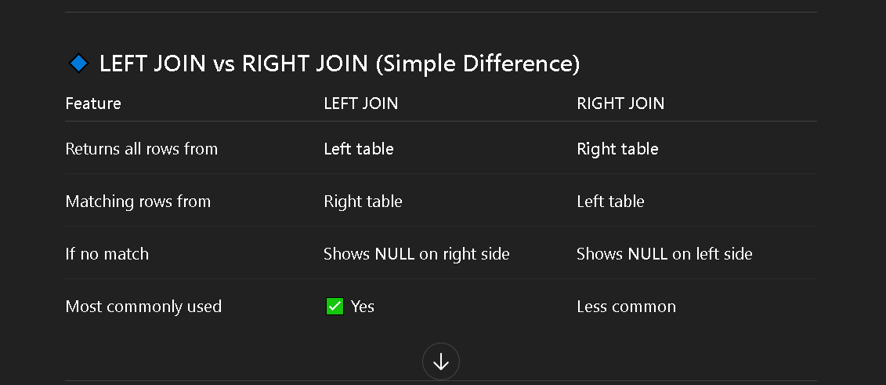
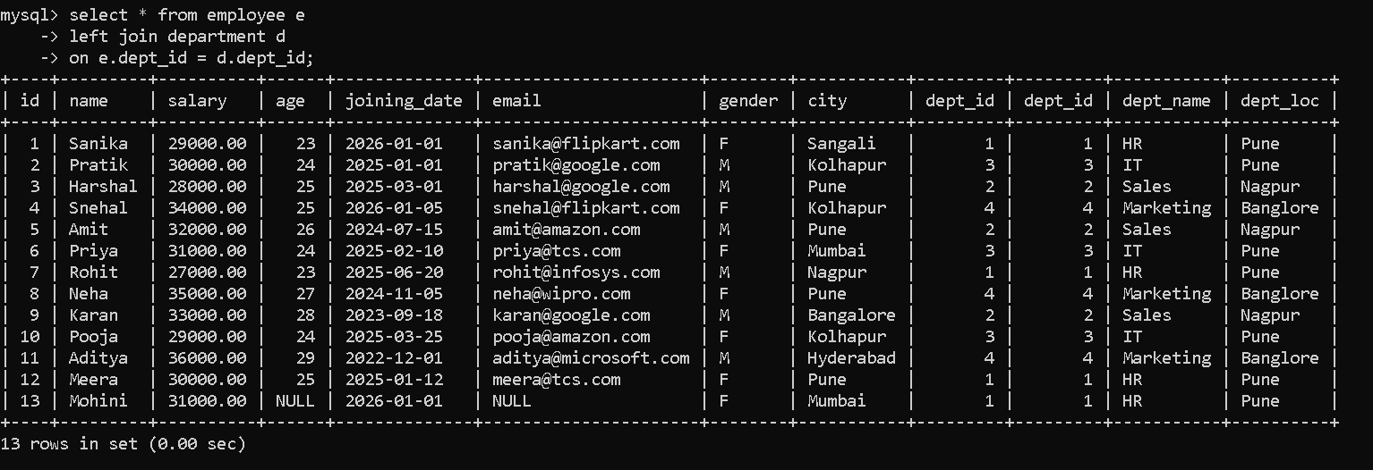
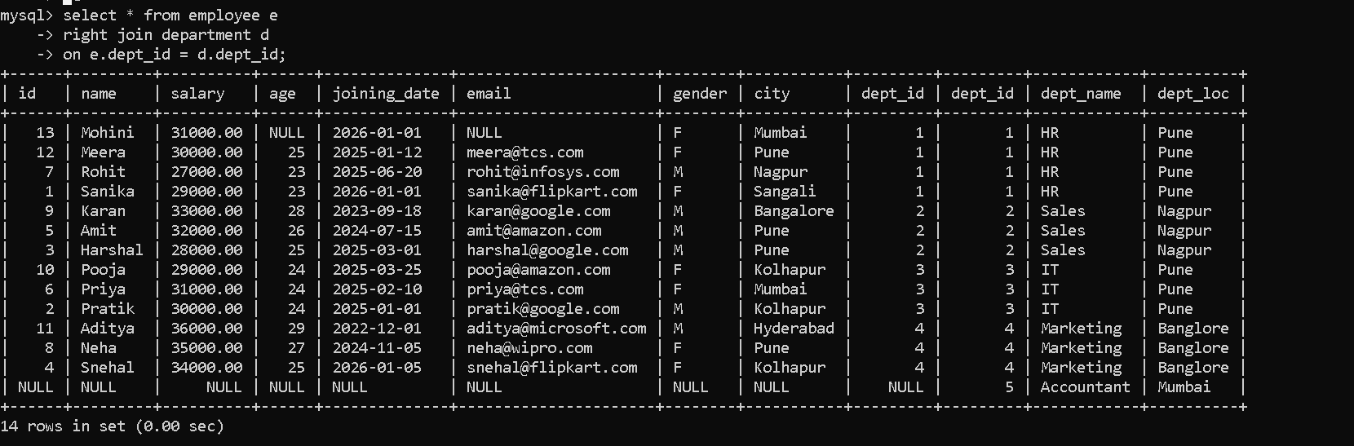

- Write a query to display all records from both employee and department tables using UNION.
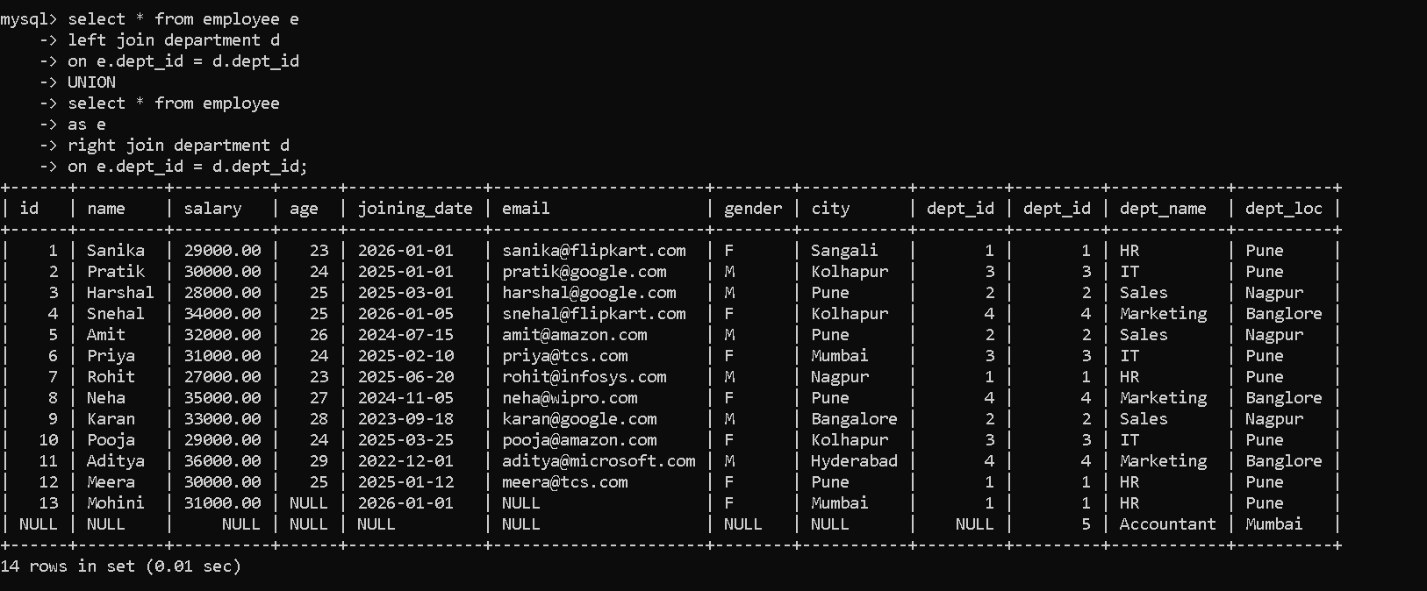

SELF JOIN (Very Important for Interviews)
- Display employee name and their manager name using a self join.
- Find the manager of a specific employee (for example, Rutuja).
- Display all employees along with their manager names, including employees who do not have managers.

Aggregate + HAVING — Real Interview Style
- Find departments where the maximum salary is greater than 35000.
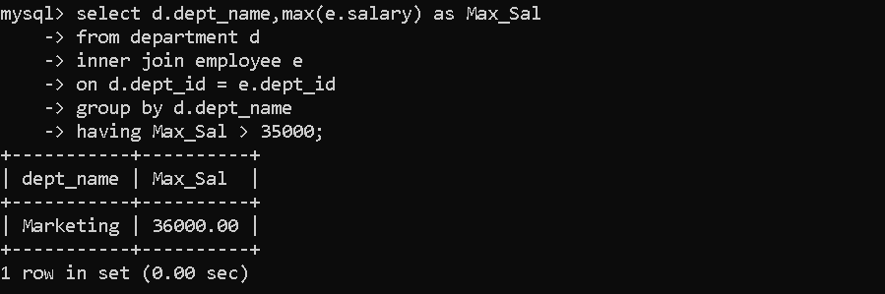

Find departments where the number of employees is greater than or equal to 3.
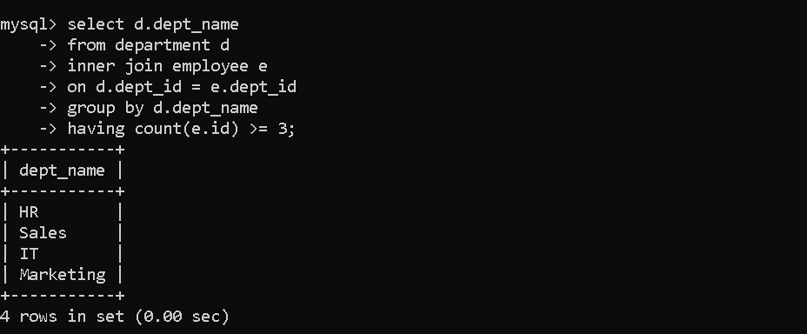
- Find departments where the average salary is greater than 30000.
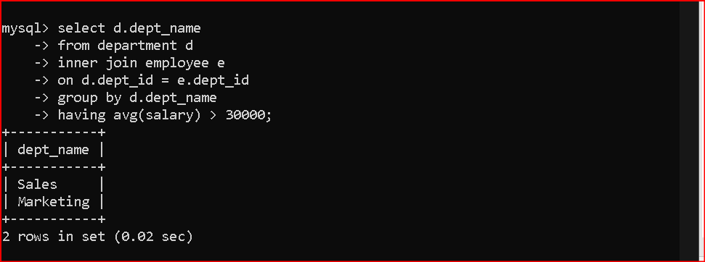

UNION — Interview Question
- Combine results from LEFT JOIN and RIGHT JOIN to display all employees and all departments.
