Ctrl + (down arrow) to go on last row 10,48,676 rows
Ctrl + (right arrow) to go on last of right side 16,384 columns

Address : (COLUMN, ROW) e.g. (B13) means B column and 13th row
- if u want to change more values then just put formula on one cell and then just drag and drop that cell to below of that

- DropDown Option
If you want to add dropdown on a cell
Go to Data Data Validation Select List Option Then select cell address

Range Address:
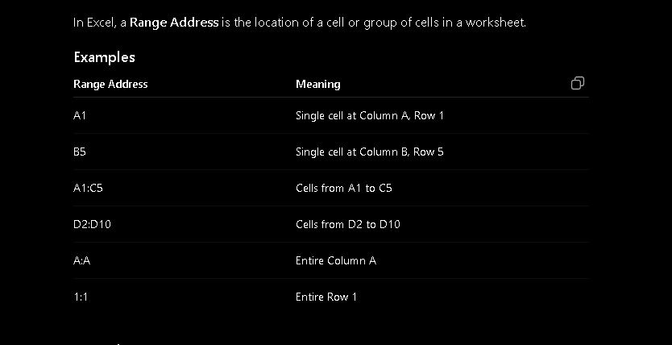

** Mathematical Functions **
- EVEN(number) rounds a number upto the nearest even integer.
e.g. =EVEN(7) : output will be 8

- ODD(number) rounds a number away from 0 to nearest odd integer
e.g. =ODD(8) : output will be 9

- POWER(number, power) return a number raise to a power
e.g. =POWER(2,3) : output will be 8 (2 x 2 x 2 = 8)

- FACT(number) return a factorial of number
e.g. =FACT(5) : output will be 120 (5 x 4 x 3 x 2 x 1 = 120)

- ROMAN(number) return a roman number of normal number
e.g. =ROMAN(address_of_column) : =roman(B12) : output wil be change of that cell value (if value is 5 then out will V)

- SUM(range) return a sum of multiples values
e.g. = SUM(10,20,30) : output will be 60 =sum(n1,n2,n3…n)
=SUM(b12:b15) : give sum this range cells =sum(range)

- SUMIF(range, criteria, sum_range) used to add values based on condition.
    - range Cells to check the condition
    - criteria Conditions to match
    - sum_range Cells to add.

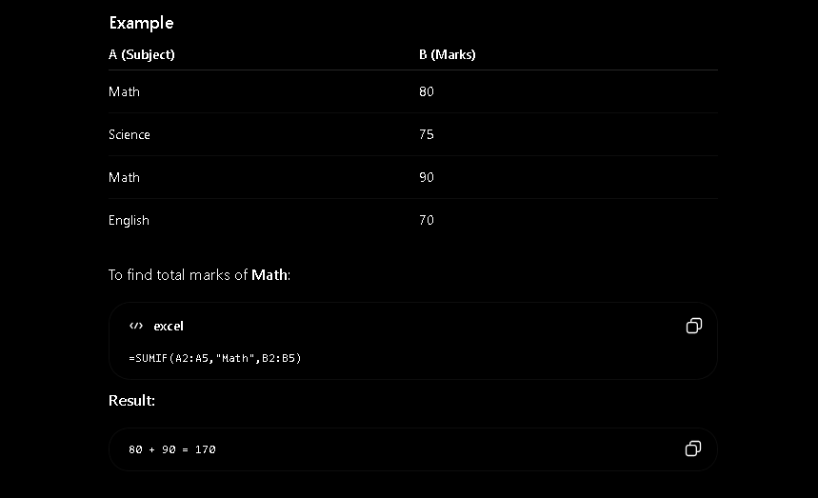
- SUMIFS(sum_range, criteria_range1, criteria1, criteria_range2, criteria2, ….) used to add values based on multiple conditions.
    - sum_range Cells to add
    - criteria_range1 First range to check
    - criteria1 First condition
    - criteria_range2 Second range to check
    - criteria2 Second condition
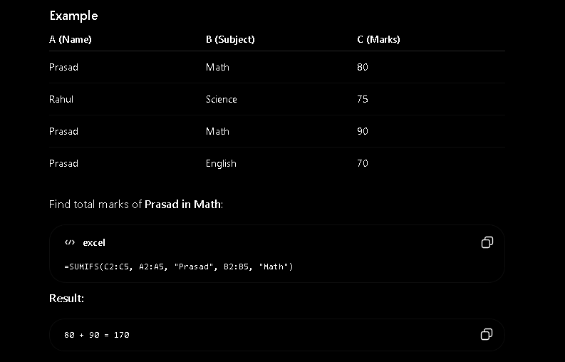
- SUMPRODUCT(array1, array2) it multiplies corresponding values in two or more ranges and then adds the results.
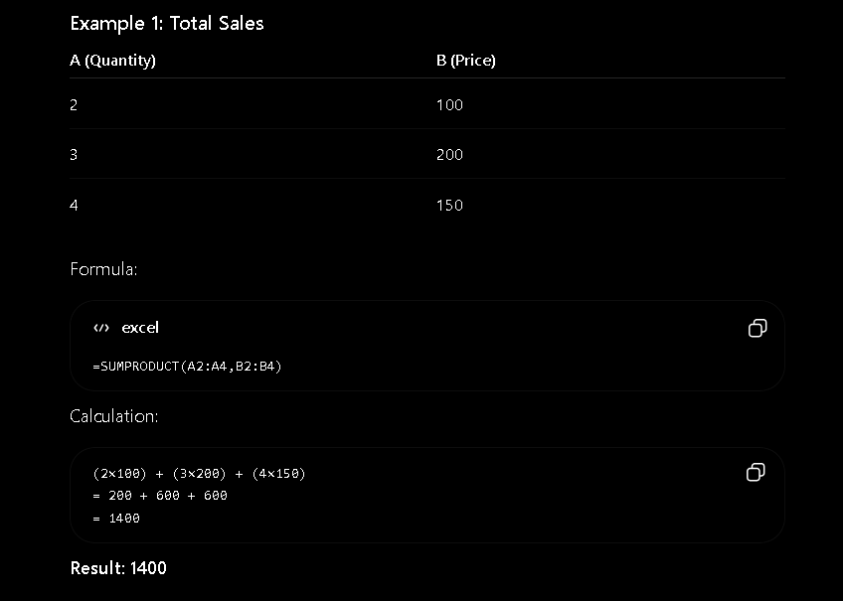
- INT(number) it rounds a number down to the nearest integer(removes the decimal part)
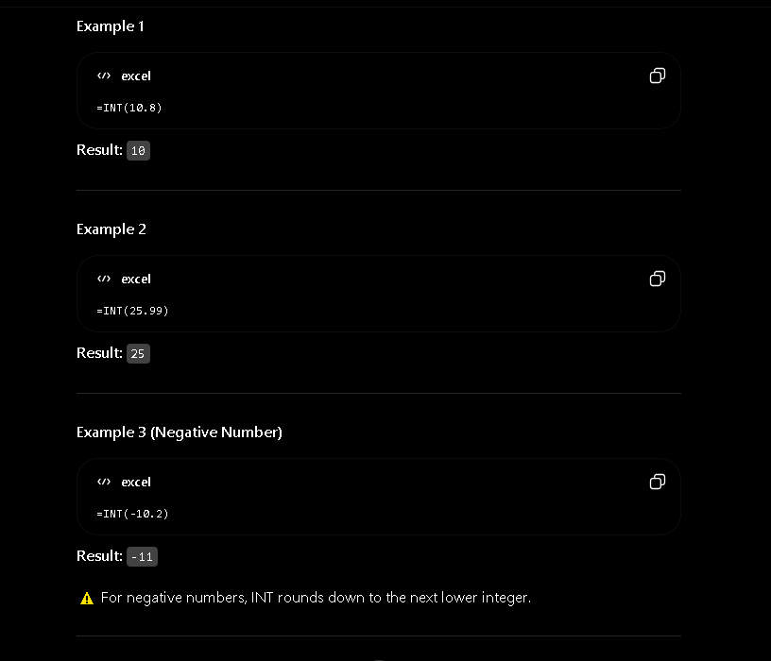
- MOD(number, divisor) it returns the remainder after dividing one number by another
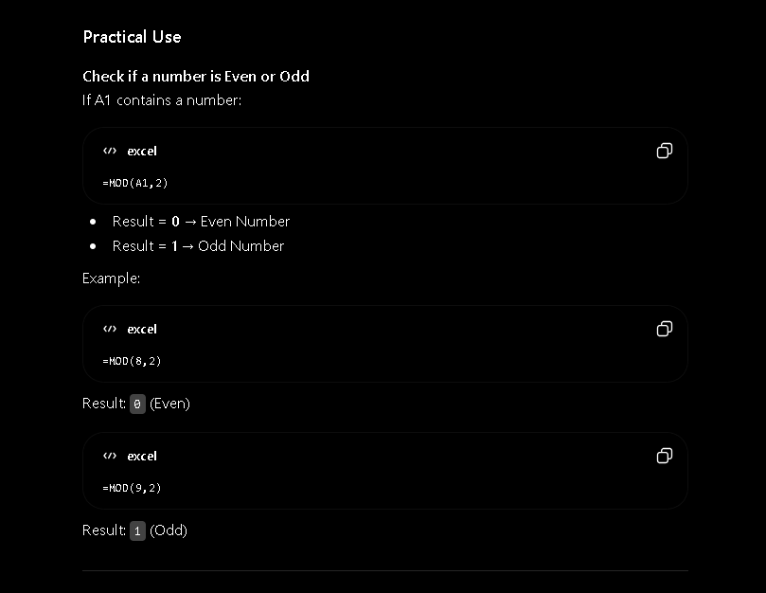
- ROUND(number, num_digits) it rounds a number to specified number of decimal places.
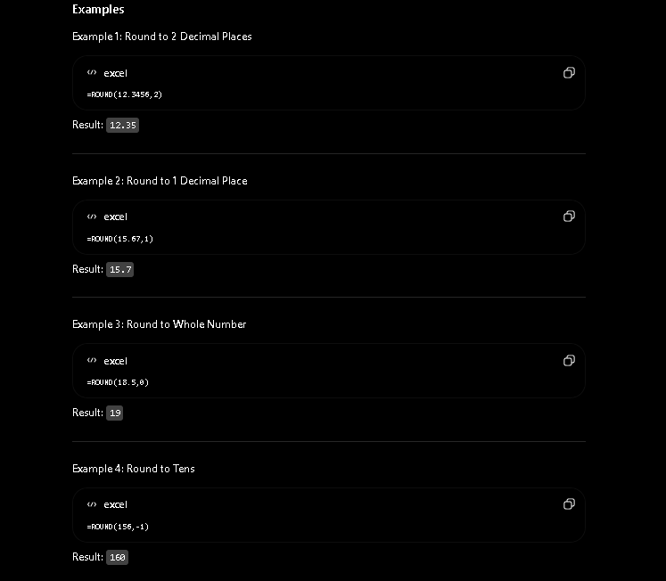
- SQRT(number) it returns the square root of number.
