- AVERAGEA(value1, value2,…) it calculates the average of values, but unlike AVERAGE(), it also considers text and logical values.
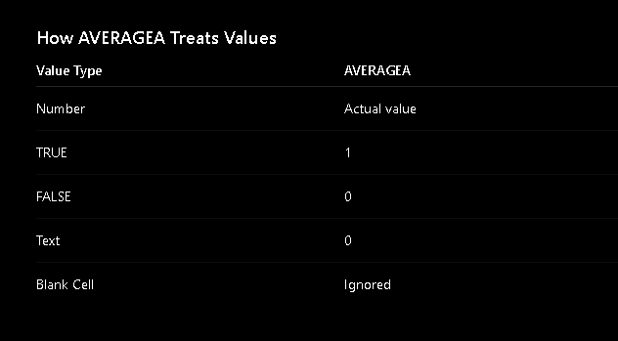
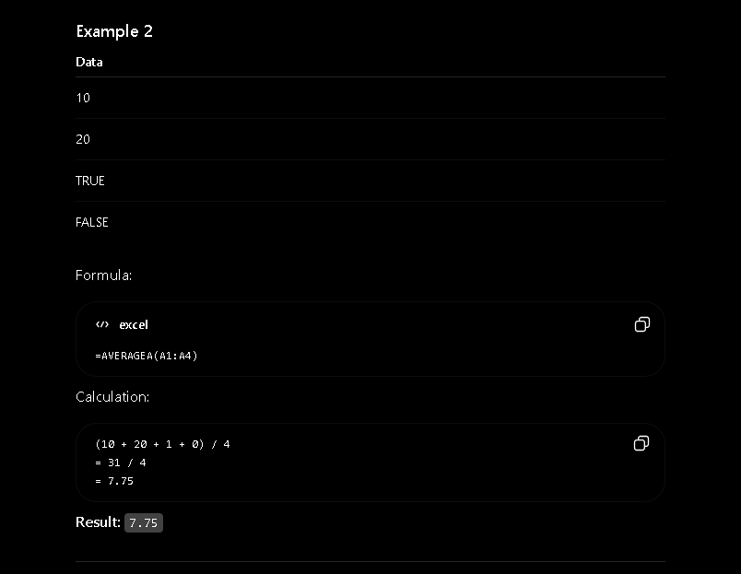

- AVERAGEIF(range, criteria, average_range) it calculates the average of cells that meet a specific condition.
    - range cells to check the conditions
    - criteria condition to match
    - average_range cells whose average will be calculated (optional)

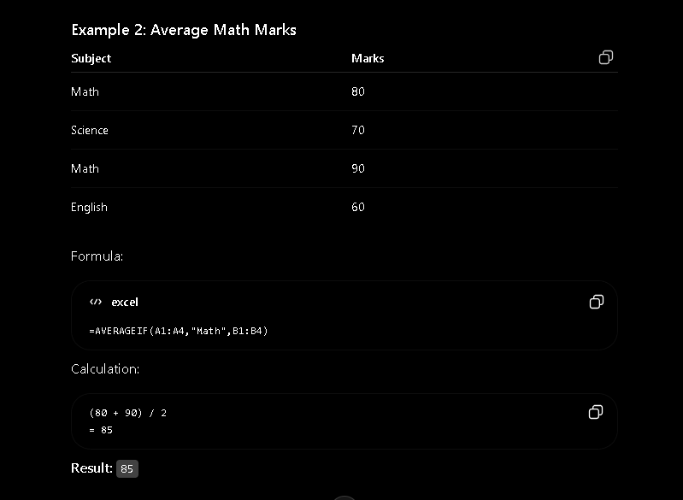

- LOOKUP(looup_value, lookup_vector, result vector) it searches for a value in row or column and returns the corresponding value from another row and column
    - Lookup_value The value to search for
    - Lookup_vector The row or column containing the value to search
    - result_vector The row or column containing the value to return
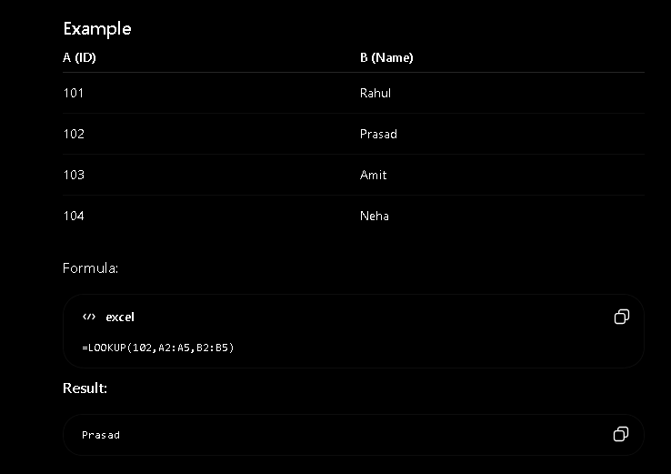

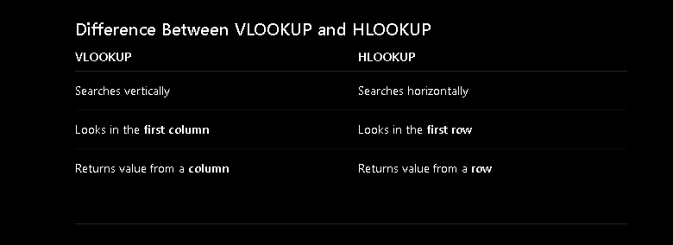
- VLOOKUP(lookup_value, table_array, col_index, range_lookup) it searches for a value in the first column of table and returns a value from another column in same row.
    - lookup_value Value to search for
    - table_array Table containing the data
    - col_index_num Column number to return
    - range_lookup False = Exact match, True = Approximate match
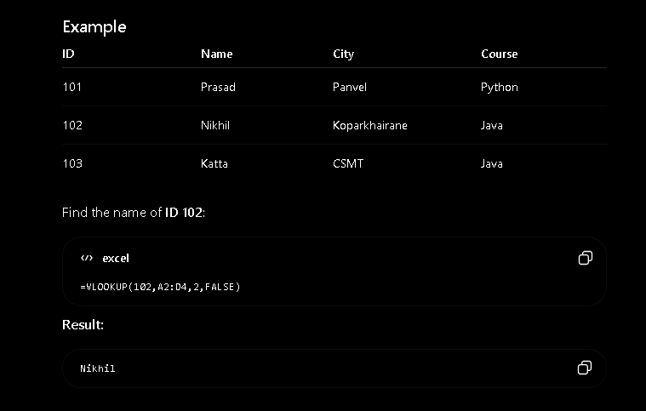
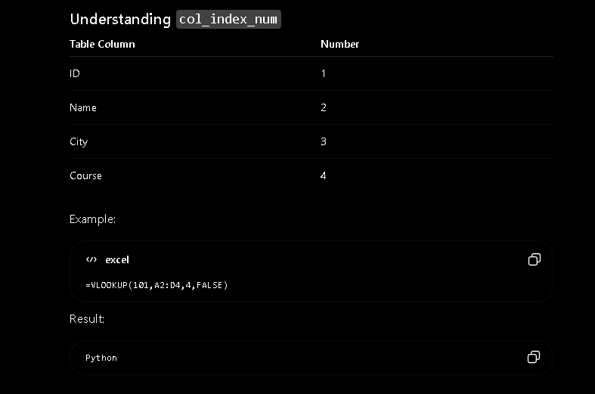
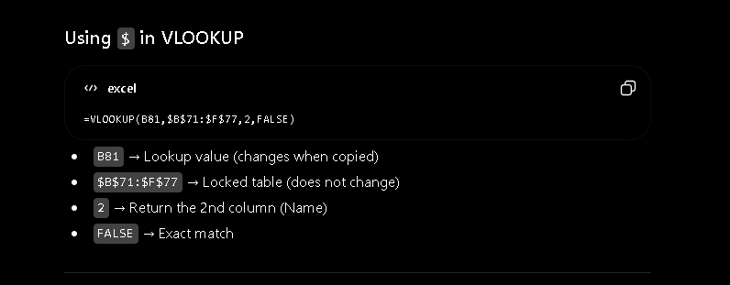
Rules of VLOOKUP:
- LOOKUP value must be in 1st column , VLOOKUP always searches from left most column
- False for exact match, used in real projects and interviews
- True for Approximate match, used for grading and slab

Common Errors of VLOOKUP:
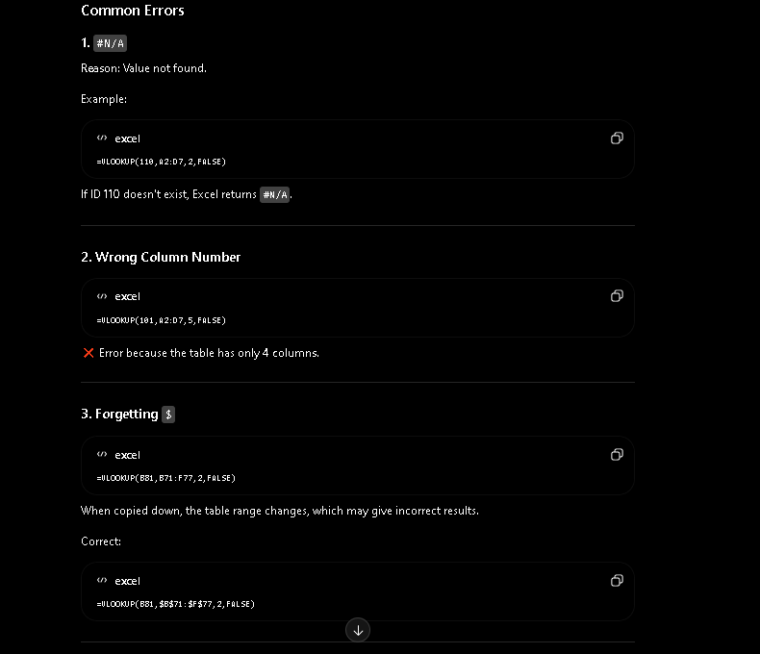

- MATCH(lookup_value, lookup_array, match_type) it returns the position (index number) of a value in a row or column not a actual value.
    - Lookup_value Value to search
    - Lookup_array Row or column to search
    - Match_type 0 = Exact match, 1 = Less than (ascending), -1 = Greater than (Descending)
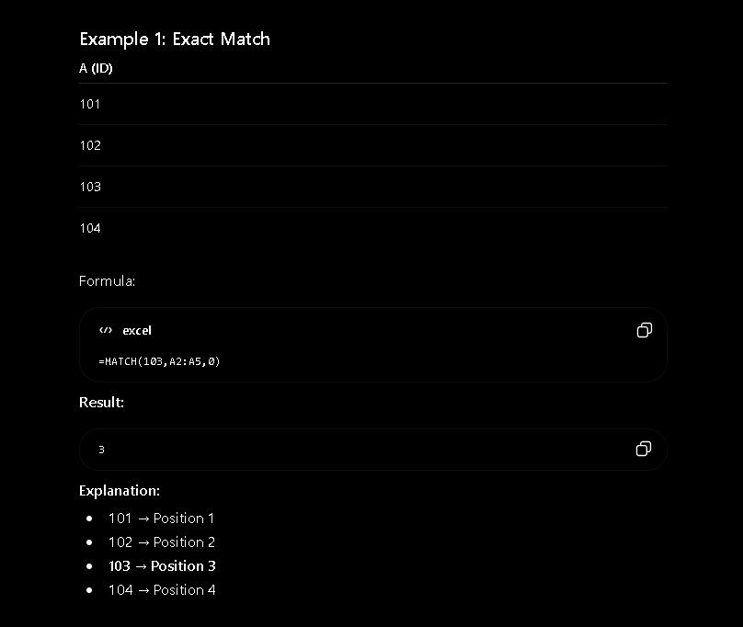
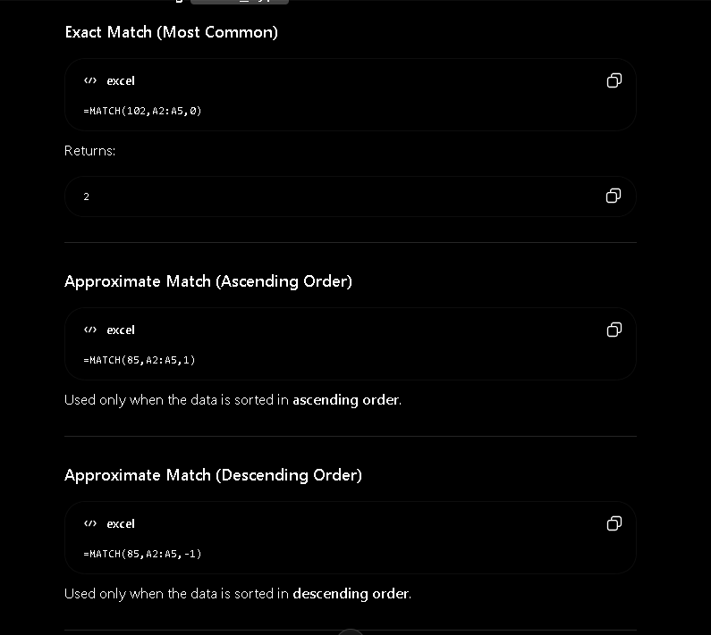
- HLOOKUP(lookup_values, table_array, row_index_num, range_lookup) it searches for a value in first row of table and returns a value from s specified row in same column.
    - Lookup_value Value to search in first row
    - Table_array Table containing the data
    - Row_index_num Row number to return
    - Range_lookup FALSE = Exact match, TRUE = Approximate match
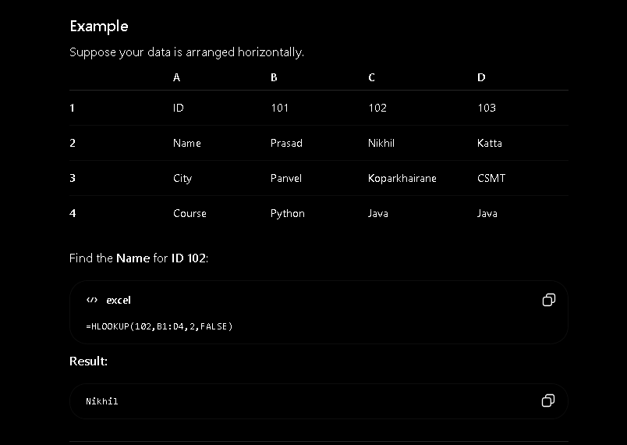
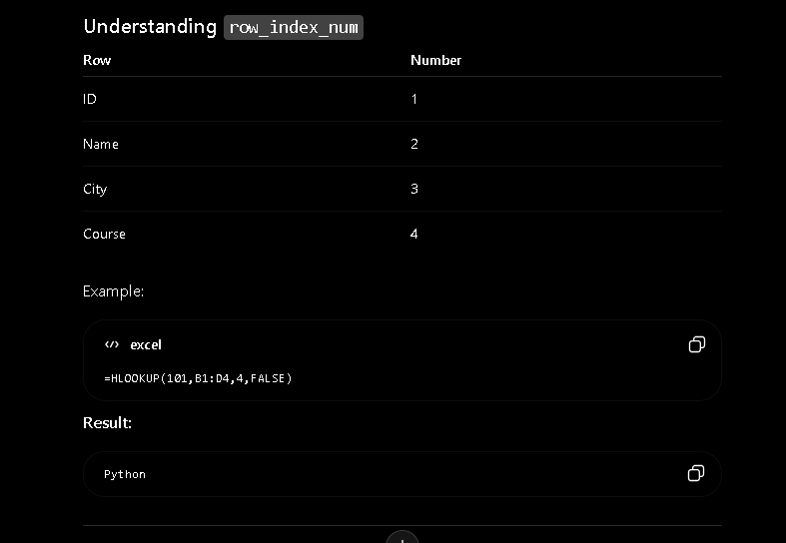
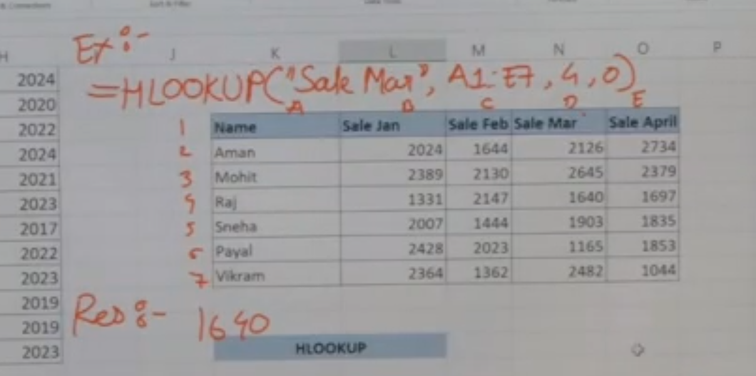
- INDEX(array, row_num, column_num) it returns the value from a specified row and column in range or table.
    - Array Table or range
    - Row_num Row Number
    - Column_num Column Number
