Ctrl + (down arrow) to go on last row 10,48,676 rows
Ctrl + (right arrow) to go on last of right side 16,384 columns

Address : (COLUMN, ROW) e.g. (B13) means B column and 13th row
- if u want to change more values then just put formula on one cell and then just drag and drop that cell to below of that
Range Address:
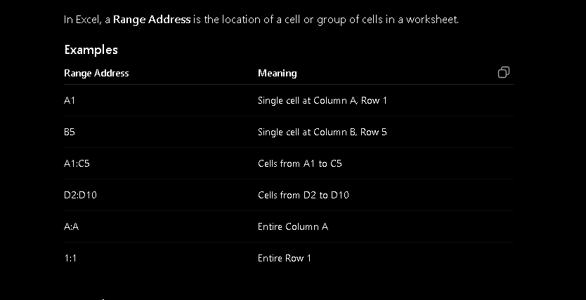

** Functions
- EVEN(number) rounds a number upto the nearest even integer.
e.g. =EVEN(7) : output will be 8

- ODD(number) rounds a number away from 0 to nearest odd integer
e.g. =ODD(8) : output will be 9

- POWER(number, power) return a number raise to a power
e.g. =POWER(2,3) : output will be 8 (2 x 2 x 2 = 8)

- FACT(number) return a factorial of number
e.g. =FACT(5) : output will be 120 (5 x 4 x 3 x 2 x 1 = 120)

- ROMAN(number) return a roman number of normal number
e.g. =ROMAN(address_of_column) : =roman(B12) : output wil be change of that cell value (if value is 5 then out will V)

- SUM(range) return a sum of multiples values
e.g. = SUM(10,20,30) : output will be 60 =sum(n1,n2,n3…n)
=SUM(b12:b15) : give sum this range cells =sum(range)

- SUMIF(range, criteria, sum_range) used to add values based on condition.
    - range Cells to check the condition
    - criteria Conditions to match
    - sum_range Cells to add.

