Q1) Write an SQL query to display employee first_name and last_name with suitable column
aliases.
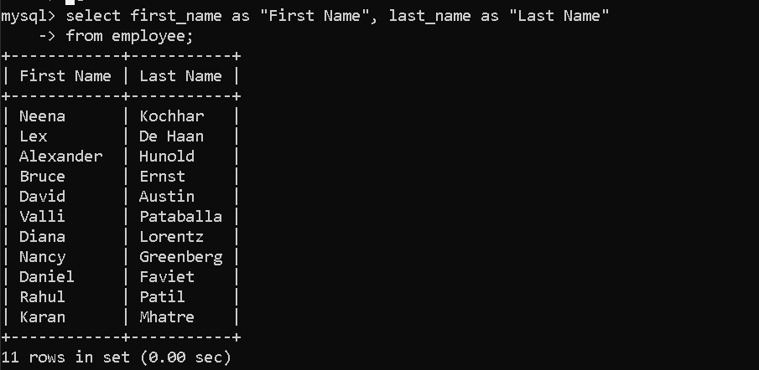
Q2) Write an SQL query to display all different department IDs available in the EMPLOYEES
table.

Q3) Write an SQL query to display all employee details sorted by first_name in descending
order.
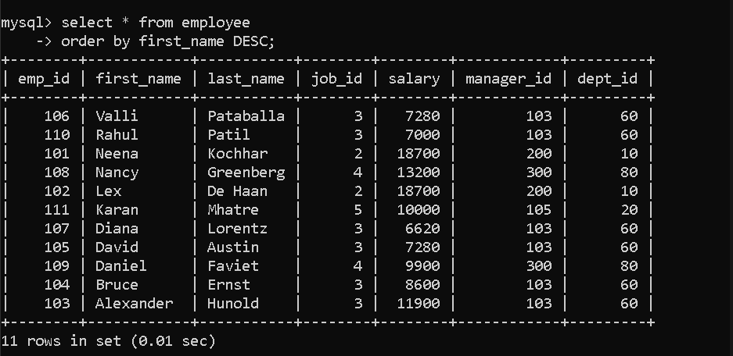
Q4) Write an SQL query to display first_name, last_name, salary, and PF for all employees.
(PF is calculated as 15% of salary.)
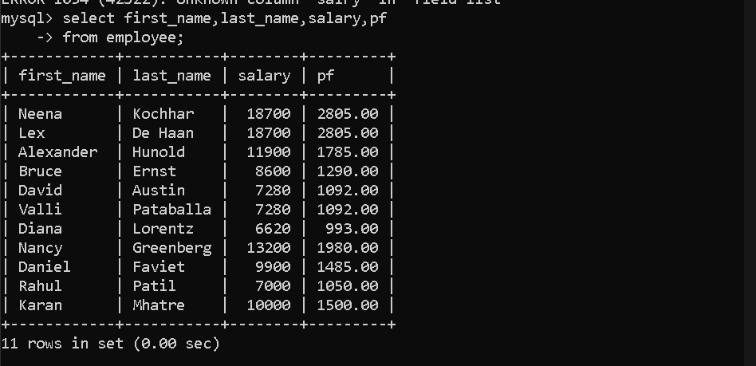
Q5) Write an SQL query to display employee_id, employee names, and salary sorted in
increasing order of salary.
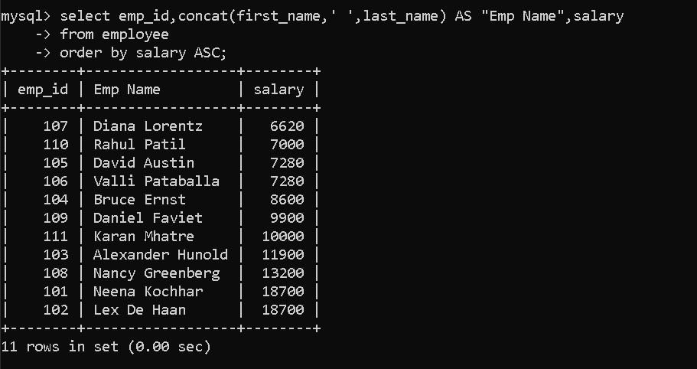
Q6) Write an SQL query to display the total salary payable to all employees.

Q7) Write an SQL query to display the highest salary and the lowest salary from the
EMPLOYEES table.
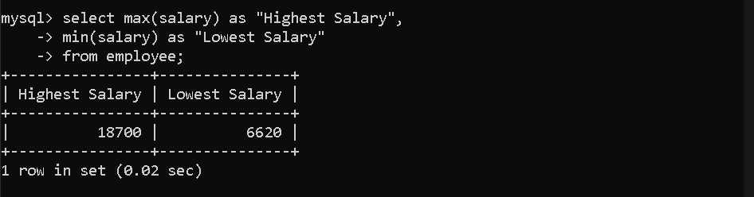
Q8) Write an SQL query to display the average salary and the total number of employees.
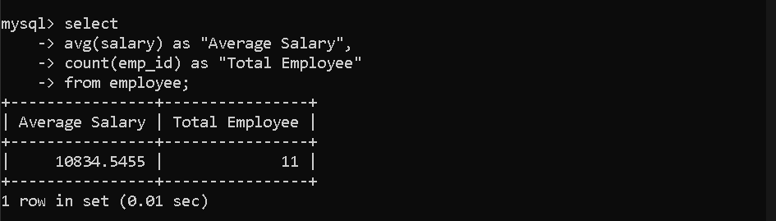
Q9) Write an SQL query to display the total number of employees working in the company.

Q10) Write an SQL query to display the number of different job roles available in the
EMPLOYEES table.


Q11) Write an SQL query to display the first 10 employee records from the EMPLOYEES table.
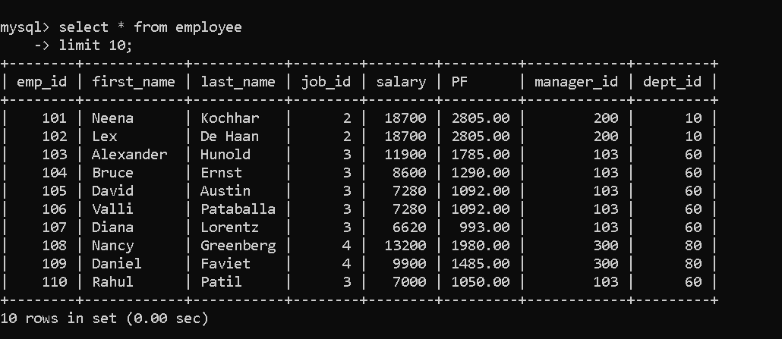
Q12) Write an SQL query to display employee names and salary for employees whose salary is
less than 10000 or greater than 15000.
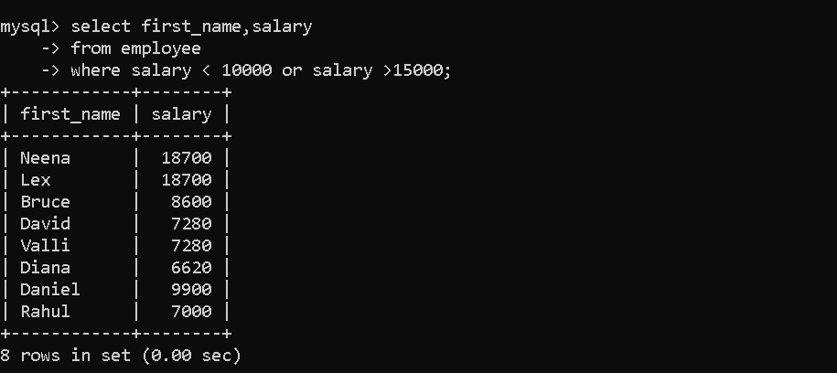
Q13) Write an SQL query to display employee names and department_id for employees working
in department 30 and department 100.
Sort the result by department_id.
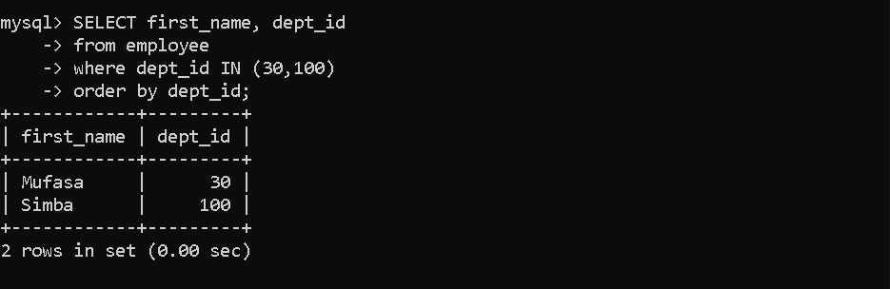
Q14) Write an SQL query to display employee names and salary for employees working in
department 30 or 100,
whose salary is outside the range 10000 to 15000.
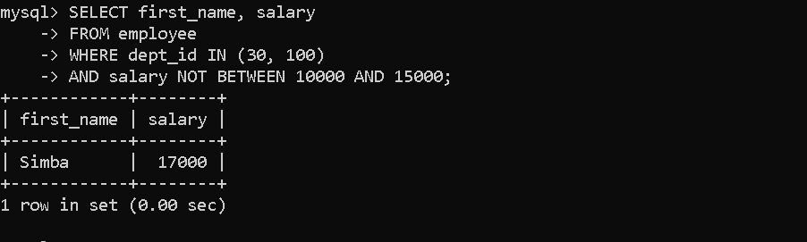
Q15) Write an SQL query to display employee names and hire_date for employees who were
hired in the year 1987.

Q16) Write an SQL query to display first_name of employees whose first_name contains both
letters 'b' and 'c'.

Q17) Write an SQL query to display last_name, job role, and salary for employees who work as
Programmer or Shipping Clerk,
and whose salary is not equal to 4500, 10000, or 15000.

Q18) Write an SQL query to display last_name of employees who’s last_name contains exactly 6
characters.

Q19) Write an SQL query to display last_name of employees having 'e' as the third character in
their last_name.

Q20) Write an SQL query to display all different job roles/designations available in the
EMPLOYEES table.

Q21) Write an SQL query to display employee details for employees who’s last_name is
BLAKE, SCOTT, KING, or FORD.
