23__VIEWS() :

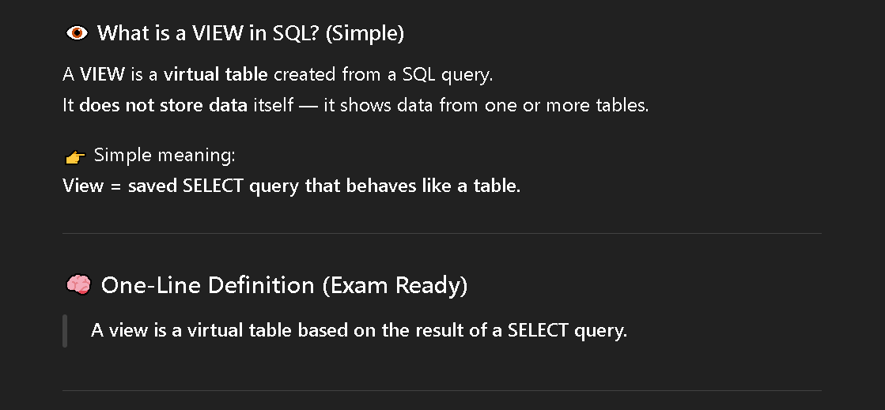

Q1) Display the number of employees who joined in each month of the year 2025.

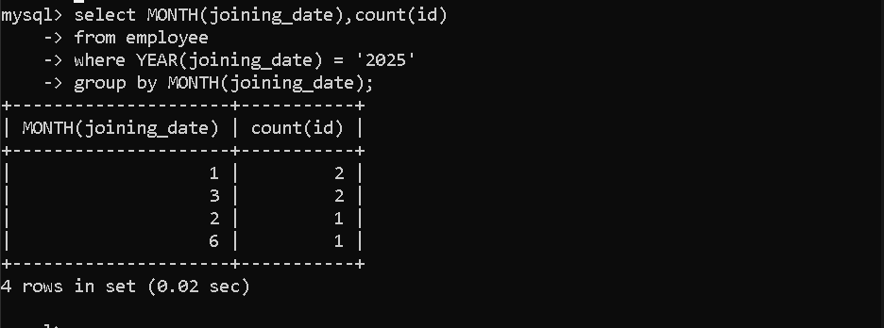

Q2) Display the number of employees who joined in each year.

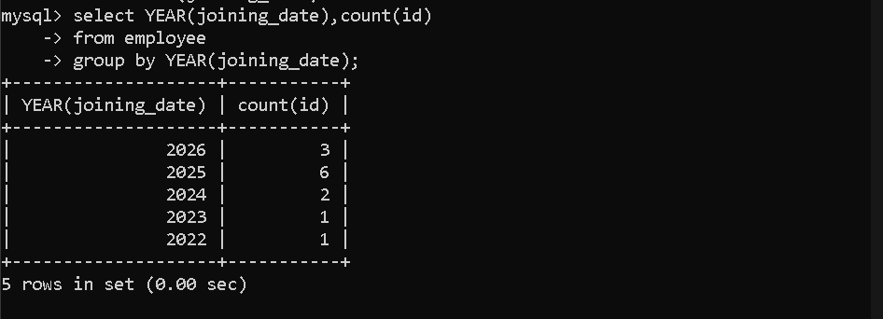

Q3) Create a view named pune_emp to display employee name and age of employees who live in Pune.

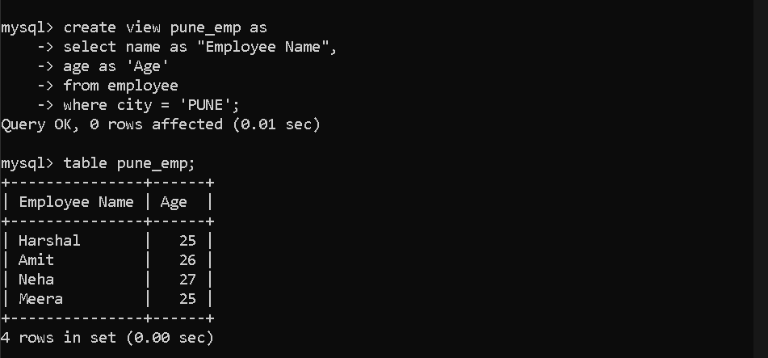

Q4) Display all records from the pune_emp view.

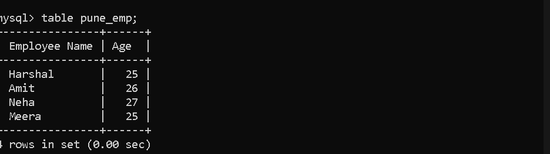

Q5) Update the age of employees to 26 in the pune_emp view where age is 25.

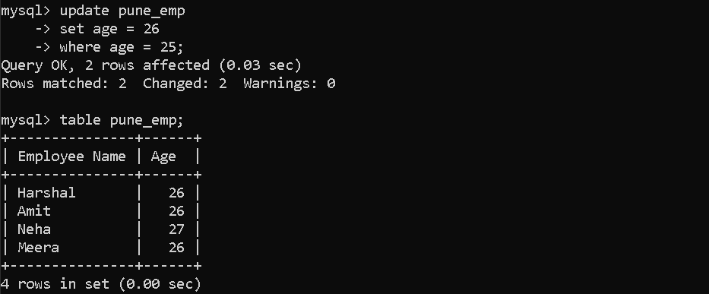

Q6) Delete records from the pune_emp view where age is 23.

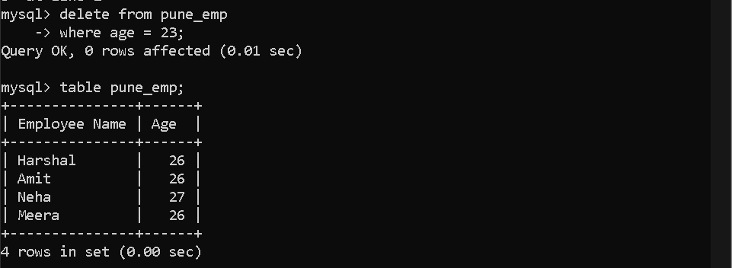

Q7) Drop the view named pune_emp.

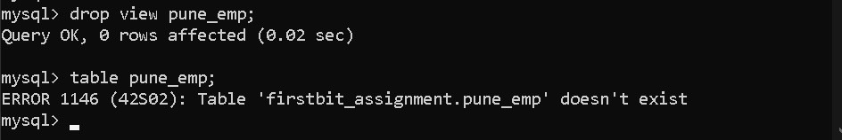

Q8) Create a view named dept_emp to display department name and number of employees in each department.

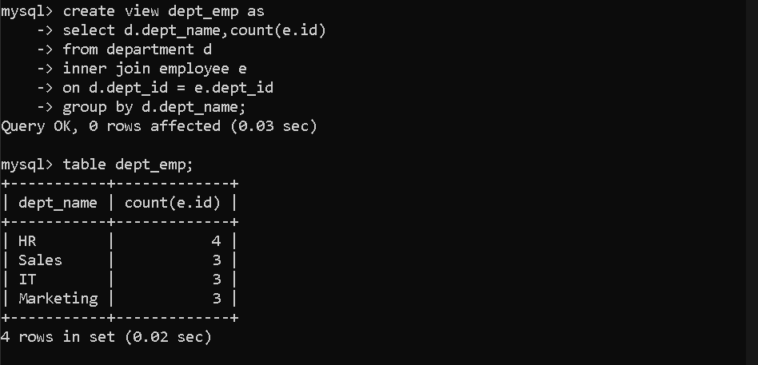

Q9) Display all records from the dept_emp view.

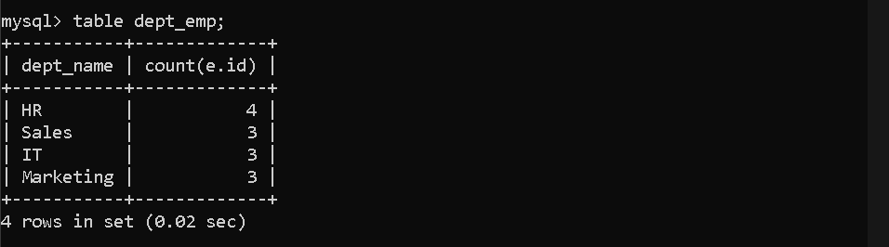

Q10) Write the general syntax to create a view.
