23__INDEX() and CASE() and LIKE() :

INDEX

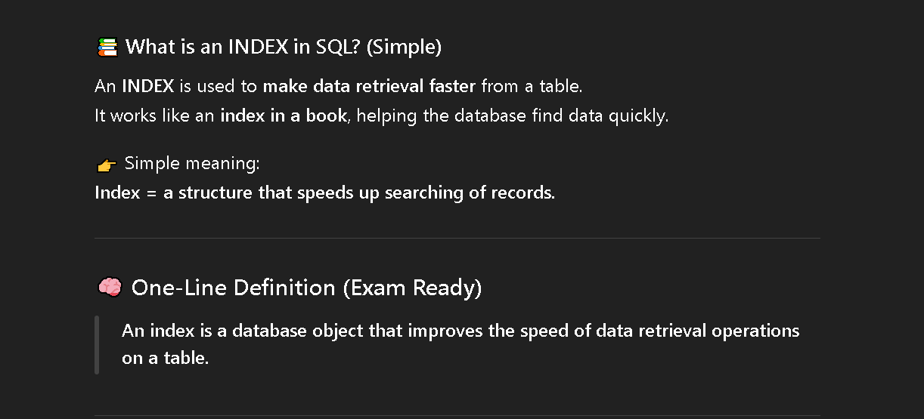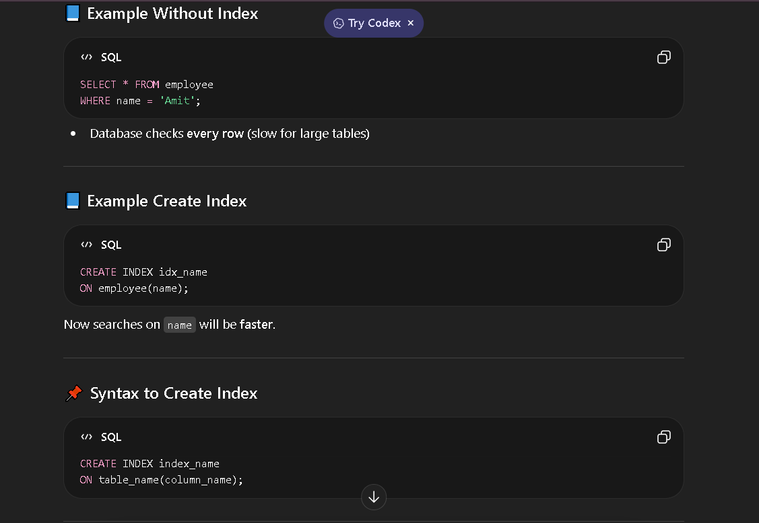

Q1) Write an SQL query to create an index on the id column of the employees table.
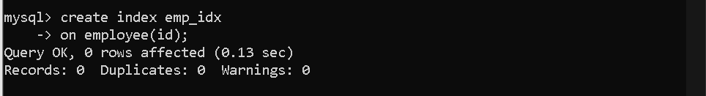
Q2) Write an SQL query to drop an index named idx_id from the employees table. 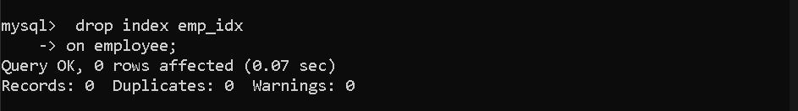
Q3) What command is used to check the execution plan of a query?
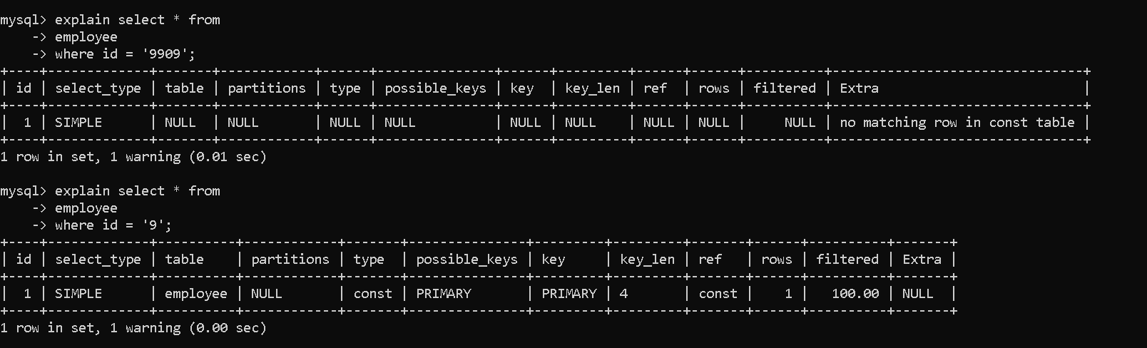

CASE Statement
Q4) Display employee name and salary category using CASE:
- Salary ≥ 35000 → Highly Paid
- Salary between 25000 and 34999 → Moderately Paid
- Salary < 25000 → Less Paid
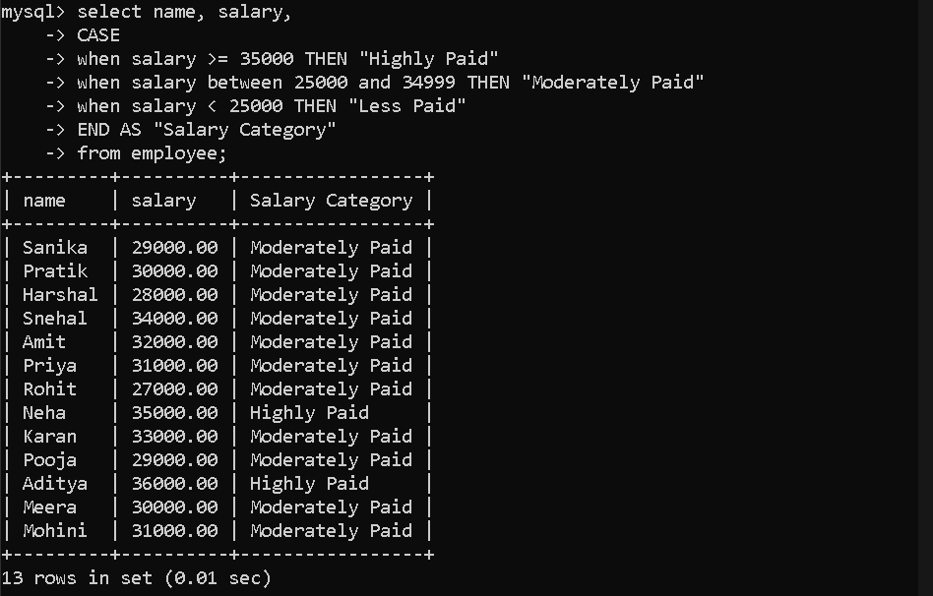

LIKE Operator (Pattern Matching)
Q5) Display names of employees whose names start with letter S.
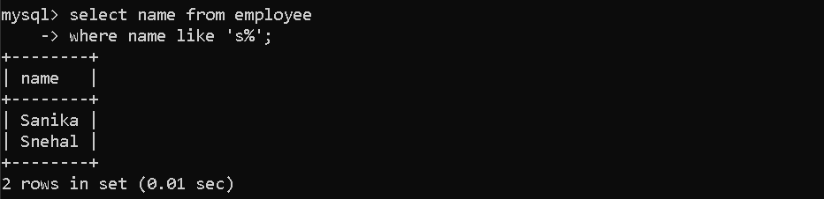
Q6) Display names of employees whose names end with letter a.
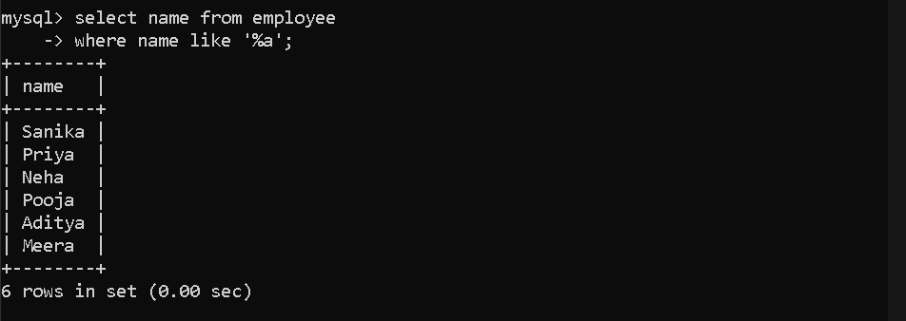
Q7) Display names of employees whose names contain letter a anywhere.
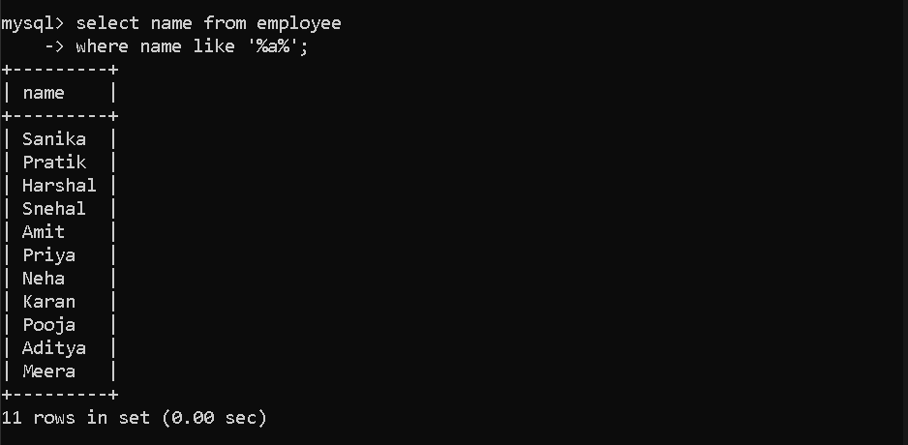

Q8) Display names of employees whose names contain letter n.
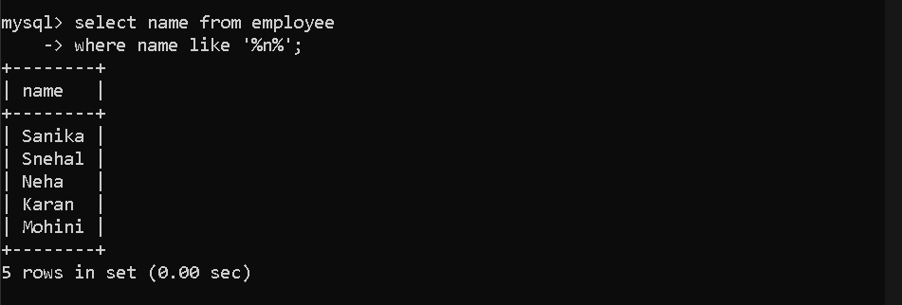
Q9) Display names of employees where the second letter is a.
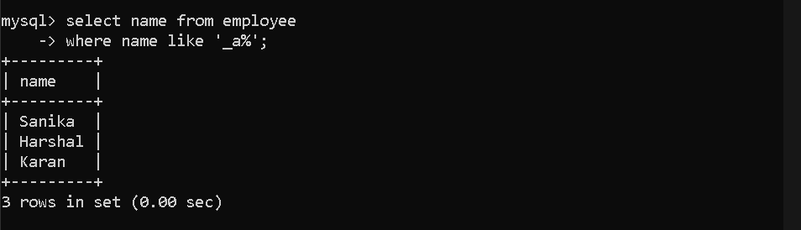
Q10) Display names of employees where the last second letter is a.
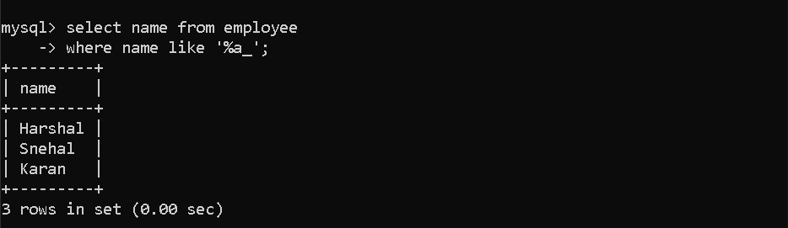
Q11) Display employee names whose email ends with @google.com.
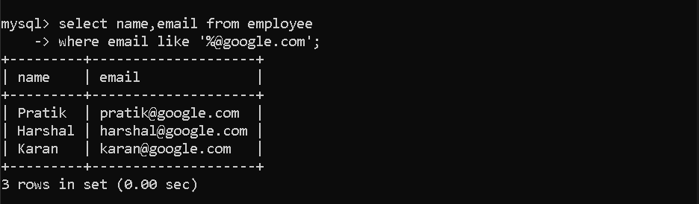
Q12) Display employee name and email where the name matches pattern p_a%.
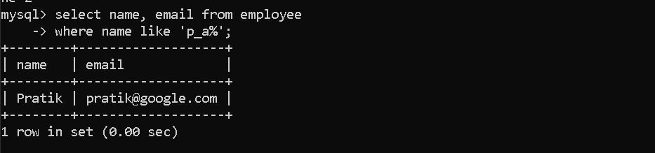

Aggregate / Sorting
Q13) Display the employee with the highest salary.
