Q1) Write an SQL query to list all books written by author 'Loni' with price less than 600.
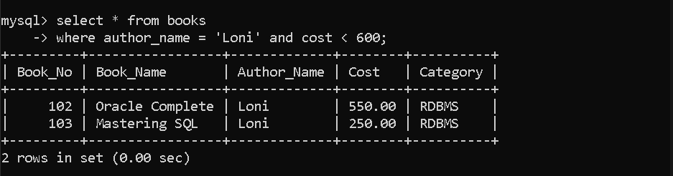
Q2) Write an SQL query to display issue details of books that are not returned yet.
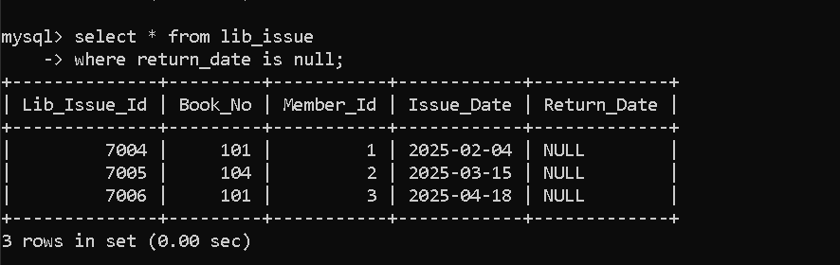
Q3) Write an SQL query to update all blank return_date values to '2025-12-31' excluding issue
IDs 7005 and 7006.
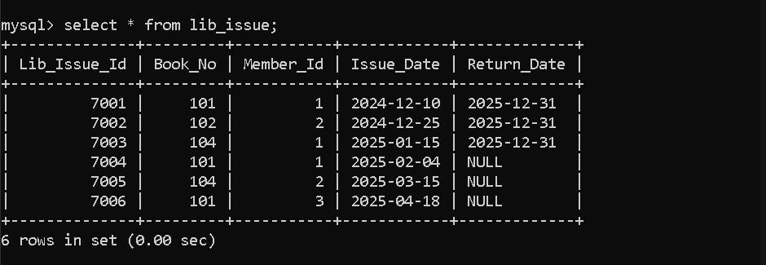
Q4) Write an SQL query to display issue details of books issued for more than 30 days.

Q5) Write an SQL query to list all books priced between 500 and 750 and belonging to category
'Database'.

Q6) Write an SQL query to list all books belonging to categories Science, Database, Fiction, or
Management.

Q7) Write an SQL query to list all members in descending order of penalty amount.

Q8) Write an SQL query to update book number 103 with cost = 300 and category = 'RDBMS'.

Q9) Write an SQL query to list all books sorted by category (ascending) and price (descending).

Q10) Write an SQL query to list all books whose name contains the word 'SQL'.

Q11) Write an SQL query to display Lib_Issue_Id, Issue_Date, Return_Date and number of days
the book was issued.

Q12) Write an SQL query to list member details ordered by their joining date.

Q13) Write an SQL query to count total books issued to member ID 1.

Q14) Write an SQL query to display total penalty due for all members.
Q15) Write an SQL query to display total number of members.
Q16) Write an SQL query to display total number of books issued.

Q17) Write an SQL query to display average membership fees paid by all members.
Q18) Write an SQL query to display each category and number of books in that category.
Q19) Write an SQL query to display book_no and number of times each book is issued, sorted
by count descending.
Q20) Write an SQL query to display maximum, minimum, total and average penalty amount
from Member table.
Q21) Write an SQL query to display member IDs who have issued more than 2 books.
Q22) Write an SQL query to display member_id, book_no and number of times the same book
was issued by that member.
Q23) Write an SQL query to display month-wise count of books issued, sorted by count
descending.
Q24) Write an SQL query to list book numbers of books that have never been issued.
Q25) Write an SQL query to list member IDs who exist in Member table and have issued at least
one book.
Q26) Write an SQL query to display member ID with highest and lowest number of books
issued.
Q27) Write an SQL query to list issue details for books issued in December or July.
Q28) Write an SQL query to display Book_No, Book_Name and Issue_Date for books issued in
December and belonging to category Database.
Q29) Write an SQL query to display Member_Id, Member_Name and Max_Books_Allowed
sorted by Max_Books_Allowed descending.
Q30) Write an SQL query to list Book_No, Book_Name, Issue_Date and Return_Date for all
books issued by member 'Richa Sharma'.

Q31) Write an SQL query to list details of members who have issued books in Database
category.
Q32) Write an SQL query to list books having the highest price in each category.
Q33) Write an SQL query to list issue details where issue_date is outside the membership period
of that member.
Q34) Write an SQL query to list members who have not issued any book so far.
Q35) Write an SQL query to list members who have issued the same book as issued by 'Garima
Sen'.
Q36) Write an SQL query to list book name and price of books not returned for more than 30
days.
Q37) Write an SQL query to list authors who have written more than one book.
Q38) Write an SQL query to display member(s) who issued the maximum and minimum number
of books.
Q39) Write an SQL query to list details of top 3 highest priced books.
Q40) Write an SQL query to calculate total cost of books currently issued but not returned.
Q41) Write an SQL query to display the book issued maximum number of times.
Q42) Write an SQL query to count how many books are issued to Lifetime members.
Q43) Write an SQL query to display each membership type and number of members in that type.
Q44) Write an SQL query to list first 5 members who joined the library.
Q45) Write an SQL query to list members (with membership type) who issued books during
December month.
Q46) Write an SQL query to list members who have not returned books yet.

Q47) Write an SQL query to list members who joined on the same date as 'Garima Sen'.
Q48) Write an SQL query to list members who issued books written by author 'Loni' in
December.
Q49) Write an SQL query to list authors whose books are least issued by Lifetime members.
Q50) Write an SQL query to list members who issued books costing more than 300 and written
by author 'Scott Urman'.
Q51) Write an SQL query to list Lifetime members who joined in year 2006 and issued only one
book.
Q52) Write an SQL query to update penalty amount of member 'Garima Sen' to 100.

