**DEVIOPS**

**SOFTWARE DEVELOPMENT LIFE CYCLE**

DEVELOPMENT TEAM

PLAN

CODE

BUILD

TEST

OPERATIONS TEAM

DEPLOY

OPERATIONS

MONITORING

WHAT BEFORE DEVOPS?

Waterfall methodology

The Waterfall methodology—also known as the Waterfall model—is a sequential development process that flows like a waterfall through all phases of a project (analysis, design, development, and testing, for example), with each phase completely wrapping up before the next phase begins.

**WATER FALL MODEL**

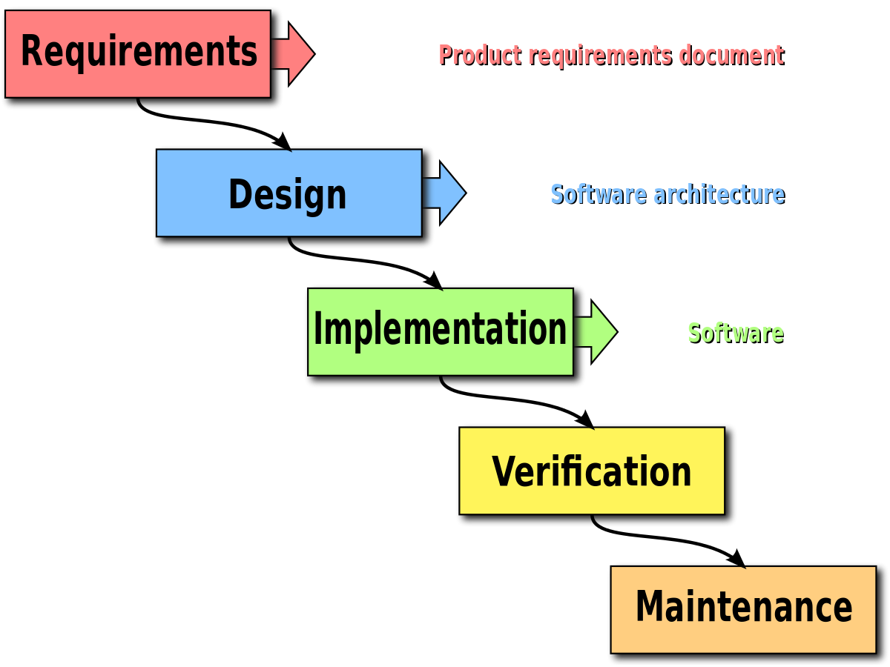

**Advantages of waterfall model:**

* Simple and easy to understand and use.
* Easy to manage due to the rigidity of the model.
* Phases are processed and completed one at a time.
* Works well for smaller projects where requirements are very well understood.

**Disadvantages of waterfall model:**

* You cannot go back a step; if the design phase has gone wrong, things can get very complicated m the implementation phase.
* High amounts of risk and uncertainty.
* Not a good model for complex and object-oriented projects.
* Poor model for long and on-going projects.
* Not suitable for the proiects where requirements are at a moderate to high risk of changing.

**AGILE METHODODLOGY**

* It is a practice that promotes continuous iteration of development and testing throughout the software development life cycle of the project.
* Both development and testing activities are concurrent, unlike the Waterfall model.
* Timeline of project is fixed.
* While the Agile approach brought agility to development, it was lost on Operations which did not come up to speed with agile practices.

**WHAT IS SCRUM?**

* Scrum is a framework that helps teams work together.
* scrum describes a set of meetings, tools, and roles that work in concert to help teams structure and manage their work.
* The Six Principles of Scrum
  + Control over the empirical process.
  + Self-organization
  + Collaboration
  + Value-based prioritization.
  + Time-boxing.
  + Iterative development

Introduction to scrum

* Are SCRUM and Agile the Same Thing?

No. Scrum is a sub-group of agile:

* Agile framework
* The SCRUM process: Planning, Sprint Cycle, Closure

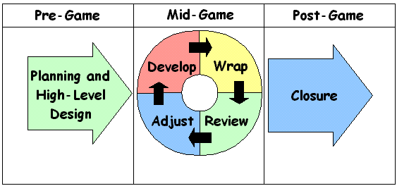

* SCRUM is based on the principles and values of the agile manifesto

# DISADVANTAGES

* + Not Effective for smaller projects.
  + Expensive to Implement.
  + Needs Experience member to be Involved.
  + Works well with small teams only.
  + Replacement of a team mate is not easy task.

# DEVOPS HISTORY?

* + DevOps was originated in the year 2008.
  + Originally it was a discussion between two people called Andrew clay and Patrick Debios.
  + In 2009 they held a summit at Belgium there they have discussed what if DevOps comes to the Market.
  + In 2014, the annual State of DevOps report was published.
  + If DevOps had a birth certificate, the father's name would be penned in as Patrick Debois.

# WHAT DEVOPS ENGINEER DO?

* DevOps Engineer is somebody who understands the Software Development Lifecycle and has the outright understanding of various automation tools for developing digital pipelines (Cl/ CD pipelines). DevOps Engineer works with developers and the IT staff to oversee the code releases.
* He introduces new Methodologies to implement the process quickly.
* He has knowledge of both Development team and Operation team as well.

# DEVOPS LIFE CYCLE:

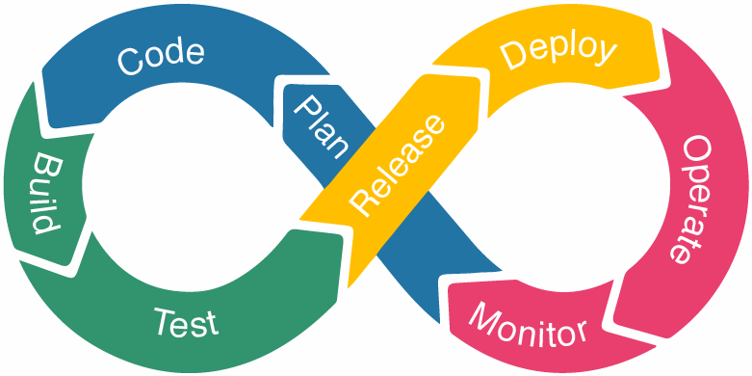

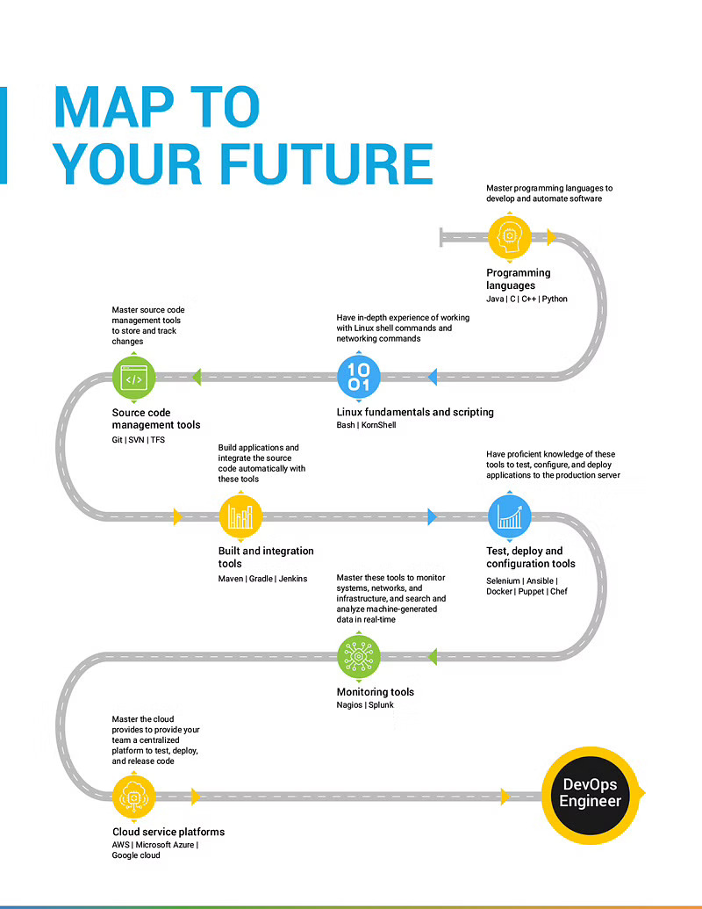

# TOOLS WE USE IN DEVOPS:

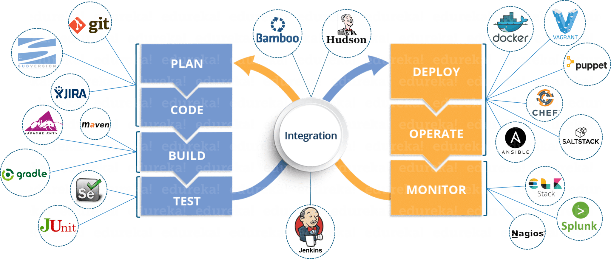

# STEPS TO CREATE EC2 INSTANCE

* + AMI - AMAZON MACHINE IMAGE contains the software configuration (OS, APP SERVERS AND APPS)

# Each AMI ID is different to one region to another region

# We have to use only free tier AMI’S

* + INSTANCE TYPE - Here we need to select instance type for free tier we can use only t2 micro (1 CPU and 1GB) and t2 nano (1 CPU and 0.5GB)

# Total instance families 64 available.

* + CONFIGURE INSTANCE - here you need to configure all your instance details like No.of Instances , Subnets, VPC, IAM Role, Tenancy all other stuff.
  + ADD STORAGE - Here you can add your data that is elastic block storage which is upto 8GB for free and extend upto 30GB.
  + ADD TAGS - You can have name tags here.
  + SECURITY GROUPS - It acts as firewall and provide security to stop unwanted access

# These are region and network specific

# Inbound and outbound rules

# Provides security at the protocol and port level access

# It acts as a firewall and deals with the traffic (http & https)

# S.G in one region can't be seen on another region

# multiple S.G's can be attached to one EC2 Instance.

* + REVIEW - You can check all the details that you have given to make EC2 Instance.

Q. What are the types of Virtualization do we have on AWS platform?

A. HVM (under AMI) & Para virtual (select community AMI's you can see there) and also para virtualization on HVM

1. GIT

* It is a VERSION CONTROL SYSTEM (VCS) or SOURCE CODE MANAGEMENT (SCM).
* It is used to track the changes in files.
* It will maintain multiple versions of the same file.
* It is platform independent.
* It is free and open-source.
* They can handle larger projects efficiently.
* They save time and developers can fetch and create pull requests without switching.

VCS HISTORY

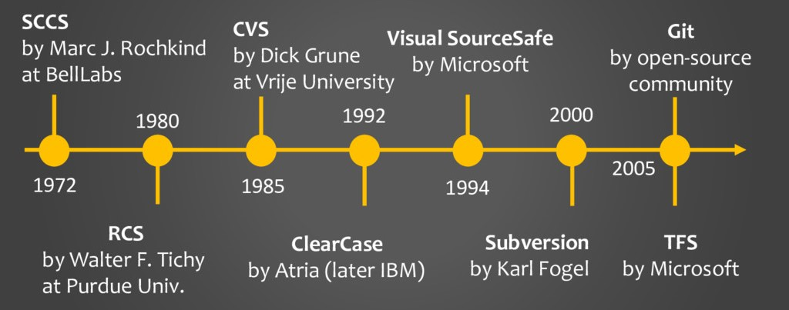

Revision Control System

* Is an early version control system (VCS). It is a set of UNIX commands that allow users to develop and maintain program code or documents. With RCS, users can make their own revisions of a document, commit changes, and merge them.
* It will track only Multiple files but not Directories.
* Allowed for single only.

Concurrent Versions System

* CVS is a version control system, an important component of Source Configuration Management (SCM). Using it, you can record the history of and documents. It fills a similar role to the free software RCS, PRCS, and Aegis packages. CVS is a production quality system in wide use around the world, including many free software projects.
* Tracks Multiple files and Directories.
* Allowed for single only.

Subversion

Subversion

* SVN is an open-source centralized version control system that is available for everyone at zero cost. It is designed to handle minor to major projects with speed and efficiency. It is developed to coordinate the work among programmers. The version control allows you to track and work together with your team members at the same workspace.
* Allowed Multiple users.

GIT STAGES:

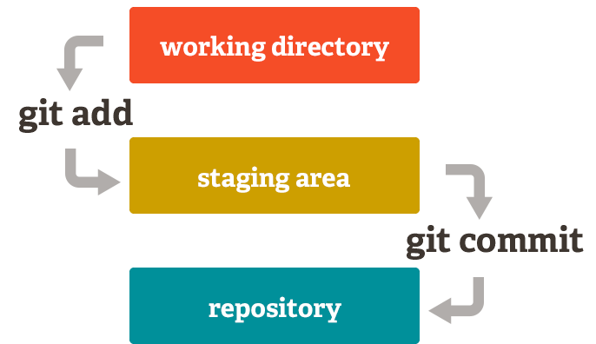

WORKING DIRECTORY

In this stage git is only aware of having files in the project. It will not track these files until we commit those files.

STAGING AREA

The staging area is like a rough draft space, it's where you can git add the version of a file or multiple files that you want to save in your next commit. In other words, in the next version of your project.

REPOSITORY

Repository in Git is considered as your project folder.

A repository has all the project-related data.

It contains the collection of the files and also history of changes made to those files.

TYPES OF REPOS:

LOCAL REPO: The Local Repository is everything in your .git directory. Mainly what you will see in your Local Repository are all of your checkpoints or commits. It is the area that saves everything (so don't delete it).

CENTRAL REPO: It will be present in the Github where you can share all your files. You need to add and commit your files before you push into Github.

REMOTE REPO: It will be present on remote hosts where you can share all your files to remote machines.

GIT COMMANDS

Change to root user = sudo -i

GIT INSTALLATION

* To install git in Linux = yum install git install -y
* To install git repository = git init .

STEPS TO COMMIT A FILE

1. Create a file : touch filename.
2. Now add the file : git add . (DOT represents current directory).
3. Commit the file with message : git commit -m “commit message” file name.
4. To see details of that file : git log
5. To see status : git status

Now all those things will be done under root user

If u want to be done by another user or as under your name, we need to configure it.

CONFIGURATION FO USER

If you want to give your username and E-mail id to those commits then,

Git config user.name “username”

Git config user.email [userxyz@gmail.com](mailto:userxyz@gmail.com)

Now give the git log command to see changes, it won’t work because after configure we haven’t……………………..

# GIT-HUB

* Github is a web-based platform used for version control.
* It simplifies the process of working with other people and makes it easy to collaborate on projects.
* Team members can work on files and easily merge their changes in with the master branch of the project.

Now if you want to push your code to Github : git remote add origin url

git push -u origin branch-name

Go to Github and check the files that you have pushed.

# GIT MERGE

* If you want to merge branch-I with branch-2 switch to branch-I first and give command git merge branch-2.
* Now that command had merged the content of branch-I to branch-2.
* Whatever the content in branch-I will be seen in branch-2 now.

GIT FORK

* A fork is a rough copy of a repository. Forking a repository allows you to freely test and debug with changes without affecting the original project.