*Magicians of the after-dark*

***TECHNITES***

# AR Sandbox

### **Abstract:**

It’s an augmented reality sandbox which changes its colour according to its height in real time. It gives height map with given reference point. Make mountain and valleys on sand in a box to make it changes.

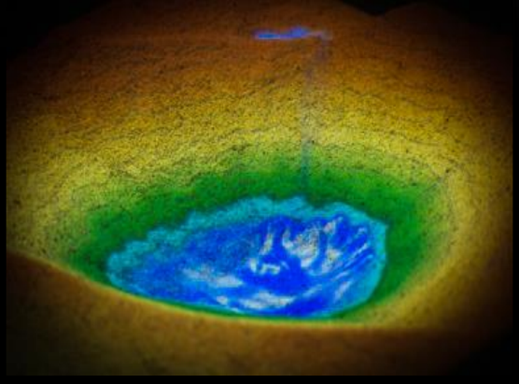

**Number of people required:** 4

## components required

|  |  |  |  |  |
| --- | --- | --- | --- | --- |
| **SERIAL NO** | **NAME OF COMPONENT** | **SPECIFICATION** | **REFERENCE LINKS** | **QUANTITY** |
| 1 | Projector |  |  | 1 |
| 2 | plywood | For making sand box |  | 2x2 m plywood est. |
| 3 | Kinect | Line motion sensing |  | 1 |
| 4 | sand | Need sand to fill a box |  | 10 -15 kg |

## tIMELINE

|  |  |
| --- | --- |
| **DATE** | **MILESTONE** |
| 1-2-2022 | Get all required equipment and ready with code for the same |
| 10-2-2022 | Testing and setting up |

## ROLES

|  |  |
| --- | --- |
| **SERIAL NO.** | **DESCRIPTION** |
| 1 | 2 python developer with knowledge of computer vision |
| 2 | 2 person for making box collecting sand and setting a project |