*Magicians of the after-dark*

***TECHNITES***

# face animate

### **Abstract:**

Face animate is a fun project which when anyone comes across it, it animates your face on screen. It has numerous filters and can animate faces when come across. Something like this.

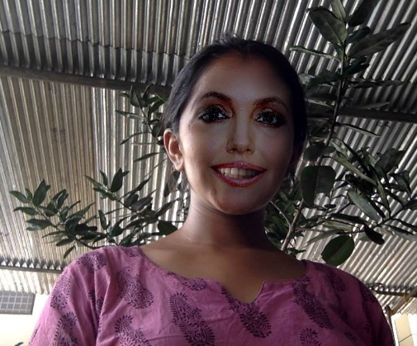

**Number of people required:** 2

## components required

|  |  |  |  |  |
| --- | --- | --- | --- | --- |
| **SERIAL NO** | **NAME OF COMPONENT** | **SPECIFICATION** | **REFERENCE LINKS** | **QUANTITY** |
| 1 | Web cam |  |  | 1 |
| 2 | Black sheet | background |  | 2x2 m |
| 3 | laptop | For running project |  | 1 |

## tIMELINE

|  |  |
| --- | --- |
| **DATE** | **MILESTONE** |
| 1-2-2022 | Ready with code and test it |
| 10-2-2022 | Testing and setting up the project |

## ROLES

|  |  |
| --- | --- |
| **SERIAL NO.** | **DESCRIPTION** |
| 1 | 2 python developer with knowledge of computer vision and making filters |