*Magicians of the after-dark*

***TECHNITES***

# Pose esTIMATION USING dEEP LEARNING MODEL OPENPOSE

### **Abstract:**

### as the name suggests, pose estimation is a technique used to estimate how a person is physically positioned, such as standing, sitting, or lying down. One way to obtain this estimate is to find the 18 “joints of the body” or as named in the artificial intelligence field: “key points.” The images below show our goal, which is to find these points in an image:

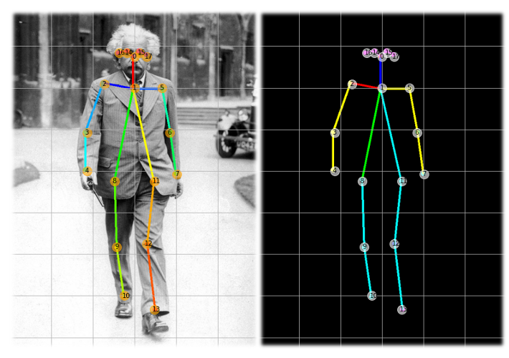

**Number of people required:** 2

## components required

|  |  |  |  |  |
| --- | --- | --- | --- | --- |
| **SERIAL NO** | **NAME OF COMPONENT** | **SPECIFICATION** | **REFERENCE LINKS** | **QUANTITY** |
| 1 | Laptop with camera |  |  | 1 |
| 2 | Black curtain for background | 2m * 2m |  | 1 |

## tIMELINE

|  |  |
| --- | --- |
| **DATE** | **MILESTONE** |
| 01/02/2022 | Need to be ready with the ML code of pose estimation |
| 10/02/2022 | Need to be ready with the Setup |

## ROLES

|  |  |
| --- | --- |
| **SERIAL NO.** | **DESCRIPTION** |
| 1 | Have a knowledge of Python, OpenCV, and TensorFlow |