*Magicians of the after-dark*

***TECHNITES***

# Prisma

### **Abstract:**

Prisma is a photo editor application that creates amazing photo effects transforming your images into paintings. Using Prisma’s filters you can make your photo look as if Picasso, Munch, or even Salvador Dali himself painted it for you! Use this amazing photo enhancer to create a unique masterpiece. Click a picture and see the effect we can save it for further use.

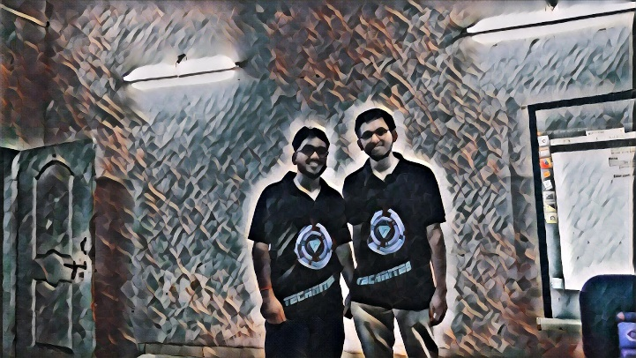

**Number of people required:** 2

## components required

|  |  |  |  |  |
| --- | --- | --- | --- | --- |
| **SERIAL NO** | **NAME OF COMPONENT** | **SPECIFICATION** | **REFERENCE LINKS** | **QUANTITY** |
| 1 | Web cam |  |  | 1 |
| 2 | Black sheet | background |  | 2x2 m |
| 3 | laptop | For running project |  | 1 |

## tIMELINE

|  |  |
| --- | --- |
| **DATE** | **MILESTONE** |
| 1-2-2022 | Ready with code and test it and if needed make user interface to upload a image |
| 10-2-2022 | Testing and setting up the project |

## ROLES

|  |  |
| --- | --- |
| **SERIAL NO.** | **DESCRIPTION** |
| 1 | 2 python developer with knowledge of computer vision and making image filters |