*Magicians of the after-dark*

***TECHNITES***

# Digital puzzle Using open cv and python

### **Abstract:**

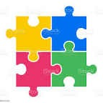

Similar puzzle pieces are scattered on the screen and the player can rearrange pieces using their hands like below picture.

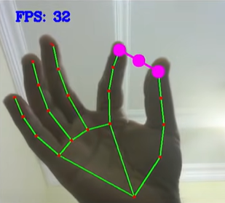

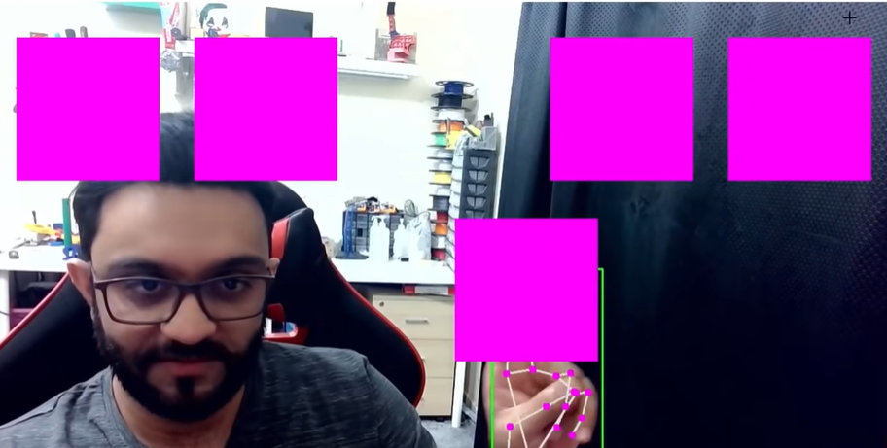

**Number of people required:** 2

## components required

|  |  |  |  |  |
| --- | --- | --- | --- | --- |
| **SERIAL NO** | **NAME OF COMPONENT** | **SPECIFICATION** | **REFERENCE LINKS** | **QUANTITY** |
| 1 | Laptop with camera | Good camera quality |  | 1 |
| 2 | Background curtain or black sheet | 2x2 meter which can cover whole body |  | 1 |

## tIMELINE

|  |  |
| --- | --- |
| **DATE** | **MILESTONE** |
| 1-02-2022 | Complete code with trials and run some test cases |
| 7-02-2022 | Add puzzle pieces and different pizzles |

## ROLES

|  |  |
| --- | --- |
| **SERIAL NO.** | **DESCRIPTION** |
| 1 | Python developer experience in open cv. |
| 2 | Helper who can help in set up project and design puzzles. |