**SDM**

**Assignment 1**

Name:-- Prasad Bhandare

Q.1) Create a local git repository in your local machine first.

Commit the initial code

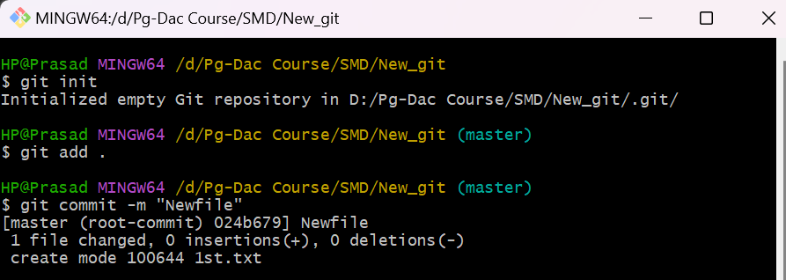

Q.2) Update the code on the remote server . Also perform some changes on remote n reflect the same on local.[push/pull operations]

Q.3) Create g1 branch on the github..................Add 1 txt file .................Raise a pull request on remote from g1 towards main........................... and merge without conflicts.



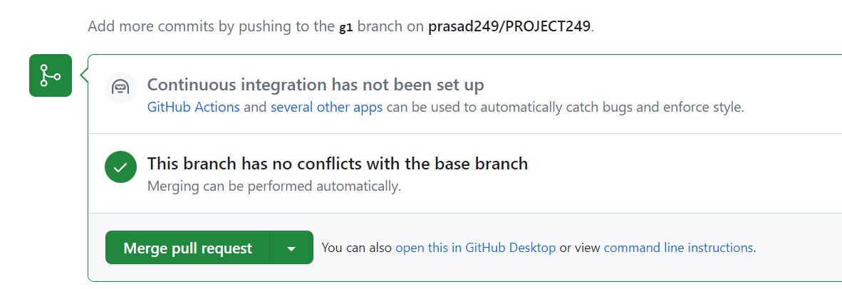

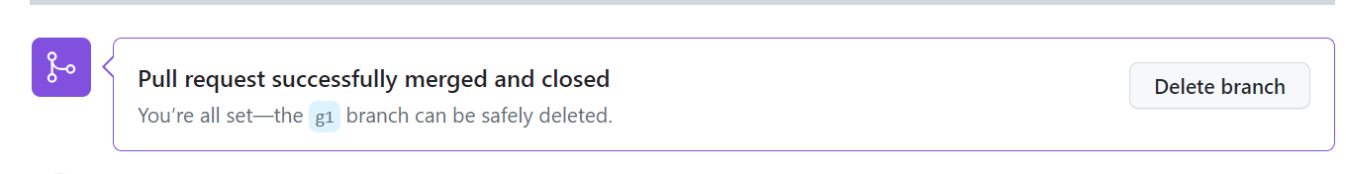

Local git: Use git commands to

o Get the updated files

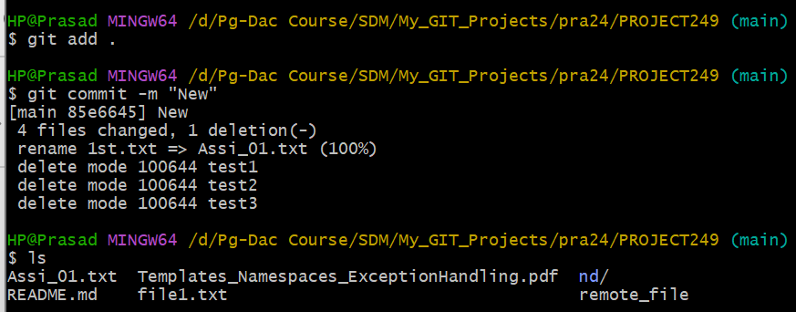

o Perform reset

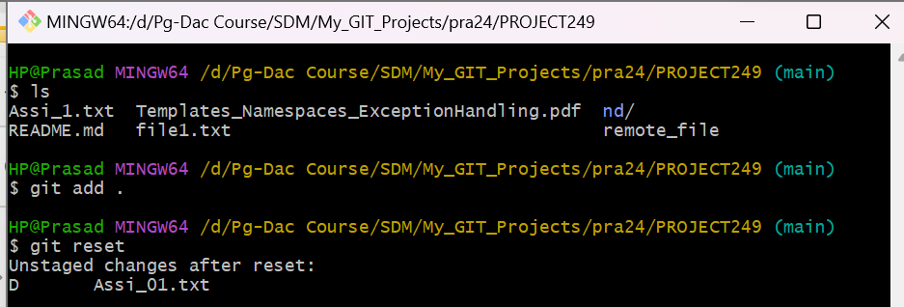

o List the changes

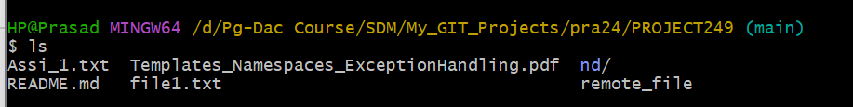

o Create local branches main>>>b1,update........b1>>>>b2,update b2>>>>>b3 and update them as well.

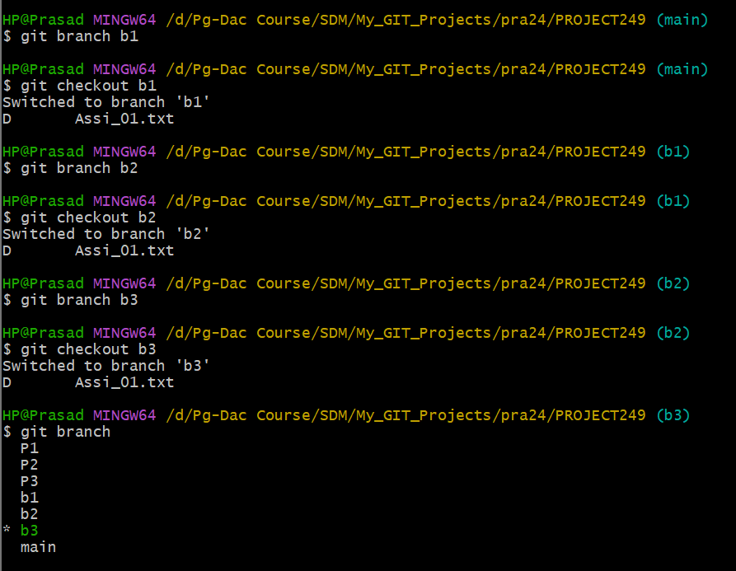git

o List the changes [via diff and via ls]

Demonstrate diff between local branches

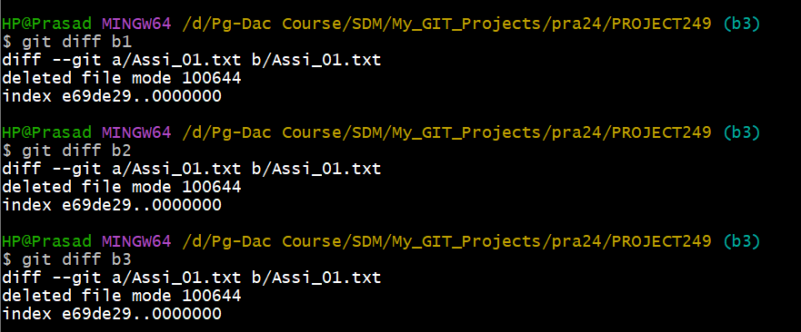

Perform LOCAL merging operation and after that delete the unnecessary ones locally as well as remote

Perform fork operations on your repository as well.