**PHP Travels**

Test Plan

**Date: Jun 21, 2024**

# 

Introduction

Test objectives

Test Approach

1. Testing Levels

2. Testing Types

Test Strategy

1. Functional Testing -

2. Non Functional Testing -

3. Regression Testing -

Test Environments

1. Hardware

2. Software

Test Deliverables

1. Test Plan Document

Resources

1. Team

2. Tools

Schedule

Entry and Exit Criteria

1. Entry Criteria

2. Exit Criteria

Risks and Contingencies

● Risk: Unavailability of the test environment.

Contingency: Have a backup environment setup.

● Risk: Delay in receiving updated builds.

Contingency: Maintain close communication with the development team.

● Risk: Incomplete test data.

Contingency: Create a comprehensive test data plan and validate it early.

● Risk: Non Availability of resource

Contingency: Backup resource planning

● Risk: Insufficient time for testing

Contingency: Adjust resources dynamically according to client needs.

Approvals

# 

# 

# 

# 

# 

# 

# 

# 

# 

# 

# 

# 

# **Introduction**

1. Purpose

The purpose of this Test Plan is to outline the testing strategy and approach for the key features of the website "[Phptravels.net](https://phptravels.net)". The features include Customer Login, Customer Profile, Customer Flight Booking, and Customer Logout. This plan aims to ensure that the website meets the required quality standards before it goes live.

1. Scope

The scope of this test plan includes the functional, non-functional, and regression testing of the following features:

* Customer Login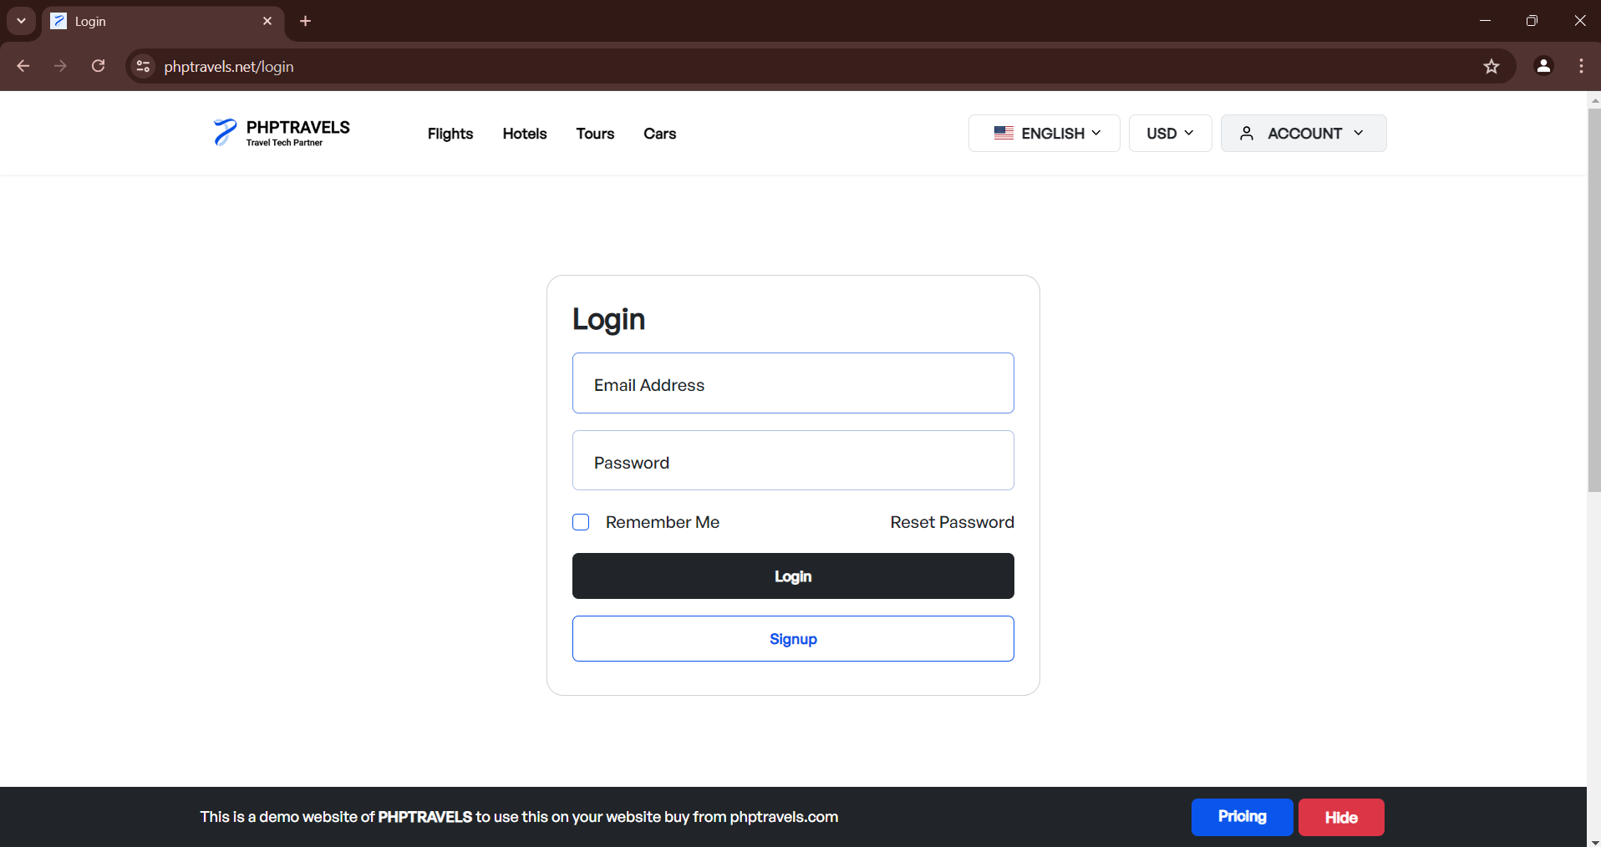
* Customer Profile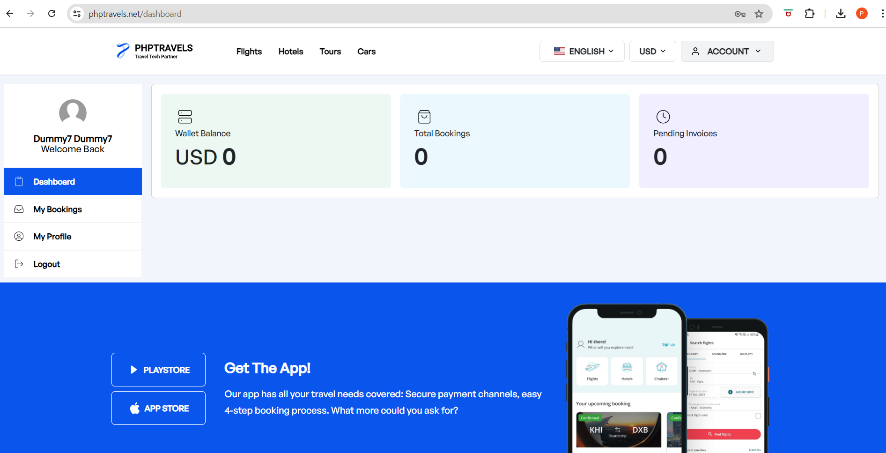
* Customer Flight Booking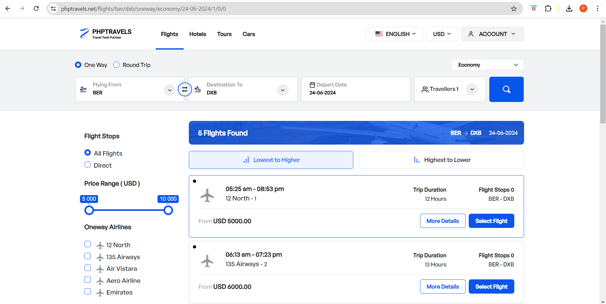
* Customer Logout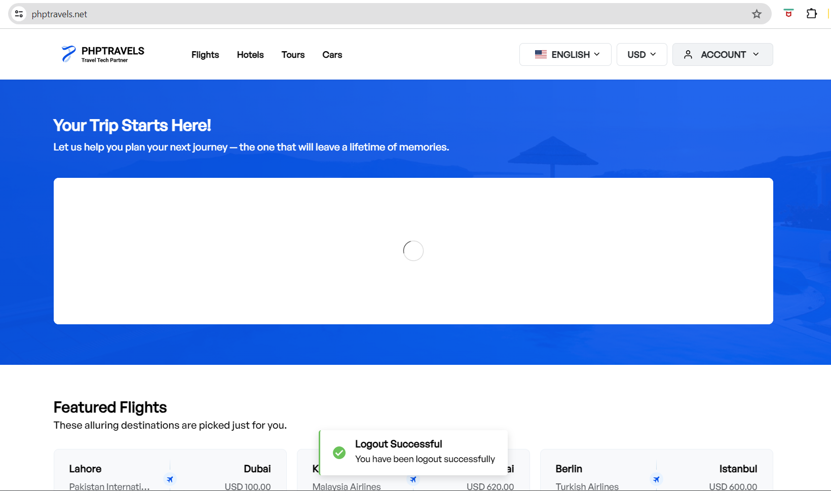

# **Test objectives**

1. Verify that the Customer Login functionality works as expected.
2. Ensure the Customer Profile can be viewed and edited correctly.
3. Confirm the Customer Flight Booking process is seamless and error-free.
4. Validate that the Customer Logout functionality properly terminates the session.

# 

# 

# **Test Approach**

## Testing Levels

* 1. **Unit Testing:** Developers will perform unit testing on individual components.
  2. **Integration Testing:** Ensure that different modules of the application work together.
  3. **System Testing:** Conduct end-to-end testing of the entire application.
  4. **Acceptance Testing:** Validate the application against user requirements.

## Testing Types

* 1. **Functional Testing:** Verify that each function of the software operates in conformance with the requirement specification.
  2. **Non-Functional Testing:** Test aspects such as performance, usability, and security.
  3. **Regression Testing:** Ensure new code changes do not adversely affect existing functionalities.

# **Test Strategy**

## Functional Testing -

* 1. **Customer Login**:
     1. Verify login with valid credentials.
     2. Verify login with invalid credentials.
     3. Verify error message for incorrect email/password.
     4. Check remember me functionality.
  2. **Customer Profile** 
     1. Verify login with valid credentials.
     2. Validate the ability to view profile details.
     3. Check the functionality of editing and saving profile details.
     4. Ensure changes are reflected immediately.
  3. **Customer Flight Booking:** 
     1. Verify the ability to search for flights.
     2. Validate booking flow: selecting flights, entering passenger details, making payments.
     3. Confirm booking confirmation and receipt generation.
     4. Check booking history in the customer profile.
  4. **Customer Logout:**
     1. Verify the logout process.
     2. Ensure the session is terminated.
     3. Check redirection to the login page post-logout.

## Non Functional Testing -

* 1. **Performance Testing:**
     + Load testing to ensure the application can handle a high number of users.
     + Stress testing to identify the breaking point of the application.
     + Response time for various functionalities.
  2. **Usability Testing:**
     + Ensure the application is user-friendly.
     + Validate that navigation is intuitive.
     + Check for clear error messages and instructions.
  3. **Security Testing:**
     + Verify secure login (HTTPS).
     + Check for vulnerabilities like SQL injection, XSS.
     + Ensure data privacy and protection.

## Regression Testing -

Re-run previous test cases to ensure new changes haven't broken existing functionality.

# **Test Environments**

## Hardware

* Servers to host the application.
* User machines for testing.

## Software

* Browser: Latest versions of Chrome, Firefox, Safari, and Edge.
* Testing tools: Selenium for automation, JIRA for bug tracking, JMeter for performance testing. Lighthouse for

# **Test Deliverables**

## Test Plan Document

1. Test Cases Document
2. Test Scripts (for automated testing)
3. Test Execution Report
4. Defect Report
5. Final Test Summary Report

# **Resources**

## Team

* Test Lead
* QA Engineers
* Automation Engineers
* Performance Testers

## Tools

* Selenium WebDriver for automated functional testing.
* JIRA for tracking issues and project management.
* JMeter for performance testing.

# Schedule

| Activity | Start Date | End Date | Remark |
| --- | --- | --- | --- |
| Test Planning | 21-06-2024 | 23-06-2024 |  |
| Test Environment Setup |  |  |  |
| Test Case Preparation |  |  |  |
| Test Execution |  |  |  |
| Defect Reporting |  |  |  |
| Regression Testing |  |  |  |
| Final Reporting |  |  |  |

# **Entry and Exit Criteria**

## Entry Criteria

* Requirement specifications are complete and approved.
* Test environment is ready.
* Test data is prepared.
* Test Scenarios are ready.

## Exit Criteria

* All critical and high-priority defects are fixed and verified.
* Test execution is complete with desired coverage.
* Test summary report is prepared and reviewed.

# **Risks and Contingencies**

## Risk: Unavailability of the test environment.

## Contingency: Have a backup environment setup.

## Risk: Delay in receiving updated builds.

## Contingency: Maintain close communication with the development team.

## Risk: Incomplete test data.

## Contingency: Create a comprehensive test data plan and validate it early.

## Risk: Non Availability of resource

## Contingency: Backup resource planning

## Risk: Insufficient time for testing

## Contingency: Adjust resources dynamically according to client needs.

# **Approvals**

- Test Lead

- QA Manager

- Project Manager

—----------------------------------------------------------------------------------------------------------------------------------

Prepared by: Prasad Valiv

Date: Jun 21, 2024

Approval:

- [Test Lead ]

- [QA Manager ]

- [Project Manager ]