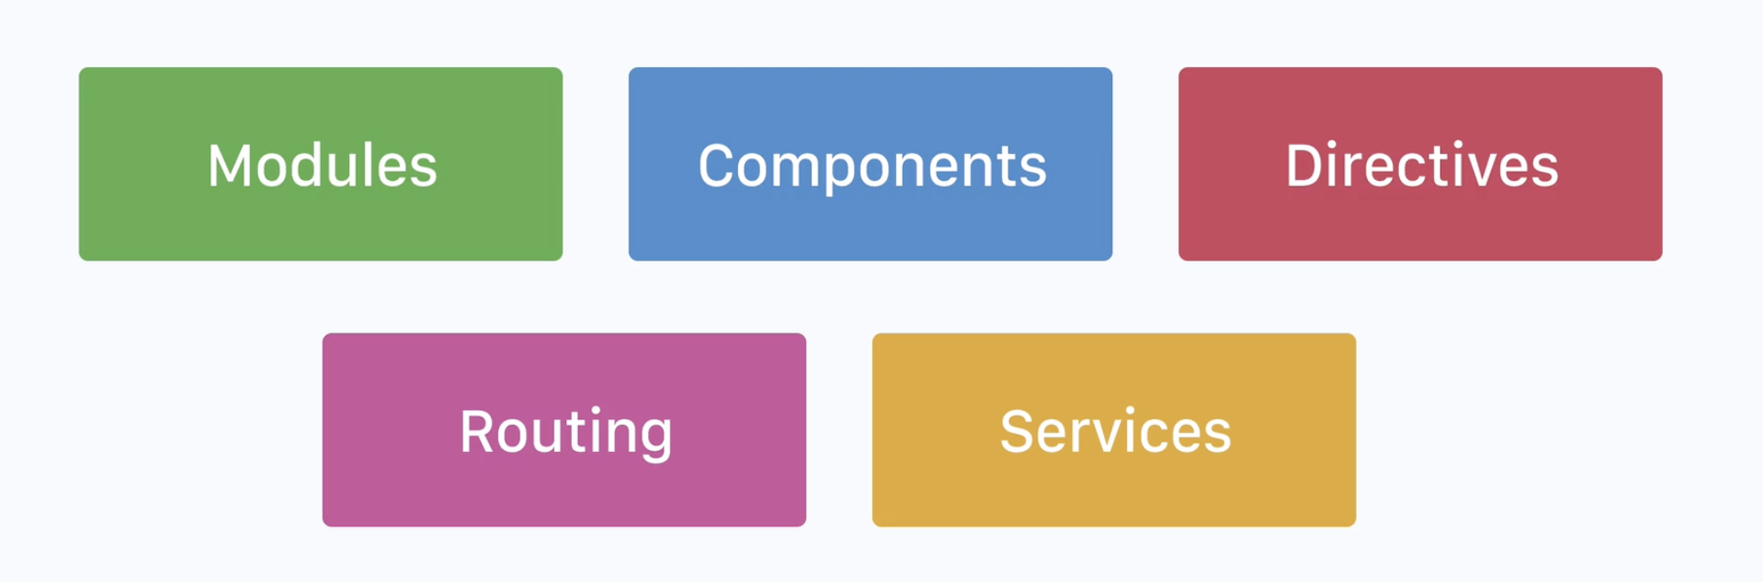

**Modules: - Building blocks that contain components, routes, services and more.**

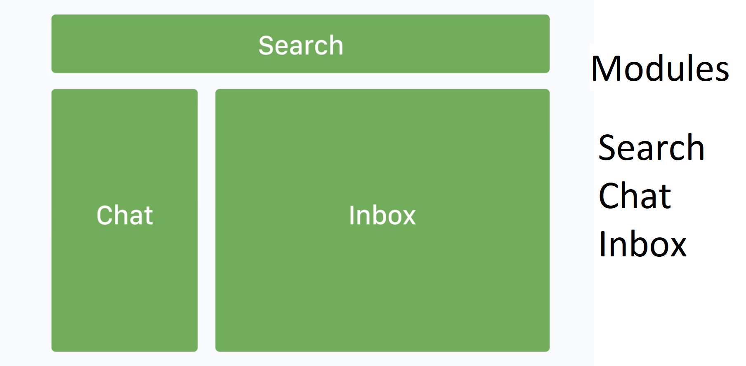

**Inside these modules you can have specific components that related to search, chat and inbox.**

**Components: - Contains template, data and logic, forming a part of DOM tree.**

**Components is an high level DOM tree node, which will then, create sub tree nodes.**

**Directives: - Attach behavior, extend or transform a particular element and it’s child.**

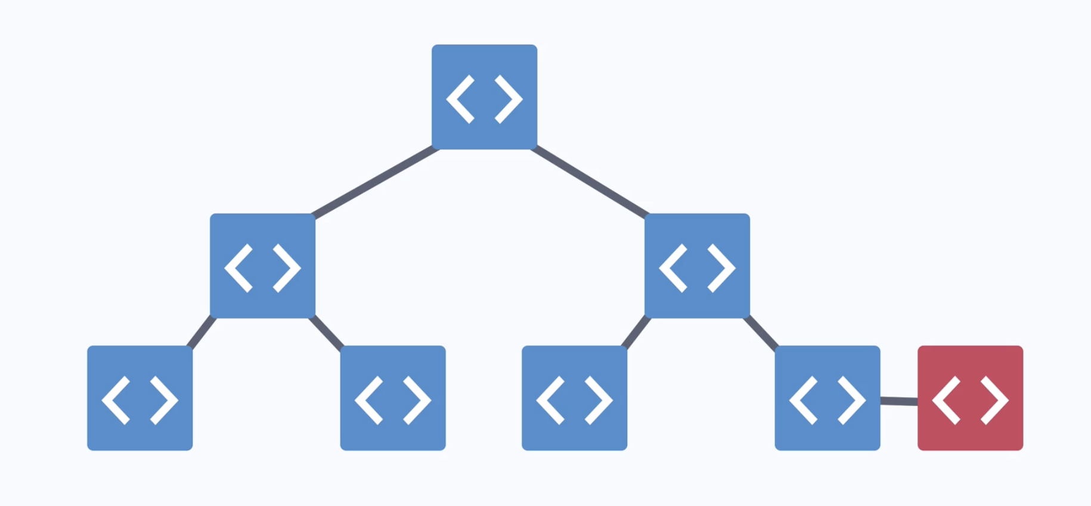

**Services: - Data layer, logic that is not component related, such as API requests.**

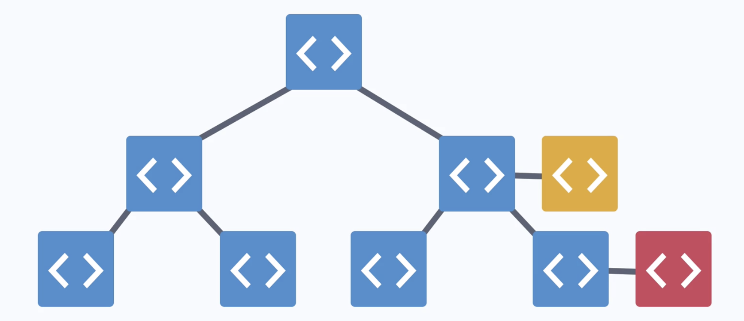

**Routing: - renders a component based on url state, drives navigation.**

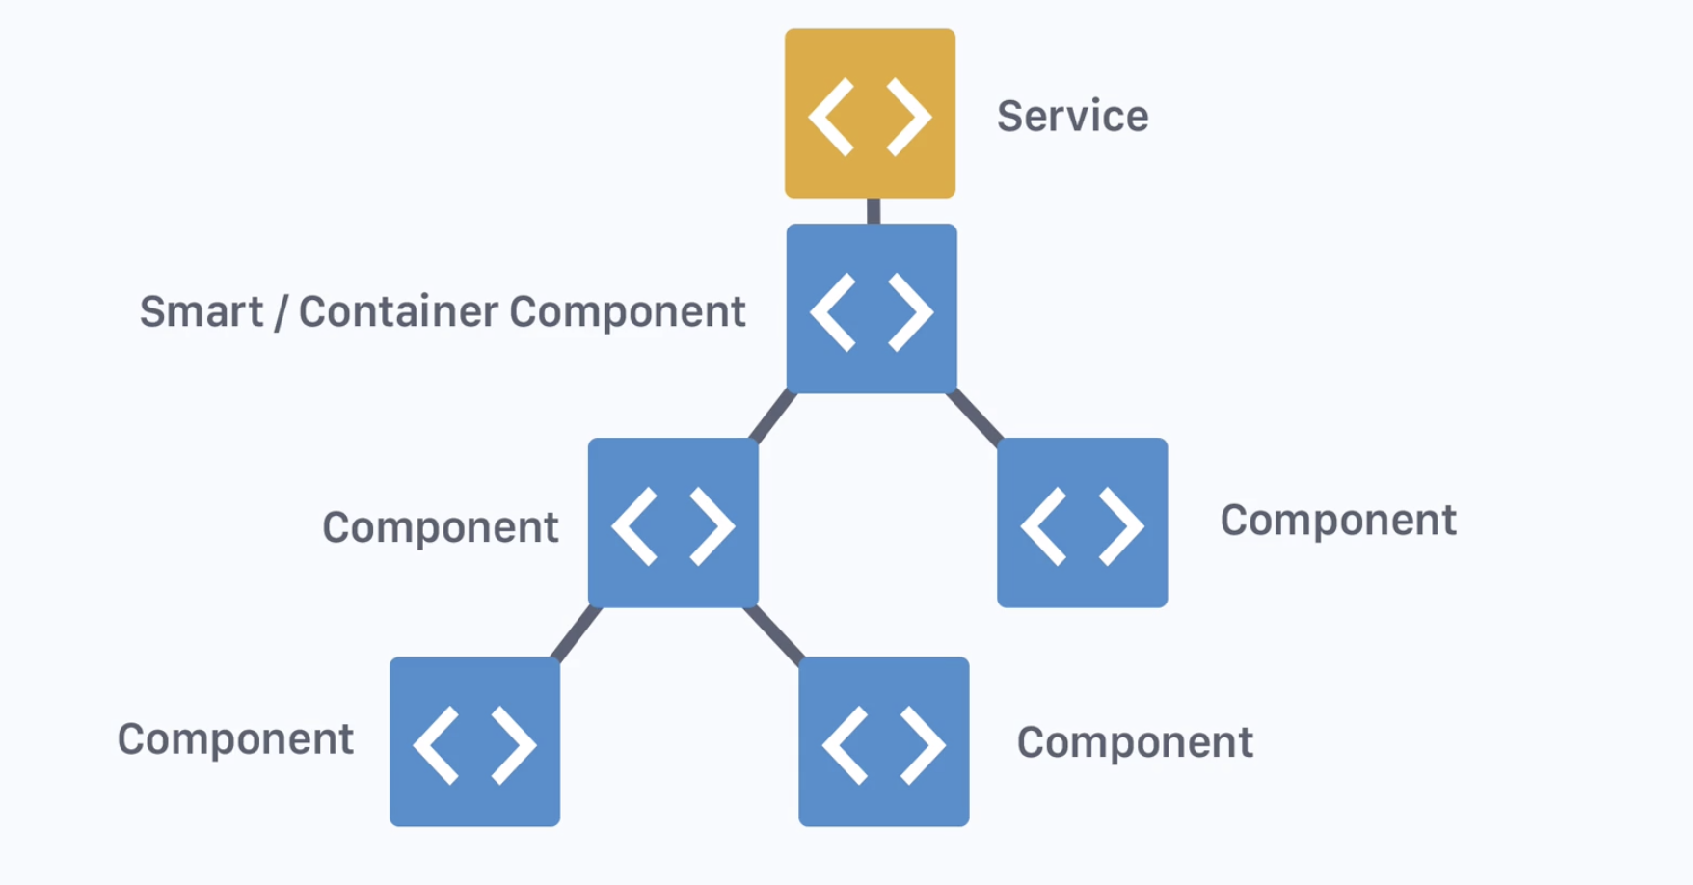

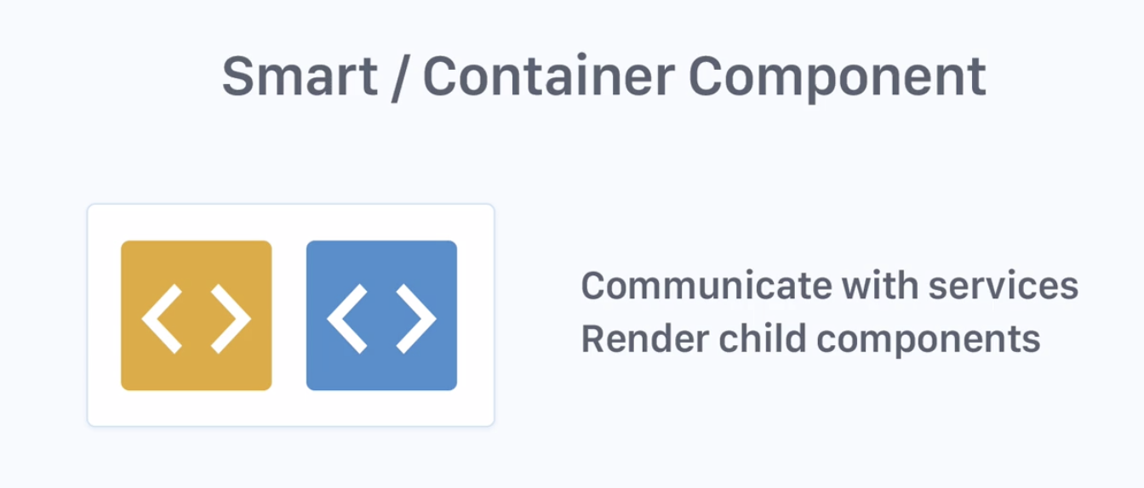

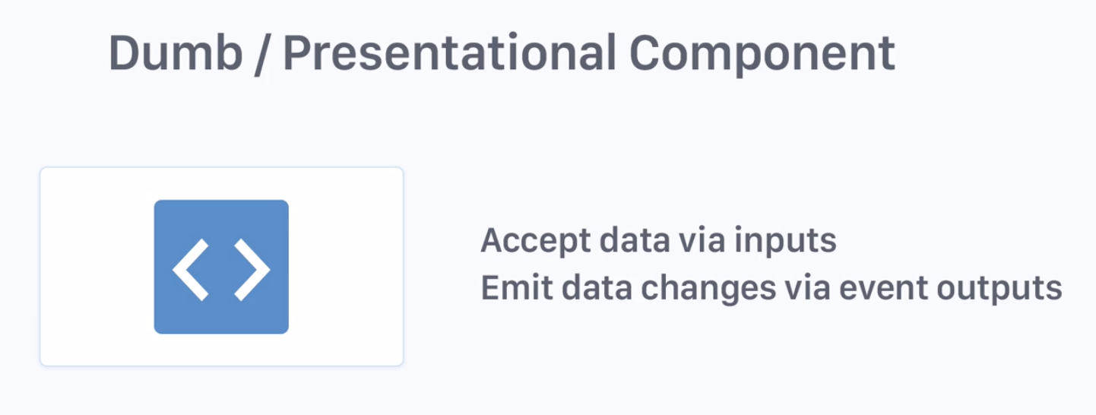

**Bracket Pair Colorizer**

**intelliSense for CSS class names in HTML**

**Angular 2 TypeScript Emmet**

**angular2-inline**

**angular2-switcher**

**vscode-Icons**

**TSLint**

**Angular 6 Snippets - TypeScript, Html, Angular Material, ngRx, RxJS & Flex Layout**

**TypeScript Hero**

**Path Intellisense**

**Auto Import**

**Angular Files**

**NgBootstrap Snippets**

**Prettier**

**npm install -g @angular/cli**

**ng new project-name**

**cd project-name**

**ng serve --open**