**Task 7**

**Name: Prasad Nagineni**

**Registration ID: SIRSS1237**

Q. Create a file via touch and update that file and also verify the timestamp and output will be redirected to another file. Add some of the data as per your choice and append that data via echo command in the same file Install httpd and set up your own web server. Copy some files from one Linux host to another Linux host via SCP. Create another VM and setup password less authentication.

Steps:

>> mkdir – command used to create a directory

>> cd – used to change directory

e.g mkdir directory_name

e.g cd REgex

let’s create a directory and its name as “Regex”

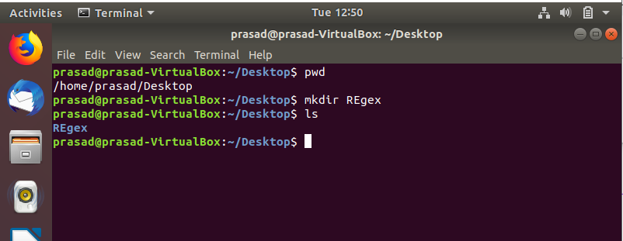

>> touch – Command used to create file without any body. The file created using touch command is empty.

e.g touch file_name

let’s create file task7.txt in Regex directory. The file task7.txt has no content.

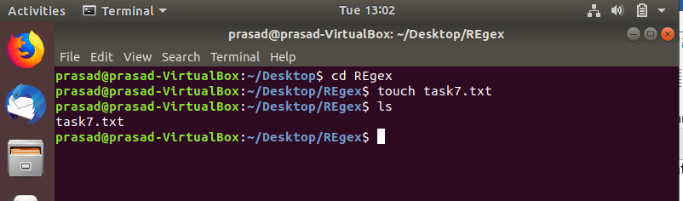

We will use vim text editor to open the file and write content inside the file.

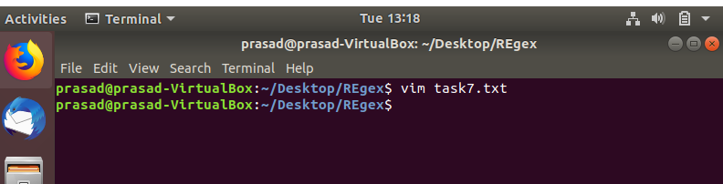

To write the content in file press ‘i’ from keyboard. After press i the mode changes to INSERT.

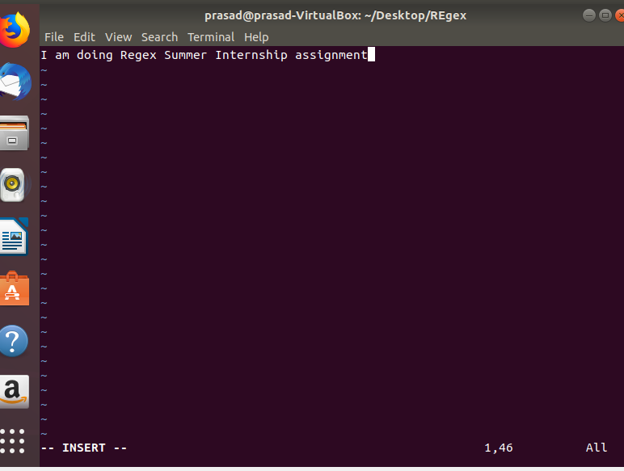

Now write content inside the file , to quit from vim text editor press ESC then type ‘:wq’ from keyboard. It will exit from text editor.

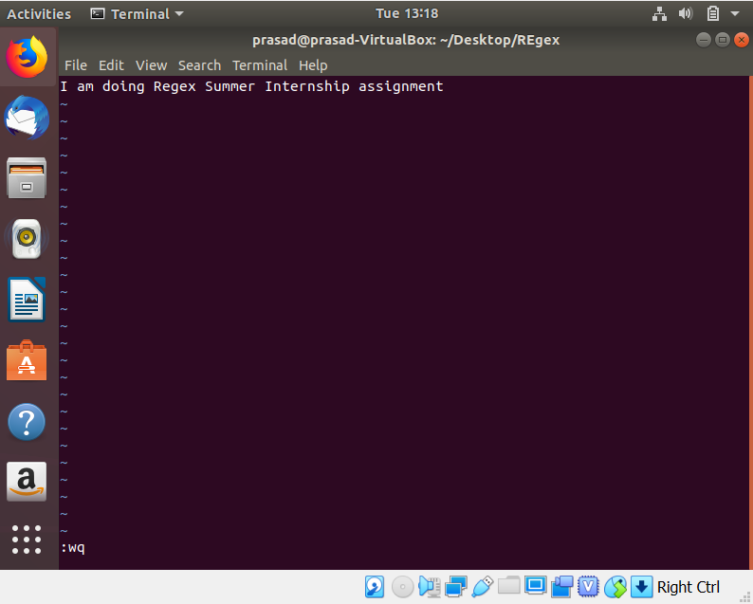

>> ls – command used to show the all list of files in current directory.

e.g ls directory_name

To show the timestamp of file, use command ls with option ‘l’

e.g ls -l

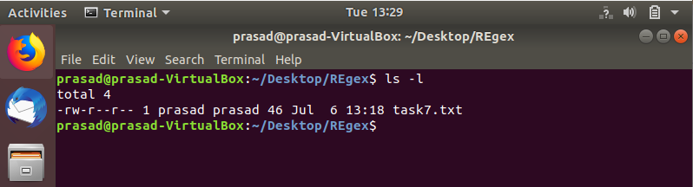

>> echo – Command used to display the line of text or use to update the content inside the file.

e.g echo “display the content inside this”

Update content inside we will use echo command as follow:

echo “My name is prasad”>>task7.txt --- message inside echo command is added to file task.txt

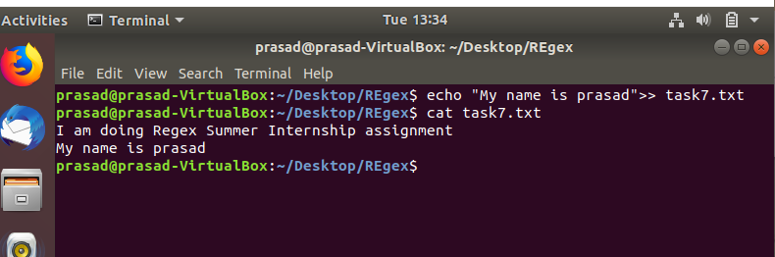

Install httpd and set up your own webserver

>> sudo apt install httpd

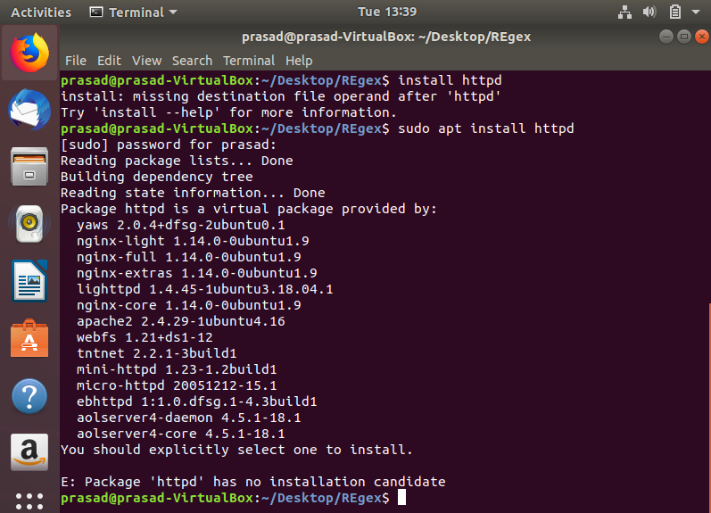

Now create a html file inside the current directory using vim text editor.

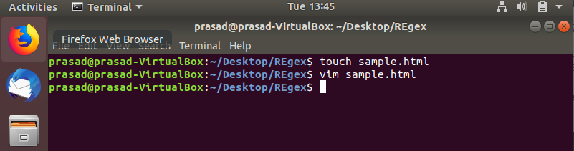

Let’s create sample.html and set title as Regex Software. Below snip is code inside the sample.html file

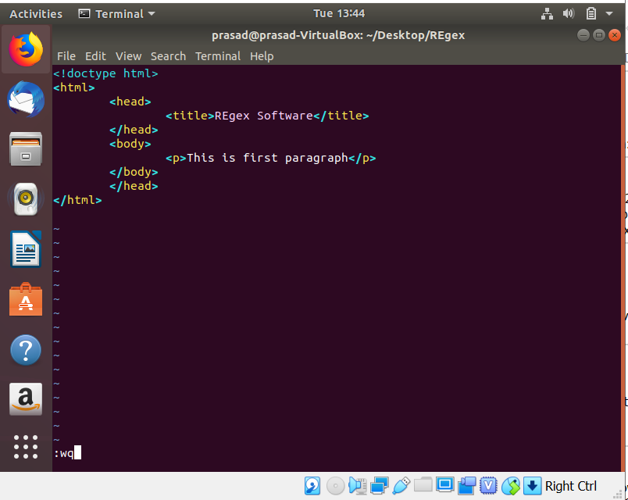

To check server , first we need to install net-tools, below is command to install net-tools

>>sudo apt install net-tools

Below is the command to check the server

>> ifconfig enp0s3 | grep inet

