|  |  |
| --- | --- |
|  | **S K SOMAIYA COLLEGE OF ARTS, SCIENCE & COMMERCE**  **Vidyavihar (East), Mumbai 400 077**  **DEPARTMENT OF INFORMATION TECHNOLOGY** |

**CERTIFICATE**

**This is to certify that the experiments done in the subject of ________Software Project Management _________ _ __**

**At S. K. Somaiya College Of Arts, Science And Commerce by _______ Prasad Vijay Jambhale _____________ Seat no. _____39_____ as partial fulfillment of B.Sc. IT degree (Semester- V) Examination for the academic year _2021-2022_.**

**Teacher Incharge: Prof. Zainab Khan**

**Name of Internal Examiner: Prof. Dr. Marielia Assumption**

**Name of Co-ordinator: Prof. Dr. Marielia Assumption**

**Table of Contents**

**CHAPTER 1: INTRODUCTION**

**1.1 Background**

**1.2 Objectives**

**1.3 Purpose, Scope, and Applicability**

**1.3.1 Purpose**

**1.3.2 Scope**

**1.3.3 Applicability**

**1.4 Achievements**

**1.5 Organisation of Report**

**CHAPTER 2: SURVEY OF TECHNOLOGIES**

**CHAPTER 3: REQUIREMENTS AND ANALYSIS**

**3.1 Problem Definition**

**3.2 Requirements Specification**

**3.3 Planning and Scheduling**

**3.4 Software and Hardware Requirements**

**3.5 Preliminary Product Description**

**3.6 Conceptual Models**

**CHAPTER 4: SYSTEM DESIGN**

**4.1 Basic Modules**

**4.2 Data Design**

**4.2.1 Schema Design**

**4.2.2 Data Integrity and Constraints**

**4.3 Procedural Design**

**4.3.1 Logic Diagrams**

**4.3.2 Data Structures**

**4.3.3 Algorithms Design**

**4.4 User interface design**

**4.5 Security Issues**

**4.6 Test Cases Design**

**Synopsis**

QUIZ is a web application for to take online test and there is no time wasting for checking the paper. With the help of quiz person can review what they learned and what they understand the key concepts of your course. Quizzes help students to identify what they know and what they don't know. The students then have a better idea of how well they know the topics, motivating them to study more and helping them to focus on information that needs more practice.

The main objective of Quiz application is to fully automated system that not only saves lot of time but also gives fast results. For students, there is no need of using extra thing like paper, pen etc. This can be used in educational institutions as well as in corporate world. Can be used anywhere any time as it is a web based application.

Quiz is a very important part of education and content revising. With the help of Quiz System, teachers would be able to create quizzes for students. Quiz management system can be implemented in colleges, universities or at home to check the preparation of students and revise the topics of different courses. Manual systems are very time consuming and difficult to grade. Quiz management system would be able to create and check the quizzes thus reducing the stress of universities staff.

When project is run for the first time it allowed the user to login in the system. Project supports login as an admin and login as a user. User who add as an admin in system will be able to create test and questions to system and also will be able to observe the result of the user which attempt tests. User who login to system will be able to select a particular test and attempt questions. After attempting and submitting the test that user will receive a message that you have attempt the test successfully. Also a user which login to system will be able to observe the result of test he/she attempt.

**1. Introduction**

**1.1 Background**

Higher education is changing. Most of the students now have access to learning materials via the Internet. According to Trow (1999), studies are needed to assist teaching staffs in high schools, colleges and universities to recognize the possibilities of using technology as an effective tool in the teaching process and to enhance the positive outcomes that it may bring about. The present study falls into this category. In general, e-learning techniques involves a combination of teaching strategies, such as assessment or self-assessment quizzes, discussion forums, and tutoring. E-assessment has advantages like reduces teacher work time on assessments.

There is the need of this system because there exist some problems faced by the manual examination systems that are delay in result processing , filing poses a problem , filtering of records is not easy , the chance of loss of records is high and also record searching is difficult. These problems can be easily overcome by Quiz System. Maintenance of the results and results is also very difficult and takes a lot of time and effort in case of manual examinations.

**1.2 Objectives**

The main objective of the project Quiz Application is to manage the details of students, examinations, marks, courses and papers. The purpose of the project is to build an application to reduce the manual work for managing the MCQ quiz. Some objectives are given following:

- To create a platform for best managing of MCQ test.

- To overcome the time consuming issues and taking MCQ tests .

- To release the marks of students as soon as possible.

- To improve student’s learning motivation.

- to enable students to practice for tests with focus.

**1.3 Purpose, Scope, and Applicability**

**1.3.1 Purpose**

The use of online quizzes has been shown to motivate students to complete assigned readings, increase participation in class discussion, and improve performance on exams for the topics covered in the quizzes. As result generated after quiz student can judge their knowledge and skills and improve themselves for better.

**1.3.2 Scope**

Quiz application is designed for Educational Institutes like Schools, Colleges, and Private Institutes to conduct tests of their students on a regular basis. The system handles all the operations and generates reports as soon as the test is completed which saves the time of teachers . When it comes to surprise test ,this system can make it possible very easily. This can be used anywhere, anytime as it is web based application. The presence of the teachers is not required while students appearing for the test.

**1.3.3 Applicability**

Functionalities of the project will be as following: - Able the examiners to punch the MCQ questions online; - Able the users to solve the questions online; - Examiners can manage the information regarding exam; - Correct answers will be evaluated by system (First it should be determining by examiner); - Users can see their result after submitting the test.

To design and implement this project we plan that the project support to different types of users apart from its administrative part. When project is run for the first time it allowed the user to select as who he/she wants to login in the system. Project support login as teacher and login as student. If a user who is student, try to login as teacher system will not allow him and vice versa. User who add as teacher in system will be able to punch test and questions to system and also will be able to observe the result of the student which attempt tests. User who login to system as student will be able to select a particular test and attempt questions depend on this test. After attempting the test and submitting that user will receive a message that you have attempt the test successfully and if the user tries to attempt the same test, system will not allow him/her. Also a user which login to system as student will be able to observe the result of test he/she attempt.

**1.4 Achievements**

In this web based quiz application we try to overcome the existing problems with following features:

- Better management;

- Connection to database for better storing of data;

- Better frontend management;

- Better backend management;

- Try to decrease error issuer during runtime

**1.5 Organisation of Report**

Chapter 1: It gives an introduction about the quiz application and use of quiz application.

Chapter 2: It gives an literature review about the existing system and proposal system of quiz application. It gives a brief overview about all the important modules used in the system.

Chapter 3: It includes planning, details of software and hardware requirements, conceptual models.

Chapter 4: It includes project design, implementation and test cases with details.

Chapter 5:

Chapter 6:

Chapter 7:

**2. Survey of Technologies**

**2.1 Existing System:**

Up to now we take examinations on paper, the idea to take examinations in our device led us to creation of the application. Earlier, correction of the answers is also a big problem to correct manually so our application gets rid of the heavy work of correcting each and every answers in manual way.

**2.2 Proposed System:**

The current system developed provides an easy access to the users. The database’s purpose is to make, establish and maintain a workflow among various entities in order to facilitate all concerned users in their different capacities or roles. Permission to the users would be granted based on the roles specified. Therefore, this provides the technical guarantee of correctness, speed and security. The software and hard requirements for the development of this project are not many and are already available in-house or are available as free as open source. The work for the project is done with the current equipment and existing software technology.

The main requirement of this application is to find questions and answers. In this application firstly the user needs to register or login using id and password. Before starting the quiz there is an instructional window, in which there are instructions related to attempt the quiz. User need to attempt quiz in limited time. After competition of quiz users can see his/her answers are right or wrong and can also see the answer of each. The questions are given by admin. Admin can see all users results.

**2.2.1 Advantages:**

* User can login and take test from any place.
* Reduces paper work.
* Saves time.
* It saves paper.
* It saves money.

**2.3 In this Section we will do Analysis of Technologies to use for implementing the project.**

**2.3.1 : FRONT END**

**2.3.1.1 HTML**

Hypertext Markup Language (HTML) is the standard markup language for documents designed to be displayed in a web browser. It can be assisted by technologies such as Cascading Style Sheets (CSS) and scripting languages such as JavaScript. Web browsers receive HTML documents from a web server or from local storage and render the documents into multimedia web pages. HTML describes the structure of a web page semantically and originally included cues for the appearance of the document.

HTML elements are the building blocks of HTML pages. With HTML constructs, images and other objects such as interactive forms may be embedded into the rendered page. HTML provides a means to create structured documents by denoting structural semantics for text such as headings, paragraphs, lists, links, quotes and other items. HTML elements are delineated by tags, written using angle brackets. Tags such as <img /> and <input /> directly introduce content into the page. Other tags such as <p> surround and provide information about document text and may include other tags as sub-elements. Browsers do not display the HTML tags, but use them to interpret the content of the page.

HTML can embed programs written in a scripting language such as JavaScript, which affects the behaviour and content of web pages. Inclusion of CSS defines the look and layout of content. The World Wide Web Consortium (W3C), former maintainer of the HTML and current maintainer of the CSS standards, has encouraged the use of CSS over explicit presentational HTML since 1997.

**2.3.1.2 CSS**

Cascading Style Sheets (CSS) is a style sheet language used for describing the presentation of a document written in a markup language like HTML.CSS is a cornerstone technology of the World Wide Web, alongside HTML and JavaScript.CSS is designed to enable the separation of presentation and content, including layout, colors, and fonts. This separation can improve content accessibility, provide more flexibility and control in the specification of presentation characteristics, enable multiple web pages to share formatting by specifying the relevant CSS in a separate .css file, and reduce complexity and repetition in the structural content.

CSS information can be provided from various sources. These sources can be the web browser, the user and the author. The information from the author can be further classified into inline, media type, importance, selector specificity, rule order, inheritance and property definition. CSS style information can be in a separate document or it can be embedded into an HTML document. Multiple style sheets can be imported. Different styles can be applied depending on the output device being used; for example, the screen version can be quite different from the printed version, so that authors can tailor the presentation appropriately for each medium. The style sheet with the highest priority controls the content display. Declarations not set in the highest priority source are passed on to a source of lower priority, such as the user agent style. The process is called cascading.

One of the goals of CSS is to allow users greater control over presentation. Someone who finds red italic headings difficult to read may apply a different style sheet. Depending on the browser and the web site, a user may choose from various style sheets provided by the designers, or may remove all added styles and view the site using the browser's default styling, or may override just the red italic heading style without altering other attributes.

**2.3.1.3 JavaScript**

JavaScript s a high-level, interpreted scripting language that conforms to the ECMAScript specification. JavaScript has curly-bracket syntax, dynamic typing, prototype-based object-orientation, and first-class functions. Alongside HTML and CSS, JavaScript is one of the core technologies of the World Wide Web. JavaScript enables interactive web pages and is an essential part of web applications. The vast majority of websites use it, and major web browsers have a dedicated JavaScript engine to execute it. As a multi-paradigm language, JavaScript supports event-driven, functional, and imperative (including object-oriented and prototype-based) programming styles. It has APIs for working with text, arrays, dates, regular expressions, and the DOM, but the language itself does not include any I/O, such as networking, storage, or graphics facilities. It relies upon the host environment in which it is embedded to provide these features.

Initially only implemented client-side in web browsers, JavaScript engines are now embedded in many other types of host software, including server-side in web servers and databases, and in non-web programs such as word processors and PDF software, and in runtime environments that make JavaScript available for writing mobile and desktop applications, including desktop widgets.

The terms Vanilla JavaScript and Vanilla JS refer to JavaScript not extended by any frameworks or additional libraries. Scripts written in Vanilla JS are plain JavaScript code. Google's Chrome extensions, Opera's extensions, Apple's Safari 5 extensions, Apple's Dashboard Widgets, Microsoft's Gadgets, Yahoo! Widgets.

**2.3.1.4 Bootstrap**

Bootstrap is a free and open-source CSS framework directed at responsive, mobile-first front-end web development. It contains CSS- and (optionally) JavaScript-based design templates for typography, forms, buttons, navigation, and other interface components.

Bootstrap is a HTML, CSS & JS Library that focuses on simplifying the development of informative web pages (as opposed to web apps). The primary purpose of adding it to a web project is to apply Bootstrap's choices of color, size, font and layout to that project. As such, the primary factor is whether the developers in charge find those choices to their liking. Once added to a project, Bootstrap provides basic style definitions for all HTML elements. The result is a uniform appearance for prose, tables and form elements across web browsers. In addition, developers can take advantage of CSS classes defined in Bootstrap to further customize the appearance of their contents. For example, Bootstrap has provisioned for light- and dark-colored tables, page headings, more prominent pull quotes, and text with a highlight.

Bootstrap also comes with several JavaScript components in the form of jQuery plugins. They provide additional user interface elements such as dialog boxes, tooltips, and carousels. Each Bootstrap component consists of an HTML structure, CSS declarations, and in some cases accompanying JavaScript code. They also extend the functionality of some existing interface elements, including for example an auto-complete function for input fields.

**2.3.2 : BACK END**

**2.3.2.1 PHP**

PHP is a server side scripting language that is used to develop Static websites or Dynamic websites or Web applications. PHP stands for Hypertext Pre-processor, that earlier stood for Personal Home Pages. PHP scripts can only be interpreted on a server that has PHP installed. The client computers accessing the PHP scripts require a web browser only. A PHP file contains PHP tags and ends with the extension ".php".

The term PHP is an acronym for PHP: Hypertext Preprocessor. PHP is a server-side scripting language designed specifically for web development. PHP can be easily embedded in HTML files and HTML codes can also be written in a PHP file. The thing that differentiates PHP with client-side language like HTML is, PHP codes are executed on the server whereas HTML codes are directly rendered on the browser.

PHP: Hypertext Preprocessor (or simply PHP) is a general-purpose programming language originally designed for web development. It was originally created by Rasmus Lerdorf in 1994.PHP code may be executed with a command line interface (CLI), embedded into HTML code, or used in combination with various web template systems, web content management systems, and web frameworks. PHP code is usually processed by a PHP interpreter implemented as a module in a web server or as a Common Gateway Interface (CGI) executable. The web server outputs the results of the interpreted and executed PHP code, which may be any type of data, such as generated HTML code or binary image data. PHP can be used for many programming tasks outside of the web context, such as standalone graphical applications and robotic drone control.

**2.3.2.2 MySQL**

MySQL is an open source relational database management system (RDBMS) based on Structured Query Language (SQL). It is one part of the very popular LAMP platform consisting of Linux, Apache, My SQL, and PHP. Currently My SQL is owned by Oracle. My SQL database is available on most important OS platforms. It runs on BSD Unix, Linux, Windows, or Mac OS. Wikipedia and YouTube use My SQL. These sites manage millions of queries each day. My SQL comes in two versions: My SQL server system and My SQL embedded system.

**RDBMS TERMINOLOGY**

Before we proceed to explain MySQL database system, let's revise few definitions related to database.

Database: A database is a collection of tables, with related data.

Table: A table is a matrix with data. A table in a database looks like a simple spreadsheet.

Column: One column (data element) contains data of one and the same kind, for example the column postcode.

Row: A row ( tuple, entry or record) is a group of related data, for example the data of one subscription.

Redundancy: Storing data twice, redundantly to make the system faster.

Primary Key: A primary key is unique. A key value cannot occur twice in one table. With a key, you can find at most one row.

Foreign Key: A foreign key is the linking pin between two tables.

Compound Key: A compound key (composite key) is a key that consists of multiple columns, because one column is not sufficiently unique.

Index: An index in a database resembles an index at the back of a book.

Referential Integrity: Referential Integrity makes sure that a foreign key value always points to an existing row.

**3. Requirement and Analysis**

**3.1 Problem Definition**

The QUIZ System is designed and developed to evaluate the competency of the person taking the quiz. The Administrator is privileged to prepare the quiz questions for the users.

It generates report of all the students who taken up the test and stores it. The quizzing system is basically objective and all the questions are related to the course subject offered for that year. The session is fixed for each student and the questions carry a time limit within which the students are supposed to answer the questions n. The student has the ability to pass the question and answer the question later within the remaining time left. The quiz program enables us to save time on assessment. It also provides instant results to the users. The assessment provided by the system is accurate and helps the professors to decide the further course of action. It is also very efficient.

**3.2 Requirements Specification**

1. System should have a scope, benefits, less cost, etc.

2. The system should be made on time, it should be within budget, with less efforts and with good quality.

3.It should be easy to install and use, and should satisfy user requirements.

**3.3 WATERFALL MODEL**

The waterfall model was selected as the SDLC model due to the following reasons:

* Requirements were very well documented, clear and fixed.
* Technology was adequately understood.
* Simple and easy to understand and use.
* There were no ambiguous requirements.
* Easy to manage due to the rigidity of the model. Each phase has specific deliverables and a review process.
* Clearly defined stages.
* Well understood milestones.Easy to arrange tasks.

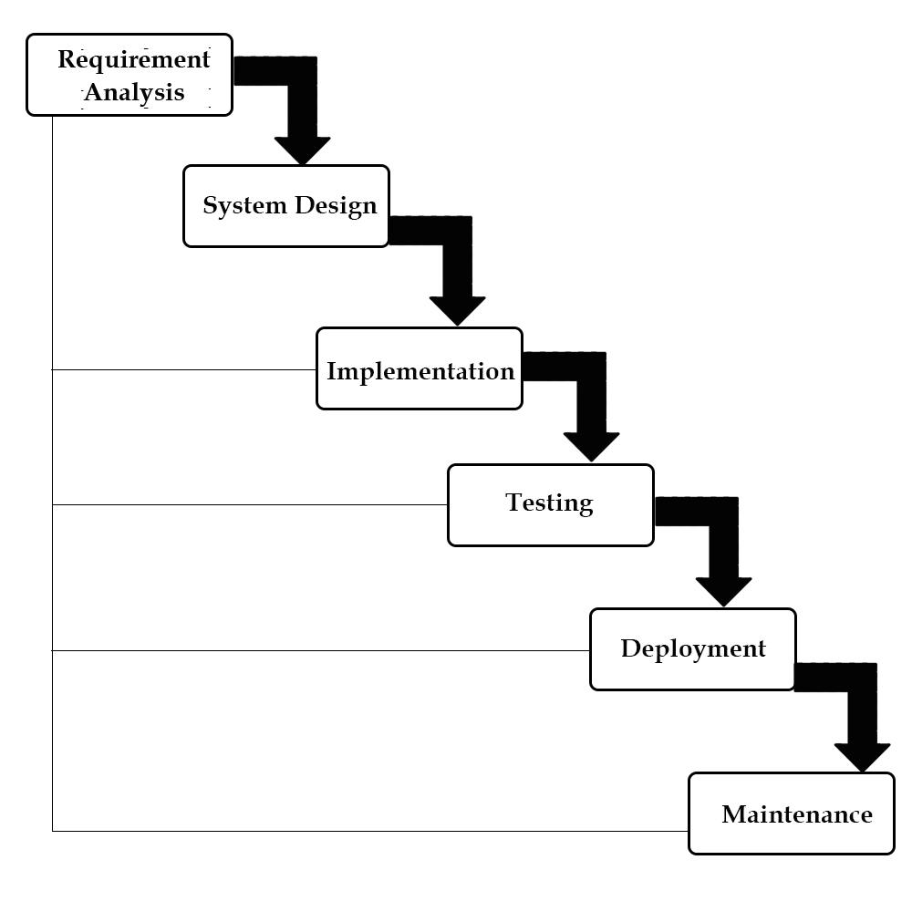

**3.4 Planning and Scheduling**

**3.4.1 Gantt Chart:**

1. A Gantt Chart is a timeline that is used as a project management  tool to illustrate

2. how the project will run.

3. You can view individual tasks, their durations and the sequencing  of these tasks.

4. View the overall timeline of the project and the expected completion  date.

5. Gantt charts are useful for planning and scheduling projects. 6. They help you assess how long a project should take, determine the  resources

7. needed, and plan the order in which you'll complete tasks.

8. They're also helpful for managing the dependencies between tasks.

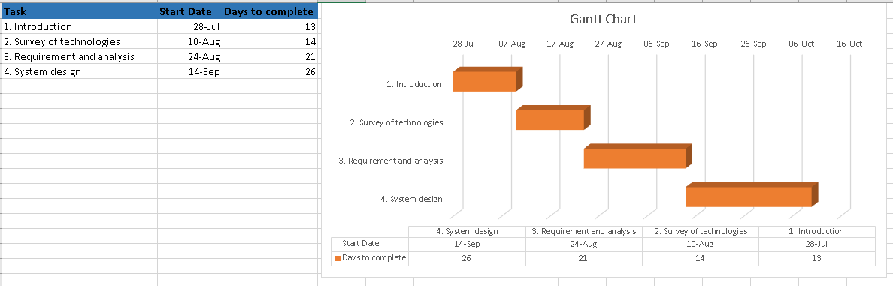

**3.5 Software and Hardware Requirements**

**Software Requirements: (For developing the software):**

**• Windows 10:**

Windows 10 is a series of operating systems developed by Microsoft. It has been released as part of its Windows NT family of operating systems.

**• Xampp server:**

XAMPP is a free and open-source cross-platform web server solution stack package developed by Apache Friends, consisting mainly of the Apache HTTP Server, MariaDB database, and interpreters for scripts written in the PHP and Perl programming languages.

**• Microsoft Visual studio code:**

Visual Studio Code is a source-code editor that can be used with a variety of programming languages, including Java, JavaScript, Go, Node.js, Python and C++. It is based on the Electron framework, which is used to develop Node.js Web applications that run on the Blink layout engine. Visual Studio Code employs the same editor component (codenamed "Monaco") used in Azure DevOps (formerly called Visual Studio Online and Visual Studio Team Services).

Instead of a project system, it allows users to open one or more directories, which can then be saved in workspaces for future reuse. This allows it to operate as a language-agnostic code editor for any language. It supports a number of programming languages and a set

of features that differs per language. Unwanted files and folders can be excluded from the project tree via the settings. Many Visual Studio Code features are not exposed through menus or the user interface but can be accessed via the command palette.

Hardware Components:

• Processor – core i3

• Hard Disk – 70 GB

• Memory – 4GB RAM

**3.5 Conceptual Models**

**3.5.1 Class diagram**

1. The class diagram is the main building block of object-oriented modeling.

2. It is used for general conceptual modeling of the structure of the application, and for detailed modelling translating the models into programming code.

3. Class diagrams can also be used for data modeling.

4. The classes in a class diagram represent both the main elements, interactions in the application, and the classes to be programmed.

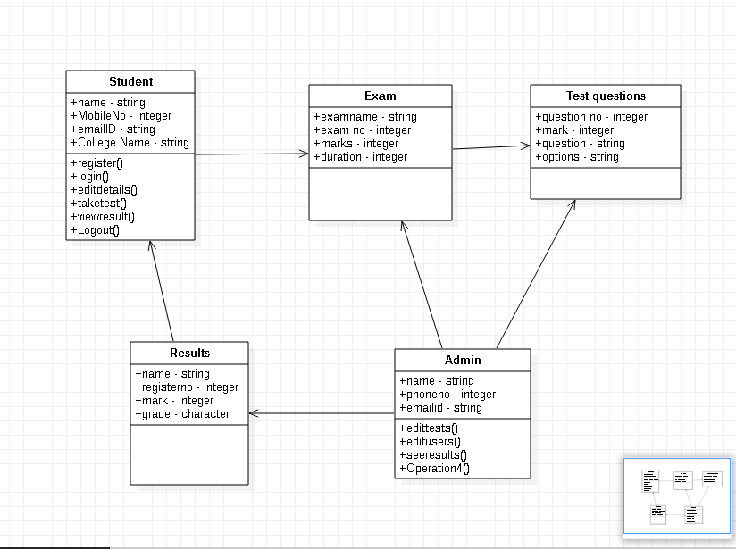

**3.5.2 Use Case Diagram**

1. A use case diagram at its simplest is a representation of a user's interaction with the system that shows the relationship between the user and the different use cases in which the user is involved.

2. A use case diagram can identify the different types of users of a system and the different use cases and will often be accompanied by other types of diagrams as well.

3. The use cases are represented by either circles or ellipses.

4. While a use case itself might drill into a lot of detail about every possibility, a use- case diagram can help provide a higher-level view of the system.

5. They provide the simplified and graphical representation of what the system must actually do.

**For user:**

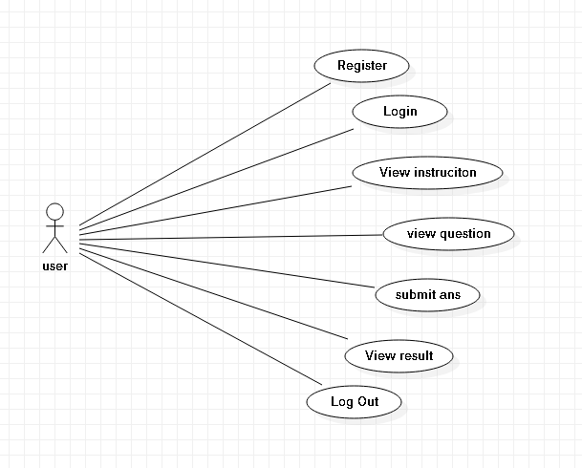

**For admin:**

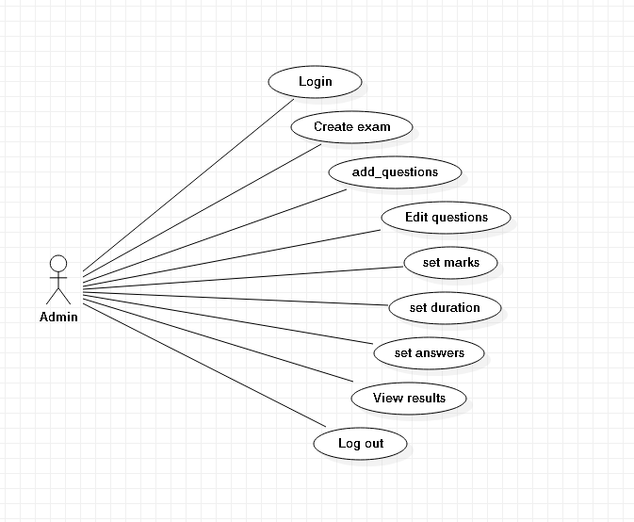

**3.5.3. Component Diagram:**

A component diagram is used to break down a large object-oriented system into the smaller components, so as to make them more manageable. It models the physical view of a system such as executables, files, libraries, etc. that resides within the node.

It visualizes the relationships as well as the organization between the components present in the system. It helps in forming an executable system. A component is a single unit of the system, which is replaceable and executable. The implementation details of a component are hidden, and it necessitates an interface to execute a function. It is like a black box whose behavior is explained by the provided and required interfaces.

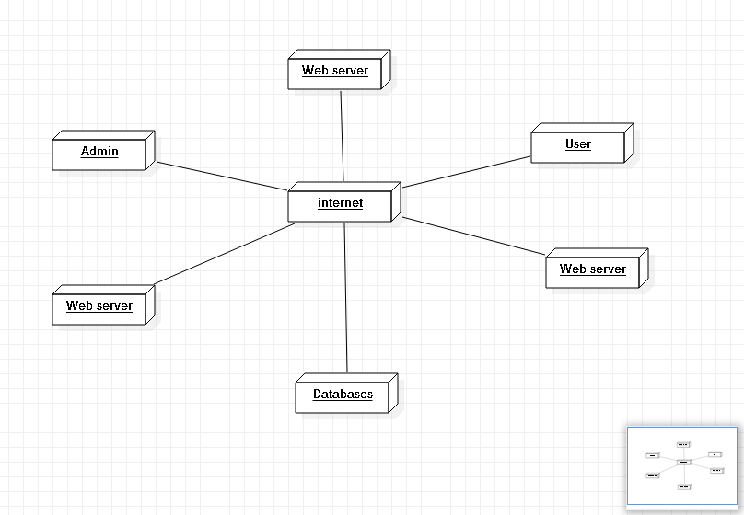

**3.5.4 State chart diagram:**

The state machine diagram is also called the Statechart or State Transition diagram, which shows the order of states underwent by an object within the system. It captures the software system's behavior. It models the behavior of a class, a subsystem, a package, and a complete system.

It tends out to be an efficient way of modeling the interactions and collaborations in the external entities and the system. It models event-based systems to handle the state of an object. It also defines several distinct states of a component within the system. Each object/component has a specific state.

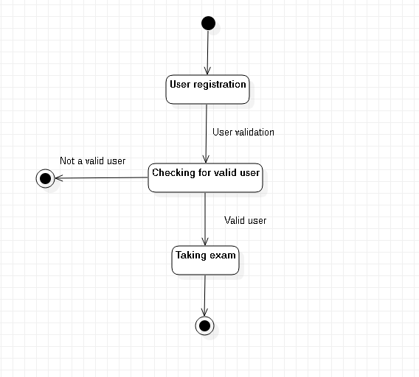

**3.5.5Sequence diagram:**

The sequence diagram represents the flow of messages in the system and is also termed as an event diagram. It helps in envisioning several dynamic scenarios. It portrays the communication between any two lifelines as a time-ordered sequence of events, such that these lifelines took part at the run time. In UML, the lifeline is represented by a vertical bar, whereas the message flow is represented by a vertical dotted line that extends across the bottom of the page. It incorporates the iterations as well as branching.

**Purpose of a Sequence Diagram**

1. To model high-level interaction among active objects within a system.
2. To model interaction among objects inside a collaboration realizing a use case.
3. It either models generic interactions or some certain instances of interaction.

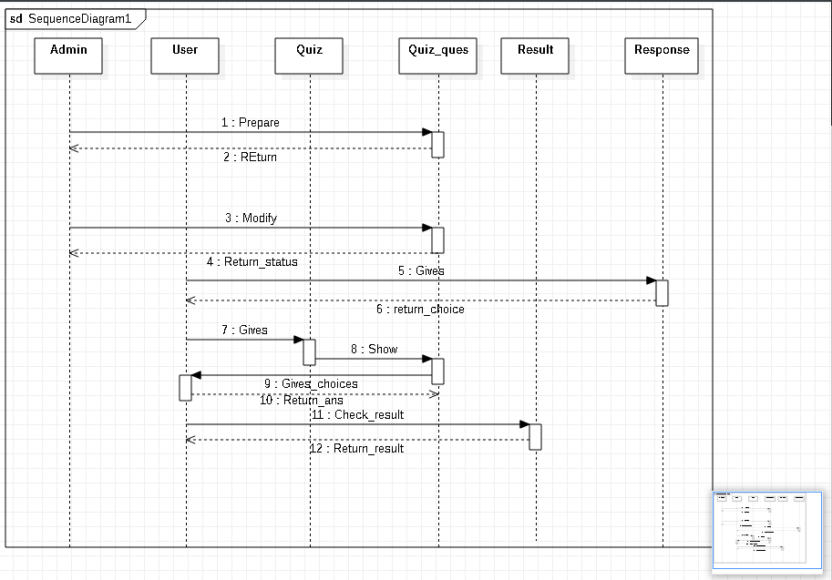

**CHAPTER 4: SYSTEM DESIGN**

4.1 **Basic Modules:**

* **Login:**

The login module will be presented to the user as first screen of app and it accepts two. parameters that are email and password. These two inputs from user will be given to the authenticator which verifies the password with the user unique identification. The login module also has option to reset the password which sends user the forget password link to their email address which they registered in registration module.

* **Home Page:**

After the user has successfully entered the email and password, they will be directed to the home page module. The home page module will include the entire menu.

* **Result module**: All operations related to result is managed by this module.
* **Quiz module**: It has been developed for managing the quiz.
* **Settings**

The user can view the current settings of the applications here. They can also update any default settings

4.**2 Data Design:**

**4.2.1 Schema Design / Sample Schema & Databases:**

**4.2.1.1 Entity-relationship diagram:**

⦁ **Entity**: Entities are objects or ideas that represent important data. Entities are typical nouns such as product, customer, location, or promotion. There are three types of entities commonly used in entity relationship diagrams.

⦁ **Relation**: Within entity-relationship diagrams, relationships are used to document the interaction between two entities. Relationships are typically verbs like assign, associate, or track and provide useful information that could not be discerned with just the entity types.

⦁ **Attribute:** ERD attributes are characteristics of the entity that help users to better understand the database. Attributes are included to include details of the varied entities that are highlighted in the diagram:

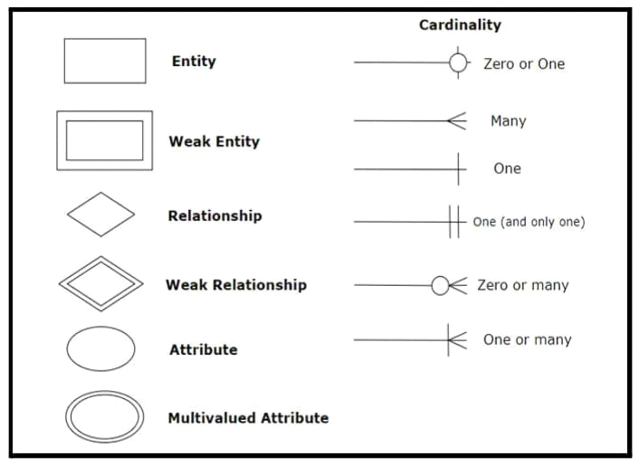

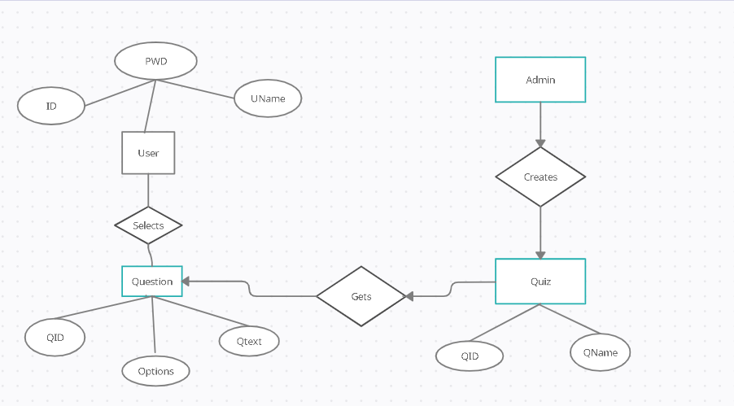

**4.2.2 Data Integrity and Constraints / Validation**

**Rules:**

• **Table name: Login**

|  |  |  |  |
| --- | --- | --- | --- |
| **Field Name** | **Data Type** | **Constraints** | **Size** |
| **Id** | **integer** | **PRIMARY**  **KEY** | **10** |
| **Username** | **varchar** | **NOT NULL** | **Max** |
| **Password** | **varchar** | **NOT NULL** | **20** |

• **Table name: Registration**

|  |  |  |  |
| --- | --- | --- | --- |
| **Field Name** | **Data Type** | **Constraints** | **Size** |
| **id** | **integer** | **PRIMARY**  **KEY** | **10** |
| **First_name** | **varchar** | **NOT NULL** | **50** |
| **Last_name** | **varchar** | **NOT NULL** | **50** |
| **Address** | **varchar** | **NOT NULL** | **50** |
| **Dob** | **numeric** | **NOT NULL** | **15** |
| **Email_id** | **varchar** | **NOT NULL** | **Max** |
| **password** | **varchar** | **NOT NULL** | **20** |
| **Gender** | **varchar** | **NOT NULL** | **10** |

* Table name: quiz

|  |  |  |
| --- | --- | --- |
| Column | Type | Null |
| quiz_id | int(11) | no |
| Quiz_name | Varchar(255) | No |
| Show_result | Int(11) | No |
| Quiz_time | Int(11) | No |

* Table name: Questions

|  |  |  |
| --- | --- | --- |
| Column | Type | Null |
| Ques_id | Int(11) | No |
| question | Varchar(255) | No |
| Quiz_id | Int(11) | No |

* Table name: Answers

|  |  |  |
| --- | --- | --- |
| column | type | Null |
| Ques_id | Int(11) | No |
| answer | Varchar(255) | No |
| Is_correct | Int(11) | no |

**4.3 Procedural Design:**

**4.3.1 Logical Diagram:**

**Activity Diagram:**

1. Activity diagram is another important diagram in UML to describe

the dynamic aspects of the system.

2. Activity diagram is basically a flowchart to represent the flow from

one activity to another activity.

3. The activity can be described as an operation of the system.

4. The control flow is drawn from one operation to another.

5. This flow can be sequential, branched, or concurrent.

6. Activity diagrams deal with all type of flow control by using

different elements such as fork, join, etc.

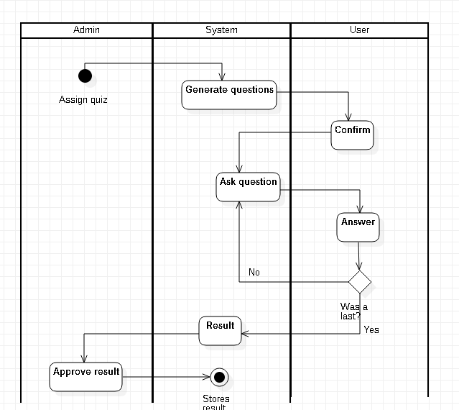

**4.4 User interface design:**

**4.4.1 Login Page:**

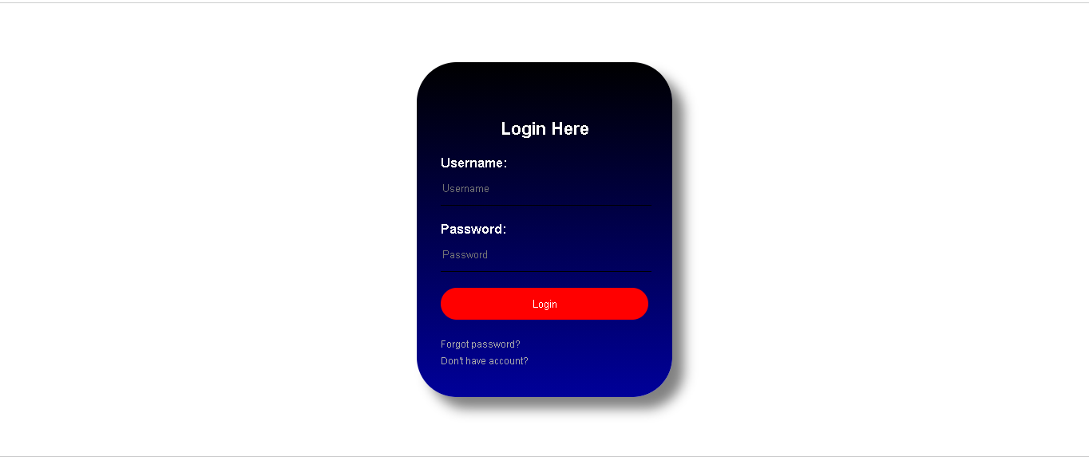

**4.5 Security Issues:**

**1.Integrity:**

While confidentiality ensures that data is seen only by those

authorized to see it, integrity ensures that data is seen only by those

authorized to change it.

Integrity is ensuring that the data you see is the real data and hasn’t

been changed in transit or at rest by someone else. The key concepts

branching off of integrity are hashing, authorization, accountability

and auditing.

**2.Availability:**

Availability is the assurance that the system and its data will be

accessible to authorized user when needed. This process ensures that

your website is up when users need it.

**3.Confidentiality:**

Simply put, confidentiality means that data should be made available

only to those authorized to view it. The key concepts branch off of

confidentiality are authentication, authorization and encryption.

**4.Authentication:**

Authentication is the process of a user proving that they are who they

claim to be within a system. This can be done in three ways: by

something you know (password or pin), something you have (token),

or something you are (biometrics). Only data classified as public

should be available to those who haven’t been authenticated.

Authentication is a basic need of almost every website.

4.6 Test Cases Design:

Testing is the process of detecting errors. Testing performs a very critical role for quality

assurance and for ensuring the reliability of software. The results of testing are used later on

during maintenance also.

**Psychology of Testing :**

The aim of testing is often to demonstrate that a program works by showing that it has no

errors. The basic purpose of testing phase is to detect the errors that may be present in the

program. Hence one should not start testing with the intent of showing that a program works, but

the intent should be to show that a program doesn’t work. Testing is the process of executing a

program with the intent of finding errors.

**Testing Objectives:**

The main objective of testing is to uncover a host of errors, systematically and with minimum

effort and time. Stating formally, we can say

➢ Testing is a process of executing a program with the intent of finding an error.

➢ A successful test is one that uncovers an as yet undiscovered error.

➢ A good test case is one that has a high probability of finding error, if it exists.

➢ The tests are inadequate to detect possibly present errors.

➢ The software more or less confirms to the quality and reliable standards.

**Levels of Testing:**

In order to uncover the errors present in different phases we have the concept of levels of

testing. The basic levels of testing are as shown below…

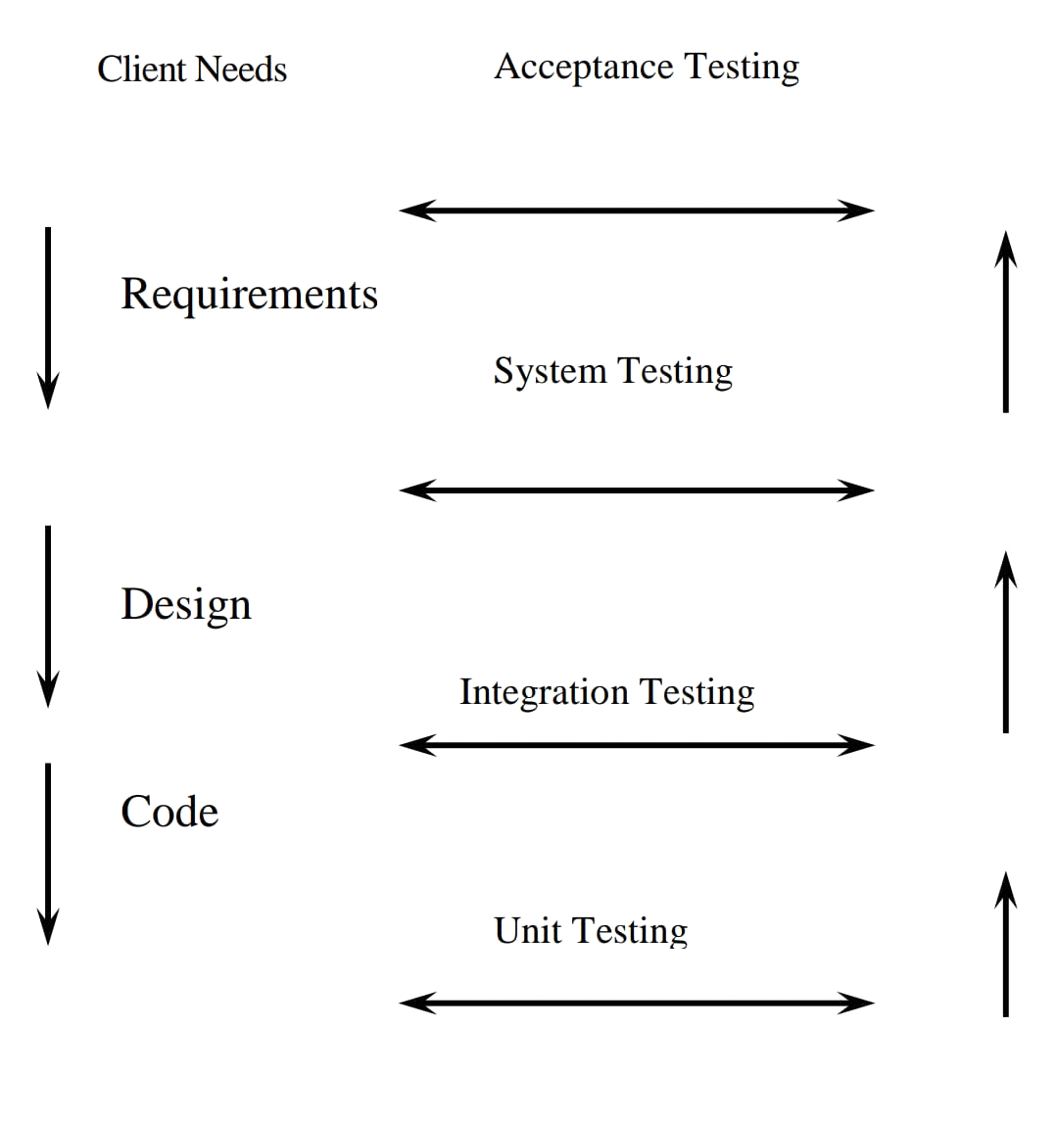

Test case for quiz system:

|  |  |  |  |  |
| --- | --- | --- | --- | --- |
| Test case ID | Login ID | Password | Expected o/p | Status |
| T1 | Valid login id from db | Valid password from db | Apropriate screen opens according to role of user | Pass |
| T2 | Login id not from db | Valid password | Please enter correct ID | Pass |
| T3 | Blank | Valid password | Please enter login id | Pass |
| T4 | Having alphabet | Valid password | Please enter correct ID | Pass |
| T5 | Having special character | Valid password | Please enter correct ID | Pass |
| T6 | Space between digits | Valid password | Please enter correct ID | Pass |
| T7 | Space at end | Valid password | Please enter correct ID | Pass |
| T8 | Valid login id | Blank space | Please enter correct password | Pass |