# Chapter: 5

**Implementation and Testing**

## 5.1 Implementation Approaches

An implementation plan is a document that outlines the steps your team should take to accomplish a shared goal or initiative. Implementation planning is the counterpart to a strategic plan. If the strategic plan details what strategies you will use to hit a specific goal, the implementation plan is the step-by-step guide for how those goals will be achieved.

The purpose of an implementation plan is to ensure that your team can answer the who, what, when, how, and why of a project before moving into the execution phase. In simple terms, it's the action plan that turns your strategy into specific tasks.

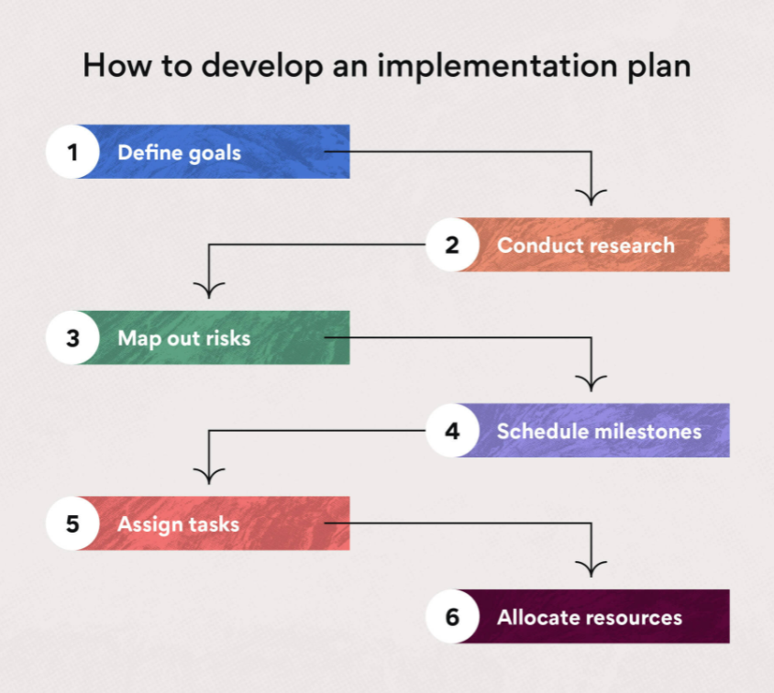

### 5.1.1 Define Goals

The first step in the implementation process is defining your goals. Determine what you hope to accomplish when your project is complete, like whether you hope to win over a new marketing client or revamp your internal content strategy. Starting with your project objectives in mind can help flesh out your project plan.

### 5.1.2 Conduct research

Once you have a broad idea of the project goals you want to achieve, you can hone in on these goals by conducting research such as interviews, surveys, focus groups, or observations. Your research should come from key experts in your field. These experts may be team members or external stakeholders. Your research outcomes should include a list of what your project timeline, budget, and personnel may look like.

### 5.1.3 Map out risks

You brainstormed risk scenarios in step one of your implementation strategies, and in step three, you’ll map out all the potential risks you may face in your project. Risks can include anything from paid time off and holidays to budget constraints and loss of personnel.

A great way to map out your risks is by using a risk register. This tool will help you prioritize project risks and prepare for them accordingly. You can also conduct a SWOT analysis, which will identify any weaknesses or threats affecting your project.

### 5.1.4 Schedule milestones

Scheduling your project milestones is an important step in the planning process because these checkpoints help you track your progress during execution. Milestones serve as metrics—they are a way to measure how far you’ve come in your project and how far you have left to go.

To visualize project milestones and keep your entire team on track, use a Gantt chart. With a Gantt chart, you can visually lay out your implementation schedule and show how long you think each task will take.

### 5.1.5 Assign responsibilities and tasks

Every action plan must include a list of responsibilities with team members assigned to each one. By assigning responsibilities, you can assess the performance of each team member and monitor progress more closely. Using a RACI chart can be an effective project management tool for clarifying roles and responsibilities.

Assigning responsibilities is different from assigning individual tasks. One team member may be responsible for overseeing the project review, while you may assign three other team members to handle the delivery and communication of the project to various teams for review. When you assign responsibilities and tasks, be sure to make your expectations clear.

### 5.1.6 Allocate resources

Resource allocation is one of the best ways to reduce risk. If you can plan out what resources you need for your project and ensure those resources will be available, you’ll avoid the risk of running out of resources mid-project. If you notice that you don’t have enough resources in this step of the implementation process, you can adjust your project accordingly before it kicks off.

Resources may include money, personnel, software, equipment, and other physical or technical materials. Time can also be a resource because the team members you need to complete the project may be working on other projects.

## 5.2 Coding Details and Code Efficiency

### 5.2.1 Code Efficiency

#### 5.2.1.1 index.php

<!doctype html>

<html lang="en">

<head>

  <!-- Required meta tags -->

  <meta charset="utf-8">

  <meta name="viewport" content="width=device-width, initial-scale=1, shrink-to-fit=no">

  <!-- Bootstrap CSS -->

  <link rel="stylesheet" href="https://cdn.jsdelivr.net/npm/bootstrap@4.6.1/dist/css/bootstrap.min.css" integrity="sha384-zCbKRCUGaJDkqS1kPbPd7TveP5iyJE0EjAuZQTgFLD2ylzuqKfdKlfG/eSrtxUkn" crossorigin="anonymous">

  <link rel="stylesheet" href="mystyle.css">

  <link rel="stylesheet" href="https://cdnjs.cloudflare.com/ajax/libs/font-awesome/4.7.0/css/font-awesome.min.css">

  <title>Quiz - Home</title>

</head>

<body>

  <?php

  include 'partials/_loginmodal.php';

  include 'partials/_signupmodal.php';

  if (isset($_GET['signupsuccess']) && $_GET['signupsuccess'] == 'true') {

    echo '<div class="alert alert-success alert-dismissible fade show" role="alert">

      <strong>Your account is created. You can now log in.</strong>

      <button type="button" class="close" data-dismiss="alert" aria-label="Close">

        <span aria-hidden="true">&times;</span>

      </button>

    </div>';

  }

  if (isset($_GET['signupsuccess']) && $_GET['signupsuccess'] == 'false') {

    echo '<div class="alert alert-warning alert-dismissible fade show" role="alert">

        <strong>' . $_GET['error'] . '</strong>

        <button type="button" class="close" data-dismiss="alert" aria-label="Close">

          <span aria-hidden="true">&times;</span>

        </button>

      </div>';

  } else {

    if (isset($_GET['loginsuccess']) && $_GET['loginsuccess'] == 'false') {

      echo '<div class="alert alert-warning alert-dismissible fade show" role="alert">

        <strong>' . $_GET['error'] . '</strong>

        <button type="button" class="close" data-dismiss="alert" aria-label="Close">

          <span aria-hidden="true">&times;</span>

        </button>

      </div>';

    }

  }

  ?>

  <div class="bg-image"></div>

  <div class="bg-text">

    <h1>Let's Quiz</h1>

    <p>Test your skills and become master</p>

    <button type="button" class="btn  m-2" data-toggle="modal" data-target="#loginModal">Log In</button>

    <button type="button" class="btn  m-2" data-toggle="modal" data-target="#signupModal">Sign Up</button>

  </div>

  <!-- Option 1: jQuery and Bootstrap Bundle (includes Popper) -->

  <script src="https://cdn.jsdelivr.net/npm/jquery@3.5.1/dist/jquery.slim.min.js" integrity="sha384-DfXdz2htPH0lsSSs5nCTpuj/zy4C+OGpamoFVy38MVBnE+IbbVYUew+OrCXaRkfj" crossorigin="anonymous"></script>

  <script src="https://cdn.jsdelivr.net/npm/bootstrap@4.6.1/dist/js/bootstrap.bundle.min.js" integrity="sha384-fQybjgWLrvvRgtW6bFlB7jaZrFsaBXjsOMm/tB9LTS58ONXgqbR9W8oWht/amnpF" crossorigin="anonymous"></script>

  <script>

    // Example starter JavaScript for disabling form submissions if there are invalid fields

    (function() {

      'use strict';

      window.addEventListener('load', function() {

        // Fetch all the forms we want to apply custom Bootstrap validation styles to

        var forms = document.getElementsByClassName('needs-validation');

        // Loop over them and prevent submission

        var validation = Array.prototype.filter.call(forms, function(form) {

          form.addEventListener('submit', function(event) {

            if (form.checkValidity() === false) {

              event.preventDefault();

              event.stopPropagation();

            }

            form.classList.add('was-validated');

          }, false);

        });

      }, false);

    })();

    document.getElementById("signuppassword").onfocus = function() {

      document.getElementById('passins').style.display = "block";

    };

    document.getElementById("signuppassword").onblur = function() {

      document.getElementById('passins').style.display = "none";

    };

  </script>

  <script src="scripts/passvalid.js">

  </script>

</body>

</html>

5.2.1.2 _loginmodal.php

<!-- Modal -->

<div class="modal fade" id="loginModal" tabindex="-1" aria-labelledby="loginModal" aria-hidden="true">

  <div class="modal-dialog">

    <div class="modal-content">

      <div class="modal-header">

        <h5 class="modal-title" id="loginModal">Log In</h5>

        <button type="button" class="close" data-dismiss="modal" aria-label="Close">

          <span aria-hidden="true">&times;</span>

        </button>

      </div>

      <div class="modal-body">

      <form method="post" action="partials/_loginhandle.php"  class="needs-validation" novalidate>

  <div class="form-group">

    <label for="loginemail">Email address</label>

    <input type="email" class="form-control" id="loginemail" name="loginemail" required>

    <div class="invalid-feedback">Please enter valid email address.</div>

    <span id="etext"></span>

  </div>

  <div class="form-group">

    <label for="loginpassword">Password</label>

            <div class="input-group">

              <!-- <input type="password" class="form-control" id="loginpassword" name="loginpassword" required pattern="(?=.*\d)(?=.*[!@#$%^&*])(?=.*[a-z])(?=.*[A-Z]).{8,}" title="Must contain at least one number and one uppercase and lowercase letter and one special character, and at least 8 or more characters"> -->

              <input type="password" class="form-control" id="loginpassword" name="loginpassword" required >

              <div class="input-group-append">

                <span class="show-pass input-group-text" onclick="toggle(this)" role="button">

                  <i class="fa fa-eye" onclick="myFunction(this)"></i>

                </span>

              <div class="invalid-feedback">Please enter password.</div>

                <div class="invalid-feedback">Please enter valid password.</div>

              </div>

            </div>

          </div>

      </div>

      <div class="modal-footer">

        <button type="button" class="btn btn-secondary" data-dismiss="modal">Close</button>

        <button type="submit" class="btn btn-primary">Log in</button>

      </div>

      </form>

    </div>

  </div>

</div>

5.2.1.3 _loginhandle.php

<?php

require'_dbconnect.php';

if($_SERVER['REQUEST_METHOD'] == 'POST'){

  $email = $_POST['loginemail'];

  $password = $_POST['loginpassword'];

  $sql = "SELECT * FROM `user` where email = '$email'";

  $result = mysqli_query($conn, $sql);

  $num = mysqli_num_rows($result);

  if($num == 1){

      while($row = mysqli_fetch_assoc($result)){

          if($password == $row['password']){

              session_start();

              $_SESSION['loggedin'] = true;

              $_SESSION['username'] = $row['firstname'];

              $_SESSION['email'] = $row['email'];

              $_SESSION['user_id'] = $row['user_id'];

              header("location: ../welcome.php?loginsuccess=true");

              exit();

          }

          else{

              $showerror = "Invalid credientials";

          }

      }

  }

  else{

      $showerror = "User not found";

  }

  header("location: ../index.php?loginsuccess=false&error=$showerror");

}

?>

5.2.1.4 _signupmodal.php

<!-- Modal -->

<div class="modal fade" id="signupModal" tabindex="-1" aria-labelledby="signupModal" aria-hidden="true">

  <div class="modal-dialog">

    <div class="modal-content ">

      <div class="modal-header">

        <h5 class="modal-title" id="signupModal"><b>Sign Up</b></h5>

        <button type="button" class="close" data-dismiss="modal" aria-label="Close">

          <span aria-hidden="true">&times;</span>

        </button>

      </div>

      <div class="modal-body">

        <form method="post" action="partials/_signuphandle.php" class="needs-validation m-3" novalidate>

          <div class="form-group row">

            <div class="col-md-6">

              <label for="signupemail">First Name</label>

              <input type="text" class="form-control" id="signupemail" name="firstname" required>

              <div class="valid-feedback">

                Looks good!

              </div>

            </div>

            <div class="col-md-6">

              <label for="signupemail">Last Name</label>

              <input type="text" class="form-control" id="signupemail" name="lastname" required>

              <div class="valid-feedback">

                Looks good!

              </div>

            </div>

          </div>

          <div class="form-group row">

            <div class="col-md-3">Gender :</div>

            <div class="form-group col-md-2 custom-control custom-radio custom-control-inline">

              <input type="radio" id="customRadioInline1" value="male" name="gender" class="custom-control-input" required>

              <label class="custom-control-label" for="customRadioInline1">Male</label>

            </div>

            <div class="custom-control col-md-2 form-group custom-radio custom-control-inline">

              <input type="radio" id="customRadioInline2" value="female" name="gender" class="custom-control-input" required>

              <label class="custom-control-label" for="customRadioInline2">Female</label>

              <div class="invalid-feedback col">Please select gender.</div>

            </div>

          </div>

          <div class="form-group">

            <label for="signupemail">Email address</label>

            <input type="email" class="form-control" id="signupemail" name="signupemail" aria-describedby="emailHelp" required>

            <div class="invalid-feedback">Please enter valid email address.</div>

          </div>

          <div class="form-group">

            <label for="signuppassword">Password</label>

            <div class="input-group">

              <input type="password" class="form-control" id="password" name="signuppassword" min="6" required pattern="(?=.*\d)(?=.*[!@#$%^&*])(?=.*[a-z])(?=.*[A-Z]).{8,}" title="Must contain at least one number and one uppercase and lowercase letter and one special character, and at least 8 or more characters">

              <div class="input-group-append">

                <span class="show-pass input-group-text" onclick="toggle(this)" role="button">

                  <i class="fa fa-eye" onclick="myFunction(this)"></i>

                </span>

                <div class="invalid-feedback">Please enter valid password.</div>

              </div>

            </div>

          </div>

          <ul class="list-unstyled" style="display: none; transition: 2s" id="passins" >

                        <li>

                            <span class="low-upper-case">

                                <i class="fa fa-circle" aria-hidden="true"></i>

                                Lowercase &amp; Uppercase

                            </span>

                        </li>

                        <li>

                            <span class="one-number">

                                <i class="fa fa-circle" aria-hidden="true"></i>

                                Number (0-9)

                            </span>

                        </li>

                        <li>

                            <span class="one-special-char">

                                <i class="fa fa-circle" aria-hidden="true"></i>

                                Special Character (!@#$^*)

                            </span>

                        </li>

                        <li>

                            <span class="eight-character">

                                <i class="fa fa-circle" aria-hidden="true"></i>

                                Atleast 8 characters

                            </span>

                        </li>

                    </ul>

            <div class="form-group">

            <label for="csignuppassword">Confirm Password</label>

            <div class="input-group">

            <input type="password" class="form-control" id="csignuppassword" name="csignuppassword" min="6" required>

              <div class="input-group-append">

                <span class="show-pass input-group-text" onclick="toggle(this)" role="button">

                  <i class="fa fa-eye" onclick="myFunction(this)"></i>

                </span>

                <div class="invalid-feedback">Please enter valid password.</div>

              </div>

            </div>

          </div>

      </div>

      <div class="modal-footer">

        <button type="button" class="btn btn-secondary" data-dismiss="modal">Close</button>

        <button type="submit" class="btn btn-primary">Submit</button>

      </div>

      </form>

    </div>

  </div>

</div>

5.2.1.5 signuphamdle.php

<?php

require'_dbconnect.php';

$showerror = false;

$showalert = false;

if($_SERVER['REQUEST_METHOD'] == 'POST'){

    $firstname = $_POST['firstname'];

    $lastname = $_POST['lastname'];

    $signupemail = $_POST['signupemail'];

    $signuppassword = $_POST['signuppassword'];

    $csignuppassword = $_POST['csignuppassword'];

    $gender = $_POST['gender'];

    $firstname = ucfirst($firstname);

    $lastname = ucfirst($lastname);

    $existuser = "SELECT * FROM `user` WHERE email='$signupemail'";

    $result = mysqli_query($conn, $existuser);

    $numexistsrows = mysqli_num_rows($result);

    if($numexistsrows == 1){

        $showerror = "Email already exists";

    }

    else{

        if($signuppassword == $csignuppassword){

            $sql = "INSERT INTO `user` (`firstname`, `lastname`, `email`, `password`, `gender`) VALUES ('$firstname', '$lastname', '$signupemail', '$signuppassword', '$gender')";

            $result = mysqli_query($conn, $sql);

            if($result){

                $showalert = true;

                header('location:../index.php?signupsuccess=true');

                exit();

            }

        }

        else{

          $showerror = "Password does not match";

      }

    }

    header("location:../index.php?signupsuccess=false&error=$showerror");

}

?>

5.2.1.6 welcome.php

<!doctype html>

<html lang="en">

<head>

  <!-- Required meta tags -->

  <meta charset="utf-8">

  <meta name="viewport" content="width=device-width, initial-scale=1, shrink-to-fit=no">

  <script type="text/javascript" src="myscript.js"></script>

  <!-- Bootstrap CSS -->

  <link rel="stylesheet" href="https://cdn.jsdelivr.net/npm/bootstrap@4.6.1/dist/css/bootstrap.min.css" integrity="sha384-zCbKRCUGaJDkqS1kPbPd7TveP5iyJE0EjAuZQTgFLD2ylzuqKfdKlfG/eSrtxUkn" crossorigin="anonymous">

  <link rel="stylesheet" href="mystyle2.css">

  <title>Quiz - Home</title>

</head>

<body>

  <?php

  session_start();

  if (isset($_SESSION['loggedin']) && $_SESSION['loggedin'] == true) {

    include 'partials/_header.php';

    include 'partials/_dbconnect.php';

    $fname = $_SESSION['username'];

    echo '<nav class="navbar navbar-expand-lg navbar-dark bg-dark">

    <a class="navbar-brand active" href="welcome.php">Home</a>

    <button class="navbar-toggler" type="button" data-toggle="collapse" data-target="#navbarSupportedContent" aria-controls="navbarSupportedContent" aria-expanded="false" aria-label="Toggle navigation">

     <span class="navbar-toggler-icon"></span>

    </button>

    <div class="collapse navbar-collapse" id="navbarSupportedContent">

    <ul class="navbar-nav mr-auto">

    <li class="nav-item change">

     <a class="nav-link" href="userquiz.php">Quiz <span class="sr-only">(current)</span></a>

    </li>

    <li class="nav-item change">

     <a class="nav-link" href="userprofile.php">Profile</a>

    </li>

    <li class="nav-item change">

     <a class="nav-link" href="userresult.php">Result</a>

    </li>

    <li class="nav-item change">

     <a class="nav-link" href="userfeedback.php">Feedback</a>

    </li>

    <li class="nav-item change">

     <a class="nav-link" href="about.php">About us</a>

    </li>

    </ul>

       <form class="form-inline my-2 my-lg-0">

       <a href="partials/_logout.php" role="button" class="btn btn-primary float-right m-2">Log out</a>

     </form>

    </div>

    </nav>';

  } else {

    header("location: index.php");

  }

  ?>

  <h1 class="text-center font-weight-bold mt-3">Welcome <?php echo $fname; ?></h1>

  <?php

  $email = $_SESSION['email'];

  // $aquizsql = "SELECT DISTINCT(quiz_id) FROM `resultrecord` WHERE `email` LIKE 'user1@gmail.com'";

  //SELECT (resultrecord.correct_ans)*100/(quiz.total_question) as percentage, resultrecord.email FROM `resultrecord` INNER JOIN quiz ON resultrecord.quiz_id=quiz.quiz_id WHERE resultrecord.email LIKE 'user1@gmail.com';

  $aquizsql = "SELECT DISTINCT(quiz_id) FROM `resultrecord` WHERE `email` LIKE '$email'";

  $aquizresult = mysqli_query($conn, $aquizsql);

  $aquizrow = mysqli_fetch_assoc($aquizresult);

  $aquiznumrows = mysqli_num_rows($aquizresult);

  ?>

  <div class="row m-5">

    <div class="col-sm-4">

      <div class="card border-dark mb-3">

        <div class="card-body p-4 text-center">

          <h3 class="card-title">No. of quizzes attempted</h3>

          <hr class="badge-dark"><br>

          <h1 class="card-text"><?php echo $aquiznumrows; ?></h1>

        </div>

      </div>

    </div>

    <?php

    $numquizsql = "SELECT count(quiz_id) FROM `quiz`;";

    $numquizresult = mysqli_query($conn, $numquizsql);

    $numquizrow = mysqli_fetch_assoc($numquizresult);

    ?>

    <div class="col-sm-4">

      <div class="card border-dark mb-3">

        <div class="card-body p-4 text-center">

          <h3 class="card-title">No. of quizzes Available</h3>

          <hr class="badge-dark"><br>

          <h1 class="card-text"><?php echo $numquizrow["count(quiz_id)"]; ?></h1>

        </div>

      </div>

    </div>

<?php

$highsql = "SELECT MAX((resultrecord.correct_ans)*100/(quiz.total_question)) as percentage, resultrecord.email FROM `resultrecord` INNER JOIN quiz ON resultrecord.quiz_id=quiz.quiz_id WHERE resultrecord.email LIKE '$email';";

$highresult = mysqli_query($conn, $highsql);

$highrow = mysqli_fetch_assoc($highresult);

?>

    <div class="col-sm-4">

      <div class="card border-dark mb-3">

        <div class="card-body p-4 text-center">

          <h3 class="card-title">Highest result</h3>

          <hr class="badge-dark"><br>

          <h1 class="card-text"><?php echo substr($highrow['percentage'], 0, 5).'%';?></h1>

        </div>

      </div>

    </div>

  </div>

<form method="post" action="partials/quizdetails.php">

  <div class="container col-md-3 mb-5">

    <div class="input-group mt-3  text-monospace">

      <input type="number" class="form-control border border-dark" name="quizcode" placeholder="Enter code..." min="1000" max="9999" autocomplete="off">

      <div class="input-group-append">

        <button class="btn btn-outline-info" type="submit" id="button-addon2">Join by code</button>

      </div>

    </div>

  </div>

</form>

  <script src="https://cdn.jsdelivr.net/npm/jquery@3.5.1/dist/jquery.slim.min.js" integrity="sha384-DfXdz2htPH0lsSSs5nCTpuj/zy4C+OGpamoFVy38MVBnE+IbbVYUew+OrCXaRkfj" crossorigin="anonymous"></script>

  <script src="https://cdn.jsdelivr.net/npm/bootstrap@4.6.1/dist/js/bootstrap.bundle.min.js" integrity="sha384-fQybjgWLrvvRgtW6bFlB7jaZrFsaBXjsOMm/tB9LTS58ONXgqbR9W8oWht/amnpF" crossorigin="anonymous"></script>

</body>

</html>

5.2.1.7 userquiz.php

<!doctype html>

<html lang="en">

<head>

  <!-- Required meta tags -->

  <meta charset="utf-8">

  <meta name="viewport" content="width=device-width, initial-scale=1, shrink-to-fit=no">

  <script type="text/javascript" src="myscript.js"></script>

  <!-- Bootstrap CSS -->

  <link rel="stylesheet" href="https://cdn.jsdelivr.net/npm/bootstrap@4.6.1/dist/css/bootstrap.min.css" integrity="sha384-zCbKRCUGaJDkqS1kPbPd7TveP5iyJE0EjAuZQTgFLD2ylzuqKfdKlfG/eSrtxUkn" crossorigin="anonymous">

  <link rel="stylesheet" href="mystyle2.css">

  <title>User quiz</title>

  <style>

    mark{

      color: red;

      background-color: yellow;

    }

  </style>

</head>

<body>

  <?php

  session_start();

  if (isset($_SESSION['loggedin']) && $_SESSION['loggedin'] == true) {

    include 'partials/_header.php';

    include 'partials/_dbconnect.php';

    if(isset($_GET['qsubmit']) && $_GET['qsubmit'] == "success"){

      echo '<div class="alert alert-success alert-dismissible fade show mb-0" role="alert">

      Your quiz is submitted.

        <button type="button" class="close" data-dismiss="alert" aria-label="Close">

            <span aria-hidden="true">&times;</span>

        </button>

    </div>';

    }

    echo '<nav class="navbar navbar-expand-lg navbar-dark bg-dark sticky-top">

    <a class="navbar-brand text-secondary" href="welcome.php">Home</a>

    <button class="navbar-toggler" type="button" data-toggle="collapse" data-target="#navbarSupportedContent" aria-controls="navbarSupportedContent" aria-expanded="false" aria-label="Toggle navigation">

     <span class="navbar-toggler-icon"></span>

    </button>

    <div class="collapse navbar-collapse" id="navbarSupportedContent">

    <ul class="navbar-nav mr-auto">

    <li class="nav-item dropdown">

        <a class="nav-link dropdown-toggle active" href="userquiz.php" id="navbarDropdown" role="button" data-toggle="dropdown" aria-expanded="false">

          Quiz

        </a>

        <div class="dropdown-menu" aria-labelledby="navbarDropdown">

        <a class="dropdown-item" href="userquiz.php?catid=0">All</a>

        ';

             $sql = "SELECT * FROM `category` LIMIT 10";

             $result = mysqli_query($conn, $sql);

             $numrows = mysqli_num_rows($result);

             if ($numrows > 0) {

               while ($row = mysqli_fetch_assoc($result)) {

                //echo'<option value="'.$row['cat_id'].'"  class="text-center"><a href="userquiz.php?catid='.$row['cat_id'].'">'.$row['cat_desc'].'</a></option>';

                echo '<a class="dropdown-item" href="userquiz.php?catid='.$row['cat_id'].'">'.$row['cat_desc'].'</a>';

               }

              }

          echo'

        </div>

      </li>

    <li class="nav-item change">

     <a class="nav-link" href="userprofile.php">Profile</a>

    </li>

    <li class="nav-item change">

     <a class="nav-link" href="userresult.php">Result</a>

    </li>

    <li class="nav-item change">

     <a class="nav-link" href="userfeedback.php">Feedback</a>

    </li>

    <li class="nav-item change">

     <a class="nav-link" href="about.php">About us</a>

    </li>

    </ul>

    <div class="form-inline my-2 my-lg-0">

    <input class="form-control mr-sm-2" type="search" placeholder="Search"  id="searchquiz" autocomplete="off"  aria-label="Search">

    <button class="btn btn-outline-success my-2 my-sm-0" onclick="search()" >Search</button>

       <a href="partials/_logout.php" role="button" class="btn btn-primary float-right m-2">Log out</a>

     </div>

    </div>

    </nav>';

  } else {

    header("location: index.php");

  }

  ?>

  <div class="col-md-9 mt-5 mx-auto">

    <?php

    if(isset($_GET['catid'])){

      if($_GET['catid'] != 0){

        $catid = $_GET['catid'];

        $sql = "SELECT * FROM `category` WHERE `cat_id`=$catid";

        $result = mysqli_query($conn, $sql);

        $row = mysqli_fetch_assoc($result);

        echo'<h2><span class="px-5 py-3 bg-primary text-white rounded-pill">Category  :   '.$row['cat_desc'].'</span></h2>';

      }

      elseif ($_GET['catid'] == 0) {

        echo'<h2><span class="px-5 py-3 bg-primary text-white rounded-pill">Category  :   All</span></h2>';

      }

    }

    ?>

  </div>

  <div class="row mx-5" id="qdiv">

    <?php

    if(isset($_GET['catid'])){

      if($_GET['catid'] == 0){

        $sql = "SELECT * FROM `quiz` WHERE `quiz_status` = 1";

      }

      else{

        $catid = $_GET['catid'];

        $sql = "SELECT * FROM `quiz` WHERE `quiz_status` = 1 AND `cat_id` = $catid";

      }

    }

    else{

      $sql = "SELECT * FROM `quiz` WHERE `quiz_status` = 1";

    }

    $result = mysqli_query($conn, $sql);

    if(!$result){

      echo '<h1>No category found</h1>';

    }

    $numrows = mysqli_num_rows($result);

    if($numrows >0){

    while ($row = mysqli_fetch_assoc($result)) {

      //echo $row['quiz_desc'].'<br>';

      echo '<div class="col-md-4 mt-5">

        <div class="card border border-secondary shadow-lg">

        <div class="card-body text-center">

          <h5 class="card-title pt-3 cdiv" >' . $row['quiz_desc'] . '</h5>

          <p>Time :  '.$row['quiz_time'].' mins<br>

          Total Questions :  '.$row['total_question'].'</p>

          <!-- <p class="card-text">With supporting text below as a natural lead-in to additional content.</p> -->

          <a href="partials/quizdetails.php?quizid=' . $row['quiz_id'] . '" class="btn btn-primary ">Start</a>

        </div>

      </div>

    </div>';

    }

  }

  else{

    echo '<div class="col-md-8 mt-5 bg-alert"><h1 class="text-center">No quizzes found</h1></div>';

  }

    ?>

  </div>

  <script type="text/javascript">

    const p = document.getElementsByClassName("cdiv");

    function search(){

      let input = document.getElementById("searchquiz").value;

      if(input !== ""){

        let regExp = new RegExp(input, "gi");

        for (let i = 0; i < p.length; i++) {

          p[i].innerHTML = (p[i].textContent).replace(regExp, "<mark>$&</mark>");

        }

      }

    }

  </script>

  <!-- Optional JavaScript; choose one of the two! -->

  <!-- Option 1: jQuery and Bootstrap Bundle (includes Popper) -->

  <script src="https://cdn.jsdelivr.net/npm/jquery@3.5.1/dist/jquery.slim.min.js" integrity="sha384-DfXdz2htPH0lsSSs5nCTpuj/zy4C+OGpamoFVy38MVBnE+IbbVYUew+OrCXaRkfj" crossorigin="anonymous"></script>

  <script src="https://cdn.jsdelivr.net/npm/bootstrap@4.6.1/dist/js/bootstrap.bundle.min.js" integrity="sha384-fQybjgWLrvvRgtW6bFlB7jaZrFsaBXjsOMm/tB9LTS58ONXgqbR9W8oWht/amnpF" crossorigin="anonymous"></script>

  <!-- Option 2: Separate Popper and Bootstrap JS -->

  <!--

    <script src="https://cdn.jsdelivr.net/npm/jquery@3.5.1/dist/jquery.slim.min.js" integrity="sha384-DfXdz2htPH0lsSSs5nCTpuj/zy4C+OGpamoFVy38MVBnE+IbbVYUew+OrCXaRkfj" crossorigin="anonymous"></script>

    <script src="https://cdn.jsdelivr.net/npm/popper.js@1.16.1/dist/umd/popper.min.js" integrity="sha384-9/reFTGAW83EW2RDu2S0VKaIzap3H66lZH81PoYlFhbGU+6BZp6G7niu735Sk7lN" crossorigin="anonymous"></script>

    <script src="https://cdn.jsdelivr.net/npm/bootstrap@4.6.1/dist/js/bootstrap.min.js" integrity="sha384-VHvPCCyXqtD5DqJeNxl2dtTyhF78xXNXdkwX1CZeRusQfRKp+tA7hAShOK/B/fQ2" crossorigin="anonymous"></script>

    -->

</body>

</html>

5.2.1.8

## 5.3 Testing Approach

Software testing is a process which is used to check the standard of software developed. It is also a process of uncovering errors in a program and makes it a feasible task. It is useful process of running the program with the intention of finding errors.

Testing is a process of executing a program with the intent of finding a mistake. Testing is a crucial element of quality assurance of the software application and presents full review of specification, design and coding. System Testing is an important phase. Testing represents an interesting anomaly for the software. Thus, a series of testing are performed for the proposed system before the system is prepared for user acceptance testing. A good test suit is one that features a high probability of finding an undiscovered error. A successful test is one that discovers the hidden errors or bugs.

The primary objective for test suit design is to derive a group of tests that has the very best livelihood for uncovering defects in software.

In order to prove that a bit of software works, the software must be tested to work out if the needs of the user are met. There are several differing types of tests used throughout the testing process. The two main sorts of testing are white box and recorder testing

### 5.3.1 Unit Testing

Unit Testing is also called as module testing. Unit testing is performed by developers. In unit testing the developer will test each module individually in the environment the code was developed in. The main goal of unit testing is to make sure that all the modules present are working as expected.

#### 5.3.1.1 User Registration

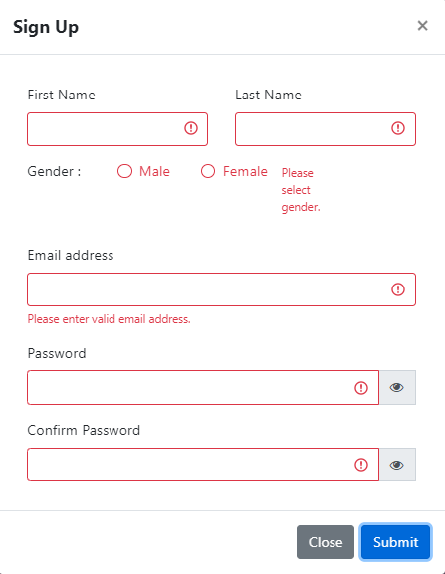

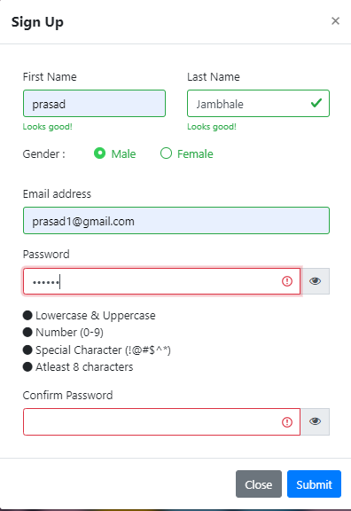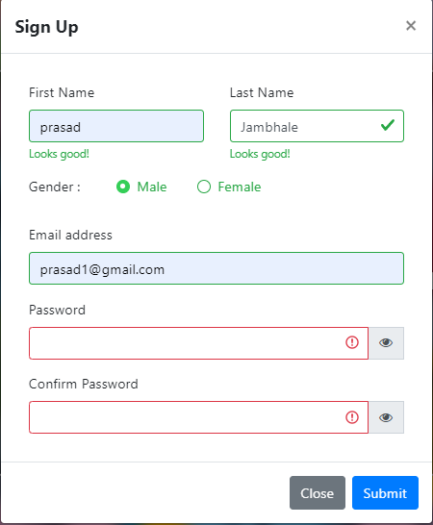

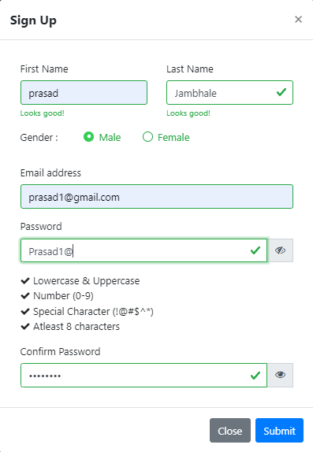

From the above figures we checking form validation i.e., whenever any user tries to register him/her to our website. In figure we are checking that if the user clicks on register button without entering any details, he/she will be shown the field input error input box will become red.

In figure user has entered his/her email and entered a password without satisfying condiitons containing a character or a number or a special character or atleast 8 character,

User will get input error and input box will become red. If password match conditions check sign will come in front of conditions.

#### 5.3.1.3 User Login

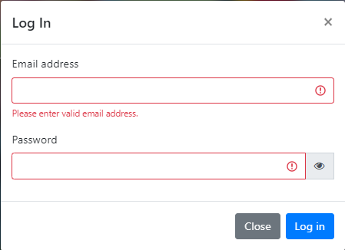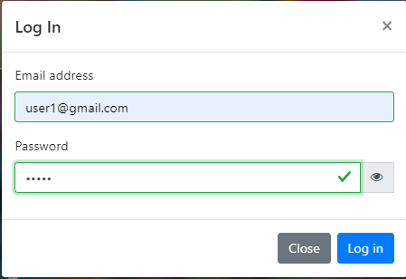

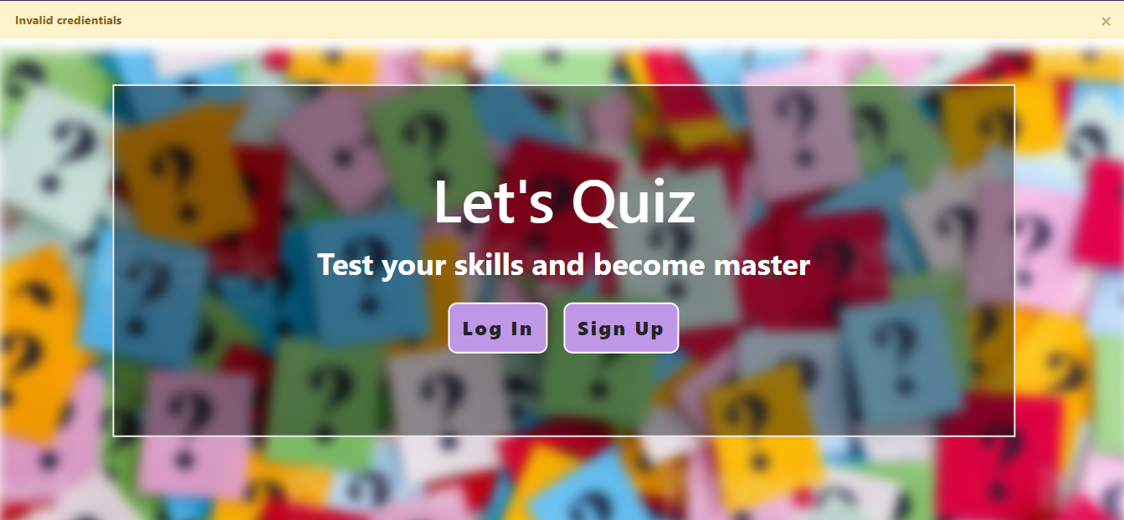

From the above figures we checking form validation i.e., whenever any user tries to login him/her to our website, we are checking that if the user clicks on register button without entering any details, he/she will be shown the field input error “Please enter valid email address”.

Also, whenever any user mistakes to write any of the field correctly the error messages display that “Invalid credentials”.

#### 5.3.1.3 Admin Login

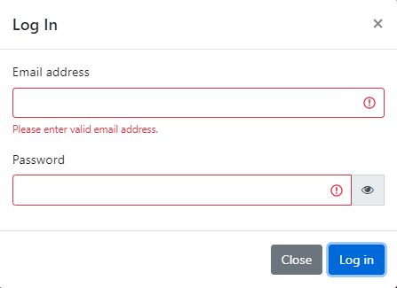

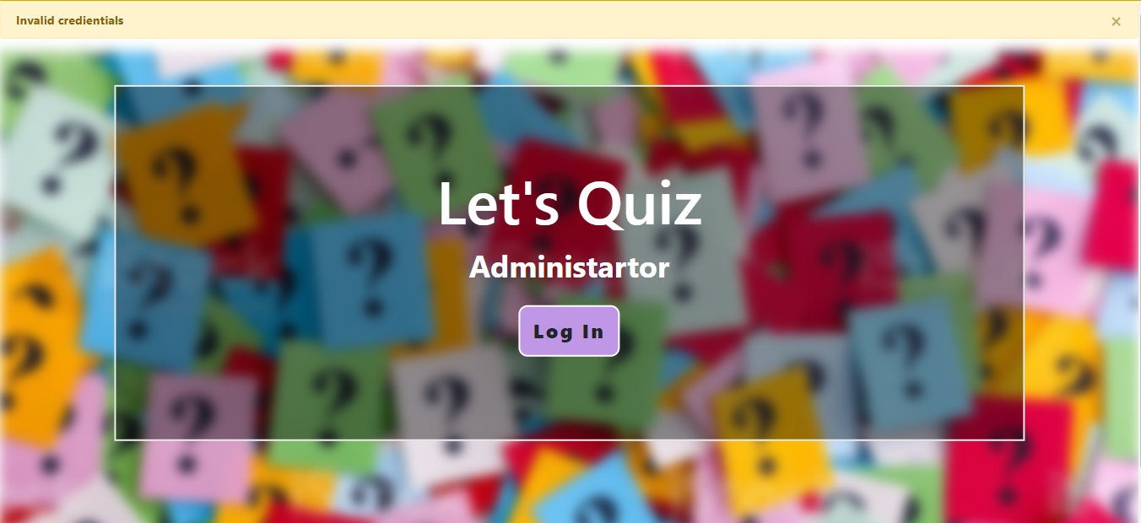

From the above figures we checking form validation i.e., whenever admin tries to register him/her to our website. In figure we are checking that if the admin clicks on login button without entering any details, he/she will be shown the field input error “Please enter valid email address” and iput border becomes red.

Also, whenever admin mistakes to write any of the field correctly the error messages display that “Invalid credentials”.

#### 5.3.1.4 Add a new category

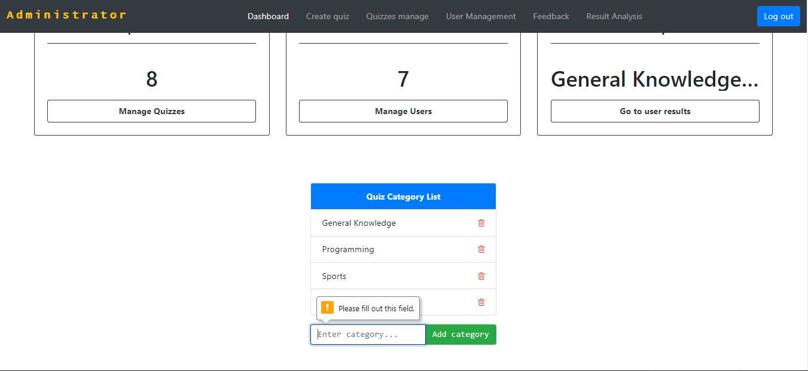

#### 5.3.1.4 Add a new quiz

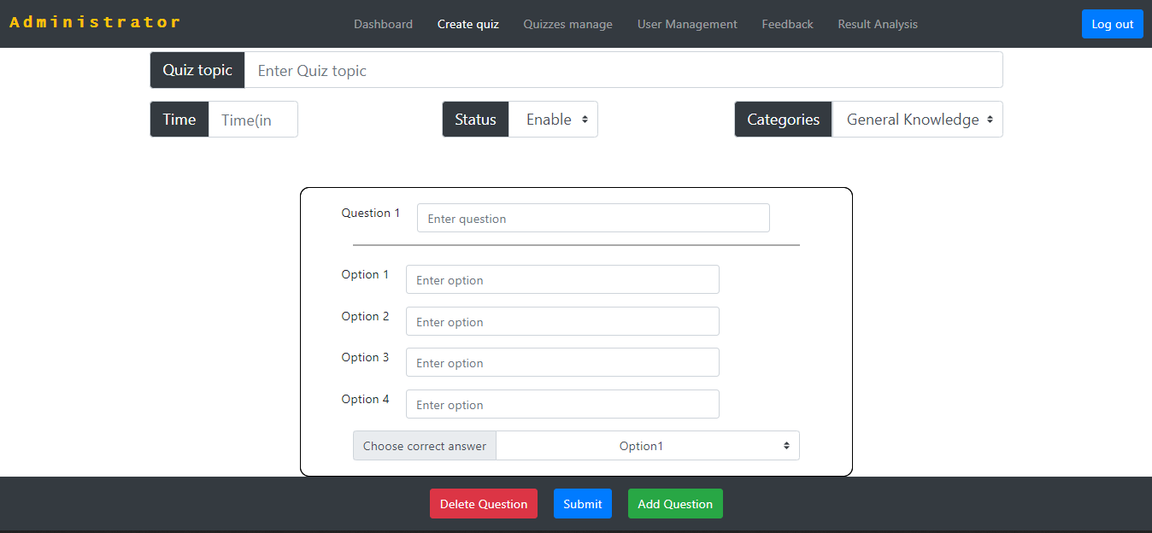

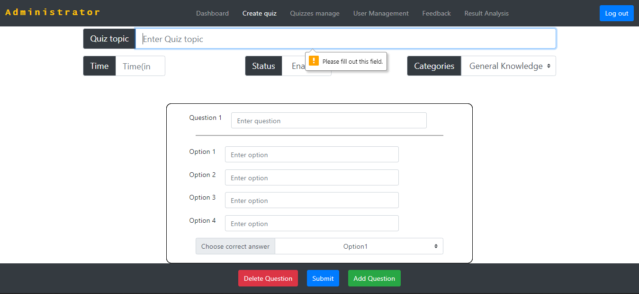

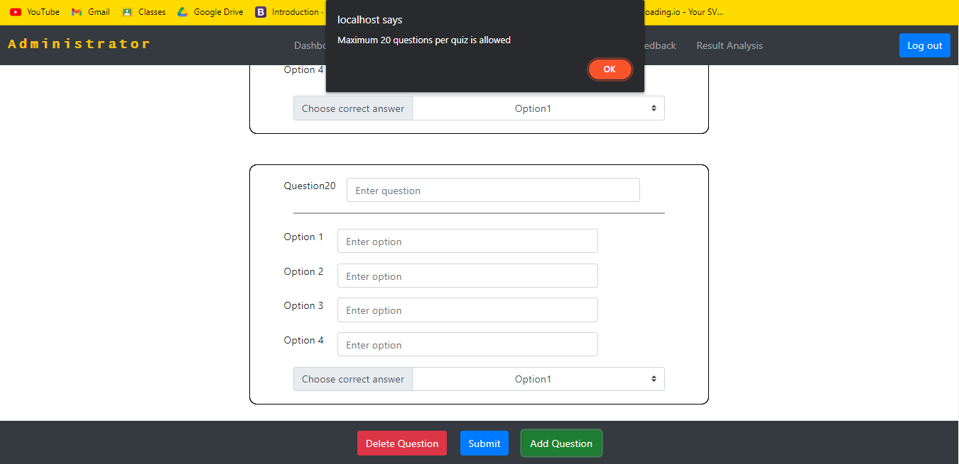

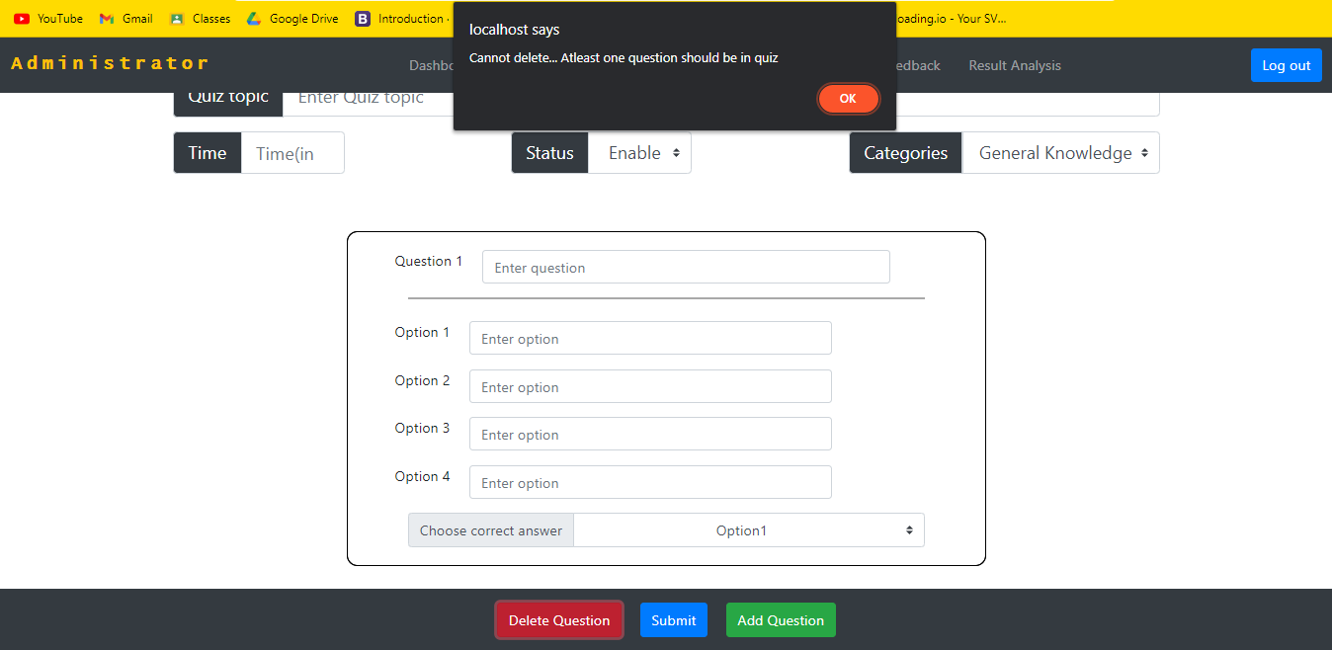

From the above figures we checking that whenever admin mistakes to write any of the field correctly the error messages display that “Please fill out this field”. Also, maximum 20 questions is allowed and mnimum 1 question is allowed per quiz.

#### 5.3.1.5 Contact Form

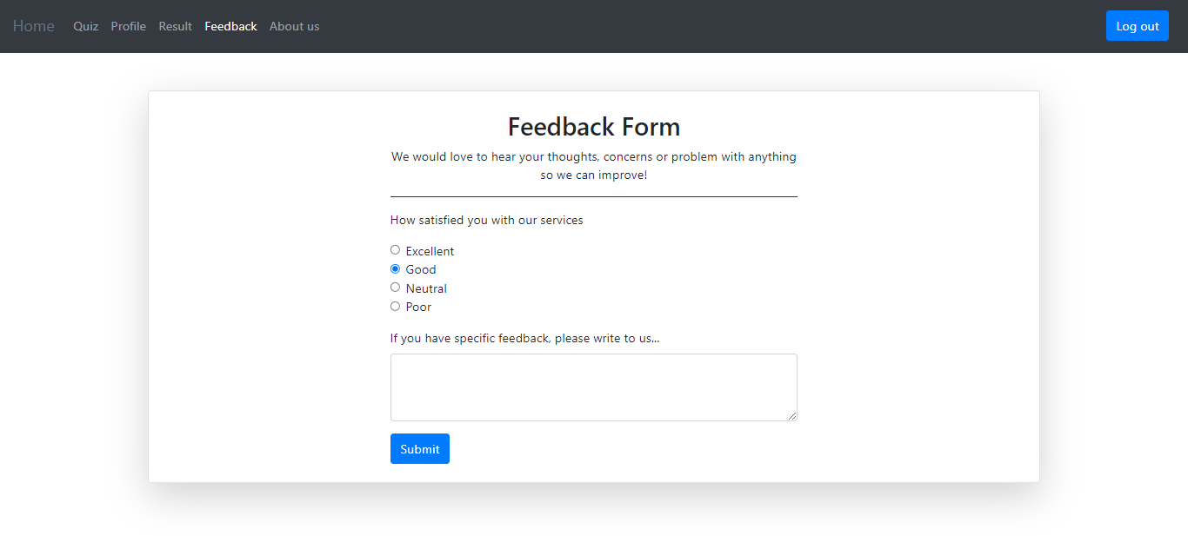

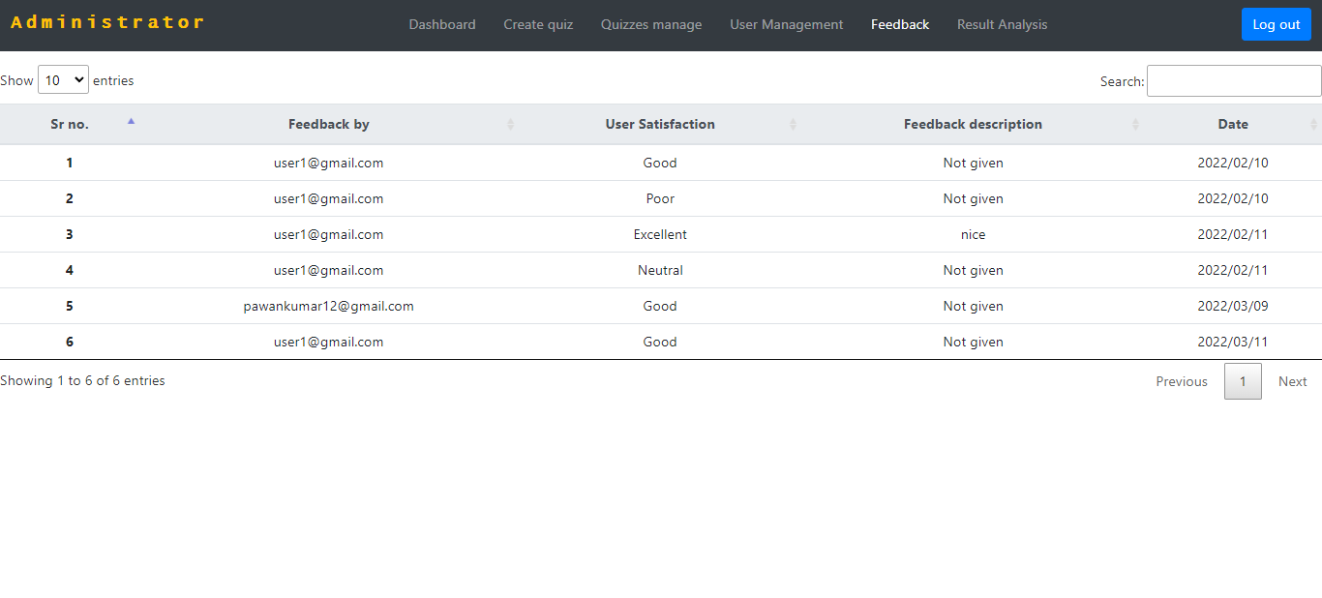

In the above figure, user can submit satisfaction and feedback. If user don’t give feedback description, in admin side it will be shown as “Not given”.

### 5.3.2 Integrated Testing

Integration refers to connectivity of all the different modules present in a project. After all the modules are tested under unit testing by the developers, they are sent for integration testing. Integration testing is also called as sting testing. The tester makes sure that all the modules are connected to each other. The transfer of data between all the unit tested modules is checked by the tester in integration testing. The integration testing process make use of Stubs and Drivers which help put data in the calling modules to test data transfer and communication.

#### 5.3.2.1 User Result and Display Result

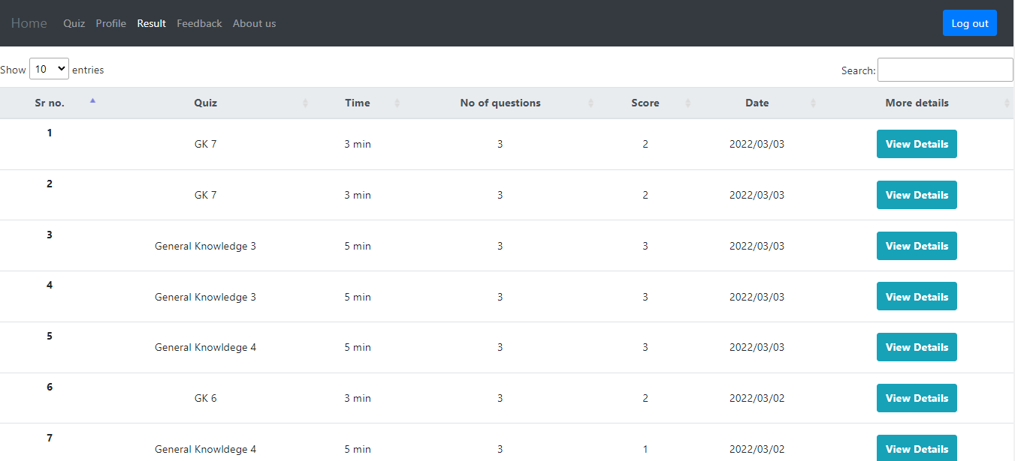

displayresult.php

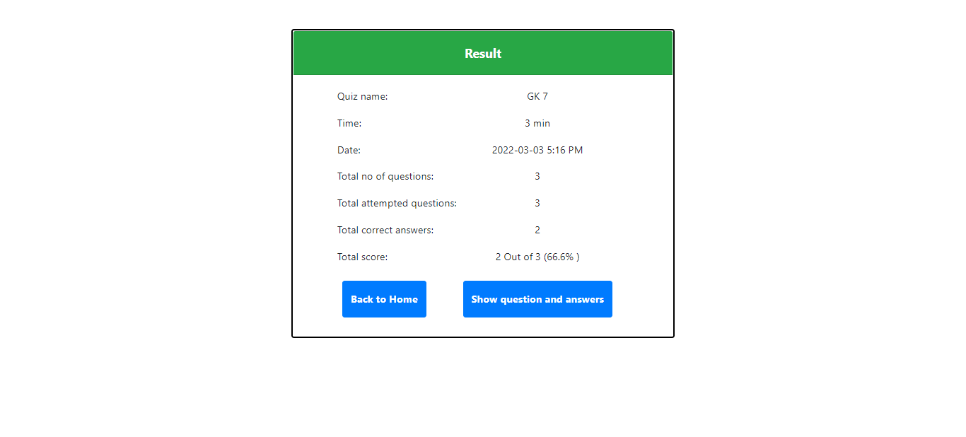

From the above figures whenever user click on view details button in result section, it will redirect to displayresult.php page. All the data will get with the help of resultid. All the details related to result id will be displayed in displayresult.php page.

### 5.3.3 Beta Testing

Beta testing is done just before the final application can be delivered to the end user or clients. A small number of end users test the final application. The users provide feedback to the developers of the application. Changes will be made based on feedback and request of the users involved in beta testing.

#### 5.3.3.1 User profile updating

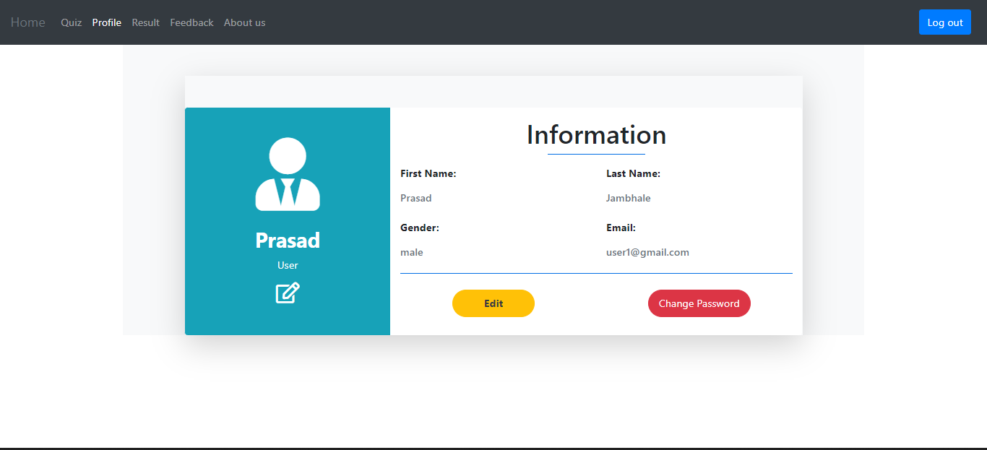

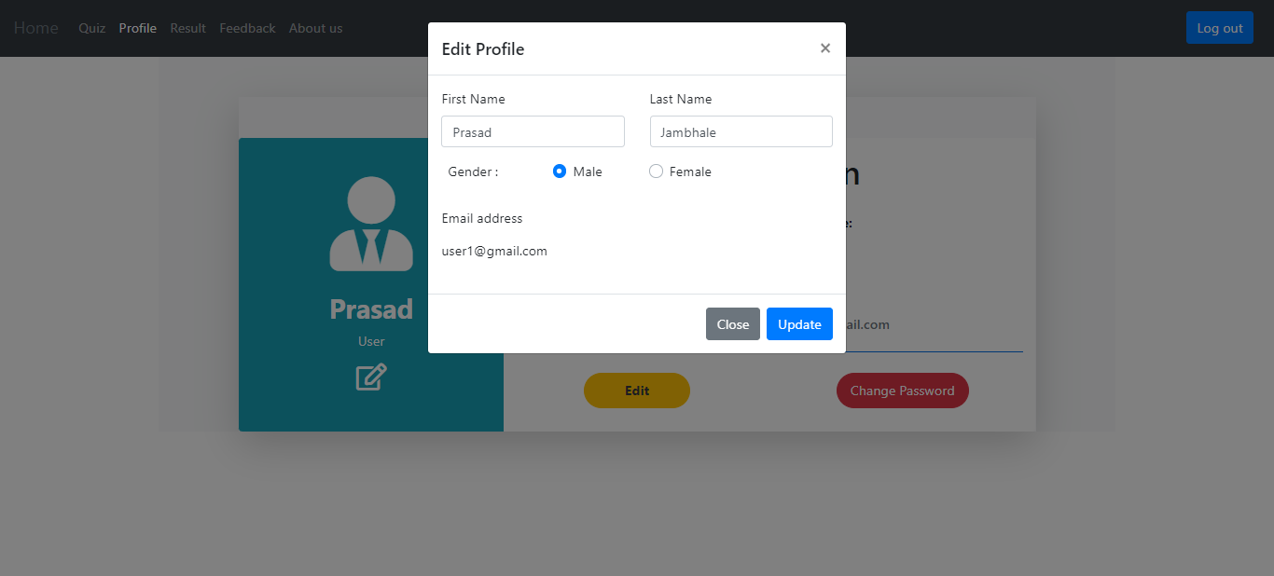

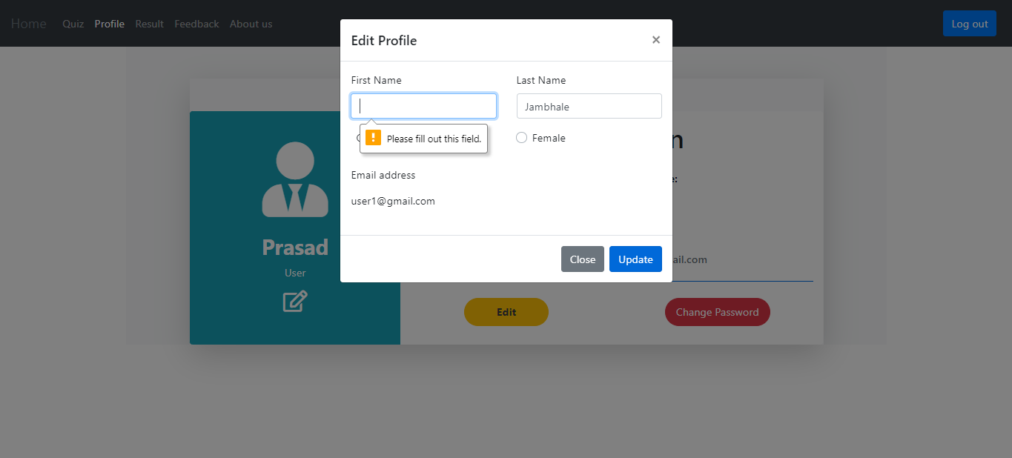

When this web application project was sold to customer one of the major flaws which was found was name updation of user in userprofile page.

In which whenever any user visits userprofile page user try to update their name with blank space only without including any character, the error messages display that “Please fill out this field”.

### 5.4 Test Cases:

### 5.4.1 Admin Login:

|  |  |  |  |  |  |  |  |
| --- | --- | --- | --- | --- | --- | --- | --- |
| **Sr. No.** | **Test Case ID** | **Test Case Name** | **Test Case Description** | **Steps** | **Expected Result** | **Actual Result** | **Test Case Status** |
| 1 | TC001 | Validate Admin | Correct username, correct password | Enter the username and password and click login button | Successful login | Successful login | Pass |
| 2 | TC002 | Validate Admin | Correct username, incorrect password | Enter the username and password and click login button | Error message | Message: Invalid Username or Password. | Pass |
| 3 | TC003 | Validate Admin | Incorrect username, correct password | Enter the username and password and click login button | Error message | Message: Invalid Username or Password. | Pass |
| 4 | TC004 | Validate Admin | Incorrect username, incorrect password | Enter the username and password and click login button | Error message | Message: Invalid Username or Password. | Pass |

### 5.4.2 Adding New Quiz Category:

|  |  |  |  |  |  |  |  |
| --- | --- | --- | --- | --- | --- | --- | --- |
| **Sr. No.** | **Test Case ID** | **Test Case Name** | **Test Case Description** | **Steps** | **Expected Result** | **Actual Result** | **Test Case Status** |
| 1 | TC005 | Add Category | New Category | Enter the category and click submit button | No error message | Category added successfully | Pass |
| 2 | TC006 | Empty Category | Empty Category | click submit button | Error message | Please fill out this field | Pass |

### 5.4.3 User Login:

|  |  |  |  |  |  |  |  |
| --- | --- | --- | --- | --- | --- | --- | --- |
| **Sr. No.** | **Test Case ID** | **Test Case Name** | **Test Case Description** | **Steps** | **Expected Result** | **Actual Result** | **Test Case Status** |
| 1 | TC07 | Validate User | Correct email, correct password | Enter the email and password and click login button | Successful login | Successful login | Pass |
| 2 | TC08 | Validate User | Correct email, incorrect password | Enter the email and password and click login button | Error message | Message: Invalid Credentials | Pass |
| 3 | TC09 | Validate User | Incorrect email, correct password | Enter the email and password and click login button | Error message | Message: User not found | Pass |
| 4 | TC10 | Validate User | Incorrect email, incorrect password | Enter the email and password and click login button | Error message | Message: User not found | Pass |

**Chapter 6**

**Results and Discussions**

1. **Welcome.php**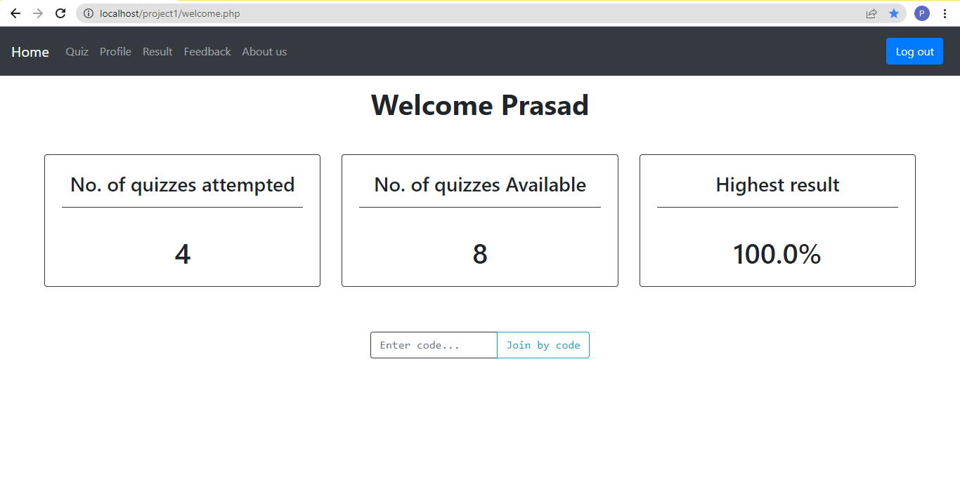

After login successfully, user redirected to welcome page. In this page user can see no of quizzes he/she attempted, no. of quizzes available, highest result of all attempted quizzes. Below user can attempt quiz by entering quiz code.

1. **Userquiz.php**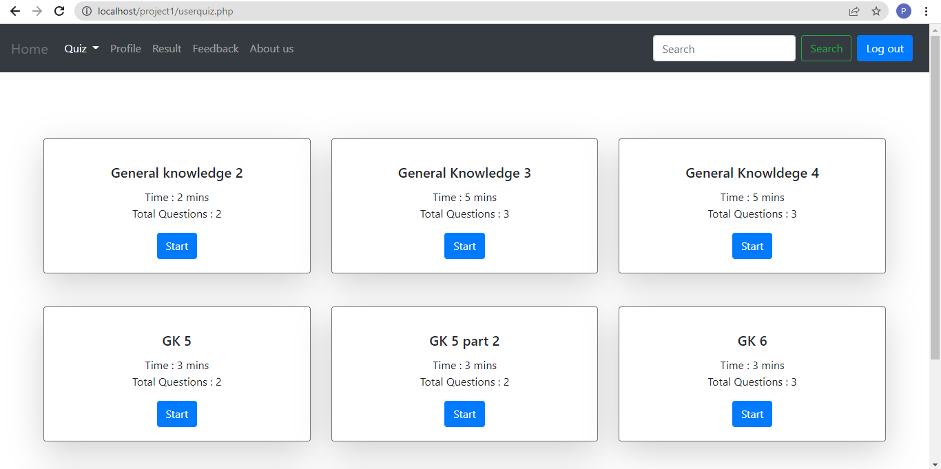

On this page, user can see all available quizzes , select category for quizzes and user can attempt quiz by clicking start button.

1. **Userprofile.php**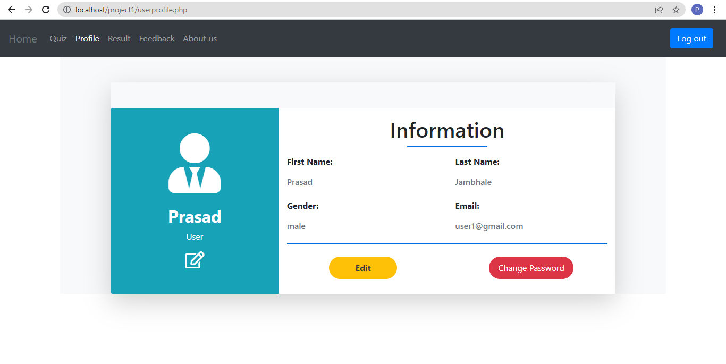

On profile page, user can see his/her profile. User can edit his details by clicking edit button. User password can be changed by using change password button.

1. **Userresult.php**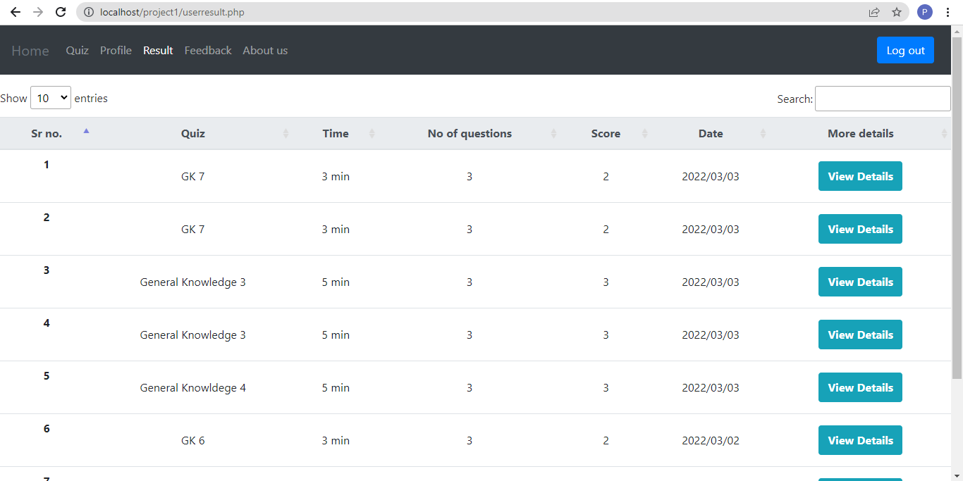

On result page, user can see all previous attempted quizzes, score. For more details, click view details, to see date, score, attempted questions, etc