**APIM**

1. Create API Management service from Market Place
2. After that click on APIs 🡪 APIs 🡪 create from definition (Open API) 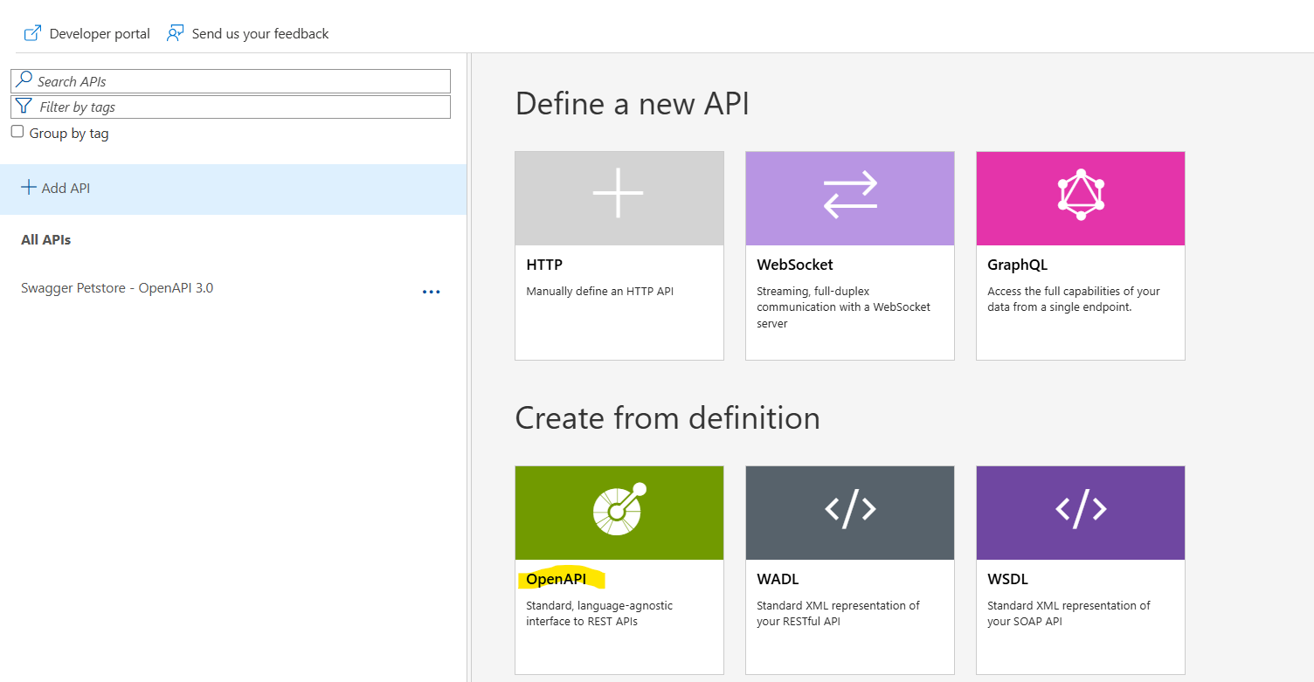
3. Select URL (json) file and the suffix for the api in frontend and create the API. Basically this will bring that API in our APIM. 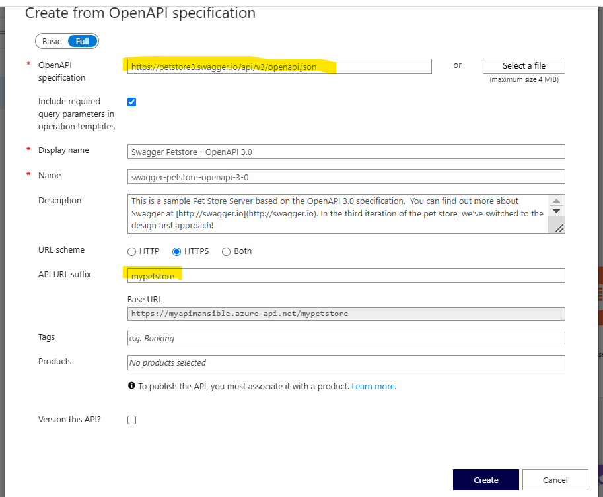
4. After that create a product and add that API in that product. Publish it.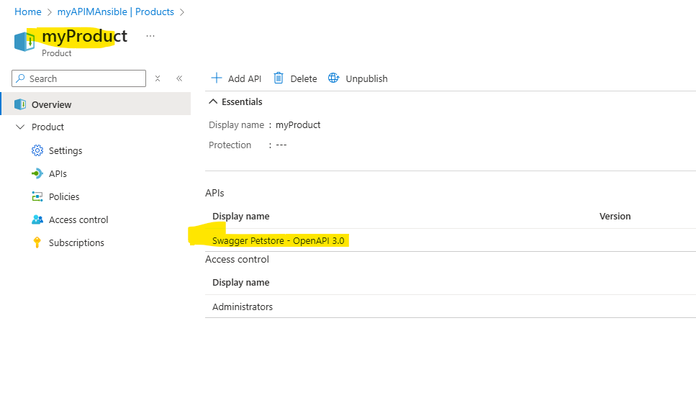
5. Once the product is published, check below options so that the users would be able to subscribe it through developer portal. Once you make all these below changes, publish the portal.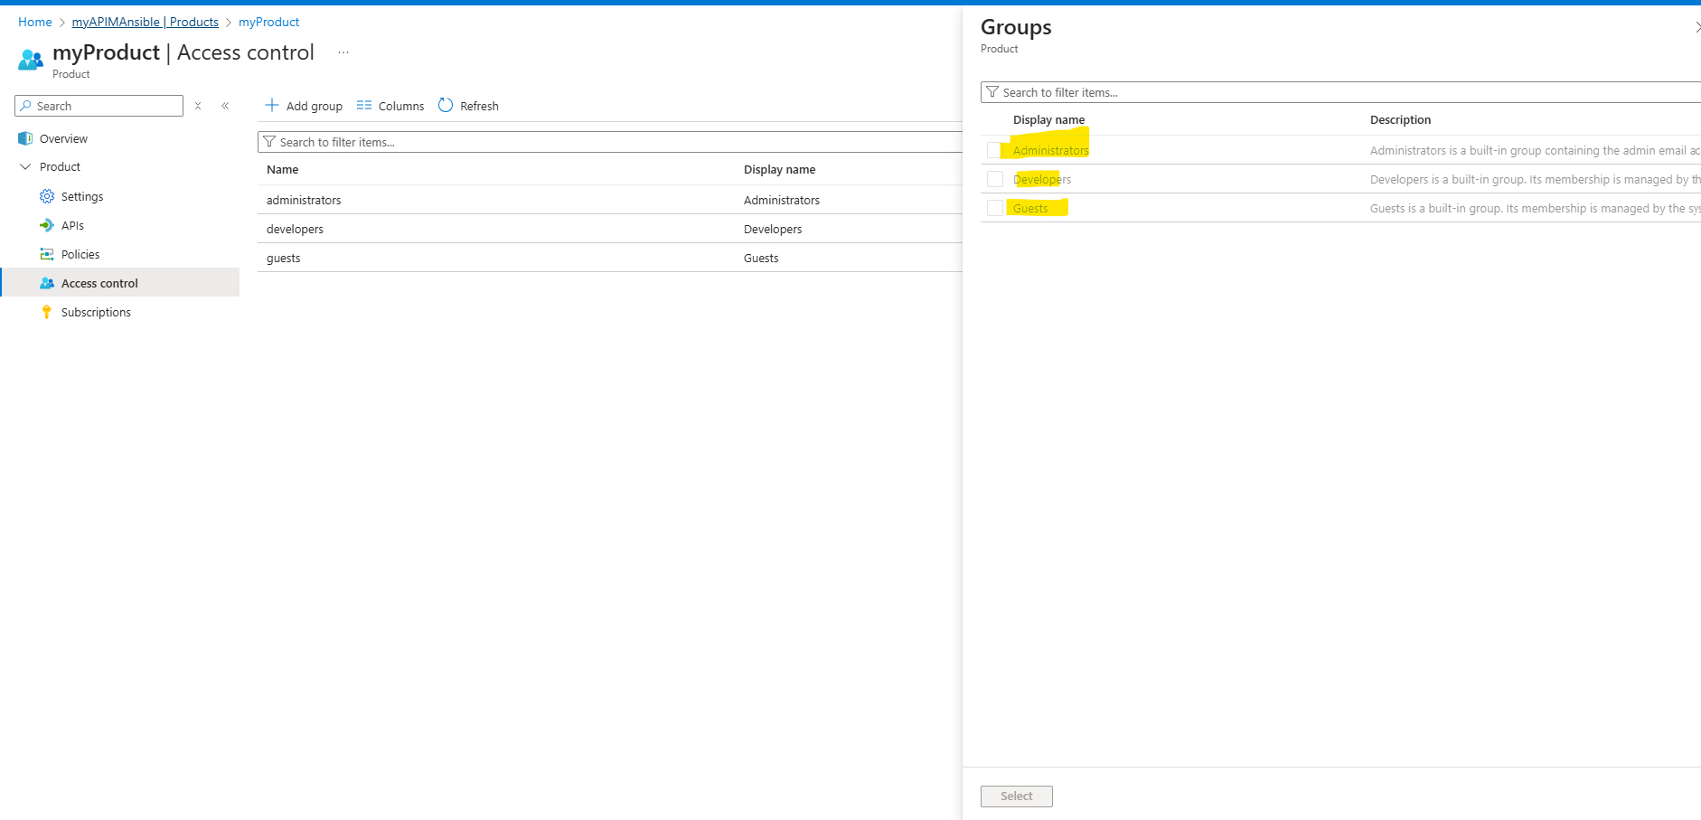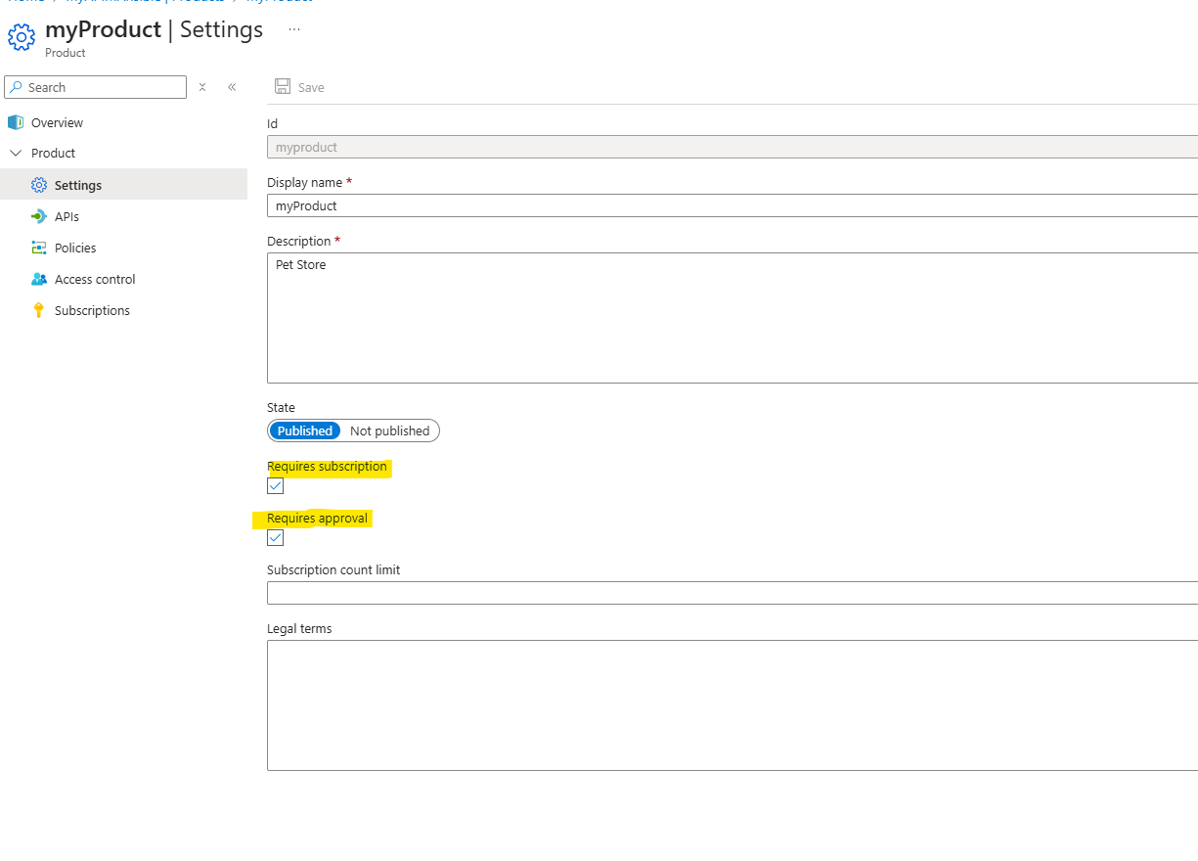

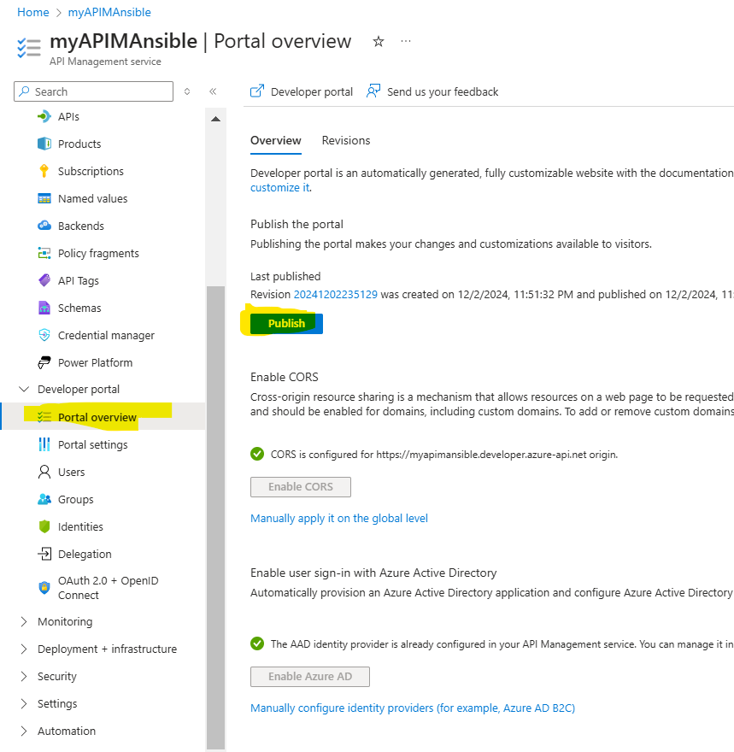

1. Access the portal using this link in overview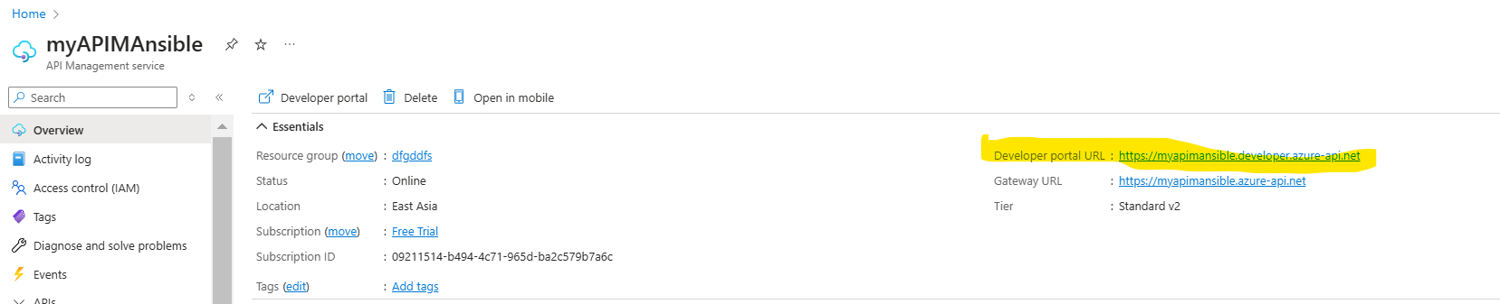
2. Once the Product is visible you can see and subscribe the product in developer portal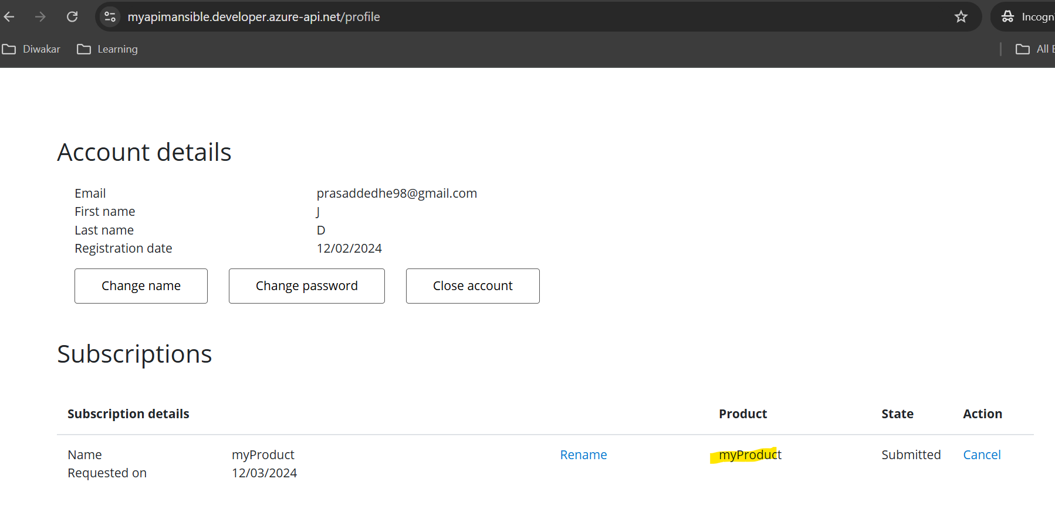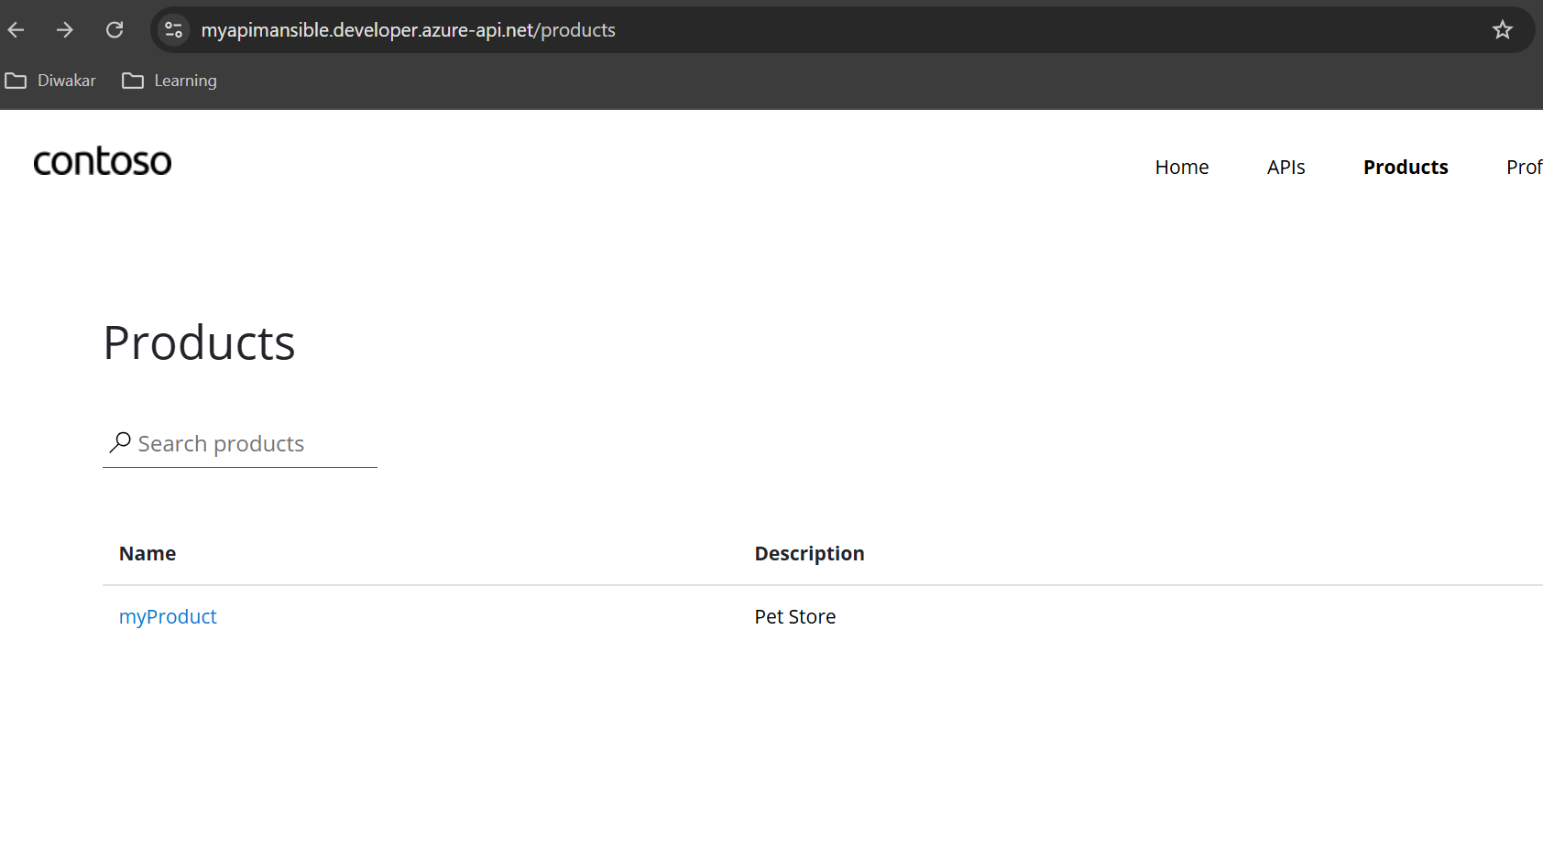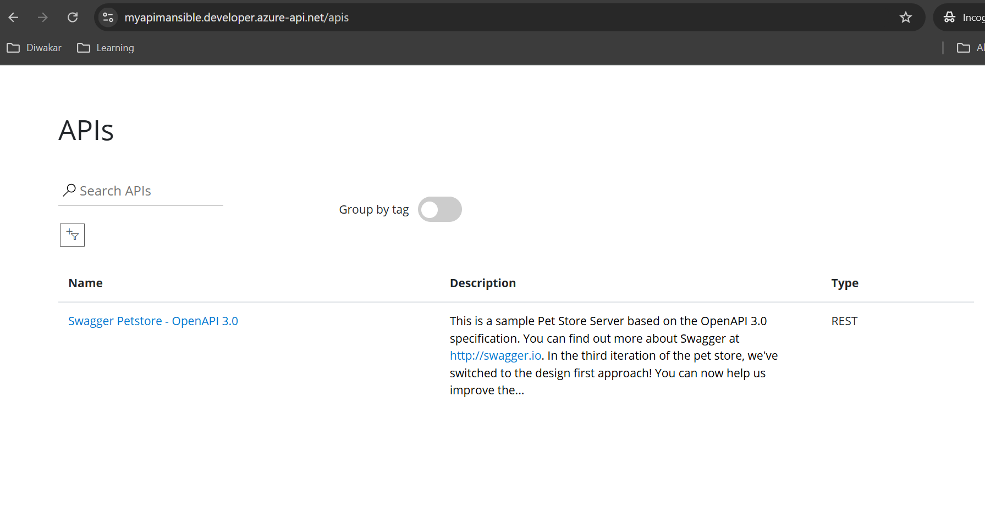
3. The request then can be approved from azure portal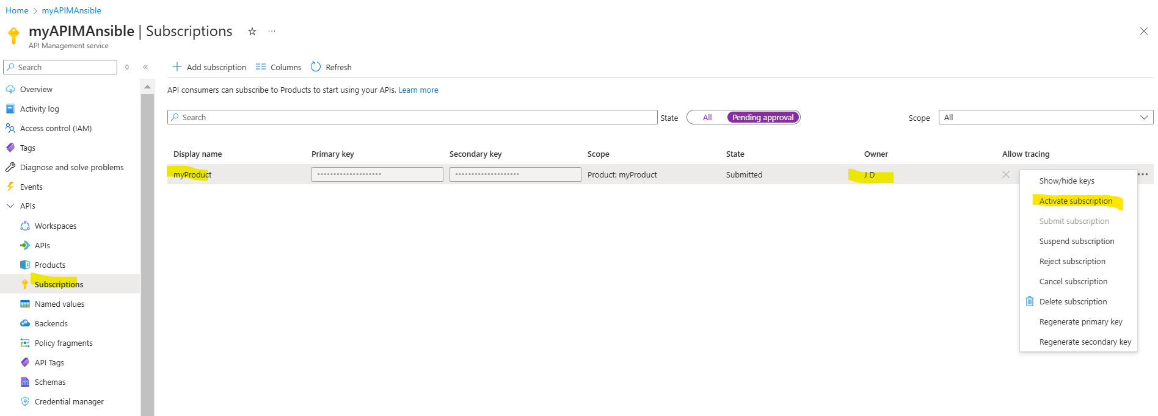
4. Once activated then you can see the APIs and the key in portal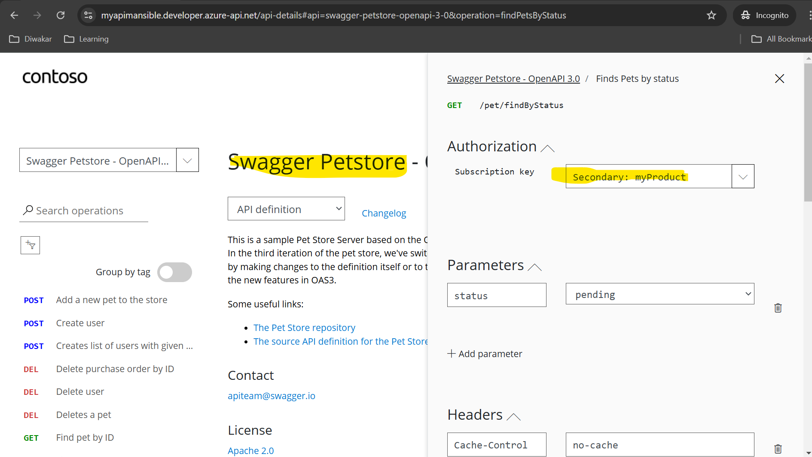
5. There are many things to be explored in API Management, like below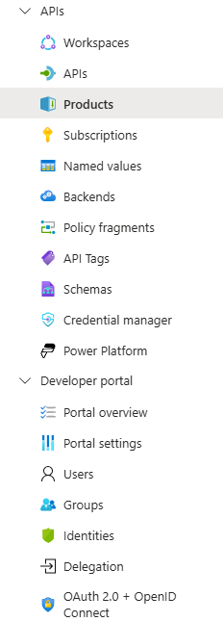
6. The Front End means how API M handles the request. The Inbound Processing means is there any changes required before passing the request to the backend, which is the original API. 