**Azure VPN (point to site)**

1. Create a function app (ASP based). Check if it is up or not. It should be up and running.
2. Create a Vnet
3. Associate the Vnet in Function App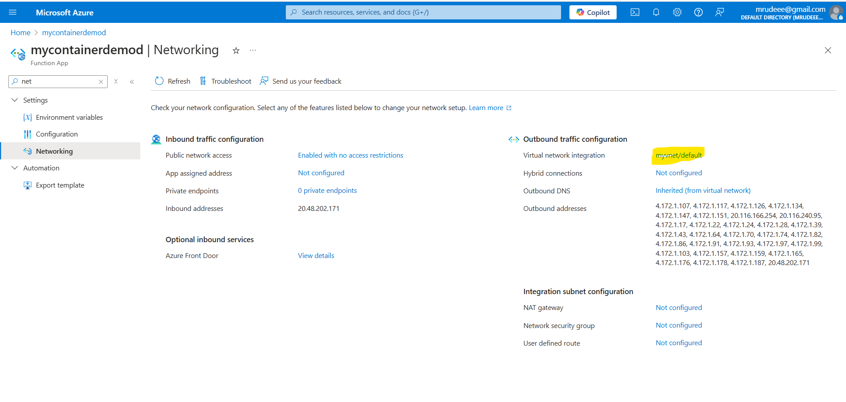
4. Change network settings of Function App to only allow traffic from the Vnet. 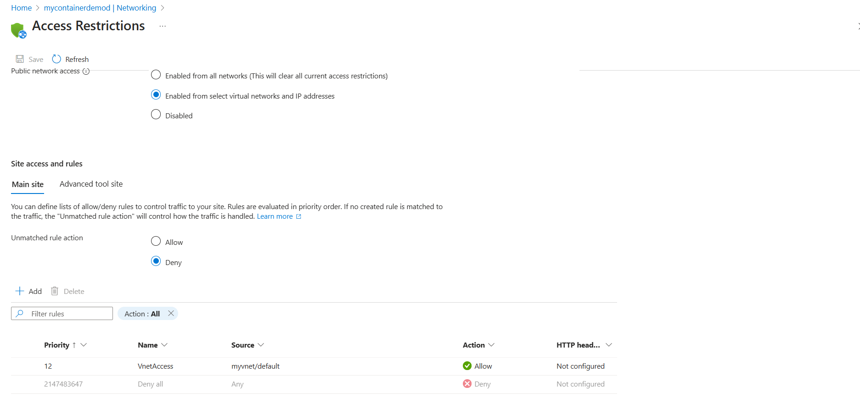
5. Once you do that the app will become unavailable from your machine. As it will be only accessible from the Vnet. 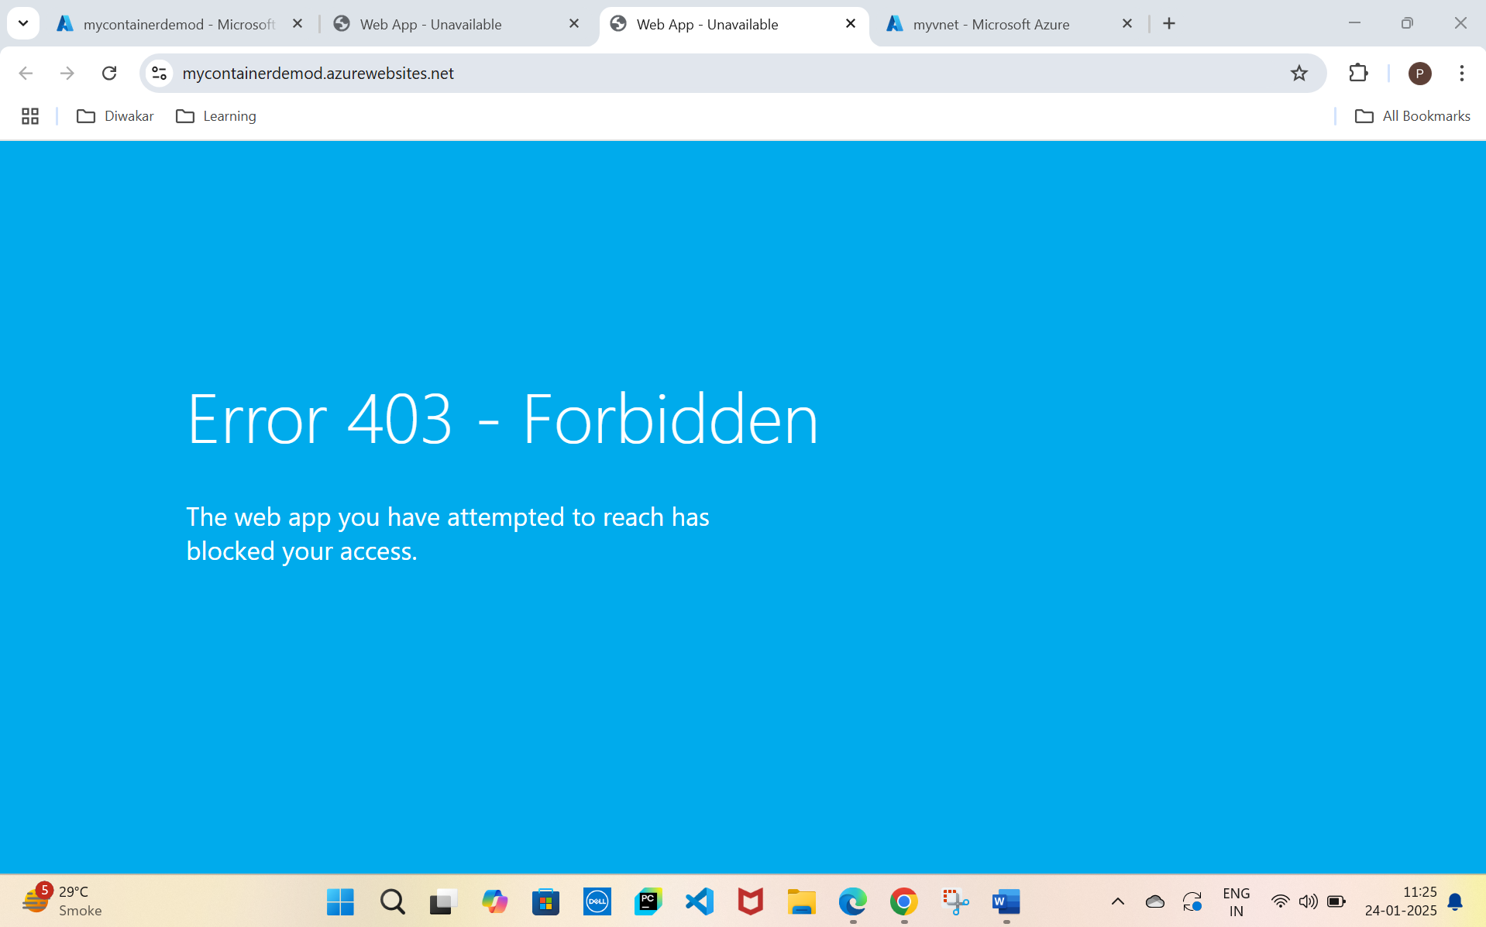
6. Now, before creating a VPN, we need to setup Virtual Network Gateway subnet in the Vnet. Create one in the Vnet. 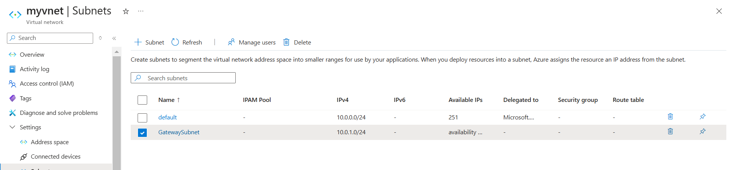
7. Now create a Virtual Network Gateway which will utilise this subnet. You can create it directly from the portal. It takes 30 mins to deploy. So relax!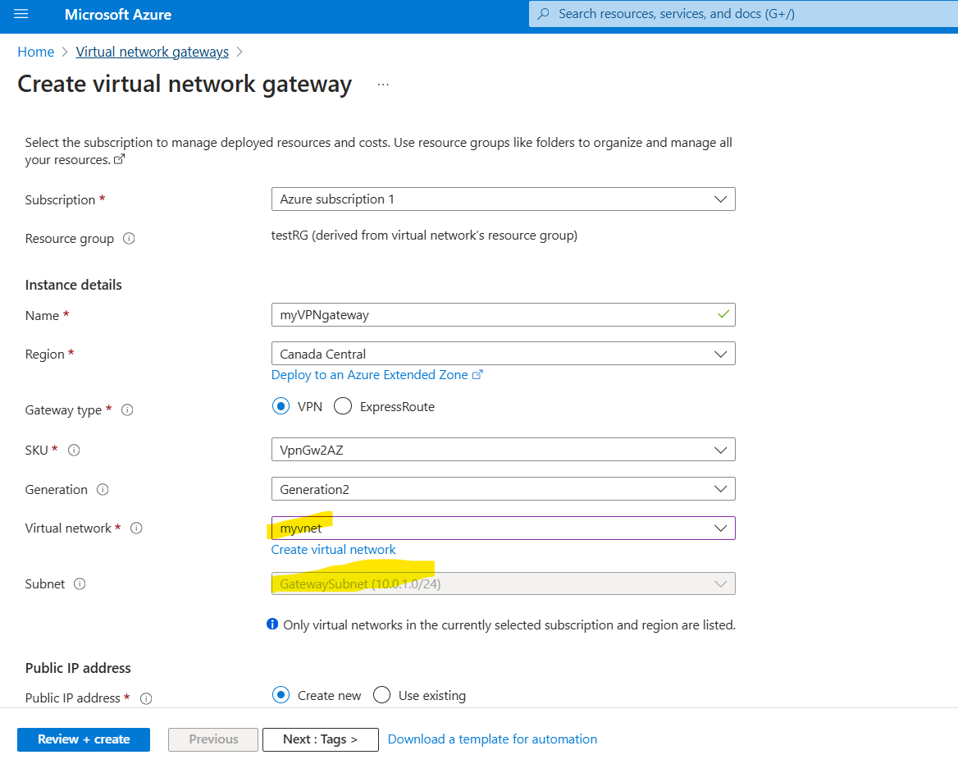
8. Now, we need to create a certificate in our machine, so that we can upload it in the Virtual Network Gateway. Why this certificate is needed? Simply for authentication. There would be two certificates we would generate
   1. Root certificate -> Lock -> Stored in VNG
   2. Client certificate -> Key -> Stored in your machine
9. Power shell commands for generating certs,
   1. Root -> 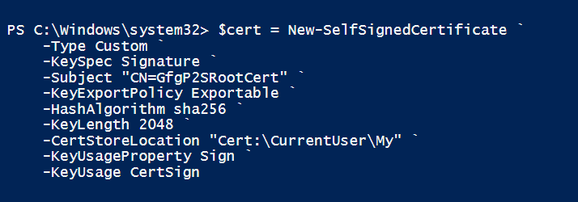
   2. Client ->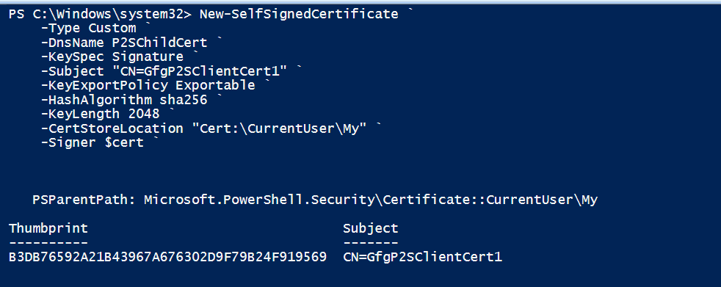
10. Now you can see these two certificates generated in the certificates manager. 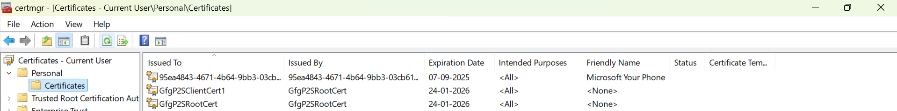
11. Right-click the certificates and select “All tasks” and then select Export. A certificate export wizard will pop up. Use the “Base-64 encoded X.509” file format for the root certificate and keep other details as default. For the client certificate, select the option “Yes, export the private key” and “Personal Information Exchange – PKCS” file format with the first and last option selected. You can now see the exported certificates. 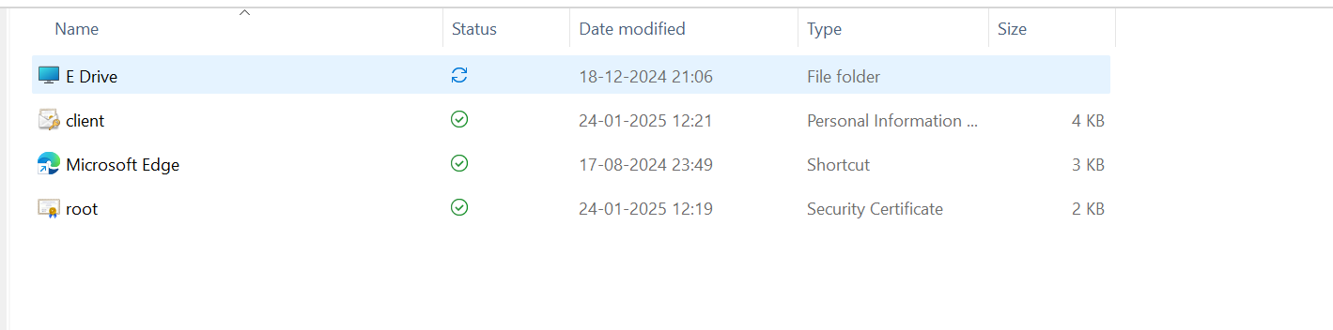
12. Now upload the root cert data (DO NOT INCLUDE the line Begining of the cert and End of the cert, in the VNG. Make sure there are no spaces). The ip mentioned, you can put the same. This ip is nothing but VGN’s asking you if you want any ip to exclude, to prevent overlapping.

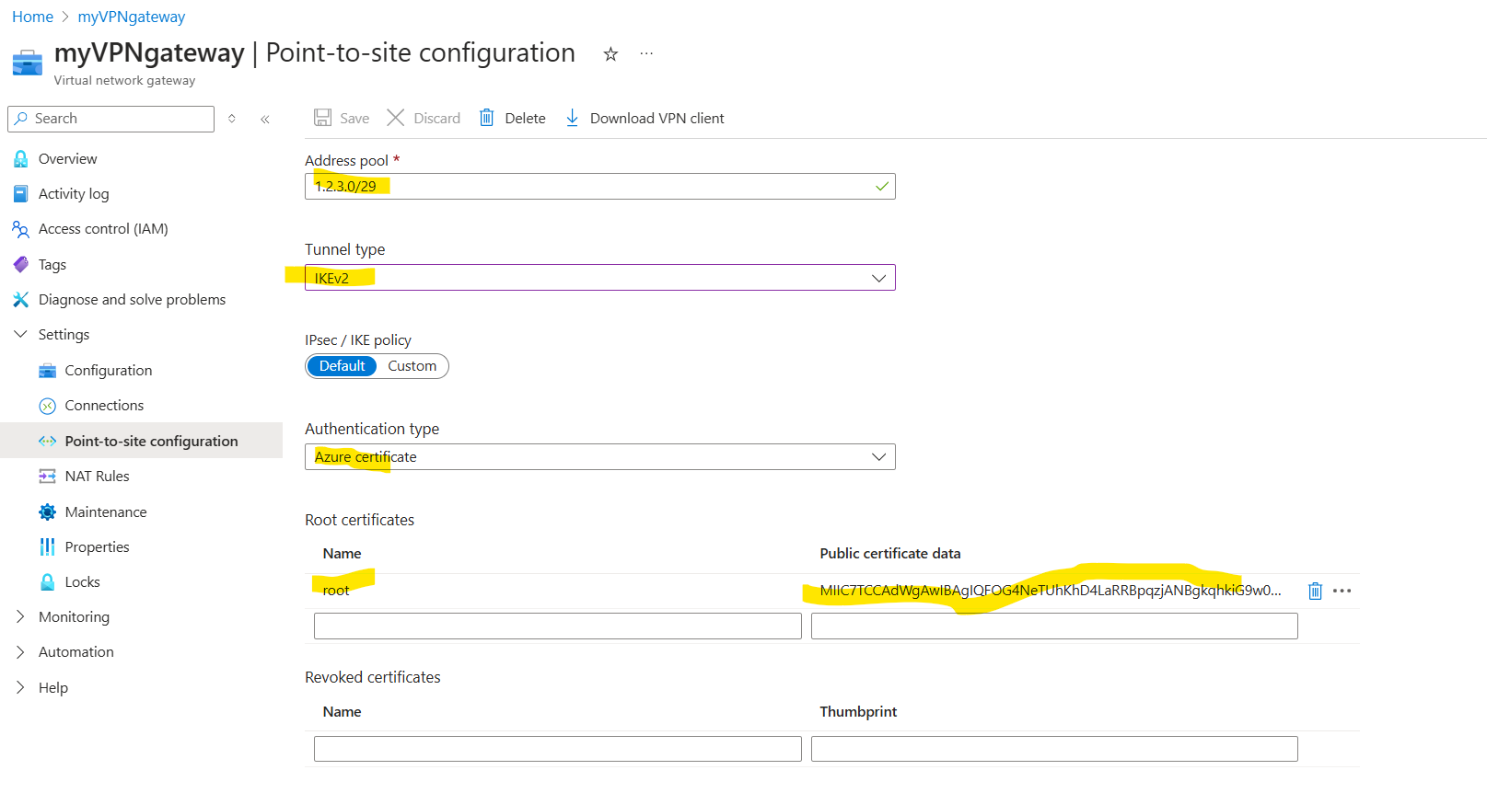

1. Once saved, click on download the VPN client. And install it in your computer. Then unzip it, select windowsAMD64. Run it as admin. 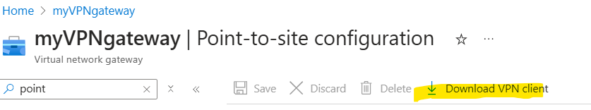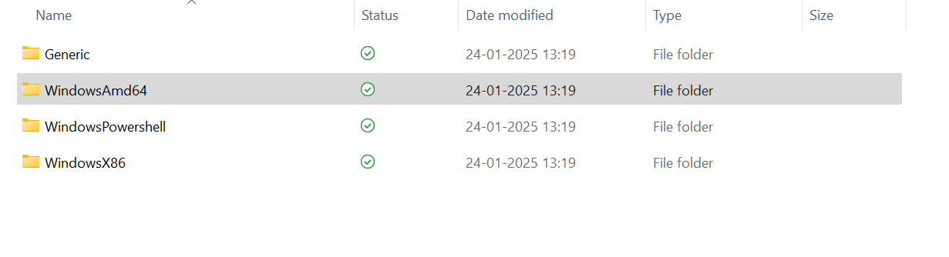
2. Once you run it, go in VPN in search bar and click connect and the VPN will be connected. 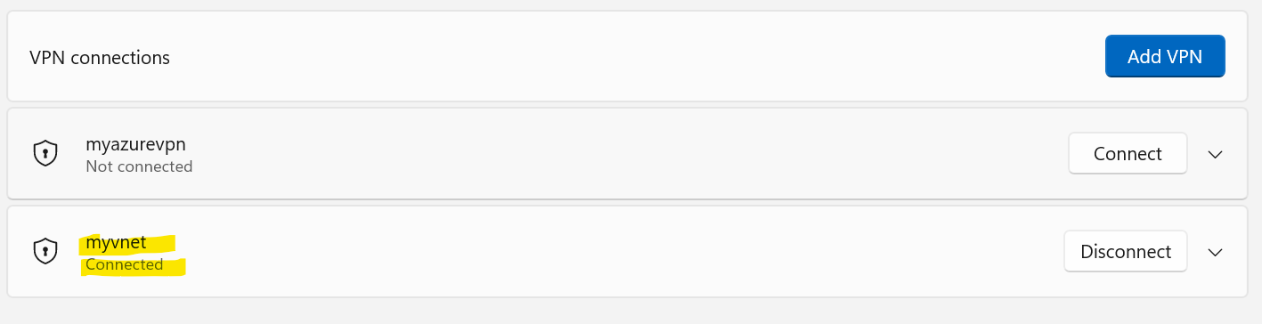
3. Add the Gateway subnet in function app. 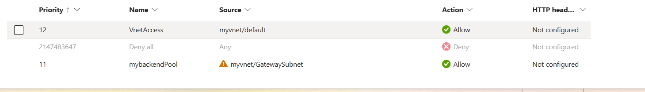
4. Now you can see the function app loading again!!!