**DATALAKE**

1. First create a storage account and while creating **uncheck** the soft delete option for each (blob, table, file, queue), else there would be error while upgrading to the data lake.
2. Now search data lake and click on upgrade. It will take almost 15-20 minutes to upgrade. 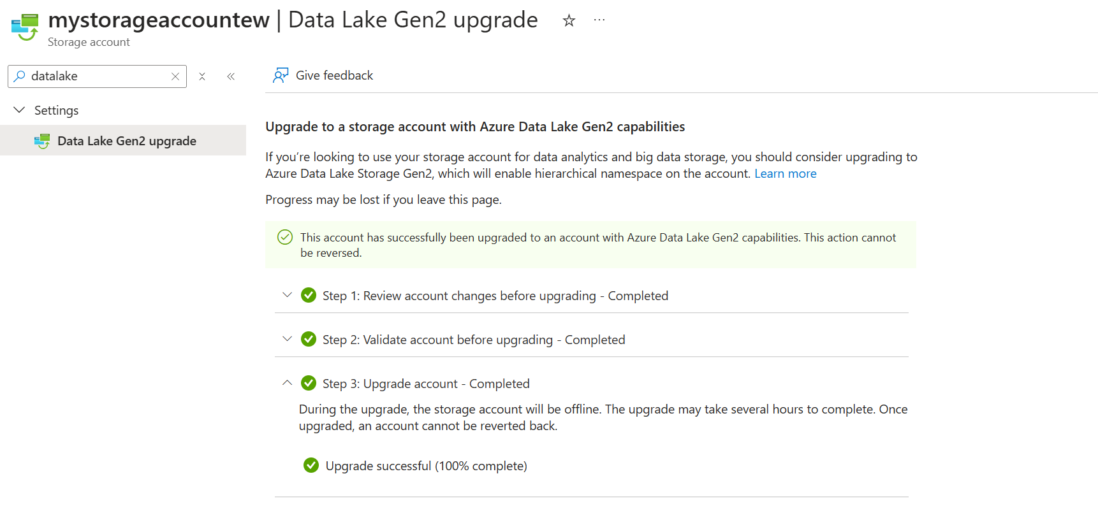
3. How is datalake different than storaeaccount? Because in datalake you can create directories. The below option only comes after you upgrade the storage account to a data lake, else it does not come. 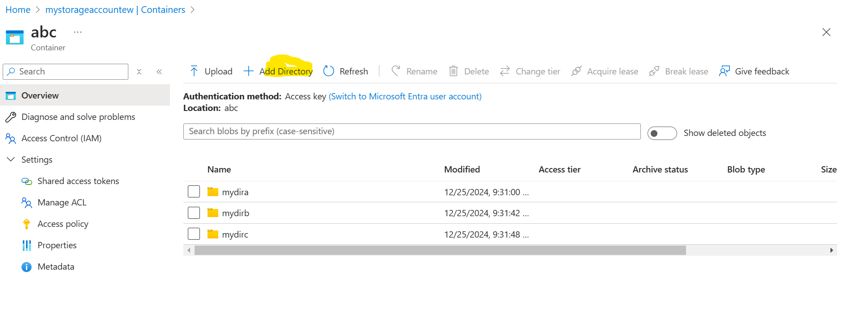
4. Also, you can fine grain directory based access to data lake for users/service principals, which you cannot give to storage account, using ACL. 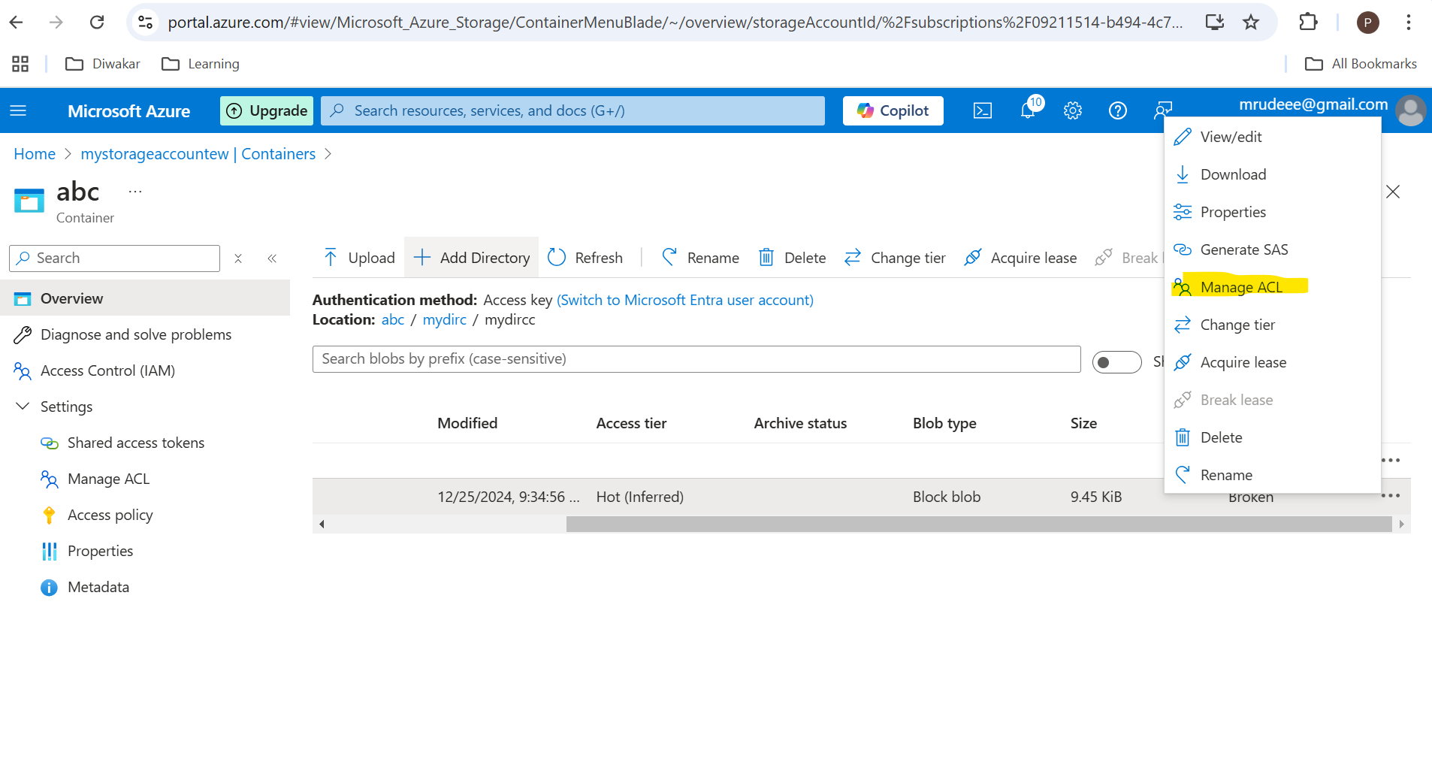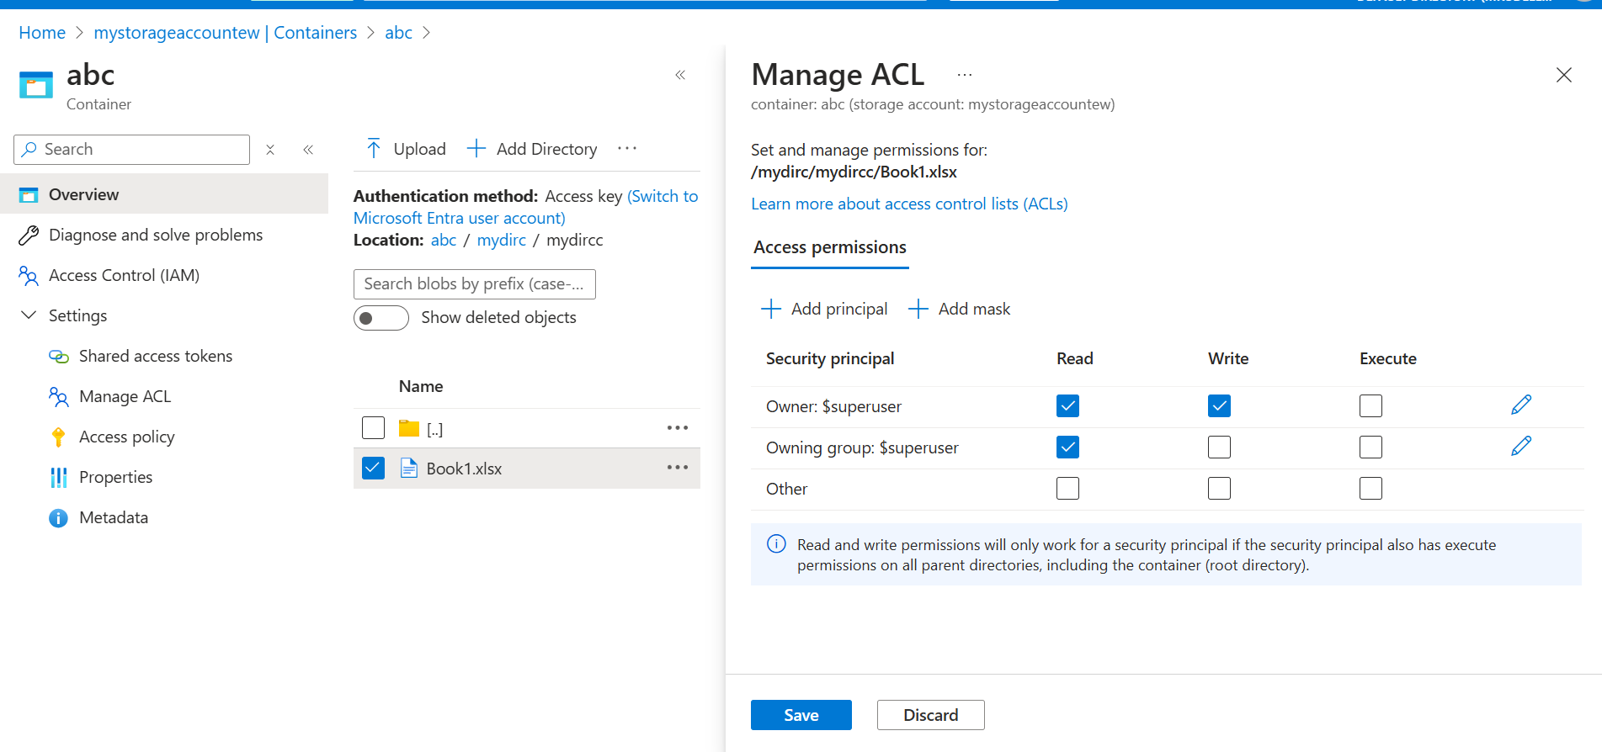
5. Also, in ADF, there is special provision for Data Lake when you create a linked service.
6. 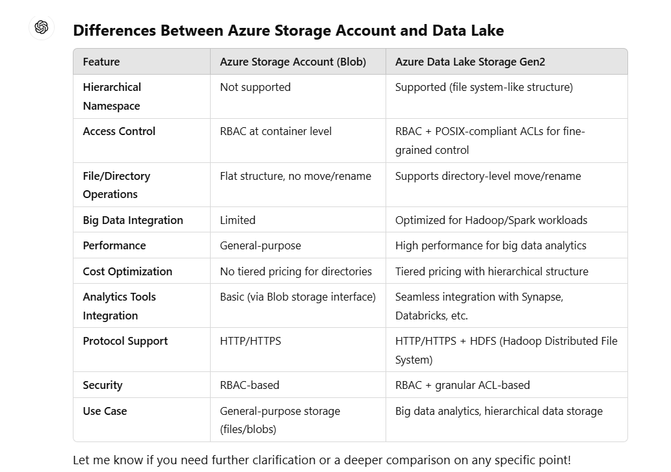Below is the list of the differences between Storage Account & Data Lake.