**Processes**

1. Ps aux 🡪 List all the process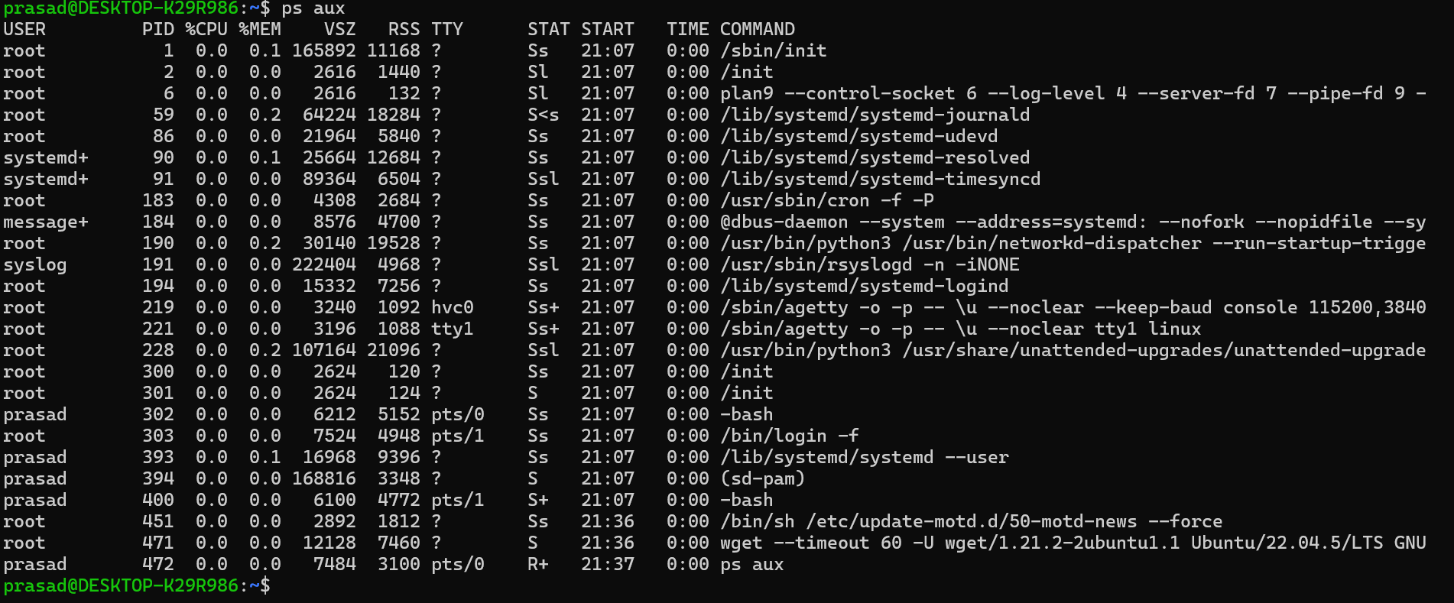
2. Command param & (sleep 3000 &)🡪 to start a process which will run in background. If you don’t put the & then the process will run in front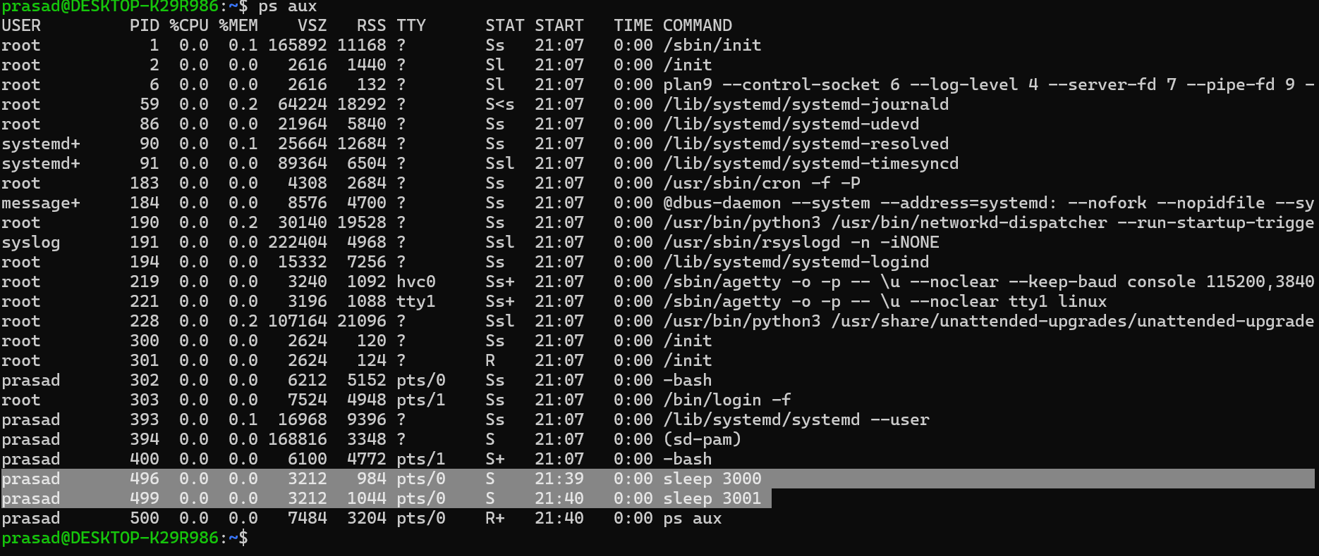
3. Jobs command will tell you the process which are running in background. 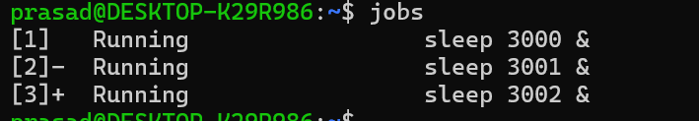
4. As said earlier, if you don’t write & then it will run it foreground. To stop it press crtl+z and then run bg. 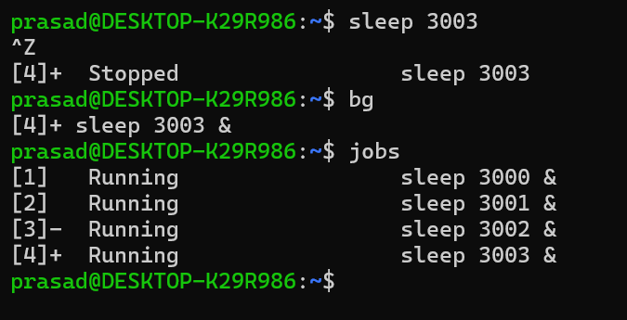
5. To bring a process to front, just command fg. 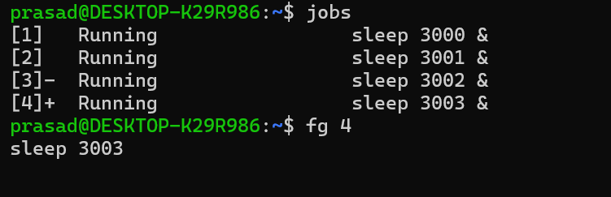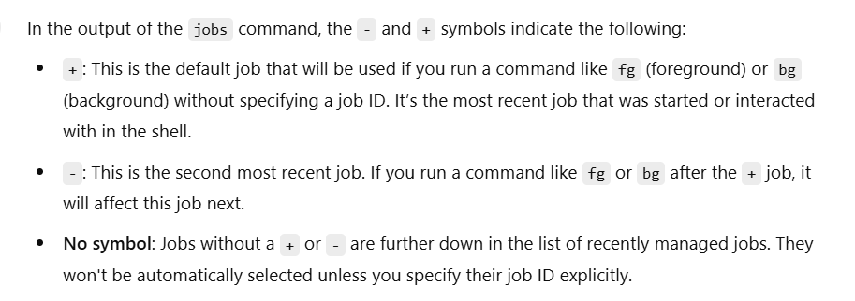
6. Kill -9 <pid> 🡪 To kill a process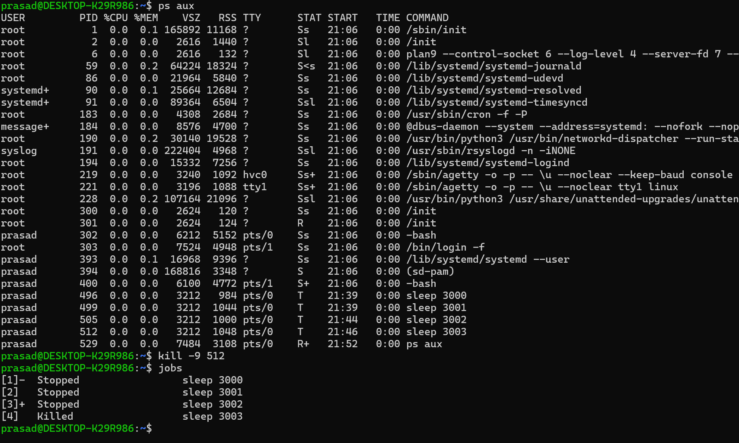
7. Some addition helpful pointers