**SOP – How to correctly push Docker image in Container Registry**

1. Most of the times we get error while pushing the image to CR. Its mostly because wrong tagging syntax.
2. But first of all lets understand why do we even require to tag the image, why can’t we simply push the image? What is a tag actually? How does a CR stores the images? And what is the correct way to handle/manage the repos in CR?
3. **But first of all lets understand why do we even require to tag the image, why can’t we simply push the image?** 🡪 Docker requires you to tag an image as it won’t know which host/namespace/repo the image needs to be pushed. Hence you need first to tag it & then only you can push it
4. **What is a tag actually?** 🡪 Tagging an image does NOT actually do anything to an image. When you tag an image it creates a **reference** (like a pointer) that image. You can see the below image. The ID will remain same for that tag and the actual image. 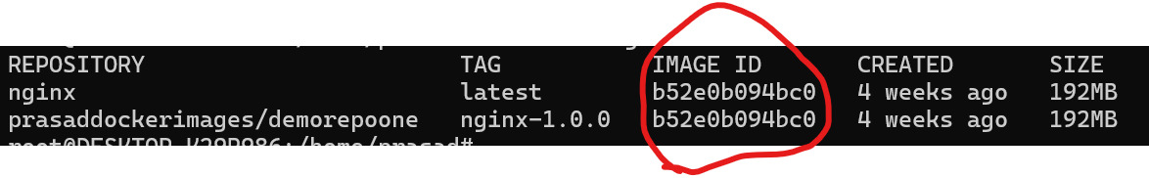
5. **How does a CR stores the images?** 🡪 A CR will store the tags one after another. You can put multiple images and its tag in one repo or you can keep one image and its tag in one repo. Note, a CR doesn’t store the name of the image. You need to explicitly give images name in the tag along with the version (like nginx-1.0.0)
6. **And what is the correct way to handle/manage the repos in CR?** 🡪 The right way to maintain images is you create one repo for each image. Why? Because then you would know that all the tags in that repo belongs to that particular image. Also, while generating the vulnerability report you would easily know which image actually has them.
7. Now lets understand how tagging actually works
8. First you need to log in inside docker
   1. Docker login -u <username> -p <password>
9. Now as per the official documentation of docker, tagging an image has following parameters
   1. HOST
   2. PORT
   3. NAMESPACE
   4. REPONAME
   5. TAG INFO
10. Host is if your CR is hosted other on Other than docker.io you have to mention it
11. Port if your CR is available on any other port than 443 then you have to mention Port
12. Namespace if is other than “Primary” then you have to mention it.
13. Repo name is mandatory
14. Tag info is mandatory
15. The standard format to tag an image is like below:
    1. Docker tag <image> [Host:Port]/namespace/reponame:Tag
    2. For a complete example,
    3. Docker tag nginx myregion.io/prasadspace/myrepo:nginx-1.0.0
16. Now let’s push it. It’s extremely simple, just remove the tag <image> part and add push
    1. Docker push [Host:Port]/namespace/reponame:Tag

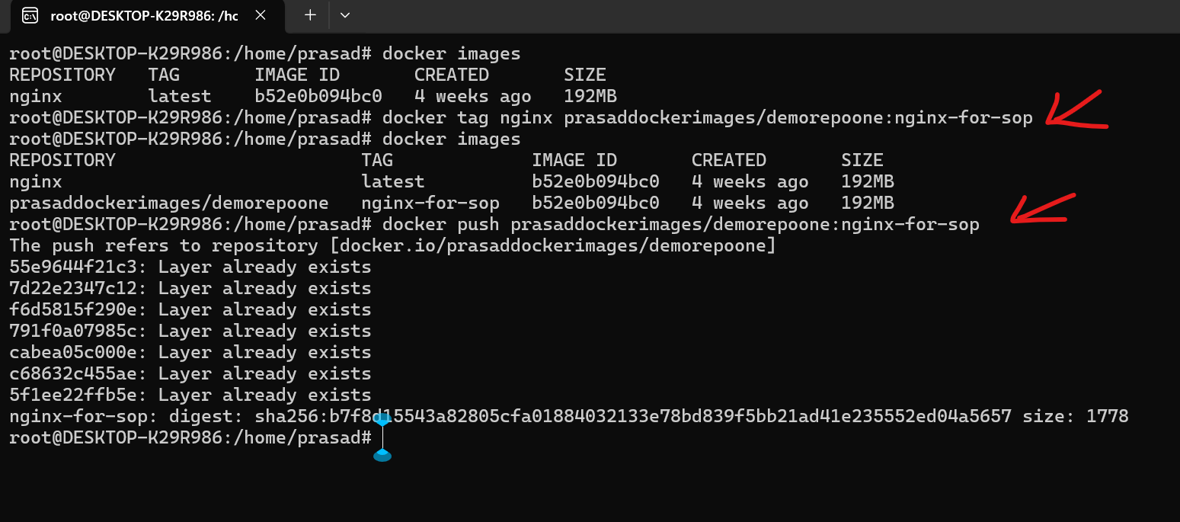

In the above image you can check that I have not mentioned Host or Post as both of them are docker.io and 443. I have given namespace, repo name and tag name. And see the push command is extremely similar to the tag command.

1. Now check the repo to see the tag pushed in the repo. 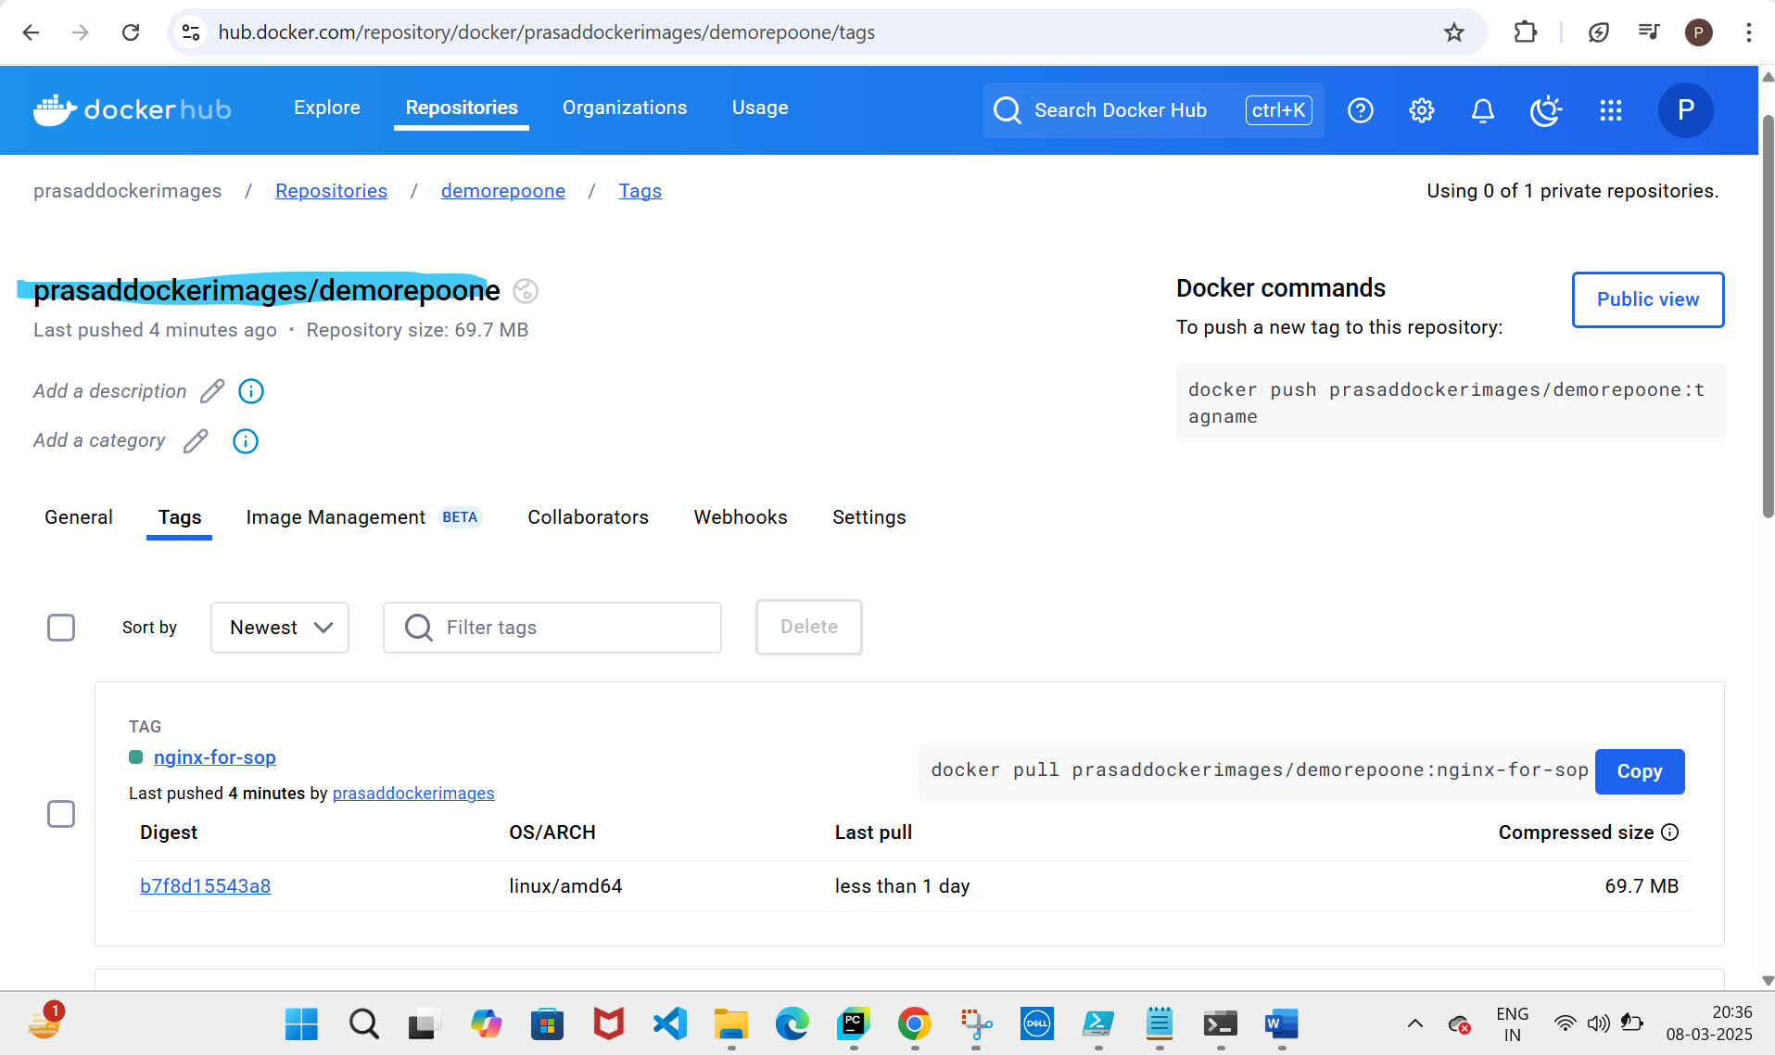
2. Also I made sure that by pushing images of different server like httpd in the same repo, and yes it works! 