**Create a self-signed certificate**

1. Connect to Linux Machine
2. Generally, it comes with openssl installed. Check version (command: openssl version)
3. Else install it
   1. sudo apt update
   2. sudo apt install openssl
4. In Ubuntu WSL, make sure in properties Copy/Paste is enabled, after that run below commands
5. Commands
   1. **openssl genpkey -algorithm RSA -out mykey.key -aes256** 🡪 Creates mykey.key
   2. **openssl req -new -key mykey.key -out myrequest.csr** 🡪 requests a csr based on key (Imp step because it asks you details like country, organization and other stuff)
   3. **openssl x509 -req -days 365 -in myrequest.csr -signkey mykey.key -out mycert.crt** 🡪 signs the CSR with key and generates cert
   4. **openssl x509 -noout -text -in mycert.crt** 🡪 Verify if cert is correct or not (Optional)
   5. copy the files to Desktop: **mv ./* /mnt/c/Users/Prasad Dedhe/Desktop** (and you would be able to see the cert, key and csr)

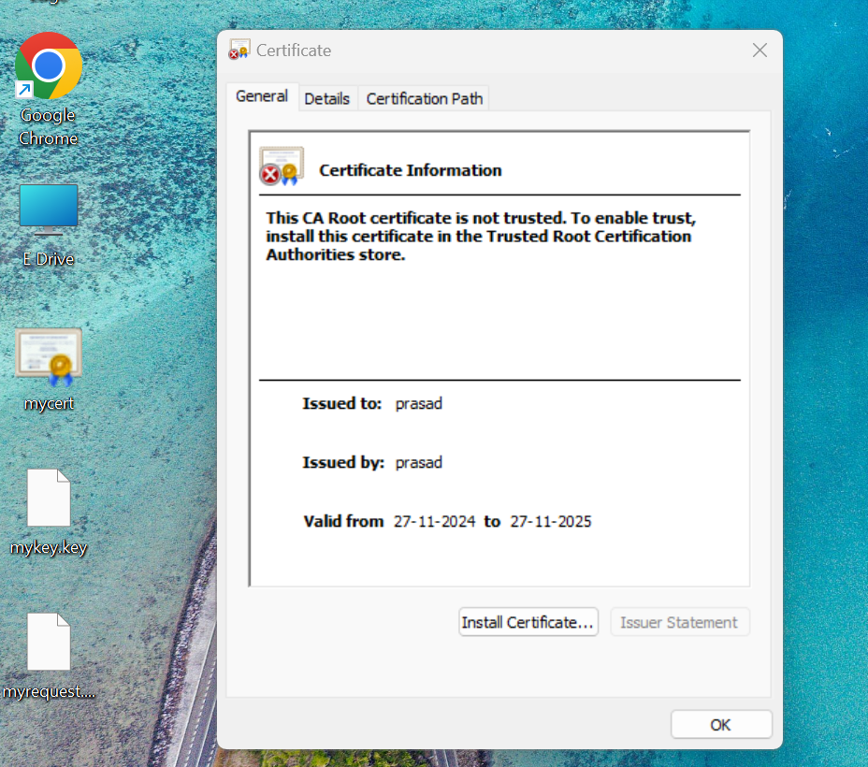

* 1. **openssl pkcs12 -export -out certificate.pfx -inkey mykey.key -in mycert.crt** 🡪 to generate pfx while which is required for binding in web apps