**App Gateway combined to Azure static webapp**

1. Static Web App in azure is created for hosting static web pages. Remember, VNET is not supported by static web app. Also, if you want to restrict the web app, then you need to create a Front Door or AG and create WAF for it.
2. Also, Web App requires automatic deployment only (from GitHub or Azure DevOps). So, for it to work, you need to have the directory connected in Azure DevOps, for that you need an owner access. 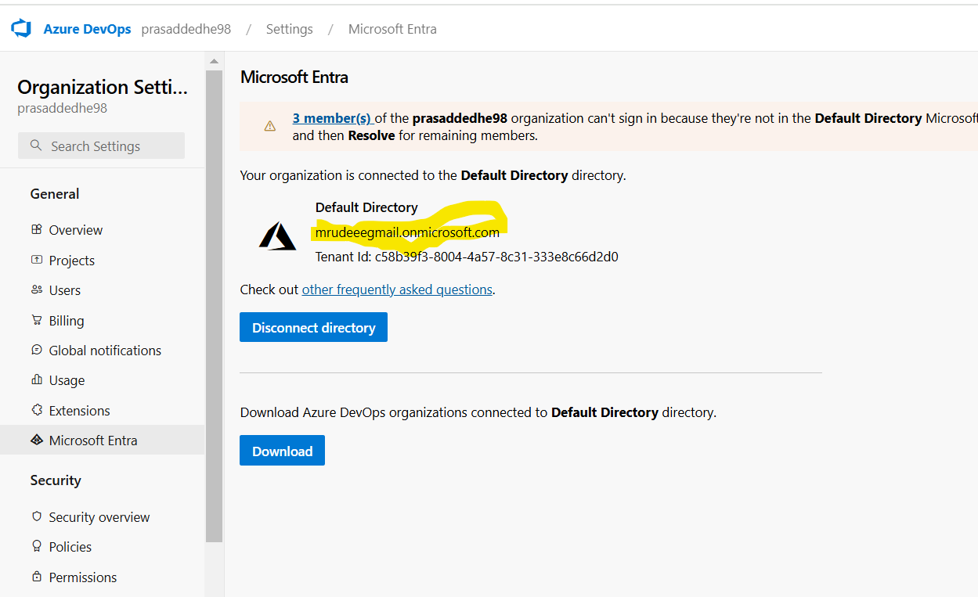
3. After that create the Static Web App from Azure Portal & while creating it will ask you which repo you want to dedicate to the static web app. 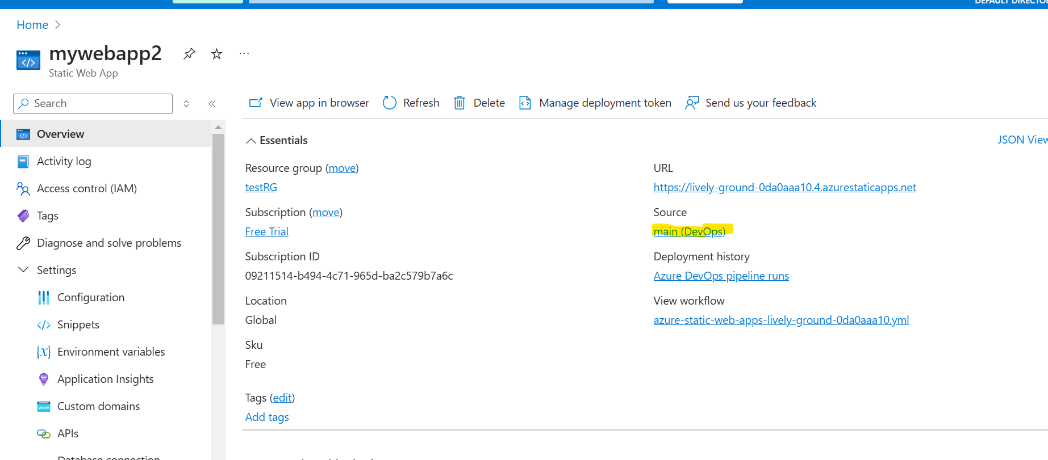4. Now, Azure will automatically create the workflow.yaml (the release yaml file) inside the repo. You need to add the production_branch: ‘main’ in that file, so when you create another branch, Azure will automatically create another environment (like stage, dev, QA). 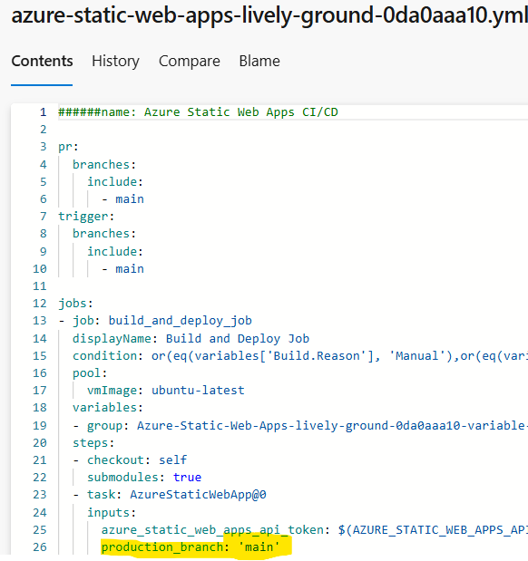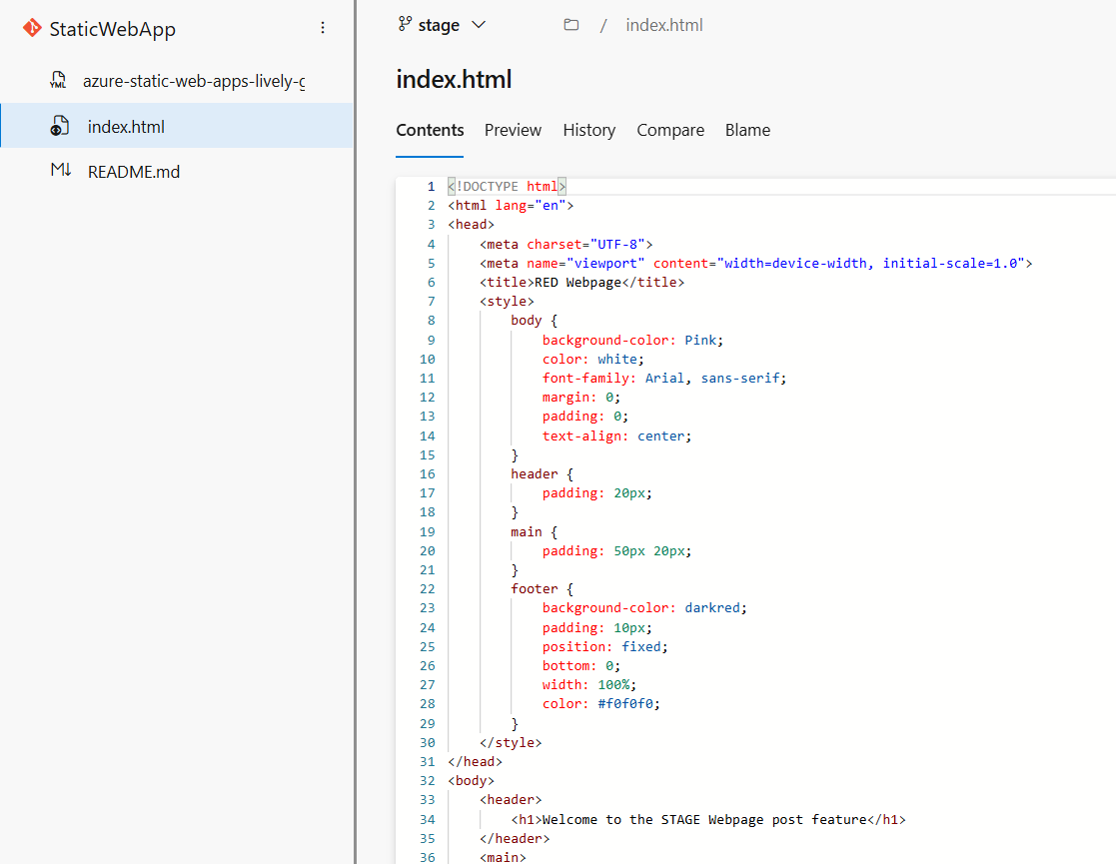
4. Now remember that in each environment you need to add this yaml file. 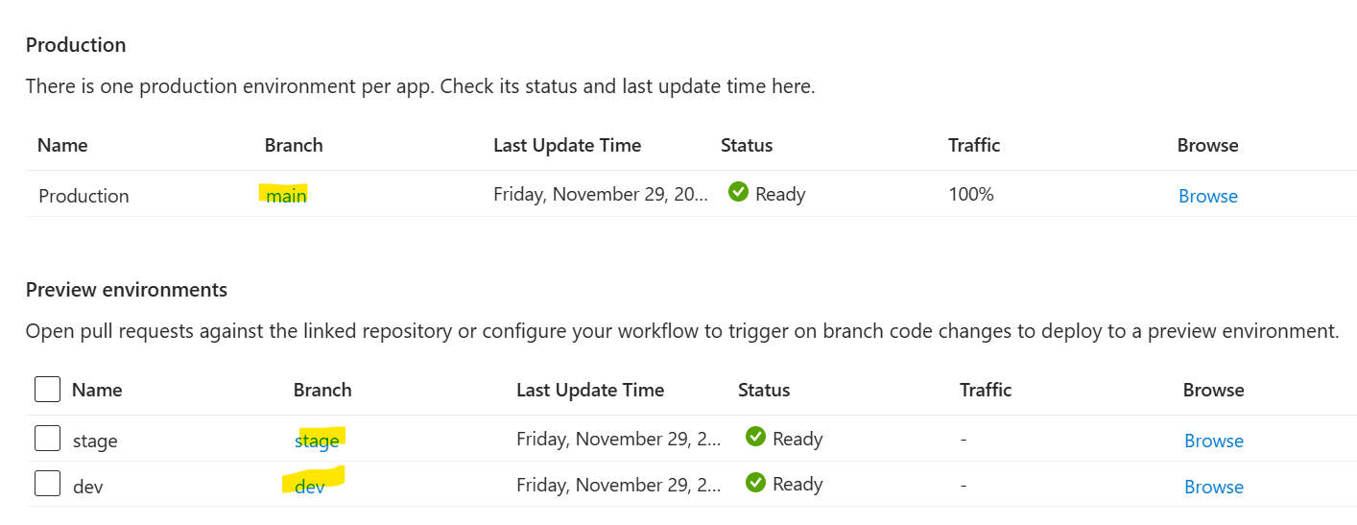
5. You can add snippets, like if you want to add some miscellaneous code in between, you can add in snippets. 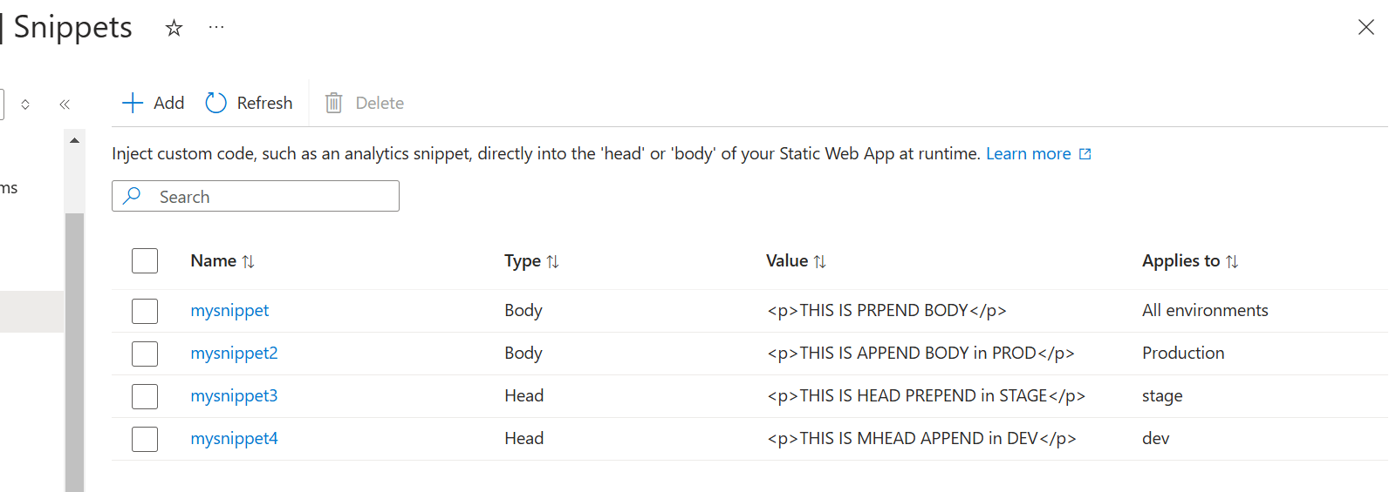
6. See all environments have different URLs and UIs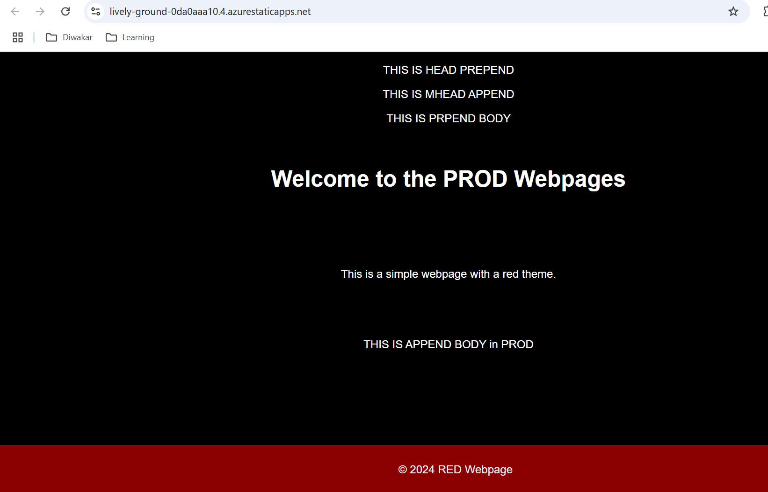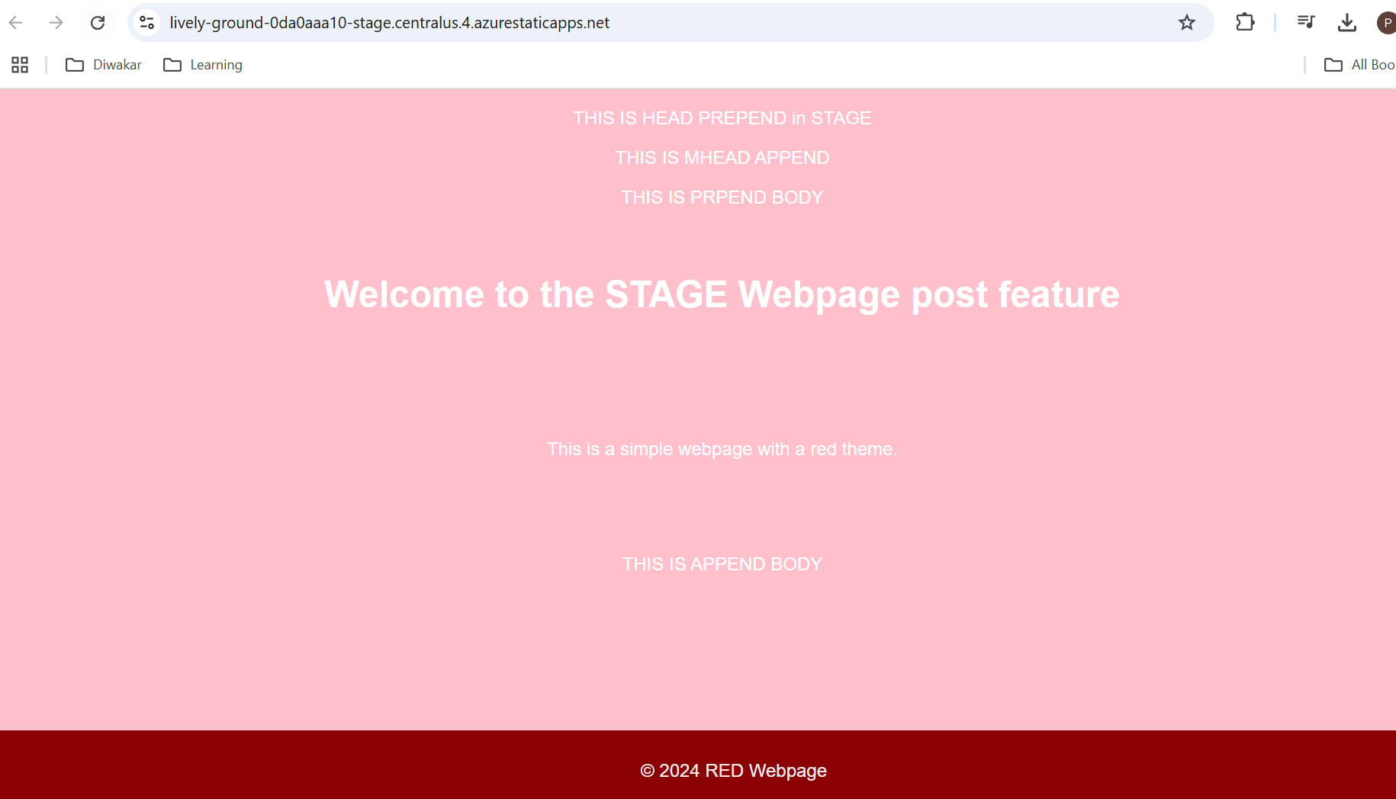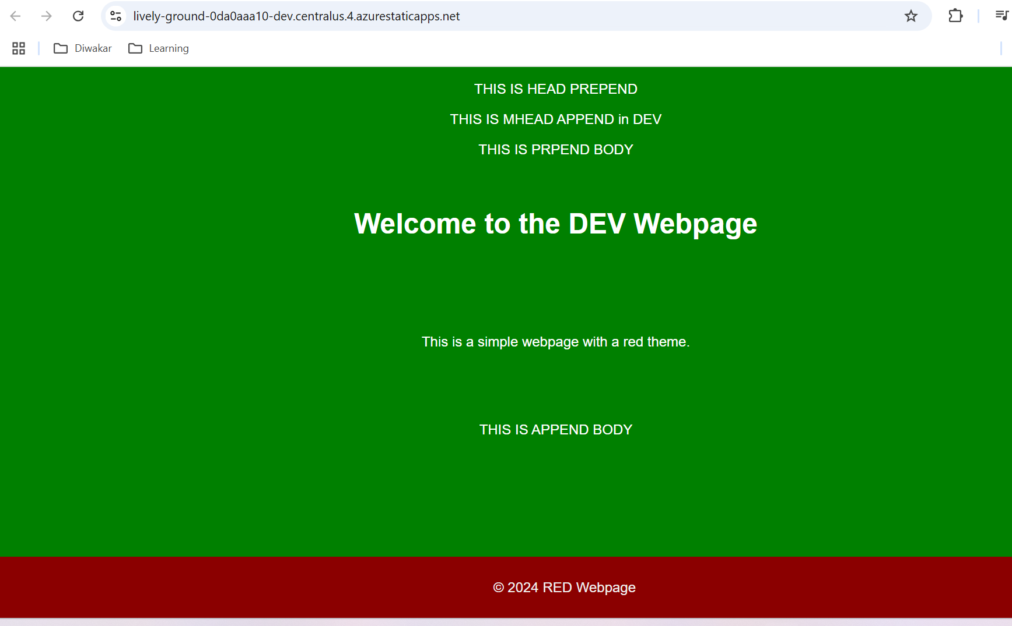
7. P.S. I have implemented access to Application Gateway to the Static Web App in APG SOP. Please check it out, if required.