**Task 1 - Ip-tool must gather**

1. Create a python script on your local machine and test it. 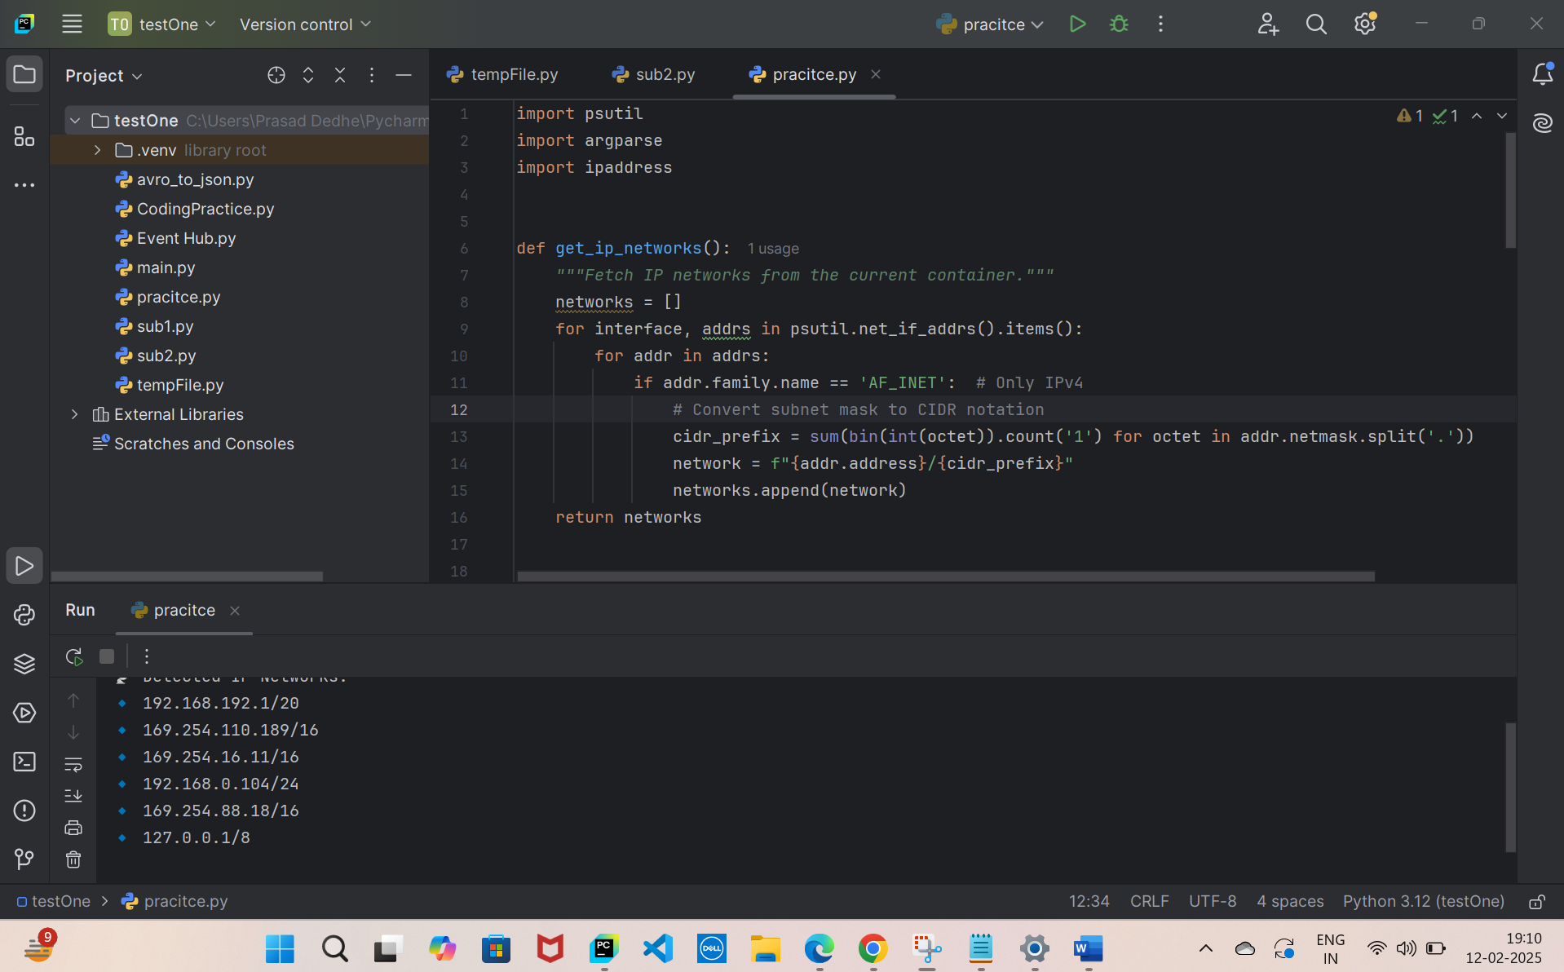
2. Create a dockerfile, make sure to have dependenet packages here. 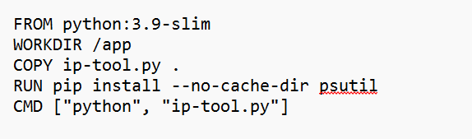
3. Build the image  
   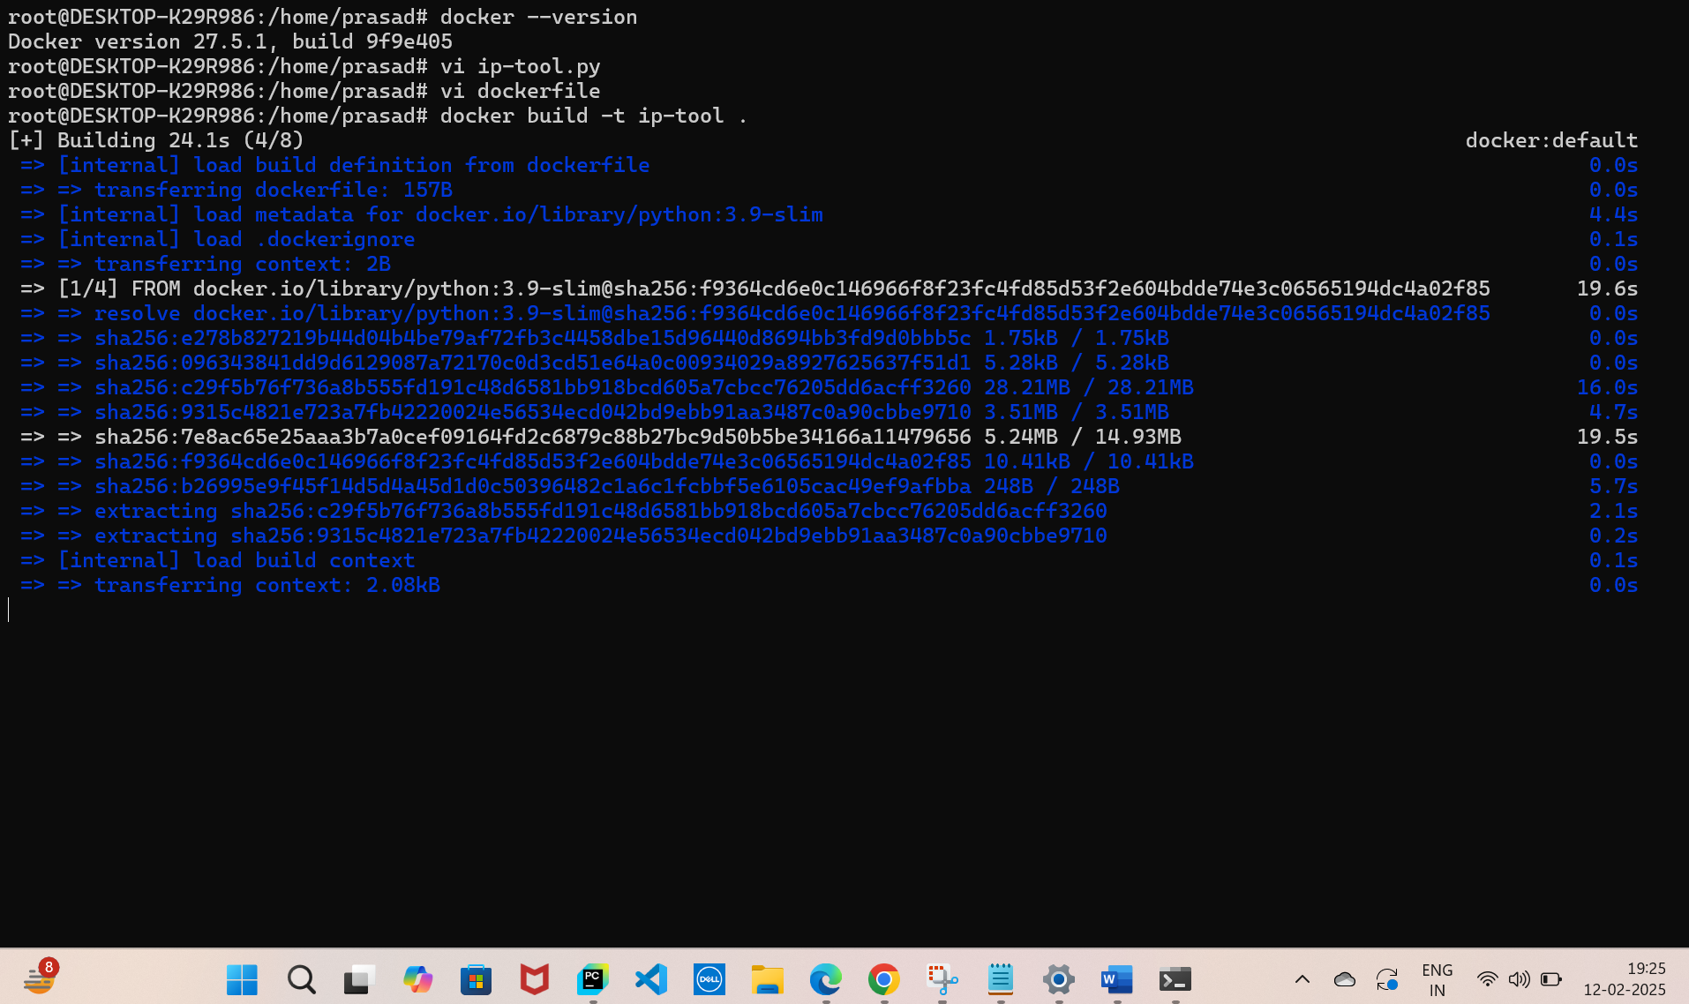
4. Run the container and test in the local machine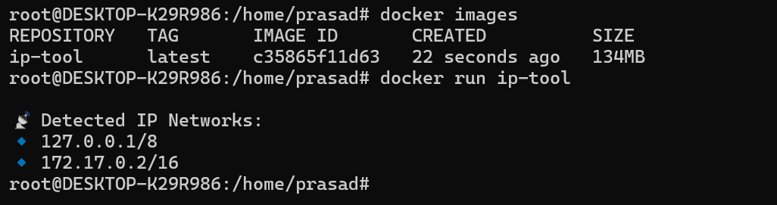
5. Now you have the image in your local, push it into your docker Repo, 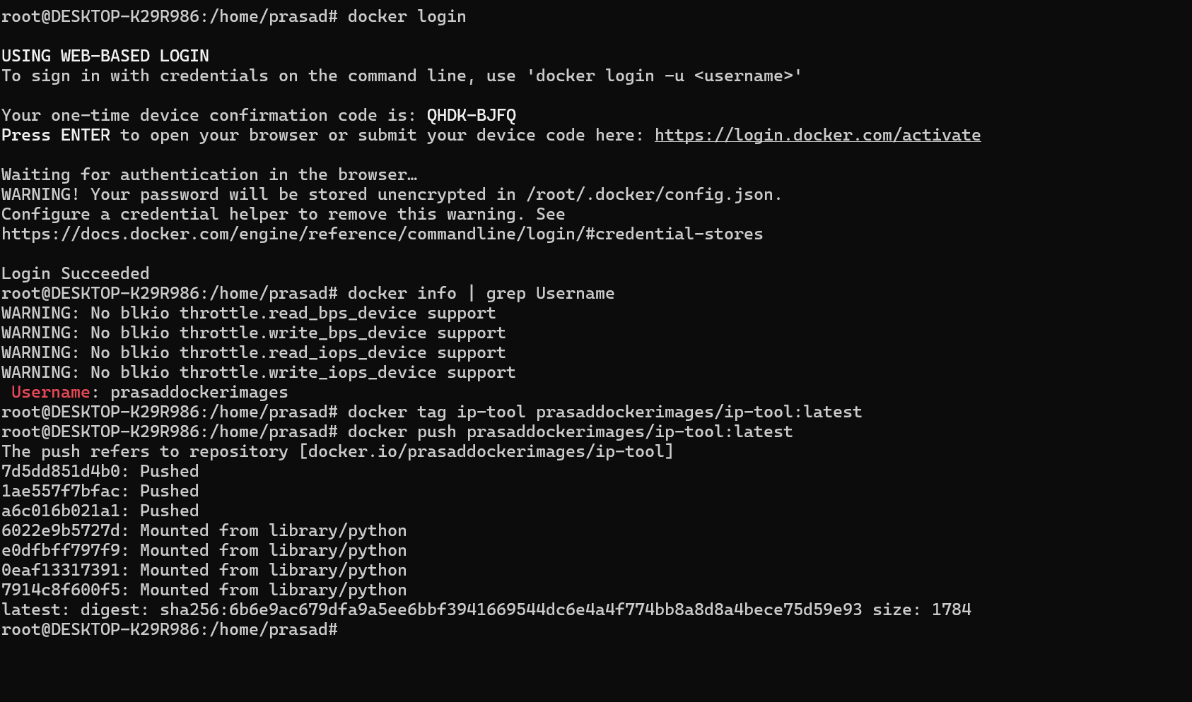
6. You would be able to see the image in docker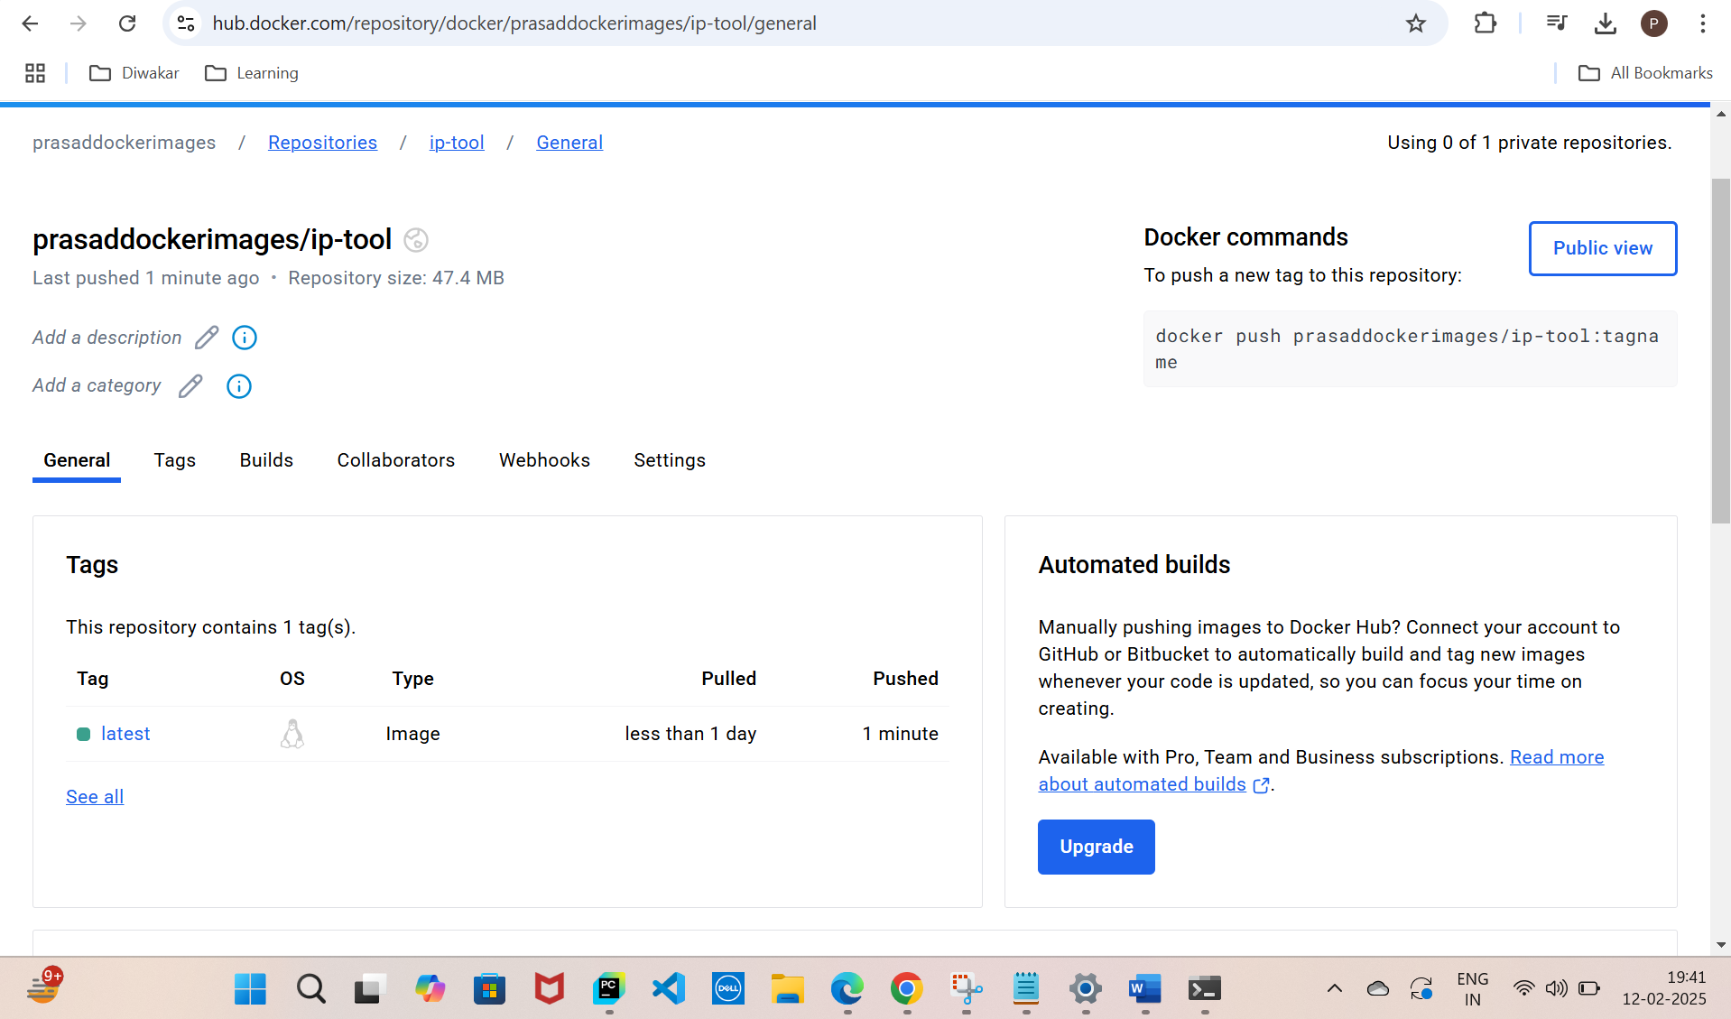
7. Now, pull the docker image in your cluster (make sure docker is installed in the cluster, In this context it is not needed since I have kept my repo public)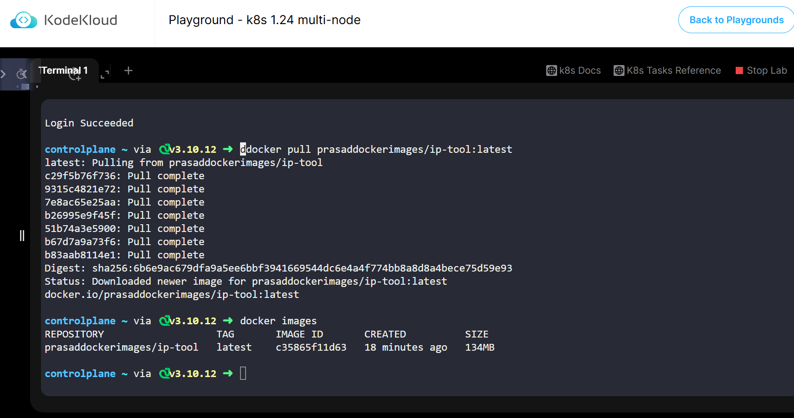
8. The next thing to do is, we need to create a deployment.yaml file and apply it. 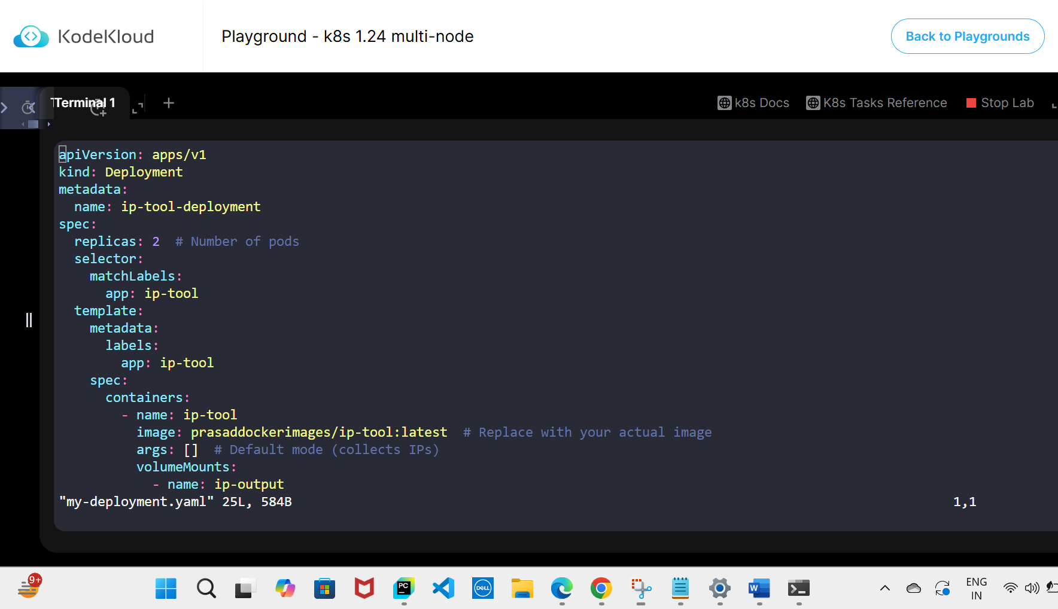
9. You can see the pods are now completed. 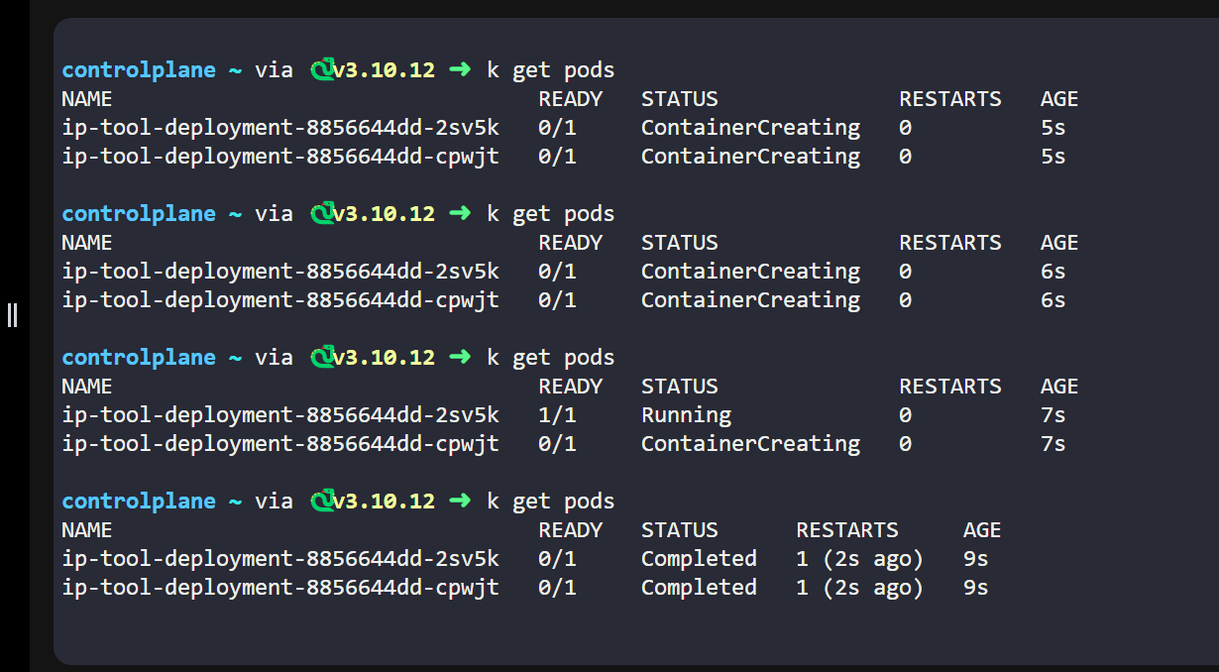
10. Now check the logs, you can see there is not a single collision