Git repo:

https://github.com/wardahsana/Auto-Deploy-Project.git

Feedback - URL 02:

In my config.yml, please see step ‘Get backend url’. I’m baking it into API_URL through front-end.

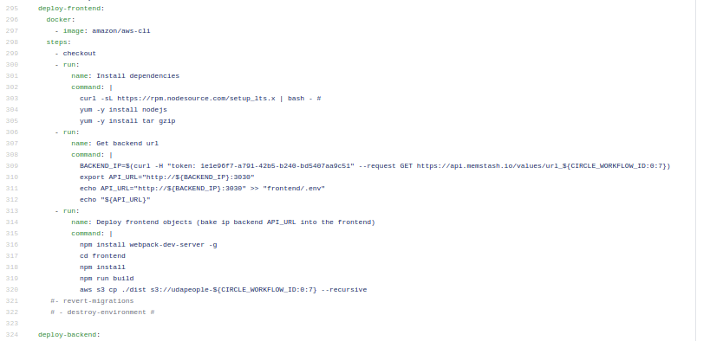

Instance status check:

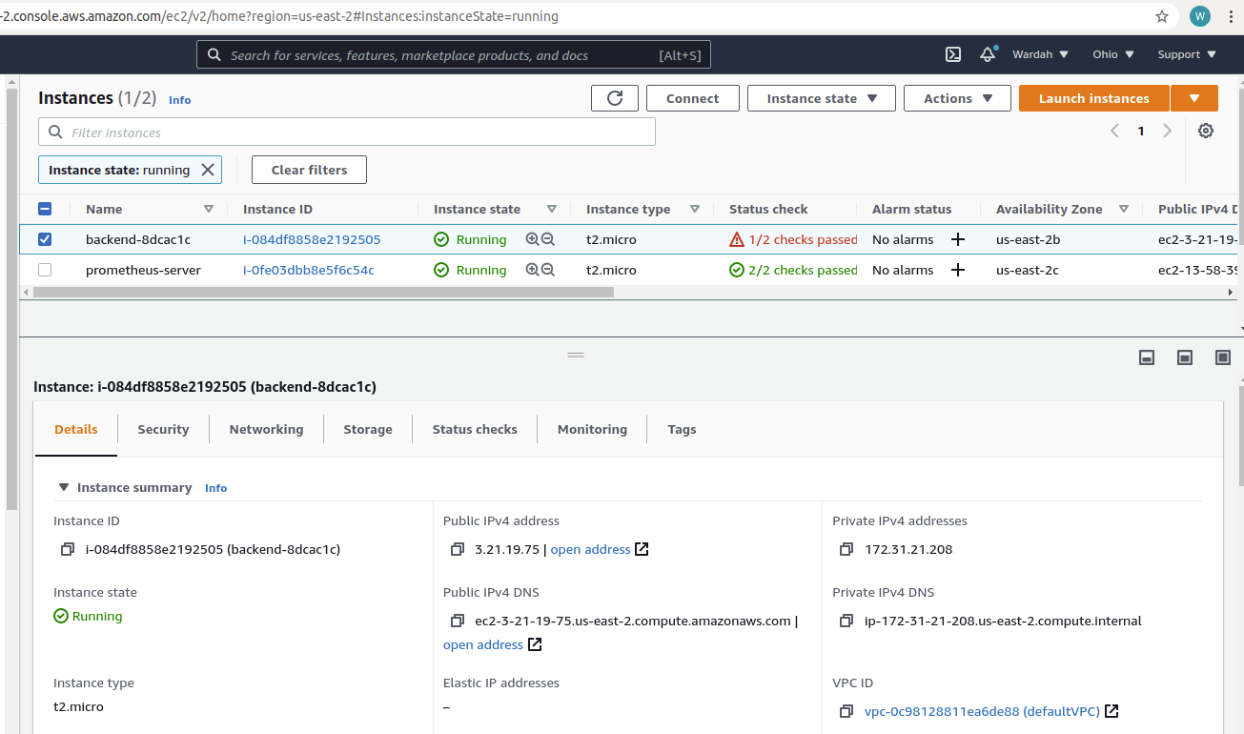

SSH into server timing out:

