KYC Stamp

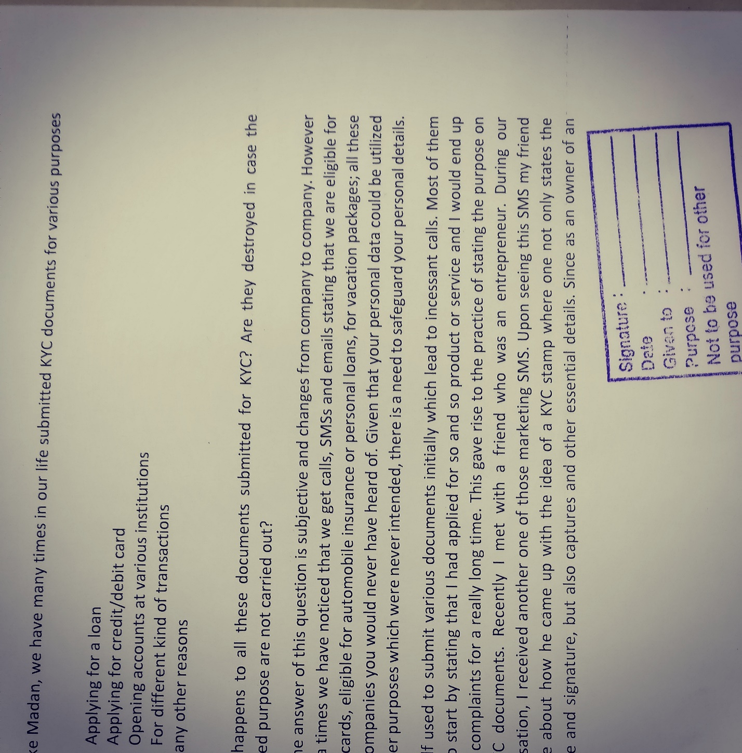

Madan was visiting the bank for the 3rd time this week and was clearly frustrated by the long serpentine queues. These lines not only lasted for hours but also caused people to enduringly argue whether the prime minister’s stand on demonetization was correct or not. Many people had come forward to distribute water and a pack of glucose biscuits to those waiting in the lines, which to a certain extent assuaged Madan’s anger and gave him the energy to debate on this national level raging issue. One of the things he heard that money hoarders were trying convert their black money to white was using unsuspecting individual’s KYC documents. This got him thinking that at right this moment, most of the bank branches were sitting on lakhs of KYC documents which could be used by these wrongdoers for converting their black money to white.

Just like Madan, we have many times in our life submitted KYC documents for various purposes like:

1. Applying for a loan
2. Applying for credit/debit card
3. Opening accounts at various institutions
4. For different kind of transactions

And many other reasons

What happens to all these documents submitted for KYC? Are they destroyed in case the intended purpose are not carried out?

Well the answer of this question is subjective and changes from company to company. However many a times we have noticed that we get calls, SMSs and emails stating that we are eligible for Credit cards, eligible for automobile insurance or personal loans, for vacation packages; all these from companies you would never have heard of. Given that your personal data could be utilized for other purposes which were never intended, there is a need to safeguard your personal details.

I myself used to submit various documents initially which lead to incessant calls. Most of them used to start by stating that I had applied for so and so product or service and I would end up raising complaints for a really long time. This gave rise to the practice of stating the purpose on the KYC documents. Recently I met with a friend who was an entrepreneur. During our conversation, I received another one of those marketing SMS. Upon seeing this SMS my friend told me about how he came up with the idea of a KYC stamp where one not only states the purpose and signature, but also captures and other essential details. Since as an owner of an enterprise, his details were utilized frequently for various office related purposes and the application of this stamp had made his life immensely easy.

The stamp captured the following details:

1. Date
2. Purpose
3. Signature
4. Name of the company it is addressed to
5. Disclaimer (which states that that the document cannot be used for any other purpose

Since the use of this stamp the number of unnecessary calls and SMSs had drastically reduced and my friend was able to sleep without any stress of his documents being misused. The stamp can be adopted not only by individuals but also by various corporations and smaller institutions for their day-to-day activities and will help curb the overall menace of illicit use of KYC documents.