**Real Estate Story – A Boom or Bust**

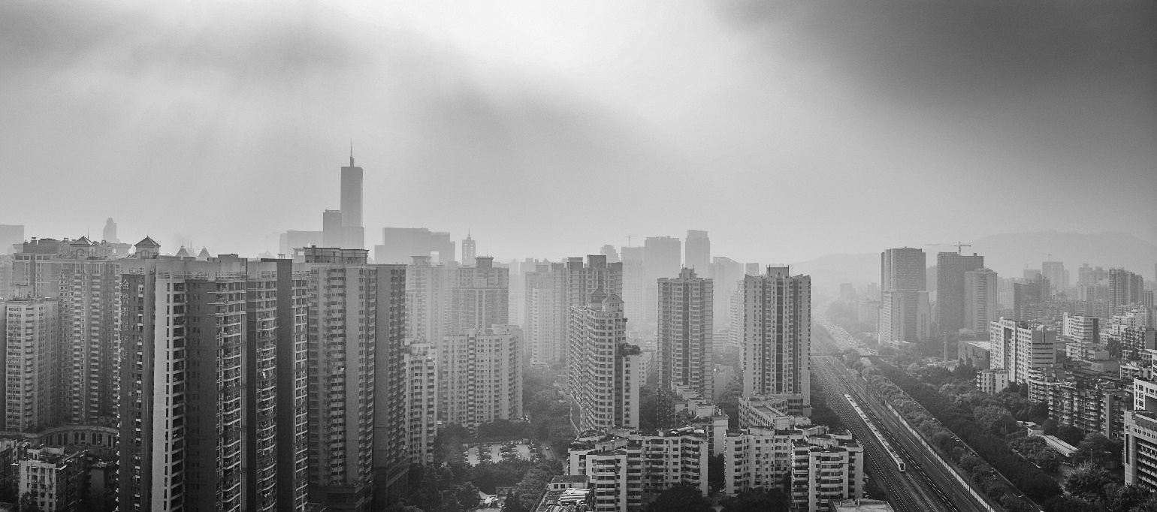

Since times immemorial, our elders have talked about the necessity to purchase a house. A shelter over one’s head has been a quest we all have fought for since centuries. Since the late 1900s and early 2000s Real Estate prices had started picking up or even sky-rocketing in various parts of the country to an extent that post 2010s buying a house has become a dream for many. For all those who own properties solely for the purpose of trading / investment, there has been a massive slowdown in the last few years. This has led many to question whether the Real Estate story, which had a fairy tale beginning, has come to an end or not. Let’s take a look.

As seen from the chart below, since 2001 the real estate market was in an initial growth phase with new metro cities such as Bangalore, New Bombay and Gurgaon (now rechristened as Gurugram) being formed to cater to the growing demand for urban cities. I distinctly remember various people who had invested in properties at the start of this cycle being the happiest given that housing prices soon started booming all over the country by as much as 4 fold in as many years. Between 2006 and 2008 price growth in real estate flew off the charts with many areas suddenly becoming unaffordable for the most of the middle class people.

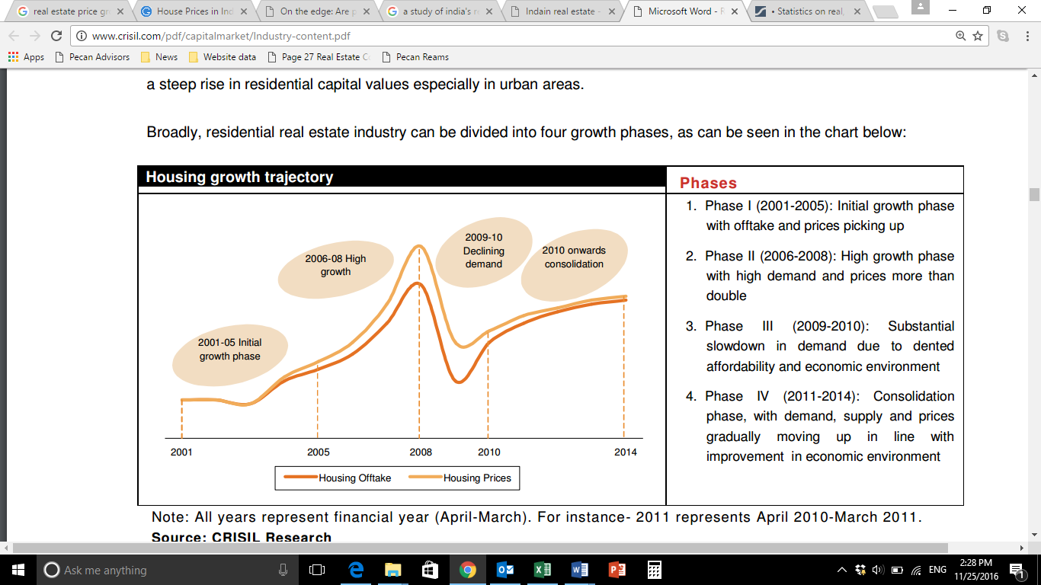

Source: Crisil Research

Then happened the 2008 global market crash which shook not just equities and bonds but almost all sectors across the globe. There was a sudden flux in prices which was caused by the real estate market crash in the US. Demand fell and so did prices as many saw a fall in confidence of the investors. Post 2010, there was consolidation in the market with demand and prices picking up albeit slowly given the improving Indian outlook in the global market.

Cut to 2016, various steps are being taken by the government to propel India to become the fastest growing nation. With initiatives such as housing for all and curb on black money, many have started expecting market prices to fall anywhere between 30% - 50% in the coming months due to Real Estate bubble having formed in the last 2 decades. However, let’s try and understand whether this actually happens or not.

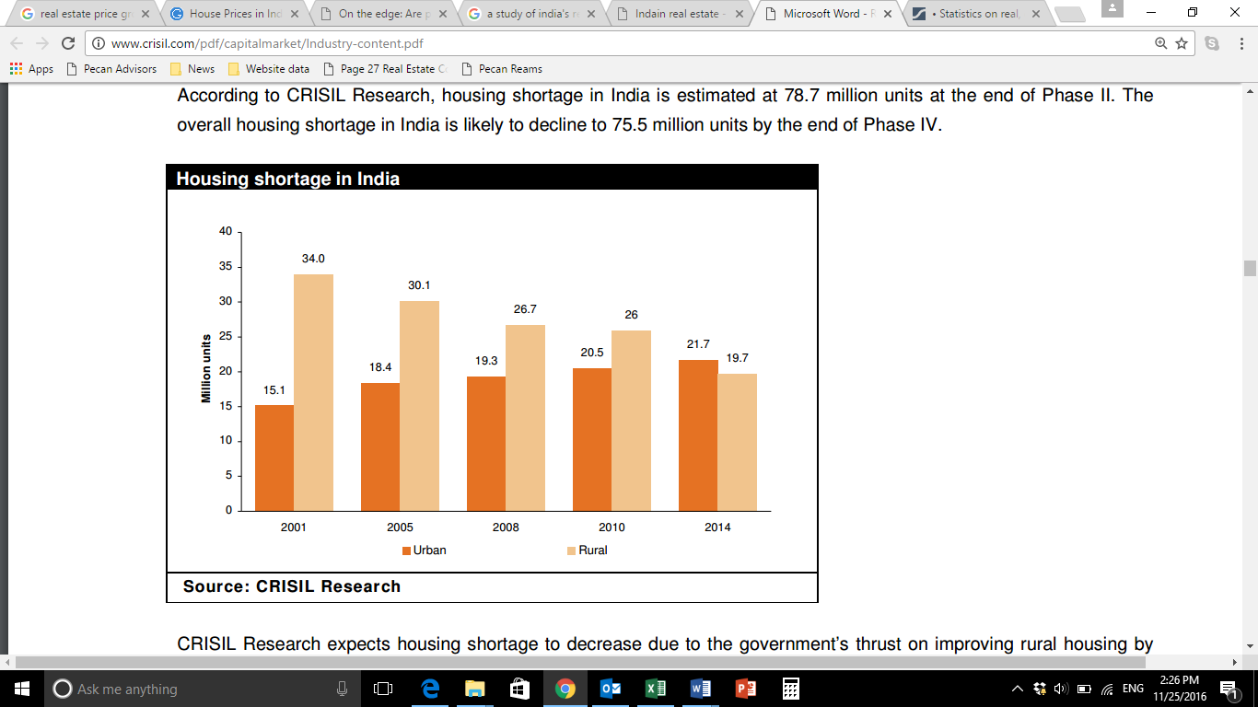

As can be seen from the above chart, there continues to be a growing shortage of housing in urban areas since 2001 with the peak being more the 21% in 2014. Despite the government’s ambitious plan of building around 20 smart cities, many feel that it would take more than a decade or so to achieve this massive target. This would mean that the prices would continue their upward trend at the current pace for the next few years. Also the increasing population and ageing current metro cities would mean an investment to upgrade the existing infrastructure in the coming years.

Although we don’t expect the prices to boom in the coming years, but neither do we see a fall as speculated by some. So even though many have missed the bus in the past, there is still scope for them to invest and reap the benefits in the coming years.