New FAQ’s

Contact

Q1. Does choosing contact type have an impact on the details to be filled?

1. Yes, choosing ‘Contact Type’ is one of the most crucial aspect of creating a contact since on the basis of selection of legal or non-legal entity the data required to be filled changes.

For Legal Entity a user has to fill their

1. Name
2. DOB
3. Gender
4. Complete address
5. Email ID
6. Contact number
7. and KYC details (if required)

For Non-legal Entity a user has to fill their

1. Name
2. Email ID
3. and Contact number

Although it is advisable to select the ‘Related Party Type’ so a s to easily identify the contact for future reference

Q2. What happens when a user selects ‘KYC required’?

1. Upon selection of ‘KYC required’, a tab of ‘KYC details’ appears in which ID Proof and Address Proof are mandatory

Owners

Q3. How to create different Categories of Owner?

A. To create different categories a user should first create an ‘Individual’ in which an approved exiting contact needs to be created as an individual owner. This qualifies an entity to not just become an owner in his/her capacity but also to be added as a legal entity in other Owner Categories such as HUF, Private Limited, Trust, etc.

Purchase

Q4. What impact does choosing a property type have on the data to be filled?

A. Upon choosing a property type, the data to be filled in the sub-tab ‘Address’ changes and so does the entire ‘Property Description’ tab

Q5. How can one capture the location in the ‘Google Map Address’ field?

A. There are 2 ways to capture the address in the ‘Google Map Address’ field.

1. You can either type the property address in the field and if the location is pre-fed in google, it will give you a result. In case google maps do not recognize the location it will give suggestion/s for the same

2. The other way is to select the ‘Go to Google Maps’ button, which as it says, will redirect you to Google Maps. From the map you have to select the location of the property and select the Google Map location address as seen below. Paste the address in the ‘Google Map Address’ field

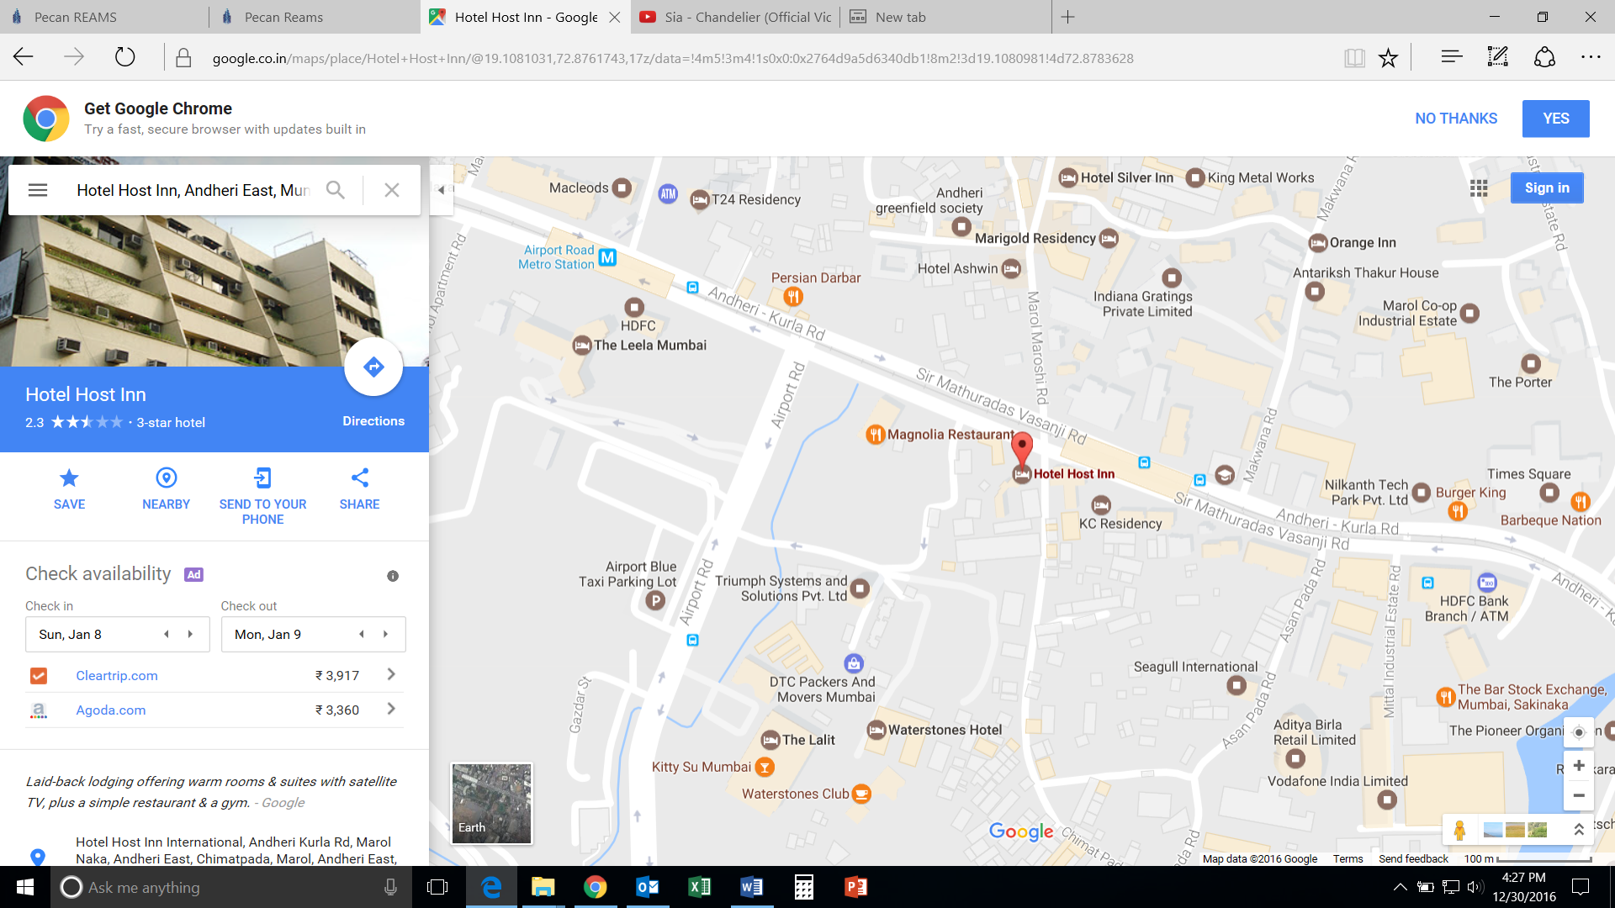

Q6. How to fill the tax column in the Purchase Schedule excel?

A. For filling the Tax column in the excel sheet of Purchase Schedule, we have created the ‘Tax’ page. This page can be accessed through the main menu tray wherein you can simply select the ‘Tax Name’ as applicable. In case of multiple taxes to be applied the user can copy paste the same and separate them in the excel using the Comma symbol “,”

Sale

Q7. Can a sale entry for a pre-leased property be passed in the system?

A. Yes, if any existing property or sub-property/properties are leased out, a sale entry can be passed in the system. The Owner can also showcase to the probable buyer the lock-in duration and lease tenure of the property.

Rent

Q8. What happens when the start and end day of a lease tenure are filled?

A. If a User has filled both the start and end date of a lease tenure then the Rent Schedule gets automatically generated and the User can simply add any other entries if required. In case any major change is needed in case of change in date of receipt of Rent, the User has to change the dates in the Rent Schedule.