Software Requirements Specification
BE Projects 2011-12

WALL BUILDING

Team 19

Pallavi Jain
Prasad Borole
Mukeshkumar Choudhary

Table of Contents

1 Introduction 3
1.1 Definitions, Acronyms and Abbreviations 3
1.2 References……………………………………………………………………….3

2 Overall Description 4

3. Details…………………………………………………...4
3.1 Functionality……………………………………………………………………..4
3.2 Supportability……………………………………………………………………5
3.3 Design Constraints……………………………………………………………..5
3.4 On-line User Documentation and Help System Requirements…………6
3.5 Interfaces…………………………………………………………………………7
3.5.1 User Interfaces………………………………………………………………7
3.5.2 Hardware Interfaces………………………………………………………...7
3.5.3 Software Interfaces…………………………………………………………7
3.5.4 Communication Interfaces………………………………………………...7

4. Risk Management……………………………………..8

Introduction

We are designing a robot that would help in building walls/fences at construction sites or any place where it is required. The robot will basically detect the position where it needs to place the bricks and then using the pick and place logic, it will place the bricks accordingly.
A ceiling camera will help robot detect the white strip co-ordinates and to place the bricks at the proper position without disturbing the others already placed earlier.

Definitions, Acronyms and Abbreviations

Pick and Place: It is a mechanism that the robot uses to save man power and also to ensure high and accurate quality placement because of constant cycle time (condition).
Zigbee module: Zigbee is a protocol that uses the 802.15.4 standard as a baseline and adds additional routing and networking functionality.
UART: It stands for Universal Asynchronous Data Receive / Transmit. It is a method of communication in which there is no need of clock for synchronization between the received and transmitted data. ZigBee uses UART for wireless communication between devices.

References

Following documents were referred for various software, hardware and algorithms used in the project:
- Manual for FIREBIRD V ATMEGA2560 Hardware.
- Manual for FIREBIRD V ATMEGA2560 Software.
- XBee manual IEEE® 802.15.4 OEM RF Modules by MaxStream, Inc

Overall Description

The working mechanism starts with the ceiling camera capturing the image of the arena and detecting the white strip placed. The wall needs to be built on this white strip. So the camera will pass the image of the arena to the system (i.e MATLAB) MATLAB will process the image and send the co-ordinates to the robot.
Now the robot will pick the brick from the location and place it at the co-ordinates fed. The loop implemented in the program will feed the next co-ordinates to the robot and the process continues.
This process continues until the wall is built.

Details

Functionality

The functions of the various hardware and software requirement are described in the following tables:

Hardware Requirements
Sr.No | Hardware | Function | Quantity
1 | FIREBIRD V ATMEGA2560 | It will be used for execution of the commands given by the user from the computer and to control various features of the robot like motion, communication, etc | 1
2 | Robotic arm | For pick and place purpose | 1
3 | ZigBee module | For wireless communication between computer and robot. | 2
4 | Ceiling camera | For capturing the image of the arena and processing the co-ordinates | 1
Software Requirements
Sr.No | Software | Function | Quantity
1 | AVR Studio | For writing the embedded C codes and creating HEX files. | 1
2 | AVR Bootloader | For burning the code on the EPROM of the robot | 1
3 | X-CTU | For communicating the co-ordinates of the strip from camera to the robot. | 1
4 | MATLAB | For image processing | 1

Supportability

For enhancing the supportability or maintainability of the project the robot body needs to be robust and dead weight be as low as possible. So we will be designing the arm with the minimum weight possible. Also the mechanism of moving the arm for pick and place purpose will require extra effort and so we are using a DC motor to run the arm mechanism.
To enhance the possibilities of re-using our project we will be making different subroutines for different functions of robots so that one can directly include our codes in their library for reusing it

Design Constraints

There are many design constraints with our project as many of the components are not available in the market.

Picking and placing mechanism:
The robotic arm that we are designing should be made enough compatible to support the firebird platform and we need to take care that the arm doesn’t reduce the efficiency of the robot. Apart from that we would need to attach a sensor on the arm to measure the height of the wall for proper brick placing.

On-line User Documentation and Help System Requirements

A user can also refer to the uploaded manuals of the robot specifying its controls and its specifications before using it practically.
The following is the flowchart for the entire process:

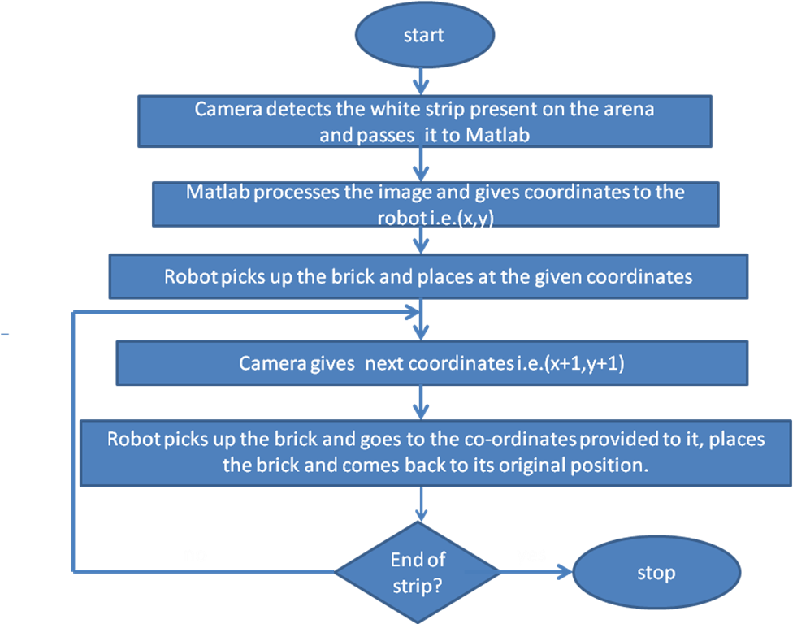

Interfaces

Our project uses ZigBee module for communication between the ceiling camera and the robot. There are two modules, one on the robot and other plugged onto the camera. ZigBee is a protocol that uses the 802.15.4 standard as a baseline and adds additional routing and networking functionality.

User Interfaces

Since the robot will perform the task on its own, no user interaction will take place.

Hardware Interfaces

- Gripper attachment: Use to perform the pick and place mechanism

- Power supply.

- Ceiling camera.

Software Interfaces
- Compiler: AVR Studio 4

- Programming languages: Embedded C

- Software: AVR Bootloader (to load the hex file)

- ZigBee: The co-ordinates of the strip will be sent to the robot using
wireless ZigBee module using the FireBird.

Communications Interfaces
We will be using ZigBee wireless standard for communication between robot and camera. The camera will capture the image and send it to MATLAB for image processing. System will send the processed co-ordinates to robot through Zigbee.

Risk Management

Since we are in final year of engineering we have learnt all sort of theory subjects but when it comes to real execution of a project, there may arise many uncertain problems and risks.

Following are the technical risks that we might be facing while completing the project :

- The firebird platform that we are using will need a detailed study of all its manuals.
- The robotic arm that we are designing needed to be made in such a way that it can be easily mounted on firebird platform and moves flexibly.
- Using the ZigBee module for the first time would be a big challenge.

