**Github**

Website : <https://github.com/>

**Signup:**

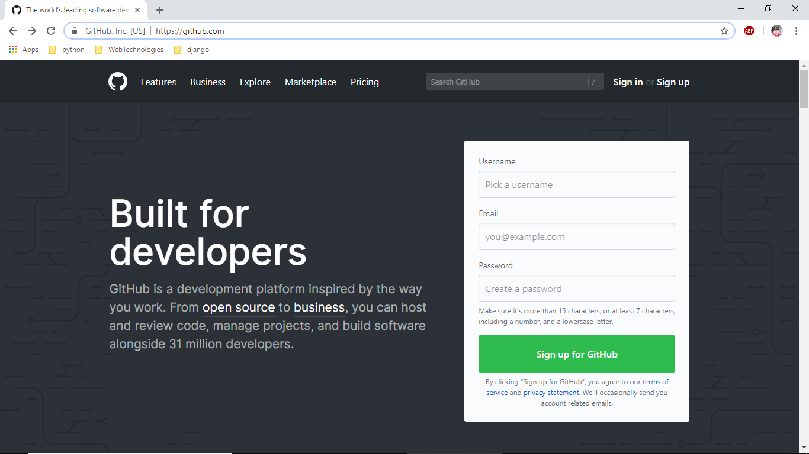

Login: <https://github.com/login>

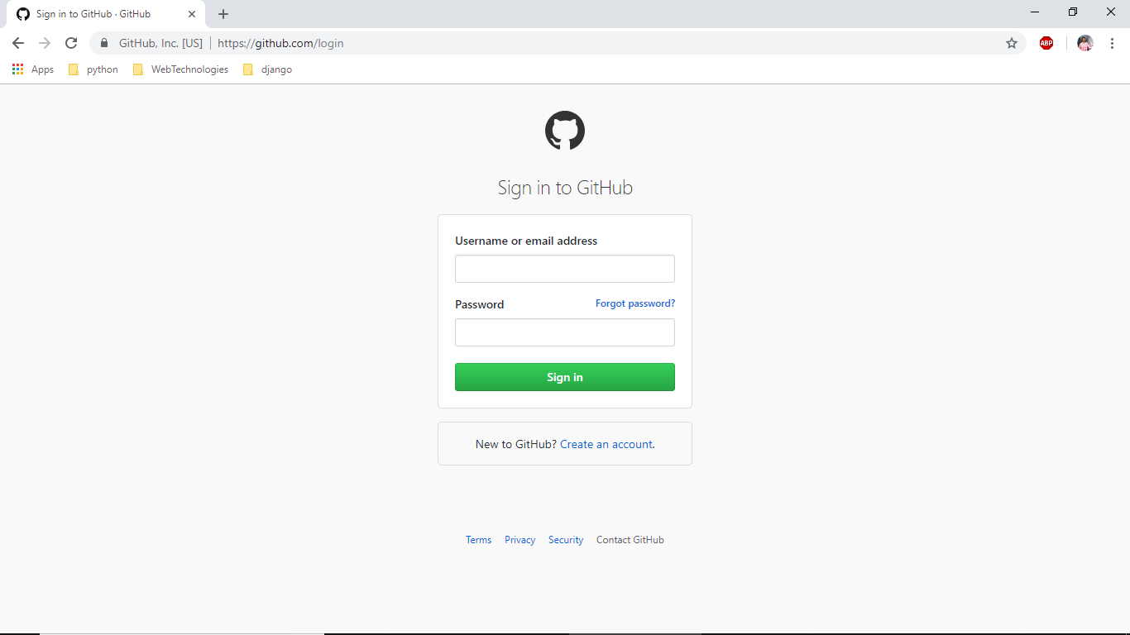

Download: <https://desktop.github.com/>

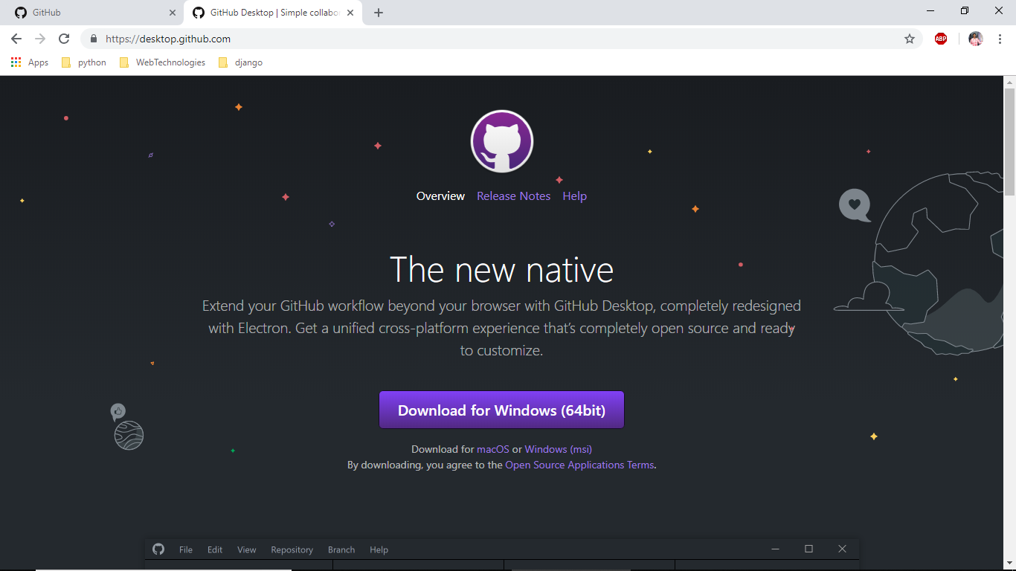

Installation:

1) Open Downloads Directory

2) Double click on “GitHubDesktopSetup.exe”

3) Enter Your Username or email address

4) Enter Your Password

5) Click on Signin (after signin success below screen is appeared)

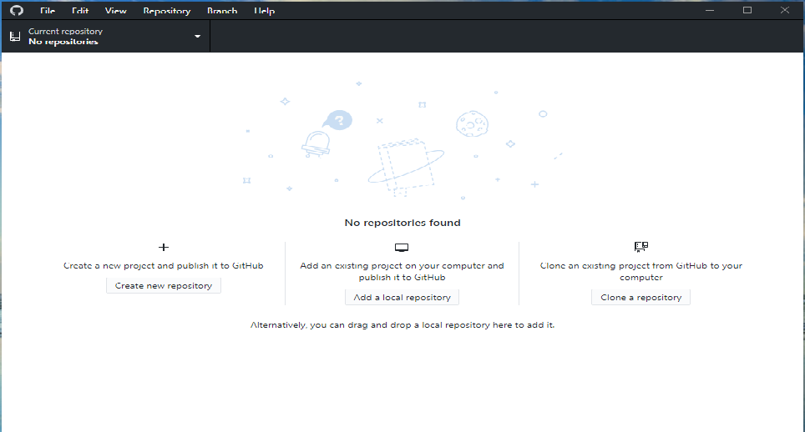

6) Open Browser and signin into github

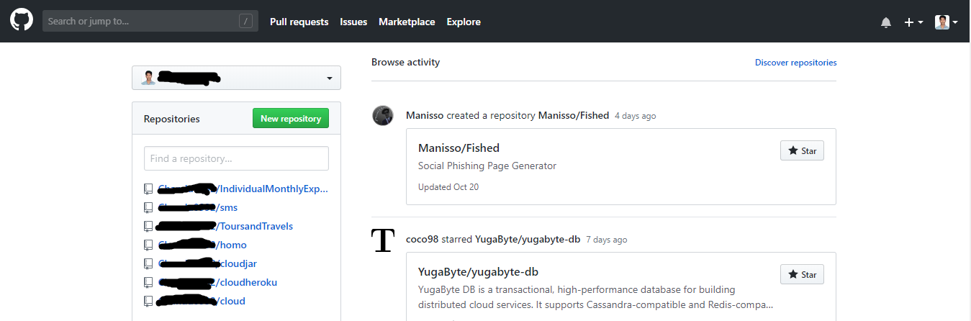

7)Click On new Repository

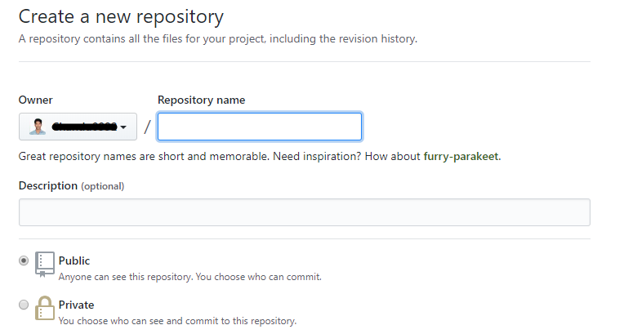

8)Give Repository name (Your Desired Name)

9) Select Public for Free access (recomended), if you want to make your repository private (no one can access your repository and it is paid.)

10) Click on Create repository

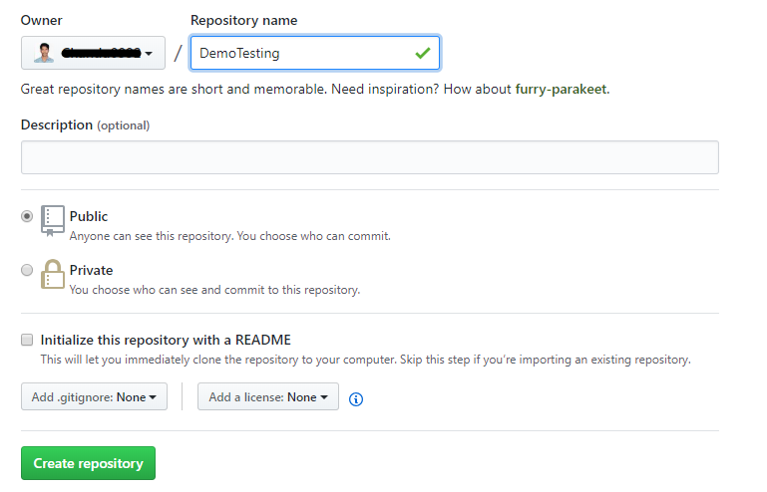

11) Open Github Desktop

12)Click on file

13) Click on Clone Repository

14) your Repository will Available below

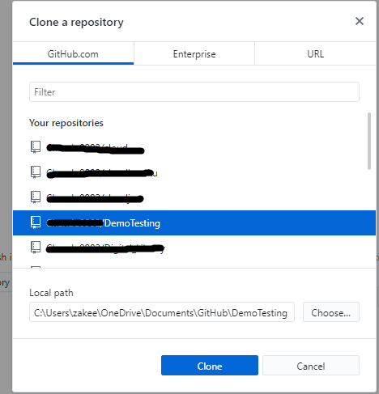

15) Click on Clone

16) Open Documents

17) There you will Find GitHub Directory

18) Inside GitHub Directoy You will See Your Repository Which is created inside you will get .git directory don’t delete that directory

19) Create a Text File inside your Repository

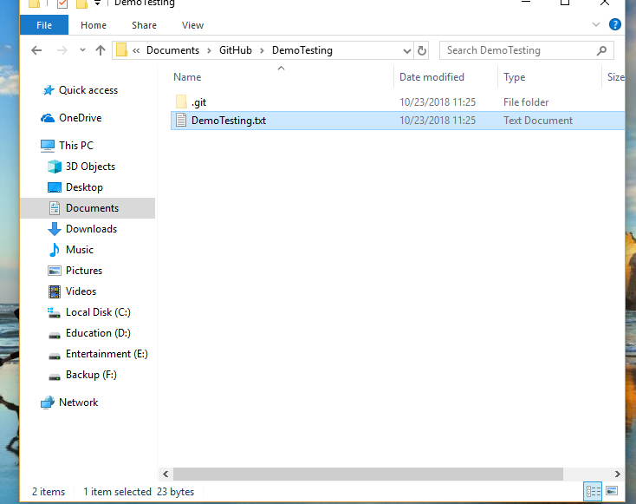

20) Now open github desktop

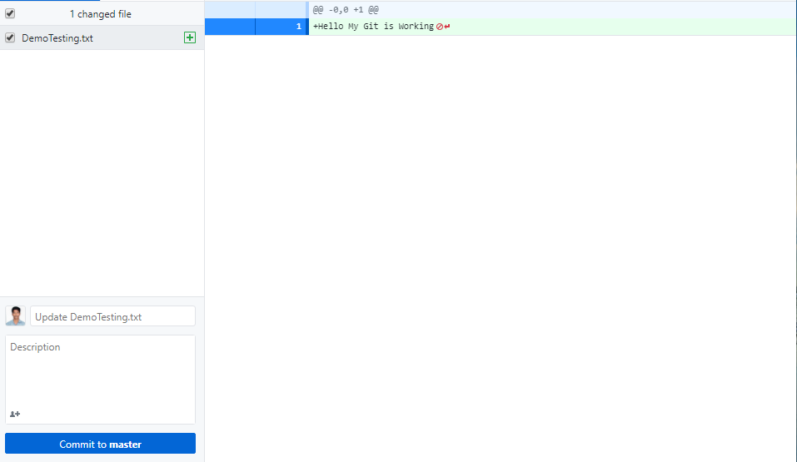

21) Git hub will detect changes automatic and click on commit to master

22)Click on Publish branch

23) Open Your git on Browser and check your repository there your files will available