SQL PROJECT REPORT
Healthcare SQL Project
Patient, hospital and treatment cost analysis using PostgreSQL

STUDENT DETAILS
Name | Hariprasad Kailas Daud
College | Vivekanand College, Chhatrapati Sambhajinagar 431001
Course | Data Analytics
Guide / Teacher | MR.[ROHIT DHANDE]

PROJECT DETAILS
Project Title | Healthcare SQL Project
Database | PostgreSQL (database: healthcare_db)
Dataset | healthcare_dataset_1000.csv: 1,000 patient records, 28 columns
Data Period | Admissions from January 2025 to May 2026, 8 cities, 5 hospitals, 5 doctors
Tables Created | 4 (hospitals, doctors, patients, readmission_log)
Questions Solved | 82 questions in 12 sections (A to L)
Business Insights | 5 insights from the query results

Contents

Project Overview 3
Database Design and ER Diagram 4
Section A Database, Tables and Basic SQL 5
Section B SELECT, WHERE, Operators and Sorting 12
Section C ALTER, UPDATE, DELETE and CASE 21
Section D Aggregate Functions, GROUP BY and HAVING 25
Section E NULL, DISTINCT, CASE and Data Cleaning 30
Section F JOIN Practice 34
Section G UNION / UNION ALL 39
Section H Subqueries 42
Section I EXISTS / NOT EXISTS 46
Section J CTE Practice 50
Section K Window Functions 57
Section L Healthcare Business Practice 67
Business Insights 71
Conclusion and Final Presentation Flow 73

How to read this report
Every question has three parts: the question itself, the SQL query (in a code box) and the query output (as a result grid screenshot). Sections follow the same A to L order as the project question list.

PROJECT

Project Overview
Objective, dataset and approach

Objective
This project uses SQL (PostgreSQL) to store and analyse a healthcare dataset of 1,000 hospital patient records. The work covers database and table design, constraints, filtering, aggregation, data cleaning, joins, subqueries, CTEs and window functions, and ends with healthcare business questions and insights.
1,000  Patient records | 28  Columns | 8  Cities | 17  Months of data

Business problem
A hospital group wants to know where treatment cost, admissions and readmissions are concentrated: which conditions, cities, hospitals, doctors and insurance types drive billing, when activity peaks, and how many patients come back after discharge.

SQL approach
The CSV was loaded into a normalized PostgreSQL design. Doctors and hospitals were moved into lookup tables, and readmissions were placed in a child table. Analysis then moves from basic filtering to aggregation, cleaning, joins, subqueries, CTEs and window functions, so every business question can be answered with a query.

Dataset columns
Group | Columns
Patient | patient_id, patient_name, age, gender, city, blood_group
Clinical | medical_condition, systolic_bp, diastolic_bp, heart_rate, oxygen_level, temperature, weight_kg, height_cm, bmi, medication, diabetic, smoker
Admission | admission_type, admission_date, discharge_date, length_of_stay, readmission, outcome
Billing and care team | treatment_cost, insurance_type, doctor, hospital

Database Design and ER Diagram

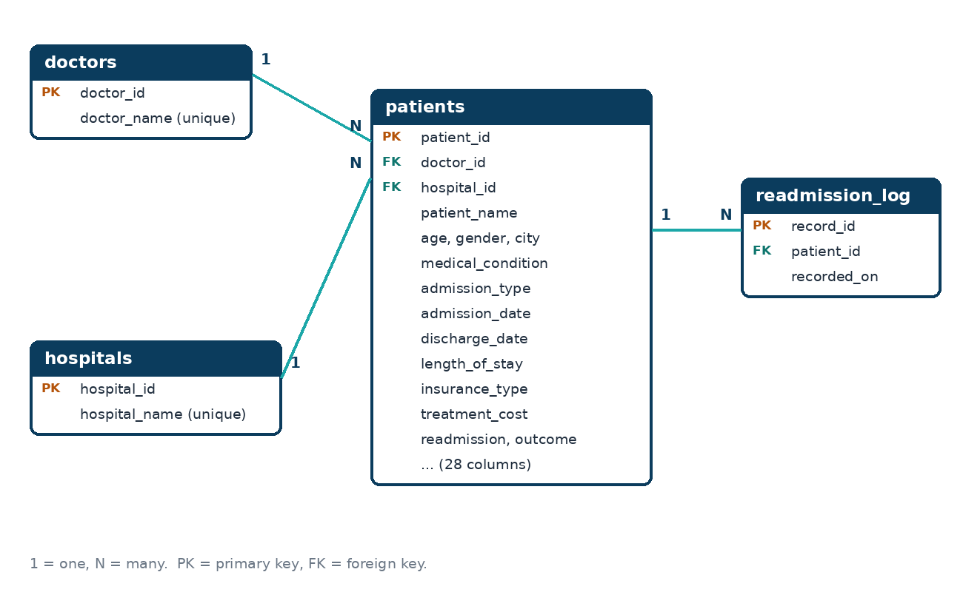

Table | Purpose | Rows | Key columns
hospitals | Lookup table of hospitals | 5 | hospital_id (PK), hospital_name (unique)
doctors | Lookup table of doctors | 5 | doctor_id (PK), doctor_name (unique)
patients | Main table, one row per admission | 1,000 | patient_id (PK), doctor_id (FK), hospital_id (FK)
readmission_log | Child table, one row per readmitted patient | 515 | record_id (PK), patient_id (FK)

SECTION A

Database, Tables and Basic SQL
Database creation, table design, constraints, inserting and viewing data
Questions in this section: 8 (A1 to A8)

A1 Create a PostgreSQL database for the project.
SQL QUERY

CREATE DATABASE healthcare_db;

OUTPUT


A2 Create the required table(s) with suitable data types.
Create the four tables
SQL QUERY

CREATE TABLE hospitals (
hospital_id SERIAL,
hospital_name VARCHAR(60) NOT NULL,
CONSTRAINT pk_hospitals PRIMARY KEY (hospital_id),
CONSTRAINT uq_hospital_name UNIQUE (hospital_name)
);

CREATE TABLE doctors (
doctor_id SERIAL,
doctor_name VARCHAR(60) NOT NULL,
CONSTRAINT pk_doctors PRIMARY KEY (doctor_id),
CONSTRAINT uq_doctor_name UNIQUE (doctor_name)
);

CREATE TABLE patients (
patient_id INT,
patient_name VARCHAR(80) NOT NULL,
age INT NOT NULL,
gender VARCHAR(10) NOT NULL,
city VARCHAR(50),
blood_group VARCHAR(5),
medical_condition VARCHAR(50),
systolic_bp INT,
diastolic_bp INT,
heart_rate INT,
oxygen_level NUMERIC(4,1),
temperature NUMERIC(4,1),
weight_kg NUMERIC(5,1),
height_cm NUMERIC(5,1),
bmi NUMERIC(4,1),
admission_type VARCHAR(20),
admission_date DATE NOT NULL,
discharge_date DATE,
length_of_stay INT,
doctor_id INT,
hospital_id INT,
insurance_type VARCHAR(20),
treatment_cost INT,
medication VARCHAR(50),
diabetic VARCHAR(3),
smoker VARCHAR(3),
readmission VARCHAR(3),
outcome VARCHAR(30),
CONSTRAINT pk_patients PRIMARY KEY (patient_id),
CONSTRAINT fk_patients_doctor FOREIGN KEY (doctor_id)
REFERENCES doctors (doctor_id),
CONSTRAINT fk_patients_hospital FOREIGN KEY (hospital_id)
REFERENCES hospitals (hospital_id),
CONSTRAINT chk_patients_age CHECK (age BETWEEN 0 AND 120),
CONSTRAINT chk_patients_gender CHECK (gender IN ('Male','Female')),
CONSTRAINT chk_patients_los CHECK (length_of_stay >= 0),
CONSTRAINT chk_patients_cost CHECK (treatment_cost >= 0),
CONSTRAINT chk_patients_dates CHECK (discharge_date >= admission_date)
);

CREATE TABLE readmission_log (
record_id SERIAL,
patient_id INT NOT NULL,
recorded_on DATE,
CONSTRAINT pk_readmission_log PRIMARY KEY (record_id),
CONSTRAINT fk_readmission_patient FOREIGN KEY (patient_id)
REFERENCES patients (patient_id)
);

OUTPUT

Load the dataset into the tables
SQL QUERY

-- Load the CSV into the tables (staging table has the same columns as the CSV)
COPY staging_healthcare FROM 'healthcare_dataset_1000.csv' CSV HEADER;

INSERT INTO hospitals (hospital_name) SELECT DISTINCT hospital FROM staging_healthcare ORDER BY 1;
INSERT INTO doctors (doctor_name) SELECT DISTINCT doctor FROM staging_healthcare ORDER BY 1;

INSERT INTO patients
SELECT s.patient_id, s.patient_name, s.age, s.gender, s.city, s.blood_group,
s.medical_condition, s.systolic_bp, s.diastolic_bp, s.heart_rate, s.oxygen_level,
s.temperature, s.weight_kg, s.height_cm, s.bmi, s.admission_type, s.admission_date,
s.discharge_date, s.length_of_stay, d.doctor_id, h.hospital_id, s.insurance_type,
s.treatment_cost, s.medication, s.diabetic, s.smoker, s.readmission, s.outcome
FROM staging_healthcare s
JOIN doctors d ON d.doctor_name = s.doctor
JOIN hospitals h ON h.hospital_name = s.hospital;

INSERT INTO readmission_log (patient_id, recorded_on)
SELECT patient_id, discharge_date FROM patients WHERE readmission = 'Yes';

OUTPUT
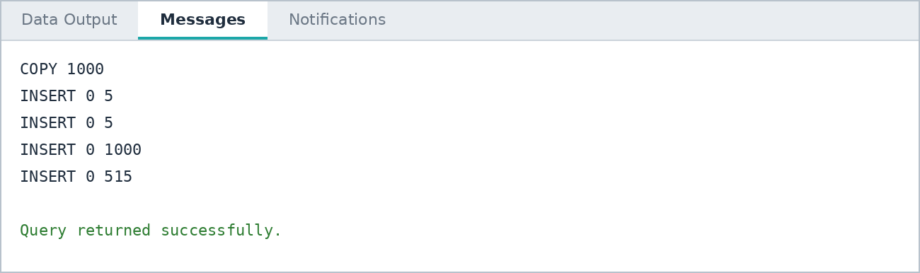
Note: The CSV holds hospital and doctor as text. They were split into two lookup tables (hospitals, doctors) and replaced by foreign keys in patients. readmission_log is the child table built from patients whose readmission = Yes.

A3 Identify and create primary key(s).
SQL QUERY

SELECT constraint_name, table_name, constraint_type
FROM information_schema.table_constraints
WHERE table_schema = 'public'
AND constraint_type = 'PRIMARY KEY'
ORDER BY table_name;

OUTPUT
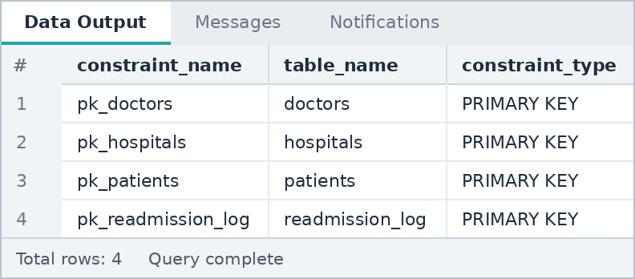
Note: patient_id is unique for every row of the dataset, so it is the primary key of patients. The other three tables use SERIAL surrogate keys.

A4 Identify relationships and create foreign key(s) where applicable.
SQL QUERY

SELECT constraint_name, table_name, constraint_type
FROM information_schema.table_constraints
WHERE table_schema = 'public'
AND constraint_type = 'FOREIGN KEY'
ORDER BY table_name, constraint_name;

OUTPUT
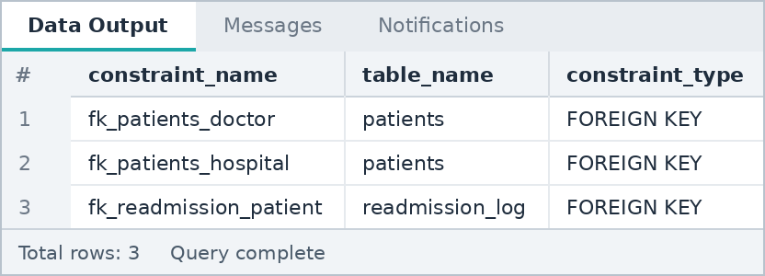
Note: Relationships: doctors 1 to N patients, hospitals 1 to N patients, patients 1 to N readmission_log (see the ER diagram in the overview).

A5 Add suitable NOT NULL, UNIQUE and CHECK constraints.
SQL QUERY

SELECT constraint_name, table_name, constraint_type
FROM information_schema.table_constraints
WHERE table_schema = 'public'
AND (constraint_type = 'UNIQUE'
OR (constraint_type = 'CHECK' AND constraint_name LIKE 'chk_%'))
ORDER BY constraint_type, constraint_name;

OUTPUT
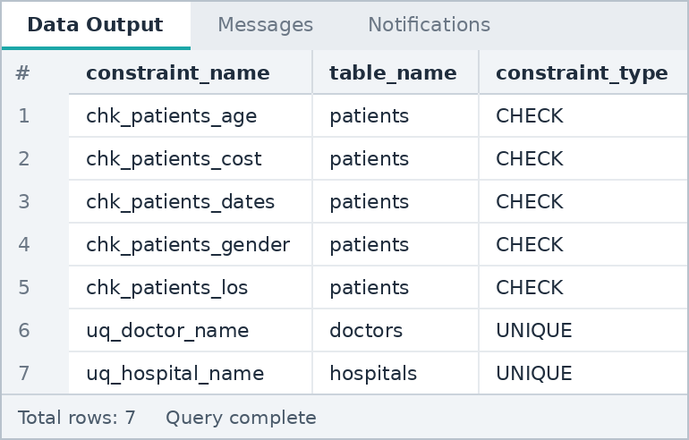
Note: NOT NULL is applied on names, age, gender and admission_date (see the CREATE TABLE statements in A2). UNIQUE stops duplicate doctor and hospital names. CHECK constraints keep age, gender, length of stay, cost and the admission/discharge dates valid.

A6 Insert at least 10 practice records manually where applicable.
SQL QUERY

INSERT INTO patients (patient_id, patient_name, age, gender, city, blood_group,
medical_condition, admission_type, admission_date, discharge_date, length_of_stay,
doctor_id, hospital_id, insurance_type, treatment_cost, medication,
diabetic, smoker, readmission, outcome)
VALUES
(1001,'Test Patient 01',34,'Female','Pune','O+','Flu','Routine','2026-05-20',
'2026-05-22',2,1,1,'Private',52000,'Paracetamol','No','No','No','Improved'),
(1002,'Test Patient 02',46,'Male','Mumbai','A+','Asthma','Emergency','2026-05-21',
'2026-05-25',4,2,2,'Government',61000,'Salbutamol','No','Yes','No','Improved'),
(1003,'Test Patient 03',58,'Female','Nashik','B+','Diabetes','Referral','2026-05-22',
'2026-05-29',7,3,3,'Self Pay',73000,'Metformin','Yes','No','No','Under Treatment'),
(1004,'Test Patient 04',29,'Male','Delhi','AB+','Migraine','Routine','2026-05-23',
'2026-05-24',1,4,4,'Private',48000,'Ibuprofen','No','No','No','Recovered'),
(1005,'Test Patient 05',63,'Female','Nagpur','O-','Hypertension','Emergency','2026-05-24',
'2026-06-01',8,5,5,'Government',88000,'Amlodipine','No','Yes','No','Under Treatment'),
(1006,'Test Patient 06',41,'Male','Hyderabad','B-','Arthritis','Routine','2026-05-25',
'2026-05-28',3,1,2,'Private',56000,'Ibuprofen','No','No','No','Improved'),
(1007,'Test Patient 07',52,'Female','Bengaluru','A-','Heart Disease','Referral','2026-05-26',
'2026-06-03',8,2,3,'Government',94000,'Atorvastatin','Yes','No','No','Referred'),
(1008,'Test Patient 08',37,'Male','Pune','AB-','Flu','Routine','2026-05-27',
'2026-05-29',2,3,4,'Self Pay',45000,'Paracetamol','No','Yes','No','Recovered'),
(1009,'Test Patient 09',68,'Female','Mumbai','O+','Diabetes','Emergency','2026-05-28',
'2026-06-05',8,4,5,'Private',79000,NULL,'Yes','No','No','Under Treatment'),
(1010,'Test Patient 10',24,'Male','Nashik','A+','Asthma','Routine','2026-05-29',
'2026-05-31',2,5,1,'Government',50000,NULL,'No','No','No','Improved');

OUTPUT

Note: Ten practice patients (IDs 1001 to 1010) were added. They are removed again in section C (question C4), so the analysis sections run on the original 1000 records.

A7 Display all records from the main table.
SQL QUERY

SELECT * FROM patients;

OUTPUT
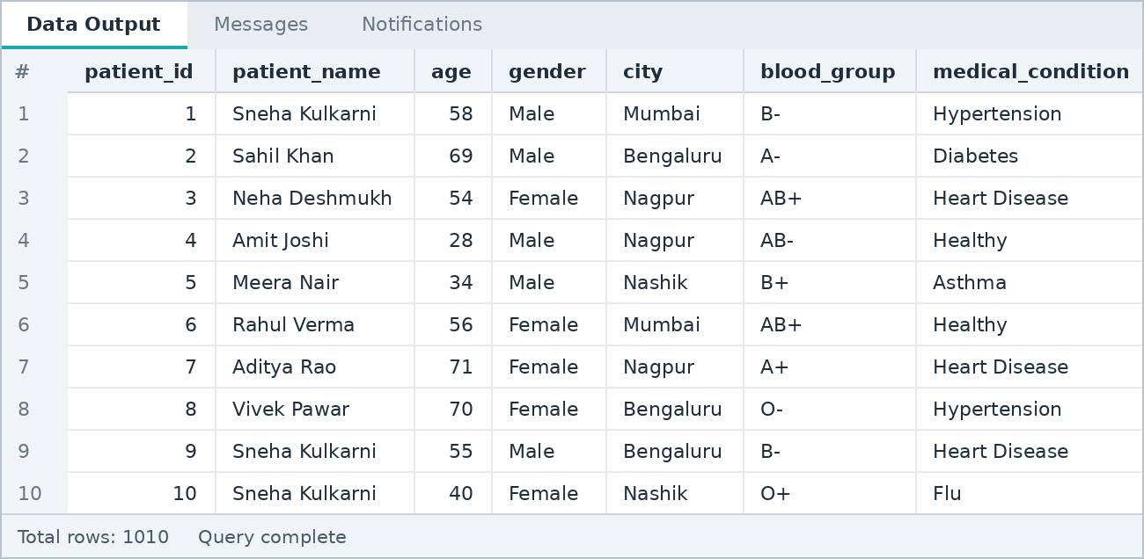
Note: The table has 28 columns, so the result grid shows the first few columns. Total rows are shown at the bottom.

A8 Display only selected columns required for analysis.
SQL QUERY

SELECT patient_id, patient_name, age, gender, city,
medical_condition, treatment_cost
FROM patients;

OUTPUT
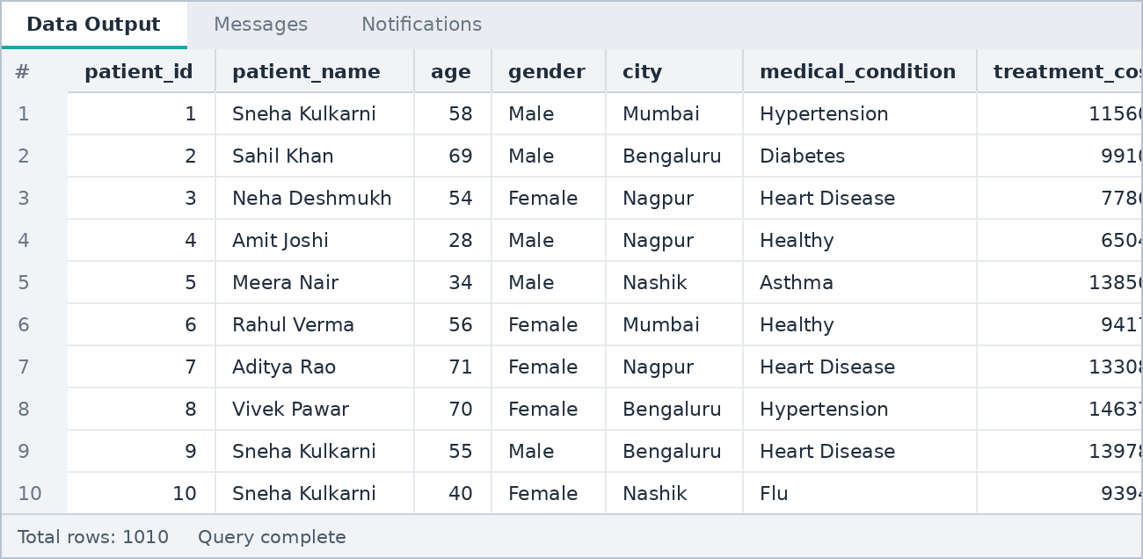

SECTION B

SELECT, WHERE, Operators and Sorting
Filtering with WHERE, AND / OR / NOT, IN, BETWEEN, LIKE, NULL checks, DISTINCT, ORDER BY, LIMIT
Questions in this section: 10 (B1 to B10)

B1 Filter records using WHERE for one condition.
SQL QUERY

SELECT patient_id, patient_name, age, city, medical_condition
FROM patients
WHERE medical_condition = 'Diabetes';

OUTPUT
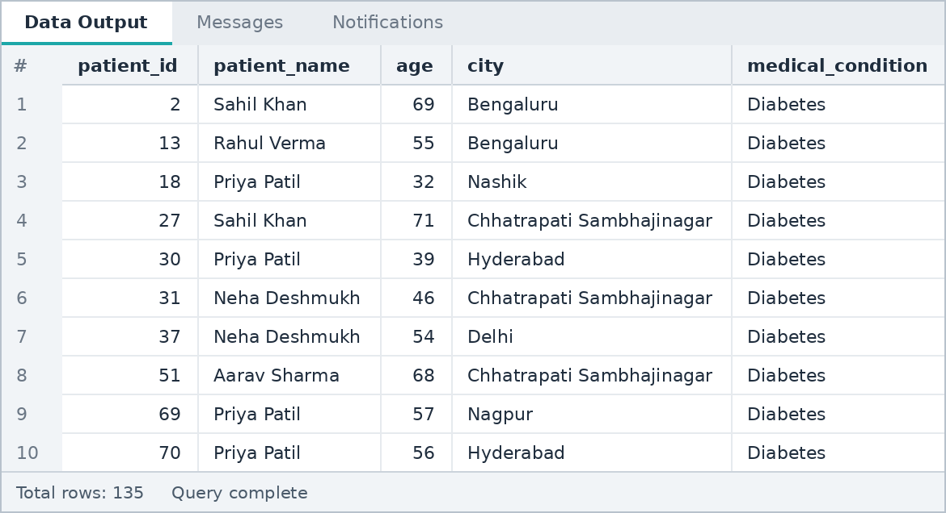

B2 Filter using AND and OR.
SQL QUERY

SELECT patient_id, patient_name, age, city, treatment_cost
FROM patients
WHERE (city = 'Pune' OR city = 'Mumbai')
AND age >= 60;

OUTPUT
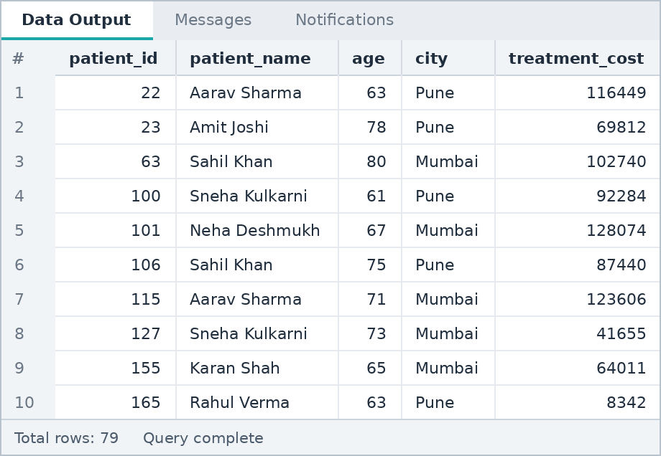

B3 Use NOT to reverse a condition.
SQL QUERY

SELECT patient_id, patient_name, admission_type, treatment_cost
FROM patients
WHERE NOT admission_type = 'Emergency';

OUTPUT
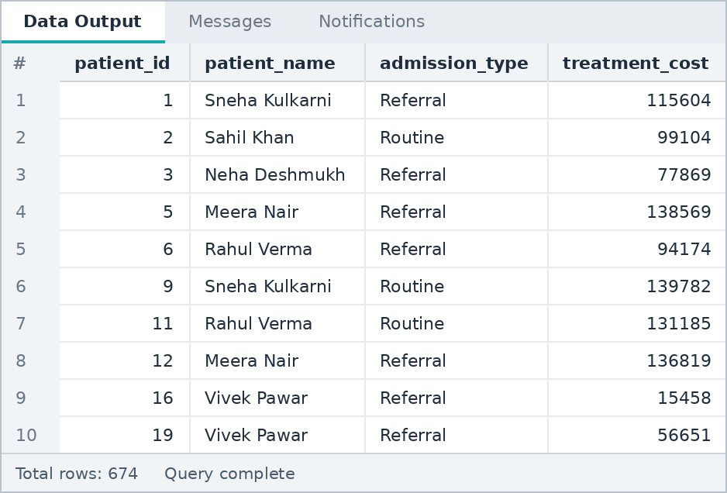

B4 Use IN and NOT IN.
IN
SQL QUERY

SELECT patient_id, patient_name, medical_condition, age
FROM patients
WHERE medical_condition IN ('Heart Disease', 'Hypertension', 'Diabetes');

OUTPUT
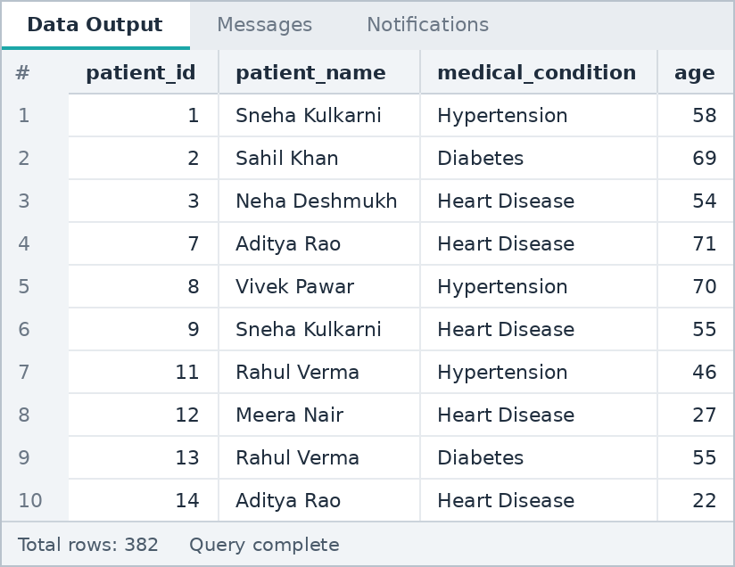
NOT IN
SQL QUERY

SELECT patient_id, patient_name, city
FROM patients
WHERE city NOT IN ('Mumbai', 'Delhi', 'Pune');

OUTPUT
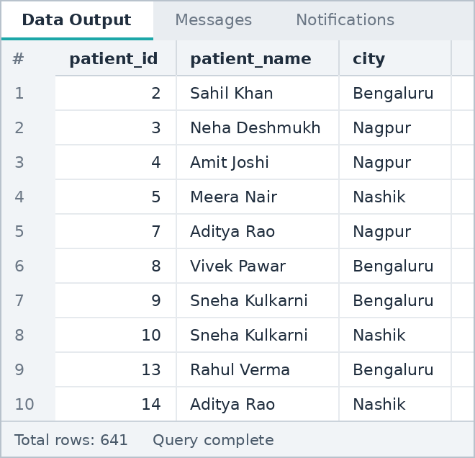

B5 Use BETWEEN and NOT BETWEEN.
BETWEEN
SQL QUERY

SELECT patient_id, patient_name, age, medical_condition
FROM patients
WHERE age BETWEEN 30 AND 45;

OUTPUT
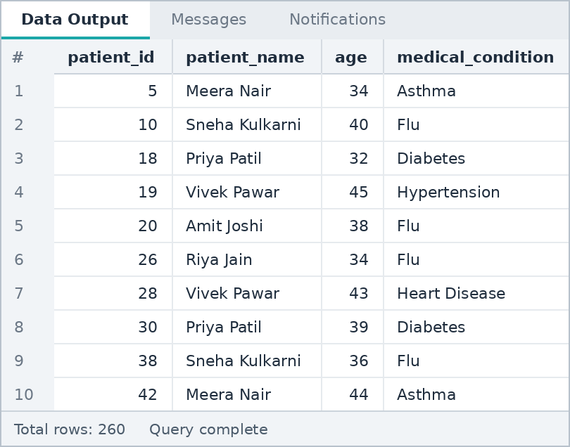
NOT BETWEEN
SQL QUERY

SELECT patient_id, patient_name, treatment_cost
FROM patients
WHERE treatment_cost NOT BETWEEN 20000 AND 130000;

OUTPUT
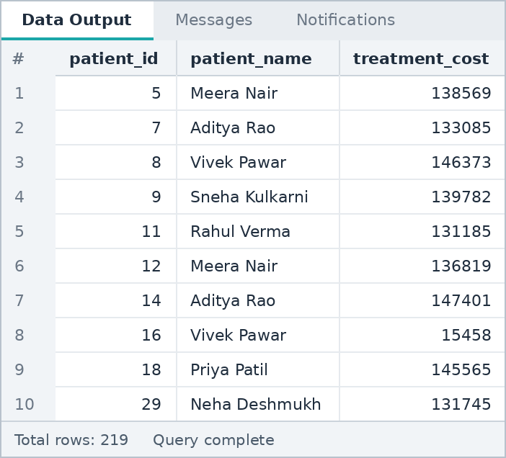

B6 Use LIKE for text-pattern searching.
SQL QUERY

SELECT patient_id, patient_name, city
FROM patients
WHERE patient_name LIKE 'S%'
AND city LIKE 'N%';

OUTPUT
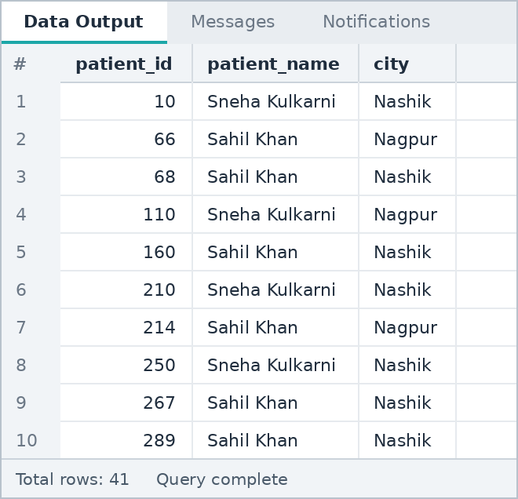
Note: 'S%' means names starting with S and 'N%' means cities starting with N (Nashik, Nagpur).

B7 Use IS NULL and IS NOT NULL.
IS NULL
SQL QUERY

SELECT patient_id, patient_name, medication
FROM patients
WHERE medication IS NULL;

OUTPUT
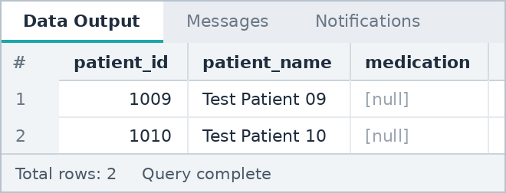
IS NOT NULL
SQL QUERY

SELECT patient_id, patient_name, medication
FROM patients
WHERE medication IS NOT NULL;

OUTPUT
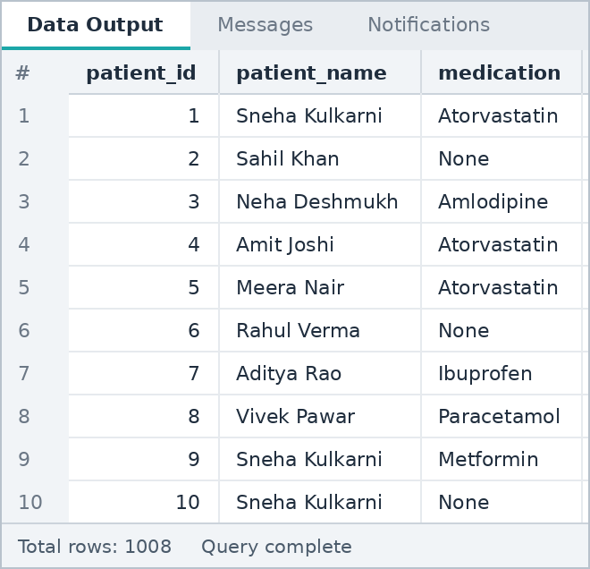
Note: The two rows with NULL medication are the practice records inserted in A6.

B8 Use DISTINCT to find unique categories.
SQL QUERY

SELECT DISTINCT medical_condition
FROM patients
ORDER BY medical_condition;

OUTPUT
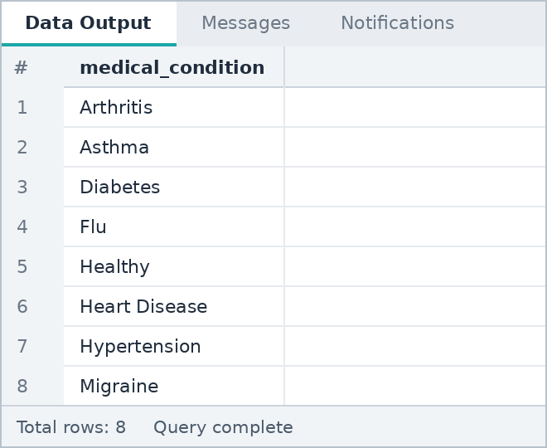

B9 Sort results using ORDER BY ASC and DESC.
Descending
SQL QUERY

SELECT patient_id, patient_name, treatment_cost
FROM patients
ORDER BY treatment_cost DESC;

OUTPUT
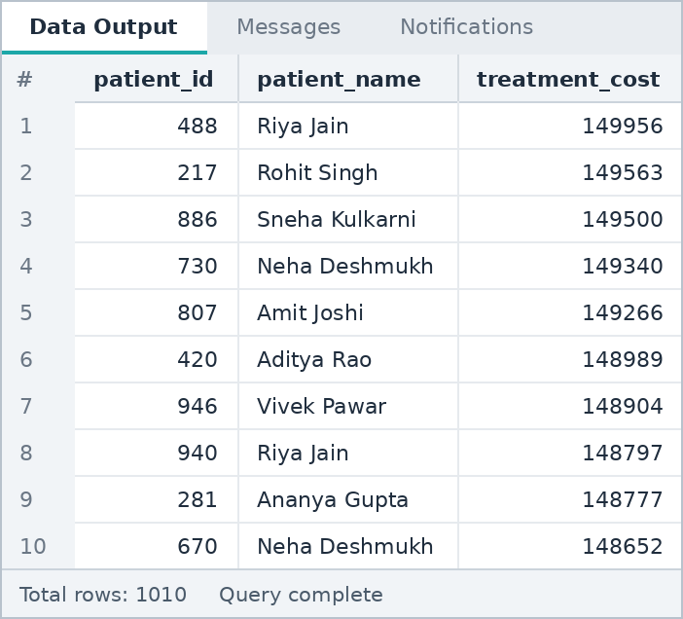
Ascending
SQL QUERY

SELECT patient_id, patient_name, age
FROM patients
ORDER BY age ASC, patient_name ASC;

OUTPUT
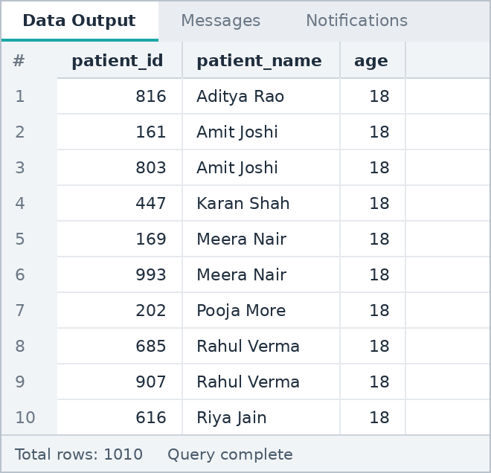

B10 Return top records using LIMIT and, where useful, OFFSET.
Top 5
SQL QUERY

SELECT patient_id, patient_name, treatment_cost
FROM patients
ORDER BY treatment_cost DESC
LIMIT 5;

OUTPUT
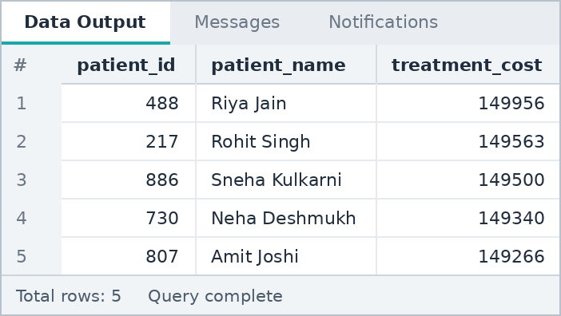
Next 5 (rank 6 to 10)
SQL QUERY

SELECT patient_id, patient_name, treatment_cost
FROM patients
ORDER BY treatment_cost DESC
LIMIT 5 OFFSET 5;

OUTPUT
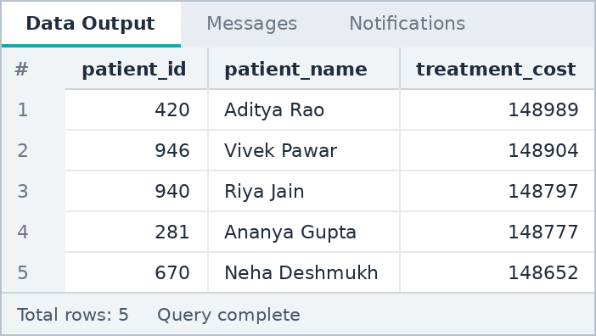

SECTION C

ALTER, UPDATE, DELETE and CASE
Changing table structure, updating and deleting records, CASE WHEN
Questions in this section: 5 (C1 to C5)

C1 Add a useful column using ALTER TABLE.
SQL QUERY

ALTER TABLE patients
ADD COLUMN cost_category VARCHAR(10);

OUTPUT

Check the new column
SQL QUERY

SELECT patient_id, patient_name, treatment_cost, cost_category
FROM patients
ORDER BY patient_id
LIMIT 5;

OUTPUT
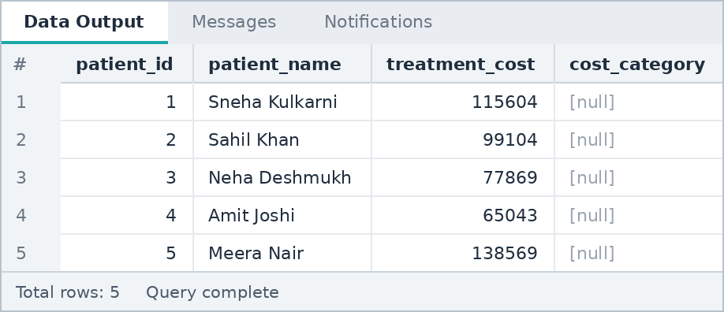
Note: The new column is empty (NULL) for all rows. It is filled in C3.

C2 Update selected records using UPDATE.
SQL QUERY

UPDATE patients
SET outcome = 'Recovered'
WHERE patient_id BETWEEN 1001 AND 1005;

OUTPUT

Check the updated rows
SQL QUERY

SELECT patient_id, patient_name, outcome
FROM patients
WHERE patient_id BETWEEN 1001 AND 1005;

OUTPUT
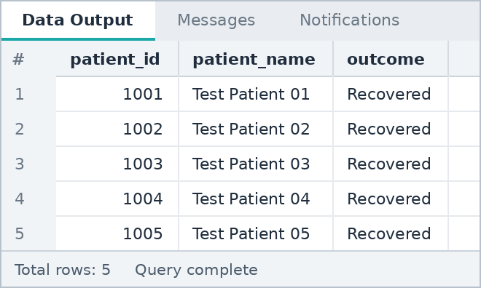

C3 Use CASE WHEN inside UPDATE for multiple conditions.
SQL QUERY

UPDATE patients
SET cost_category = CASE
WHEN treatment_cost < 40000 THEN 'Low'
WHEN treatment_cost < 100000 THEN 'Medium'
ELSE 'High'
END;

OUTPUT
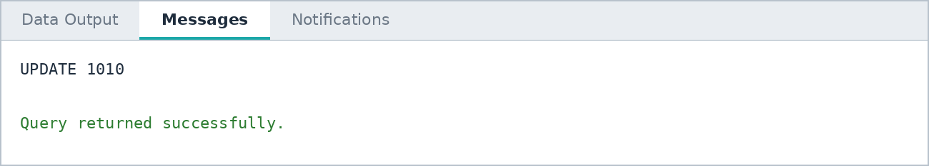
Check the result
SQL QUERY

SELECT cost_category, COUNT(*) AS patients
FROM patients
GROUP BY cost_category
ORDER BY patients DESC;

OUTPUT
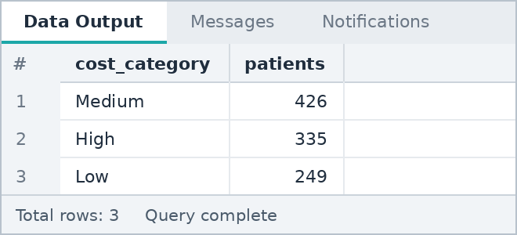

C4 Delete selected test records using DELETE with WHERE.
SQL QUERY

DELETE FROM patients
WHERE patient_id > 1000;

OUTPUT

Check the remaining rows
SQL QUERY

SELECT COUNT(*) AS total_patients
FROM patients;

OUTPUT
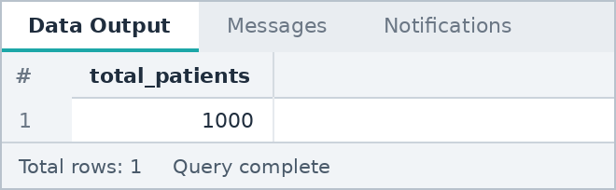

C5 Explain DELETE vs TRUNCATE vs DROP.

Command | What it removes | WHERE allowed | Table structure | Can be rolled back
DELETE | Selected rows (or all rows) | Yes | Stays | Yes, inside a transaction
TRUNCATE | All rows at once, fast | No | Stays | Yes in PostgreSQL, inside a transaction
DROP | The whole table with its data | No | Removed | Yes in PostgreSQL, inside a transaction
Note: Example: DELETE FROM patients WHERE patient_id > 1000; removes only the test rows. TRUNCATE TABLE readmission_log; empties the table but keeps it. DROP TABLE readmission_log; deletes the table itself. These were not run on the project data.

SECTION D

Aggregate Functions, GROUP BY and HAVING
COUNT, SUM, AVG, MIN, MAX, grouping and filtering groups
Questions in this section: 8 (D1 to D8)

D1 Use COUNT, SUM, AVG, MIN and MAX.
SQL QUERY

SELECT COUNT(*) AS total_patients,
SUM(treatment_cost) AS total_cost,
ROUND(AVG(treatment_cost),2) AS avg_cost,
MIN(treatment_cost) AS min_cost,
MAX(treatment_cost) AS max_cost
FROM patients;

OUTPUT
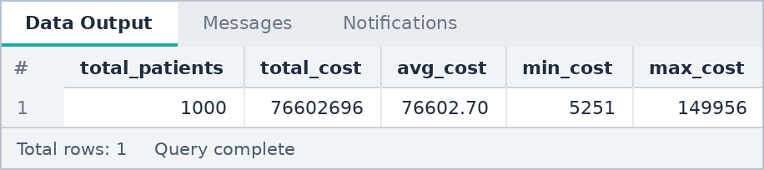

D2 Calculate totals by category using GROUP BY.
SQL QUERY

SELECT medical_condition, SUM(treatment_cost) AS total_cost
FROM patients
GROUP BY medical_condition
ORDER BY total_cost DESC;

OUTPUT
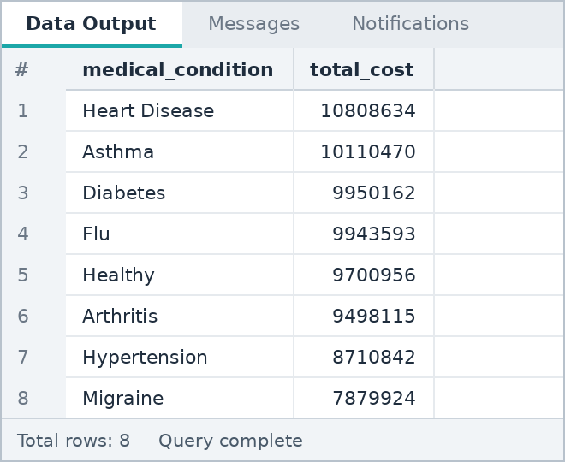

D3 Calculate averages by category.
SQL QUERY

SELECT admission_type,
ROUND(AVG(length_of_stay),2) AS avg_stay_days,
ROUND(AVG(treatment_cost),2) AS avg_cost
FROM patients
GROUP BY admission_type
ORDER BY avg_cost DESC;

OUTPUT
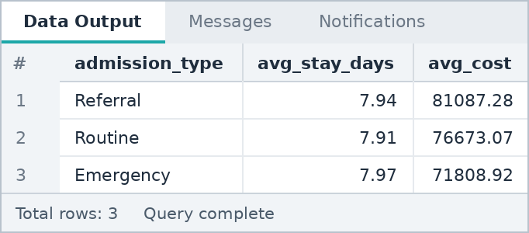

D4 Calculate counts by category.
SQL QUERY

SELECT outcome, COUNT(*) AS patients
FROM patients
GROUP BY outcome
ORDER BY patients DESC;

OUTPUT
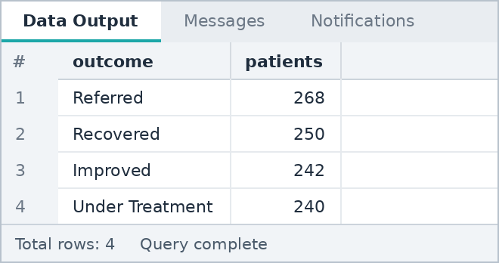

D5 Calculate totals by city/region/department/category.
SQL QUERY

SELECT city, COUNT(*) AS patients, SUM(treatment_cost) AS total_cost
FROM patients
GROUP BY city
ORDER BY total_cost DESC;

OUTPUT
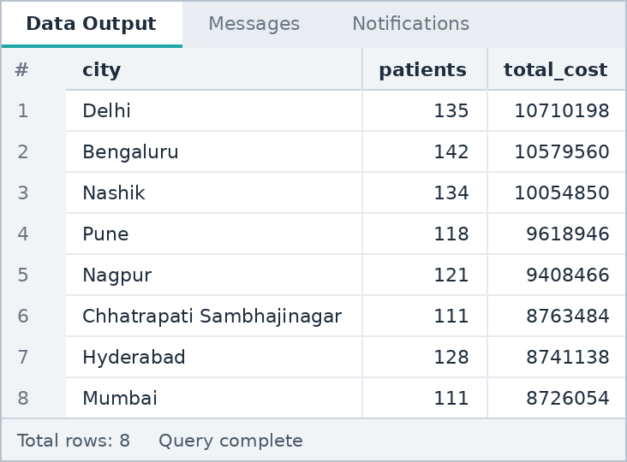

D6 Use HAVING with COUNT or SUM.
HAVING with COUNT
SQL QUERY

SELECT medical_condition, COUNT(*) AS patients
FROM patients
GROUP BY medical_condition
HAVING COUNT(*) > 130
ORDER BY patients DESC;

OUTPUT
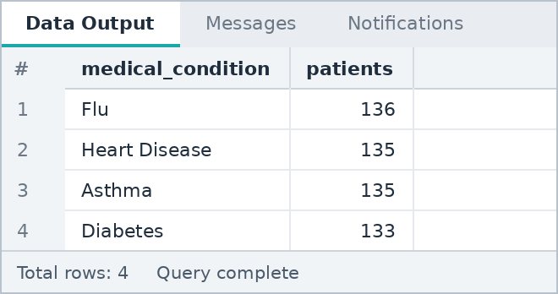
HAVING with SUM
SQL QUERY

SELECT city, SUM(treatment_cost) AS total_cost
FROM patients
GROUP BY city
HAVING SUM(treatment_cost) > 9500000
ORDER BY total_cost DESC;

OUTPUT
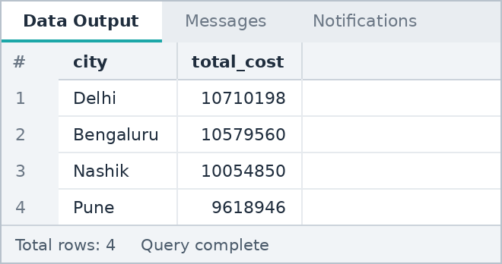

D7 Find groups above a selected threshold.
SQL QUERY

SELECT insurance_type, ROUND(AVG(treatment_cost),2) AS avg_cost
FROM patients
GROUP BY insurance_type
HAVING AVG(treatment_cost) > 76500
ORDER BY avg_cost DESC;

OUTPUT
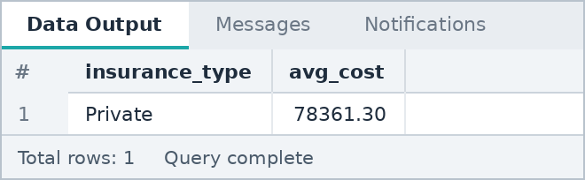
Note: Threshold used: average treatment cost above 76,500.

D8 Find the group with the highest aggregate value.
SQL QUERY

SELECT city, SUM(treatment_cost) AS total_cost
FROM patients
GROUP BY city
ORDER BY total_cost DESC
LIMIT 1;

OUTPUT
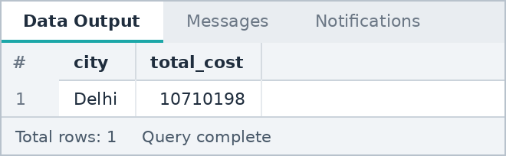

SECTION E

NULL, DISTINCT, CASE and Data Cleaning
CASE classification, COALESCE, blank values, duplicates and standardized labels
Questions in this section: 5 (E1 to E5)

E1 Create a CASE classification with at least 3 categories.
SQL QUERY

SELECT CASE
WHEN age < 36 THEN 'Young Adult (18-35)'
WHEN age < 60 THEN 'Middle Aged (36-59)'
ELSE 'Senior (60+)'
END AS age_group,
COUNT(*) AS patients
FROM patients
GROUP BY age_group
ORDER BY patients DESC;

OUTPUT
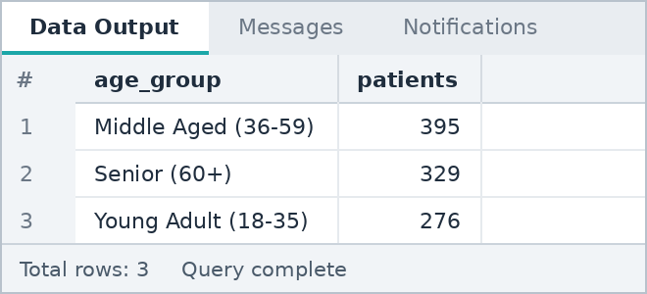

E2 Use COALESCE to handle NULL values.
SQL QUERY

SELECT patient_id, patient_name, medication,
COALESCE(NULLIF(medication, 'None'), 'Not Prescribed') AS medication_clean
FROM patients
WHERE medication = 'None'
ORDER BY patient_id;

OUTPUT
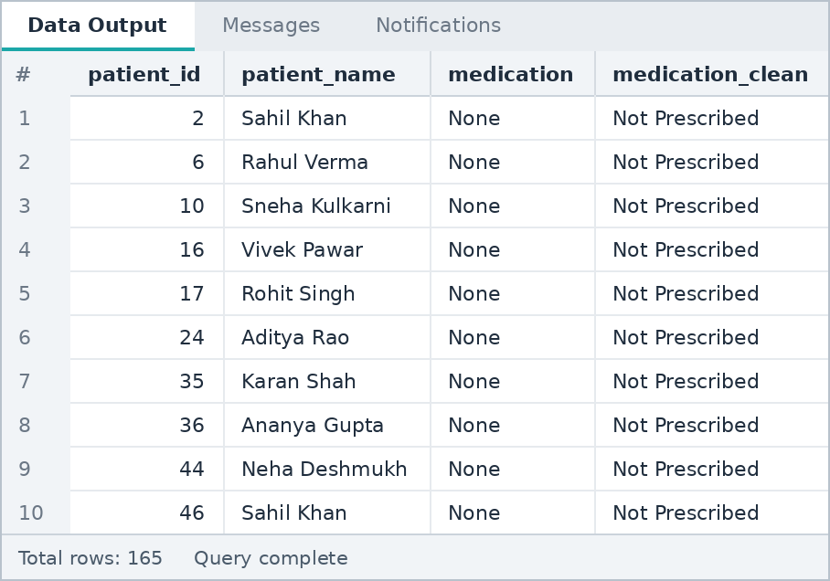
Note: In the dataset the value 'None' is stored as text. NULLIF converts it to a real NULL and COALESCE replaces that NULL with a clear label.

E3 Identify blank values if present.
SQL QUERY

SELECT SUM(CASE WHEN patient_name IS NULL OR TRIM(patient_name) = '' THEN 1 ELSE 0 END) AS blank_names,
SUM(CASE WHEN city IS NULL OR TRIM(city) = '' THEN 1 ELSE 0 END) AS blank_city,
SUM(CASE WHEN medication IS NULL OR TRIM(medication) = ''
OR medication = 'None' THEN 1 ELSE 0 END) AS no_medication
FROM patients;

OUTPUT
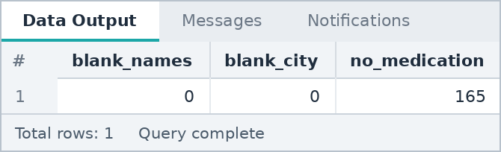
Note: Names and cities are complete. Only medication has empty entries (165 patients with None).

E4 Find duplicates using GROUP BY and HAVING COUNT(*) > 1.
Repeated names
SQL QUERY

SELECT patient_name, COUNT(*) AS occurrences
FROM patients
GROUP BY patient_name
HAVING COUNT(*) > 1
ORDER BY occurrences DESC;

OUTPUT
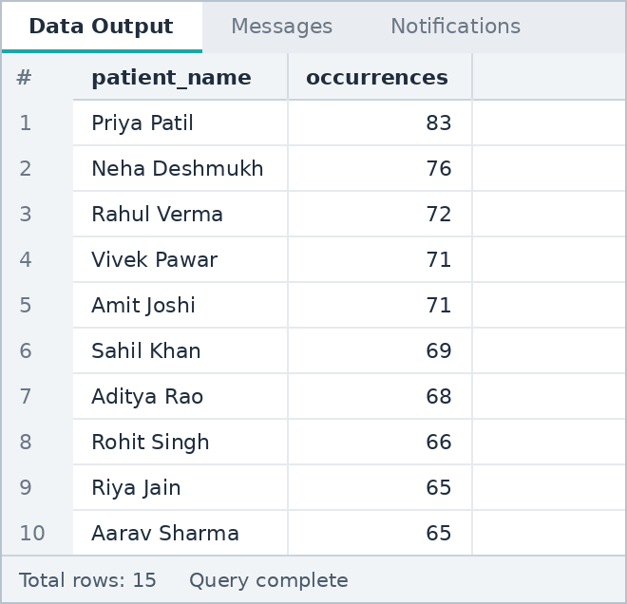
Real duplicates (same name, age, city and admission date)
SQL QUERY

SELECT patient_name, age, city, admission_date, COUNT(*) AS occurrences
FROM patients
GROUP BY patient_name, age, city, admission_date
HAVING COUNT(*) > 1;

OUTPUT
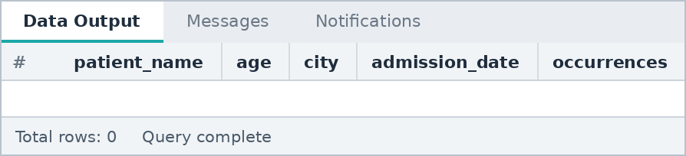
Note: Only a few names exist in the dataset, so names repeat many times. But no record repeats on name + age + city + admission date, and patient_id is unique, so there are no true duplicate records.

E5 Create a cleaned output with standardized labels.
SQL QUERY

SELECT patient_id,
UPPER(TRIM(patient_name)) AS patient_name,
UPPER(city) AS city,
CASE WHEN diabetic = 'Yes' THEN 'Diabetic' ELSE 'Non-Diabetic' END AS diabetes_status,
CASE WHEN smoker = 'Yes' THEN 'Smoker' ELSE 'Non-Smoker' END AS smoking_status,
COALESCE(NULLIF(medication, 'None'), 'Not Prescribed') AS medication
FROM patients
ORDER BY patient_id;

OUTPUT
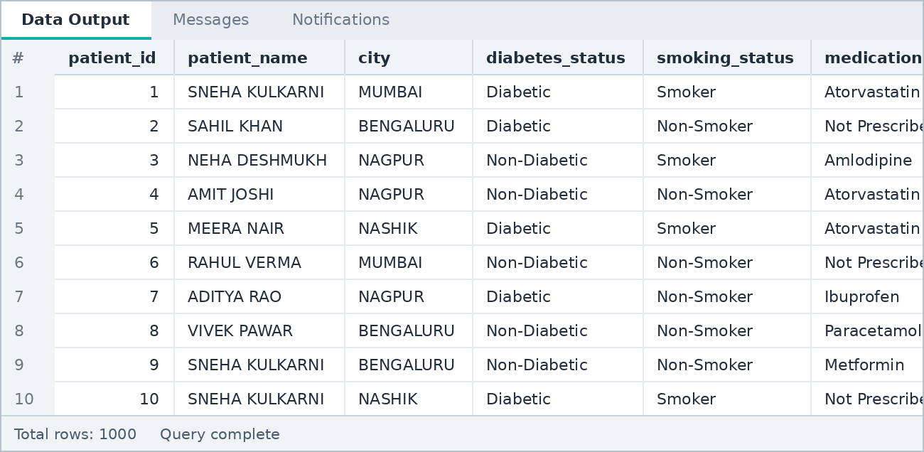

SECTION F

JOIN Practice
INNER JOIN, LEFT JOIN, unmatched records, three-table joins
Questions in this section: 6 (F1 to F6)

F1 INNER JOIN two related tables.
SQL QUERY

SELECT p.patient_id, p.patient_name, d.doctor_name, p.medical_condition
FROM patients p
INNER JOIN doctors d ON p.doctor_id = d.doctor_id
ORDER BY p.patient_id;

OUTPUT
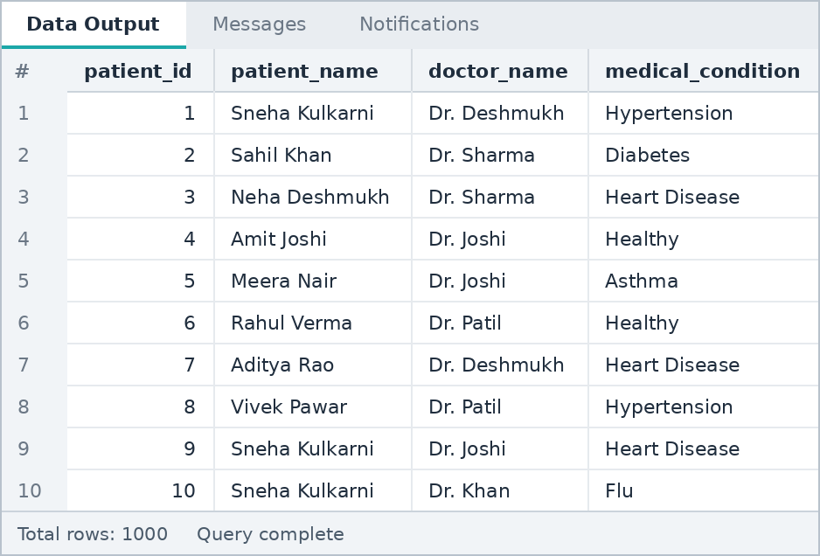

F2 LEFT JOIN two related tables.
SQL QUERY

SELECT p.patient_id, p.patient_name, p.readmission, r.record_id, r.recorded_on
FROM patients p
LEFT JOIN readmission_log r ON p.patient_id = r.patient_id
ORDER BY p.patient_id;

OUTPUT
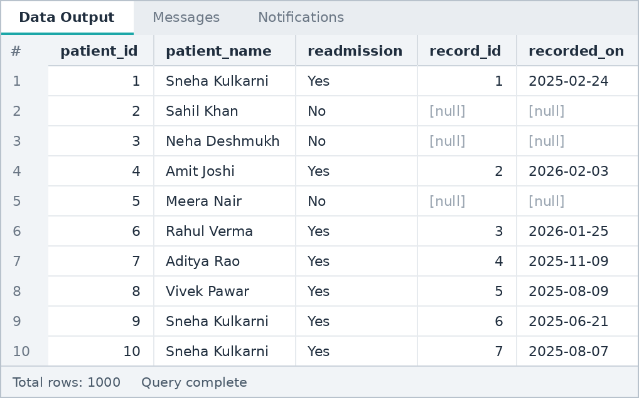
Note: Patients without a readmission record show [null] in record_id and recorded_on.

F3 Find parent records with no child record.
SQL QUERY

SELECT p.patient_id, p.patient_name, p.medical_condition
FROM patients p
LEFT JOIN readmission_log r ON p.patient_id = r.patient_id
WHERE r.record_id IS NULL
ORDER BY p.patient_id;

OUTPUT
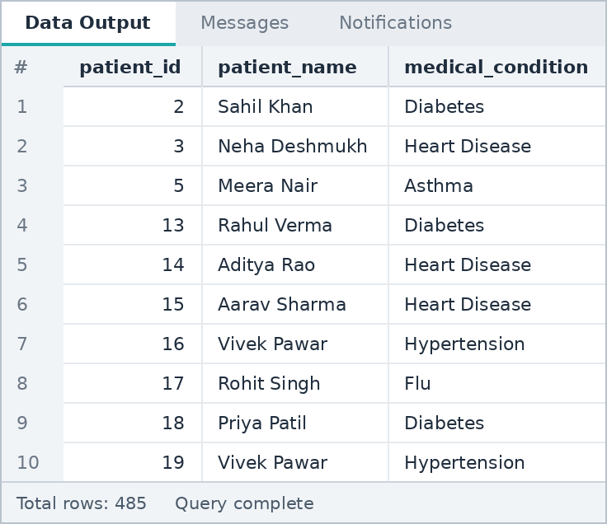
Note: These are the patients who were never readmitted.

F4 JOIN three tables and create a summary.
SQL QUERY

SELECT h.hospital_name, d.doctor_name,
COUNT(*) AS patients,
SUM(p.treatment_cost) AS total_cost
FROM patients p
JOIN doctors d ON p.doctor_id = d.doctor_id
JOIN hospitals h ON p.hospital_id = h.hospital_id
GROUP BY h.hospital_name, d.doctor_name
ORDER BY total_cost DESC;

OUTPUT
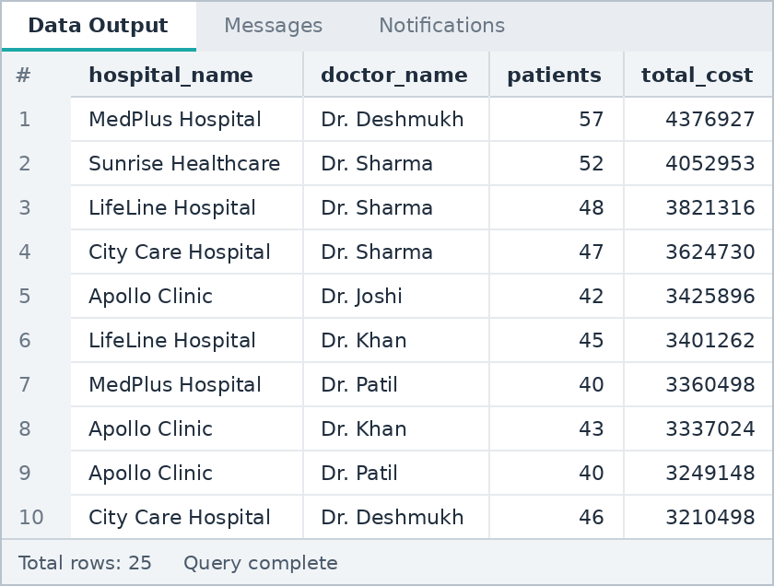

F5 Use JOIN + GROUP BY for category/entity totals.
SQL QUERY

SELECT h.hospital_name,
COUNT(p.patient_id) AS patients,
SUM(p.treatment_cost) AS total_cost,
ROUND(AVG(p.treatment_cost),2) AS avg_cost
FROM hospitals h
JOIN patients p ON p.hospital_id = h.hospital_id
GROUP BY h.hospital_name
ORDER BY total_cost DESC;

OUTPUT
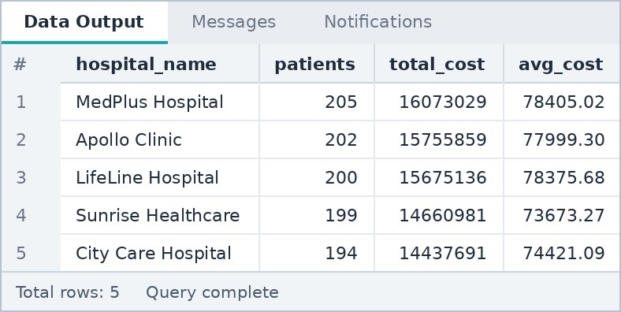

F6 Compare two related tables and find unmatched records.
SQL QUERY

SELECT 'Patients without readmission record' AS unmatched_type, COUNT(*) AS records
FROM patients p
LEFT JOIN readmission_log r ON p.patient_id = r.patient_id
WHERE r.record_id IS NULL
UNION ALL
SELECT 'Readmission records without patient', COUNT(*)
FROM readmission_log r
LEFT JOIN patients p ON p.patient_id = r.patient_id
WHERE p.patient_id IS NULL;

OUTPUT
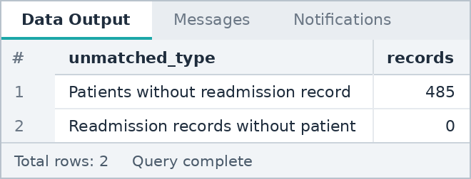
Note: 485 patients have no readmission record, and no readmission record is orphaned (every record points to a valid patient).

SECTION G

UNION / UNION ALL
Combining result sets
Questions in this section: 3 (G1 to G3)

G1 Write a UNION between two compatible result sets.
SQL QUERY

SELECT city FROM patients WHERE diabetic = 'Yes'
UNION
SELECT city FROM patients WHERE smoker = 'Yes'
ORDER BY city;

OUTPUT
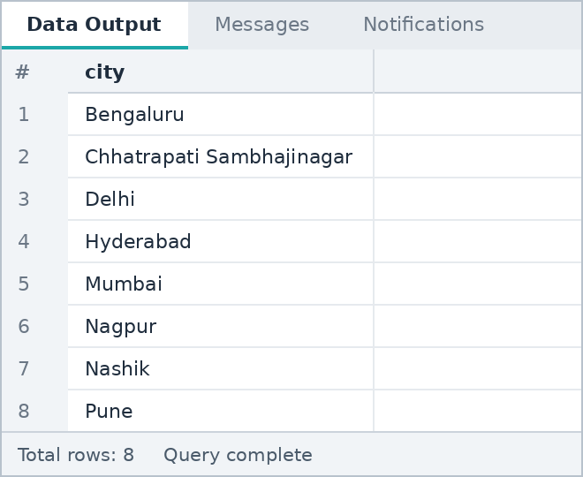
Note: UNION removes duplicates, so each city appears once.

G2 Write UNION ALL and explain the difference.
SQL QUERY

SELECT 'UNION' AS method, COUNT(*) AS rows_returned
FROM (SELECT city FROM patients WHERE diabetic = 'Yes'
UNION
SELECT city FROM patients WHERE smoker = 'Yes') t
UNION ALL
SELECT 'UNION ALL', COUNT(*)
FROM (SELECT city FROM patients WHERE diabetic = 'Yes'
UNION ALL
SELECT city FROM patients WHERE smoker = 'Yes') t;

OUTPUT
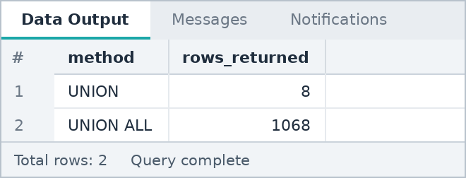
Note: UNION removes duplicate rows (8 unique cities), while UNION ALL keeps every row (567 diabetic + 501 smoker = 1068). UNION ALL is faster because it does no duplicate check.

G3 Combine two business categories into one result.
SQL QUERY

SELECT patient_id, patient_name, treatment_cost, 'Emergency admission' AS category
FROM patients
WHERE admission_type = 'Emergency' AND treatment_cost > 148000
UNION ALL
SELECT patient_id, patient_name, treatment_cost, 'Private insurance'
FROM patients
WHERE insurance_type = 'Private' AND treatment_cost > 148000
ORDER BY treatment_cost DESC;

OUTPUT
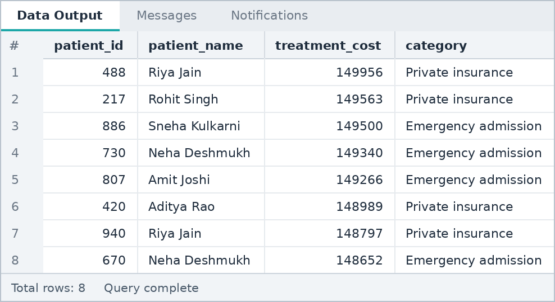
Note: Patients with cost above 148,000 from two business categories in one list.

SECTION H

Subqueries
Scalar, multi-row and correlated subqueries
Questions in this section: 5 (H1 to H5)

H1 Find records above the overall average using a scalar subquery.
SQL QUERY

SELECT patient_id, patient_name, treatment_cost
FROM patients
WHERE treatment_cost > (SELECT AVG(treatment_cost) FROM patients)
ORDER BY treatment_cost DESC;

OUTPUT
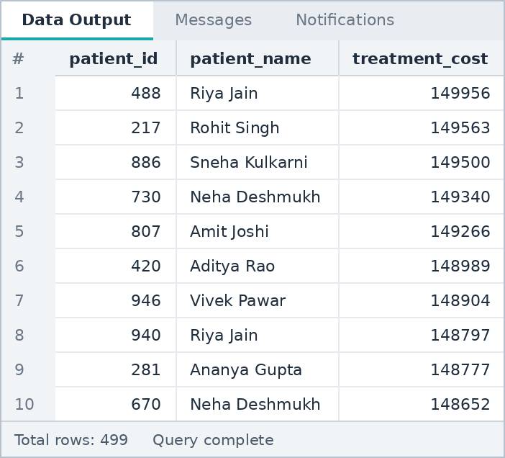

H2 Find the maximum and minimum value using subqueries.
SQL QUERY

SELECT patient_id, patient_name, treatment_cost
FROM patients
WHERE treatment_cost = (SELECT MAX(treatment_cost) FROM patients)
OR treatment_cost = (SELECT MIN(treatment_cost) FROM patients);

OUTPUT
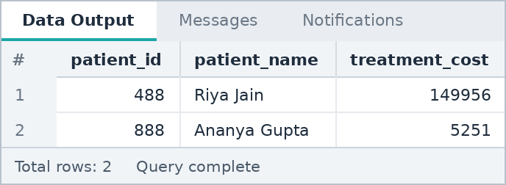

H3 Use IN with a multi-row subquery.
SQL QUERY

SELECT patient_id, patient_name, medical_condition, doctor_id
FROM patients
WHERE doctor_id IN (SELECT doctor_id
FROM doctors
WHERE doctor_name IN ('Dr. Sharma', 'Dr. Khan'))
ORDER BY patient_id;

OUTPUT
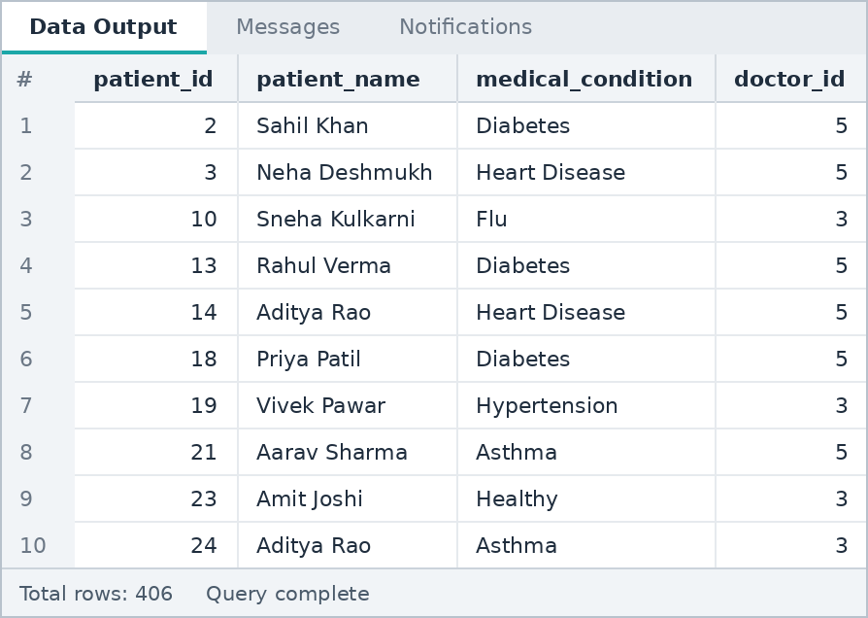

H4 Use NOT IN with a multi-row subquery.
SQL QUERY

SELECT patient_id, patient_name, medical_condition
FROM patients
WHERE patient_id NOT IN (SELECT patient_id FROM readmission_log)
ORDER BY patient_id;

OUTPUT

H5 Compare each entity with its category/group average using a correlated subquery.
SQL QUERY

SELECT p.patient_id, p.patient_name, p.medical_condition, p.treatment_cost
FROM patients p
WHERE p.treatment_cost > (SELECT AVG(p2.treatment_cost)
FROM patients p2
WHERE p2.medical_condition = p.medical_condition)
ORDER BY p.patient_id;

OUTPUT
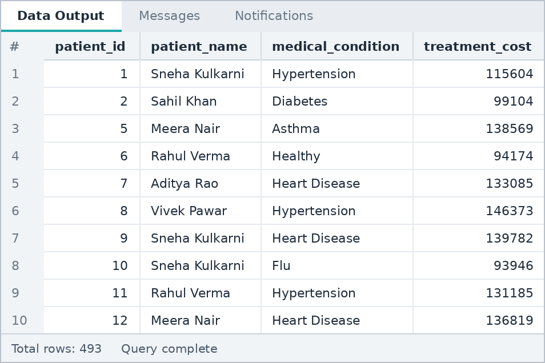
Note: Each patient's cost is compared with the average cost of the same medical condition.

SECTION I

EXISTS / NOT EXISTS
Existence checks and correlated subqueries
Questions in this section: 4 (I1 to I4)

I1 Use EXISTS to find entities having related records.
SQL QUERY

SELECT d.doctor_id, d.doctor_name
FROM doctors d
WHERE EXISTS (SELECT 1 FROM patients p WHERE p.doctor_id = d.doctor_id);

OUTPUT
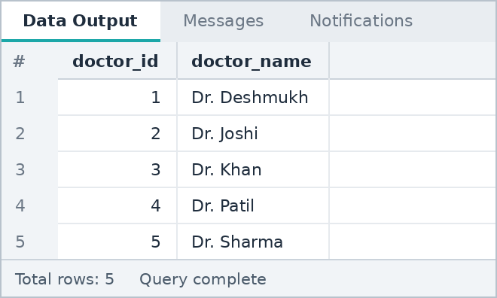

I2 Use NOT EXISTS to find entities without related records.
SQL QUERY

SELECT p.patient_id, p.patient_name, p.medical_condition
FROM patients p
WHERE NOT EXISTS (SELECT 1 FROM readmission_log r WHERE r.patient_id = p.patient_id)
ORDER BY p.patient_id;

OUTPUT

I3 Use a correlated subquery to find the maximum value within each group.
SQL QUERY

SELECT p.medical_condition, p.patient_id, p.patient_name, p.treatment_cost
FROM patients p
WHERE p.treatment_cost = (SELECT MAX(p2.treatment_cost)
FROM patients p2
WHERE p2.medical_condition = p.medical_condition)
ORDER BY p.medical_condition;

OUTPUT
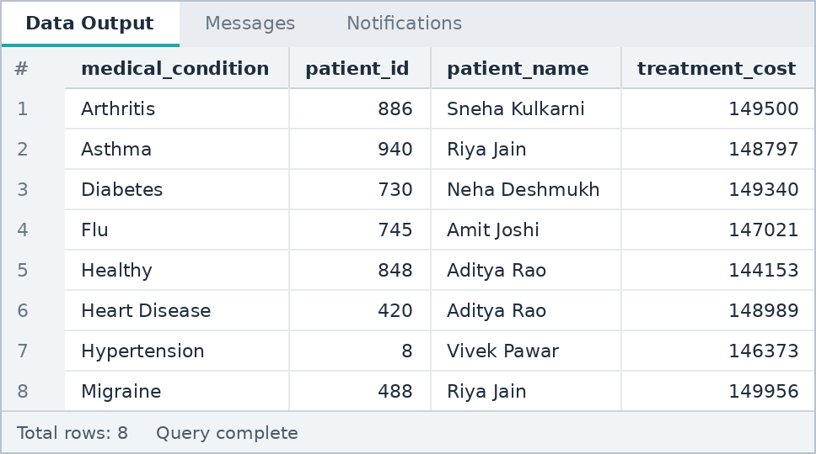

I4 Explain IN vs EXISTS using your dataset.
SQL QUERY

SELECT
(SELECT COUNT(*) FROM patients
WHERE patient_id IN (SELECT patient_id FROM readmission_log)) AS count_using_in,
(SELECT COUNT(*) FROM patients p
WHERE EXISTS (SELECT 1 FROM readmission_log r
WHERE r.patient_id = p.patient_id)) AS count_using_exists;

OUTPUT
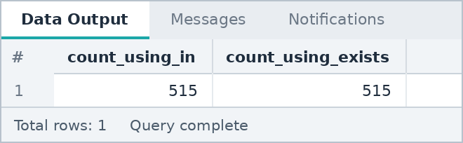

 | IN | EXISTS
How it works | Builds the list of values from the subquery, then checks membership | Checks row by row whether at least one matching row exists
Returns | Compares actual values | TRUE or FALSE only (the selected column does not matter)
NULL handling | NOT IN returns nothing if the list contains a NULL | NOT EXISTS is safe with NULLs
Best when | The subquery result is small | The subquery table is large or the check is correlated
Note: Both queries return the same 515 patients who have a readmission record. EXISTS is the safer choice for the "no record" case (NOT EXISTS).

SECTION J

CTE Practice
WITH clauses, multiple CTEs and final reports
Questions in this section: 7 (J1 to J7)

J1 Create a basic CTE and query it.
SQL QUERY

WITH high_cost AS (
SELECT * FROM patients WHERE treatment_cost > 100000
)
SELECT patient_id, patient_name, medical_condition, treatment_cost
FROM high_cost
ORDER BY treatment_cost DESC;

OUTPUT
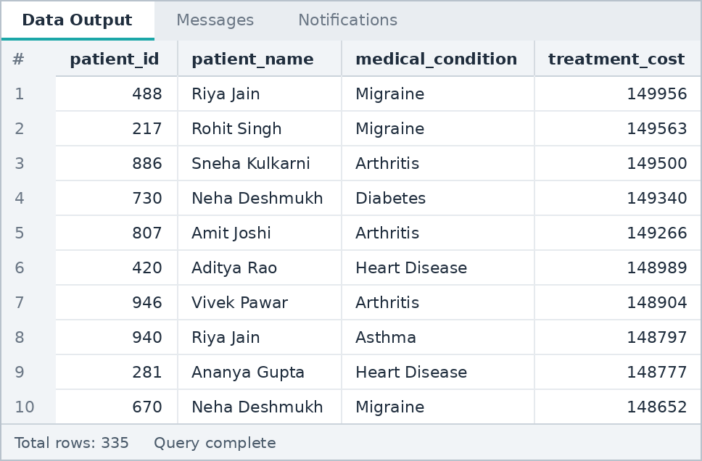

J2 Create a CTE with GROUP BY.
SQL QUERY

WITH condition_summary AS (
SELECT medical_condition,
COUNT(*) AS patients,
SUM(treatment_cost) AS total_cost
FROM patients
GROUP BY medical_condition
)
SELECT * FROM condition_summary
ORDER BY total_cost DESC;

OUTPUT
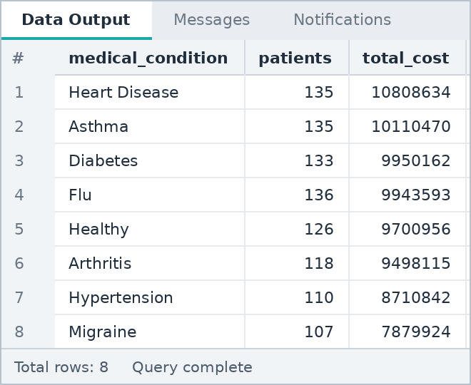

J3 Create two CTEs and JOIN them.
SQL QUERY

WITH cond_avg AS (
SELECT medical_condition, ROUND(AVG(treatment_cost),2) AS avg_cost
FROM patients GROUP BY medical_condition
),
emergency_cnt AS (
SELECT medical_condition, COUNT(*) AS emergency_cases
FROM patients WHERE admission_type = 'Emergency'
GROUP BY medical_condition
)
SELECT a.medical_condition, a.avg_cost, e.emergency_cases
FROM cond_avg a
JOIN emergency_cnt e ON a.medical_condition = e.medical_condition
ORDER BY a.avg_cost DESC;

OUTPUT
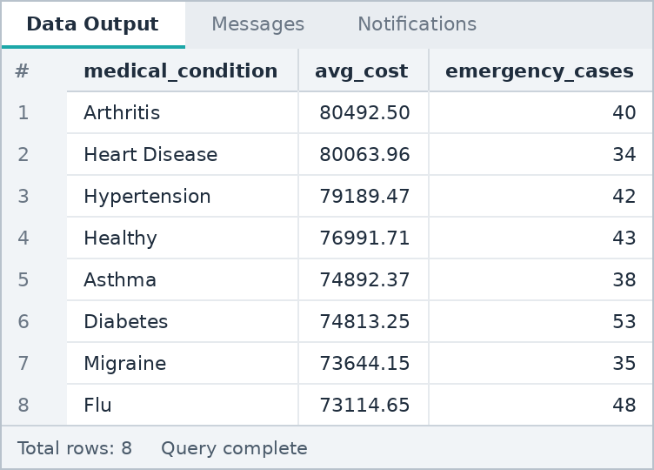

J4 Create three CTEs for three separate metrics and combine them.
SQL QUERY

WITH city_patients AS (
SELECT city, COUNT(*) AS patients FROM patients GROUP BY city
),
city_cost AS (
SELECT city, SUM(treatment_cost) AS total_cost FROM patients GROUP BY city
),
city_stay AS (
SELECT city, ROUND(AVG(length_of_stay),2) AS avg_stay FROM patients GROUP BY city
)
SELECT p.city, p.patients, c.total_cost, s.avg_stay
FROM city_patients p
JOIN city_cost c ON p.city = c.city
JOIN city_stay s ON p.city = s.city
ORDER BY c.total_cost DESC;

OUTPUT
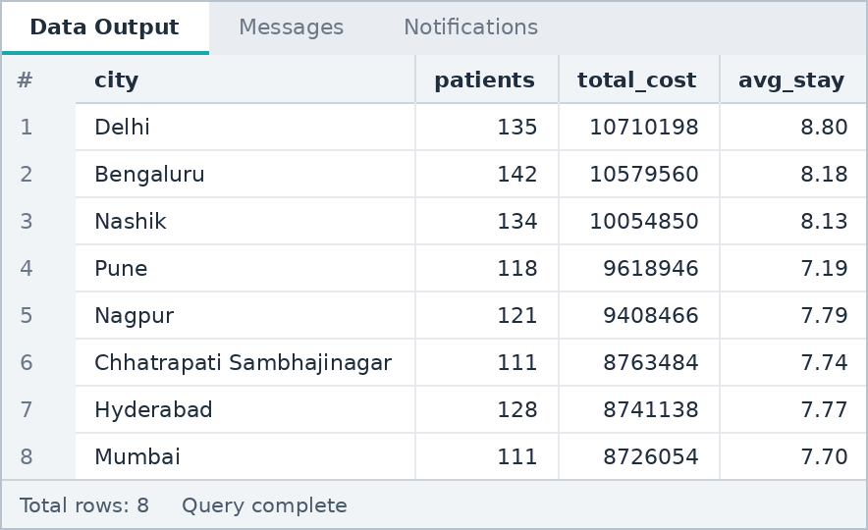

J5 Create a CTE for entity totals and filter high-value entities.
SQL QUERY

WITH doctor_totals AS (
SELECT doctor_id, COUNT(*) AS patients, SUM(treatment_cost) AS total_cost
FROM patients
GROUP BY doctor_id
)
SELECT d.doctor_name, t.patients, t.total_cost
FROM doctor_totals t
JOIN doctors d ON d.doctor_id = t.doctor_id
WHERE t.total_cost > (SELECT AVG(total_cost) FROM doctor_totals)
ORDER BY t.total_cost DESC;

OUTPUT
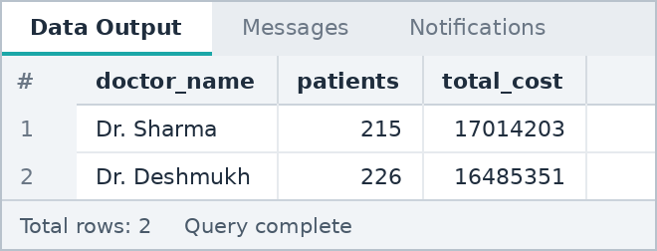
Note: Doctors whose total billing is above the average doctor total.

J6 Create a monthly/category summary using a CTE.
SQL QUERY

WITH monthly AS (
SELECT TO_CHAR(admission_date, 'YYYY-MM') AS month,
COUNT(*) AS admissions,
SUM(treatment_cost) AS total_cost
FROM patients
GROUP BY TO_CHAR(admission_date, 'YYYY-MM')
)
SELECT * FROM monthly
ORDER BY month;

OUTPUT
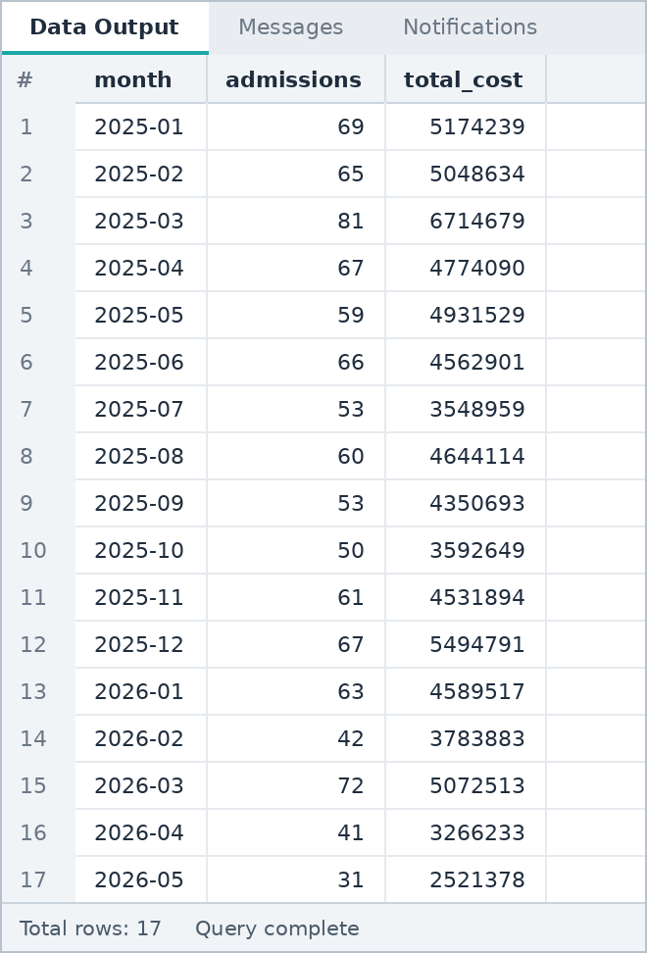

J7 Create a final report using multiple CTEs and at least one JOIN.
SQL QUERY

WITH hospital_stats AS (
SELECT hospital_id, COUNT(*) AS patients, SUM(treatment_cost) AS total_cost
FROM patients GROUP BY hospital_id
),
emergency_stats AS (
SELECT hospital_id, COUNT(*) AS emergency_cases
FROM patients WHERE admission_type = 'Emergency' GROUP BY hospital_id
)
SELECT h.hospital_name, s.patients, e.emergency_cases, s.total_cost
FROM hospitals h
JOIN hospital_stats s ON s.hospital_id = h.hospital_id
JOIN emergency_stats e ON e.hospital_id = h.hospital_id
ORDER BY s.total_cost DESC;

OUTPUT
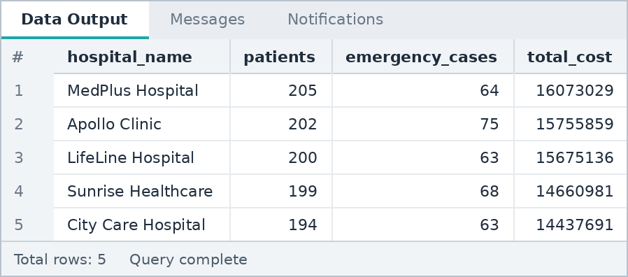

SECTION K

Window Functions
ROW_NUMBER, RANK, DENSE_RANK, running totals, LAG and LEAD
Questions in this section: 12 (K1 to K12)

K1 Use ROW_NUMBER() to number all records by a relevant metric.
SQL QUERY

SELECT patient_id, patient_name, treatment_cost,
ROW_NUMBER() OVER (ORDER BY treatment_cost DESC) AS row_no
FROM patients;

OUTPUT
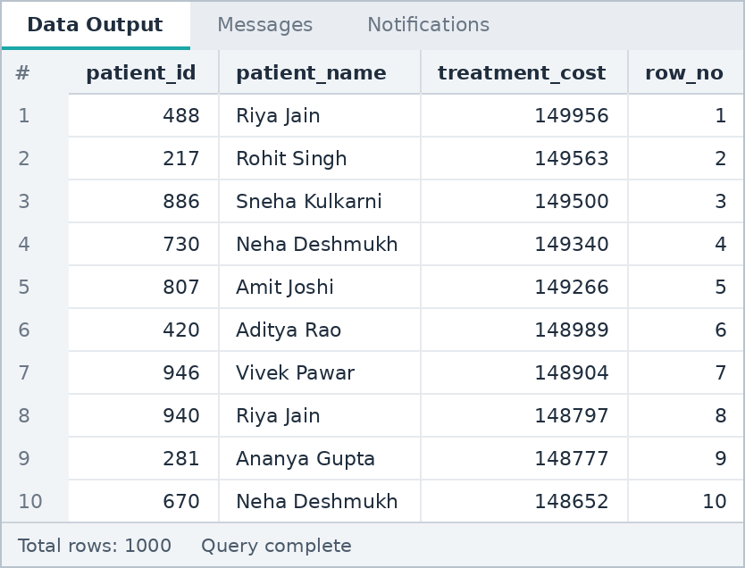

K2 Use ROW_NUMBER() with PARTITION BY category/entity group.
SQL QUERY

SELECT medical_condition, patient_id, treatment_cost,
ROW_NUMBER() OVER (PARTITION BY medical_condition
ORDER BY treatment_cost DESC) AS row_no
FROM patients
ORDER BY medical_condition, row_no;

OUTPUT
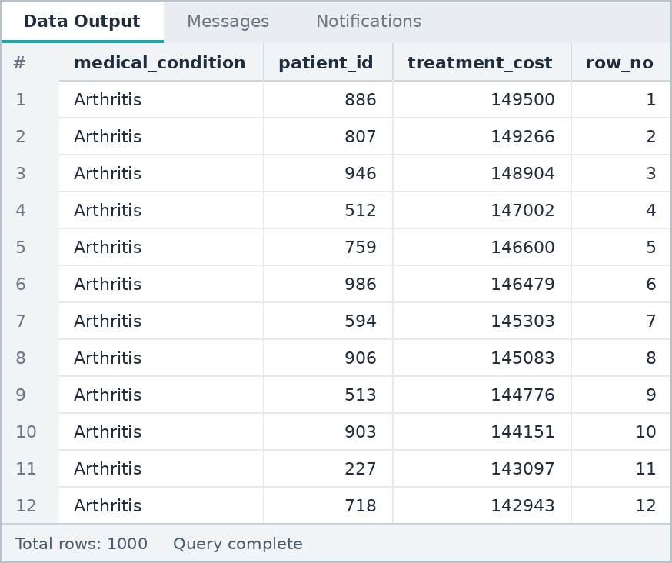

K3 Use RANK() to rank entities by a metric.
SQL QUERY

SELECT city, SUM(treatment_cost) AS total_cost,
RANK() OVER (ORDER BY SUM(treatment_cost) DESC) AS cost_rank
FROM patients
GROUP BY city;

OUTPUT
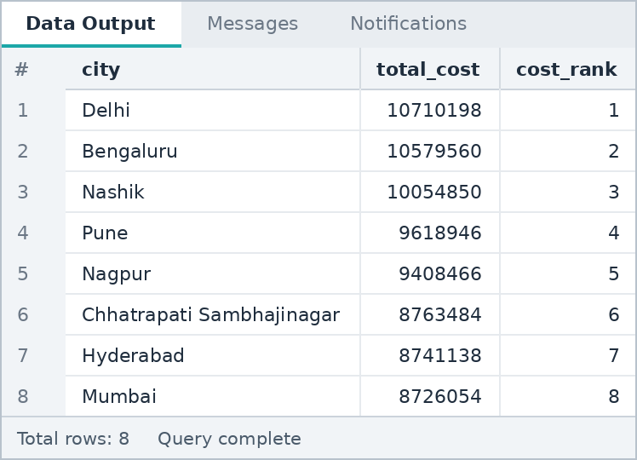

K4 Compare RANK() and DENSE_RANK() when ties exist.
SQL QUERY

SELECT blood_group, COUNT(*) AS patients,
RANK() OVER (ORDER BY COUNT(*) DESC) AS rank_no,
DENSE_RANK() OVER (ORDER BY COUNT(*) DESC) AS dense_rank_no
FROM patients
GROUP BY blood_group;

OUTPUT
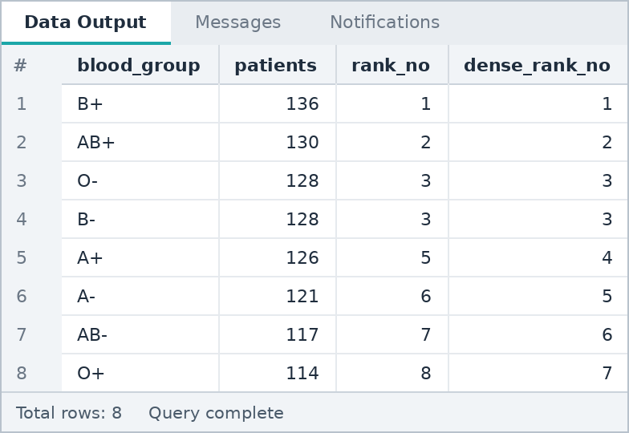
Note: B- and O- both have 128 patients (a tie). RANK gives both rank 3 and then skips to 5. DENSE_RANK gives both rank 3 and continues with 4 without any gap.

K5 Find the top 3 entities in each category.
SQL QUERY

SELECT medical_condition, patient_id, patient_name, treatment_cost, rn
FROM (
SELECT medical_condition, patient_id, patient_name, treatment_cost,
ROW_NUMBER() OVER (PARTITION BY medical_condition
ORDER BY treatment_cost DESC) AS rn
FROM patients
) t
WHERE rn <= 3
ORDER BY medical_condition, rn;

OUTPUT
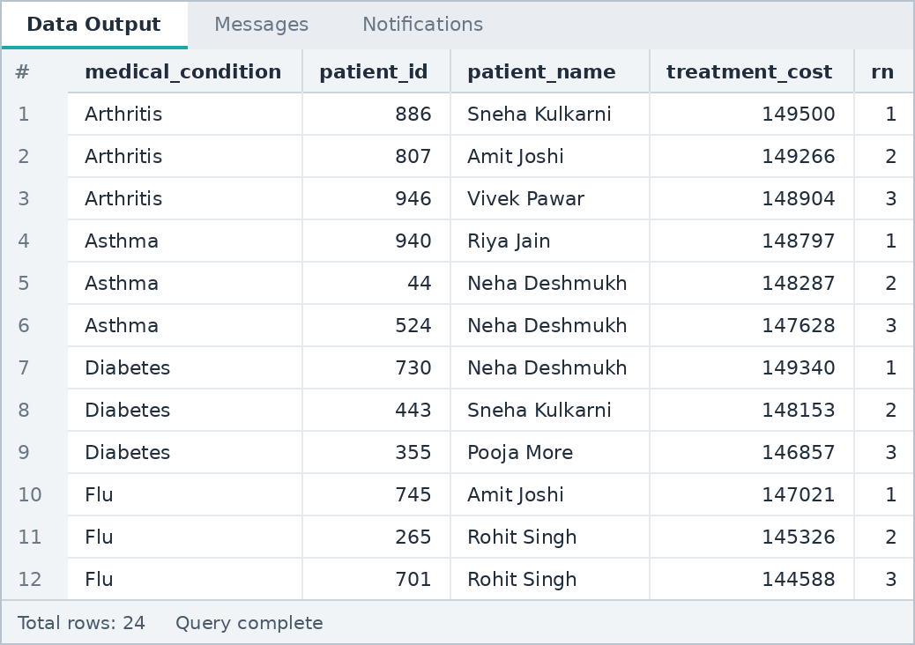

K6 Find the highest-value record in each category.
SQL QUERY

SELECT admission_type, patient_id, patient_name, treatment_cost
FROM (
SELECT admission_type, patient_id, patient_name, treatment_cost,
ROW_NUMBER() OVER (PARTITION BY admission_type
ORDER BY treatment_cost DESC) AS rn
FROM patients
) t
WHERE rn = 1;

OUTPUT
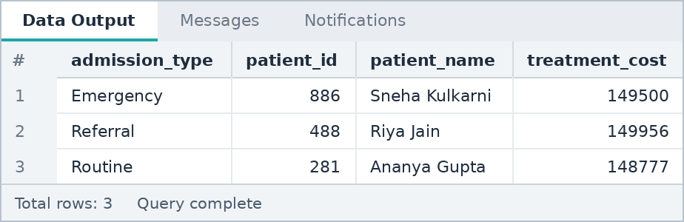

K7 Find the second-highest value in each category.
SQL QUERY

SELECT medical_condition, patient_id, patient_name, treatment_cost
FROM (
SELECT medical_condition, patient_id, patient_name, treatment_cost,
DENSE_RANK() OVER (PARTITION BY medical_condition
ORDER BY treatment_cost DESC) AS dr
FROM patients
) t
WHERE dr = 2
ORDER BY medical_condition;

OUTPUT
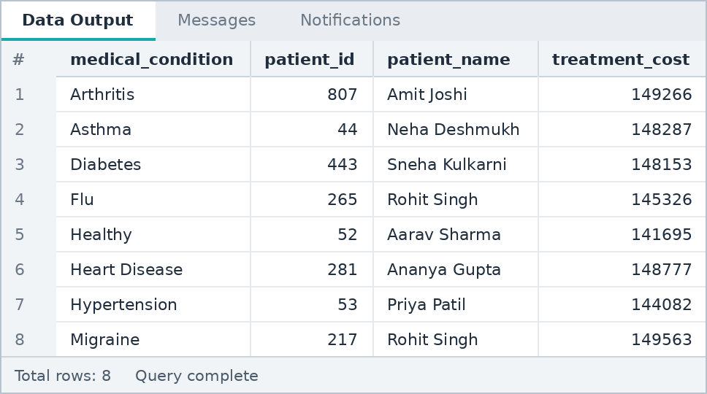

K8 Calculate a running total ordered by date.
SQL QUERY

WITH daily AS (
SELECT admission_date, SUM(treatment_cost) AS daily_cost
FROM patients
GROUP BY admission_date
)
SELECT admission_date, daily_cost,
SUM(daily_cost) OVER (ORDER BY admission_date) AS running_total
FROM daily
ORDER BY admission_date;

OUTPUT
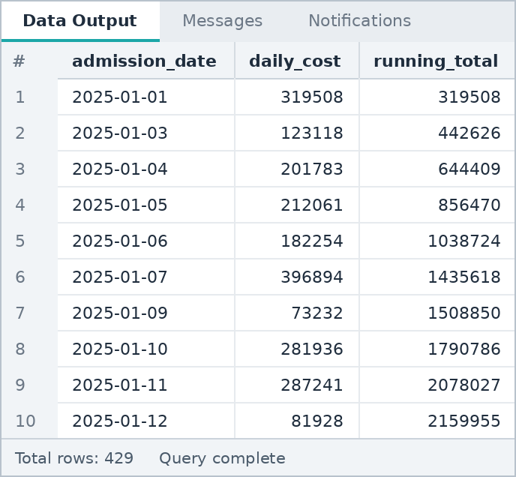

K9 Use LAG() to compare current and previous value.
SQL QUERY

WITH monthly AS (
SELECT TO_CHAR(admission_date, 'YYYY-MM') AS month,
SUM(treatment_cost) AS total_cost
FROM patients
GROUP BY TO_CHAR(admission_date, 'YYYY-MM')
)
SELECT month, total_cost,
LAG(total_cost) OVER (ORDER BY month) AS previous_month_cost
FROM monthly
ORDER BY month;

OUTPUT
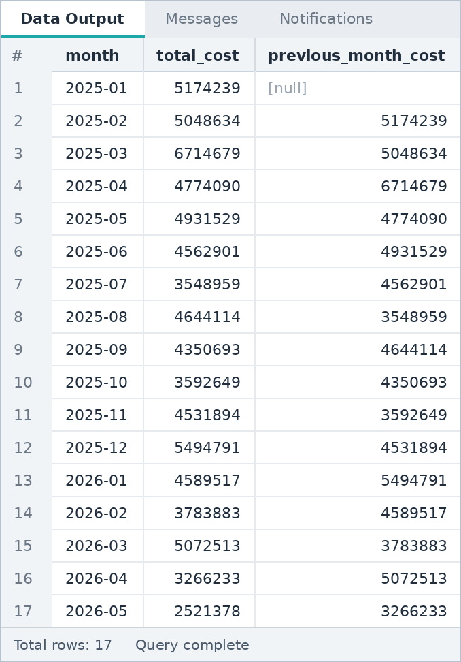

K10 Use LEAD() to compare current and next value.
SQL QUERY

WITH monthly AS (
SELECT TO_CHAR(admission_date, 'YYYY-MM') AS month,
SUM(treatment_cost) AS total_cost
FROM patients
GROUP BY TO_CHAR(admission_date, 'YYYY-MM')
)
SELECT month, total_cost,
LEAD(total_cost) OVER (ORDER BY month) AS next_month_cost
FROM monthly
ORDER BY month;

OUTPUT
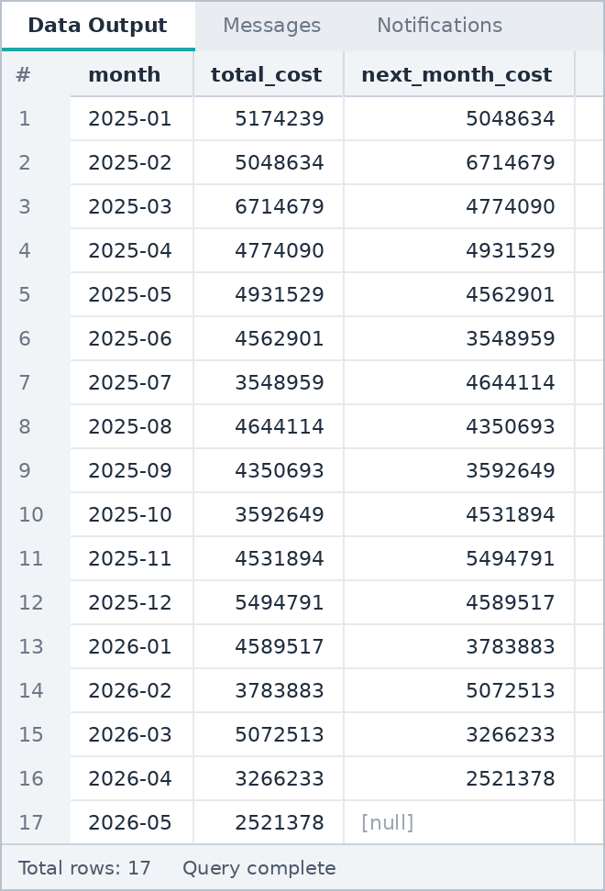

K11 Calculate current-minus-previous using LAG().
SQL QUERY

WITH monthly AS (
SELECT TO_CHAR(admission_date, 'YYYY-MM') AS month,
SUM(treatment_cost) AS total_cost
FROM patients
GROUP BY TO_CHAR(admission_date, 'YYYY-MM')
)
SELECT month, total_cost,
total_cost - LAG(total_cost) OVER (ORDER BY month) AS change_from_previous
FROM monthly
ORDER BY month;

OUTPUT
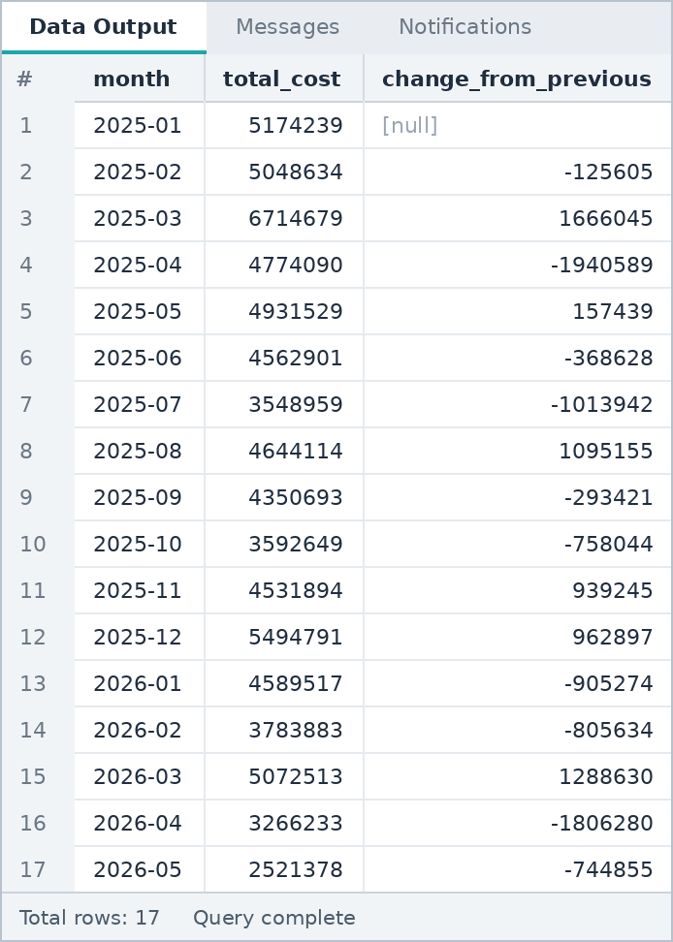
Note: The first month has no previous month, so the change is NULL.

K12 Use a CTE + window function to create a top-entities-per-category report.
SQL QUERY

WITH city_condition AS (
SELECT medical_condition, city, SUM(treatment_cost) AS total_cost
FROM patients
GROUP BY medical_condition, city
),
ranked AS (
SELECT medical_condition, city, total_cost,
RANK() OVER (PARTITION BY medical_condition
ORDER BY total_cost DESC) AS city_rank
FROM city_condition
)
SELECT medical_condition, city, total_cost, city_rank
FROM ranked
WHERE city_rank <= 3
ORDER BY medical_condition, city_rank;

OUTPUT
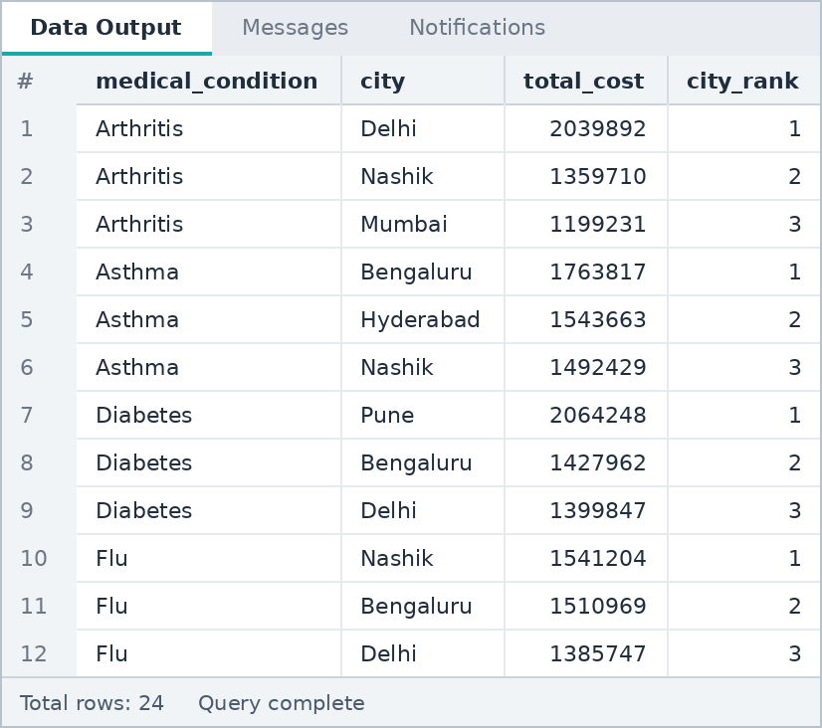
Note: Top 3 cities by total treatment cost for every medical condition.

SECTION L

Healthcare Business Practice
Business questions, final summary and insights
Questions in this section: 9 (L1 to L9)

L1 Count patients/users/visits/appointments/claims.
SQL QUERY

SELECT COUNT(*) AS total_admissions,
COUNT(DISTINCT city) AS cities,
SUM(CASE WHEN admission_type = 'Emergency' THEN 1 ELSE 0 END) AS emergency_admissions,
SUM(CASE WHEN readmission = 'Yes' THEN 1 ELSE 0 END) AS readmissions
FROM patients;

OUTPUT
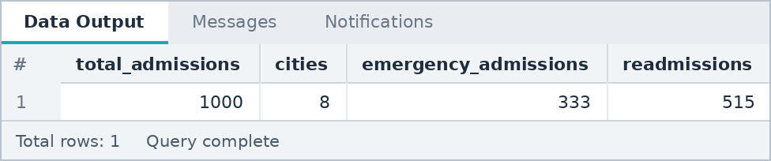

L2 Find average age or another suitable patient metric.
SQL QUERY

SELECT gender,
COUNT(*) AS patients,
ROUND(AVG(age),1) AS avg_age,
ROUND(AVG(bmi),1) AS avg_bmi,
ROUND(AVG(length_of_stay),1) AS avg_stay_days
FROM patients
GROUP BY gender;

OUTPUT
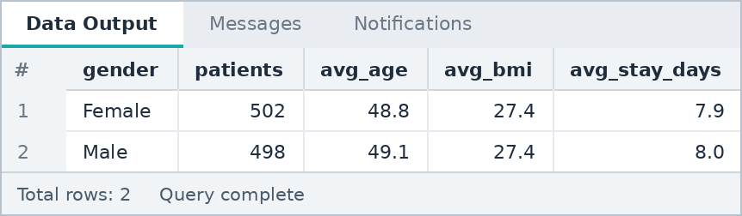

L3 Find total billing/claim/medical expense value.
SQL QUERY

SELECT insurance_type,
COUNT(*) AS patients,
SUM(treatment_cost) AS total_billing
FROM patients
GROUP BY insurance_type
ORDER BY total_billing DESC;

OUTPUT
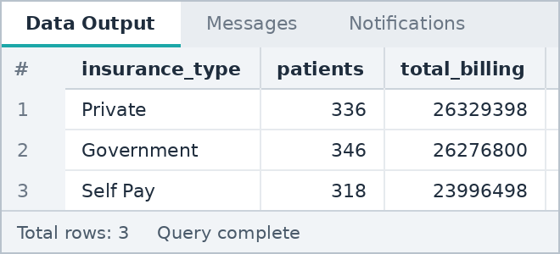

L4 Find activity by doctor, department, hospital or category.
SQL QUERY

SELECT d.doctor_name,
COUNT(*) AS patients,
SUM(p.treatment_cost) AS total_billing,
ROUND(AVG(p.length_of_stay),1) AS avg_stay_days
FROM patients p
JOIN doctors d ON p.doctor_id = d.doctor_id
GROUP BY d.doctor_name
ORDER BY patients DESC;

OUTPUT
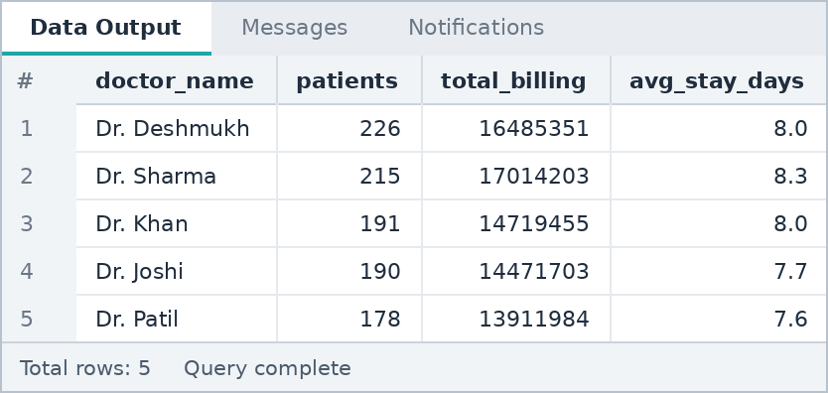

L5 Find patients/entities with no appointment/visit/claim/record.
SQL QUERY

SELECT h.hospital_name, COUNT(*) AS patients_without_readmission
FROM patients p
JOIN hospitals h ON p.hospital_id = h.hospital_id
LEFT JOIN readmission_log r ON p.patient_id = r.patient_id
WHERE r.record_id IS NULL
GROUP BY h.hospital_name
ORDER BY patients_without_readmission DESC;

OUTPUT
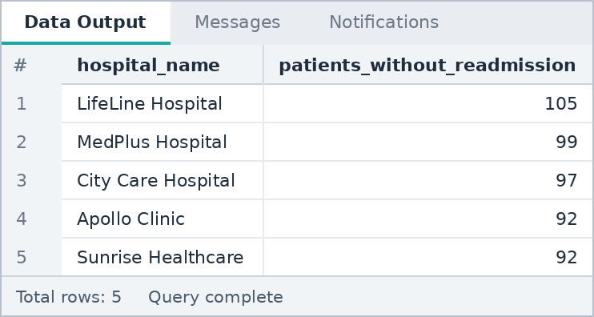

L6 Find the month with the highest activity or billing.
SQL QUERY

SELECT TO_CHAR(admission_date, 'YYYY-MM') AS month,
COUNT(*) AS admissions,
SUM(treatment_cost) AS total_billing
FROM patients
GROUP BY TO_CHAR(admission_date, 'YYYY-MM')
ORDER BY total_billing DESC
LIMIT 1;

OUTPUT
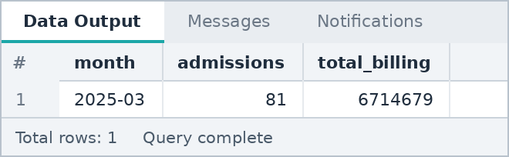

L7 Find the highest-cost/highest-billed category or entity.
SQL QUERY

SELECT medical_condition,
SUM(treatment_cost) AS total_billing,
ROUND(AVG(treatment_cost),2) AS avg_cost
FROM patients
GROUP BY medical_condition
ORDER BY total_billing DESC
LIMIT 3;

OUTPUT
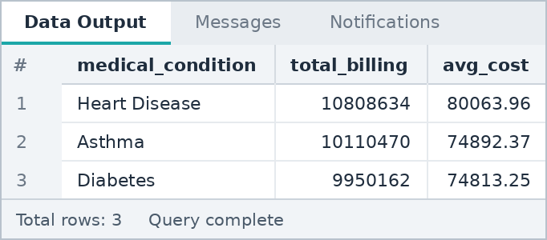

L8 Create a final patient/entity summary using JOIN + CTE.
SQL QUERY

WITH readmit AS (
SELECT patient_id, COUNT(*) AS readmission_count
FROM readmission_log
GROUP BY patient_id
)
SELECT p.patient_id, p.patient_name, d.doctor_name, h.hospital_name,
p.treatment_cost, COALESCE(r.readmission_count, 0) AS readmissions
FROM patients p
JOIN doctors d ON p.doctor_id = d.doctor_id
JOIN hospitals h ON p.hospital_id = h.hospital_id
LEFT JOIN readmit r ON p.patient_id = r.patient_id
ORDER BY p.treatment_cost DESC;

OUTPUT
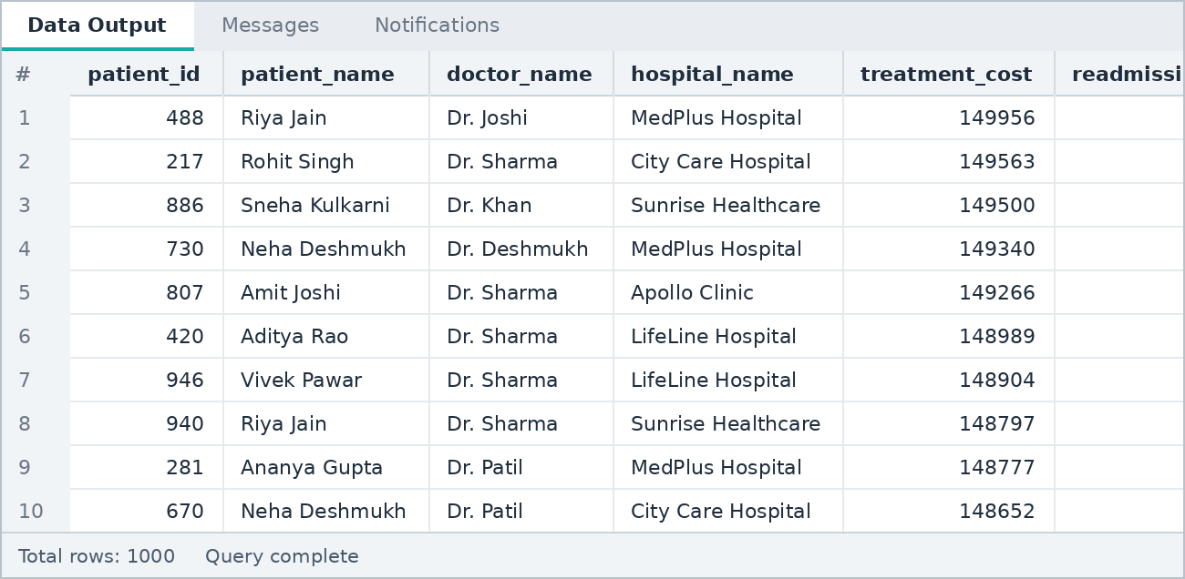

L9 Write 5 business insights from your SQL results.
1 | Heart Disease drives the highest billing  Heart Disease patients generated 10,808,634 in treatment cost, about 14.1% of the total 76,602,696 (L7, D2). Arthritis has the highest average cost per patient (80,492.50, J3), so cost per case and total cost point to different conditions.  Action: Plan budgets and specialist capacity around cardiac care first.

2 | Billing is spread across cities, with Delhi and Bengaluru in front  Delhi leads with 10,710,198 (14.0% of billing) and Bengaluru follows with 10,579,560 (13.8%) (D5, D8). Only four of the eight cities cross the 9.5 million mark (D6), so no single city dominates.  Action: Focus service expansion and staffing in the top cities.

3 | March 2025 was the peak month  March 2025 had the highest activity: 81 admissions and 6,714,679 in billing (L6, K9). That is about 49% above the average month over the 17 months in the data (about 4.5 million).  Action: Check what caused the spike and prepare capacity for similar periods.

4 | More than half of the patients have a readmission record  515 of 1,000 patients (51.5%) have a readmission record, while 485 have none (L1, F3, F6). Emergency admissions make up 333 of the 1,000 cases (33.3%).  Action: Review discharge planning and follow-up care, because a readmission rate this high is a quality concern.

5 | Referral admissions and Private insurance cost the most per patient  Referral admissions average 81,087 per patient against 76,673 for Routine and 71,809 for Emergency (D3). Private insurance has the highest average cost (78,361, D7), and the three insurance types have almost equal total billing (L3).  Action: Review pricing and approval rules for referral cases and private plans.

WRAP UP

Conclusion
Final presentation flow

All 82 project questions were solved in PostgreSQL on the healthcare dataset, from table design and constraints to CTEs, window functions and business analysis. The results show where treatment cost is concentrated (Heart Disease, Delhi and Bengaluru, March 2025), that more than half of the patients have a readmission record, and that referral and private-insurance cases cost the most per patient.

Final presentation flow
Step | What to present
1. Dataset | Healthcare dataset with 1,000 patient records and 28 columns. Tables: hospitals, doctors, patients, readmission_log, with the ER diagram.
2. Business problem | Find where treatment cost, admissions and readmissions are concentrated across conditions, cities, hospitals, doctors and insurance types.
3. SQL approach | Table design and constraints, filtering, aggregation, cleaning, joins, subqueries, CTEs and window functions (sections A to K).
4. Findings | The five business insights from section L (question L9) with the recommended actions.

