 | Remedy Acknowledgement  Technical Design Document
 | Prepared By / Last Updated By | Reviewed By | Approved By
Name | Dharani Prasad,  Himanshu Kumar Singh,  Shaik Ayesha,  Bhavana Ganji,  Sai Rama Sushma Priya Vippagunta
Role | PAT
Signature
Date

Table of Contents

1.0 Introduction 3
1.1 Purpose of this document 3
1.2 Project overview 3
2.0 Solution Summary 3
2.1 Scope 3
2.2 Assumptions 3
2.3 Dependencies 3
2.4 Risks 3
3.0 Schematic Diagram 3
4.0 System Design 4
4.1 Proposed design 4
4.2 Component inventory 4
5.0 Database Design 4
5.1 Data Model 4
5.2 Tables Structure 4
6.0 Appendices 4
6.1 Glossary 4
6.2 Other 5
7.0 Terms & Conditions 5
8.0 Change Log 5

Introduction

Purpose of this document
This document is aimed at:

    - Providing the necessary inputs to the detailed requirements gathering phase and further on for the SDLC processes.

    - This document also serves to establish the traceability between the Business Objectives and the requirements identified in the proposed solution and how they satisfy the stated objectives.

    - Provide expectation traceability in terms of the requirements and the user expectation

    - Serves as a formal template for documenting the Business Requirements which also includes statutory and regulatory requirements.

The purpose of this document is to systematically capture requirements for the project and the system to be developed. Functional requirements are captured in this document. It also serves as the input for the project scoping.

Project overview
Objectives

Below are the objectives that shall be fulfilled post the execution of this project:

The Remedy Acknowledgement system is a ticketing Helpdesk application that is built as a ticket delivery tool in a system and to facilitate and can be used as a communication channel by the IT Department with users, in terms of supporting the provision and use of facilities related to systems and technology evaluate problems that often occur.

The following are the important modules in the system

      - Remedy Creation for the User
      - View Remedy information for Admin/Support Analyst
      - Assigning remedies to Support Analyst
      - Update status of remedies.

Solution Summary

Scope
Admin:
- Login to the system
- Should be able to assign the Support Analyst to the remedies raised.
- Should be able to react to the user technical issues
- Should be able to react to the user feedbacks.
- Logout
Support Analyst:
- Should be able to register and login to the system.
- Should be able to view Assigned remedies from Admin.
- Should be able to react to the user technical issues and closing remedy.
- Logout

User:
As a user:
- Should be able to register and login to the system.
- Should be able to report the technical issues.
- Should be able to give feedback.
- Should be able to Reopen the remedy.
- Logout.

Assumptions
It is assumed that this UI will automatically adjust to any device as the
base of this website is made with bootstrap. As bootstrap is responsive
and easy to write.

Dependencies
    - Availability of database design characteristics and access shall be defined.
    - Resource availability throughout each of the sprint.

Risks
- None

Schematic Diagram
A schematic, or schematic diagram, is a representation of the elements of a system using abstract, graphic symbols rather than realistic pictures. It gives an overview of overall system

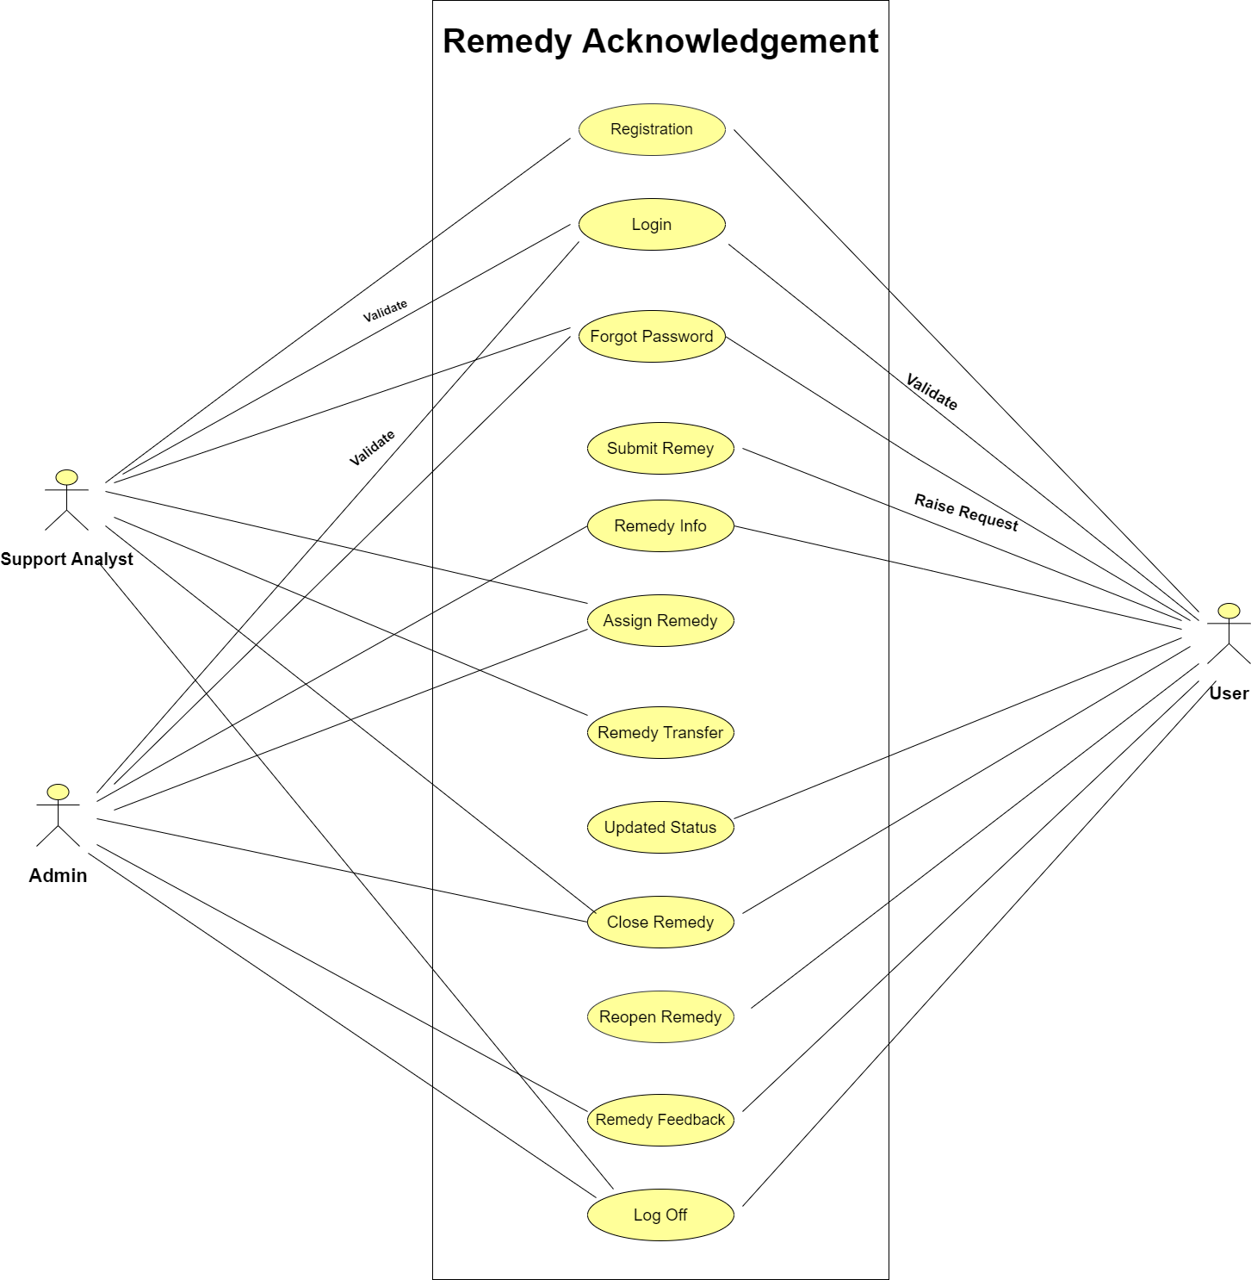

System Design

Proposed design
The Project is made using Spring boot as middle ware which contains all the business logic.
Here we used Maven as a build tool. Maven is a powerful project management tool that is based on POM (Project Object Model). It is used for project build and dependency.
The different technologies used for the development of entire application is listed below:
Frontend – JSP, Bootstrap, Html, CSS
The view of the software is made in JSP files using HTML,CSS and Bootstrap. JSTL tags are also used to reduce the complexity of code and make the code easy to write.

Backend – SQL, Hibernate, JPA
The backend is responsible for storing and organizing data, and ensuring everything on the client-side actually works. The backend communicates with the front-end, sending and receiving information to be displayed as a web page.
Hibernate ORM is an object–relational mapping tool for the Java programming language. It provides a framework for mapping an object-oriented domain model to a relational database. Here we used MySQL to fetch the records from the Database.

Component inventory
Below is the overall functional flow of the project including the components of interaction

    - Creation of Admin/User/Support Analyst Registration and login pages .

    - Performing Authentication for Admin/User/Support Analyst.

    - Remedy Creation for User.

    - View Remedy Information for Admin/Support Analyst.

    - Assigning Remedy to Support Analyst by Admin.

    - Update status of Remedy .

    - Review by user.

    - Other validations like Forgot-Id, Password and Log-off.

Database Design

Data Model
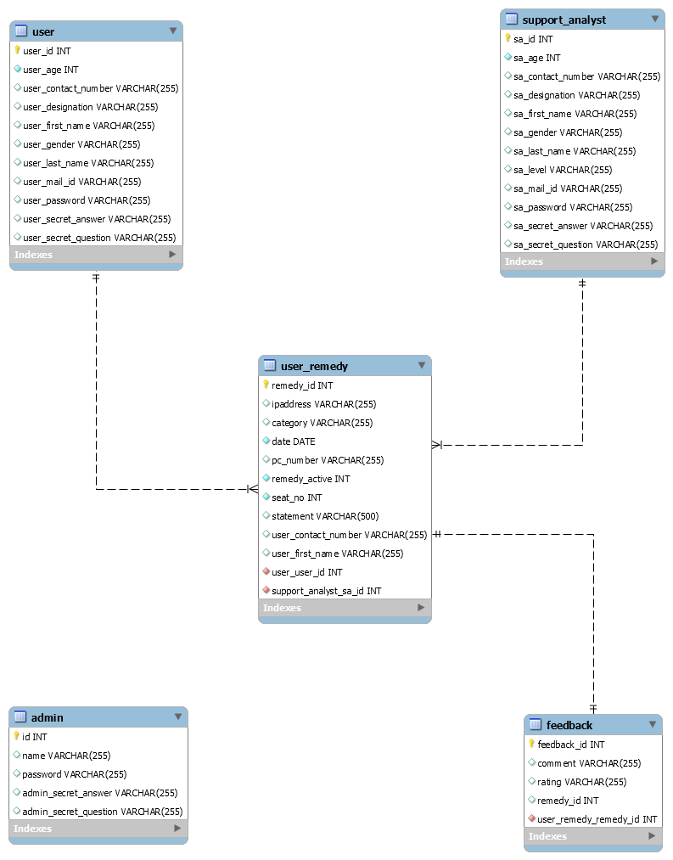

Tables Structure

Table 1.0(User)

Field name | Field type | Field length | Mandatory
user_id | int |  | Primary Key ,Not Null
user_age | int |  | Not Null
user_contact_number | Varchar | 255 | Null
user designation | Varchar | 255 | Null
user first name | Varchar | 255 | Null
user_gender | Varchar | 255 | Null
user_last_name | Varchar | 255 | Null
user mail id | Varchar | 255 | Null
user password | Varchar | 255 | Null
user_secret_Answer | Varchar | 255 | Null
user_secret_question | Varchar | 255 | Null

Table 1.1(Support Analyst)

Field name | Field type | Field length | Mandatory
Sa_id | int |  | Not Null
Sa_age | int |  | Not Null
Sa_contact_number | Varchar | 255 | Null
Sa_designation | Varchar | 255 | Null
Sa_firstname | Varchar | 255 | Null
Sa_gender | Varchar | 255 | Null
Sa_last_name | Varchar | 255 | Null
Sa_level | Varchar | 255 | Null
Sa_mail_id | Varchar | 255 | Null
Sa_password | Varchar | 255 | Null
Secret_answer | Varchar | 255 | Null
Secret_question | Varchar | 255 | Null

Table 1.3(Admin)
Login Table
Field name | Field type | Field length | Mandatory
admin_Id | int |  | Not Null
name | Varchar | 255 | Null
password | Varchar | 255 | Null
admin_secret_question | Varchar | 255 | Null
admin_secret_answer | Varchar | 255 | Null

Table 1.4(User_Remedy)
Field name | Field type | Field length | Mandatory
remedy_Id | int |  | Primary key,Not Null
ip_address | Varchar | 255 | Null
category | Varchar | 255 | Null
pc_number | Varchar | 255 | Null
remedy_active | int |  | Not Null
seat_no | int |  | Not Null
statement | Varchar | 500 | Null
user_contact_number | Varchar | 255 | Null
user_first_name | Varchar | 255 | Null
date | Date |  | Null
user_Id | Int |  | Not Null ,Foreign Key
support_analyst_id | Int |  | Null, Foreign Key
User Remedy Table

Table 1.5(Feedback)
Field name | Field type | Field length | Mandatory
feedback_Id | int |  | Primary key,Not Null
rating | Varchar | 255 | Null
comment | Varchar | 255 | Null
remedy_id | int |  | Not Null ,Foreign Key
Feedback Table

Appendices

Glossary
Acronyms | Definitions

Other

Terms & Conditions
Gencs shall be solely responsible for all its acts and omissions under this program. Gencs will comply at all times with all applicable laws. Gencs shall not use any Cognizant’s name, logo and trademark in any promotional materials or other communications with third parties without the prior written consent of Cognizant. Any materials used by gencs in relation to program will not infringe the copyrights, trademarks, patents, trade secrets or other intellectual property rights, privacy or similar rights of any person or entity. Gencs agrees not to post, draw, make, display any content that is threatening, libelous, obscene, defamatory, abusive, pornographic, or advocates/encourages any conduct that could constitute a criminal offence or give rise to any civil liability. Cognizant its associates’ personal details including but not limited to name, address, contact number shall not be shared or forwarded to any third party, without prior written consent of Cognizant, its associates. All intellectual property provided by Cognizant, as part of program shall be owned exclusively by Cognizant. Genc shall indemnify, defend and indemnify Cognizant its associates, officers, directors from and against any claims, demands, loss, damage, liability, causes of action, judgments, or costs and expenses of every nature (including attorney’s fees and expenses) incurred by Cognizant based on any claim that any breach of terms and conditions of this program.

Change Log

- Version Number | - Changes made
V<n.n> | <If the change details are not explicitly documented in the table below, reference should be provided here>
V<n.n> | Page no | Changed by | Effective date | Changes effected

