# A Report on Java Project

# Student Details Management

GROUP MEMBERS

1.Palla Durga Prasad – AP22110011422

2.Merugu Jagan Venkat – AP22110011396

3.Gorripati Hemanth – AP22110011383

4.Yerukala Shashi Kanth – AP22110011380

5. Gnana Manjari Munuswamy – AP22110011473

|  |  |  |  |  |
| --- | --- | --- | --- | --- |
|  |  |  |  |  |

**1. Introduction**

The Student Details Management is a desktop-based application designed to enhance the efficiency of managing student academic records in educational institutions. Developed using Java Swing for an interactive graphical interface and Oracle 10g Express Edition for secure data storage, the system enables educators to perform tasks such as adding, updating, searching, and analyzing student marks across various subjects. Key features include sorting by total marks, ranking students, and exporting data to CSV files for reporting purposes. The application aims to simplify administrative tasks while ensuring data accuracy and user accessibility.

This project addresses the need for a reliable, organized, and user-centric tool to handle student performance data. By combining Java’s cross-platform capabilities with Oracle’s robust database management, the system provides a scalable solution suitable for small to medium-sized schools. This report details the project’s objectives, technical implementation, features, challenges, outcomes, and potential improvements, offering a comprehensive overview of its development and functionality.

**2. Objectives**

The core objectives of the Student Details Management are:

* To develop an intuitive and visually appealing interface for managing student records and marks.
* To establish seamless connectivity with an Oracle database for secure and efficient data operations.
* To implement functionalities for adding, editing, deleting, and searching student records with ease.
* To incorporate advanced features such as sorting by total marks, calculating percentages, assigning ranks, and exporting data for external use.
* To enforce input validation to ensure data integrity and minimize errors.
* To create a modular, maintainable, and extensible codebase using Java and JDBC principles.
* To provide real-time feedback to users through status updates and error notifications.

**3. System Overview**

**3.1 Technologies Used**

* **Programming Language**: Java (JDK 24)
* **GUI Framework**: Java Swing
* **Database**: Oracle 10g Express Edition
* **JDBC Driver**: ojdbc8.jar
* **Development Environment**: Command-line tools or IDEs such as IntelliJ IDEA, Eclipse, or VS Code
* **Operating System**: Platform-independent (tested on Windows and Linux environments)

**3.2 System Architecture**

The application employs a three-tier client-server architecture:

* **Client Layer**: A Java Swing-based graphical interface that allows users to interact with the system through input fields, buttons, and tables.
* **Application Layer**: Java logic that processes user inputs, enforces business rules (e.g., percentage calculations, ranking algorithms), and manages database interactions via JDBC.
* **Data Layer**: Oracle 10g XE database, hosting tables for student details and marks, with sequences for generating unique identifiers.

**3.3 Database Schema**

The database is structured with two primary tables:

* **students**: Stores student information.
  + student_id: Primary key, auto-incremented using student_id_seq.
  + roll_number: Unique identifier for each student, ensuring no duplicates.
  + name: Student’s full name.
  + class_name: Class or grade of the student (e.g., 10A, 12B).
* **marks**: Stores subject-specific marks for each student.
  + mark_id: Primary key, auto-incremented using mark_id_seq.
  + student_id: Foreign key linking to the students table.
  + subject: Name of the subject (e.g., Mathematics, Science).
  + marks_obtained: Marks scored, stored as a string to handle nulls and validated as numbers in the application.
  + Unique constraint on (student_id, subject) to prevent multiple entries for the same subject per student.

Two sequences, student_id_seq and mark_id_seq, generate unique IDs for the students and marks tables, respectively.

**4. Implementation Details**

**4.1 Setup and Configuration**

* **Oracle 10g XE Installation**: The database was installed, and the listener was configured to operate on port 1521. A dedicated user, student_user, was created with privileges (CONNECT, RESOURCE, CREATE SEQUENCE) to manage the application’s data.
* **Database Setup**: SQL scripts were executed to create the students and marks tables, along with sequences for ID generation. Sample data was optionally inserted to facilitate testing.
* **Java Environment**: JDK 24 was installed, and the ojdbc8.jar file was included in the classpath to enable JDBC connectivity to Oracle.
* **Code Compilation and Execution**: The Java source file, EnhancedMarksReport.java, was compiled and run using command-line tools or an IDE, with ojdbc8.jar specified in the classpath.

**4.2 Key Features**

The application offers a comprehensive set of features to manage student records:

* **Search and View Records**: Users can filter students by roll number, name, class, subject, or marks. Results are displayed in a tabular format, showing subject-wise marks, total marks, percentage, and rank.
* **Add/Edit Student Data**: A dedicated tab allows users to input or modify student details and marks for six predefined subjects (Mathematics, Science, English, History, Geography, Computer Science). Input validation ensures marks are numeric and within the 0–100 range.
* **Update Records**: Users can select a student from the search results, populate their details in the edit form, make changes, and save updates to the database.
* **Delete Records**: Selected students can be removed after a confirmation prompt, deleting both their details and associated marks.
* **Sort by Total Marks**: The system sorts the results table by total marks in descending order, recalculating ranks to account for ties.
* **Export to CSV**: Users can export all or filtered records to a CSV file, enabling offline analysis or reporting.
* **Clear Form**: Input fields can be reset to facilitate new searches or data entries.
* **Status Feedback**: A status bar at the bottom of the interface provides real-time updates on actions (e.g., “Search complete,” “Student added”) and highlights errors in red.
* **Input Validation**: The system checks for mandatory fields, valid numeric inputs, and adherence to mark ranges, preventing invalid data from entering the database.

**4.3 User Interface**

The GUI is designed using Java Swing with a tabbed layout for clarity:

* **Search & View Tab**: Contains input fields for search criteria (roll number, name, class, subject, marks), a scrollable table for displaying results, and buttons for actions (Search, Sort, Update, Delete, Add New, Export, Clear).
* **Add/Edit Student Tab**: Includes text fields for student details (roll number, name, class) and marks for each subject, along with Save and Clear buttons.
* The interface adopts the Nimbus look-and-feel for a modern aesthetic, with a fallback to the cross-platform look-and-feel if Nimbus is unavailable. The layout uses GridBagLayout and BorderLayout for responsive and organized component placement.

**4.4 Database Operations**

* **JDBC Integration**: The application connects to Oracle using the jdbc:oracle:thin driver, with connection parameters (URL: jdbc:oracle:thin:@localhost:1521:XE, username: student_user, password: password) defined as constants.
* **SQL Queries**:
  + **Search**: A dynamic SQL query with pivot logic retrieves subject-wise marks for display, using MAX and CASE to handle missing marks and NVL for null values.
  + **Insert/Update**: Transactions are managed with conn.setAutoCommit(false) to ensure atomicity when inserting or updating student details and marks.
  + **Delete**: Deletion involves removing marks first, followed by the student record, using prepared statements to prevent SQL injection.
* **Error Handling**: SQL exceptions are caught, displayed to the user via JOptionPane dialogs, and logged to the console for debugging. Status messages provide immediate feedback on operation success or failure.

**4.5 Code Structure**

* **Main Class**: EnhancedMarksReport extends JFrame and encapsulates the entire application logic.
* **Helper Class**: StudentRecord is a static inner class that holds student data for processing search results and ranking.
* **Modular Methods**: Functions like performSearch, saveStudent, sortByTotal, and exportResults handle specific tasks, improving code readability and maintainability.
* **Event Listeners**: Action listeners on buttons and selection listeners on the table enable dynamic user interactions.

**5. Challenges and Solutions**

* **Challenge**: Ensuring compatibility between Oracle 10g XE and the ojdbc8.jar driver, given the database’s older version.
  + **Solution**: Tested connectivity thoroughly; provided guidance to switch to ojdbc6.jar or ojdbc14.jar if compatibility issues occur.
* **Challenge**: Preventing duplicate marks entries for the same student and subject.
  + **Solution**: Implemented a unique constraint on (student_id, subject) in the marks table, enforced at the database level.
* **Challenge**: Accurately ranking students with tied total marks.
  + **Solution**: Developed a ranking algorithm that assigns identical ranks to students with equal totals and increments ranks appropriately for subsequent students.
* **Challenge**: Validating user inputs to avoid database errors or inconsistent data.
  + **Solution**: Added client-side validation for mandatory fields, numeric marks, and range checks (0–100), with descriptive error messages displayed via dialogs.
* **Challenge**: Managing complex database transactions for insert and update operations.
  + **Solution**: Used JDBC transaction management (setAutoCommit(false), commit, rollback) to ensure data consistency, especially when updating multiple tables.
* **Challenge**: Designing an intuitive and responsive GUI for diverse user needs.
  + **Solution**: Utilized Swing’s layout managers (GridBagLayout, BorderLayout) and a tabbed pane to organize components logically, with clear labels and feedback mechanisms.

**6. Outcomes and Benefits**

* **Streamlined Operations**: The system reduces the time and effort required to manage student marks, replacing manual or spreadsheet-based methods.
* **Enhanced Usability**: The clean, tabbed interface and real-time feedback make the application accessible to non-technical users, such as teachers or administrators.
* **Data Accuracy**: Robust validation and database constraints ensure reliable and consistent records.
* **Scalability**: The Oracle backend and modular Java code support expansion to accommodate more students, subjects, or features.
* **Cross-Platform Support**: Java’s portability allows the application to run on Windows, Linux, or macOS without modification.
* **Analytical Capabilities**: Features like sorting, ranking, and CSV export enable educators to analyze student performance and generate reports for decision-making.
* **Error Resilience**: Comprehensive error handling and status updates minimize disruptions and guide users through corrective actions.

**7. Future Enhancements**

* **User Authentication and Roles**: Implement login functionality with role-based access (e.g., admin, teacher) to enhance security and control.
* **Graphical Analytics**: Integrate charts or graphs (e.g., using JFreeChart) to visualize student performance trends, such as subject-wise averages or class rankings.
* **Cloud-Based Database**: Transition to a cloud-hosted Oracle database for remote access and improved scalability.
* **Dynamic Subject Management**: Allow users to add, remove, or modify subjects through the interface, updating the database schema dynamically.
* **Batch Data Import**: Enable importing student records and marks from CSV or Excel files to streamline bulk data entry.
* **Web or Mobile Version**: Develop a web-based interface using Java frameworks (e.g., Spring Boot) or a mobile app to increase accessibility.
* **Audit Logging**: Record user actions (e.g., add, update, delete) in a log table to track changes for accountability.
* **Multilingual Support**: Add support for multiple languages to cater to diverse user bases.

**8. Result Analysis**

**Outputs :**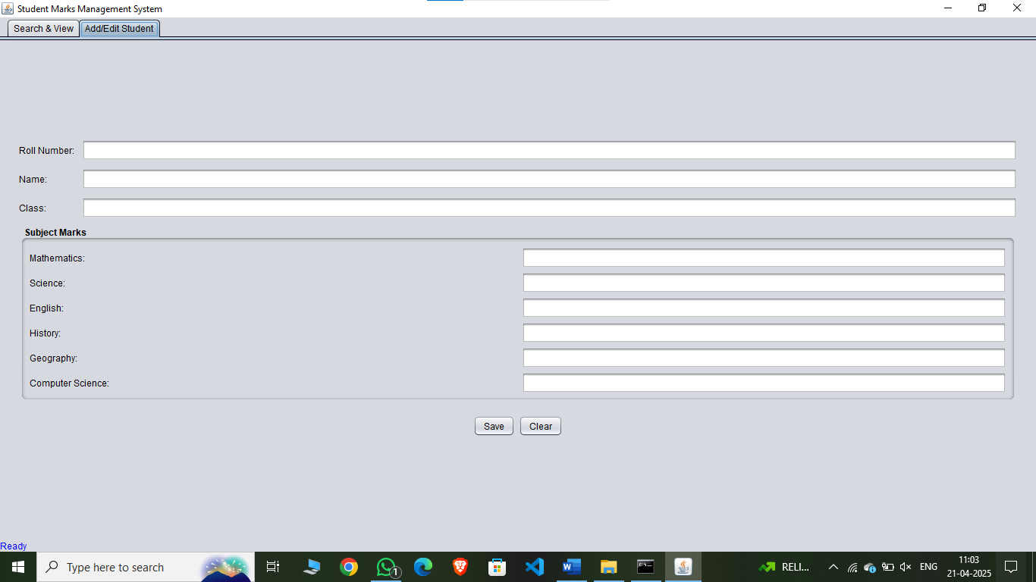

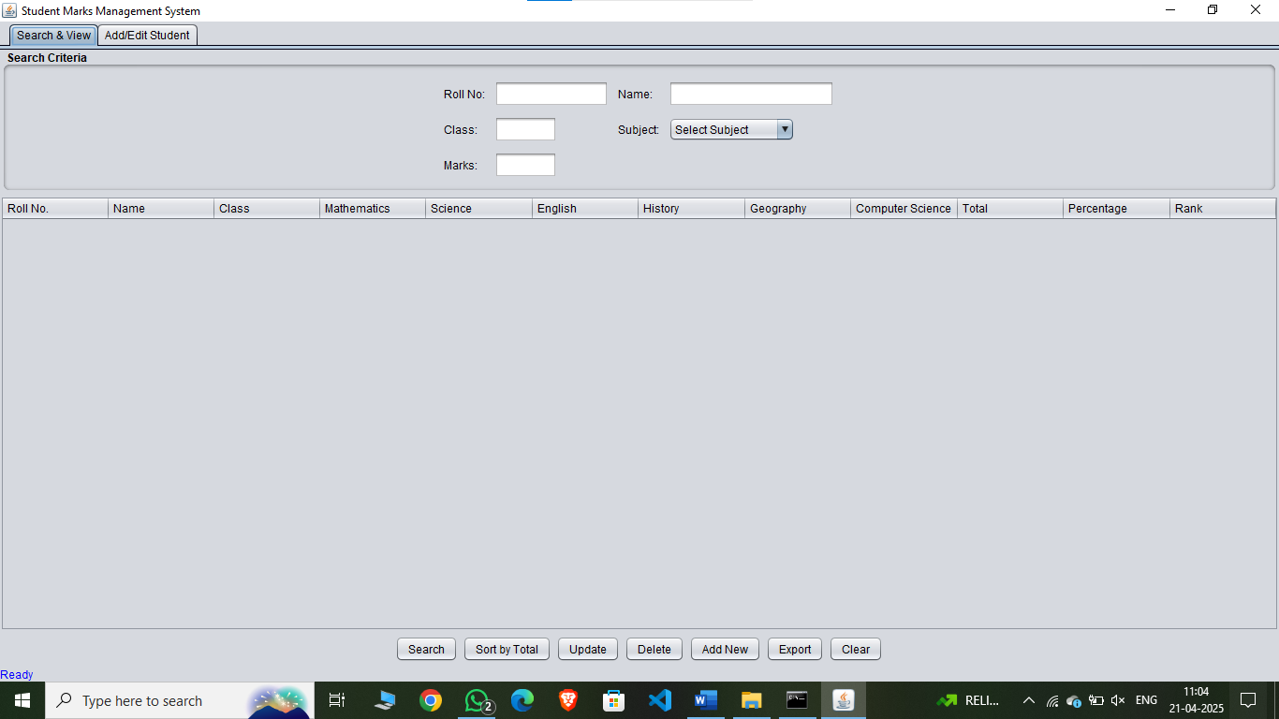

**9. Testing and Validation**

* **Unit Testing**: Individual methods (e.g., saveStudent, performSearch) were tested with various inputs to ensure correct behavior.
* **Integration Testing**: Database operations were verified by checking table contents after insert, update, and delete actions using SQL*Plus.
* **User Interface Testing**: The GUI was tested for responsiveness, ensuring buttons, tabs, and table interactions worked as expected across different screen resolutions.
* **Edge Case Testing**: Handled scenarios like empty inputs, invalid marks, duplicate roll numbers, and database connection failures, confirming proper error messages and recovery.
* **Performance Testing**: The system was tested with sample datasets (up to 100 students) to ensure acceptable response times for searches and updates.

**9. Conclusion**

The Student Details Management represents a successful implementation of a desktop application tailored to the needs of educational institutions. By integrating Java Swing’s user-friendly interface with Oracle 10g XE’s reliable data storage, the system delivers essential functionalities such as data entry, search, modification, and reporting. The project overcomes challenges related to database compatibility, input validation, and transaction management, resulting in a robust and efficient tool. Its modular design and cross-platform compatibility make it adaptable for future enhancements, positioning it as a valuable asset for managing student academic records. The development process highlights the power of Java and Oracle in building practical, real-world applications.

**10. References**

* Java SE 24 Official Documentation
* Oracle 10g Express Edition User Guide
* JDBC API Documentation for Oracle Database Connectivity
* Java Swing Programming Guide
* Oracle SQL Reference Manual