AUTOHEAL AI
TECHNICAL DESIGN & SYSTEM ARCHITECTURE
Autonomous Web Application Recovery System Using AI-Based Fault Diagnosis

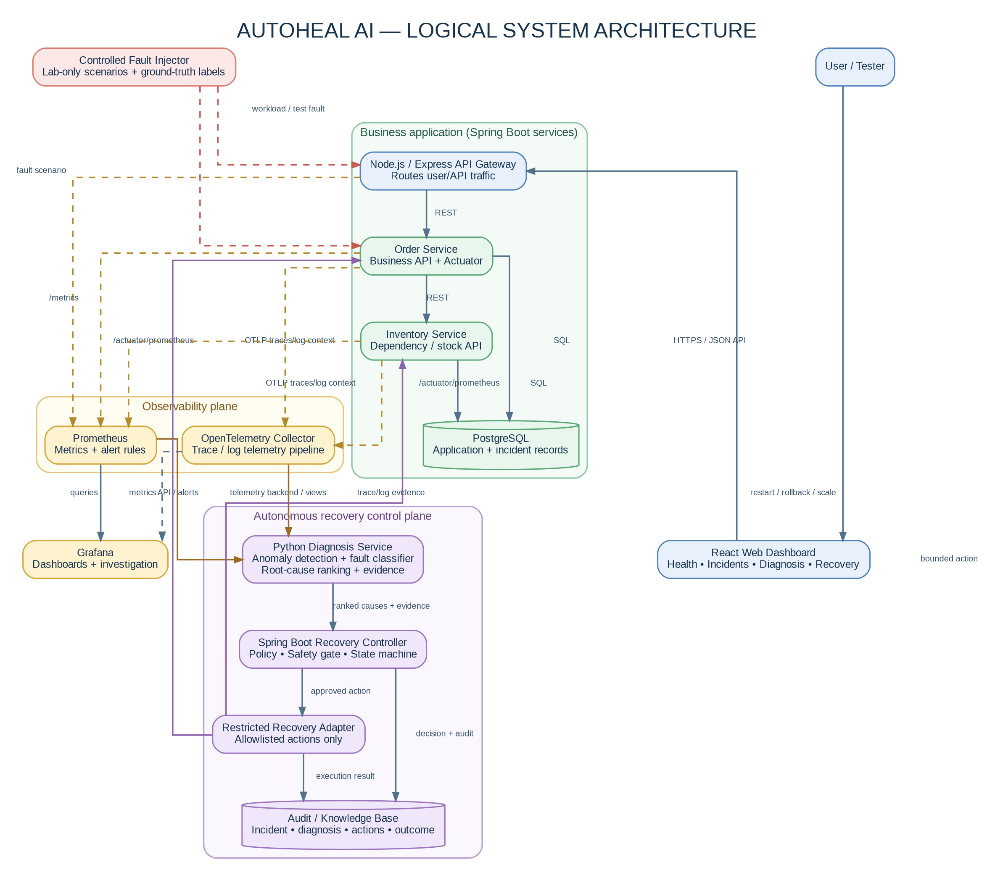
Design baseline: Windows development → Docker Compose → Kubernetes (later phase)
Application name: AutoHeal AI | Tagline: Detect • Diagnose • Recover • Verify
Version 1.0 | 15 October 2026 | University Project Technical Design

Document Control and How to Use This Design
Item | Definition
Purpose | Define the logical and deployable architecture, component responsibilities, data contracts, safety model, and verification design for AutoHeal AI.
Audience | Student developers, project supervisor, AI/ML implementer, backend developer, tester and viva examiner.
Status | Implementation baseline. Specific thresholds and measured results must be established through experiments; illustrative values are not results.
Alignment | Matches the phase-wise handbook: Spring Boot services, Node.js gateway, React UI, Python FastAPI diagnosis service, PostgreSQL, Prometheus, Grafana, OpenTelemetry, Docker Compose first, Kubernetes later.
Primary constraint | Autonomous action is restricted to a disposable lab environment and an allowlisted recovery adapter. No production systems are in scope.

Reading path
1. First read Sections 1–6 to understand the system boundary, logical architecture, and responsibilities.
2. Use Figures 1–7 as the common source of truth for the implementation. Component names in code and docs should match these names.
3. Follow Sections 7–14 when implementing telemetry, AI diagnosis, recovery decisions, storage and APIs.
4. Use Sections 15–19 for security, testing, deployment sequencing, acceptance criteria and references.
Design principle
Separate detection, diagnosis, decision, execution and verification. A model prediction is evidence for a policy decision, not direct permission to execute an operational command.

Contents and Figure Register
- 1. System purpose, scope and architecture decisions
- 2. Logical system architecture and closed-loop control flow (Figures 1–2)
- 3. Component specification and local deployment architecture (Figure 3)
- 4. AI diagnosis pipeline and feature/data boundaries (Figure 4)
- 5. Fault-to-recovery interaction sequence and controller state machine (Figures 5–6)
- 6. Incident, diagnosis and recovery data model (Figure 7)
- 7. REST APIs, payload contracts and model-serving design
- 8. Recovery policy, safety, verification and security
- 9. Implementation phase mapping and fault scenarios
- 10. Test strategy, evaluation metrics and model comparisons
- 11. Repository structure and version baseline
- 12. Risks, architectural decisions and technical references

1. System Purpose, Scope and Assumptions

1.1 Project objective
AutoHeal AI is a research prototype that continuously observes a distributed web application, detects anomalous behaviour, diagnoses likely root causes from correlated telemetry, recommends a bounded recovery action, checks that action against a safety policy, executes an approved action in a controlled test environment, and verifies whether the application recovered.

1.2 Problem being addressed
Monitoring often identifies a symptom—such as high response latency or an HTTP 5xx spike—but the symptom may originate from a downstream service, database, recent deployment or network dependency. Applying the wrong recovery (for example, restarting a healthy API when the database is slow) may waste time or amplify the incident. AutoHeal AI therefore preserves a separation between symptom detection, root-cause diagnosis and remediation.

1.3 Included in the first release
- React dashboard for application health, current incident, ranked diagnosis and recovery history.
- Node.js/Express gateway for front-end API calls and routing to backend services.
- Spring Boot order-service and inventory-service; PostgreSQL for application data and incident/recovery records.
- Prometheus metrics, OpenTelemetry traces/log context and Grafana dashboards.
- Python FastAPI model service with a rule-based baseline, Isolation Forest anomaly detection and Random Forest fault classification.
- Dependency-aware root-cause ranking using service relationships, trace evidence and temporal symptoms.
- Spring Boot recovery controller with an explicit state machine, allowlisted action adapter, audit records and verification checks.
- Controlled fault-injection runner and labelled experiment dataset.

1.4 Out of scope
- Unrestricted execution of shell commands proposed by a model or LLM.
- Automatic modification of source code or arbitrary production configuration.
- Guaranteed diagnosis of all unseen fault types.
- Production-grade multi-region failover or destructive database repair.
- Claims of research novelty without a literature comparison and empirical results.

1.5 Assumptions
The initial environment is a Windows laptop with Docker Desktop/WSL 2. The initial deployment uses Docker Compose. Kubernetes/Minikube is introduced after the Compose version is reliable. Public datasets can supplement evaluation but do not replace a custom fault-injection dataset because recovery outcomes must be observed under the target architecture.

2. Architecture Principles and Design Decisions
Decision | Chosen approach | Why it is appropriate | What would trigger revisiting it
Application decomposition | Node.js gateway + small Spring Boot services | Matches course technology hints and provides realistic dependencies without creating too many services. | The project needs more services to study propagation or service-mesh behaviour.
AI implementation | Python FastAPI service, separated from application services | Python has practical ML tooling; model changes should not force backend rewrites. | A measured deployment constraint favours in-process Java inference.
Baseline first | Rules/thresholds before ML | Provides interpretable baselines and makes the system testable before training data exists. | Only after baseline experiments and data quality checks pass.
Root-cause method | Rank candidate services with metric + trace + dependency evidence | Useful with moderate data; avoids requiring a GNN from day one. | Graph learning is warranted only if data volume and ablations support it.
Control/execution separation | Recovery controller invokes a restricted adapter | Prevents the model or dashboard from directly executing privileged commands. | Never remove this boundary; implementation may change.
Recovery default | Dry-run first; fail closed on unknown diagnosis | False autonomous actions can worsen failures. | No relaxation without measured safety evidence and supervisor approval.
Local first | Docker Compose before Kubernetes | Reduces environment and debugging complexity. | Introduce Kubernetes once tests and contracts pass.
Telemetry retention | Time-windowed features plus evidence references | Keeps model input consistent and storage manageable. | Raw logs/traces can be retained for a short lab investigation window.
Reproducibility | Pin versions and model/feature/policy versions | Makes results traceable and avoids silent experimental drift. | Any upgrade creates a new experiment configuration.

2.1 Architecture quality goals
Goal | Design response | Verification
Diagnosability | Every diagnosis has ranked causes, evidence references, model version and feature-window timestamps. | A test reviewer can explain why the predicted service was ranked first.
Safety | Action allow-list, target allow-list, confidence/risk checks, cooldown, retry limit, audit trail. | Unauthorized actions count must remain zero in the test campaign.
Recoverability | Action execution is bounded and followed by repeated application-level health checks. | Recovery status is based on observed health, not on a successful command exit code.
Reproducibility | Pinned configuration, episode IDs, seed/config manifest and train/validation/test split manifest. | Another run can reproduce the same fault scenario and evaluation split.
Modularity | Independent gateway, business services, diagnosis service, controller and action adapter. | Each service can be unit-tested and started/restarted independently.

3. Logical System Architecture
Figure 1 is the canonical logical architecture. Solid blue/green/purple paths represent application or control flow; dashed amber paths represent telemetry; dashed red paths represent controlled test input. The diagram intentionally shows both the business plane and the recovery control plane because diagnosis should observe the system, while remediation needs a separate authority boundary.
Figure 1. AutoHeal AI logical architecture: business application, observability plane, diagnosis service and restricted recovery control plane.

3.1 Reading Figure 1
1. The browser uses the React dashboard; the dashboard calls the Node.js gateway rather than accessing internal services directly.
2. The gateway routes business requests to Spring Boot services. The order service calls inventory and database dependencies, providing a small dependency graph for diagnosis.
3. Prometheus scrapes numeric metrics such as request count, error rate, latency and resource utilization. OpenTelemetry carries trace context and the log/trace pipeline.
4. The Python Diagnosis Service reads evidence through telemetry query interfaces and returns a structured diagnosis. It does not execute recovery actions.
5. The Spring Boot Recovery Controller validates candidate actions against policy and sends only approved actions to a restricted Recovery Adapter.
6. The Incident/Audit Knowledge Base records what was observed, what the model concluded, why an action was allowed or denied, and whether health recovered.
7. The fault injector is a test-only component. Fault identity is stored as ground truth for evaluation and must not be passed as a predictive feature to the model.

3.2 System trust boundaries
Boundary | Allowed traffic | Controls
Browser → gateway | HTTPS/JSON in non-local deployment; localhost HTTP in development | CORS allowlist, request validation, session/auth design if deployed beyond localhost.
Gateway → business services | Internal REST calls | Service DNS, timeouts, structured request IDs, no open internal ports to the host unless needed.
Telemetry → diagnosis | Read-only query access | Dedicated credentials or local network policy; only approved metric/log/trace queries.
Diagnosis → recovery controller | Structured diagnosis payload | Schema validation; confidence is advisory and re-evaluated by policy.
Controller → recovery adapter | Named action + target + correlation ID | Allow-list only, RBAC/limited permissions, timeouts, cooldown, audit events.
Fault injector → application | Lab scenarios only | Feature flag/test profile, separate network/credentials, no production target configuration.

4. End-to-End Fault Diagnosis and Recovery Flow
Figure 2 defines the system loop. Each step should create a traceable event in the incident record. A recovery is not complete until verification passes. If diagnosis is uncertain, the policy denies autonomous action and records the reason.
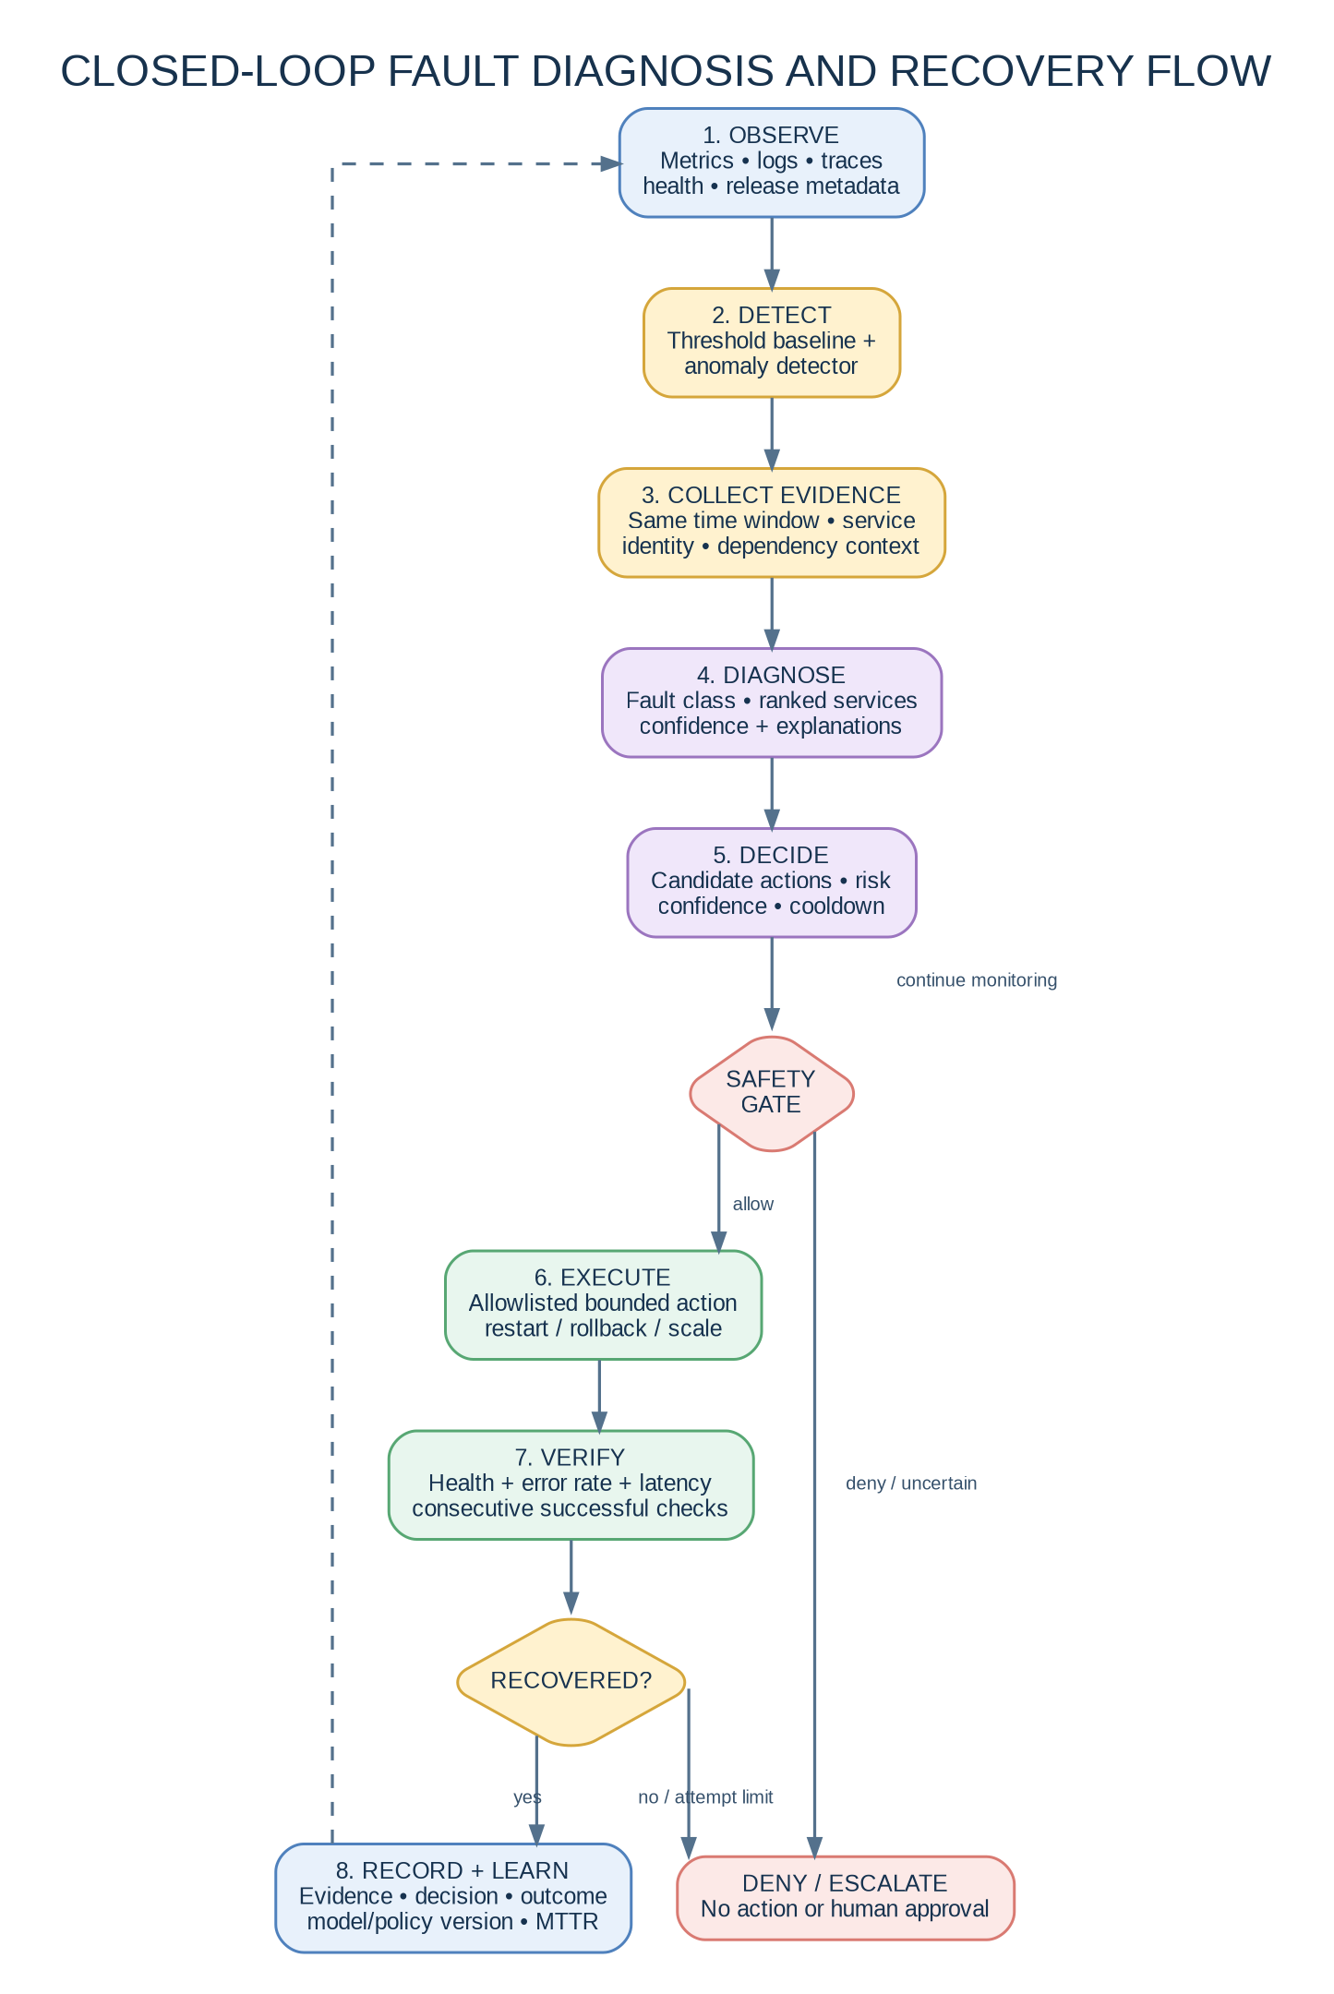
Figure 2. Closed-loop control flow from observation through detection, diagnosis, policy, recovery verification and feedback.

4.1 Processing sequence
Step | Component | Required output | Failure/uncertainty handling
1. Observe | Telemetry stack | Aligned telemetry windows and health status | Mark missing telemetry; do not treat missing data as a healthy value.
2. Detect | Thresholds + anomaly model | Anomaly flag, score, timestamp, affected service candidates | Suppress duplicate incident triggers within an incident window; do not auto-act on one noisy sample.
3. Gather evidence | Evidence adapter | Metrics, recent logs/traces, dependency relations, release metadata | Use a bounded lookback window and record unavailable modalities.
4. Diagnose | Python diagnosis service | Fault class, ranked services, confidence and evidence | Return unknown/low-confidence if the model cannot distinguish causes.
5. Decide | Recovery policy | Candidate action, target, risk and rationale | Select no action when no policy matches the fault.
6. Safety gate | Spring Boot controller | ALLOW or DENY with policy reason | Check allow-list, target, confidence, cooldown, retry budget and current health.
7. Execute | Recovery adapter | Action ID, result, timestamps and command outcome | Timeout action; never loop indefinitely. An execution result is not recovery success.
8. Verify | Recovery verifier | Success / partial / failed | Require consecutive healthy checks and escalate after bounded retries.
9. Learn/audit | Incident store | Evidence, decisions, outcome and MTTR | Record model/policy versions; use history as features only if leakage is prevented.

5. Component Specification and Ownership
Component | Technology | Responsibilities | Inputs → outputs
React dashboard | React + TypeScript recommended | Show system health, incident timeline, ranked causes, recovery state, and test controls. No privileged recovery logic. | Reads gateway APIs → UI state and audit timeline.
API gateway | Node.js 24 LTS + Express | Front-door routing, request validation, API aggregation and correlation IDs. Not the AI decision-maker. | Browser JSON → downstream REST request / response.
Order service | Java 21 + Spring Boot 4.1.x line | Business endpoint, database calls, metrics and trace instrumentation. | HTTP request → order response, metrics and spans.
Inventory service | Java 21 + Spring Boot 4.1.x line | Dependency endpoint that makes propagation scenarios observable. | Order-service request → stock response / error.
PostgreSQL | PostgreSQL 17.x container line | Application data and audit/incident persistence. Use migrations and named volume. | SQL operations → business data and incident entities.
Prometheus | Pinned stable container image | Scrape metrics, evaluate rule thresholds, expose query API and alert state. | /metrics endpoints → time-series store and alerts.
OpenTelemetry Collector | Pinned stable container image | Receive OTLP telemetry, apply processors, export traces/log context to selected backends. | OTLP → normalized telemetry pipeline.
Grafana | Pinned stable container image | Visualize operational metrics and investigation dashboards. | Prometheus and optional trace/log backends → panels.
Diagnosis service | Python 3.12 + FastAPI + scikit-learn | Feature validation, anomaly detection, fault classification, root-cause ranking and evidence response. | Time-window features/evidence → JSON diagnosis.
Recovery controller | Java 21 + Spring Boot | Incident state machine, action policy, safety gate, orchestration and verification. | Diagnosis + policy → allowed action or deny/escalate.
Recovery adapter | Restricted module/service | Maps named remediation actions to tightly scoped platform operations. | Validated action request → action execution result.
Fault injector | Python or test harness | Create named, repeatable scenarios in the test environment; preserve true labels separately. | Scenario definition → run manifest and injected fault.
Incident knowledge store | PostgreSQL tables | Persist incidents, observations, diagnoses, actions, verification checks and audit events. | Service events → persistent experimental records.

5.1 Ownership rule
Separation of responsibilities
The Diagnosis Service answers “what is likely wrong?” The Recovery Controller answers “is an action allowed under policy?” The Recovery Adapter answers “can this approved action be executed within its permissions?” The Verifier answers “did the service actually recover?” These responsibilities should not be merged into one model prompt or endpoint.

6. Local Deployment Architecture
The first operational target is Docker Compose. All services run on one developer laptop and communicate over a private Compose network. Only the dashboard/gateway and Grafana need host-published ports in the baseline. Database and internal service ports should not be published unless a development tool requires them.
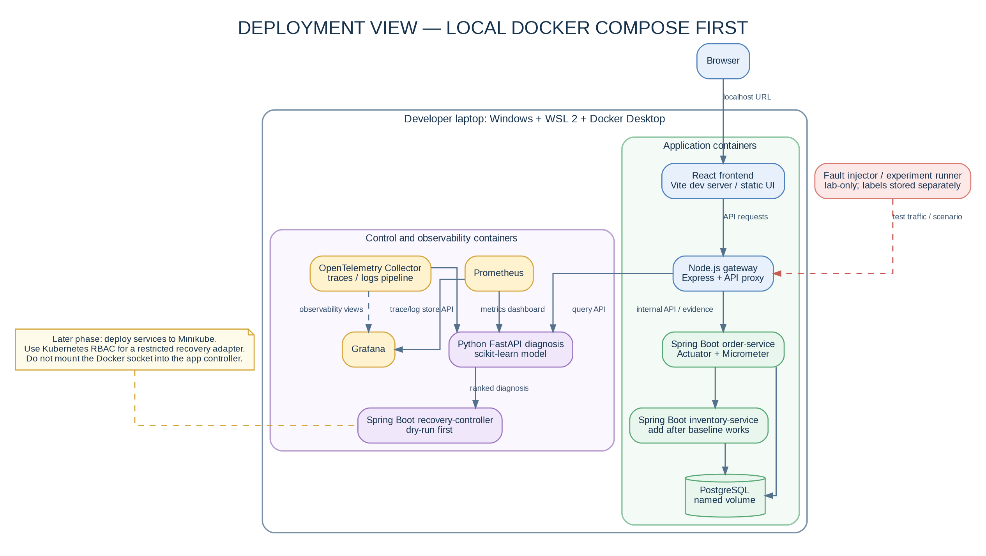
Figure 3. Local Docker Compose deployment view, with Kubernetes/Minikube intentionally deferred to a later phase.

6.1 Suggested network and port plan
Service | Container port (example) | Host publish? | Reason
React UI / web server | 5173 in development or 8080 static server | Yes, development only | Browser access.
Node gateway | 3000 | Yes, localhost only | Browser-facing API entry point.
Order service | 8080 | No by default | Internal routing; health endpoint can be queried inside Compose.
Inventory service | 8080 (separate container) | No by default | Internal dependency only.
PostgreSQL | 5432 | No by default | Only backend services need access.
Prometheus | 9090 | Yes, localhost only | Developer diagnostics/target verification.
Grafana | 3000 (container internal; change gateway host mapping to avoid conflict) | Yes, localhost only | Dashboard access. Example host port 3001 maps to container 3000.
Diagnosis service | 8000 | No by default | Internal API consumed by recovery controller.
Recovery controller | 8081 | No by default | Internal control API; expose read-only dashboard API through gateway.
OpenTelemetry Collector | 4317 gRPC / 4318 HTTP | No by default unless SDK needs host access | OTLP ingestion from app containers.

6.2 Environment variables and secrets
Use `.env.example` for names and safe defaults, but do not commit real credentials. Use Compose secrets or locally ignored `.env` for passwords. Set service URLs using Compose service DNS (for example, `http://order-service:8080`) rather than `localhost` from inside a container. A container’s `localhost` refers to that same container.

6.3 Kubernetes migration target
In Phase 14 of the implementation handbook, move the validated services to Minikube. Use Deployments/Services, liveness/readiness/startup probes, resource requests/limits, ConfigMaps and Secrets. The recovery controller must not receive cluster-admin. Create a dedicated service account and Role/RoleBinding limited to the namespaces, deployments and operations needed for the lab. Verify the effective permissions with Kubernetes authorization checks before enabling any live recovery operation.

7. AI Diagnosis Pipeline
The AI pipeline is deliberately staged. The first version should use features from well-defined telemetry windows and avoid raw-log language modelling. It is easier to validate, explains better in a viva, and requires less data than training a deep sequence model or graph neural network from scratch.
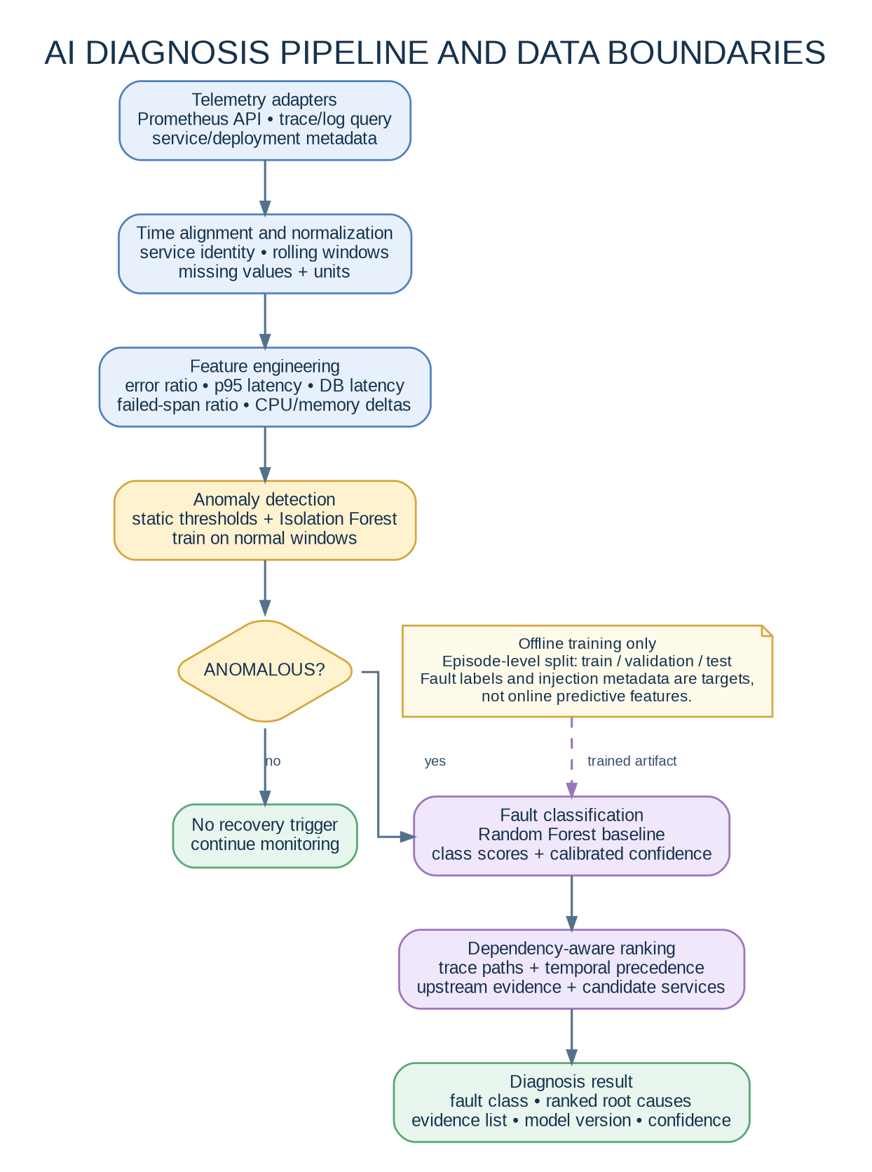
Figure 4. Diagnosis pipeline showing evidence alignment, feature engineering, anomaly detection, fault classification and dependency-aware root-cause ranking.

7.1 Data-flow requirements
- Every observation window has a timestamp range, service identity, application version and schema version.
- Use consistent time windows; start with 30-second or 60-second aggregated windows and evaluate what detects the target faults best.
- Numeric feature groups include request volume, 4xx/5xx ratios, p50/p95/p99 latency, CPU, memory, restarts, OOM count, database latency/connection errors and failed span ratio.
- Structured evidence can add exception family, span status, parent-child service relationship and recent deployment event.
- Keep run_id, fault injection ID, ground-truth fault label, end-of-incident time and recovery outcome as metadata/targets, not input features.
- Use explicit missingness flags and do not silently replace missing telemetry with zero unless zero is the semantically correct value.
- Persist the feature schema version and model version with every inference response.

7.2 Recommended models by stage
Stage | First implementation | Training/use rule | Output
Anomaly detection | Static rules + Isolation Forest | Train unsupervised detector using clean normal-operation windows; tune thresholds only on validation runs. | Anomaly score, trigger flag, affected service/window.
Fault classification | Random Forest classifier | Supervised labels: application crash, CPU pressure, memory pressure, DB latency/outage, network degradation, bad deployment, traffic overload, normal/unknown. | Class scores and predicted fault family.
Root-cause ranking | Dependency-aware evidence score | Combine service-level anomaly, time precedence, failed spans and dependency edges; calibrate weights on validation episodes. | Ranked services + evidence refs.
Confidence | Calibrated class probabilities plus top-two margin | Calibrate on held-out validation data; keep out-of-distribution/unknown fallback. Isolation Forest scores are not probabilities. | Confidence indicator + model limitations.
Optional research extension | XGBoost/LightGBM or graph-aware model | Only add if the dataset size, baseline results and ablation plan justify it. | Comparative result, not required for first working prototype.

7.3 Avoiding data leakage
Critical experimental rule
Split by fault episode or experiment run—not by random telemetry row. Adjacent windows from the same injected incident are correlated. If windows from one episode appear in both training and test sets, reported test performance can be artificially high. Injection messages and future recovery outcomes must also be excluded from predictive features.

8. Fault-to-Recovery Interaction Sequence
Figure 5 provides the interaction order for a fault-injection experiment. It should also be used as the basis for integration tests, because it makes clear which component owns each event and which evidence must be saved.
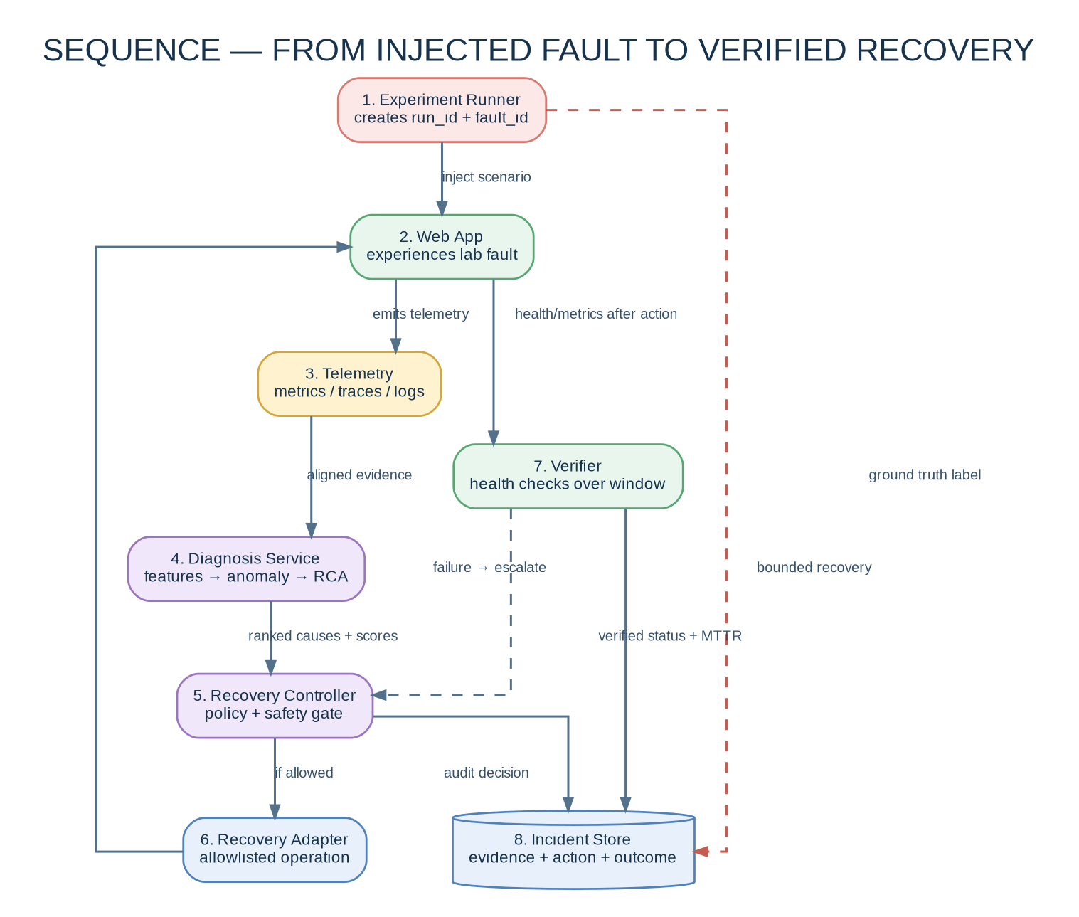
Figure 5. Interaction sequence: test fault → telemetry → AI diagnosis → policy decision → bounded action → verification → audit record.

8.1 Example: database latency incident
1. The fault injector starts run `RUN-DBLAT-001` and introduces controlled database latency only in the test deployment. It stores start time and ground-truth label outside the model feature table.
2. The order service and database continue to emit request metrics and traces. The p95 latency, failed/slow span ratio and database latency rise in the same window.
3. The anomaly detector triggers an incident. The evidence adapter fetches the aligned service metrics, trace summary, logs and deployment history for the configured lookback period.
4. The diagnosis service returns a ranked root cause and evidence. If the result is unknown or confidence is too low, the recovery controller denies automatic action.
5. If diagnosis supports a known transient dependency issue, policy may allow bounded retry/backoff. A database restart is not the default response to latency because it could worsen availability or risk data integrity.
6. The verifier checks health and latency for consecutive intervals. If the service remains unhealthy, it stops after the retry budget and escalates.
7. The incident store records ground truth for evaluation, the diagnosis, action policy version, execution result, verification summary and recovery duration.

9. Recovery Controller State Machine
Figure 6 is the required controller state machine. The implementation should encode these states explicitly (for example, as an enum plus persisted state transitions) so that duplicate alerts cannot trigger concurrent or infinite remediation loops.
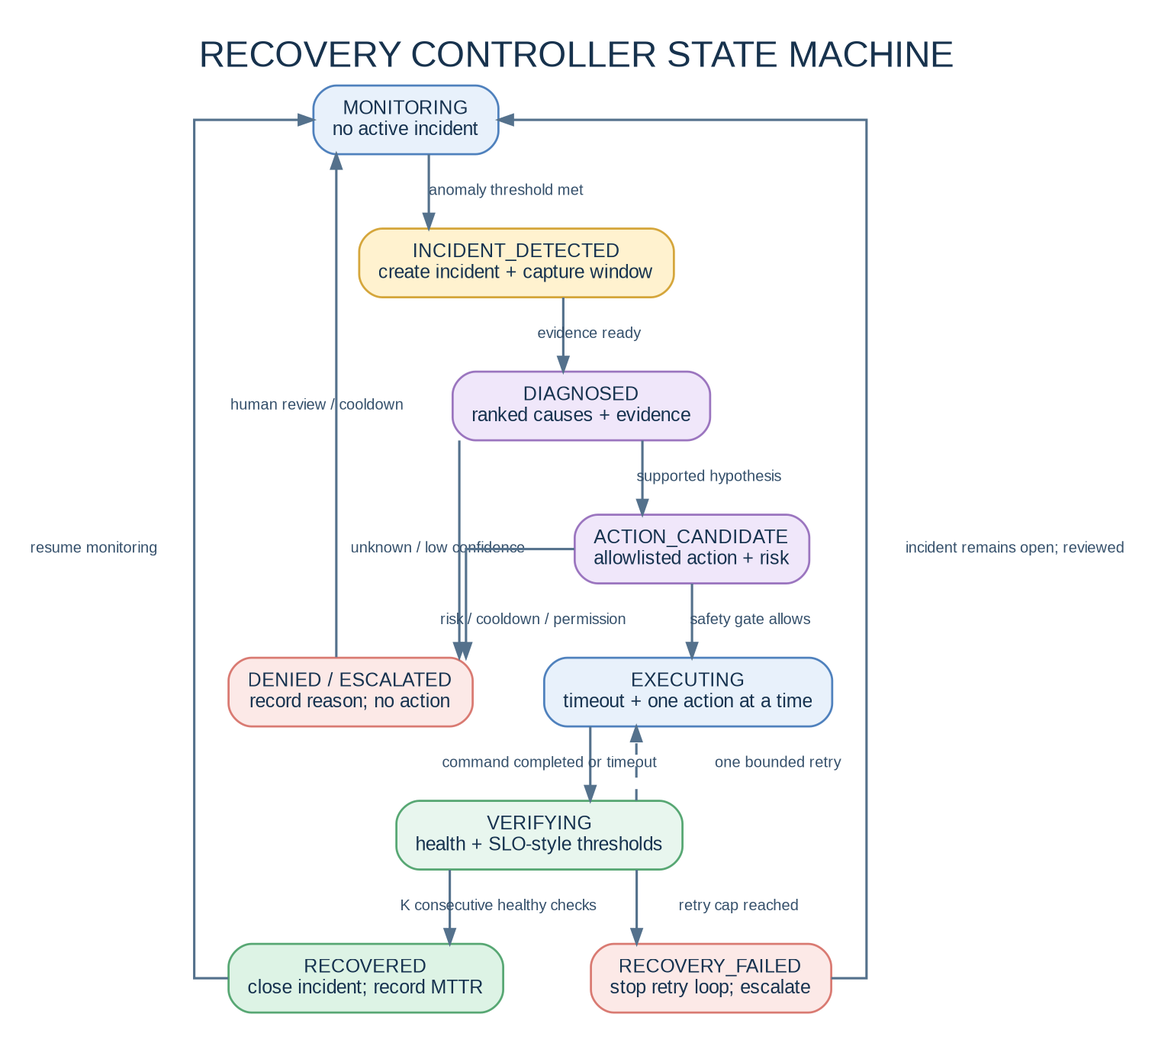
Figure 6. Recovery lifecycle states and the transitions for allow, deny, execution, verification, success, retry and escalation.

9.1 State definitions
State | Entry condition | Exit condition | Invariant
MONITORING | No active incident is being processed. | Anomaly rule is met. | No remediation is running.
INCIDENT_DETECTED | New incident ID is created. | Evidence collection is complete. | Repeated alerts are associated with the same incident where appropriate.
DIAGNOSED | Diagnosis response passes schema validation. | Candidate policy found or escalation. | Ranked causes and model metadata are stored.
ACTION_CANDIDATE | Policy maps diagnosis to a candidate action. | Safety gate allows/denies. | Action and target must be allowlisted.
EXECUTING | Controller grants one approved execution lease. | Adapter returns result or timeout. | Only one recovery action is active per target/incident.
VERIFYING | Action ends or times out. | Healthy checks pass or retry cap reached. | Command success alone is not recovery success.
RECOVERED | Consecutive verification checks are healthy. | Incident is closed and monitoring resumes. | Record verified recovery time, not merely action start time.
DENIED / ESCALATED | Unknown cause, low confidence, risk failure or policy denial. | Human review/cooldown clears the incident. | No action runs after denial.
RECOVERY_FAILED | Verification does not recover within retry budget. | Manual review/corrective action. | No unbounded retry loops; incident remains auditable.

10. Incident and Recovery Data Model
The persistent model needs to support both application operation and controlled research evaluation. Keep the fault-injection ground-truth label in experiment metadata. A production-like inference record must not expose the label to the model as a feature. Store references to raw telemetry where possible instead of copying large logs/traces into database rows.
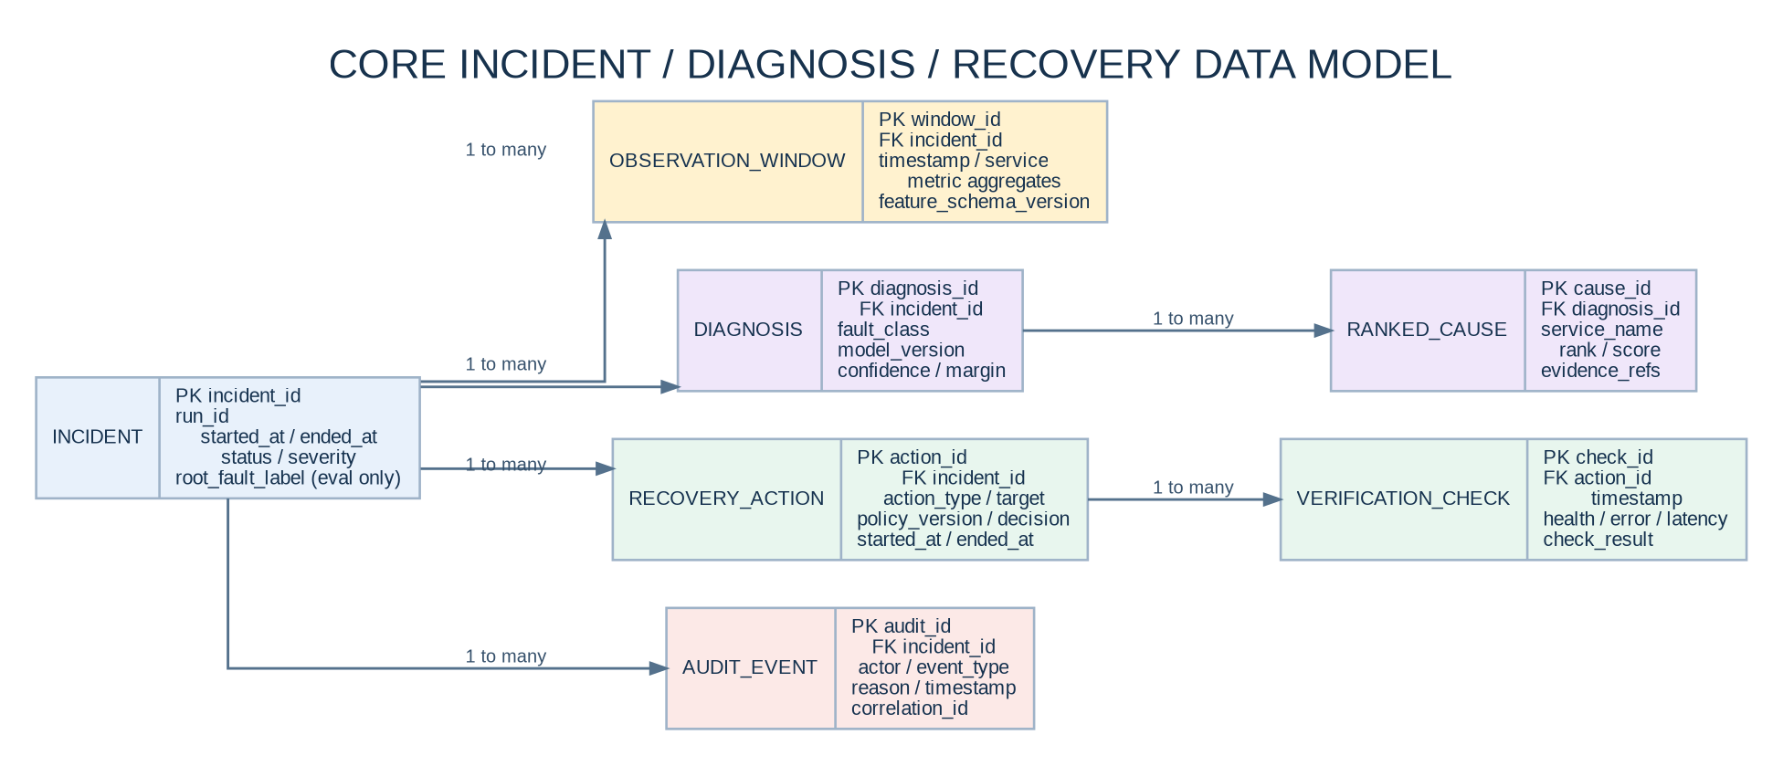
Figure 7. Relational data model for incidents, telemetry windows, diagnosis hypotheses, recovery actions, verification checks and audit records.

10.1 Core entities
Entity | Required fields (minimum) | Purpose
incident | incident_id PK, run_id, started_at, ended_at, status, severity, affected_service, scenario_id | One end-to-end failure episode and its lifecycle.
observation_window | window_id PK, incident_id FK, start/end timestamp, service_name, feature_schema_version, metrics_json or normalized feature fields | Time-aligned observations. For model training, export rows to CSV/Parquet with a separate split manifest.
diagnosis | diagnosis_id PK, incident_id FK, fault_class, model_version, confidence, top_two_margin, created_at, explanation_json | One inference or re-diagnosis decision.
ranked_cause | cause_id PK, diagnosis_id FK, service_name, rank, score, evidence_refs | Service-level ranked root-cause hypotheses.
recovery_action | action_id PK, incident_id FK, action_type, target, policy_version, decision, decision_reason, started_at, ended_at, execution_status | Candidate action, policy decision and execution record.
verification_check | check_id PK, action_id FK, timestamp, health_status, error_ratio, p95_latency, dependency_status, result | Repeated checks proving or rejecting recovery.
audit_event | audit_id PK, incident_id FK, actor/service, event_type, reason, timestamp, correlation_id | Append-only record of system decisions and control actions.
experiment_run | run_id PK, scenario_id, config_hash, app_version, model_version, seed, start/end, ground_truth_label | Reproducible fault campaign metadata. Ground truth is restricted to evaluation/training pipeline.

10.2 Data retention and redaction
Keep raw log/trace payloads only as long as needed for incident investigation. Persist summaries and references. Redact access tokens, passwords, personal data and arbitrary request bodies before storing logs or training features. Use bounded field lengths and avoid raw stack traces as uncontrolled model input in the initial version.

11. REST API and Payload Contracts
External browser traffic is routed through the Node gateway. Internal diagnosis and recovery endpoints should be reachable only from the private Compose/Kubernetes network. Use explicit versioning under `/api/v1` once contracts stabilize.

11.1 Gateway / operator API
Method and path | Purpose | Expected response
GET /api/v1/health | Aggregate health view for the dashboard. | Service health list, timestamp and overall status.
GET /api/v1/incidents | List recent incidents. | Paged incident summaries and lifecycle status.
GET /api/v1/incidents/{incidentId} | View one incident timeline. | Observations, diagnoses, actions, verification and audit references.
GET /api/v1/diagnosis/current | Current diagnosis summary. | Fault class, ranked root causes, confidence, model version and evidence list.
GET /api/v1/recovery/{actionId} | Track recovery. | Action state, result, verification state and duration.
POST /api/v1/experiments | Start an allowlisted lab scenario. | run_id, scenario_id, status; disabled outside test profile.
POST /api/v1/recovery/dry-run | Check a proposed action without executing it. | Allowed/denied, policy reason, target and risk summary.
POST /api/v1/recovery/execute | Request an allowlisted recovery action. | Action ID, state and audit ID; requires policy authorization.

11.2 Diagnosis service contract
Request example (timestamps and identifiers are illustrative)
POST /internal/v1/diagnose
Content-Type: application/json

{
"incident_id": "INC-20261015-0001",
"window_start": "2026-10-15T10:20:00Z",
"window_end": "2026-10-15T10:21:00Z",
"services": ["order-service", "inventory-service"],
"evidence_refs": ["prometheus://query/abc", "trace://trace-id/xyz"],
"feature_schema_version": "1.0"
}

Diagnosis response example (scores are illustrative; not benchmark results)
{
"incident_id": "INC-20261015-0001",
"anomaly_detected": true,
"fault_type": "DATABASE_LATENCY",
"confidence": 0.86,
"model_version": "rf-fault-v1.0",
"ranked_causes": [
{"service": "postgresql", "rank": 1, "score": 0.86,
"evidence": ["db_latency_high", "slow_db_spans"]},
{"service": "order-service", "rank": 2, "score": 0.54,
"evidence": ["p95_latency_high", "dependent_on_database"]}
],
"recommended_action": "BOUNDED_RETRY",
"limitations": ["database health endpoint unavailable"]
}

11.3 Recovery execution request
POST /internal/v1/recovery/execute

{
"incident_id": "INC-20261015-0001",
"action_type": "ROLLBACK_DEPLOYMENT",
"target": "order-service",
"requested_by": "recovery-controller",
"policy_version": "policy-1.0",
"idempotency_key": "INC-20261015-0001:rollback:order-service"
}

The adapter must reject unknown action names, unknown targets, stale requests, duplicate idempotency keys and targets outside the lab allow-list. Every rejection must return a reason code and write an audit event.

12. Diagnosis Model and Feature Design

12.1 Initial feature schema
Feature group | Example fields | Engineering notes
Traffic | request_count, request_rate, active_requests | Compare against a workload baseline; volume changes latency interpretation.
HTTP health | status_4xx_count, status_5xx_count, error_ratio | Use ratio denominators and minimum sample counts to avoid noisy low-volume ratios.
Latency | latency_p50_ms, latency_p95_ms, latency_p99_ms | Use consistent histogram quantiles and time windows across services.
Resources | cpu_pct, memory_pct, restart_count, oom_count | Distinguish resource pressure from the symptom of downstream waiting.
Database | db_latency_ms, db_error_count, db_connections_used, pool_wait_ms | Collect from application instrumentation and/or database exporter if available.
Traces/dependencies | failed_span_ratio, dependency_timeout_count, slow_dependency_count, upstream/downstream IDs | Aggregate per service and window; preserve trace references for explanations.
Deployment/config | seconds_since_deploy, version_changed, config_hash_changed | Use only information available at inference time. Avoid future-known bad-release labels.
Labels/targets (not inputs) | fault_class, root_cause_service, injected_fault_id, recovery_success | Labels are reserved for supervised training/evaluation; do not put them into the feature vector.

12.2 Model-serving contract
- Load a versioned model artifact at service startup; do not retrain automatically during an incident.
- Validate feature names, units, order, missingness and schema version before inference.
- Return `unknown` or `insufficient_evidence` when required evidence is missing or confidence is below the validation-selected threshold.
- Log latency and model version, but do not log secrets or entire raw request bodies.
- Run model evaluation offline. Promote a new model only after held-out episode tests and manual review.

12.3 Confidence interpretation
A model probability is not automatically a reliable confidence estimate. Calibrate the supervised classifier on a separate validation set (for example with isotonic or sigmoid calibration if appropriate), inspect reliability diagrams, and record top-1/top-2 margin. Isolation Forest returns an anomaly score; it should not be presented as a calibrated probability. The recovery policy must also use evidence sufficiency and action risk, not confidence alone.

13. Recovery Policy, Safety Gate and Verification

13.1 Action mapping baseline
Diagnosis/evidence | Candidate action | Policy constraints
Service process/Pod absent | Restart/replace service instance | Lab target only; cooldown and bounded retries; verify service ready.
Error spike strongly follows a known deployment | Rollback deployment | Known-good rollout revision required; ensure no DB schema change makes rollback unsafe; verify after rollback.
Sustained high traffic + resource saturation | Scale within limits | Require sustained windows, target maximum replica count and available cluster capacity.
Transient dependency failure | Bounded retry with backoff | Only for idempotent operations; strict attempt/time limit.
Database outage | Escalate; retry or configured failover only | No blind database restart in the first implementation; preserve data integrity.
Network degradation | Retry/failover to known healthy dependency | Target health must be verified; avoid retry storms.
Low confidence, conflicting evidence or unknown class | No action / human escalation | Fail closed; record evidence and reason.

13.2 Safety gate conditions
- Action type is on a hard-coded allow-list. The model cannot create a new action type or command string.
- Target resource is on a lab-environment allow-list and is resolved by the adapter, not by interpolating user-provided shell text.
- Model confidence and top-two margin pass validation-selected thresholds; required evidence is present; the fault is in a supported policy class.
- Risk score is acceptable for the action; a known-good deployment revision is available for rollback.
- No other recovery action is running against the same target; cooldown and per-incident retry budget are not exhausted.
- Preconditions and postconditions are checked. The action has an explicit timeout and idempotency key.
- Every allow or deny decision records policy version, reason, evidence IDs and operator/actor identity.

13.3 Example policy configuration
Illustrative policy file — the example thresholds are not experimentally validated
policy_version: "1.0"
mode: "dry-run" # change to execute only after validation
allowed_targets:
- order-service
- inventory-service
rules:
- fault_type: "BAD_DEPLOYMENT"
action: "ROLLBACK_DEPLOYMENT"
min_confidence: 0.85 # illustrative; tune on validation data
max_attempts_per_incident: 1
cooldown_seconds: 300
- fault_type: "SERVICE_CRASH"
action: "RESTART_SERVICE"
min_confidence: 0.80 # illustrative; tune on validation data
max_attempts_per_incident: 2
cooldown_seconds: 120
default:
action: "ESCALATE"
reason: "No safe policy matched"

13.4 Recovery verification definition
Define “healthy” using more than process existence. A recovery should require the target service to be ready, its key request health to be back within a configured error-rate/latency envelope, and its critical dependencies to be reachable. These conditions should hold for K consecutive checks (for example, three checks, with interval selected for the experiment). Tune thresholds against normal-operation data; do not blindly use the same threshold for every workload.
recovery_result = SUCCESS only if:
target_ready == true
AND error_ratio < configured_error_limit
AND p95_latency_ms < configured_latency_limit
AND dependencies_healthy == true
for K consecutive verification checks

If checks time out or the retry budget is exhausted:
mark RECOVERY_FAILED
stop automated retries
preserve evidence and escalate

14. Security, Privacy and Operational Reliability

14.1 Critical safety controls
Control | Implementation requirement
No arbitrary shell execution | The controller passes enum-like actions and structured targets to an adapter. The adapter maps them to known operations; it never executes model-generated command text.
Least privilege | Docker Compose services run with only needed permissions. Kubernetes adapter uses a dedicated ServiceAccount and namespace-scoped RBAC; do not grant cluster-admin.
Docker socket warning | Do not mount `/var/run/docker.sock` or its Windows equivalent into the main controller/API container. Access to the Docker daemon is effectively highly privileged. For local action tests, prefer dry-run first and a separate restricted host/test runner.
Authentication/internal network | Internal endpoints should not be published to the host by default. If exposed for development, bind to localhost and use explicit authentication outside isolated lab use.
Secrets | Credentials belong in ignored local environment files or secret mechanisms, never in Git, test labels, telemetry fields or model features.
Auditability | Record user/actor, incident, policy/model version, input evidence IDs, action/target, allow/deny reason, timestamps and verification result.
Rate limits / loop protection | Deduplicate incidents, add cooldown, lock target during action and cap attempts per incident.
Test isolation | Fault injector only accepts predefined scenarios and lab targets. Disable it outside the test profile. Never point experiments at external or production resources.

14.2 Observability and reliability
- Propagate a correlation ID/trace ID from gateway through downstream calls and controller events wherever technically possible.
- Use bounded timeouts on all HTTP/DB/telemetry queries. A stalled observability backend must not create unbounded controller threads.
- Apply retries with exponential backoff and jitter to telemetry queries; do not retry non-idempotent business operations blindly.
- Keep the diagnosis service read-only toward the infrastructure. Only the recovery adapter has action permissions.
- If telemetry or diagnosis is unavailable, default to monitoring/degraded mode or escalation—not automatic speculative remediation.
- Use readiness/liveness probes for service management, but do not confuse Kubernetes container self-healing with root-cause diagnosis.

15. Implementation and Deployment Mapping
Handbook phase | Architecture work | Done means
Phase 0–1 | Install tools, create repository, version manifest and API contracts. | Commands work; repository is initialized; dependencies are pinned.
Phase 2–3 | Build Spring Boot order service, Node gateway and React UI. | Business request path works; tests and health endpoints pass.
Phase 4 | Add PostgreSQL and Docker Compose. | One command starts the app; data uses a named volume.
Phase 5–6 | Instrument metrics/traces/log context; add Prometheus and Grafana. | Target metrics appear; dashboard shows normal and injected-fault trends.
Phase 7–8 | Create fault injector and dataset pipeline. | A run creates a reproducible manifest and time-windowed labelled samples.
Phase 9–10 | Implement threshold/Isolation Forest detector and Random Forest classifier. | Held-out episode performance and confusion matrix can be produced.
Phase 11 | Implement dependency-aware root-cause ranking. | Diagnosis response returns ranked services with evidence references.
Phase 12 | Implement policy, safety gate and dry-run recovery adapter. | Unsafe/unknown actions are denied; allowed decision reasons are auditable.
Phase 13 | Implement post-action verifier and knowledge base. | Recovery status is determined from consecutive health checks.
Phase 14 | Deploy to Minikube and scope Kubernetes RBAC. | Controlled lab action works with restricted permissions.
Phase 15–16 | Run experiments, analyse results and demonstrate whole loop. | Results are reproducible and no fabricated performance numbers are reported.

16. Fault Scenarios and Expected System Behaviour
Scenario | Injection method (lab only) | Primary evidence | Expected diagnosis | Candidate action / expected control
Service crash | Stop/kill designated service instance. | Health failed, restart/process state, 5xx surge. | SERVICE_CRASH / named service. | Restart/replace only if allowed; verify ready and healthy.
CPU saturation | Controlled CPU load in test container. | CPU sustained high, p95 up, traffic context. | CPU_EXHAUSTION or capacity saturation. | Scale only with sustained evidence and max-replica guard.
Memory pressure | Bounded memory load in test container. | Memory slope, memory percent, OOM/restart events. | MEMORY_PRESSURE. | Restart only if policy supports it; no unbounded restarts.
DB latency | Add delay in test DB or DB query layer. | DB latency, slow DB spans, order-service latency. | DATABASE_LATENCY; DB likely root. | Bounded retry/backoff; avoid blind DB restart.
DB outage | Stop test DB container/service. | Connection failures, span errors, dependent 5xx. | DATABASE_FAILURE. | Escalate or preconfigured failover; preserve data.
Network degradation | Inject latency/loss in test network. | Timeouts by dependency and trace paths. | NETWORK/DEPENDENCY_FAILURE. | Retry only if safe; fail over to verified healthy target.
Bad deployment | Deploy known faulty lab revision. | Release timestamp followed by error surge. | BAD_DEPLOYMENT. | Rollback known-good revision; verify post-rollback behavior.
Traffic overload | Generate controlled load. | Request rate, latency, resource saturation and errors. | TRAFFIC_OVERLOAD. | Scale or load-shed within fixed limits.
Unknown / mixed fault | Overlap symptoms or remove a telemetry source. | Conflicting evidence and low diagnostic margin. | UNKNOWN / LOW_EVIDENCE. | Deny autonomous action; preserve evidence and escalate.

17. Test Strategy and Acceptance Criteria

17.1 Test layers
Layer | Tests | Minimum acceptance condition
Unit | Feature-window parser, rule engine, confidence policy, action allow-list, state transitions. | Deterministic tests cover normal and invalid cases; rejected actions never reach adapter.
Contract | Gateway-to-service APIs, diagnosis request/response schema, controller/adapter schema. | Versioned contracts validate; unknown fields/action names are handled safely.
Integration | Compose startup, database migrations, Prometheus scrape, OTLP export, model API connectivity. | All expected targets show UP; basic evidence can be queried end to end.
Fault-injection | One controlled scenario per class, with cleanup check. | Run manifest records scenario and timings; normal environment returns after cleanup.
Closed loop | Fault → detection → diagnosis → dry-run → action → verification. | A test can trace all stages by incident_id/run_id and correlation IDs.
Safety | Unknown class, low confidence, out-of-allowlist target, repeated event, adapter timeout. | All invalid/unsafe requests are denied; retry cap and cooldown are enforced.
Performance | Baseline vs monitoring and inference enabled. | Measure request latency, CPU/RAM overhead; set acceptance target before final runs.
Reproducibility | Repeat same scenarios with frozen code/model/config versions. | Run manifest, split manifest and output metrics are stored and reviewable.

17.2 Research metrics
Dimension | Metric | Operational definition
Detection | Precision, Recall, Macro-F1, false-positive rate | Report both telemetry-window and incident-level results where possible.
Detection time | MTTD | First valid detection timestamp minus injection start.
Classification | Macro-F1, balanced accuracy, confusion matrix | Use held-out fault episodes; show per-class errors.
Localization | Top-1, Top-3, MRR | Rank position of the ground-truth faulty service; define ties consistently.
Recovery | MTTR, success rate, attempt count | Use verified healthy time; report failed/non-recovered incidents separately.
Safety | Incorrect action rate, escalation rate, unauthorized actions | Target zero unauthorized actions; report all denied and incorrect actions.
Overhead | CPU/RAM added, request latency delta | Compare app baseline against monitoring and diagnosis enabled.
Robustness | Performance by load, fault intensity and missing modality | Show degradation under changed workload and incomplete telemetry.

17.3 Model and policy comparison
- B0: static thresholds + fixed action mapping.
- B1: rule-based diagnosis + fixed policy.
- B2: Random Forest diagnosis + same recovery policy.
- B3: metrics plus structured log/trace features.
- B4: B3 plus dependency-aware root-cause ranking.
- B5: full proposed system with safety gate, verification and history.
- Ablations: remove dependency graph, remove logs/traces, remove historical features, replace ML with rules, and compare dry-run versus approved autonomous recovery in a sandbox.
Research integrity
Do not place assumed numbers in the results table. The contribution is supported only if repeated experiments show measurable improvements (or identify a meaningful failure mode) relative to baselines. Report confidence intervals and avoid overstating statistical significance.

18. Repository Structure and Configuration Baseline
Recommended source repository layout
AutoHeal-AI/
frontend/ # React dashboard
gateway/ # Node.js / Express gateway
app-services/
order-service/
inventory-service/
recovery-controller/ # policy, safety, state machine
diagnosis-service/ # Python FastAPI + ML
app/ models/ feature_schema/ tests/
fault-injector/ # predefined lab-only scenarios
monitoring/
prometheus/ grafana/ otel-collector/
database/migrations/
experiments/
manifests/ outputs/ split_manifests/
datasets/ # generated data; large raw files not committed
docs/
architecture.md api-contracts.md
version-manifest.md model-card.md
docker-compose.yml .env.example .gitignore README.md

18.1 Version baseline
Technology | Baseline release line | Notes
Java / JDK | 21 LTS | Use JDK, not JRE. Pin Maven Wrapper and dependencies through the generated project.
Spring Boot | 4.1.x stable line from Spring Initializr | Check compatibility with required dependencies and choose a stable patch; commit wrapper and dependency lock/config.
Node.js | 24.x LTS | Commit package-lock.json; use `npm ci` for reproducible installs.
Python | 3.12.x | Create a virtual environment; pin scikit-learn/FastAPI/Pydantic dependencies after a clean install works.
PostgreSQL | 17.x container line | Use a named volume; avoid removing volumes during normal teardown.
Prometheus / Grafana / OTel | Pinned stable images chosen for the tested build | Do not use `latest` in final experiment manifests; record image digests or exact tags.
Docker Compose | Version bundled with current Docker Desktop | Record `docker compose version` and Docker Desktop version.
Kubernetes | Minikube after Compose is stable | Record `kubectl version`, Minikube version and node capacity.

18.2 Configuration that must be versioned
- `docs/version-manifest.md`: OS build, WSL version, Docker Desktop/Compose, JDK, Node, Python, service library versions, container tags.
- Feature schema and units; telemetry aggregation window; missing-value policy; service dependency map.
- Fault scenario parameters, workload profile, random seed where applicable, run manifest and cleanup result.
- Train/validation/test split manifest by incident episode; model artifact hash; model version; evaluation output.
- Recovery policy version, thresholds, retry limits, cooldown, allowed targets and Kubernetes RBAC manifest.

19. Risks, Decisions and Technical References

19.1 Primary risks and mitigations
Risk | Impact | Mitigation
Too many services too early | Integration failures become hard to isolate. | Start with one Spring Boot service, gateway and DB; add inventory service after core path passes.
Weak or biased dataset | Model scores do not generalize. | Use repeated varied episodes, episode-level splits, clear labels, normal runs and per-class evaluation.
Label leakage | Inflated test accuracy. | Separate fault injector ground-truth metadata from online feature store and maintain split manifests.
Uncalibrated confidence | Unsafe remediation may be allowed. | Calibrate on validation episodes, add unknown/abstain outcome and require action-risk checks.
Recovery makes outage worse | Compounding failure or data risk. | Dry-run first; restricted allow-list; bounded attempts; safe default is escalation.
Monitoring outage | Missing evidence may appear as healthy state. | Represent missing telemetry explicitly and deny autonomous recovery when evidence is insufficient.
Privilege escalation through Docker/Kubernetes | Controller compromise could control the host/cluster. | No Docker socket in application controller; least-privilege Kubernetes RBAC and dedicated adapter.
Version drift | Results cannot be reproduced. | Pin versions/tags, record hashes and create new experiment IDs after any upgrade.

19.2 Key technical references
- Spring Boot Actuator and metrics: Health and Micrometer metrics for Spring services. https://docs.spring.io/spring-boot/reference/actuator/metrics.html
- Node.js documentation: Runtime and API documentation for the gateway. https://nodejs.org/en/docs
- OpenTelemetry documentation: Language instrumentation, Collector and telemetry concepts. https://opentelemetry.io/docs/
- Prometheus documentation: Metrics model, scrape configuration and query API. https://prometheus.io/docs/introduction/overview/
- Grafana documentation: Dashboards and data-source integration. https://grafana.com/docs/grafana/latest/
- Docker Compose documentation: Local multi-container deployment and service networking. https://docs.docker.com/compose/
- Kubernetes self-healing: Existing platform recovery features; do not claim restart alone as research novelty. https://kubernetes.io/docs/concepts/architecture/self-healing/
- Kubernetes probes: Liveness, readiness and startup semantics. https://kubernetes.io/docs/concepts/configuration/liveness-readiness-startup-probes/
- Kubernetes RBAC: Scope privileges for the recovery adapter. https://kubernetes.io/docs/reference/access-authn-authz/rbac/
- RCAEval dataset/project: Public root-cause evaluation resources; inspect dataset licensing and schema before use. https://github.com/phamquiluan/RCAEval
- DiagFusion paper/project: Multimodal microservice diagnosis motivating metric/log/trace evidence integration. https://arxiv.org/abs/2302.10512
- DiagMLP paper/project: Useful comparison point for questioning whether complex graph models always outperform simpler baselines. https://arxiv.org/abs/2501.02766
- scikit-learn documentation: Isolation Forest, Random Forest, calibration and evaluation tooling. https://scikit-learn.org/stable/

Final Architecture Summary
AutoHeal AI is built as a controlled autonomic loop around a normal distributed web application. The application plane handles user requests. The observability plane exposes time-aligned symptoms and trace context. The diagnosis service proposes fault classes and ranked root causes with evidence. The recovery controller evaluates a bounded policy and safety gate. The recovery adapter executes only a permitted action. The verifier judges whether health actually recovered. Finally, the incident store records the complete chain so the same system can be tested scientifically.
Build order
React/Node gateway + one Spring Boot service + PostgreSQL → Compose → metrics/traces → controlled fault injection → dataset → baseline diagnosis → ML classifier → dependency ranking → dry-run policy → one low-risk recovery → verification → Kubernetes. Do not enable autonomous actions before dry-run safety tests pass.

