EC4307 Web Application Development
Mini Project Report
EventEase
Smart Event Management & Registration Platform
Item | Details
Student name | [Your full name]
Index number | [Your index number]
Technology | MERN stack: MongoDB, Express.js, React, Node.js
Main entity (CRUD) | Events (with ticket types, bookings and tickets)
GitHub repository | https://github.com/prasadilmi2003-lgtm/eventfull
Submission date | 31 October 2026

1. Introduction
Finding events, registering for them and managing attendance are still done with scattered tools such as social media posts, forms and spreadsheets. EventEase is a full-stack web application that brings these tasks into one platform. Organizers publish events and define ticket types, attendees search for events, book tickets and receive a unique QR ticket, and administrators review events and manage user accounts. All data is stored persistently in a MongoDB database.

1.1 Objectives
- Provide complete Create, Read, Update and Delete (CRUD) operations on the main entity, events, backed by MongoDB.
- Let attendees search, filter and sort events, and book tickets without the system ever selling more tickets than exist.
- Issue a unique QR ticket for every seat and let organizers verify and check in attendees at the entrance.
- Support three roles (attendee, organizer, administrator) with permissions enforced on the server.
- Validate input on both the client and the server and show clear error messages.
- Provide a responsive, consistent interface that works on desktop, tablet and phone.

1.2 Users and roles
Role | What the role can do
Attendee | Register and log in, browse and search events, save favourites, book tickets, view QR tickets, cancel bookings, write reviews, edit profile.
Organizer | Create, edit, submit, cancel and delete own events with ticket types; see attendee lists and sales analytics; check attendees in using their QR code.
Administrator | View platform statistics and reports, approve, reject or unpublish events, suspend or reactivate user accounts.

2. Technologies and System Architecture

2.1 Technologies used
Layer | Technology | Purpose
Frontend | React 19, Vite, React Router 7 | Single-page application with client-side routing and fast development builds.
Styling | Tailwind CSS 4, Lucide icons | Responsive layout and a consistent violet design system.
HTTP client | Axios | One shared instance that sends the login cookie with every request.
Backend | Node.js, Express 5 | REST API with routes, controllers and middleware.
Database | MongoDB, Mongoose 9 | Document database with schemas, validation, indexes and references.
Security | JWT, bcryptjs, Helmet, CORS, Zod | Authentication, password hashing, secure headers and request validation.
Extras | qrcode.react, Google Gemini API | QR ticket images and an AI help chatbot.
Tools | Git and GitHub, MongoDB Compass, VS Code | Version control, database inspection and development.

2.2 Architecture
EventEase follows a three-tier architecture. The React application in the browser talks only to the Express REST API, and only the API talks to MongoDB. During development Vite forwards every request that starts with /api to the backend on port 5000, so the HTTP-only login cookie works without extra cross-origin settings.
- A React component calls the API through the shared Axios instance (client/src/lib/api.js).
- Express matches the route and runs the middleware: protect checks the JWT cookie and authorize checks the role.
- The controller validates the input, applies the business rules and uses a Mongoose model to read or write MongoDB.
- The result is returned as JSON, or as { message, errors } with a suitable status code (400, 401, 403, 404, 409) that a central error handler formats.
The project is split into two folders: client/ (components, pages, context, hooks and utilities) and server/ (models, controllers, routes, middleware, configuration and a seed script).

2.3 REST API
Area | Main endpoints
Authentication | POST /api/auth/register, /login, /logout; GET and PATCH /api/auth/me; forgot-password and reset-password.
Events | GET /api/events (search, filter, sort, pages) and /featured; GET /api/events/:id; POST, PATCH and DELETE /api/events; POST /publish and /cancel.
Organizer | GET /api/organizer/events, /dashboard, /events/:id/attendees and /analytics.
Bookings and tickets | POST /api/bookings; GET /bookings/my and /:id; POST /bookings/:id/cancel; GET /tickets/my; POST /tickets/check-in.
Admin | GET /api/admin/dashboard, /users, /events, /reports; PATCH /users/:id/status and /events/:id/review.
Other | Favourites, reviews, notifications, contact form and the AI chat endpoint.

3. Database Design
The database is a MongoDB database named eventease with seven collections. Ticket types are embedded inside events, and booking items are embedded inside bookings. Figure 1 shows the entity relationship diagram (ERD) drawn from the Mongoose models.
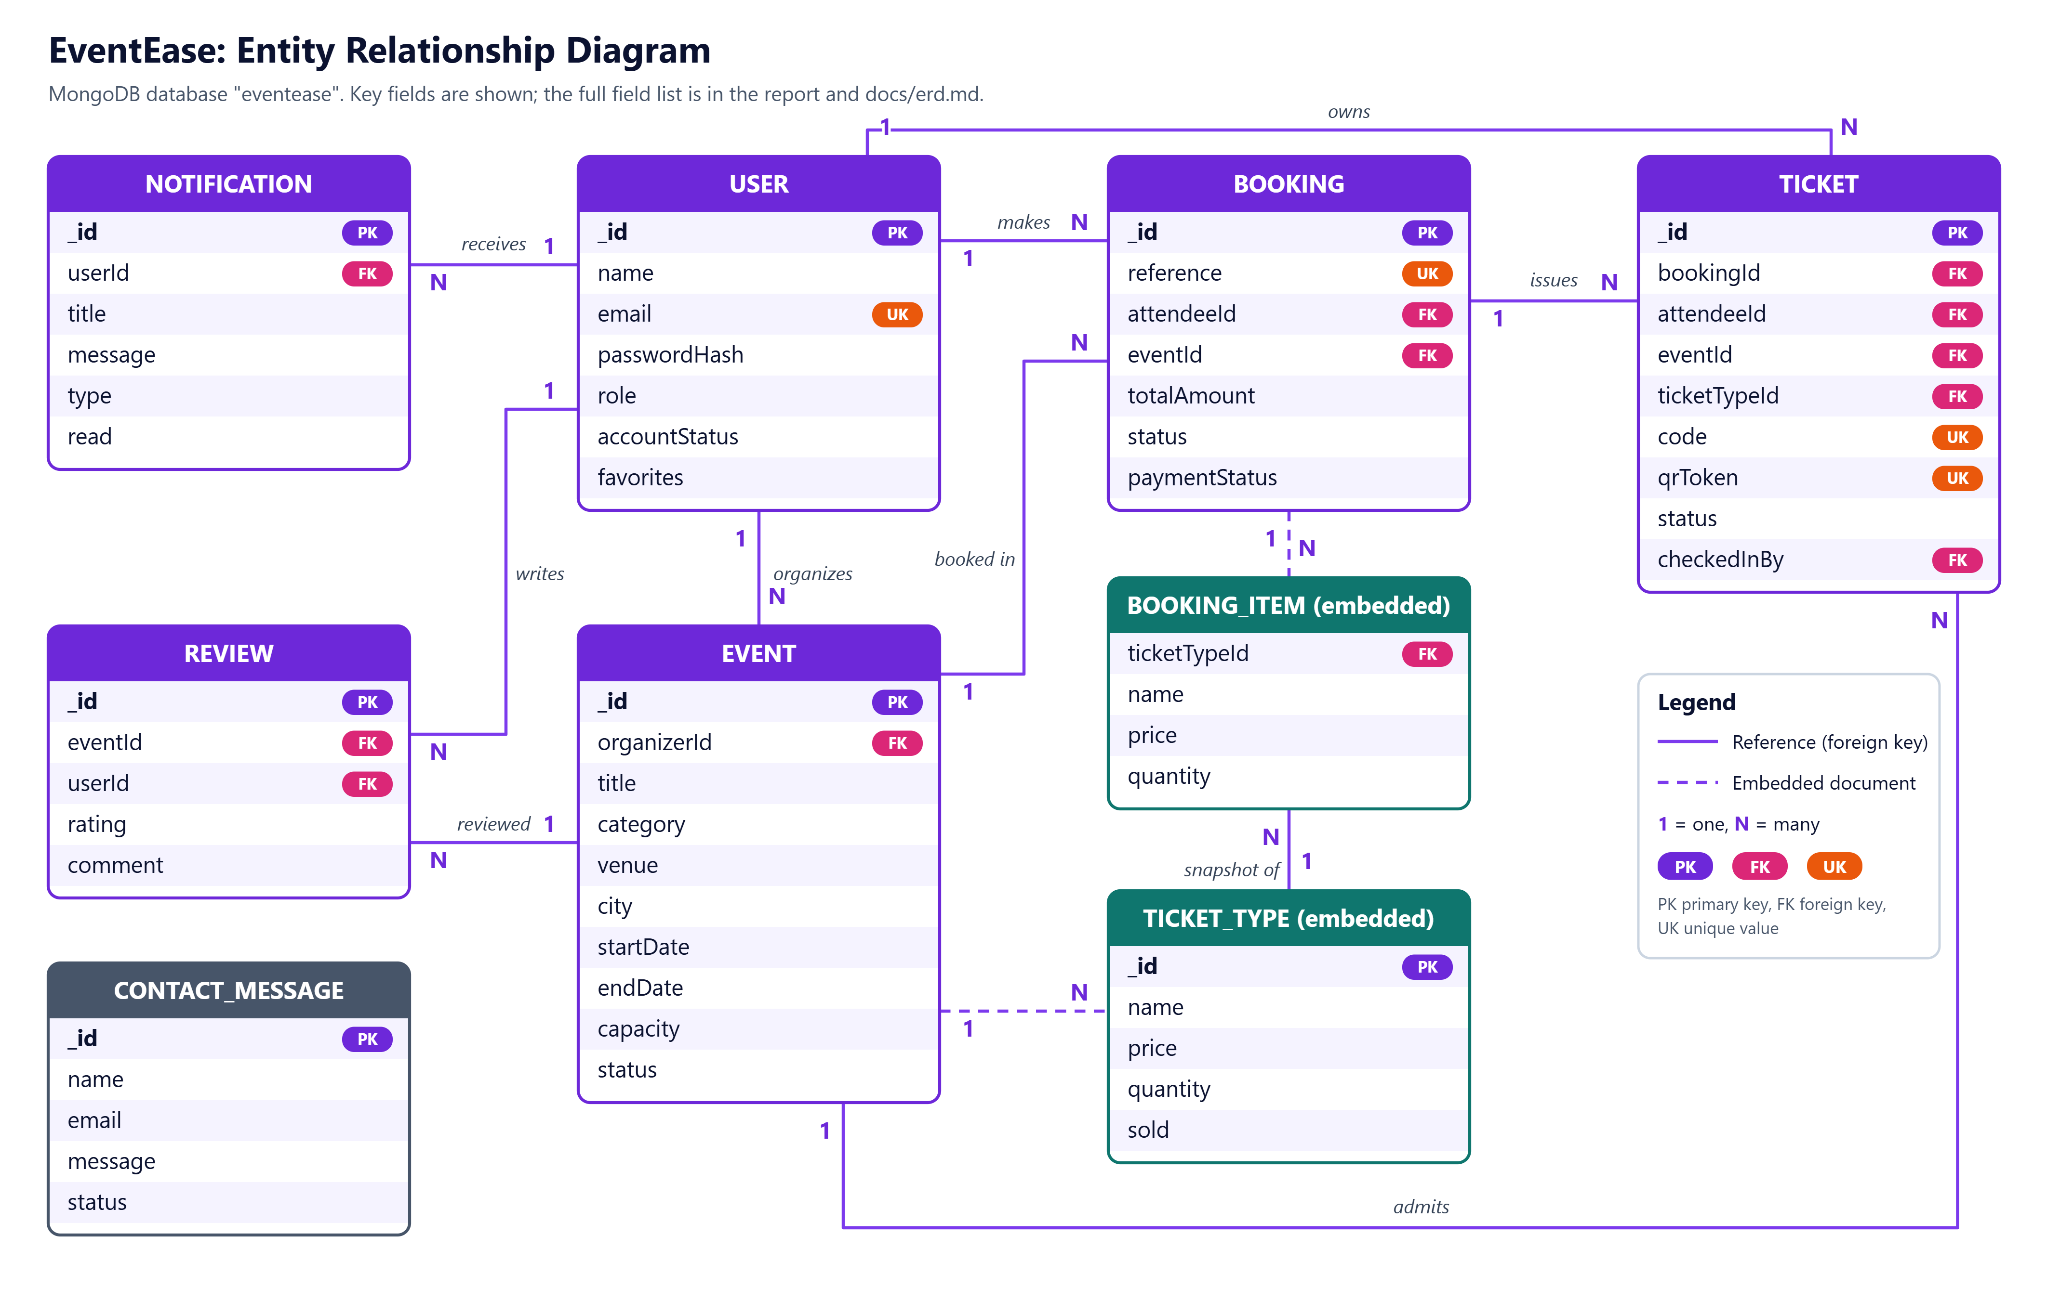
Figure 1: Entity relationship diagram (PK = primary key, FK = foreign key, UK = unique)

3.1 Collections
Collection | Purpose and key fields
users | Accounts. Unique email, bcrypt password hash, role (attendee, organizer, admin), account status, favourite event ids.
events | Event details, category, dates, capacity and status (draft, pending, published, rejected, cancelled). Embeds the ticket types; organizerId references users.
bookings | One booking per purchase: unique reference, attendee, event, items (name and price snapshot), total amount, status, payment status.
tickets | One document per seat: unique code, unique QR token, status (valid, checked_in, cancelled), check-in time and who checked in.
reviews | Rating 1 to 5 and comment; one review per user per event.
notifications | Messages for a user, with type and read flag.
contactmessages | Messages sent from the contact form (no relationships).

3.2 Design decisions
- Embedded ticket types. They are always read together with their event, never on their own, and each event has only a few. One read returns everything the event page needs.
- Separate tickets collection. One booking can contain many seats and each seat needs its own QR code and check-in status.
- Price snapshots. Booking items keep the ticket name and price at the time of purchase, so later price changes do not alter old bookings.
- Indexes and keys. Unique indexes on email, booking reference, ticket code and QR token, and on the pair (event, user) for reviews; query indexes on event status, date, category, city and organizer; a text index for event search.

4. Implementation

4.1 CRUD operations on events
Events are the main entity. Every operation is stored in MongoDB and is restricted to the event owner or an administrator.
Operation | User action | API | Rules enforced
Create | Organizer fills in the Create event form with ticket types and saves a draft. | POST /api/events | Server validation; new events start as draft and the organizer is taken from the login, not from the form.
Read | Visitors browse, search, filter by category, date, price and location, sort and page through events; open an event page. | GET /api/events, /api/events/:id | Only published events are public; drafts are visible to the owner and administrators.
Update | Organizer edits the event in the same form. | PATCH /api/events/:id | Owner or admin only (403 otherwise); cancelled events cannot be edited.
Delete | Organizer clicks the bin icon and confirms in a dialog. | DELETE /api/events/:id | Blocked with 409 if confirmed bookings exist (cancel the event instead); removes related tickets and favourites.
Events follow a lifecycle: the organizer saves a draft, submits it as pending, and an administrator approves it (published) or rejects it with a reason. An organizer can also cancel an event, which cancels its bookings.

4.2 Booking, ticket inventory and QR check-in
- The attendee chooses ticket types and quantities; the server reads the prices from the database and calculates the total, so a changed price in the browser has no effect.
- Seats are reserved with one atomic MongoDB update (findOneAndUpdate with a condition on the sold count and $inc), so two buyers cannot take the last seat. If one item of a multi-ticket booking fails, the earlier reservations are rolled back.
- A confirmed booking receives a unique reference (EE-XXXXXX) and one ticket per seat with a unique code and a random QR token that contains no personal data.
- Cancelling a booking marks its tickets as cancelled and returns the seats to the ticket types.
- At the entrance the organizer enters or scans the token. The server checks that the ticket exists, belongs to the selected event, is not cancelled and has not been used, then records the check-in time and the staff member.

4.3 User interface
The interface uses a violet and pink colour theme with photography, rounded cards and glass-style panels. Figures 2 to 9 show the main screens captured from the running application.
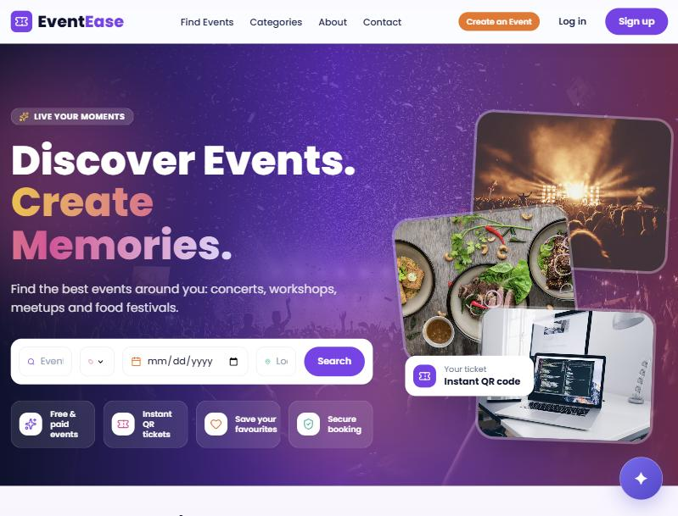  Figure 2: Home page with search bar | 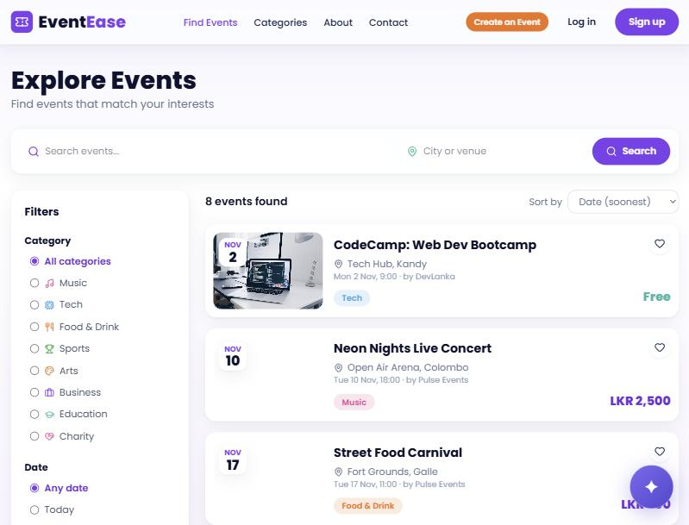  Figure 3: Explore page with filters and sorting
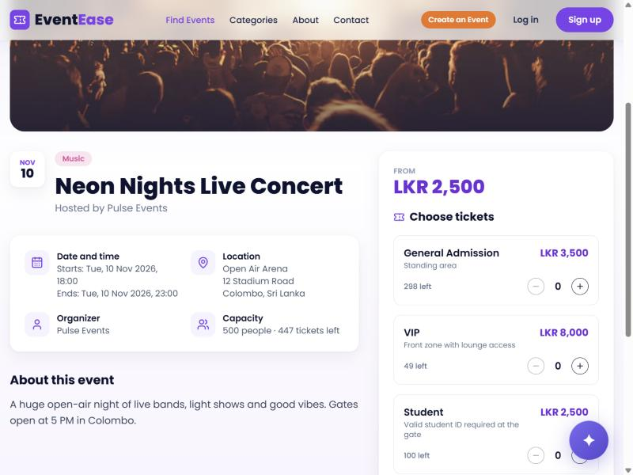  Figure 4: Event details and ticket selection | 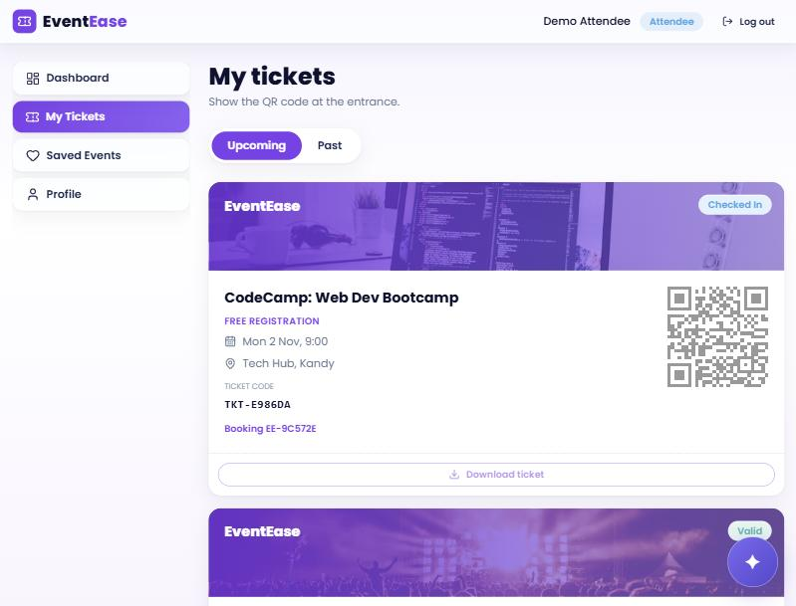  Figure 5: Attendee tickets with QR codes
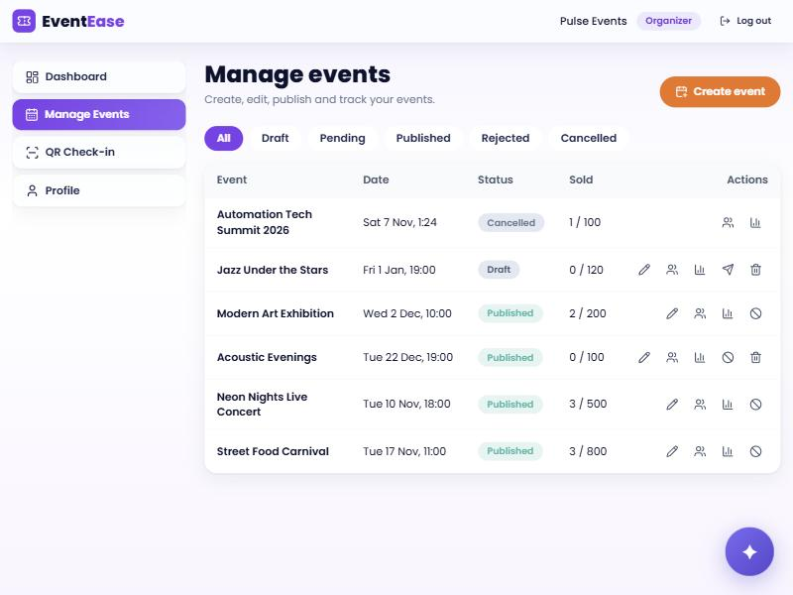  Figure 6: Organizer event list with edit, delete and other actions | 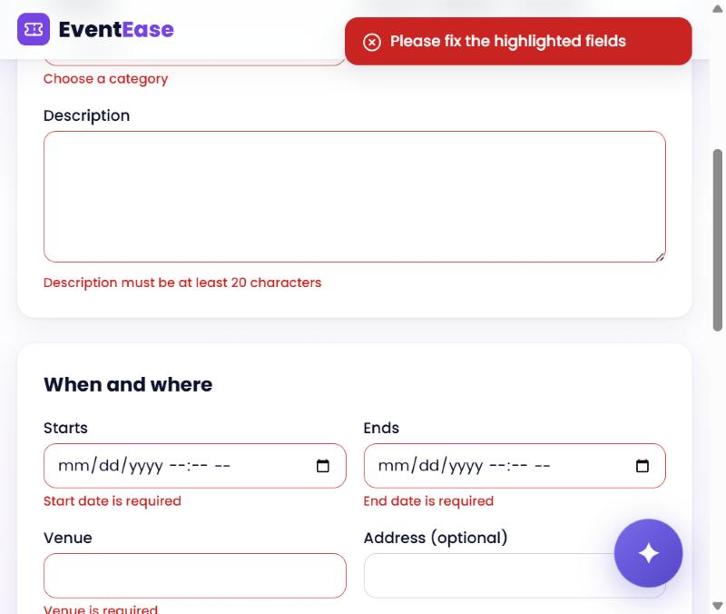  Figure 7: Create event form showing validation errors
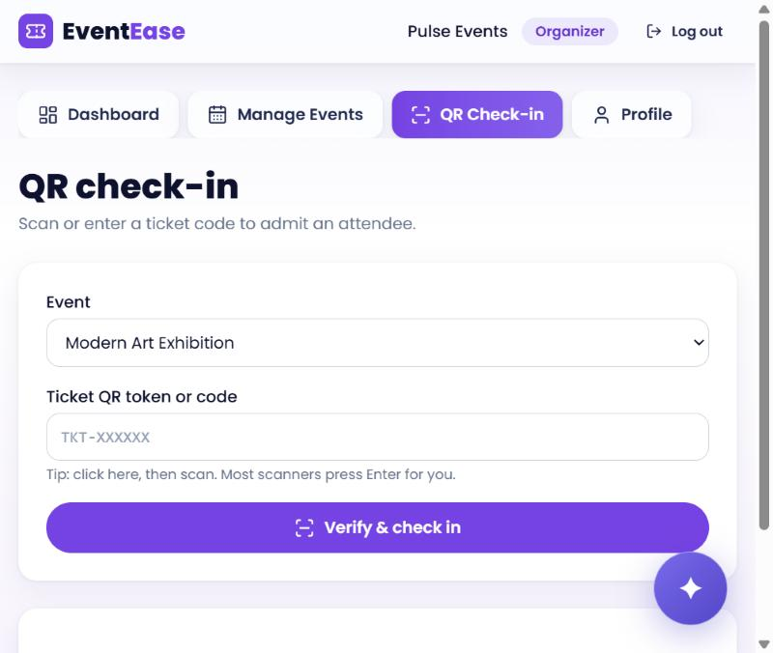  Figure 8: QR check-in for organizers | 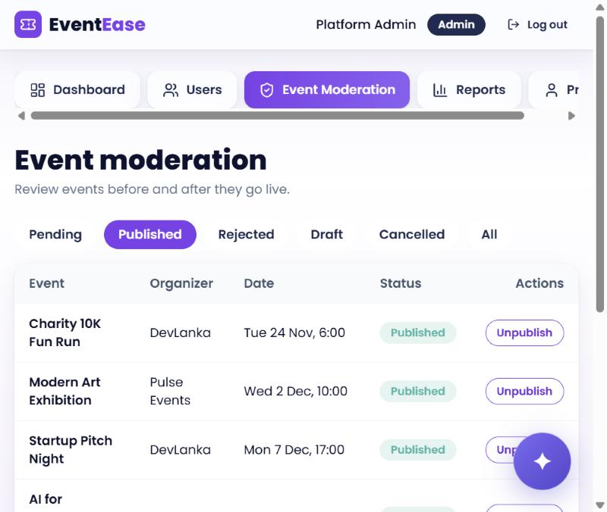  Figure 9: Administrator event moderation

4.4 Validation and error handling
- Client side: forms check every field before sending (required fields, email format, password rules, dates, price and quantity) and show the message under the field, as in Figure 7.
- Server side: controllers validate every request again (event input rules, Zod schemas for authentication, Mongoose schema constraints), because the browser cannot be trusted.
- Consistent errors: the API returns { message, errors } with the right status code, and a central error handler formats unexpected errors without exposing internal details.
- User feedback: toast notifications for success and failure, loading skeletons, empty states and retry buttons when a request fails.

4.5 Security
- Passwords are hashed with bcrypt (12 rounds); plain passwords are never stored.
- Login uses a JWT valid for 7 days, stored in an HTTP-only cookie so JavaScript cannot read it. In production the cookie is Secure with SameSite set for cross-site use.
- Role-based authorization middleware protects every restricted route, and controllers check ownership so an organizer can only manage their own events.
- Helmet sets secure HTTP headers; CORS accepts only the configured front-end origin in production; secrets such as the database address and API keys are kept in a .env file that is not committed to Git.
- Totals are calculated on the server, and QR tokens are random and unguessable.

4.6 Additional features
Beyond the core requirements the application includes favourites, ticket reviews, in-app notifications, an organizer analytics page with sales charts, an attendee list with CSV export, and an AI chatbot (Google Gemini) that answers questions about the platform.

5. Testing
The back end includes an automated API test script (server/src/utils/testSuite.js, 53 assertions) that runs against the live API with the command npm test. It covers: health check, registration and duplicate rejection, login and cookies, suspended account blocking, profile updates, event search and filters, organizer draft creation and submission, administrator approval and rejection, atomic ticket inventory under concurrent requests, unique booking references and QR tokens, ticket verification and repeated check-in rejection, booking cancellation with seat restoration, favourites and the contact form.
Test result: [paste the summary line printed by npm test, for example "X passed, 0 failed"]
In addition, the main screens of each role (attendee, organizer, administrator) were exercised in the browser against the running back end and the database was inspected in MongoDB Compass to confirm that created, edited and deleted events were stored and removed.

6. Limitations and Future Work
- Payments are simulated. Paid bookings are recorded as paid without a payment gateway; a provider such as Stripe with signed webhooks is the next step.
- No email delivery. Booking confirmations and password reset links are not sent by email.
- QR scanning. Check-in accepts a typed or scanner-entered code; scanning with the device camera is not implemented.
- Local deployment. The system runs locally with a local MongoDB database; a deployment guide for Atlas, Render and Vercel is included in the repository (docs/deployment.md).
- Further hardening. Rate limiting on login and image upload to a storage service would be added for production.

7. Conclusion
EventEase meets the project requirements: it provides complete CRUD on events with persistent MongoDB storage, a validated and secured REST API, a documented database design, role-based dashboards, safe ticket booking with QR check-in, and a responsive interface. Building it gave practical experience with the MERN stack, REST design, authentication with cookies, database modelling and handling concurrent updates safely.

References
- React documentation. https://react.dev
- Express.js documentation. https://expressjs.com
- MongoDB manual and Mongoose documentation. https://www.mongodb.com/docs and https://mongoosejs.com
- Tailwind CSS documentation. https://tailwindcss.com/docs
- Vite documentation. https://vite.dev
- Photographs from Unsplash. https://unsplash.com

