**Case study approach:**

1. **Input files**

* 2019-Nov.csv
* 2019-Oct.csv

1. **Store given CSV input files inside folder “casestudyinput” in S3 bucket**

* s3://hivecasestudy/casestudyinput/

1. **Create folder “case_study” in HDFS and copy files from S3 into case_study folder**

* hadoop fs -mkdir /case_study
* hadoop distcp s3://hivecasestudy/casestudyinput/2019-Nov.csv /case_study/2019-Nov.csv
* hadoop distcp s3://hivecasestudy/casestudyinput/2019-Oct.csv /case_study/2019-Oct.csv

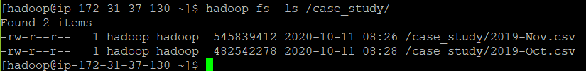

1. **Launch Hive and create database with name “db_hive”**

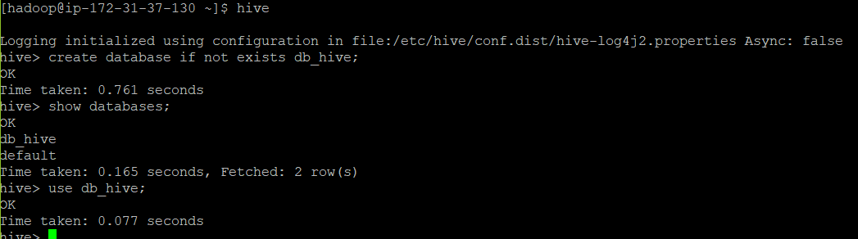

1. **Create table with name “oct_nov_data” using CSVserde**

* create table oct_nov_data (event_time timestamp,event_type string,product_id string,category_id string,category_code string,brand string,price float,user_id bigint,user_session string) row format serde 'org.apache.hadoop.hive.serde2.opencsvserde'with serdeproperties ("separatorchar" = ",") stored as textfile tblproperties("skip.header.line.count" = "1");

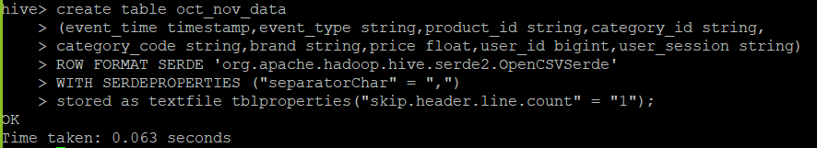

* desc oct_nov_data;

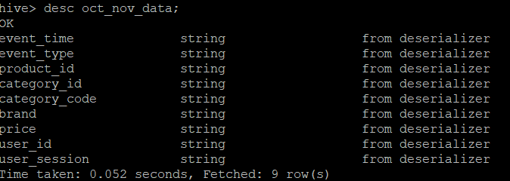

1. **Loading data from HDFS into Hive table “oct_nov_data”**

* load data inpath '/case_study/2019-Oct.csv' into table oct_nov_data;
* load data inpath '/case_study/2019-Nov.csv' into table oct_nov_data;

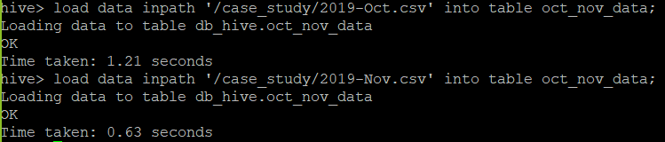

* **Make headers visible by using below command**
  + set hive.cli.print.header=true;
* **Check data**
  + select * from oct_nov_data limit 5;

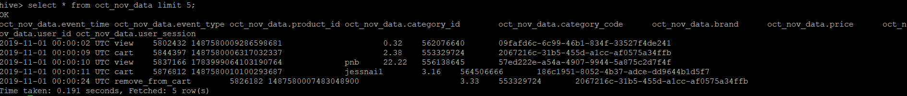

* **Count rows in data**
  + Select count(*) from oct_nov_data;

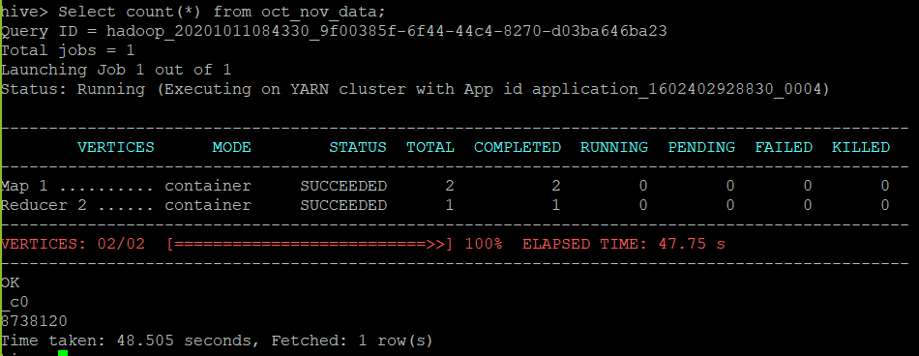

1. **Create new table “oct_nov_table” to get the desired datatype for (event_time, price and user_id)**

* create table oct_nov_table (event_time timestamp,event_type string,product_id string,category_id string,category_code string,brand string,price float,user_id bigint,user_session string);
* desc oct_nov_table

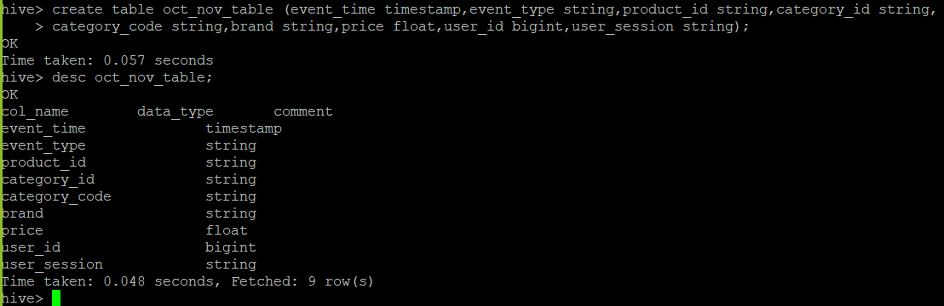

1. **Insert data from “oct_nov_data” into “oct_nov_table” with desired data type**

* insert into table oct_nov_table select from_unixtime(unix_timestamp(event_time)), event_type, product_id, category_id, category_code, brand, price, user_id, user_session from oct_nov_data;
* select * from oct_nov_table limit 5;

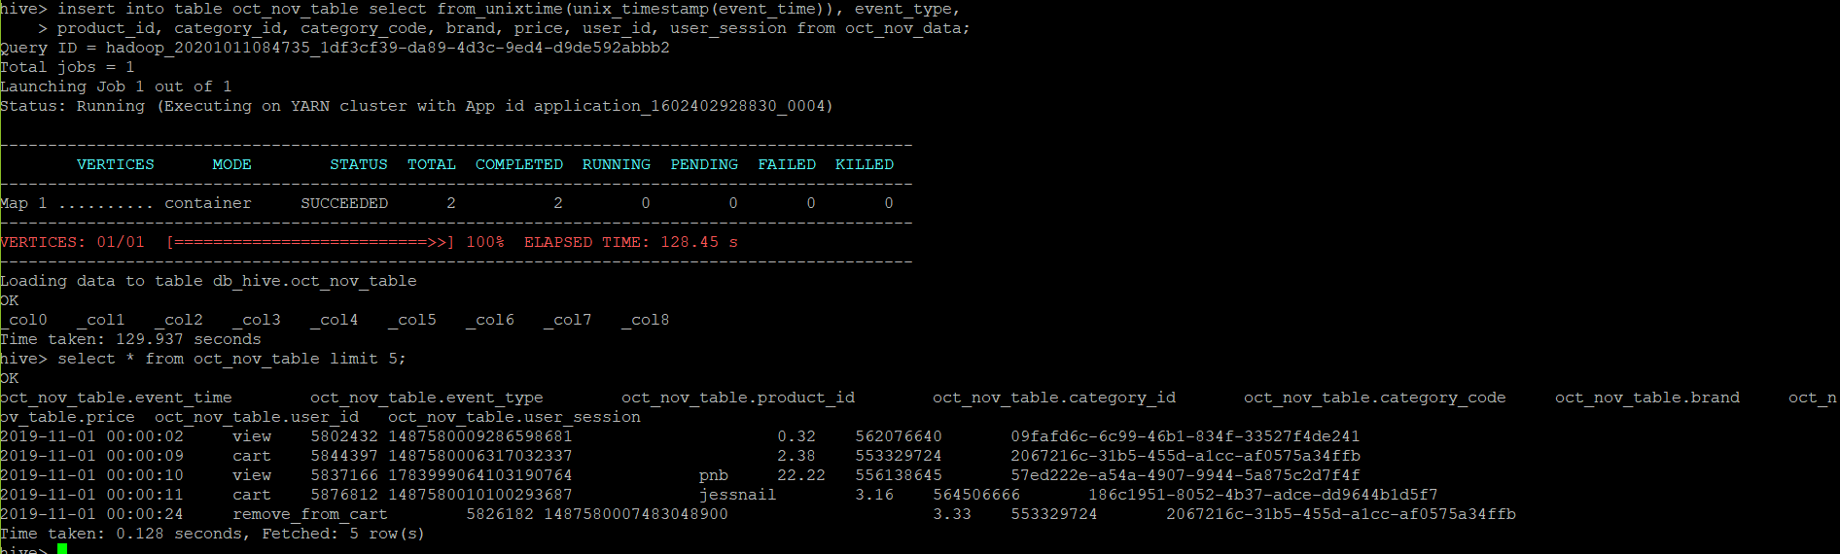

1. **Create table “dyna_part_event_type” with dynamic partitioning on event_type to optimize the query performance**

* **Enable the dynamic partitioning in Hive** 
  + set hive.exec.dynamic.partition=true;
  + set hive.exec.dynamic.partition.mode = nonstrict;
* **Create table dyna_part_event_type**
  + create table if not exists dyna_part_event_type (event_time timestamp,product_id string,category_id string,category_code string,brand string,price float,user_id bigint,user_session string) partitioned by (event_type string) row format delimited fields terminated by ',' lines terminated by '\n';
* **Insert data into table dyna_part_event_type from oct_nov_table**
  + insert into table dyna_part_event_type partition (event_type) select from_unixtime(unix_timestamp(event_time)), product_id, category_id, category_code, brand, price, user_id, user_session, event_type from oct_nov_table;

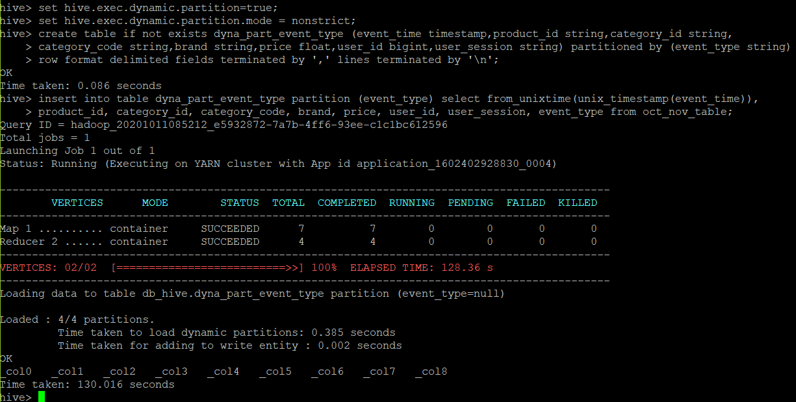

* **show partitions dyna_part_event_type;**

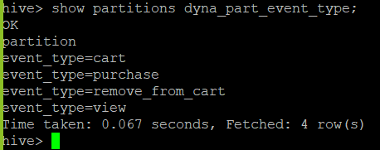

1. **Query 1: Find the total revenue generated due to purchases made in October**

* **Without optimization:**
  + select date_format(event_time,'MMM') as month, round(sum(price),2) as total_sum_purchases

from oct_nov_table

where event_type = 'purchase' and date_format(event_time,'MMM')= "Oct"

group by date_format(event_time,'MMM');

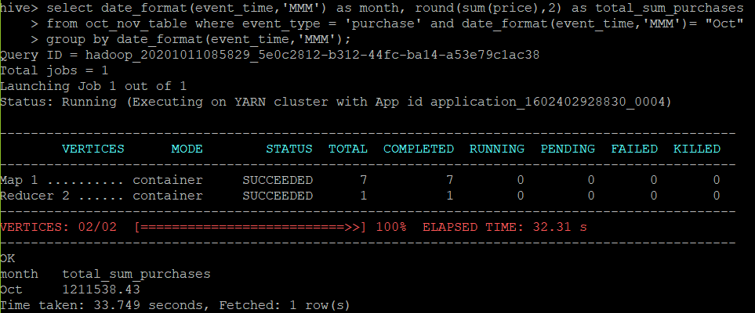

* **With optimization:**
  + select date_format(event_time,'MMM') as month, round(sum(price),2) as total_sum_purchases

from dyna_part_event_type where event_type = 'purchase' and date_format(event_time,'MMM')= "Oct"

group by date_format(event_time,'MMM');

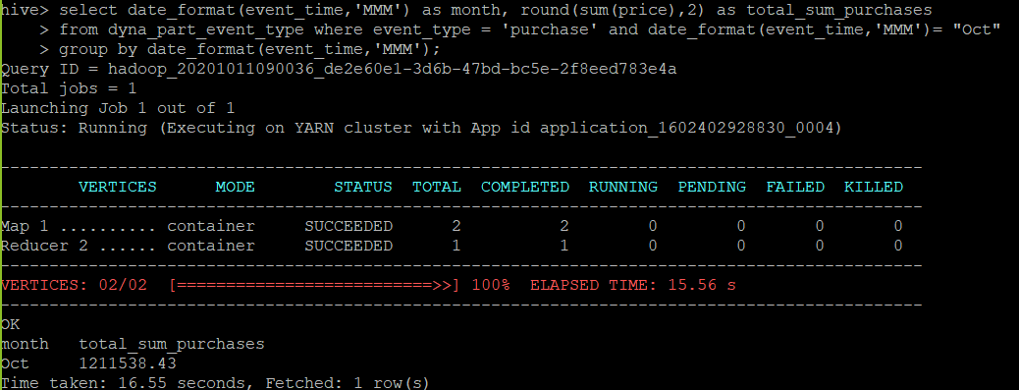

Insights:

Total revenue generated due to purchases made in October is 1211538.43

1. **Query 2: Write a query to yield the total sum of purchases per month in a single output.**

* **Without optimization:**
  + select date_format(event_time,'MMM') as month, round(sum(price),2) as total_sum_purchases

from oct_nov_table where event_type = 'purchase'

group by date_format(event_time,'MMM');

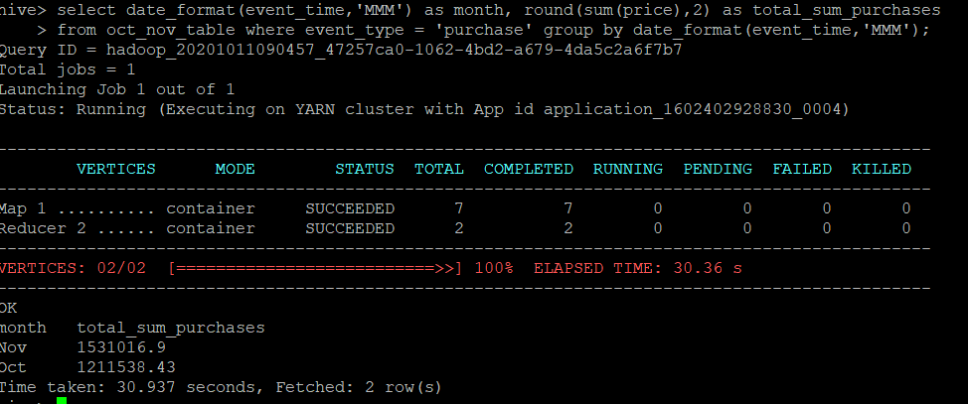

* **With optimization:**
  + select date_format(event_time,'MMM') as month, round(sum(price),2) as total_sum_purchases

from dyna_part_event_type where event_type = 'purchase'

group by date_format(event_time,'MMM');

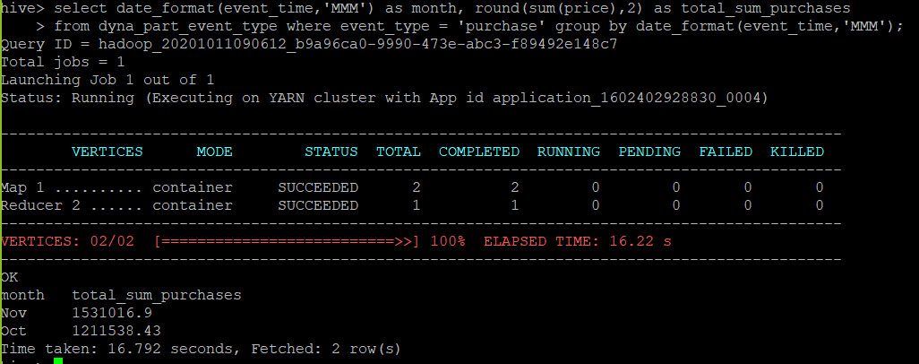

Insights:

Total sum of purchases per month:

Oct - 1211538.43

Nov - 1531016.90

1. **Query 3: Write a query to find the change in revenue generated due to purchases from October to November.**

* **Without optimization:**
  + with monthly_sales as

(select month(event_time) as month, sum(price) as total_sales

from oct_nov_table where event_type = 'purchase' group by month(event_time))

select round(q1.total_sales-q2.total_sales,2) as change_in_revenue from monthly_sales as q1 inner join monthly_sales as q2 on q1.month = q2.month + 1 ;

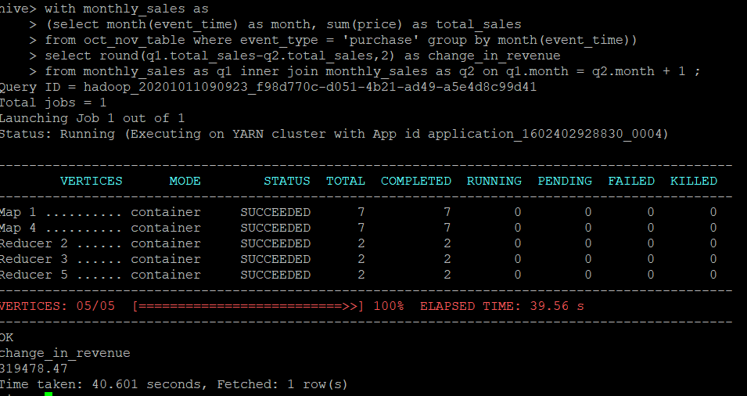

* **With optimization:**
  + with monthly_sales as

(select month(event_time) as month, sum(price) as total_sales

from dyna_part_event_type where event_type = 'purchase' group by month(event_time))

select round(q1.total_sales-q2.total_sales,2) as change_in_revenue from monthly_sales as q1 inner join monthly_sales as q2 on q1.month = q2.month + 1 ;

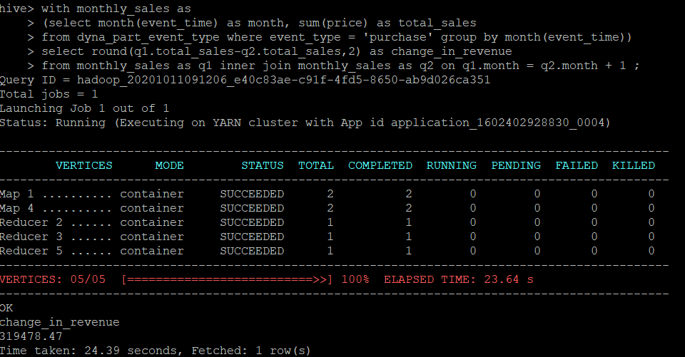

Insights:

change in revenue generated due to purchases from October to November is 319478.47

1. **Create table “dyna_part_category” with dynamic partitioning on category_code to optimize the queries.**

* create table if not exists dyna_part_category (product_id string) partitioned by (category_code string) row format delimited fields terminated by ',' lines terminated by '\n';
* insert into table dyna_part_category partition (category_code) select product_id, category_code from oct_nov_table;

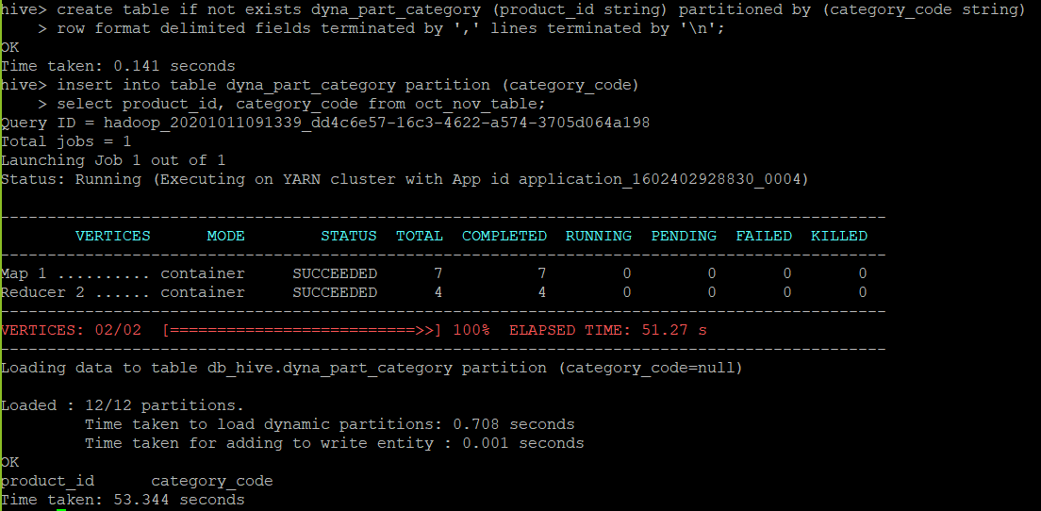

* show partitions dyna_part_category;

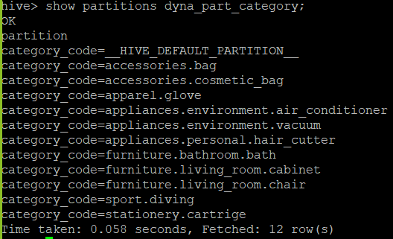

1. **Query 4: Find distinct categories of products. Categories with null category code can be ignored.**

* **Without optimization:**
  + select distinct(category_code) as category from oct_nov_table where length(category_code)>0;

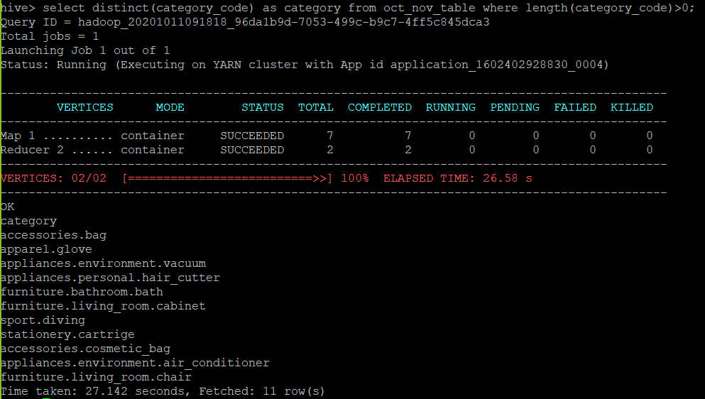

* **With optimization:**
  + select distinct(category_code) as category from dyna_part_category where length(category_code)>0;

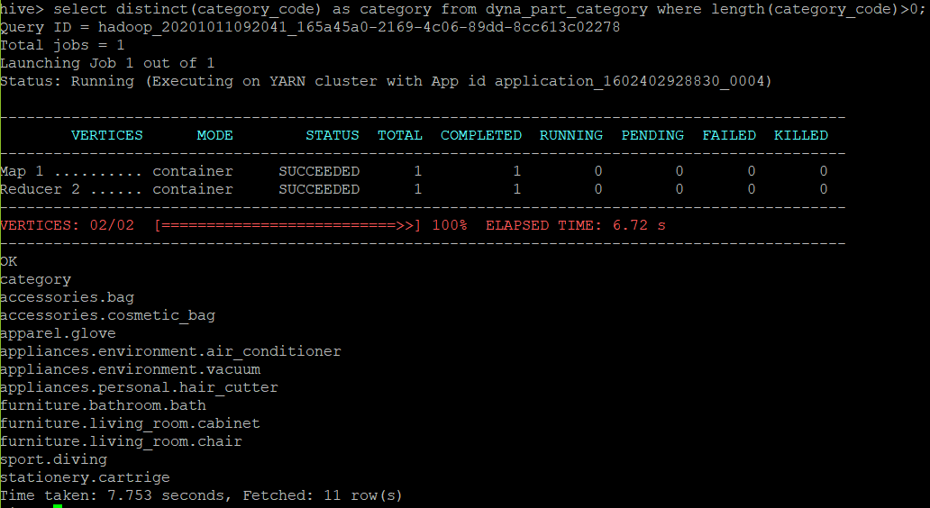

Insights:

List of different product categories shown in above result.

1. **Query 5: Find the total number of products available under each category.**

* **Without optimization:**
  + select category_code, count(distinct product_id) as product_count

from oct_nov_table where length(category_code)>0

group by category_code order by product_count desc;

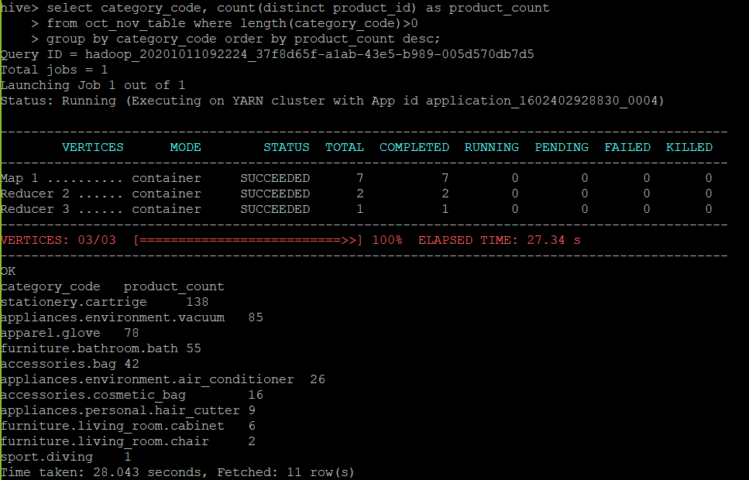

* **With optimization:**
  + select category_code, count(distinct product_id) as product_count

from dyna_part_category where length(category_code)>0

group by category_code order by product_count desc;

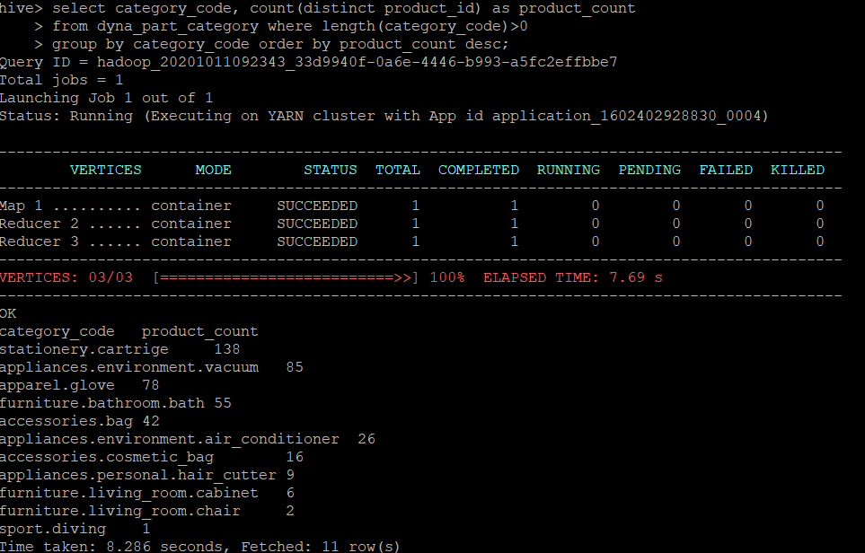

Insights:

Total number of products available under each category is shown in above result.

1. **Create table “bucket_brand” with dynamic partitioning on event_type and bucketing on brand to optimize the queries.**

* create table if not exists bucket_brand (event_time timestamp, brand string, price float) partitioned by (event_type string) clustered by (brand) into 10 buckets

row format delimited fields terminated by ',' lines terminated by '\n';

* insert into table bucket_brand partition(event_type) select event_time, brand, price, event_type from oct_nov_table;

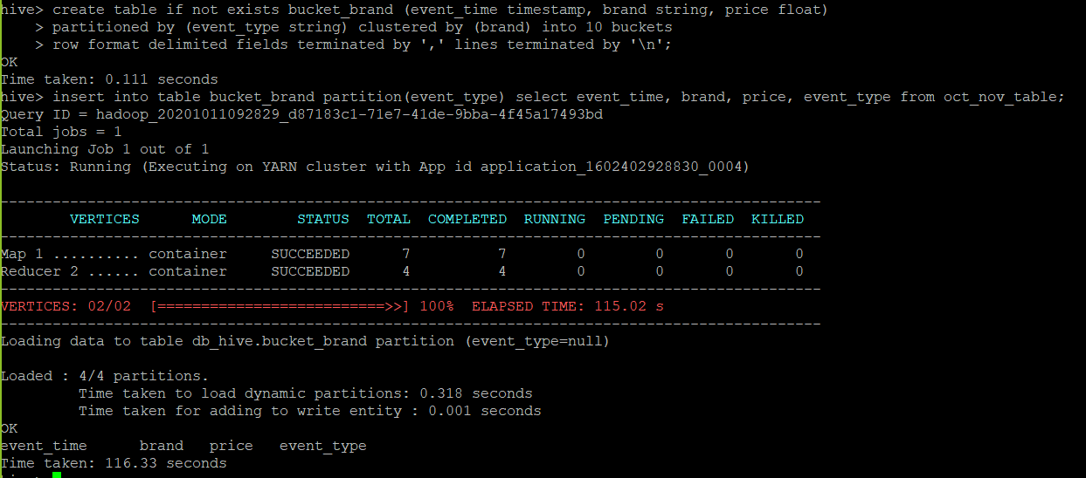

1. **Query 6: Which brand had the maximum sales in October and November combined.**

* **Without optimization:**
  + select brand, round(sum(price),2) as max_sales

from oct_nov_table where length(brand)>0 and event_type = 'purchase'

group by brand order by max_sales desc limit 1;

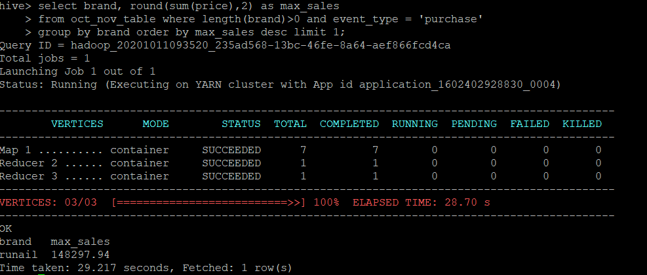

* **With optimization:**
  + select brand, round(sum(price),2) as max_sales

from bucket_brand where length(brand)>0 and event_type = 'purchase'

group by brand order by max_sales desc limit 1;

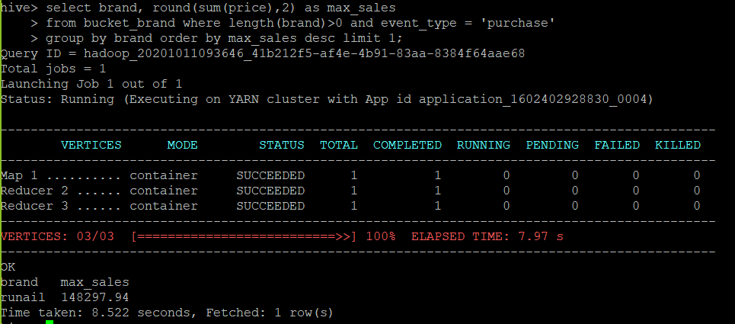

Insights:

Runail brand had the maximum sales in October and November combined which is 18297.94.

1. **Query 7: Which brands increased their sales from October to November.**

* **Without optimization:**
  + with com_data as

(select month(event_time) as month, brand, sum(price) as sales

from oct_nov_table where event_type = 'purchase' and length(brand)>0

group by month(event_time),brand order by month desc)

select q1.brand as brand, round((q1.sales - q2.sales),2) as sales_diff

from com_data as q1 inner join com_data as q2 on (q1.brand = q2.brand and q1.month = q2.month + 1) where (q1.sales - q2.sales) > 0 order by sales_diff desc;

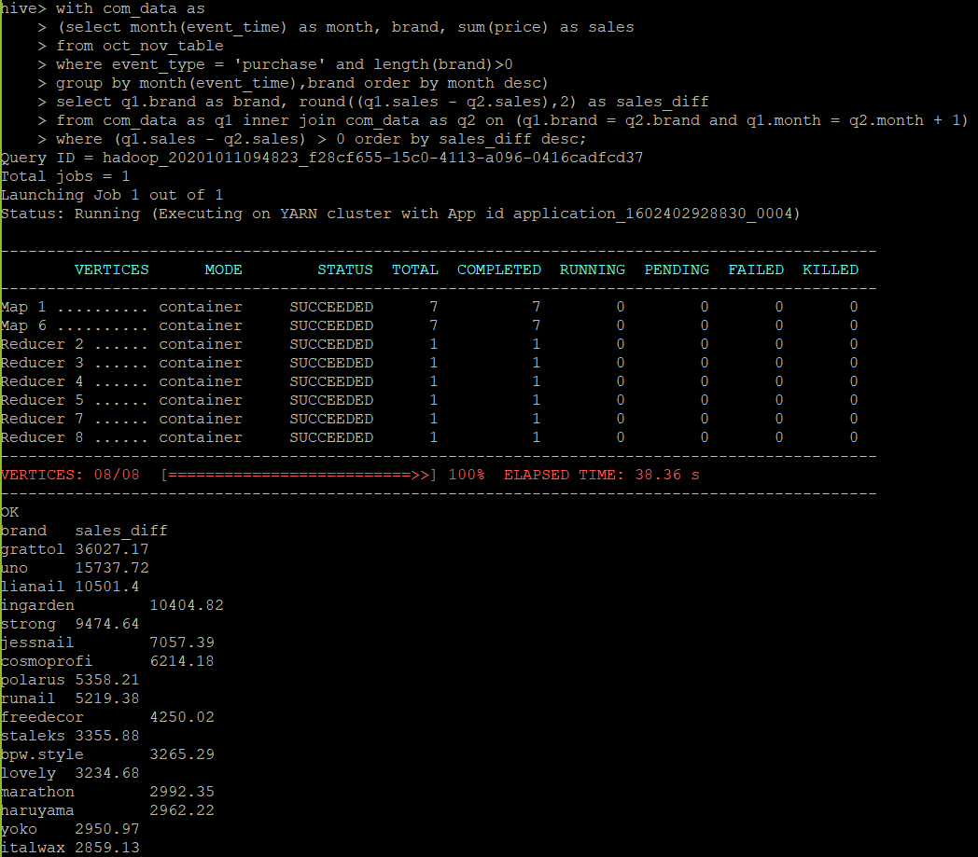

Continued….

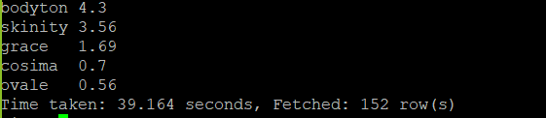

* **With optimization:**
  + with com_data as

(select month(event_time) as month, brand, sum(price) as sales

from bucket_brand where event_type = 'purchase' and length(brand)>0

group by month(event_time),brand order by month desc)

select q1.brand as brand, round((q1.sales - q2.sales),2) as sales_diff

from com_data as q1 inner join com_data as q2 on (q1.brand = q2.brand and q1.month = q2.month + 1) where (q1.sales - q2.sales) > 0 order by sales_diff desc;

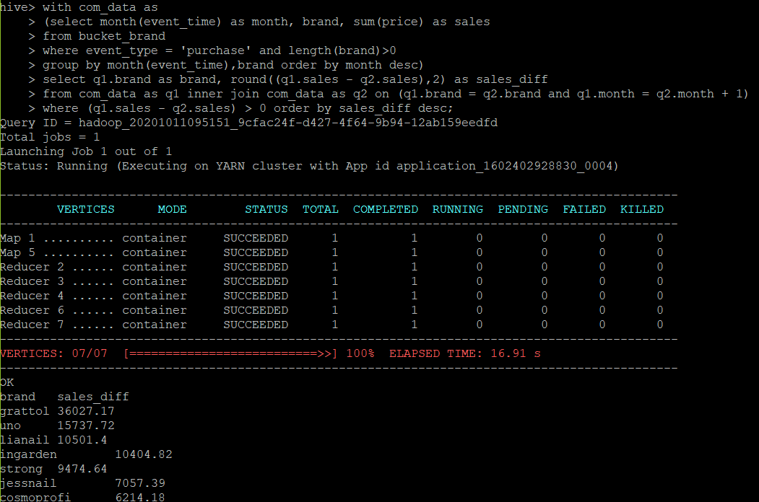

Continued….

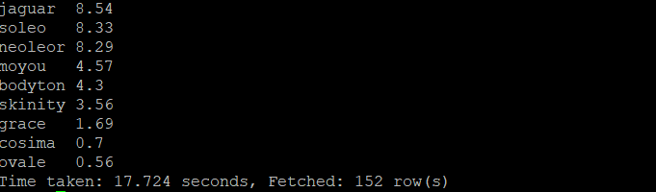

Insights:

Approximately 152 brands increased their sales from October to November



1. **Query 8: Your company wants to reward the top 10 users of its website with a Golden Customer plan. Write a query to generate a list of top 10 users who spend the most.**

* **Without optimization:**
  + select user_id, round(sum(price),2) as total_spend from oct_nov_table

where event_type = 'purchase' group by user_id

order by total_spend desc limit 10;

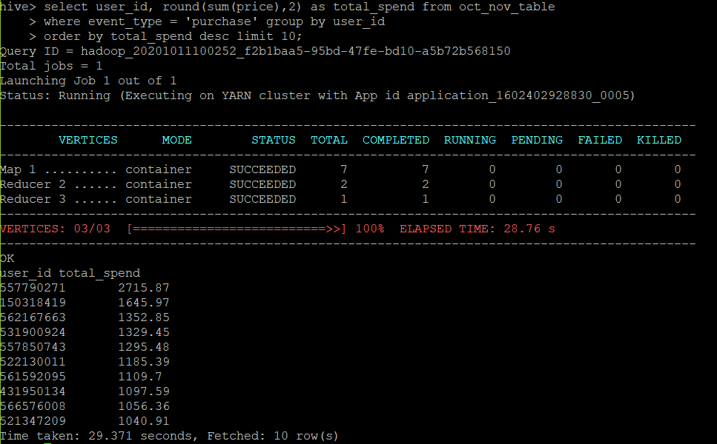

* **With optimization:**
  + select user_id, round(sum(price),2) as total_spend from dyna_part_event_type

where event_type = 'purchase' group by user_id

order by total_spend desc limit 10;

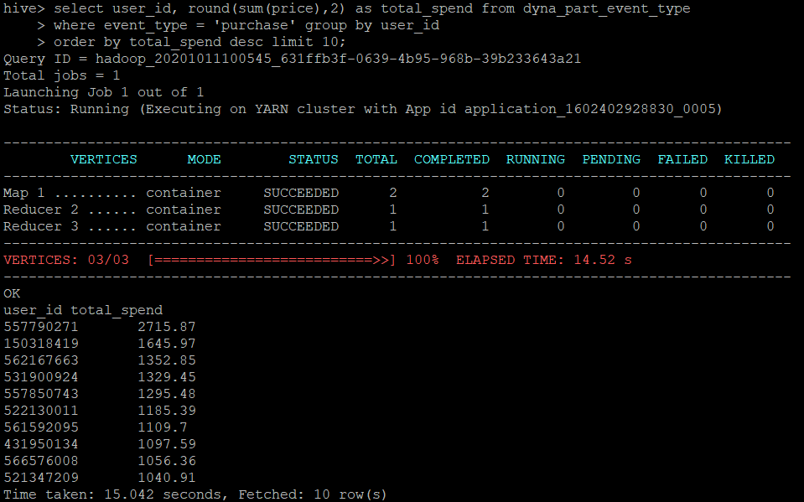

Insights:

List of top 10 users who spend the most are shown in above result.

**Overall comparison of execution time for each Query with and without optimization:**

