**Blockade of ACE-2: The Receptor for SARS-CoV-2**

SARS-CoV-2 uses receptor ACE2 for the cellular entrance. Theoretically, blockade of ACE2 can prevent the infection of SARS-CoV-2. Chen and Du thus performed the molecular docking study and they found that TCM-derived compounds, including as baicalin could interact with ACE2 [3]. Therefore, these compounds as well as herbs containing these ingredients may have the capacity to inhibit the infection of SARS-CoV-2.

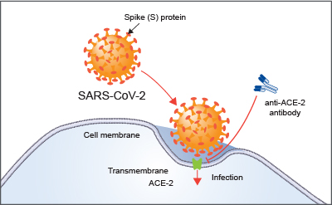

***Figure 1.*** *ACE-2 is the host cell receptor responsible for mediating infection by SARS-CoV-2, the novel coronavirus responsible for coronavirus disease 2019 (COVID-19). Treatment with anti-ACE-2 antibodies disrupts the interaction between virus and receptor[2]*

**Indian Trumpet Tree:(Tree of Damocles/ Shayonak Kul / Shyonaka )**

The chemical constituents obtained from different parts of plant include baicalein-7-O-diglucoside (Oroxylin B), baicalein-7-O-glucoside, chrysin, apegenin, prunetin, sitosterol, oroxindin, biochanin-A, ellagic acid, baicalein and its 6- and 7-glucuronides, scutellarein, tetuin, antraquinone and aloe-emodin.

It is used for treatment of different ailments such as cancer, diarrhea, fever, ulcer and jaundice. Recent in vivo and in vitro studies have indicated its antiinflammatory, antiulcer, hepatoprotective, anticancer, antioxidant, photocytotoxic, antiproliferative, antiarthritic, antimicrobial, antimutagenic and immunostimulant properties.[1]

**REFERENCES:**

[1] A Review on the Taxonomy, Ethnobotany, Chemistry and Pharmacology of Oroxylum indicum Vent

Harminder, V. Singh, A. K. Chaudhary, Indian J Pharm Sci. 2011 Sep-Oct; 73(5): 483–490. doi: 10.4103/0250-474X.98981, PMCID: PMC3425058

[2] https://www.rndsystems.com/resources/articles/ace-2-sars-receptor-identified

[3] Chen H and Du Q. Potential Natural Compounds for Preventing 2019-nCoV Infection. Preprints 2020.

#Anti-ACE-2 Antibody

# TMPRSS2 inhibitor