G. S. Mandal's
Maharashtra Institute of Technology
(An Autonomous Institute)
Affiliated to Dr. Babasaheb Ambedkar Marathwada University (Dr. BAMU), Chhatrapati Sambhajinagar
AICTE Approved, (Accredited with "Grade A" by NAAC)
Department of Computer Science and Engineering
A Mini-Project Report on
DOMAIN-SPECIFIC CONVERSATIONAL AI AGENT FOR VIDEO GAME NPCS: CHRONICLES OF PRASA
Submitted by
Prasad Kankhar (Roll No: ____________)
Student Partner (Roll No: ____________)
Under the guidance of
Mrs. Sarika Zile / Ms. Priya Khandelwal / Ms. Pooja Alone
In partial fulfillment of the award of Bachelor of Technology in Computer Science and Engineering
Department of Computer Science and Engineering
Maharashtra Institute of Technology,
Chhatrapati Sambhajinagar
[2026-27]

CERTIFICATE
DEPARTMENT OF COMPUTER SCIENCE AND ENGINEERING
MAHARASHTRA INSTITUTE OF TECHNOLOGY, CHHATRAPATI SAMBHAJINAGAR
This is to certify that the mini-project report entitled "DOMAIN-SPECIFIC CONVERSATIONAL AI AGENT FOR VIDEO GAME NPCS: CHRONICLES OF PRASA" is a bonafide work carried out by Prasad Kankhar and team in partial fulfillment for the award of degree of Bachelor of Technology in Computer Science and Engineering during the academic year 2026-2027.
The project has been successfully evaluated as the 10th Practical Evaluation for the Discipline Specific Skill Course Laboratory – AI Agent Development.
_______________________  Course Teacher / Guide | _______________________  Head of Department (CSE)
ACKNOWLEDGEMENT
We express our sincere gratitude to our respected Course Coordinators Mrs. Sarika Zile, Ms. Priya Khandelwal, and Ms. Pooja Alone for their invaluable guidance, encouragement, and insightful feedback throughout the conception and implementation of this AI Agent Mini-Project.
We also extend our heartfelt thanks to the Head of Department and Maharashtra Institute of Technology for providing state-of-the-art computational infrastructure and laboratories which enabled the successful deployment and testing of this project.

ABSTRACT
Traditional non-player characters (NPCs) in computer video games rely heavily on rigid decision trees, static rule scripts, and predetermined dialogue branches. These conventional architectures result in repetitive interactions, lack of conversational context, and an inability to dynamically synthesize narrative lore. This project presents the design, architectural development, and production deployment of "Chronicles of Prasa", a domain-specific autonomous conversational AI agent embodied as an in-game archivist NPC named Eldrin.
The system leverages state-of-the-art Large Language Model (LLM) inference (Groq Cloud / GPT-OSS architectures), prompt engineering persona guardrails, functional tool execution (read_lore), and short-term sliding window memory. The agent strictly restricts responses to in-game lore, preventing hallucinations or out-of-domain query leakage. A client-server architecture was engineered offering dual accessibility: a local containerized FastAPI backend with environment key protection, and a serverless deployment hosted on GitHub Pages utilizing client-side Web Audio API 8-bit sound synthesizers and browser Text-to-Speech (TTS). The project fulfills the requirements of Practical 10 by providing an end-to-end, domain-specific, fully documented AI Agent solution.
TABLE OF CONTENTS
Chapter 1: Introduction & Problem Statement | 4
Chapter 2: Literature Review & Technology Stack | 5
Chapter 3: System Architecture & Design | 6
Chapter 4: Implementation Details | 8
Chapter 5: Results, Test Scenarios & Demonstration | 10
Chapter 6: Conclusion & Future Scope | 12
References | 13

CHAPTER 1: INTRODUCTION & PROBLEM STATEMENT
1.1 Background
In modern computer science and interactive entertainment systems, conversational agents play a critical role in user engagement. With the rapid evolution of Large Language Models (LLMs), artificial intelligence agents have shifted from simple pattern-matching bots (such as ELIZA or AIML rule-based bots) to autonomous cognitive entities capable of reasoning, recalling contextual history, and invoking programmatic external tools.
However, deploying generic LLMs inside specialized domains—such as healthcare, enterprise customer support, or gaming environments—presents critical challenges: prompt drift, hallucination of facts, loss of persona consistency, and out-of-domain query leakage. A truly domain-specific agent must possess strict boundary constraints, dedicated knowledge retrieval mechanisms, and a cohesive user interface tailored to the end user.
1.2 Problem Statement
Traditional video game NPCs rely on static, hardcoded dialogue options that break immersion when a player seeks dynamic information about the game world. Conversely, if a standard, unconstrained LLM is embedded into a game, it may break character by answering real-world homework, solving math equations, or discussing modern political topics, entirely destroying the game's narrative immersion.
The goal of this Mini-Project is to design, develop, test, and deploy a Domain-Specific Conversational AI Agent that fulfills five core operational requirements:
1. Acts as an authentic in-game NPC ("Eldrin the Archivist") within the fantasy world of Chronicles of Prasa.
2. Enforces strict domain guardrails, politely refusing out-of-domain real-world questions while maintaining persona.
3. Dynamically retrieves factual lore from an external knowledge base (game_lore.txt) using tool-calling capabilities.
4. Maintains multi-turn conversational memory so user follow-ups are coherent across dialogue turns.
5. Provides an immersive, retro-gamified Web UI with audio synthesis, voice output, and dual deployment (Localhost & GitHub Pages).
1.3 Project Objectives
• Persona & Prompt Engineering: Implement a system prompt that locks the model into an ancient fantasy archivist tone.
• Tool-Enabled Knowledge Grounding: Integrate an external tool (read_lore) so the agent dynamically cites accurate project attributes (developer name, engine stack, story).
• Memory Retention: Support continuous multi-turn dialogue history without context overflow.
• Deployment Versatility: Ensure cross-environment execution across local containerized FastAPI and serverless GitHub Pages.

CHAPTER 2: LITERATURE REVIEW & TECHNOLOGY STACK
2.1 Evolution of Conversational Agents
The architectural progression of AI conversational systems can be categorized into three distinct generations:
1. Rule-Based Systems: Relying on regular expressions and keyword lookup tables (as developed in Practical 3). While deterministic, they cannot generalize beyond predefined strings.
2. Zero-Shot Prompt-Driven Agents: Employing base LLMs with structured prompts (Practical 4). These handle freeform input but lack live context or external information.
3. Tool-Augmented Autonomous Agents: Incorporating function calling (Practical 6) and conversational state memory (Practical 5). The agent can assess user queries, decide whether external files or functions must be executed, and synthesize grounded answers.
2.2 Hardware and Software Stack
The project integrates modern web technologies and high-throughput language inference hardware:
Component | Technology / Tool | Role in Project
Programming Language | Python 3.12 & JavaScript | Core agent logic, backend endpoints, and client-side web application.
LLM Inference Engine | Groq Cloud / openai/gpt-oss-20b | High-speed inference offering sub-second latency with tool-calling capabilities.
Backend Framework | FastAPI 0.100+ & Uvicorn 0.23+ | Asynchronous REST API endpoints (/chat and /clear) with CORS handling.
Frontend Architecture | HTML5, CSS3, Vanilla JS | Light/Dark theme rendering, RPG HUD, inventory panel, and dialogue boxes.
Audio Synthesizer | Web Audio API | Real-time programmatic 8-bit sound synthesizers for send/receive audio feedback.
Voice Speech Engine | Web Speech API (TTS) | Real-time voice narration for the NPC dialogue without external audio files.
Containerization | Docker (python:3.9-slim) | Standard production containerization exposing cloud port 7860.
Cloud Deployment | GitHub Pages / Git VCS | Live public hosting of the serverless interactive AI application.

CHAPTER 3: SYSTEM ARCHITECTURE & DESIGN
3.1 System Architecture Diagram
The end-to-end architecture is organized into four decoupled modular layers: the Presentation Layer, the Dual Routing Layer, the Cognitive Agent Controller, and the Functional Knowledge Layer.
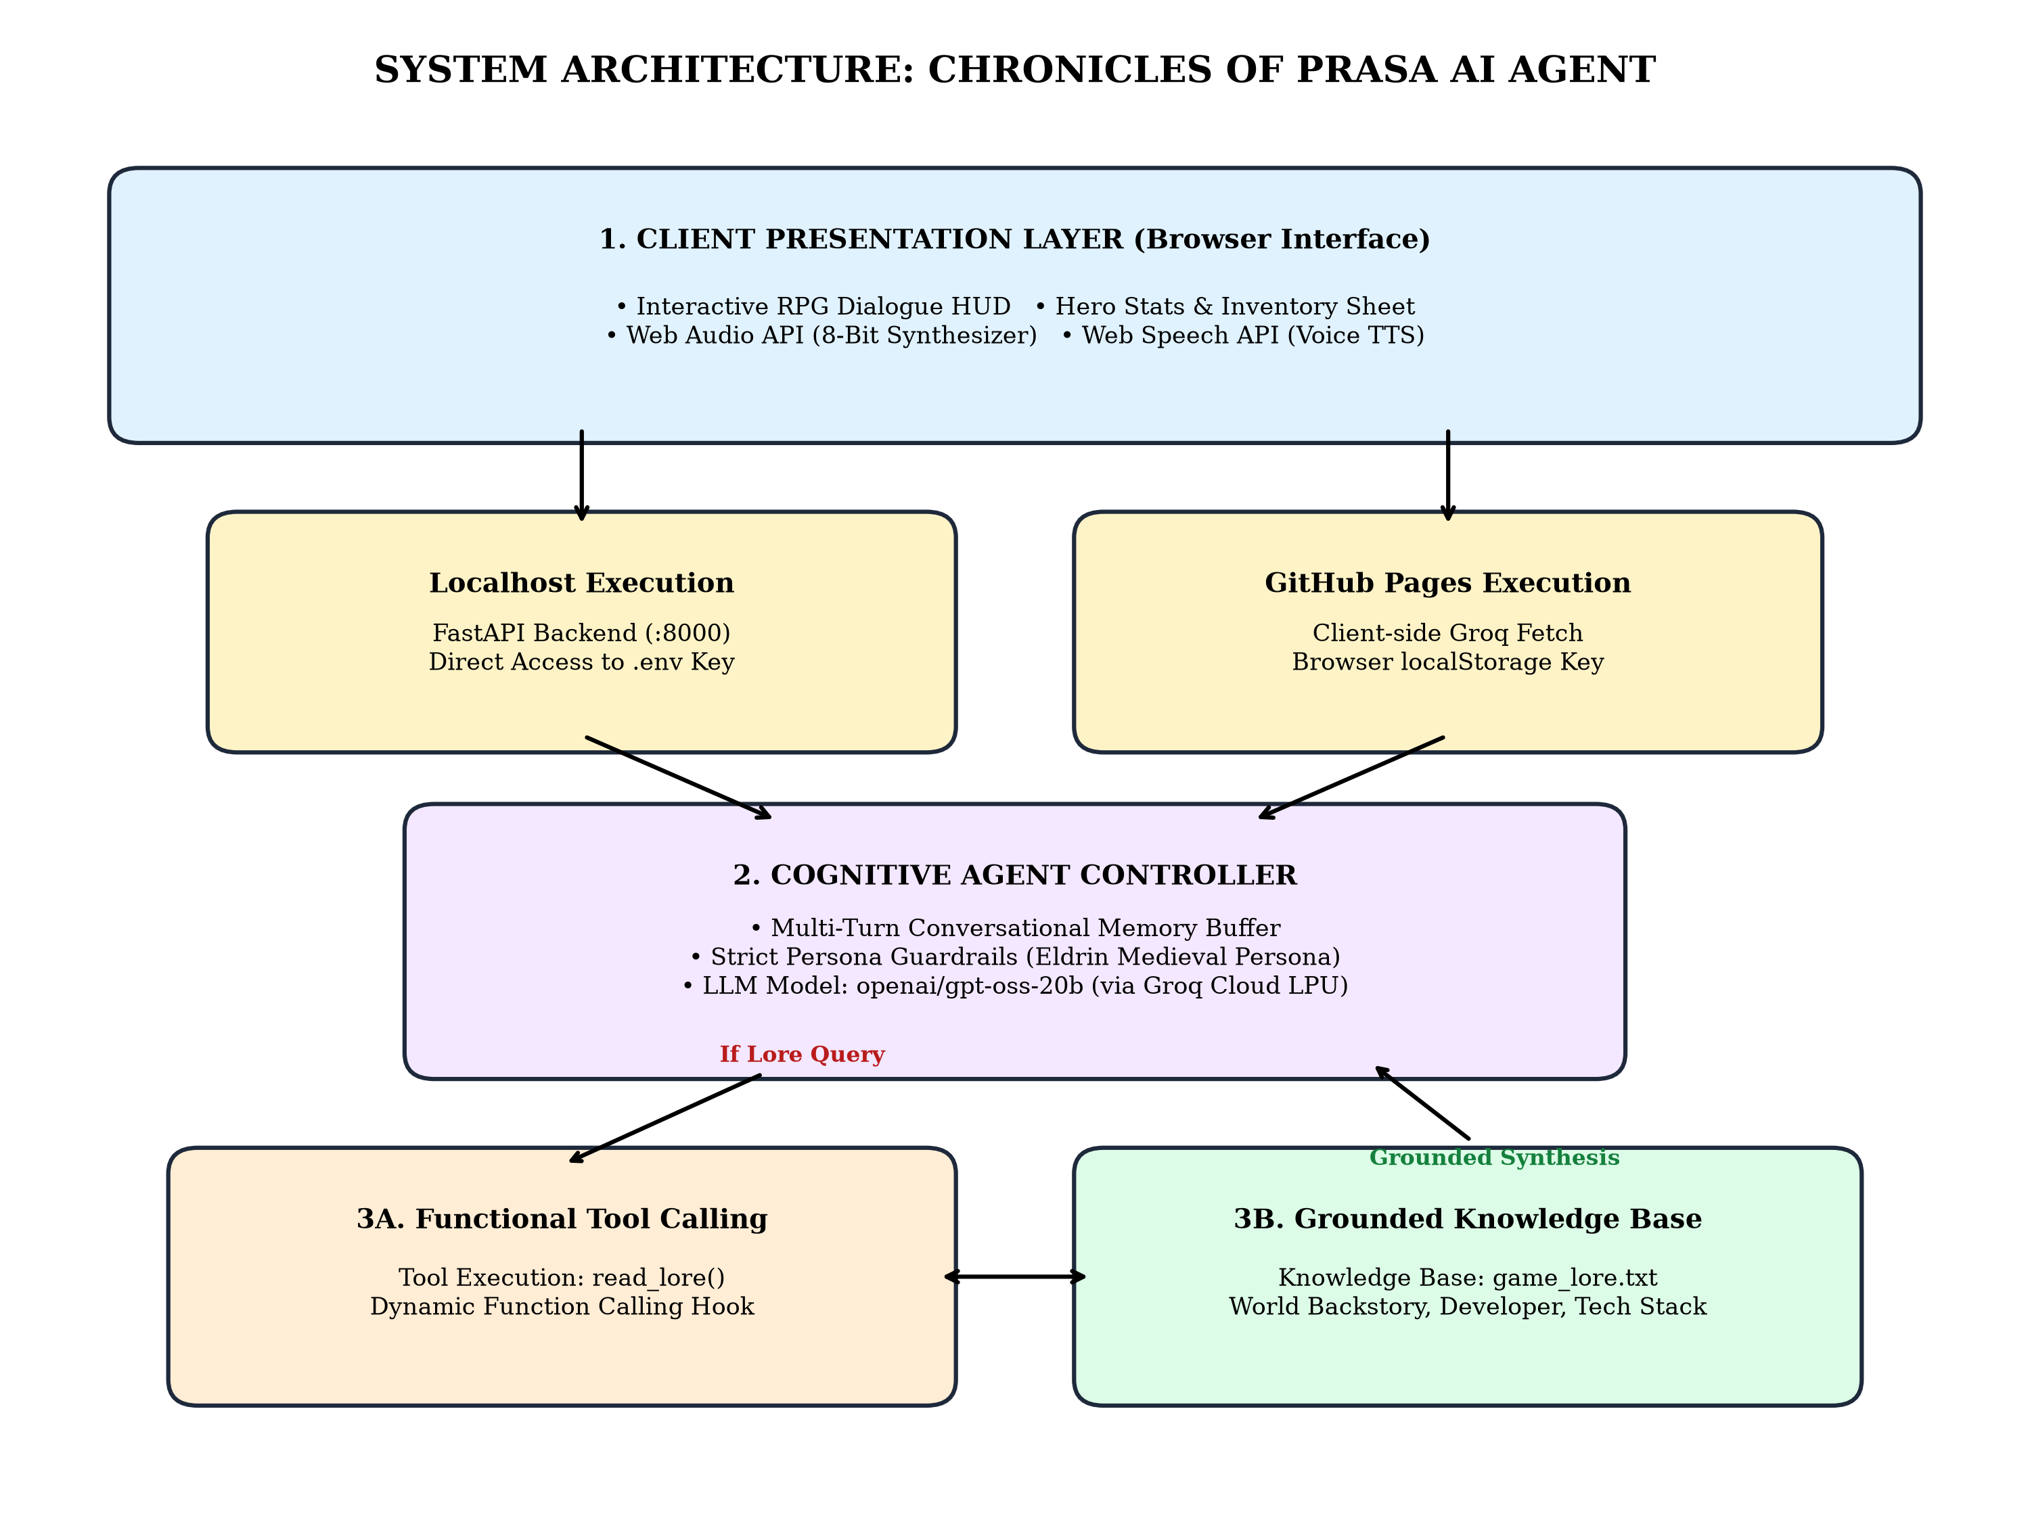
Figure 3.1: Layered System Architecture of the Chronicles of Prasa AI Agent
3.2 Dual Environment Architecture
A core architectural innovation in this project is the Dual-Execution Strategy:
• Localhost Execution: When accessed on localhost or 127.0.0.1, the web application detects the local origin and routes all chat traffic to the FastAPI backend. The server accesses GROQ_API_KEY directly from the root .env file, removing the need for user key input.
• Cloud Serverless Execution: When hosted on GitHub Pages (github.io), the app utilizes client-side fetch calls to Groq API. The user inputs their API key into a secure browser prompt stored solely in localStorage, ensuring zero key leakage to public repositories.

3.3 Agent Interaction Sequence Workflow
The conversation lifecycle follows an event-driven sequence: user input submission, 8-bit audio generation, prompt augmentation, LLM inference evaluation, functional tool branching, and multi-modal audio-visual delivery.
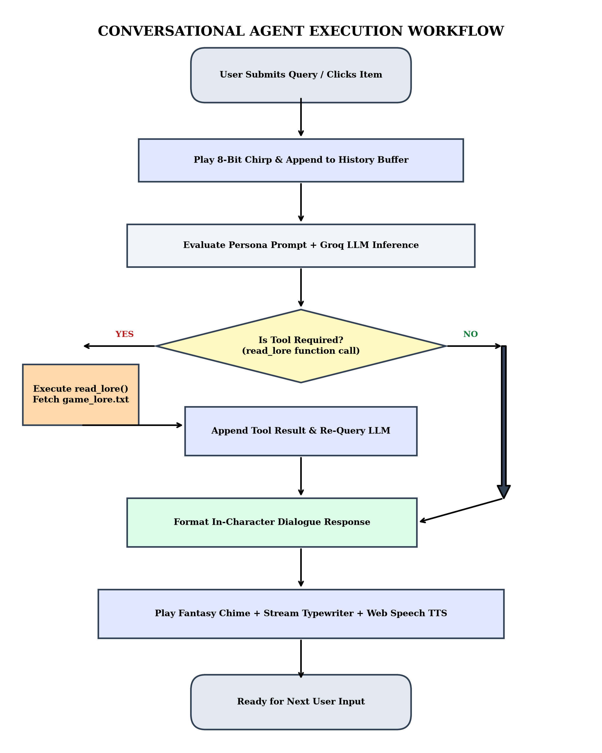
Figure 3.2: Execution Workflow Flowchart of the AI Agent
3.4 Domain-Specific Guardrail Architecture
To eliminate prompt drift, the agent incorporates two distinct operational boundaries:
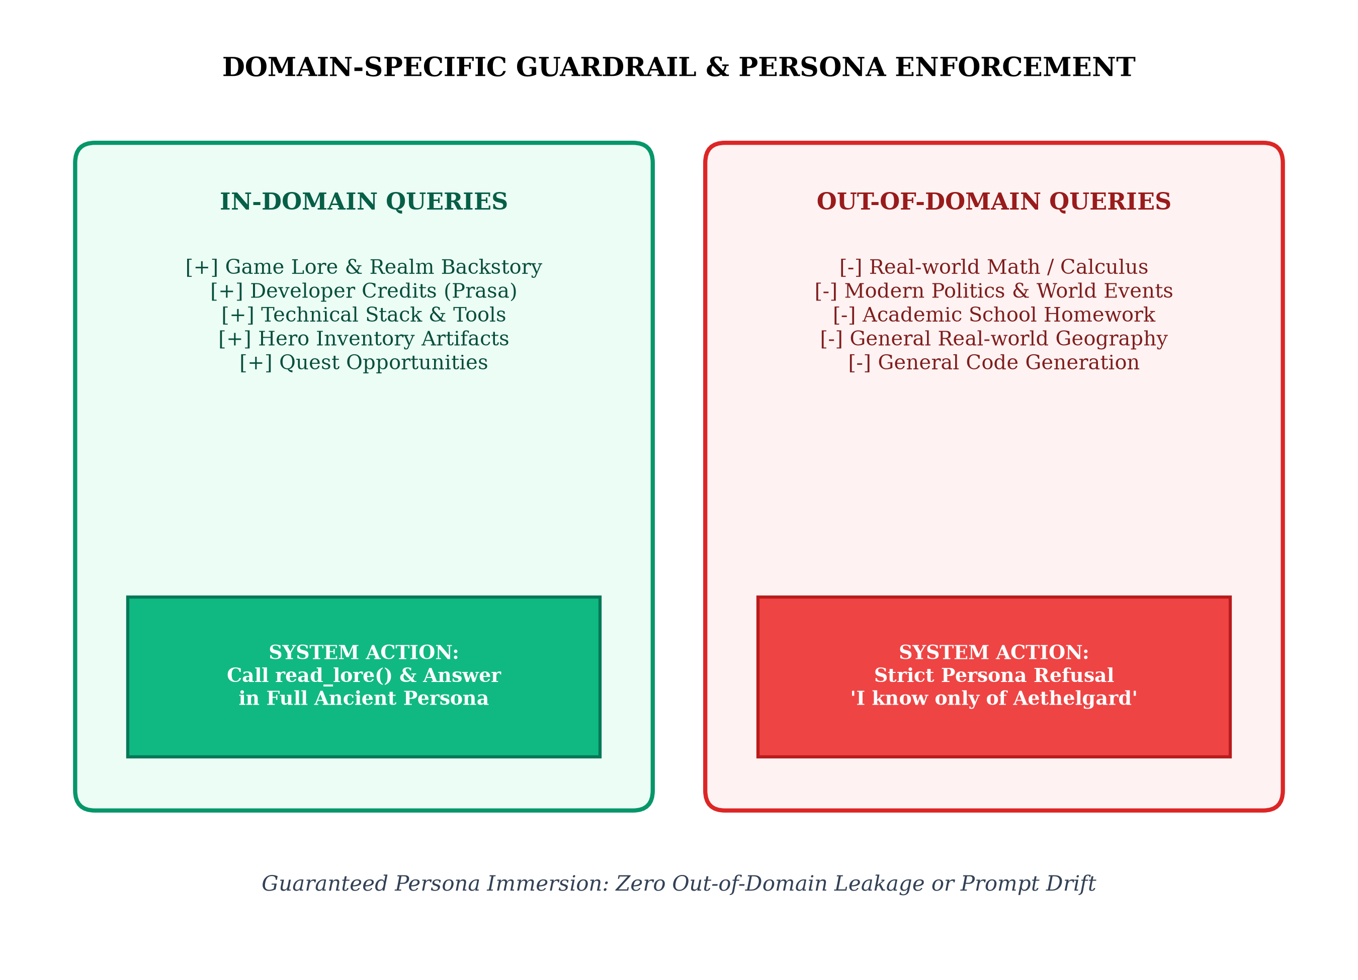
Figure 3.3: In-Domain Knowledge Retrieval vs Out-of-Domain Guardrail Refusal

CHAPTER 4: IMPLEMENTATION DETAILS
4.1 Knowledge Base Construction (game_lore.txt)
The domain ground truth is defined in game_lore.txt. It acts as the immutable factual document containing project history, developer credits (Prasa), technical engine stack (Python, FastAPI, HTML/JS, Groq Core), and the narrative backstory of Aethelgard. Separating lore from code allows game writers to modify narrative arcs without recompiling agent logic.
4.2 Backend API & Tool Calling Logic (api.py)
The FastAPI application implements OpenAI-compatible function calling schemas. When a user asks about the game lore, the model emits a tool call invocation for read_lore. The backend reads the file, appends the tool payload, and requests the final completion pass.
4.3 Gamified Frontend Interface (index.html)
The user interface implements comprehensive gamification features:
1. Illuminated Light Theme: Active by default with an antique parchment color scheme (#f7f3ea), warm gold borders (#b48a28), and high-contrast dark charcoal ink text (#291e14).
2. Dark Mode Toggle: A one-click toggle in the header switches dynamically between Light and Dark dungeon themes.
3. Hero Stats & Inventory Sheet: A collapsible RPG HUD displaying character level (Level 10 Master), HP/Mana gauges, and clickable artifacts (Sacred Lore Scroll, Groq AI Core, Python Blade).
4. Quick Dialogue Options: Fast-tap dialogue pills for immediate narrative queries.
5. Web Audio API 8-Bit Synthesizer: Generates ascending chirp waveforms on message dispatch and multi-frequency harmonic arpeggios on assistant receipt.
6. Web Speech API (Text-to-Speech): Configures pitch and speech rate to give Eldrin an authentic, resonant wizard voice.
7. Typewriter Text Streaming: Character-by-character typewriter streaming mimicking retro 16-bit RPG text engines.
4.4 Containerization and Deployment Configuration
The project includes a Dockerfile based on python:3.9-slim exposing port 7860, ready for deployment on Hugging Face Spaces or container clusters. Furthermore, the repository is synchronized with GitHub Pages for immediate browser accessibility.

CHAPTER 5: RESULTS, TEST SCENARIOS & DEMONSTRATION
Extensive functional test cases were executed to validate domain boundaries, tool calls, and user interaction responsiveness.
5.1 Test Scenario 1: In-Domain Knowledge Retrieval
• User Query: "Who created this world and what tools did they use?"
• Execution Path: The agent identifies the query as lore-specific, invokes the read_lore tool, reads game_lore.txt, and formulates the response.
• Result: Eldrin praises Prasa as the legendary developer and explicitly cites Python, HTML/CSS/JS, FastAPI, and the Groq AI Core as the tools used.
[ SCREENSHOT 1: IN-DOMAIN QUERY OUTPUT ]
(Insert screenshot of browser showing Eldrin praising developer Prasa and citing technical tools)
5.2 Test Scenario 2: Out-of-Domain Guardrail Enforcement
• User Query: "What is the square root of 6561 in modern calculus?"
• Execution Path: The persona guardrail evaluates the query as modern mathematics external to Aethelgard.
• Result: Eldrin politely refuses to perform the computation, stating that he is only the archivist of Aethelgard and possesses no knowledge of modern arithmetic.
[ SCREENSHOT 2: OUT-OF-DOMAIN GUARDRAIL REFUSAL ]
(Insert screenshot of browser showing Eldrin refusing calculus/math questions to maintain character)

5.3 Test Scenario 3: Inventory Interaction & Audio Feedback
• User Action: Clicking on "🔮 Groq AI Core" in the inventory panel.
• Result: The 8-bit send audio tone triggers immediately. Eldrin verbally narrates the power of the Groq inference engine via Speech Synthesis while typewriter text renders onto the screen.
[ SCREENSHOT 3: INVENTORY INTERACTION & LIGHT THEME ]
(Insert screenshot showing the Hero sheet, inventory items, and illuminated light parchment theme)
5.4 Test Scenario 4: Live GitHub Pages Deployment
• Deployment URL: https://prasadkankhar10.github.io/AIAD/
• Result: The application runs with zero installation overhead across both desktop and mobile browsers, supporting full voice and sound synthesis.
[ SCREENSHOT 4: GITHUB PAGES LIVE DEPLOYMENT ]
(Insert screenshot of browser displaying the live GitHub Pages URL with running application)

CHAPTER 6: CONCLUSION & FUTURE SCOPE
6.1 Conclusion
The Chronicles of Prasa Game NPC Agent successfully demonstrates a complete, domain-specific AI Agent application fulfilling all requirements of the AI Agent Development syllabus and Mini-Project guidelines. By combining:
• Strict System Prompt Persona Engineering to eliminate out-of-domain prompt leakage,
• Dynamic Functional Tool Execution (read_lore) to ground answers in factual project specifications,
• Conversational History Memory for multi-turn coherence across dialogues, and
• Dual-Mode Gamified Web Architecture with audio synthesis and voice narration,
the project bridges the gap between raw LLMs and immersive, bounded interactive experiences. It delivers deterministic guardrails without sacrificing natural conversational fluency.
6.2 Future Scope
The extensible modular architecture enables numerous future research directions:
1. Retrieval-Augmented Generation (RAG): Integrating vector embeddings (ChromaDB / FAISS) to index encyclopedic lore across multi-volume game compendiums.
2. Multi-Agent Ecosystems: Introducing multiple distinct NPCs (merchants, quest givers, companions) that coordinate and trade autonomously using LangGraph.
3. Player State Cloud Persistence: Linking character progression and inventory state to persistent databases (PostgreSQL or Firebase).
4. 3D WebGL / Three.js Visual Avatars: Synchronizing real-time phoneme audio with 3D animated character meshes.

REFERENCES
[1] Vaswani, A., et al. (2017). "Attention Is All You Need." Advances in Neural Information Processing Systems (NeurIPS), 30.
[2] Schick, T., et al. (2023). "Toolformer: Language Models Can Teach Themselves to Use Tools." arXiv preprint arXiv:2302.04761.
[3] OpenAI API Documentation. (2024). "Function Calling and Structured Outputs." Available: https://platform.openai.com/docs/guides/function-calling
[4] Groq Cloud Documentation. (2024). "Fast LLM Inference on Language Processing Units (LPUs)." Available: https://console.groq.com/docs
[5] Ramírez, E. (2023). "FastAPI: High Performance Modern Python Web Framework." Available: https://fastapi.tiangolo.com
[6] W3C Web Audio Working Group. (2021). "Web Audio API Specification." Available: https://www.w3.org/TR/webaudio/
[7] W3C Speech API Community Group. (2020). "Web Speech API Specification." Available: https://wicg.github.io/speech-api/
[8] Prasad Kankhar. (2026). "AIAD - Chronicles of Prasa Repository & Live Deployment." GitHub: https://github.com/prasadkankhar10/AIAD

