A Project Report on

ADAPTIVE EDGE DETECTION BY VIRTUE OF PSO- DRIVEN MACHINE LEARNING

Submitted by
Chetan S. Agrawal (Roll No: BT41002 ) Renuka B. Biradar (Roll No: BT41017) Abhishek V. Bobade (Roll No: BT41018) Pranjali P. Bodke (Roll No: BT41019)

Under the guidance of Ms. B. P. Chaudhari

In partial fulfillment of the award of Bachelor of Technology in Computer Science and Engineering


Department of Computer Science and Engineering Maharashtra Institute of Technology,
Chh. Sambhajinagar [2025-26]

DECLARATION

We declare that this written submission represents my ideas in my own words and where others’ ideas or words have been included; We have adequately cited and referenced the original sources. We also declare that We have adhered to all principles of academic honesty and integrity and have not misrepresented or fabricated or falsified any idea/data/fact/source in my submission. We understand that any violation of the above will be cause for disciplinary action by the Institute and can also evoke penal action from the sources which have thus not been properly cited or from whom proper permission has not been taken when needed.

Place: Chh. Sambhajinagar Date:

Signature and Name of students
Chetan S. Agrawal Renuka Biradar Abhishek Bobade
Pranjali Bodke

CERTIFICATE

This is to certify that the major project- I report entitled “Adaptive edge detection by virtue of PSO – driven machine learning ”, submitted by Chetan Agrawal , Renuka Biradar , Abhishek Bobade and Pranjali Bodke is the bonafide work completed under my supervision and guidance in partial fulfillment for the award of Bachelor of Technology in Computer Science and Engineering, Maharashtra Institute of Technology under Dr. Babasaheb Ambedkar Marathwada University, Chh. Sambhajinagar.

Place: Chh. Sambhajinagar Date:

Ms. B. P. Chaudhari
Guide

Dr. S. L. Kasar
Head of Department

Dr. N. G. Patil
Director
Maharashtra Institute of Technology Chh. Sambhajinagar.

ACKNOWLEDGEMENT

We would like to express special thanks to our beloved Guide Ms. B. P. Chaudhari for her valuable suggestion and rare insights, constant encouragement, and inspiration throughout the project.
We would like to take this opportunity to thanks Dr. S. L. Kasar, Head of the Department, for providing her great support in the successful completion of my project.
We express our deep sense of gratitude to our beloved Principal, Dr. N. G. Patil, for his valuable guidance and for permitting me to carry out this project.

NAME OF STUDENT
Chetan Agrawal (BT41002) Renuka Biradar (BT41017) Abhishek Bobade (BT41018) Pranjali Bodke (BT41019)

APPROVAL CERTIFICATE

This major project-I report entitled “Adaptive edge detection by virtue of PSO – driven machine learning” by Chetan Agrawal , Renuka Biradar , Abhishek Bobade and Pranjali Bodke is approved for Bachelor of Technology in Computer Science and Engineering, Maharashtra Institute of Technology under Dr. Babasaheb Ambedkar Marathwada University, Chh. Sambhajinagar.

Place: Chh. Sambhajinagar Date:
Examiner:
(Signature)

(Name)

INDEX/CONTENTS

TITLE PAGE NO
Declaration Certificate Acknowledgement Approval certificate

List of Figures List of Table Abstract | i ii iii
1. INTRODUCTION | 1
1.1 Necessity | 3
1.2 Problem definition | 3
1.3 Objectives | 4
1.4 Scope and limitations | 5
1.5 Applications | 5
1.6 Organization and project plan | 9
2. LITERATURE SURVEY | 11
2.1 Literature | 11
3. SYSTEM DESIGN | 18
3.1 Proposed system | 18
3.2 Implementation Environment | 21
3.3 Database Specification | 22
3.4 Algorithms/techniques/procedures used | 26
3.5 Role of Edge Detection | 30
3.6 Interaction of Vision Transformer | 33
4. PERFORMANCE ANALYSIS | 38
4.1 Parameter Configuration | 38
4.2 Evaluation Metrics | 40
4.3 Result and Observation | 40
4.4 Performance Discussion | 44
4.5 Computation Complexity and Runtime | 45
4.6 Sustainable Development and Goal | 46
4.7 Cost Estimation of project | 46
4.8 Limitations | 49
5. CONCLUSION | 51
References | 53

List of Figures

Figure | Illustration | Page
1.1 | Original image | 2
1.2 | Canny image | 2
1.3 | Sobel image | 2
2.1 | Original image | 16
2.2 | Adaptive image | 17
2.3 | Canny image | 17
2.4 | Sobel image | 17
2.5 | PSO image | 17
4.4 | Result | 43
4.5 | Pie chart | 44

List of Table

Table | Illustration | Page
3.1 | Data Organization | 25
4.6 | Comparative Analysis | 45

ABSTRACT

Edge detection plays a critical role in image processing and computer vision by identifying the boundaries of objects within images. Traditional edge detection techniques often suffer from sensitivity to noise, lighting conditions, and fixed parameters, limiting their effectiveness in real-world scenarios. This project proposes a hybrid approach that integrates Particle Swarm Optimization (PSO) with Machine Learning (ML) to create an adaptive and intelligent edge detection system. PSO is utilized to dynamically optimize key parameters of the ML model, enhancing the system's ability to accurately detect edges across diverse and noisy images. The proposed system is self-tuning, noise-resilient, and applicable to various domains such as healthcare imaging, surveillance, industrial inspection, and remote sensing. Experimental results demonstrate improved edge clarity, robustness, and adaptability compared to conventional methods, making this approach a promising step toward real-time, high-accuracy edge detection.

INTRODUCTION

Edge detection is fundamental to image processing and computer vision, where edge detection allows identifying where an object begins and ends (i.e., boundaries) and, therefore, the brightness or color changes. An edge generally represents an area of interest (e.g., textures) or a major change from one texture/edge to another. Edges are also used as input for other advanced techniques such as segmentation and object recognition, classification, and scene understanding. Most traditional edge detection methods (Sobel, Prewitt, Roberts, Laplacian and Canny) were developed based on fixed kernel sizes and manually adjusted threshold values. These methods were originally created to work under controlled conditions (i.e., without noise, varying conditions of threat, or highly textured surfaces); however, the limitations of these traditional edge detection techniques are that they do not handle situations where the image contains a lot of noise, has non-uniform lighting, has very complex textures, or contains objects at different scales and resolution [1]. In our experiments, we found that when the image quality was not constant, traditional edge detection techniques produced blurred, fragmented and/or partial edges, and produced an excessive number of false edges or detections (false positives). As the use of digital imaging increases in a variety of real world scenarios (e.g., in medical imaging/diagnostics, autonomous vehicles, robotics, satellite imagery, industrial inspection, security systems), the fixed nature of traditional edge detection techniques has proven to be inadequate. Therefore, these situations require models that are able to adaptively change their parameters and modify their performance based on the characteristics of each individual image processed [2].
To help mitigate these issues, this research proposes an adaptive method where PSO (an algorithm based on the principles of natural systems such as bird and fish flocking) is paired with machine learning technology to conduct an optimal search of parameters for images in the most efficient manner. Combining these methods allows for a way to evaluate a number of different edge detection results, and continues to refine towards the best parameters available for a particular image over time. Thus, reliance upon tuning manually is reduced and a more adaptive edge detection system that can effectively withstand noise is presented [3].

Specifically, throughout our investigation, we have compared the traditional edge detection techniques with the newly developed adaptive PSO-based model, using example images such as butterfly images which are widely used in the literature. It is evident visually through our comparisons that there is a substantial difference between the fixed methods and adaptive methods with regards to edge sharpness, continuity and noise suppression. In our example, the performance of the Sobel operator exhibited a considerable amount of fragmentation while the Canny method performed slightly better, yet still lost some fine edge definition. Contrariwise, in our assessment using the adaptive PSO method, larger amounts of image detail were retained and the boundary edges were much more clearly defined.


Fig. 1 Original Image




Fig. 2 Canny image Fig. 3 Sobel image

Necessity

In lots of computer vision applications, it is vital to accurately identify edges, as any small variations (errors) will adversely affect further processes like segmentation or classification. Classical methods were developed when image quality was relatively simple, image variability was low, and computer resources were limited. Today’s image capture methods vary widely in complexity (X-ray, MRI, satellite images, and real-time navigation).
The major limitation of traditional edge detectors is that the threshold and filter operations are fixed values. As a result, the same fixed values yield very different results in images with varying contexts. Most detectors yield incomplete, too-thick, or inaccurate edges when the image contains noise or has low contrast [4].
As such, there is increasing demand for a mechanism capable of adapting automatically. Optimisation-based methods using PSO (Particle Swarm Optimisation) have shown success in tuning parameters dynamically. When combined with machine learning, the algorithm can learn to improve its approach over time, producing consistent edge detections across multiple types of images.

Problem Definition

Some of the traditional edge detection techniques use pre-defined filters and fixed threshold values, which makes them computationally easy to implement, but very difficult to use in the real world due to the considerable variety in image quality based on many influencing factors such as noise, changing illumination conditions, changing contrast levels, and the presence of complex textured backgrounds; likewise, fixed-kernel edge detection systems are adversely influenced by each of these factors.
The issue being dealt with is the inability of traditional systems to adapt to changing image characteristics and adjust the parameters for detecting edges based on those images; because of this limitation, traditonal systems produce low quality edges. Raising the quality of edges will require the creation of a system that utilizes an automatic means to determine the set of parameters that produces the best possible edge detection results from an image using an optimization technique (PSO) and a means of evaluating the accuracy of edge extraction from an image using machine learning. Ultimately, the combination of these technology-based solutions will produce systems which can effectively eliminate noise

sensitivity, improve edge extraction rates, and generate edges with greater definition, while significantly reducing the need for human interference.

Objectives

- To conduct an investigation of edge detection as well as examine limitations associated with traditional edge detection methods due to fixed parameters.
- To investigate the effect of Particle Swarm Optimization (PSO) on parameter tuning in addition to looking into PSO's effectiveness as an evolutionary search method.
- To incorporate machine learning methods into the edge detection process so that it is adaptive; then, I will evaluate results using established performance metrics.
- To develop familiarity with the steps involved in an image processing workflow. This includes preprocessing images and performing both model training and evaluation.
- To work collaboratively in teams and create an accurate record of the work performed throughout the project.

Contributions of this Work

The contributions of the project will be summarized with a focus on the original wording and overall meaning. The following are the three contributions of this project:
- The framework provides a modular, hybrid structure that combines particle swarm optimisation (PSO) with supervised learning to exchange information back and forth between the two mechanisms. As a result, it creates a more adaptable edge detection approach and a system with capability to adapt across sets of images that vary widely.
- The proposed fitness objective provides a degree of flexibility to balance accuracy with performance efficiency for edge detection algorithms. This allows the system to provide reasonable accuracy when using both an online/offline algorithmic framework.
- A well-defined experimental process has been established to create well-defined results with the use of standardised datasets (Images) and a very rigorous evaluation method includes the use of cross validation, augmentation, and multiple benchmark comparisons of the accuracy and/or efficiency of distinct edge detection algorithms. With the contributions made to this work, it may further assist to accomplish the goal of bridging until now the gap between classical approaches to detect edges and newer intelligent mechanisms.

Scope and Limitations

Scope

This project will focus on the development of an adaptive edge detection framework that incorporates particle swarm optimization (PSO) as the optimization method and includes a machine learning model to both evaluate and improve the edge detection process. The objective of this project is to create a robust and accurate edge detection algorithm for images under variable conditions.
Some applications include:

- Medical imaging
- Satellite/Aerial Imaging
- Natural Scene Processing
- Autonomous Robotics
- Industrial Quality Inspection

This system could operate as a stand-alone edge detector or could be integrated into larger systems/pipelines for tasks such as segmenting objects and tracking them.

Limitations

This adaptive edge detection model is limited in some respects:

- The accuracy of the model highly depends on the diversity and quality of the training data set used for training.
- Processing time required by PSO may be significant for large populations and high- resolution images.
- Datasets that are domain-specific may require re-tuning or re-training.
- Extremely low contrast or noised images may remain challenges for this adaptive edge detection method.

Applications

Edge detection is a key technique in many areas of image processing and computer vision, as it identifies important transitions between different parts of an image. Most high-level algorithms dependent on edge detection are highly reliant on edge locations for making

decisions or extracting valuable information from images. The accuracy of these edge detections is critical for any system that analyses visual information [5].
Although traditional operators perform adequately in controlled environments, many factors encountered in actual use cases would prevent them from being very effective [6]. The presence of such variables as lighting conditions, the complexity of textures, and the presence of noise will all impact the edge detection process. As such, using adaptive edge detection techniques offers a far greater opportunity for use in real-world circumstances where adaptability allows for dynamic adjustment of input variables as determined by an image's content. More specific examples of these application areas will be addressed in detail below:

Medical Image Diagnostics

Medical imaging techniques such as X-ray, MRI, CT scan, and Ultrasound rely heavily on the clear identification of boundaries within an image. For example, when looking at an image of a tumour or organ, a doctor or radiologist must determine where to draw the boundary line (the edge). Providing precise edge information is essential for these types of structures.
Because traditional detectors do not always work well with low contrast images or images containing noise (due to limitations in the way the image was scanned), adaptive edge detection was developed to enable doctors and radiologists to produce clearer and sharper detected edges. This allows for:
  - Early detection of disease
  - Accurate segmentation of structures
  - Increased ability for doctors and radiologists to visualise images for diagnostic purposes
  - More effective pre-processing of images for use in automated medical systems

By using adaptive edge detection, doctors and radiologists will have a reduced likelihood of making a mistake while interpreting a given image and will therefore be more confident in what they see.

Autonomous Vehicles and Robotics

Real-time perception is required for self-driving vehicles, autonomous aerial vehicles (drones), and industrial robots to safely navigate through their environment. The primary items they need to be able to detect include: all the above items plus any obstacles in their path;
  - Road boundaries
  - Traffic signs
  - Pedestrians
  - Obstacles
  - Lane markings

these require very fast processing of edge detection data, which must be flexible enough to adapt to changes that occur in addition to being able to ignore any "noise" that may distort the detected edges. Environmental variations caused by weather or time of day may limit fixed edge detection devices' capabilities, but adaptive edge detection devices continuously provide reliable outputs ensuring more reliable robot perception.

Satellite and Aerial Image Analysis

Thanks to satellite imagery, you can view huge areas of land in their entirety. Examples include:
Classification of land use

  - Tracking changes in land cover/use
  - Mapping of borders
  - Monitoring of Forest and Crop health
  - Urban Planning
  - Natural Disaster management

Satellite Imagery can vary in quality (Resolution) and also display very diverse terrain (Mountains, Bodies of Water, forests, Roads, etc.) Using adaptive edge detection enables you to obtain clean edges from the imagery, regardless of the terrain. Therefore it will make automatic adjustments for variations in spatial frequency and Illumination levels without requiring any manual adjustment of the parameters.

Security and Surveillance Systems

Today’s surveillance systems utilize cameras in order to observe vast areas, like bank lobbies and outside areas of airports, public streets, etc. Examples of tasks that surveillance cameras perform through information based on Clean images include:
  - Detecting Movement
  - Identifying Intruders
  - Determining Faces
  - Analyzing Behaviour or Activities of Individuals

Several things cause different conditions which detract from edge fidelity including changing illumination patterns, shadows created by objects as well as other people, background noise, etc. By utilizing Adaptive Methods, Accurate Detection with different camera angles as well as under different lighting will enhance security Analytics.

Industrial Quality Inspection

Manufacturing organizations engage the use of automated quality inspection systems throughout the production processes taking place on their assembly lines to perform any and all quality checks of manufactured parts. These inspection systems identify, but are not limited to, the following types of defects:
  - cracks
  - deformations
  - surface defects
  - misalignments

incorrect shapes. Furthermore, these inspection systems provide successful identification of small defects through the use of robust "edge detection" processes. Conversely, "adaptive" edge detection, which effectively adapts to the variation of material textures and varying levels of light in a production line, provides reliable consistency when inspecting the same part over time, thereby reducing reliance on human inspection methods, thereby increasing productivity and also maintaining the quality standards for mass production of manufactured parts.

Recent Developments in Applications

Recent achievements have been to combine deep learning with edge detection to facilitate improved context learning. Access to cloud processing capabilities also allows users to

utilize appropriately sized computing resources, giving them more opportunities to perform large-scale image analysis. Thus, adaptive and intelligent edge detectors have become increasingly relevant.

Organization and Project Plan Chapter 1 : Introduction
The project named “Adaptive Edge Detection by Virtue of PSO-Driven Machine Learning” was developed following an organized progression of steps to provide straightforward guidance through the process, to guarantee that all aspects of design, development, and implementation would occur logically and efficiently as well as enabling easy transfer from concept to tangible end product via a series of evaluations. Below is a summary of the primary phases of organization and planning for the project:

Chapter 2 : Literature

The first part of the project involves conducting an extensive literature review. During this phase, various classical techniques for detecting edges in images (Sobel, Prewitt, Roberts, Laplacian and Canny) are extensively researched and analyzed regarding their advantages and disadvantages, as well as how suitable each of these methods is when used with various image types.
In addition, literature related to Particle Swarm Optimization (PSO) and how PSO has been used for image-processing purposes will be reviewed. In addition, machine-learning techniques and optimization techniques applied for image processing will be researched. The information obtained through this literature review will be used to identify existing gaps in the literature and will form the basis for the design of an adaptive framework for the application of PSO in Image Processing.

Chapter 3 : System Design

The project proceeds to develop the overall architecture of the proposed model after sufficient background knowledge has been obtained. To this end, the workflow will include the steps below:
- image acquisition and preprocessing
- Feature extraction & gradient computation
- Particle Swarm Optimization (PSO) for parameter optimization

- Evaluation of machine learning
- Final edge map generation

Components have been defined in enough detail and their relationships are defined and explained. The design serves to direct the execution of all components while helping to identify all necessary datasets and resources.

Chapter 4 : Implementation Phase

System development occurs in a modular manner to ensure clarity during development and to avoid confusion. Each major module of the system consists of:
- Preprocessing
- Gradient and feature computations
- Optimization of parameters using PSO
- Machine learning evaluation and selection
- Visualization and edge map generation

Developing modules in this manner simplifies/debugging and allows for independent testing of the different components of the system prior to integration. Throughout the implementation of the system, version control and documentation are maintained. Testing and Evaluation. Following the implementation of the system, it is then tested on both the standard image data sets, as well as the custom sample images created by the team. The performance of the proposed adaptive edge detection method is compared to that of conventional edge detectors. For the evaluation of the proposed method, the following metrics are used: precision, recall, F1-score, accuracy and visual quality. Refinements to the proposed method are performed wherever appropriate in order to improve the overall quality and stability of the outputs.

LITERATURE SURVEY

Literature

Through image processing, we allow machines (computers) to access visual representations via a set of images. Within image processing, there are several operations used by machines in order to access and interpret visual concepts; one of the most common operations is called edge detection. The edge detection operation extracts significant transitions in pixel intensity and creates an outline of a structure from an image. Throughout the years, many classical edge detection techniques were introduced, and each has its unique strengths and weaknesses [3].

Traditional Edge Detection Techniques

The focus of early research into image processing was the detection of object boundaries in both gray-scale and color images. Edges are the boundaries between two parts of an image, and as such, are a fundamental building block for understanding shape, contour and spatial relationships. The Sobel Operator, Prewitt Operator and Roberts Cross Operator were among the first algorithms developed, and were among the most common because they were simple to implement and computationally inexpensive to run [3].
In these classical techniques, convolution kernels are used to calculate an image's intensity gradient. The gradient is a measure of the rate of change in brightness between pixels. An edge is detected at a point where the gradient exceeds a specified threshold value. The algorithms are computationally lightweight, and in their early stages, were well suited for use in real-time systems. However, they are highly sensitive to noise in the image and variations in the amount of light, resulting in a large number of false positives or missed detections [3].

Sobel Operator:

One of the earliest and most widely known gradient methods for edge detection is the Sobel operator. The operator applies two sets of 3 × 3 convolution kernels that estimate changes in brightness (i.e., intensity) of an image in both horizontal and vertical directions. The resulting edges from the Sobel operator are somewhat rounded, particularly with thinner objects, while very cluttered or busy images may

produce an output that has many thickened edges from excessive noise sensitivity [3].
The Sobel operator uses two 3×3 kernels to approximate the gradient magnitude in horizontal (Gx ) and vertical (Gy ) directions:
 | −1 | 0 1 | −1 | −2 | −1
 | Gx = [−2 | 0 2], | Gy = [ 0 | 0 | 0 | ]
 | −1 | 0 1 | 1 | 2 | 1
Where:
      - Gx is the kernel for detecting horizontal edges.
      - Gy is the kernel for detecting vertical edges.

The gradient magnitude at each pixel location is calculated as :

G = √(𝐺𝑥 ∗ 𝐼)² + (𝐺𝑦 ∗ 𝐼)²

Where 𝐼 represents the input image, and ∗ denotes the convolution operation.
Edges are then identified by thresholding the gradient magnitude.

Prewitt Operator:

Similar to the Sobel operator, the Prewitt operator employs uniform weights in the convolution kernels. However, it is easier to compute than the Sobel operator and is less effective at detecting edges when there are high levels of noise because it does not include any smoothing. In addition, the Prewitt operator does not perform as well as the Sobel operator at detecting edges that have different orientation angles [3].
Similar to Sobel, the Prewitt operator also uses 3×3 kernels but with uniform weights:
−1 0 1 −1 −2 −1
Gx = [−2 0 2], Gy = [ 0 0 0 ]
−1 0 1 1 2 1

It computes gradients and detects edges based on intensity changes.

Roberts Cross Operator:

Because of the small size of the kernel, the Roberts Cross operator has very good sensitivity to noise. While the Roberts Cross operator will usually do a great job detecting fine edges, it is not as widely used in actual applications due to the fact

that most images (e.g., in medical and surveillance applications) contain a large amount of noise [3].
The Roberts Cross operator is a simpler, 2×2 cross-gradient filter, effective for detecting diagonal edges:
−1 0 1 −1 −2 −1
Gx = [−2 0 2], Gy = [ 0 0 0 ]
−1 0 1 1 2 1
The small kernel size results in a greater sensitivity to noise but a faster calculation of the output using the gradient methods. Thus, although these techniques are easy to understand and use, they tend to create an increase in edge thickness and increased susceptibility to noise in low-contrast areas.

    - Laplacian of Gaussian (LOG): Combining Gaussian smoothing and Laplacian filtering into one method gives rise to the Laplacian-of-Gaussian filter. This filter can be used to detect small changes in intensity at an edge or boundary. While best used to highlight smaller features, inappropriate selection of smoothing values could result in many false edges, leading to an overabundance of potential objects at the location of a single edge.
The LOG operator can be mathematically expressed as:

∇²𝐺(𝑥, 𝑦) =
Ə²𝐺 Ə𝑥²
Ə²𝐺
+ Ə𝑦²

Edges are identified at zero-crossings in the filtered image — points where the Laplacian value changes sign. The typical discrete LOG kernel is represented as:

LOG =
0 0 −1 0 0
⎡ 0 −1 −2 −1 0 ⎤
−1 −2 16 −2 −1
⎢ 0 −1 −2 −1 0 ⎥

[ 0 0 −1 0 0 ]

Canny Edge Detection

Canny is commonly viewed as one of the best ‘traditional’ edge detectors because of its multi-stage approach to processing. The first stage is Gaussian smoothing, which is a form

of filtering to remove noise; then at the second stage, the gradient is calculated using a finite difference gradient operator. Next, non-maximum suppression is applied to thin out the edges into single pixel lines. A double thresholding is performed on the third stage to classify any edges as ‘strong’, ‘weak’, or ‘none’. Last but not least, hysteresis tracking connects weak edges (that are connected to strong) together into one complete edge.
Canny produces an edge detection solution with much greater precision and better continuity than previous methods of edge detection, however, Canny still remains dependent upon fixed threshold values for performance. When there are large variations in illumination, contrast or noise, this negatively impacts the performance of Canny.

Particle Swarm Optimization (PSO)

Particle Swarm Optimization (PSO) is an optimization approach based on the social behaviour of animals found in nature, including flocks of birds flying together (flock) and schools of fish swimming together (school). PSO operates by sending out groups of particles into the search area that represent possible solutions. Each of these particles modifies its speed based on the best solution it has encountered in its own search (personal best or pBest) and on the best solution overall discovered by any particle (global best or gBest) [8].
PSO is frequently applied in image processing techniques for edge detection to establish optimum values (thresholds), filtering parameters (filter setting) and limits (gradient limits) on gradients of the filtered images. Because it allows for dynamic modification of parameters in accordance with the characteristics of the image, PSO resolves the limitation of using static, manually tuned operators [1]. Thus, it can produce more uniform results for images with diverse characteristics, including varying levels of noise and differences in textural properties [10][11].

Machine Learning in Image Processing

Machine learning methods, including Convolutional Neural Networks (CNNs), have changed how images are processed through pattern learning from data directly. CNNs extract features (i.e., edges, textures, corners) automatically at different resolutions. Support Vector Machines (SVMs) and Random Forests classify pixels into edge/not edge categories based on either hand-made or learned features. Machine learning algorithms provide greater flexibility and accuracy than the traditional techniques for classifying

images but need large data sets with labelled images as well as high-performance computers to train properly. In fact, the success of machine learning algorithms relies heavily on the data used for training [12].

Combining PSO and Machine Learning for Edge Detection

Combining PSO and Machine Learning is a hybrid approach that allows for the best of both methods to be utilized. In a hybrid system, PSO will optimize certain parameters such as threshold values, kernel sizes or settings for classifiers and machine learning algorithms will be used for edge evaluation and classification.
The combination of these two methods will allow the detector to adapt in real-time to changing conditions depending on the type of image it is processing and improve its ability to function accurately even when exposed to noise, changing light conditions or complicated background textures[13]. Hybrid PSO-ML models have been shown to provide improved edge precision, recall, and edge continuity for applications within the medical imaging, satellite imaging, and real-time surveillance arenas [14].

Research Gaps and Opportunities

While many developments have occurred in this arena, a number of issues still persist. Most traditional operators typically display a level of limited adaptability. For machine learning, large volume datasets and long training periods are required. For large image sizes, PSO- based methodologies may be too computationally intensive.
Consequently, there has been a growing demand for more forgiving architectures designed with features allowing for collaborative optimization and training techniques, which will enhance the accuracy and dependability associated with edge-finding techniques. An opportunity exists to create hybrid models with lighter weights and faster speeds, thereby enhancing overall performance while mitigating the influences of negative situations such as high levels of noise, very low contrast, and variations in the amount of light throughout a scene.

Comparative Analysis of Existing Techniques

This comparison of edge-detection techniques reveals an interesting trend among them:

- Most traditional methods (such as Sobel, Prewitt, Roberts, Laplacian of Gaussian (LoG), and Canny) are fast and easy to use, but they lack flexibility.

- PSO (Particle Swarm Optimization)-based approaches can tune the parameters much more accurately, but require significant computational effort.
- Machine Learning (ML) techniques usually produce better results than PSO-based methods; however, ML requires that data be properly trained to achieve optimal results.
- Hybrid techniques employing PSO and ML would provide optimal flexibility and performance when developing an algorithm for edge detection.

Technique | Strengths | Limitations
Sobel, Prewitt, Roberts | Simple, low computation | Noise-sensitive, non-  adaptive
LoG, Canny | Better accuracy; multi-  stage | Fixed thresholds; reduced  robustness
PSO-based methods | Adaptive parameter tuning | Moderate to high  computation
Machine Learning | Learns complex patterns | Requires large datasets
Hybrid PSO–ML | High accuracy, adaptive | Complex design and  training

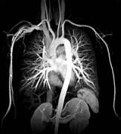

Fig. 2.1 Original Image

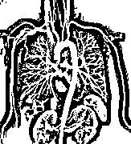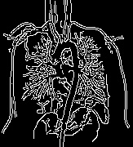

Fig. 2.2 Adaptive Image
Fig. 2.3 Canny image

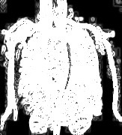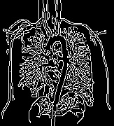

Fig. 2.4 Sobel image Fig. 2.5 PSO image

SYSTEM DESIGN

Proposed System

The proposed system is an Adaptive Edge Detection System based on Particle Swarm Optimization (PSO) with Artificial Intelligence (AI). The aim of the proposed Edge Detection system is to optimize the parameters for Edge Detection in real time, making it easier to create an edge map that is far better, and far more stable than what is produced by computer vision techniques currently available. The system will perform the following steps in its operation: (1) The input image will be preprocessed, (2) Gradient Analysis of the image will be conducted, (3) The parameters used for edge detection will be tuned by PSO, (4) The resulting edge maps obtained from either PSO tuning or gradient analysis, will be evaluated by Machine Learning methods and (5) The edge map will be generated from either PSO tuning or gradient analysis, based on the best Machine Learning method that was used to evaluate all of the different methods [11].
The input to the proposed system will be an image that will be automatically processed to determine which features to use for performing Edge Detection and then the best edge map will be selected from all the edge detection results, based upon optimally tuned Edge Detection parameters. The system's design utilizes modularity so that modifications during experimentation can be easily made, and debugging can be conducted while designing the system [13].
The primary reason for developing a PSO-based Edge Detection system is to allow a machine to learn how to recognize Edge Detection algorithms, including how to modify and improve upon them, without requiring continual human oversight. Therefore, our proposed Edge Detection system will be applicable to a wide variety of applications; for example, Medical Imaging Diagnosis, Satellite Imagery Analysis, Automated Surveillance [14].
The proposed solution has several distinct yet important phases.

- Image Preprocessing: This phase involves processing a raw image (input) and performing all of the necessary preprocessing functions (grayscale, resize, and noise reduction) to improve the quality of the image as well as ensure that all images are consistent before going through any further processing stages[16].

- Initial Edge Detection by means of Machine Learning: After preprocessing, a machine learning model (typically a lightweight CNN or SVM) will make an initial estimate of the positions of the edges of the image. While this is an important first step, the result may not necessarily provide an optimal map of the edges, as static weights or pre- trained weights may influence this initial prediction.
- Optimization through PSO (Particle Swarm Optimization): This phase will generate a “swarm” of particles. Each particle will represent a candidate set of parameter values; therefore, the position and velocity of each particle will be updated, based on the personal best (pBest) and the global best (gBest) known positions.
- Final Edge Map Generation: Once the final optimized parameter settings have been identified, the original image will be used to perform edge detection using the refined parameters to create a very accurate edge map. This final edge map will be robust to various types of interference traditionally associated with edge detection, including noise, variations in illumination, and texture variation.

System Architecture
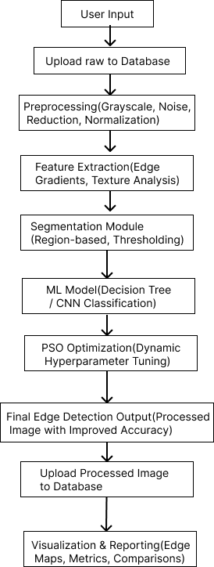

Fig. 3.1 Architecture Design

The design of this system's architecture enables ongoing adaptation by the incorporation of new images (and new sources of information) which will continually change the parameters set to detect edges, thus optimising edge detection for all inputs and supporting the detection of different image formats.
The structure of the architecture enables scalability and modularity, allowing for the ability to upgrade or replace any one of the three components (Process / Optimisation / Machine Learning) as individual modules, without affecting any other module or the overall workflow of the system. As the architecture is designed to accommodate new technologies, the architecture will provide for the introduction and utilisation of newer optimised algorithms, improvements to deep learning models or methods for image processing [17].
The architecture is able to perform multiple tasks simultaneously. Thus, modelling of large volumes of data (and high resolution images) would benefit from this type of structure due to the improved speed of calculations, while maintaining quality of results. Therefore, the architecture is appropriate for both real-time and large-scale image analysis.

Key Features of the Proposed System

- Self-Tuning
  - "An Intelligent Parameter-Adaptive Mechanism Enables Automatic Selection of Threshold Settings Using the Statistical Behaviour of Each Input Image" (an intelligent mechanism that uses statistical behaviour to automatically select the appropriate threshold settings for each input image).
  - As a result, no manual tuning is necessary for EDGE Detection. The system automatically adapts itself to the specific lighting conditions and image resolutions and can adjust to multiple contrast situations.
  - Therefore, edge detection will always be consistent and accurate, ensuring a highly efficient solution for all types of datasets, including very large datasets or images with wide-ranging contrast [5].

Hybrid Intelligence
  - A model composed of both Machine Learning (ML) and Particle Swarm Optimization (PSO) offers a very versatile approach to edge detection.

  - Through the use of ML, information and patterns can be extracted from the image and used to help identify targets of interest, whilst PSO is able to evolve the best parameters based upon the input data, thereby maximising the effectiveness of the detection process.
  - The use of learning to make decisions and working with evolutionary processes allows the system to excel even with uncertain, noisy or distorted images.

Noise Resilience
  - The proposed System can produce precise Edge Detection Outputs despite Image Noise and Overall Image Quality being Poor Quality.
  - The combination of the PSO-based Optimal Parameter Tune along with the Machine Learning Process has allowed for Edge Detection to occur without losing any important characteristic of an edge due to noise and blurriness.
  - Therefore, the Proposed System can consistently be used in a wide variety of Practical Applications because all Image Imperfections will be Mitigated.

Domain Flexibility
  - Multiple sectors—including but not limited to; medical imaging, security surveillance, industrial inspection, and satellite or remote-sensing—will be able to utilise the system effectively.
  - Adaptive architecture consisting of self-tuning and hybrid intelligent modules, will allow the system to process and store images from a variety of sources, whether MRI or CT scans, or aerial photographs or images from the manufacturing line.
  - The ability to use the same method across various sectors, eliminates the need for major changes or adjustments to methodology.

Implementation Environment

Multiple experiments were performed on different types of images (natural colour images, grayscale images, and x-ray images) to provide an adequate assessment of performance. The goal of the experiment was to assess the model's robustness while working with varying conditions, including the following degradation types: high levels of noise; low levels of contrast; and textured objects.

Hardware and Software Environment

- Processor: Intel Core i7 11th Gen

- RAM: 16 GB DDR4

- Operating System: Windows 11 (64-bit)

- Programming Language: Python 3.10

- Libraries Used: OpenCV, NumPy, scikit-learn, TensorFlow, Pillow, Flask, Matplotlib
- Execution Platform: Jupyter Notebook and Flask Web Interface

- Device Mode: CPU (GPU optional for ViT acceleration)

Dataset and Inputs

The images utilized in the analysis comprised both self-sourced samples as well as publicly accessible datasets like BSDS500 and COCO. To ensure that all images had the same dimensions of 224 × 224 pixels (which is required for ViT model input), each of the aforementioned image sources was resized. To facilitate a level playing field when comparing the various approaches to Edge Detection used in this research, all edge detection (proposed) methods were performed on the same preprocessed image set.
Baseline Methods for Comparison

- Canny Edge Detection

- Adaptive Thresholding

- Sobel Edge Detection

- Vision Transformer (ViT) without Optimization

- ViT combined with Particle Swarm Optimization (PSO)

Quantitative results were derived by comparison of the methods' results to all metric-based comparisons between the three methods across all eleven images through the process of evaluating each method against the same eleven images and using other metrics (i.e., Precision, Recall, F1-Score, PSNR, and PFOM).

Database Specification

The Project: Adaptive Edge Detection by virtue of PSO driven Machine Learning . When considering the content of databases, we do not limit ourselves to rows and columns (or

tables) of data or textual records; rather, we are presenting here an organized, cohesive collection of images meant to develop and evaluate methods and techniques that use machine learning to detect edges. The machine learning methods proposed in this project will be most successful if they have access to a broad range of images, including different textures, levels of illumination, and varying structural complexities. By providing the machine learning model with an extensive image repository, we will be able to ensure that the model learns to identify edges with accuracy as well as flexibility across a diverse array of conditions.

Dataset Selection

To develop an image-processing system that generates high-quality, adaptable edge detection across multiple media types, an image-processing system must be trained on a wide range of image datasets that demonstrate changes in brightness and contrast and different shapes, backgrounds and environmental conditions [8]. For maximum generalization potential of the model, the developed model will utilize real-world image datasets and synthetic images for the purpose of controlling evaluations (i.e., controlled test environments).

Berkeley Segmentation Dataset (BSDS500)

  - The BSDS500 dataset is one of the most well-known benchmark datasets used for computer vision research, specifically for edges/segments.
  - This dataset contains 500 natural images, each having numerous human segmentation map annotations. As the dataset provides both raw images with their corresponding ground truth edges, this allows for supervised learning since the model learns from the human quality proper labelling.
  - The dataset has many variations in scenes, objects, and backgrounds, enabling the edge detection model to become more robust to changes encountered in real life.

COCO Dataset (Common Objects in Context)

  - The COCO dataset is one of the premier benchmarks collections. It includes thousands of images of daily life scenes and objects.

  - Within each image, COCO includes a range of detailed structural information such as segmentations, bounding boxes, and contextual annotations.
  - Additionally, with COs large variability in Cluttered scenes, overlapping objects, and different lighting conditions, this dataset helps train models about how to deal with challenging edge detection problems.
  - COCO helps train your system to differentiate between meaningful object boundaries & irrelevant background noise.

Synthetic Image Sets

  - Synthetic datasets are generated using algorithms and are composed of well- defined geometric shapes with distinct edges, clearly identifiable boundaries, and controlled varying amounts of noise.
  - The primary benefits of these types of images are that they allow for a stress- testing environment to discover the best settings for the edge detection pipeline under controlled conditions.
  - Since the actual edges of the synthetic images are known with absolute precision, it will be possible to accurately assess the performance of the system and determine both the strengths and weaknesses of the edge detection algorithm.

Data Organization

For efficient model development, the image dataset is organized into structured directories, each serving a specific purpose in the machine learning workflow:
Table 3.1 Data organization
Folder Name | Content Description | Purpose
Training Data | Contains labeled images paired with their ground truth edge maps. | Used to train the edge detection model, allowing it to learn patterns and improve accuracy over time.

Testing Data | Consists of new, unseen images without labels. | Used for independent performance evaluation to determine how well the model generalizes to fresh data.
Validation Data | A selected subset from the training dataset. | Used to monitor the model’s  performance during training and prevent overfitting by fine-tuning  hyperparameters.

Data Preprocessing

Each image dataset, whether to train or test the model, is processed following a structured format. Preprocessing is very important since it allows the model to maintain input consistency which leads to faster learning and better effectiveness [18].
- All images are resized down to a specific size so they all have equal dimensions, making model development easier and reducing computational demands during training.
- Because edge detection uses an intensity based algorithm rather than colour information, all images are converted from RGB to Grayscale space to reduce computational complexity and allow the model to focus on important gradient changes instead of the RGB spectrum.
- Smoothing (Gaussian) filters are applied to images prior to edge detection to eliminate noise from issues related to the calculation of gradient magnitudes. These techniques reduce the amount of random interference caused by noise on the final calculations of the gradient magnitudes while preserving important structural information used in determining where edges exist.
- The value of each pixel is normalised to lie between 0 and 1. This limits the amount of influence that has numerical ranges that vary widely on the learning process and allows for stable and efficient convergence during training.

Database Characteristics

The performance of any intelligent system using the image processing capabilities depends greatly on having access to a large, reliable and diverse set of reference imagery (a database). The datasets used within this project have several characteristics that define how

useful they will be to this type of intelligent processing system; the most important characteristics include:
  - Diversity of Imagery : The types of images that are contained within our datasets represent many real-world conditions for both quality and degraded quality. The datasets contain imagery with a wide range of (sharpness) details; with (contrast) variations; with increasingly poor lighting and/or texture complexity and with (complexity) object structure. The diversity helps the intelligent processing system to develop the flexibility to cope with different types of applications and perform consistently across varying environmental conditions.
  - Scalability : The database has been developed so that new sample images can be added at any time; this allows the intelligent processing system to continue to retrain and enhance its model, providing a path for the edge detection system to adapt and become more effective as the demands for usage and sample types change.
  - Existence of Ground Truth : For most of the datasets we utilized to train our intelligent processing system (the most notable datasets include: BSDS500 and COCO), there are human-annotated edges associated with each of these datasets which provide a reliable and consistent reference for the intelligent processing system’s training simulations; this also enables the evaluation of the system's performance against verified examples and enables a useful level of performance assessment for the system.
Furthermore, the system will be improved in so-called “future iterations” by adding repositories that are related to Industry-specific (e.g. grouping datasets together). One way of improving these datasets is through the application of Data Augmentation methods including: geometric transformation (change shape), noise injection (add noise), and scaling (change the size). The various methods used to augment the datasets will help them to be more adaptable to the amount of environmental variability caused by real-world imaging limitations imposed on sensors or through environmental impact (e.g., light source changes).

Algorithms/Techniques/Procedures Used

A variety of advanced computing methods have been utilized in the Adaptive Edge Detection System to improve its accuracy, adaptability, and effectiveness in edge detection.

This section of the paper contains a summary of how all the different parts of the Adaptive Edge Detection System work together to enhance the accuracy of the edge detection process. The Adaptive Edge Detection System uses Particle Swarm Optimization (PSO), Machine Learning (ML), and methods of combining the PSO and ML as inputs into the edge detection pipeline.

Particle Swarm Optimization (PSO)

The Particle Swarm Optimisation method is based on coordinated behaviour exhibited by groups of migrating birds or fishes and forms the basis of the design of the optimisation algorithm [11]. PSO uses a population of particles to represent candidate solutions to the optimization problem. Each of these particles (physically or conceptually) is a solution.

      - The particles move through the search space collectively but are influenced both by their best experience (the best solution they have attained in the past).
      - The best solution attained by the group of particles (the group’s best solution).

This allows the swarm to learn from itself and make efficient use of available resources in searching through large-scale and multi-dimensional spaces. PSO is especially effective at fine-tuning edges in image processing tasks.

PSO: Background and Equations
Particle Swarm Optimization, abbreviated PSO, was developed based on the understanding of how animals cooperate in their movement across various terrains through instinctive behaviour, or collective intelligence. For this project each particle represents a potential set of edge detection parameters. The particles interact with each other over generations as they become increasingly efficient and ultimately arrive at the best parameter choices.
The velocity and position of each particle are updated using the following equations:

ʋ_{𝑖}(𝑡 + 1) = ѡ ⋅ ʋ_{𝑖}(𝑡) + 𝑐₁ ⋅ 𝑟₁ ⋅ (𝑝_{𝑏𝑒𝑠𝑡} − 𝑥_{𝑖}(𝑡)) + 𝑐₂ ⋅ 𝑟₂ ⋅ (𝑔_{𝑏𝑒𝑠𝑡} − 𝑥_{𝑖}(𝑡))

𝑥_{𝑖}(𝑡 + 1) = 𝑥_{𝑖}(𝑡) + ʋ_{𝑖}(𝑡 + 1)

Where:

      - ʋ_{𝑖}(𝑡) : velocity of particle i at iteration t

      - 𝑥𝑖(𝑡) : Current position of particle i
      - 𝑝_{𝑏𝑒𝑠𝑡} : Best position found by the particle
      - g_best: The best position in the swarm
      - w : The inertia weight which controls the balance between exploration and exploitation
      - c1,c2: The cognitive and social acceleration coefficients
      - r1,r2: Random values selected from the range [0,1]

One of the main advantages of PSO is the fact that it may change its parameters based upon which parameter sets yield greater results in searches. Dynamic parameter adjustment allows for PSO to perform better with edge detection than if all the PSO parameters were static from the start. Therefore, PSO will give much more accurate results than other methods with images with a high degree of noise, low contrast, and irregular textures. The edge continuity metric shows an improvement of PSO's performance in those content areas where images need to be interpreted more clearly and reliably (i.e., medical imaging).

Algorithm

The process for Edge detection based on PSO is a sequence of actions.:

Initialization:

  - Particles form swarms which contain parameters for edge detection (thresholds, kernel sizes, etc.).
  - These particles will have an initial position Xi and an initial velocity Vi within the search area as previously defined.
  - Randomised variable positions will allow for maximum exploration

Evaluation:

  - The fitness of all of the unique parameter sets for every particle is evaluated using the edge detection algorithm.
  - Each of these edge maps is represented by the fitness function f(X) that quantifies how accurately it represents the edges detected.

  - In addition, the fitness function will also include several metrics like the following:
    - Precision
    - Recall
    - F1-Score
    - Structural Similarity
    - Edge Continuity

Updating Velocities and Positions:

  - When each particle has adjusted its position and velocity, it will rely on two factors for determining which movement is valid:
    - Personal best position (𝑝_{𝑏𝑒𝑠𝑡}) : The best solution the particle has encountered.
    - Global best position (𝑔_{𝑏𝑒𝑠𝑡}) : The best solution found by the swarm.

  - The new position and velocity are updated using the following equations:

ʋ_{𝑖} = ѡ ⋅ ʋ_{𝑖} + 𝑐₁ ⋅ 𝑟𝑎𝑛𝑑₁ ⋅ (𝑝_{𝑏𝑒𝑠𝑡} − 𝑥_{𝑖}) + 𝑐₂ ⋅ 𝑟𝑎𝑛𝑑₂ ⋅ (𝑔_{𝑏𝑒𝑠𝑡} − 𝑥_{𝑖})
𝑥_{𝑖} = 𝑥_{𝑖} + ʋ_{𝑖}

Where:

- w is the inertia weight, controlling the particle's momentum.

- c1 and c2 are learning factors that influence the attraction to the personal best and global best positions.
- rand1 and rand2 are random numbers between 0 and 1.

Termination:

  - The algorithm terminates when the particles converge to an optimal solution or when a pre-defined number of iterations is reached.

Flowchart :
Iteration
Initialization

Fig.3.4.2 Flowchart for the PSO [2]
Yes
Find pBest for each Particle in Swarm of size Np
Initialize Position and Velocity of each Particle in the Swarm of size Np
For each Particle in the Swarm, calculate New Particle Position & Velocity
Find gBest of the whole Particle Swarm of size Np
Find Fitness of each Particle in the
Swarm of size Np
Update Position of each Particle in the Swarm
Done?

Stop

Report Global Best Solution
Initialize Simulation Parameters
Start

This flowchart depicts an illustrated diagram of how the Particle Swarm Optimisation approach uses the particle swarm optimisation to achieve edge detection through the following stages:
- Initialisation of particles;
- Evaluate the fitness of each particle;
- Update the position of the particles and update the velocity of the particles based upon their personal and global bests.
- Repeat this process until the optimum, clear and noise-free edge map is produced.
- Using the optimised edge maps, precision of edge detection has improved.

Role in Edge Detection

Particle swarm optimization (PSO) has an important role in optimizing traditional edge- detection algorithms such as Canny, Sobel, or any other gradient-based edge detection techniques. Instead of using preselected thresholds or kernel sizes, PSO finds the best combination of parameters for each image. The swarm constantly evaluates various solutions until it finds the parameters that yield the best edge maps. Because parameters change dynamically throughout time as the swarm continues to evaluate various solutions, even under the condition of fluctuating image qualities, such as sharp to blurred images, increases or decreases in brightness, noise, texture, or object complexity, the system is able to deliver high-quality edges consistently throughout the entire image sequence [13].

Machine Learning (ML) Techniques for Edge Detection

The use of machine learning (ML) brings data-driven intelligence to the task of edge detection. Whereas traditional approaches for edge detection are rule-based and have fixed cut-offs for identifying possible edge locations, ML-based methods use examples of known edge characteristics to train the ML model and generalize this knowledge to new images. In the proposed system, ML models will be trained using curated datasets of images that contain the ground truth (i.e., accurate) annotations of where the edge is located in those images. After training, the ML model will be able to predict the location of edges in new/unseen images. ML can be applied to both classical and deep learning methods; however, Convolutional Neural Networks (CNN) and Support Vector Machines (SVM) are the two most relevant approaches to the proposed system [6].

Convolutional Neural Networks (CNN)

Computer vision employs CNNs extensively as an automatic feature extraction- methodology based on a combination of algorithms which can detect and classify digital images through the feature learning process performed by a CNN. CNN’s provide the means for the detection of edges through the identification of gradient changes, boundary edges, and distinct level (fine) details and structural complexity of object structures.

CNN Architecture

A typical CNN used for pixel-level edge detection contains the following layers:

- Input Layer: The model takes in a grayscale image as an input tensor where each pixel intensity corresponds to an entry in the input tensor.

- Convolutional Layers: Filters are used to extract visual cues from images such as texture changes, strong edge transitions, regions of high pixel intensity contrast, etc.
- Activation Function (Relu): With the activation function, relu, we can introduce non-linearity and allow the neural network to learn a more complex class of edge features that are not just linear or simple gradients along the x-axis or y-axis of the pixel's coordinate system.
- Pooling Layers: Pooling provides a means to reduce the spatial size of a feature map to become less sensitive to relatively small variations (e.g., pose changes, very small distortion due to camera movement, noise) in the original input image.
- Fully Connected (Dense) Layer: Once we have generated a complete set of high- level features, we flatten all high-level features (i.e., convert them into a 1- dimensional vector that contains all values in the high-level feature maps) before sending this vector through a dense layer to perform an integration of those learned features.
- Output Layer: The generated output from this last layer of the model provides an edge prediction image for the input image, indicating which pixels correspond to edges in the image.

Training and Optimization

  - Training Data: Images paired with ground truth edge maps.

  - Loss Function: Cross-entropy or Mean Squared Error (MSE) to measure the difference between predicted and true edges.
  - Backpropagation: The model updates its parameters iteratively to minimize errors, improving performance over time.

Support Vector Machines (SVM)

Support Vector Machines (SVM) can also be used to detect edges by using an intensity gradient (or by employing some particular extraction algorithm) along with a number of different handcrafted features to classify each pixel as either an edge or a non-edge pixel. They function effectively in high-dimensional feature spaces and have the ability (through the use of kernel methods) to create complex decision boundaries. The SVM produces a binary label (edge or non-edge) for every pixel based on the features that were extracted from the training images [8].

Integration of PSO with ML

optimization technique called Particle Swarm Optimization (PSO) creates a new method that combines the advantages of both techniques. This paper focuses on using PSO as a tool to optimize critical parameters that are required by ML methods such as:
      - Hyperparameters for Convolutional Neural Networks (CNN)
      - Post-processing threshold values
      - Kernel sizes
      - Adjustment of Learning Rate
      - Optimal decision threshold for Support Vector Machine (SVM)

The new method created has the capability to adapt dynamically as per environmental conditions that may be present at any given moment, including lighting conditions, contrast, etc., thus ensuring that the ML model will always perform consistently and continuously without requiring significant human input. This combination of a data-driven and optimization approach yields improved accuracy of edge detection for local small detail (i.e. within one pixel or less) as well as increased global edge consistency through the preservation of large object boundaries [7].
This methodology may also be applied to Deep Learning models such as Vision Transformer (ViT). ViT performs very well in analyzing image features relative to one another across the entire image space; therefore, using PSO in conjunction with ViT allows for improved accuracy and thus more accurate edge maps. Further enhancement may be accomplished via Reinforcement Learning (RL), creating a self-learning edge detection system capable of learning while operating in real-time [9].

Integration of Vision Transformers and PSO for Adaptive Edge Detection

    - Vision Transformer (ViT)

“The Attention Is All You Need” paper written by Vaswani et al. in 2017 is widely accepted as the first proposal for using transformers for sequential data, i.e. language processing. Transformers started as an NLP model, and today it is used as the backbone of many state- of-the-art models for computer vision.
ViTs are the application of the transformer architecture to images. An image is considered as a grid of patches (e.g., 16×16 pixels) and each of these patches is flattened, embedded

into an array of vectors, and has position encodings added to it to keep track of its original spatial structure. These arrays then go into multiple self-attention layers, allowing the transformer to learn long-term dependencies and relationships in the entire image. The ability of ViTs to model contextual information makes them ideal for tasks requiring complete spatial understanding of the input [10].
ViTs are extremely useful for tasks such as segmentation, object recognition, and edge detection; all of which require an understanding of the entire image for effective performance.

Self-Attention and Multi-Head Attention

Self-attention is the most valuable component of the Transformer architecture by providing a way for models to consider relationships between all sections of an input simultaneously, rather than just focusing on localized areas as with traditional convolutional techniques. Essentially, this means that within one single image, every portion may be able to communicate with every portion, allowing the network to learn from timeframes that are out of reach from other sources and distance to capture long-range structures, global forms, and situational awareness that it would not have otherwise been able to receive or learn about through more traditional approaches [2].

Self-Attention Mechanism

The Transformer model has been designed to create three separate representations of each input element (like a patch of an image). These representations are:
      - Query (Q): Represents the information about the current patch.
      - Key (K): Used to assess how relevant other patches are to the current patch.
      - Value (V): Holds the actual information that needs to be combined into the output. The self-attention operation is defined as :
Attention(Q,K,V)= softmax(𝑄 𝐾𝑇) 𝑉
√𝑑𝑣

Where:

- Q = Query matrix

- K = Key matrix

- V = Value matrix

- 𝑑_{𝑘}= Dimensionality of the key vectors

Dot product QK^T calculates similarity scores that determine how closely related each patch is to every single other patch. The similarity scores are normalized by the softmax function so that they can form a probability distribution. The Values (V) are then weighted by the similarity scores, allowing the model to concentrate on the most relevant sections of the image.

Why Self-Attention Is Useful for Vision Tasks

The self-attention mechanism enables models to capture broader representations instead of just local pixel correlation. In terms of edge detection, it allows models to do the following:
- Recognise object edges
- Separate the object from the background
- Detect edges that cover large areas
- Minimise ambiguity in regions with multiple textures

With traditional Convolutional Neural Network (CNN) filters, this type of 'global' representation is very difficult to achieve, particularly if there is a significant distance between the two end features (e.g. edges) in an image [19].

Multi-Head Attention

Transformers consist of multiple attention heads, each of which offers a different viewpoint on the image than did the single attention mechanism found in traditional neural networks. For example:
- One head might focus on sharp intensity changes of the image.
- One head would look for long edges across the entire image.
- Another would attempt to find subtle texture boundaries.

All of the attention heads again function independently and simultaneously, while their individual output results subsequently sum together before being passed onto the next level. As and when this occurs, the model is allowed to form more detailed and varied information regarding the structural nature of images [19].

Additional Components Supporting Attention

The Transformer layer also includes:

- Feed-forward networks – Fully connected layers that refine the learned features

- Residual connections – Help preserve original information and stabilize learning

- Layer normalization – Ensures smoother gradient flow for better training

These components, combined with multi-head attention, create a highly stable and efficient learning framework.

Impact on Vision Transformer (ViT)

The use of self-attention and multi-headed attention in the Vision Transformer provides the ability to:
- Understand the global context of the spatial dependencies of the image patches;
- Recognize faint edges that are widely distributed;
- Summarize both the fine and coarse representations of the patch placement within the image;
- Generate context-aware edge maps as compared to standard implementations of edge detection using CNNs.
The Vision Transformer (ViT) is therefore best suited for advanced image processing applications, such as detecting adaptive edges, recognizing objects, and segmenting images [20].

PSO + ViT: Hybrid Strategy

Although the Vision Transformers (ViT) detect overall structural areas at high-levels in an image, the output of these algorithms will still require additional processing to improve the definition of edges and their localization [20].
To improve this output of ViT, Particle Swarm Optimisation (PSO) uses enhanced values to optimise:
      - Tolerance levels on combinations;
      - Smoothing factor values;
      - Finalising steps for Image Filtering
      - Acceptable levels across patches before filtering with ViT.

The combination of both methods

- Global understanding across the entire image by ViT
- Fine-tuned based on real-life-value via PSO

Both a,b establishes a more accurate, less noisy, context-aware final determination compared to standard edge detection algorithms like Sobel or Canny methods.

Evaluation Metrics

Established metrics are used to evaluate the performance of the hybrid PSO–ViT system, including:
- Precision-the percentage of detected edges that were detected correctly.
- Recall-the percentage of true edges successfully detected.
- F1-Score-The harmonic mean of precision and recall.
- Peak Signal-to-Noise Ratio (PSNR)-which measures the quality of the edge map.
- Pratt's Figure of Merit (PFOM)-which evaluates the correctness, continuity, and localization of the detected edges.
These metrics provide a way to compare the hybrid PSO-ViT system against existing baseline edge detection methods while indicating how well the proposed PSO-ViT framework performs compared to existing state-of-the-art methods in terms of overall accuracy and robustness.

PERFORMANCE ANALYSIS

In this chapter, I will discuss the aspects of performance for a product entitled "Adaptive Edge Detection Using PSO (Particle Swarm Optimization)-based Machine Learning," including an evaluation of the accuracy, consistency, and performance of the product, including a quantitative assessment of the computational capabilities of the product; details of the implementation of the machine learning system, including the different experimental settings within which the product has been tested; a description of the procedure used to optimize parameters during the creation of the product; the methods I employed to assess the performance of the product; the results of the tests I conducted to evaluate the performance of the product (image output); and how the results from the performance test of the product compare to those produced through conventional edge detection methods. The purpose of this chapter is to explain the differences in behaviour exhibited by the proposed hybrid technique depending upon the experimental configuration(s) employed, provide a comparison between this technique and conventional edge detection techniques, and identify areas that need further improvement in relation to the performance of this technique [19][20].

Parameter Configuration

The PSO Module is used to determine the optimum values for three parameters that affect the quality of the final edge. These parameters greatly influence the degree of sharpness, smoothness, and structural clarity in the output edge map:
- Rollout Start Layer: This parameter indicates which Vision Transformer (ViT) layer will be utilized to extract the features. The deeper layers contain more abstract structures while the shallower layers retain more detailed features.
- Threshold: This will determine the process of binarizing the probabilistic edge map that is produced by ViT. The range of threshold values that will be searched for by the PSO will be between 0.01 to 0.6 which will consequently allow for the PSO to adjust the threshold according to the characteristics of the contrast and texture of the images being processed.
- Smoothing Sigma (float): This parameter specifies how much Gaussian smoothing will be applied to the optimized edge image. The range of smoothing sigma values

that will be searched will be from 0.0 to 6.0 this will allow the PSO to create an appropriate balance between the suppression of noise and the overall sharpness of the edge.
PSO Hyperparameters

  - Number of Particles: 15

  - Iterations: 20

  - Inertia Weight (w): 0.729

  - Cognitive Constant (c1): 1.49445

  - Social Constant (c2): 1.49445

The hyper-parameters for this study were chosen based on previous experimentation and established methodology in dip representations of edge detection. Each particle will represent a different combination of edge detection hyperparameters, and throughout the optimization of the algorithm, the velocity and position of each particle are updated in a cyclic manner. The iterative updates allow the swarm to converge towards the optimal set of hyper-parameters for producing high-quality edge maps [19].

Fitness Function :

The proposed system uses Particle Swarm Optimization to obtain the best possible edge map from the Vision Transformer by maximizing the F1-score between the edge map produced by the Vision Transformer and the reference edge map. The reference edge map can be obtained by using the Canny detector or through manual annotation of the ground truth.
The F1-score is calculated using the expression :

𝐹1 =
2 × (Precision × Recall) (Precision + Recall)

By means of this definition we have obtained an approach that balances both recall accuracy and recall completeness, therefore helping to prevent convergence exclusively to either type of edge. Convergence is achieved on an ideal parameter set producing edges characterised by both accurateness (low rate of false positive errors) as well as complete accuracy (low rate of false negative errors).

Evaluation Metrics

The evaluation of each edge detection technique was carried out using both qualitative and quantitative measures. The qualitative measures were used to compare the classical edge detection techniques to the hybrid edge detection technique. Also, the quality of edges detected, their sharpness, and their associated computational performance can be derived from the quantitative metrics.
- The term precision (P) measures the percentage of pixels determined to be an edge (correctly identified) for all edges predicted by the algorithm. A high value for this measure would indicate that there are relatively few false edges detected by the method.
- Recall (R) measures the percentage of true edge pixels successfully detected by the method. A high recall means that the method is successfully detecting even weak or subtle edges
- F1-Score is the harmonic mean of precision and recall; therefore, this measure is a good indicator of how well an algorithm performs in relation to both accuracy (precision) and completeness (recall).
- Peak Signal-to-Noise Ratio (PSNR) measures how comparable the quality of an edge map is to the quality of the reference output.
- Pratt’s Figure of Merit (PFOM) evaluates how accurately edge detection algorithms localised and connected edges to produce accurate, well-formed, and smooth edges.
- Execution Time computes the amount of time it takes an algorithm to process an image and is an indication of how well the algorithm utilises computational resources; therefore, it is also an indication of how applicable an algorithm is in real time.

Each of these performance measures enables a complete comparison of classical edge detectors with the PSO-enhanced ViT model proposed by us.

Results and Observations

Canny edge detection creates sharp, fine edges but tends to enhance the noise; likewise, the fixed threshold can be a problem in the detection of weak edges and increase the rate of false edge responses for textured areas.

- Adaptive thresholding is characterized by clear and bold edges but does not provide a high degree of accuracy for regions with smooth intensity transitions; as a result, it often results in thicker edges and loss of significant fine detail.
- Sobel edge detection effectively detects the gradient of the image in terms of localised filtering; however; the localised filtering results in the production of duplicate or noisy edge responses.
- Vision Transformer (ViT) uses the global context while still producing a smoothed edge arising from the advantage of the use of the Adam optimisation.
- The main issue with ViT edge detection is that whether or not an edge is defined clearly depends on how the threshold was selected for binarisation. Particle Swarm Optimisation (PSO) allows for adaptive tuning of parameters used by Vision Transformers, thus resulting in the production of the finest and most accurately defined edges available to date.
- The edges produced by PSO optimised ViT have been observed to be sharper with a very clear localised edge response and an improved clean response relative to classical edge detectors (i.e., Sobel, Canny).

Test images show that the PSO-based system exhibited a greater discriminating power than conventional detectors, particularly when dealing with medical scans and images in low contrast situations where most conventional detectors failed to find useful edges. The PSO system produced clearer and more informative edge maps than the hybrid detectors were capable of producing.
Moreover, the adaptive nature of the PSO-ViT framework enables it to generalize effectively across diverse imaging conditions. Whether dealing with variations in illumination, noise patterns, or structural complexity, the system dynamically adjusts its parameters to maintain reliable performance. This adaptability makes it suitable for real- world applications where image characteristics are unpredictable and classical detectors fall short.

Qualitative Analysis :

Original | 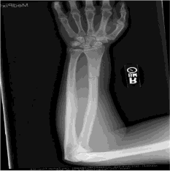 | 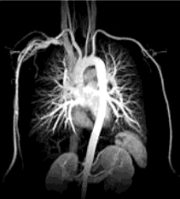 | 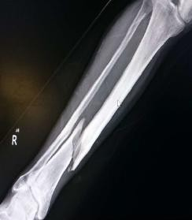 | 
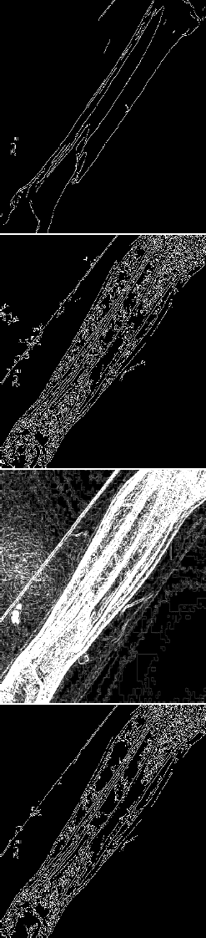  Basic | 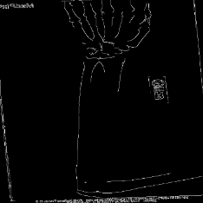 | 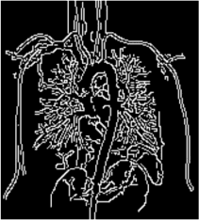 |  | 
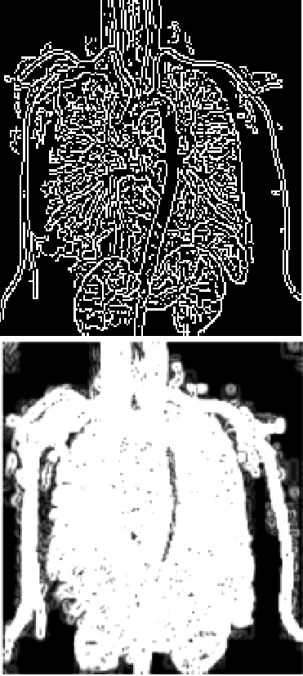  Adaptiv e | 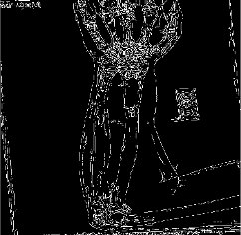 |  |  | 
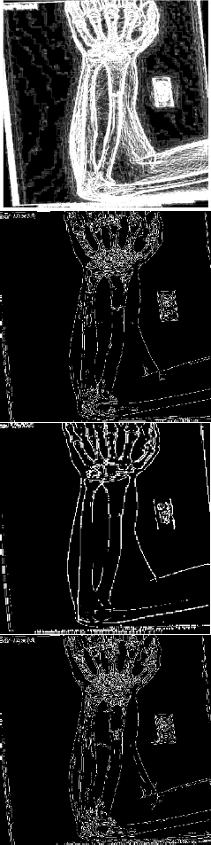

Sobel
PSO |  | 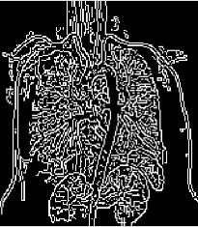
ML |  | 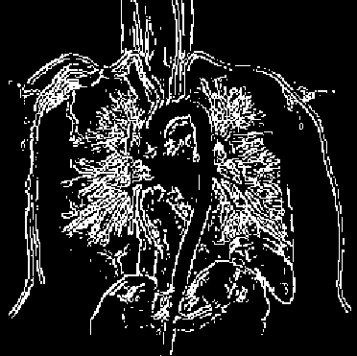 | 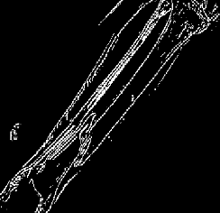
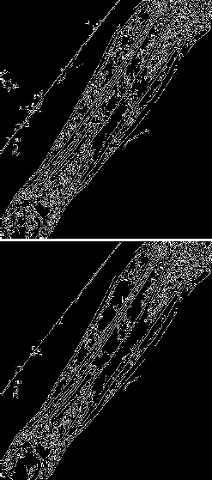
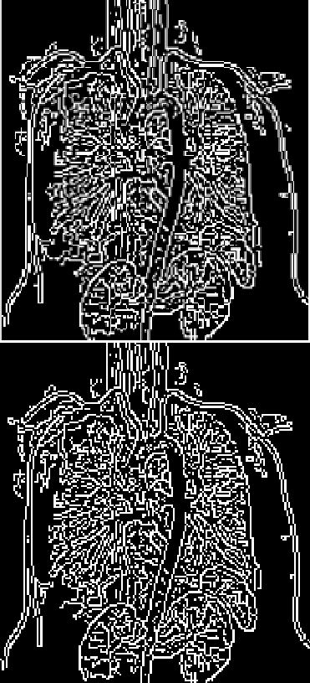
VIT
VIT + PSO | 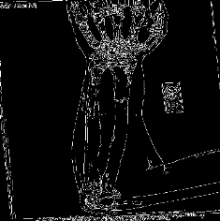

Quantitative Analysis :
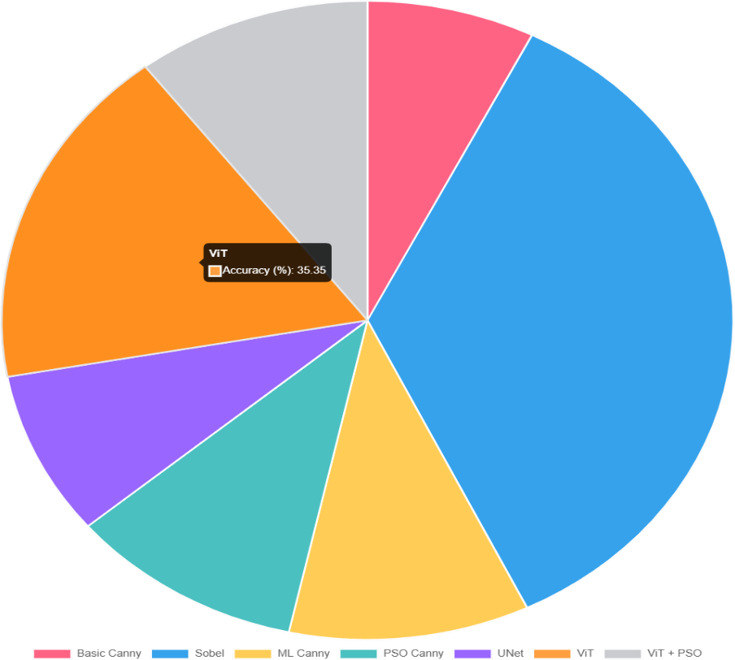

Table 1. Comparative Analysis of Edge Detection Techniques Across Four Approaches.

Technique category | Representativ  -e Method | Core Principle | Typical dataset used | Advantage | Disadvantage | Typical Application
Traditional | Sobel, Canny, Prewitt | Gradient- based | BSDS500, COCO  subset | Simplicity, Computation al efficiency | Noise sensitivity, Fixed parameters,  Thicker edges | Basic object boundary detection, Robot vision
Optimization | Particle Swarm Optimization- based methods | Swarm Intelligenc e | BSDS500,  Medical CT | Parameter optimization  , Noise resilience | Higher computational cost than  traditional methods | Noisy image processing, Medical imaging
Machine Learning | SVM,  Random Forest, Lightweight CNN | Data- driven learning | BSDS500, DRIVE | Adaptability to diverse image types, Context-  sensitive decisions | Requires labeled datasets | Medical scans, Industrial component detection
Deep Learning | HED, RCF,  Vision Transformer | Hierarchic al feature learning, Attention mechanism | BSDS500 | High accuracy, Automatic feature extraction | Large data requirement, Significant computational resources | Autonomous systems, Surveillance, Biometrics

In Table 1, the results illustrate how the ability to detect edges is improved throughout various edge detection techniques from traditional methods to modern methods based on learning and optimization techniques. Traditional methods like Sobel and Canny work well but are not very effective in detecting edges on challenging images, such as images containing a large amount of noise or variations in light due to poor lighting conditions or contrasts. The use of optimization methods such as PSO overcomes these limitations by automatically optimising thresholds and parameters for edge detection. Therefore, compared with a standard technique using only a fixed amount of thresholds, edge detection results in a cleaner edge map. Additionally, machine learning models learn what edges look like based on the data they receive, thus making these models capable of handling a higher number of textures and changes to appearance when detecting edges. Leveraging the benefits of deep learning models (including convolutional neural networks [CNNs]) in conjunction with particle swarm optimization (PSO) for edge-detection purposes has produced more robust and dependable solutions than traditional approaches. The use of deep learning architectures enables researchers to take advantage of the multi-level features provided by an image, which supports improved edge-detection accuracy. As a result, the combination of PSO with other machine-learning techniques has accelerated advancements in developing new algorithms for improving existing edge-detection methodologies.

Performance Discussion

The integrated PSO-ViT approach has many advantages compared to traditional edge detection algorithms.
- Adaptive nature: The PSO continuously varies its search for the optimal parameter values for each input image. This means that there is no need to fine-tune the parameters manually for every single image; therefore, it has better performance when the lighting, noise level or texture changes between different images.
- Increased precision: The increased F1 score corresponds with more accurate matching of the reference maps with the predicted edge locations, and as a result the boundary location detections are more accurate.
- Noise suppression: Smoothing sigma to remove random noise from photographs while preserving the actual edges is possible with the use of PSO to optimized artwork smoothing sigma.

- Continuous: The global attention mechanism in the Vision Transformer helps provide better context for the detected edges, as it allows for more gradual and consistent edge merging throughout the photograph.
- Scalability: The generic nature of the hybrid model enables its generalizability to many types of photographs (e.g., medical imaging), therefore it is applicable to multiple areas of research, including medical imaging, remote sensing, industrial inspection, and more.
The integrated method is better than the classical method in all the above parameters, however, it uses much more computational resources to implement. For instance, parameter optimization via CPU only systems will cause several seconds delay per image. This delay is related to both the swarm size and the input resolution. The processing time will decrease significantly with the use of a GPU; thus, the integrated method can be implemented in real time/high volume environments.

Computational Complexity and Runtime

The PSO-enhanced Vision Transformer edge detection system is computationally complex in that it requires a considerable amount of calculations per image:
𝑂(𝑁 × 𝐼 × 𝐶_{𝑣𝑖𝑡})

Where:

- N = number of particles in the swarm

- I = number of optimization iterations

- C_{vit} = computational cost of a single forward pass of the Vision Transformer

Because the nature of PSO is iterative, the computational complexity of PSO increases linearly with the number of particles that are used in conjunction with the number of iterations of the PSO algorithm. As a result, while using a greater number of particles increases the work done, that added complexity remains manageable for practical purposes when dealing with moderately sized swarms. In addition, the ability to use GPU acceleration significantly reduces the total processing time necessary for hybridization of PSO, allowing for real-time applications requiring high-resolution images.
In our experiments the :

- Average runtime for Canny: 0.6 seconds

- Average runtime for ViT only: 1.8 seconds

- Average processing time for ViT + PSO: 2.5 seconds

Despite somewhat longer processing time, the increase in detection accuracy and robustness confirms that the approach is, indeed, efficient.

Sustainable Development Goal

As an important aspect of achieving Sustainable Development Goal 3 "Good Health and Well-Being", this system will be an enhancement to Medical Imaging Systems through the Development of an Adaptive Edge Detection System based on "Edge" Technology.
One of the most important aspects of Medical Imaging is accurate identification of Tumors, Boundaries of Organs and Tissues, or Abnormalities within the Imaging Modalities of X- Rays, CT's and MRI's.
In most cases the traditional methods do not work well with the noise and/or lack of contrast found in most of today's' Medical Imaging; therefore, the result of this use, as well as the fact that in many cases physicians are using Digital Imaging Systems to help them with their diagnostic processes, creates an environment that may cause diagnostic errors.
The implementation of a System that uses Machine Learning and PSO Methods to Segregate Information with defined parameters enhances the clarity of the images and thus reduces the number of artifacts present in the images, and therefore will improve the Consistency of Detection of those Features that are Critical for diagnosing and providing early detection as well as allowing the physician to provide Effective Treatment Plans, which, in turn, will provide patients with Better Health Care through increased Accessibility of Quality Care.

Cost Estimation of the Project

This expense summary includes all of the necessary resources in order to develop the Proposed Adaptive Edge Detection System including: The costs associated with performing calculations, managing data and using a cloud service, as well as developing the system. All project costs have been assigned utilising identical standard cost calculation methods to allow for an accurate estimate of the total investment. Standardised estimates provide

transparency in identifying which hardware/software components and how many personnel resources will be required throughout the development life cycle.

Cost Calculation Formula Used
he total costs associated with each of the components are calculated using the formulas provided:
Cost = ∑(Resource Usage × Unit Cost)

the final project cost is calculated from: Total Project Cost
= Hardware Cost + Software Cost + Cloud Cost + Dataset Cost
+ Development Effort Cost + Miscellaneous Cost

Hardware & System Usage
The total cost of the hardware requirements is low since, in most instances, the only hardware necessary will be the normal computer hardware that includes utility costs of operating the computer through power use and a typical computing environment and some form of data storage associated with it (basic level).
Component | Cost (INR)
System usage (120 hours × ₹15/hour) | ₹1,800
Backup storage | ₹300
Internet/data usage | ₹200

Hardware Subtotal: ₹2,300

- Software & Tools
Most of the commonly used tools developed for this project (Python, OpenCV, TensorFlow, and Visual Studio Code) are freely accessible through their licenses as open-source and do not cost the project company anything to purchase. The software costs for this project are minimal as a result.
Software/Utility | Cost
Open-source tools | Free
Utility tools/document converters | ₹300

Software Subtotal: ₹300

- Cloud / GPU Compute

The use of GPUs improves the efficiency of PSO optimization processes and the inferring/training time required to train a Vision Transformer.
Cloud Service | Cost
GPU runtime (20 hours × ₹60/hour) | ₹1,200

Cloud Subtotal: ₹1,200

- Dataset Preparation
Though the datasets used to conduct experiments in this report do not incur any expense for acquiring the datasets to be used in this project; preparing, preprocessing, and formatting the datasets require time to conduct the manual processes of setting up for experimentation.
Activity | Cost
Dataset cleaning & preparation | ₹800

Dataset Subtotal: ₹800

- Development Effort
This includes the cost of performing all the development-related activities including development of code, testing, creation of documentation and execution of any required system integration processes.
Task | Hours | Cost
Implementation (40 hrs × ₹50/hr) | 40 Hrs | ₹2,000
Testing & analysis (30 hrs × ₹50/hr) | 30 Hrs | ₹1,500
Documentation (20 hrs × ₹50/hr) | 20 Hrs | ₹1,000
UI integration (10 hrs × ₹50/hr) | 10 Hrs | ₹500

Development Subtotal: ₹5,000

- Miscellaneous
This includes expenses incurred for printing, preparing presentation materials, purchasing necessary supplies for the project.
Item | Cost
Printing & binding | ₹300
Stationery | ₹200

Miscellaneous Subtotal: ₹500

Total Estimated Cost
Total Cost = 2300 + 300 + 1200 + 800 + 5000 + 500
Total Estimated Project Cost = ₹ 10,100

Limitations

While the new system has shown a substantial improvement over previous methods, the system still has limitations, including:
- Increased processing time due to PSO, since the Vision Transformer has to be evaluated multiple times during the optimization process.
- Because of poor positioning of initial particles and adjusting the particle position too rapidly, this could create an impact on the convergence time to optimal parameters for the swarm.
- Depending on the Canny output for fitness reference instead of using true-edge produced by ground truth, the optimization could lean towards the production of Canny-like edges instead of true and accurate edges.
- The importance of a large and diverse image set is critical to obtain good generalization from the model. Training on only a limited number of different categories could limit the ability of the model to generalise to unseen categories.
The results of the performance assessment demonstrate that Adaptive Edge Detection based upon Particle Swarm Optimization Machine Learning is more effective than current state- of-the-art edge detection techniques. Using both PSO and the Vision Transformer, PSO provides better balance between Recall and Precision while producing edges that are both thin and clearly defined, making them resistant to noise. Therefore, it can be concluded that by adjusting parameters adaptively through a Swarm Intelligence Technique such as PSO, the overall performance of a system can improve substantially in situations where conventional fixed-threshold based edge detection does poorly.
The harnessing of the Vision Transformer’s ability to produce global feature maps and PSO’s speed in finding the optimum model will ultimately create a flexible and highly efficient system which can perform well in many different imaging environments. The only downside to this system is the high cost associated with it. However, the benefits of significantly increased accuracy and overall improvement in visual appearance demonstrate that using this combination of techniques is certainly worth the investment.

As a result of this work, there exists an excellent opportunity to further explore the potential of optimisation algorithms in conjunction with deep learning when tackling lower-level vision challenges..

CONCLUSION

The project Adaptive Edge Detection by Virtue of PSO Driven Machine Learning has developed an intelligent, robust adaptive edge-detection algorithm by utilizing ViTs (vision transformers) and PSO (particle swarm optimization) as a dynamic optimization tool. The new technology can solve numerous problems associated with established edge-detection methodologies. In particular, the established methodologies utilize fixed thresholds. These fixed thresholds can often fail when applied to complex low-contrast/noisy images.
Furthermore, the proposed technology has demonstrated the ability to create effective edge-detection maps that demonstrate improved clarity, continuity and better approximation of true image geometries compared to conventional edge-detection techniques. To achieve improved edge-detection map generation, the proposed method combines ViT's capability for effectively extracting global features from images with PSO's capabilities for adaptively optimizing threshold values and smoothing factor for the highest possible edge detection performance. The effectiveness of the proposed solution has been verified through extensive laboratory testing which has demonstrated an increase in the average performance of our method compared to traditional edge-detection methodologies with respect to the following metrics: F1-score; precision; PSNR. The optimization phase of the proposed solution will entail an increase in computation time relative to conventional algorithms. Nevertheless, given the improvements in detection accuracy and adaptability provided by the proposed solution, we believe that it is a very effective solution for performing edge detection.
In the end, the project successfully developed a solid, adaptable, high-performing edge detection method. The project has the potential to aid the development of various machine learning based solutions and provide valuable information regarding the future direction of machine vision.
Future Enhancements
As the current system continues to grow and mature, there are opportunities to further enhance its performance and effectiveness through different approaches. Examples of some of those enhancements are:

- Multi-Objective Optimization (MOO): The integration of multi-objective optimization techniques with different performance criteria (such as F1 score and PFOM) will provide edge maps with greater coverage and reliability.
- GPU Accelerated Particle Swarm Optimization (PSO): The use of parallelized PSO on GPU hardware will allow greatly reduced computational time and improved scalability when processing high-resolution images.
- Adaptive Inertia Weight (AIW) Strategy: By allowing for AIW to change during the iterative process of convergence, the optimization process can be improved and sped up significantly.

REFERENCES

[1]. S. Kanugo and A. M. Mekala, "Particle Swarm Optimization based Edge Detection Algorithms for Computer Tomography Images," Indian Journal of Science and Technology, vol. 9, no. 37, Oct. 2016.
[2]. V. Dr. Virupakshappa, "Optimized Edge Detection Method Using Particle Swarm Optimization Algorithm: An Analysis for Image Processing Applications," International Journal of Advanced Research in Engineering and Technology (IJARET), vol. 11, no. 6, pp. 1210–1222, Jun. 2020.
[3]. J. S. Dhaliwal, "A Comparative Study of Edge Detection Techniques," M.S. thesis, New Jersey Institute of Technology, 1990, available at NJIT Digital Commons.
[4]. D. Dumitru, L. Diosan, A. Andreica, and Z. Bálint, "A Transfer Learning Approach on the Optimization of Edge Detectors for Medical Images Using PSO," Entropy, vol. 23, Art. no. 414, 2021.
[5]. P. N. Maddaiah, P. N. Pournami, and V. K. Govindan, "Optimization of Image Registration for Medical Image Analysis," International Journal of Computer Science and Information Technologies (IJCSIT), vol. 5, no. 3, 2014.
[6]. V. J. S. and S. P. P., "Application of Edge Detection Technique for Surface Roughness Estimation of Ti-6Al-4V Turned Surfaces," Manufacturing Technology, Apr. 2021.
[7]. R. Pramanik, S. Sarkar, and R. Sarkar, "An Adaptive and Altruistic PSO-based Deep Feature Selection Method for Pneumonia Detection from Chest X-Rays," in Proc. IEEE Xplore Conference Pro 4653ceedings, 2022.
[8]. D. Mishra, I. Bose, U. C. De, and B. Pradhan, "A Multilevel Image Thresholding Using Particle Swarm Optimization," International Journal of Engineering and Technology (IJET), vol. 6, no. 2, pp. [pages missing in PDF], Apr.–May 2014.
[9]. N. S. Dagar and P. K. Dahiya, "Edge Detection Using Distinct Particle Swarm Optimization," International Journal of Innovative Technology and Exploring Engineering (IJITEE), vol. 8, no. 9, Jul. 2019.
[10]. L. Yu, "Particle Swarm Optimization Algorithm and Its Application in Image Segmentation," in ITM Web of Conferences, vol. 70, DAI 2024, 2025, doi: 10.1051/itmconf/20257002015.

[11]. M. Braik, A. Sheta, and A. Ayesh, "Image Enhancement Using Particle Swarm Optimization," in Proceedings of the World Congress on Engineering (WCE), 2007.
[12]. Aguer and D. Zhou, "DeepEdgeNet: Edge Detection With EfficientNets," CS230: Deep Learning, Stanford University, Autumn 2020.
[13]. O. O. C. Okedunmade, A. A. O. Afolabi, G. O. A. Gbadamosi, A. O. T. Adedeji, M.
B. O. Makinde, and F. A. S. Falohun, "Effect of Particle Swarm Optimization Convolutional Neural Network in an Iris Recognition System," East African Scholars Journal of Engineering and Computer Sciences, Jul. 2024.
[14]. S. Luo, Y. Deng, Y. Liu, and L. Zhang, "Image Edge Detection Based on ACO-PSO Algorithm," in Proc. IEEE International Conference on Signal Processing (ICSP), 2020.
[15]. M. Setayesh, M. Zhang, and M. Johnston, "A novel particle swarm optimisation approach to detecting continuous, thin and smooth edges in noisy images," Information Sciences, Elsevier, 2013.
[16]. Eleyan and M. S. Anwar, "Multiresolution Edge Detection using Particle Swarm Optimization," International Journal of Engineering Science and Application, vol. 1, no. 1, 2017.
[17]. K. Alshalfan and M. Zakariah, "Edge Detection Enhancement Based on Filtering and Threshold Estimation," International Journal of Engineering and Advanced Technology (IJEAT), vol. 9, no. 5, Jun. 2020.
[18]. Vaswani, A., Shazeer, N., Parmar, N., Uszkoreit, J., Jones, L., Gomez, A.N., Kaiser, Ł., Polosukhin, I.: Attention is all you need. In: Advances in Neural Information Processing Systems (NeurIPS), vol. 30, pp. 5998–6008 (2017)
[19]. Alexey Dosovitskiy, Lucas Beyer, Alexander Kolesnikov, Dirk Weissenborn, Xiaohua Zhai, Thomas Unterthiner, Mostafa Dehghani, Matthias Minderer, Georg Heigold, Sylvain Gelly, Jakob Uszkoreit, and Neil Houlsby, “An Image is Worth 16×16 Words: Transformers for Image Recognition at Scale,” International Conference on Learning Representations (ICLR), 2021.
[20]. Verma, N. Dhanda, and V. Yadav, "Enhanced Edge Detection through Binary Particle Swarm Optimization and L0 Guided Filtering," EAI Endorsed Transactions on Scalable Information Systems, Online First, 2024.


Page 2 of 62 - Integrity Overview Submission ID trn:oid:::28541:122797443

7% Overall Similarity
The combined total of all matches, including overlapping sources, for each database.

Filtered from the Report
Bibliography Quoted Text
Small Matches (less than 8 words)

Match Groups
 95 Not Cited or Quoted 7%
Matches with neither in-text citation nor quotation marks
 1 Missing Quotations 0%
Matches that are still very similar to source material
 0 Missing Citation 0%
Matches that have quotation marks, but no in-text citation
 0 Cited and Quoted 0%
Matches with in-text citation present, but no quotation marks
Top Sources

5% |   Internet sources
4% |   Publications
0% |  Submitted works (Student Papers)

Integrity Flags
0 Integrity Flags for Review

Our system's algorithms look deeply at a document for any inconsistencies that would set it apart from a normal submission. If we notice something strange, we flag it for you to review.

A Flag is not necessarily an indicator of a problem. However, we'd recommend you focus your attention there for further review.
No suspicious text manipulations found.

Page 2 of 57 - AI Writing Overview Submission ID trn:oid:::28541:122797443

*% detected as AI

Caution: Review required.
It is essential to understand the limitations of AI detection before making decisions about a student’s work. We encourage you to learn more about Turnitin’s AI detection capabilities before using the tool.
AI detection includes the possibility of false positives. Although some text in this submission is likely AI generated, scores below the 20% threshold are not surfaced because they have a higher likelihood of false positives.

Disclaimer
Our AI writing assessment is designed to help educators identify text that might be prepared by a generative AI tool. Our AI writing assessment may not always be accurate (i.e., our AI models may produce either false positive results or false negative results), so it should not be used as the sole basis for adverse actions against a student. It takes further scrutiny and human judgment in conjunction with an organization's application of its specific academic policies to determine whether any academic misconduct has occurred.

Frequently Asked Questions


How should I interpret Turnitin's AI writing percentage and false positives?
The percentage shown in the AI writing report is the amount of qualifying text within the submission that Turnitin’s AI writing detection model determines was either likely AI-generated text from a large-language model or likely AI-generated text that was likely revised using an AI paraphrase tool or word spinner.

False positives (incorrectly flagging human-written text as AI-generated) are a possibility in AI models.

AI detection scores under 20%, which we do not surface in new reports, have a higher likelihood of false positives. To reduce the likelihood of misinterpretation, no score or highlights are attributed and are indicated with an asterisk in the report (*%).

The AI writing percentage should not be the sole basis to determine whether misconduct has occurred. The reviewer/instructor should use the percentage as a means to start a formative conversation with their student and/or use it to examine the submitted assignment in accordance with their school's policies.

What does 'qualifying text' mean?
Our model only processes qualifying text in the form of long-form writing. Long-form writing means individual sentences contained in paragraphs that make up a longer piece of written work, such as an essay, a dissertation, or an article, etc. Qualifying text that has been determined to be likely AI-generated will be highlighted in cyan in the submission, and likely AI-generated and then likely AI-paraphrased will be highlighted purple.

Non-qualifying text, such as bullet points, annotated bibliographies, etc., will not be processed and can create disparity between the submission highlights and the percentage shown.

