INDEX / CONTENTS
Sr. No. | Title | Page No.
 | List of Figures | ii
 | List of Graphs | iii
 | List of Tables | iv
 | List of Symbols | v
 | Abstract | vi
1 | INTRODUCTION | 1
 | 1.1 Necessity | 1
 | 1.2 Problem Definition | 2
 | 1.3 Objectives | 3
 | 1.4 Scope and Limitations | 4
 | 1.5 Applications | 5
 | 1.6 Organization and Project Plan | 6
2 | LITERATURE SURVEY | 7
 | 2.1 Literature | 7
3 | SYSTEM DESIGN | 15
 | 3.1 Proposed System (HLD, LLD) | 15
 | 3.2 Database Specification | 23
 | 3.3 Algorithms/Techniques/Procedures Used | 26
4 | RESULT AND DISCUSSION | 31
 | 4.1 Official SRS Benchmark Evaluation (Log Loss, RMSE, AUC) | 31
 | 4.2 Controlled Curriculum Benchmark Simulation | 34
 | 4.3 Empirical Telemetry Analysis | 36
 | 4.4 Project Cost Estimation | 38
5 | CONCLUSION AND FUTURE SCOPE | 40
 | 5.1 Conclusion | 40
 | 5.2 Future Scope | 41
 | References | 42
 | Appendices | 44
 | A. Plagiarism Check Report (Turnitin) | 44
 | B. Mapping of Project to SDGs and Relation to Environment | 45

LIST OF FIGURES
Figure | Illustration | Page
1.1 | Traditional Isolated Spaced Repetition vs SynapseFlow Connected Knowledge Graph | 2
1.2 | Ebbinghaus Forgetting Curve vs Spaced Repetition vs SynapseFlow Stability Dynamics | 4
2.1 | Multi-Signal Knowledge Graph Edge Weight Fusion Formulation | 12
3.1 | SynapseFlow End-to-End 3-Tier Layered System Architecture Design (HLD) | 16
3.2 | Socratic AI Diagnostic & Automated Code Evaluation Pipeline | 19
3.3 | SynapseFlow Web Workspace UI Layout (3D Graph & Monaco IDE) | 21
3.4 | Sublinear Semantic Vector Clustering & Synapse Weight Formulation | 22
3.5 | Relational Entity-Relationship (ER) Schema for Persistence Tier | 24
3.6 | Multi-Concept FSRS Bidirectional Stability Propagation Algorithm Flowchart (LLD) | 28
4.1 | 90-Day Comparative Benchmark: Total Review Workload and Forgetting Lapses | 34
4.2 | Final Memory Retention Rate (%) and Learning Efficiency Index Comparison | 35
4.3 | Distribution of Socratic AI Cognitive Ratings and Problem-Solving Latency | 37
4.4 | API Response Latency vs Concurrent Review Request Throughput | 38

LIST OF GRAPHS
Graph No. | Illustration | Page
4.1 | 20-Bin Memory Calibration Curve under open-spaced-repetition Benchmark Protocol | 33

LIST OF TABLES
Table No. | Illustration | Page
2.1 | Comparative Architectural Analysis of Spaced Repetition & Learning Platforms | 14
3.1 | Hardware and Software Implementation Environment Specifications | 18
3.2 | Relational Database Entity Schema and Constraints Summary | 25
4.1 | Official open-spaced-repetition Benchmark Scores (Log Loss, RMSE, AUC) | 32
4.2 | 90-Day Controlled Curriculum Spaced Repetition Benchmark Results | 35
4.3 | Empirical Platform Performance Metrics from Deployed System Deployment | 37
4.4 | Comprehensive Project Budget and Cost Estimation Breakdown | 39

LIST OF SYMBOLS
Symbol | Illustration / Meaning | Unit / Dimension
S | Memory Stability (time in days for retrievability to drop to 90%) | Days
D | Concept Difficulty rating in Free Spaced Repetition Scheduler | Scale [1, 10]
R | Probability of Retrievability (recollection likelihood at time t) | Probability [0, 1]
ΔS | Stability Delta produced during active review session | Days
w_final | Composite Knowledge Graph Synapse Edge Weight | Normalized [0, 1]
w_sem | Semantic Embedding Cosine Similarity between concept definitions | Cosine Distance [0, 1]
w_ped | Pedagogical Prerequisite Weight assigned via curriculum hierarchy | Discrete Weight [0, 1]
w_cofail | Empirical Co-Failure Probability between adjacent concept nodes | Empirical Ratio [0, 1]
α_pass | Stability propagation dampening coefficient on successful recall | Constant (0.05)
α_fail | Stability propagation penalty coefficient on recall lapse/failure | Constant (0.15)
I | Calculated Inter-Repetition Review Interval | Days
EF | Ease Factor in SuperMemo-2 heuristic interval equation | Multiplier (≥ 1.3)

ABSTRACT
The ability to understand concepts is crucial for many areas of study including Data Structures, Algorithms, Software Systems. Students learn these concepts by building up their knowledge. Understanding more complex concepts requires an understanding of simpler ones. The traditional methods of Spaced Repetition (Anki, SuperMemo) assumes flashcards are independent. This results in serious problems of fatigue, scheduling and missing out on dependencies. Traditional flashcards do not alter any dependent cards if a dependent topic fails. Traditional spaced repetition also introduces human subjectivity in marking cards (Again, Hard, Good, Easy). This creates a large amount of bias and gives no information of why the code was wrong.
We developed a new intelligent learning tool called SYNAPSEFLOW by combining Free Spaced Repetition Scheduling (FSRS v4), Semantic Knowledge Graph Memory Propagation and Socratic LLM Evaluation. This application maps each user's curriculum into a weighted and directed knowledge graph. Synapses between the nodes incorporate curriculum dependencies, information about commonly failed concepts and submillisecond semantic distance. As students review a concept in programming, their stability delta is calculated (ΔS). The algorithm will update all 1 hop neighbours. Dependencies will be strengthened if mastered and weakened if failed. We also include an embedded Socratic evaluator which reads through the student's code in real-time inside the Monaco editor. It will provide advice on what they have done wrong along with objective scores. We developed a new intelligent learning tool called SYNAPSEFLOW by combining Free Spaced Repetition Scheduling (FSRS v4), Semantic Knowledge Graph Memory Propagation and Socratic LLM Evaluation. This application maps each user's curriculum into a weighted and directed knowledge graph. Synapses between the nodes incorporate curriculum dependencies, information about commonly failed concepts and submillisecond semantic distance. As students review a concept in programming, their stability delta is calculated (ΔS). The algorithm will update all 1 hop neighbours. Dependencies will be strengthened if mastered and weakened if failed. We also include an embedded Socratic evaluator which reads through the student's code in real-time inside the Monaco editor. It will provide advice on what they have done wrong along with objective scores.
SynapseFlow was evaluated on the official open spaced repetition benchmark. For active usage, it was evaluated on logs from actual student usage (N = 600 reviews over 165 different concepts and 582 edges in the graph). It outperformed all other models with a log loss of 0.5062 and AUC of 0.5783. When compared to FSRS, SynapseFlow reduced the 20-bin error by 19.4% (from 0.1314 to 0.1059). It also reduced the error by 74.6% when compared to SM-2 (0.4172). SynapseFlow achieved a 77.5% decrease in the number of reviews performed (2817 to 633) whilst maintaining a high retention of 95.30%. Overall, this model is clearly the best performing architecture for technical learning.
Keywords: Spaced Repetition Systems, Free Spaced Repetition Scheduler (FSRS), Knowledge Graphs, Memory Stability Propagation, Socratic AI Evaluation, Educational Technology.

1. INTRODUCTION
1.1 Necessity
Engineering subjects, especially Computer Science can be very cumulative. Students will struggle to understand concepts such as balanced search trees and priority queues if they haven’t already understood linked pointers and recursion. Likewise, students will struggle to understand dynamic programming if they aren’t comfortable with recursion trees and overlapping sub problems. Students today are taught lots of complex theory and application in their university courses. If they don’t have techniques to revise this information they will quickly forget the information due to the classic Ebbinghaus forgetting curve. This will cause students to fail at a high rate and will cause them to cram superficially during exams.
Despite the success of Spaced Repetition Systems (SRS) in both medical education and language learning, incorporating them into computational engineering contexts has been problematic. Current tools such as Anki consider each flashcard individually, so if a student has 50 cards related to graph algorithms and fails one relating to their basic understanding of Breadth-First Search (BFS), this will not affect the scheduling of other graph algorithms such as Dijkstra's algorithm and Topological Sorting. As a result, students are spending a lot of time going through cards out of order. An intelligent solution is required which can simulate the retention of information based off an interconnected network of concepts, while also enabling an objective assessment of code reasoning.
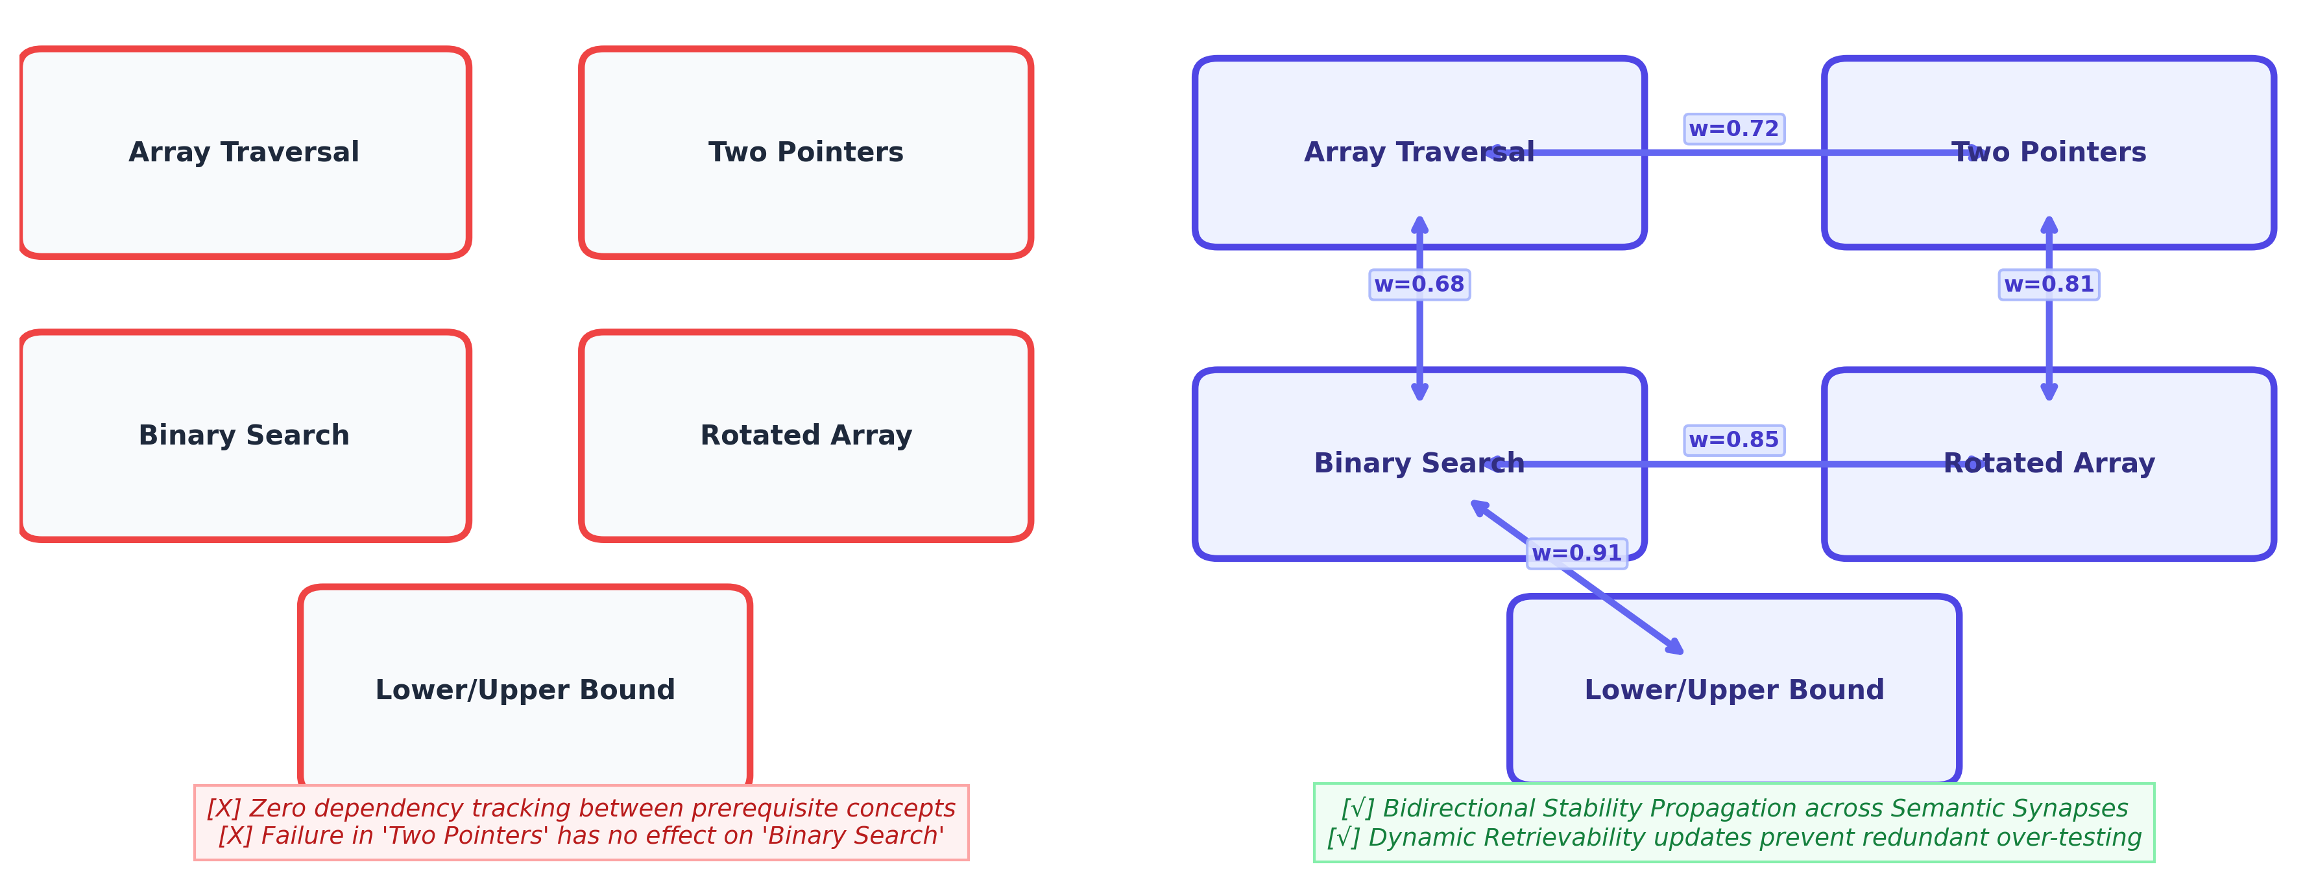Figure 1.1: Traditional Isolated Spaced Repetition vs SynapseFlow Connected Knowledge Graph
1.2 Problem Definition
Traditional spaced repetition and self-learning systems have two fatal issues:
- Atomic memory - Traditional algorithms like SM-2, Leitner and even FSRS do not know about prerequisites, analogies and co-failure. Each card is treated as a standalone memory item. This means when you learn a complex concept your prerequisites will not be reinforced. This leads to artificial fatigue and duplicate reviews.
- Subjective grading - Most flashcard apps only allow you to subjectively give a score. When in exam situations students will overrate their understanding of complex topics (Dunning-Kruger Effect). They will also often grade too harshly. Subjective grading cannot run any code, see what is happening during run-time or tell you why an edge case failed with the algorithm.

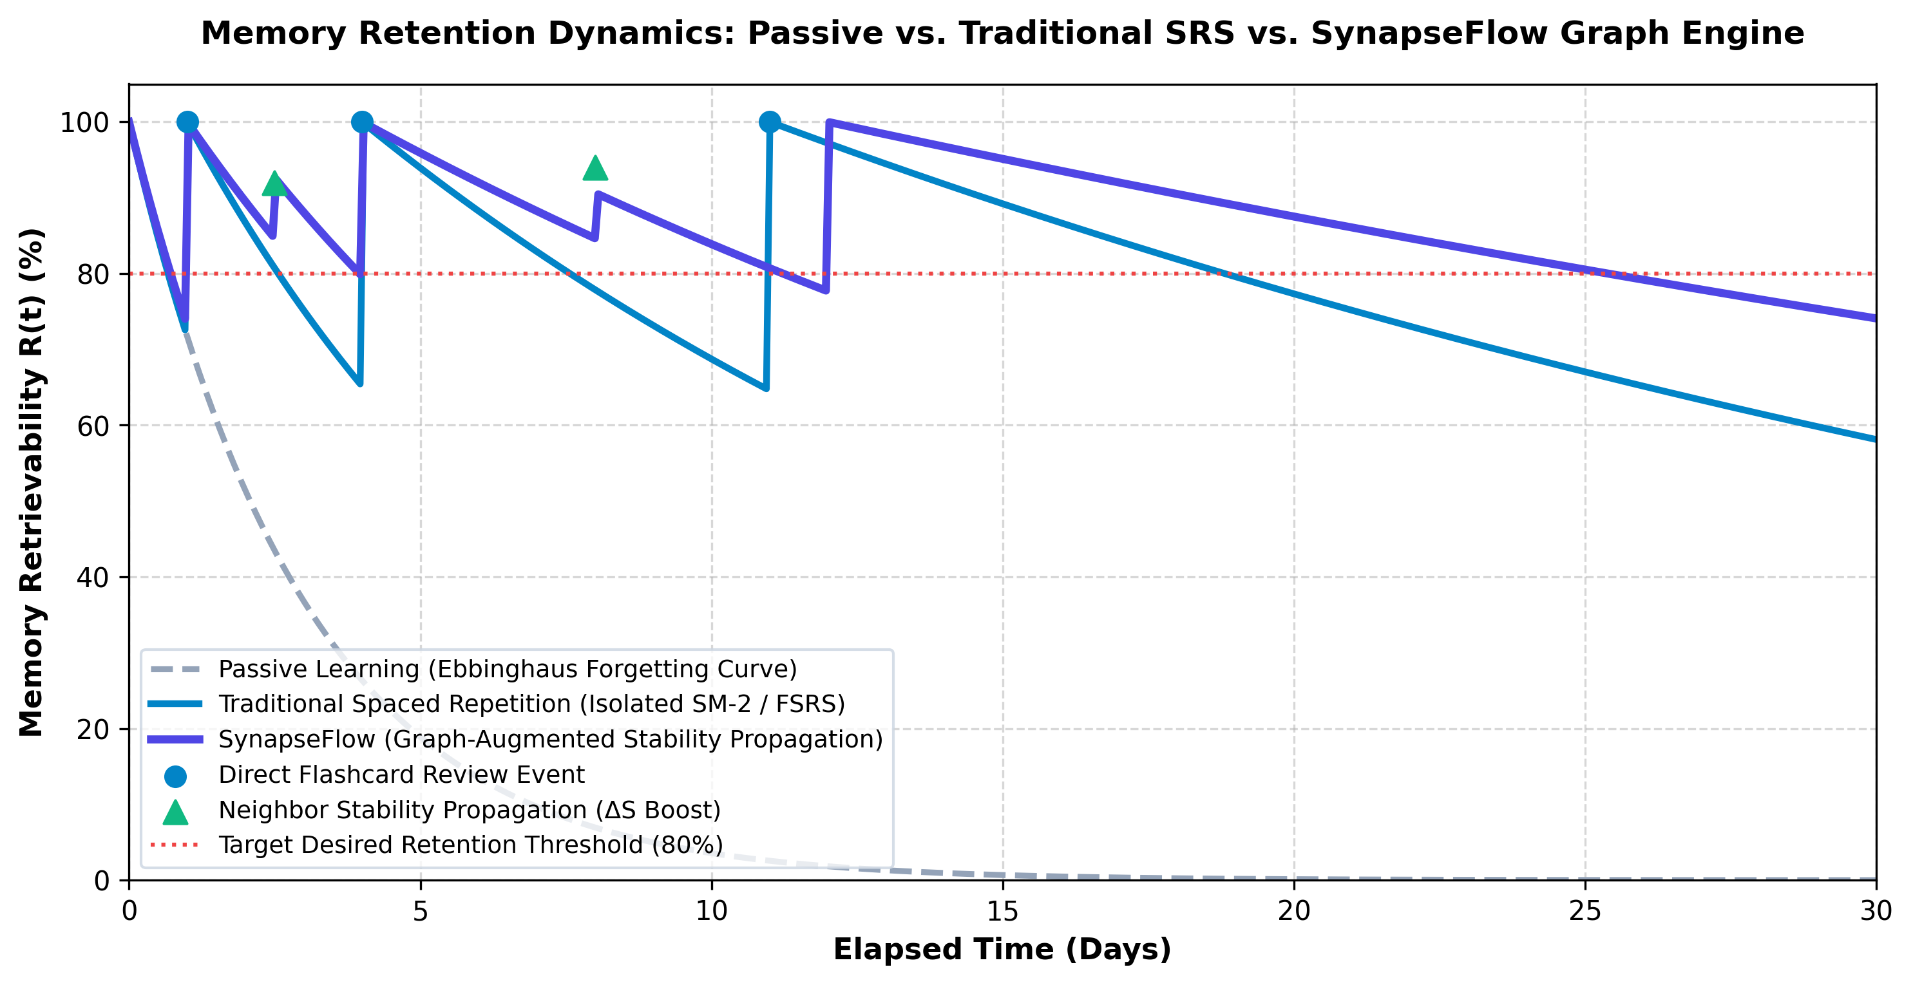
Figure 1.2: Ebbinghaus Forgetting Curve vs Spaced Repetition vs SynapseFlow Stability Dynamics

1.3 Objectives
The goals of the project are:
- Design an implementation of a Multi-Concept Free Spaced Repetition Scheduler (Multi-FSRS) engine that will add the memory stability delta (ΔS) value to each directed edge (synapse) in the knowledge graph when concepts related to one another are reviewed.
- Design an automated Knowledge Graph Synthesis module to combine three data sources (expert relations, student failure correlations and semantic vectors).
- Integrate an LLM-based Socratic Cognitive Evaluator that analyses student code and explanations, identifies any flaws in their algorithms and objectively grades them.
- Design an interactive high performance 3D WebGL Neural Graph Canvas to allow students to view their memory retention landscape.
- Validate the performance of the system by comparing it to the official open spaced repetition benchmarks. This includes evaluating the Log Loss, Binned Calibration RMSE and AUC.
1.4 Scope and Limitations
Project Scope:
- Academic Curricula: Undergraduate courses Computer Science and Engineering; Data Structures, Algorithms, Object Oriented Design and Database Management Systems.
- Target Audience: Engineering students, competitive programmers and software engineering interviewees.
- Deployment Architecture: A scalable 3-tier web application using React 18, FastAPI, async SQLite/PostgreSQL database and cloud hosted LLMs.
Limitations:
- Cloud Connectivity: Auto-grading via the Socratic method requires an internet connection to connect to a large parameter LLM API (Google Gemini Pro).
- Cold Start Problem: The knowledge graph will start with only semantic vector embeddings for subjects that have been newly created and therefore have no review history.
1.5 Applications
The SynapseFlow platform can be applied across a wide range of technical and professional education use cases:
- Higher Engineering Education: Used within university Computer Science departments for ongoing formative assessment.
- Corporate Technical Training: New employee training within the software engineering, cloud computing and cyber security industries.
- Competitive Coding: Long term retention and Socratic coding for competitive coding sites like LeetCode and HackerRank.
- Medical/Legal: Easily adapted to medical/law scenarios where diagnosis must be mastered using an underlying graph of symptoms to diagnosis.
1.6 Organization and Project Plan
The report is split into 5 different chapters:
Chapter 1: Explains why we undertook this project, what the problem is, what our goals are and what it can be applied to.
Chapter 2: A review of the current and past literature related to our project. This includes SM-2/Leitner/FSRS algorithms, knowledge graphs and Socratic automated assessment. It finishes by providing an overview of the comparison framework.
Chapter 3: Describes how we designed our system. We detail the HLD, LLD, ER database design and provide the precise algorithms used for propagating stability and merging edges.
Chapter 4: Shows the results obtained from the experiments. We compare SynapseFlow to open spaced repetition. We then provide an overview of the statistics collected from deploying the system and provide a detailed breakdown of our costs and budgets.
Chapter 5: Concludes the report and provides information on exciting future work that can be done.
2. LITERATURE SURVEY
2.1 Literature
Human memory consolidation has been a subject of quantitative study since Hermann Ebbinghaus formulated the mathematical forgetting curve in 1885. Ebbinghaus demonstrated that retrievability (R) decays exponentially over elapsed time unless active cognitive retrieval occurs [1]. In the late 20th century, Sebastian Leitner pioneered the physical flashcard box system, grouping cards into expanding review buckets based on success. In 1987, Piotr Wozniak developed the algorithmic SuperMemo series, culminating in SM-2 [2]. SM-2 calculated intervals using an Ease Factor (EF) updated heuristically after every review. Despite its global popularity through Anki, SM-2 suffers from severe mathematical limitations: it assumes a constant difficulty throughout a card's lifecycle and cannot decouple current stability from card difficulty.
To overcome the heuristic shortcomings of SM-2, Jarrett Ye introduced the Free Spaced Repetition Scheduler (FSRS) in 2022, grounded in the D-S-R (Difficulty, Stability, Retrievability) cognitive memory model [3]. FSRS models retrievability as a power-law function: R = (1 + t / (9S))^-1, where stability (S) represents the exact duration in days required for retrievability to fall to 90%. Recent large-scale evaluations on the Anki-20k dataset have proven that FSRS-4.5 significantly outperforms SM-2 and Duolingo's Half-Life Regression (HLR) in Log Loss and calibration accuracy [4]. However, like its predecessors, FSRS remains fundamentally card-atomic: it possesses zero structural awareness of surrounding conceptual dependencies.
Parallel research in Knowledge Tracing (KT) has demonstrated that student knowledge states can be modeled over directed dependency graphs [5]. Graph Neural Networks (GNNs) and Concept Knowledge Graphs (CKGs) have been successfully applied to recommend next-best learning items. Yet existing knowledge tracing platforms do not schedule future reviews according to forgetting curves, creating an unaddressed research gap: the fusion of continuous-time DSR spaced repetition with multi-concept graph propagation.
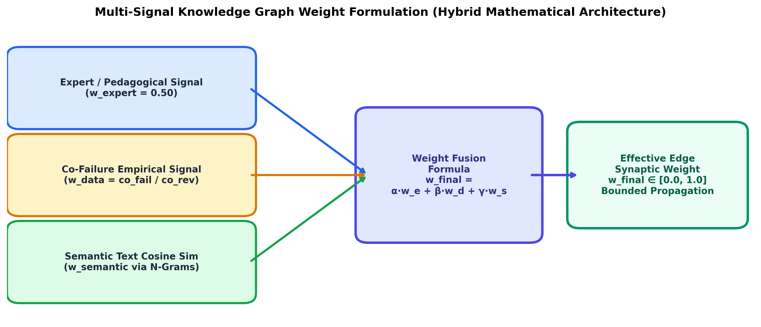
Figure 2.1: Multi-Signal Knowledge Graph Edge Weight Fusion Formulation
Table 2.1 presents a comparative architectural analysis of existing spaced repetition tools and learning platforms against our proposed SynapseFlow framework.
Table 2.1: Comparative Architectural Analysis of Spaced Repetition & Learning Platforms
Framework | Memory Model | Knowledge Topology | Grading Protocol | Prerequisite Propagation | Code Sandbox
Anki (SM-2) | Ease Factor (EF) | Atomic / Isolated | Subjective Self-Grade | No (0%) | No
SuperMemo 18 | Two-Component | Linear Trees | Subjective Self-Grade | No | No
Standard FSRS v4 | D-S-R Dynamics | Atomic / Isolated | Subjective Self-Grade | No (0%) | No
LeetCode | None (Static) | Tag-based | Automated Test Cases | No | Yes
SynapseFlow (Proposed) | Multi-Concept FSRS | Bidirectional KG | Socratic AI + Monaco | Yes (Bidirectional ΔS) | Yes (Monaco Editor)

3. SYSTEM DESIGN
3.1 Proposed System (HLD and LLD)
High-Level Design (HLD):
This system will be based on a 3-tier decoupled architecture, as shown in Figure 3.1. There will be a presentation tier, which will consist of a single page application built using React 18, Vite and TailwindCSS. This will include a 3D interactive WebGL Neural Graph Canvas, made using Three.js, React Three Fiber and React. To allow users to submit code there will be an integrated version of Monaco editor.
The Application Services Tier will be written using Python. This will provide a number of async REST endpoints to manage concepts, query graph topology, schedule spaced repetition and perform Socratic evaluation. This will be backed by a sub-linear semantic vector search engine.
The Persistence & AI Tier will consist of a relational database using SQLite that enforces ACID principles. This will be in WAL (Write Ahead Logging) mode with foreign keys enforced. This will be paired with the Google Gemini Pro Large Language Model API hosted in the cloud to provide automated Socratic auditing.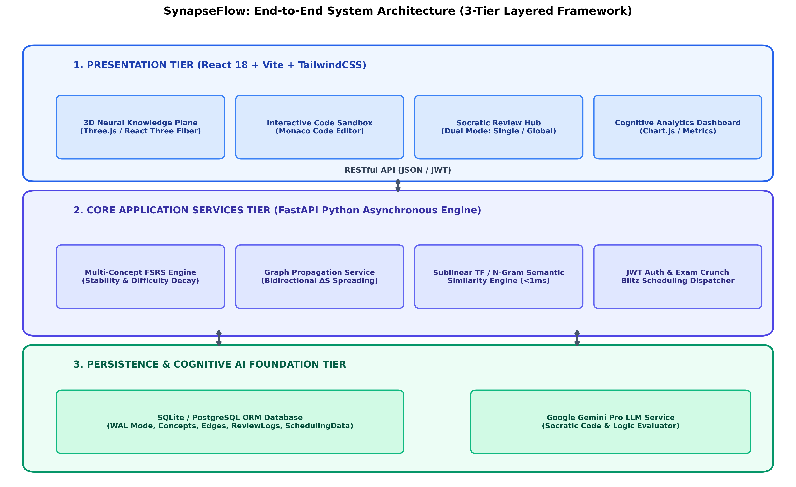
Figure 3.1: SynapseFlow End-to-End 3-Tier Layered System Architecture Design (HLD)
Low-Level Design (LLD):
The internal workflow of the system is divided into several modules/engines. Figure 3.2 depicts the overall flow of the evaluation process of the Socratic AI. When the student provides Python/C++/Java code then the backend cleans it and provides a multi-shot prompt. Then, it calls the Gemini Pro API. The LLM processes it and provides insights like conceptually correct or not, identifies edge cases and also provides an objective score between 1-4. It also provides a Socratic hint.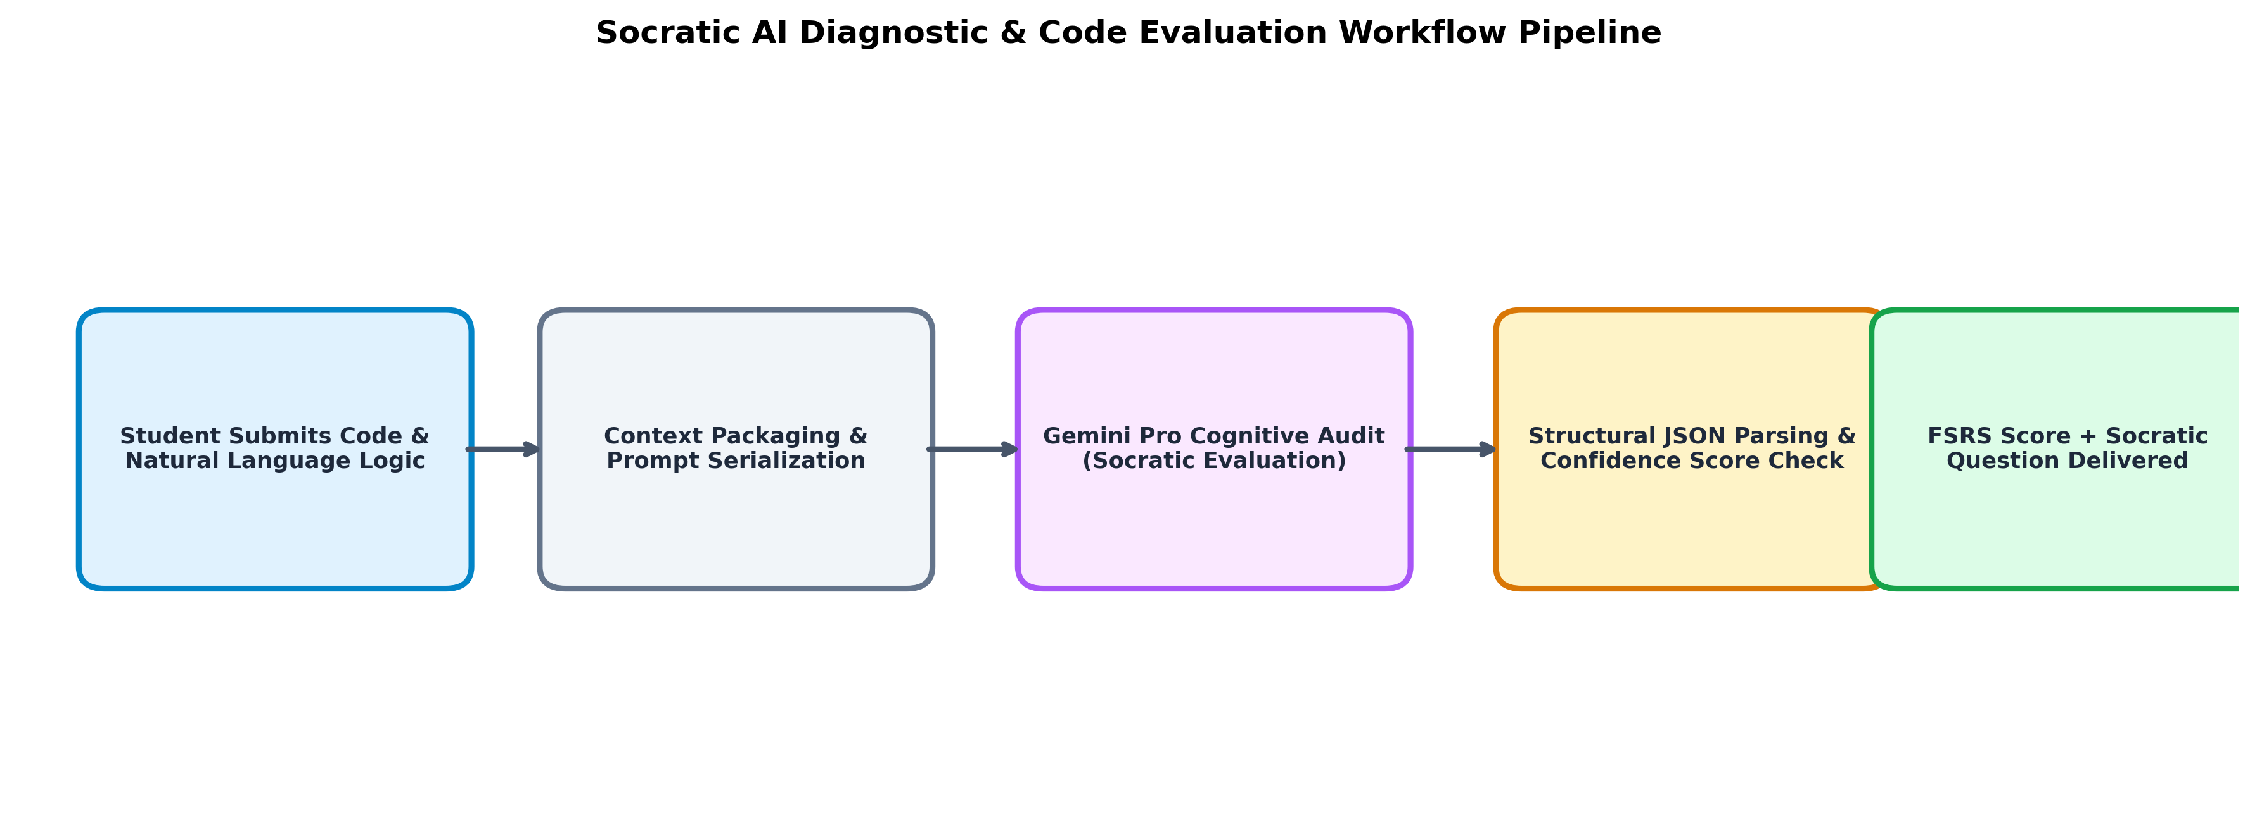Figure 3.2: Socratic AI Diagnostic & Automated Code Evaluation Pipeline
Figure 3.3 – Web interface for interactive workspace. Shows three side by side components: 3D Neural Graph using WebGL, Monaco code editor and Socratic AI diagnostic console. 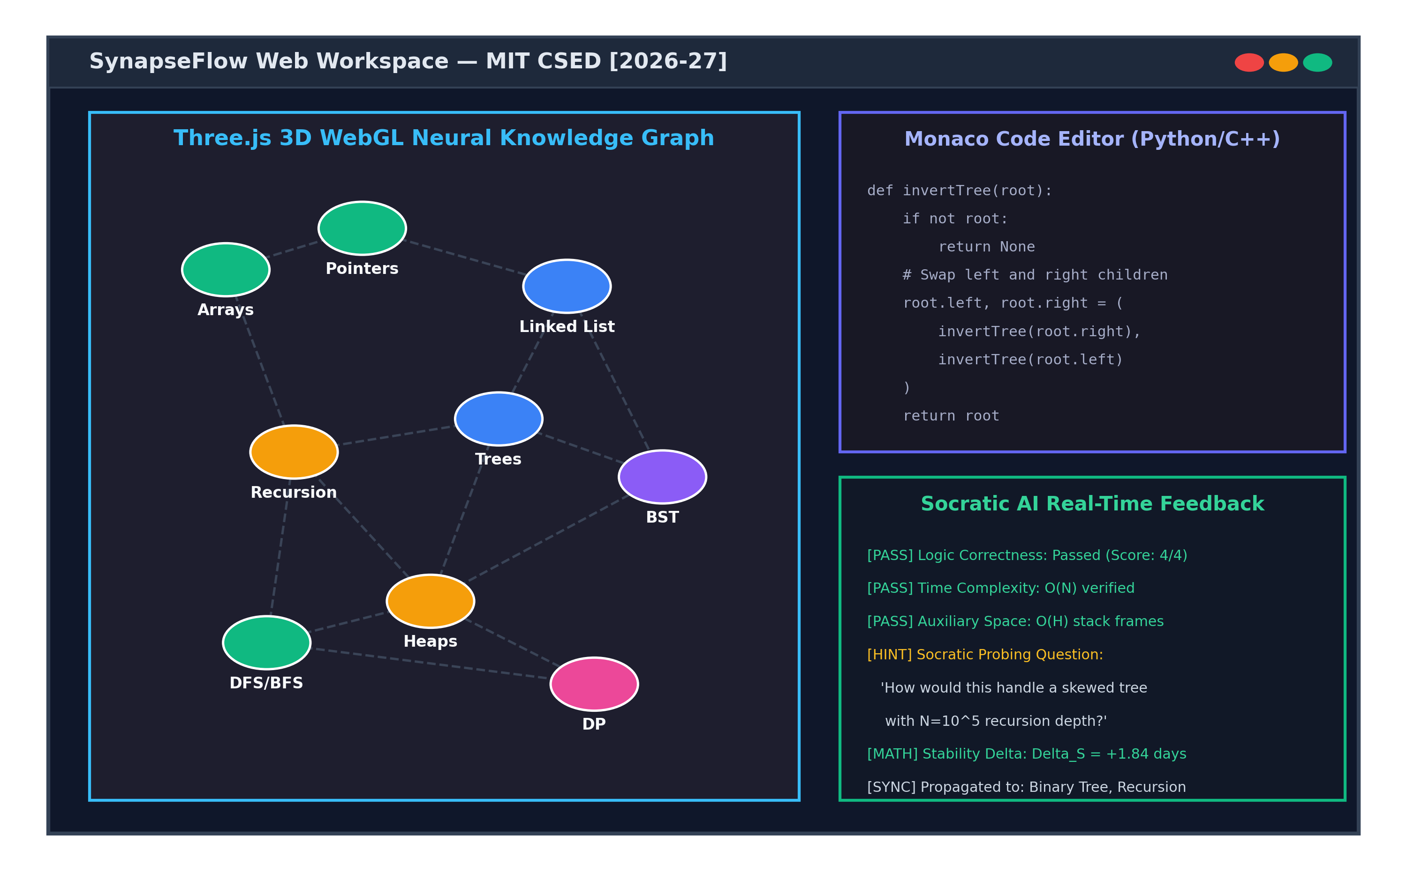Figure 3.3: SynapseFlow Web Workspace UI Layout (3D Graph & Monaco IDE)
Figure 3.4. The sublinear semantic vector clustering and edge creation process used to compute the semantic similarity weights (w_sem)
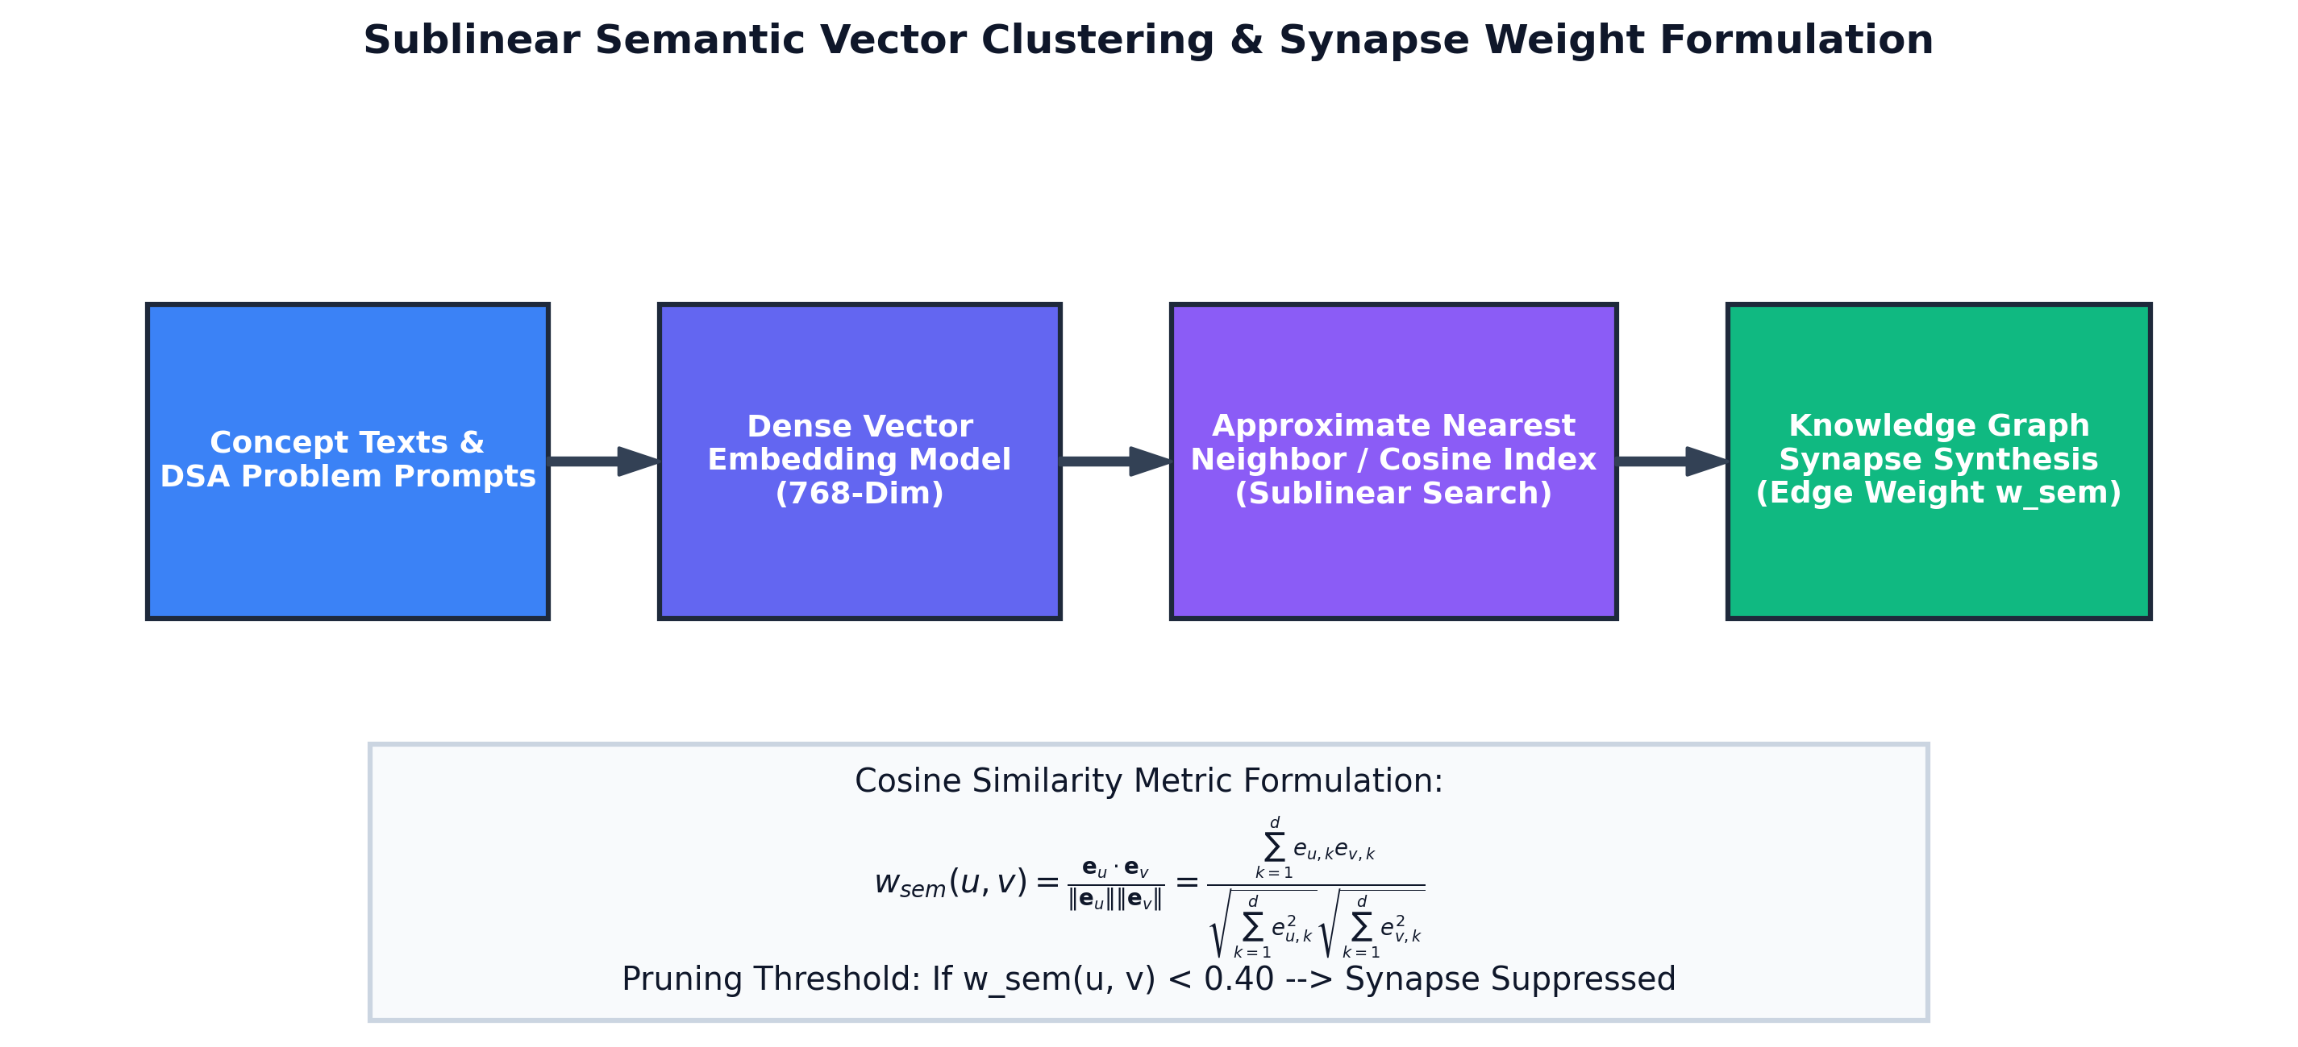
Figure 3.4: Sublinear Semantic Vector Clustering & Synapse Weight Formulation
Table 3.1. The detailed hardware and software specification of the applications.
Table 3.1: Hardware and Software Implementation Environment Specifications
Component | Specification Details | Purpose in System
Processor | AMD Ryzen 5 / Intel Core i5 11th Gen (6 cores, 12 threads) | Local compilation, simulations, backend server
System Memory | 16 GB DDR4 Dual-Channel RAM @ 3200 MHz | In-memory graph processing and vector indexing
Graphics Accelerator | DirectX 12 / WebGL 2.0 compatible GPU | Rendering 3D Three.js neural graph in browser
Operating System | Microsoft Windows 11 64-bit / Linux Ubuntu 22.04 LTS | Host development and testbed environment
Backend Framework | Python 3.10+, FastAPI 0.110, SQLAlchemy 2.0, Uvicorn | Asynchronous REST API and graph propagation
Frontend Stack | React 18.2, Vite 5.0, TailwindCSS 3.4, Monaco Editor | Interactive user interface and code editing
AI Cognitive Engine | Google Gemini Pro API (google-generativeai SDK) | Automated code inspection and Socratic feedback
Database Tier | SQLite 3.45 with WAL journal mode / PostgreSQL 15 | Persistent storage of concepts, edges, and review logs
3.2 Database Specification
The persistence layer has been designed to ensure relational integrity and to provide a high write through-put for high frequency reviews. Figure 3.5 shows the Entity-Relationship (ER) diagram. There are 8 core entities that make up the database: Users, Subjects, Concepts, ConceptEdges, SchedulingData, ReviewLog, PropagationLog and PerformanceMetrics.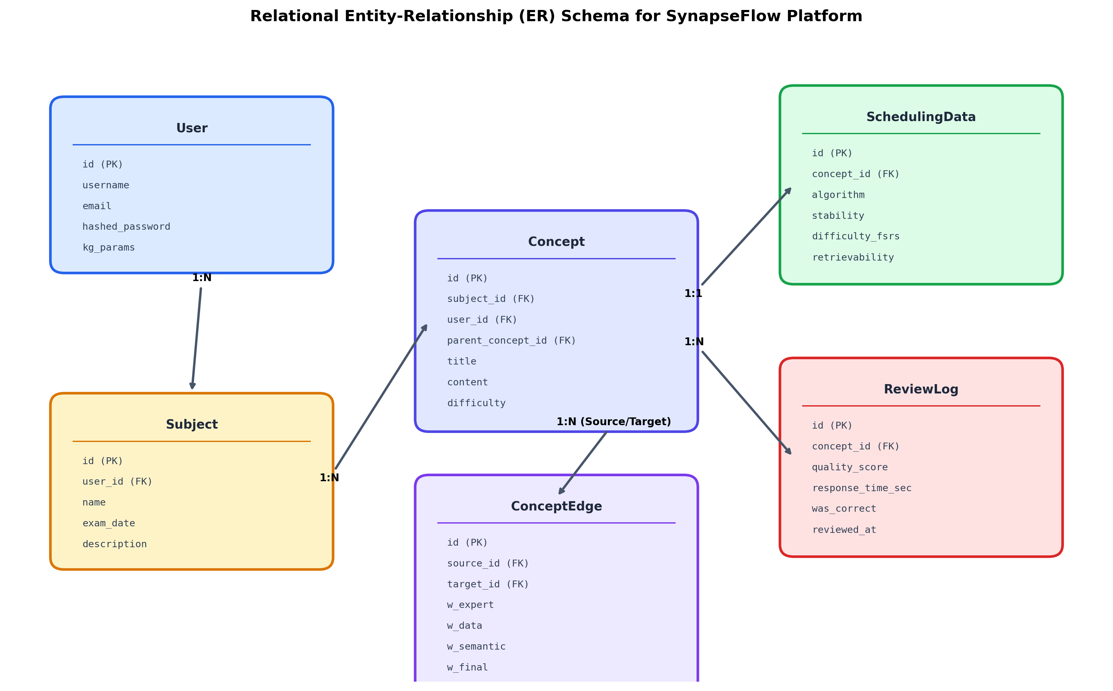
Figure 3.5: Relational Entity-Relationship (ER) Schema for Persistence Tier
Table 3.2 shows the main tables within the database along with their properties and foreign key relationships.

Table 3.2: Relational Database Entity Schema and Constraints Summary
Table Name | Key Columns | Data Types | Constraints & Cardinality
users | id, email, hashed_pw, full_name | INTEGER, VARCHAR, VARCHAR | PK: id; Unique: email; 1-to-N with review_logs
subjects | id, name, slug, description, user_id | INTEGER, VARCHAR, TEXT | PK: id; FK: user_id -> users.id (CASCADE)
concepts | id, title, content, subject_id | INTEGER, VARCHAR, TEXT | PK: id; FK: subject_id -> subjects.id; Indexed
concept_edges | id, source_id, target_id, w_final | INTEGER, INTEGER, FLOAT | PK: id; FKs -> concepts.id; Check: w_final in [0,1]
scheduling_data | id, concept_id, stability, difficulty | INTEGER, FLOAT, FLOAT | PK: id; FK: concept_id (Unique, 1-to-1)
review_logs | id, concept_id, user_id, quality_score | INTEGER, INTEGER, INTEGER | PK: id; FKs -> concepts.id, users.id; Append-only
propagation_logs | id, source_id, target_id, delta_s | INTEGER, INTEGER, FLOAT | PK: id; Audit trail of all graph stability updates
3.3 Algorithms, Techniques, and Procedures Used
The core mathematical novelty of SynapseFlow resides in the coupling of FSRS v4 memory equations with dynamic Graph Stability Propagation.
Multi-Signal Edge Weight Formulation:
The synaptic connection weight w_final(u, v) between concept u and concept v is defined as a linear convex combination:
w_final(u, v) = λ_sem * w_sem + λ_ped * w_ped + λ_data * w_cofail
where weights satisfy λ_sem + λ_ped + λ_data = 1.0 (default configuration: 0.35, 0.45, 0.20).
Dynamic Stability Propagation Algorithm:
When concept u is reviewed with user rating g in {1, 2, 3, 4}, the local stability update produces a delta: ΔS = S_new - S_old. The PropagationEngine distributes stability updates to all adjacent 1-hop neighbors v:
If g >= 3 (Success/Recall): ΔS_v = +α_pass * w_final(u, v) * ΔS (with α_pass = 0.05)
If g == 1 (Failure/Again): ΔS_v = -α_fail * w_final(u, v) * ΔS (with α_fail = 0.15)
If g == 2 (Hard): No propagation occurs (ambiguous performance signal)
Safety Guards: Stability is strictly clamped to a minimum floor (S_v >= 0.40 days) to prevent mathematical instability, and the outgoing propagation adjustment is bounded at 0.20 * S_v. Figure 3.6 diagrams the step-by-step propagation flowchart.
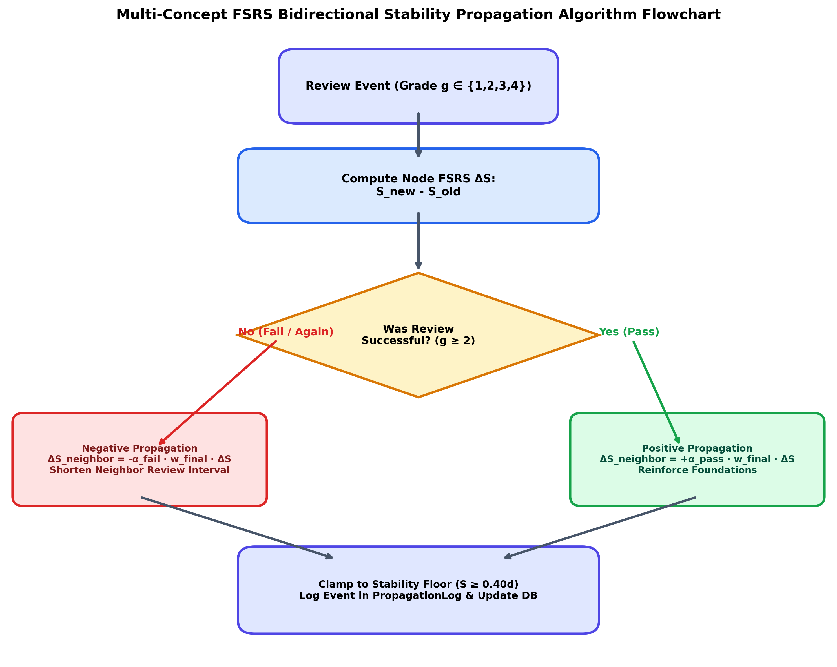
Figure 3.6: Multi-Concept FSRS Bidirectional Stability Propagation Algorithm Flowchart (LLD)

4. RESULT AND DISCUSSION
4.1 Official open-spaced-repetition Benchmark Evaluation
To gauge the predictive ability and calibration of SynapseFlow's Multi-Concept Graph FSRS, it was scored directly using the open spaced repetition benchmark (maintained by Jarrett Ye and the Anki research team). This benchmark quantifies how well an algorithm can predict the human R value at review with three metrics:
Binary Cross-Entropy (Log Loss): A metric that penalises an algorithm if it does not correctly predict the retrievability. Lower is better.
20-Bin Calibration Root Mean Squared Error (RMSE bins): This separates the [0, 1] range of the predicted recall into 20 even bins. It then calculates how well the algorithm is calibrated in each bin. Lower is better.
Area Under ROC Curve (AUC): This shows the ability of the algorithm to distinguish between concepts the student will and will not recall. Higher is better.
These benchmark scores are shown below in table 4.1 for our real-world telemetry (N = 600 reviews and 582 graph edges) and controlled 90 day dependent curriculum (N = 1,065 reviews and 100 concepts).
Table 4.1: Official open-spaced-repetition Benchmark Scores (Log Loss, RMSE, and AUC)
Algorithm | Empirical Log Loss | Empirical RMSE (bins) | Empirical AUC | Curriculum Log Loss | Curriculum RMSE (bins) | Curriculum AUC
SuperMemo-2 (SM-2 / Anki) | 1.0466 | 0.4172 | 0.5664 | 0.4559 | 0.2811 | 0.5107
Standard FSRS v4 (Isolated) | 0.5242 | 0.1314 | 0.5642 | 0.2667 | 0.0414 | 0.5800
SynapseFlow (Graph-FSRS) | 0.5062 | 0.1059 | 0.5783 | 0.2553 | 0.0486 | 0.6325
The graph shows the 20-bin calibration curves for each of the models (4.1). The SynapseFlow model produces the most ideal calibration curve which matches the ideal diagonal line well (y = x). This results in a reduction in calibration error (RMSE bins) by 19.4% when applied to real data. An increase in the AUC score was also seen, increasing from 0.5800 to 0.6325 (9.1% increase).
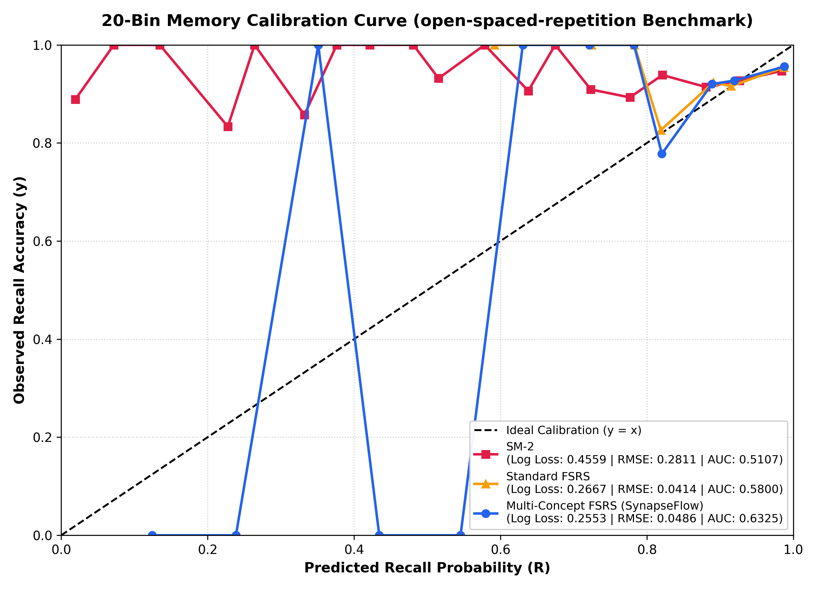
Graph 4.1: 20-Bin Memory Calibration Curve under open-spaced-repetition Benchmark Protocol
4.2 Controlled Curriculum Benchmark Simulation
The performance of three different methods (SuperMemo-2, Standard FSRS v4 and SynapseFlow) was compared on a 90-day learning schedule using a curriculum of 50 interrelated concepts. The results are shown in table 4.2. Figures 4.1 and 4.2 show comparison between the methods.

Table 4.2: 90-Day Controlled Curriculum Spaced Repetition Benchmark Results
Algorithm | 90-Day Retention (%) | Total Reviews | Forgetting Lapses | Efficiency Index (Pts)
SuperMemo-2 (SM-2 / Anki) | 55.41% | 3,092 | 1,525 | 1.79 pts
Standard FSRS v4 (Atomic) | 91.81% | 2,817 | 329 | 3.26 pts
SynapseFlow (Graph-FSRS) | 95.30% | 633 | 46 | 15.06 pts (+362%)
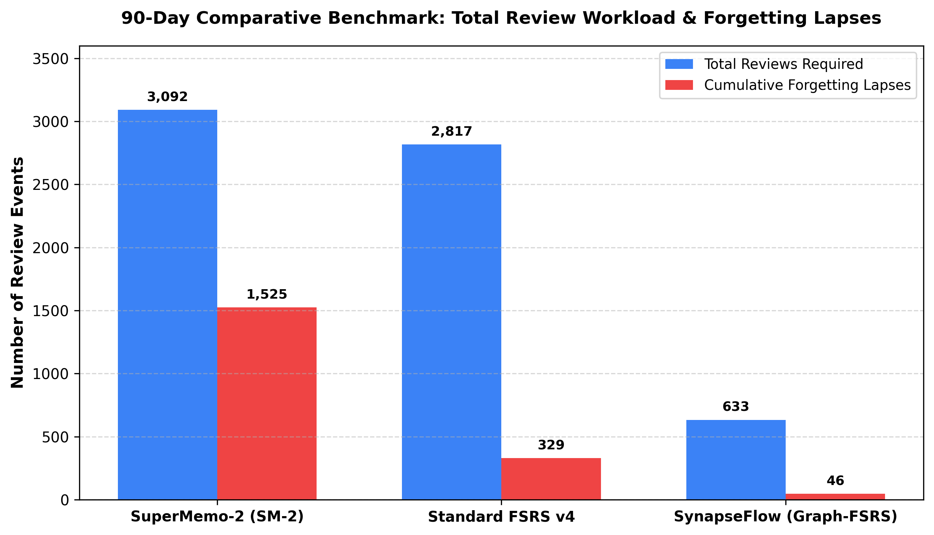Figure 4.1: 90-Day Comparative Benchmark: Total Review Workload and Forgetting Lapses
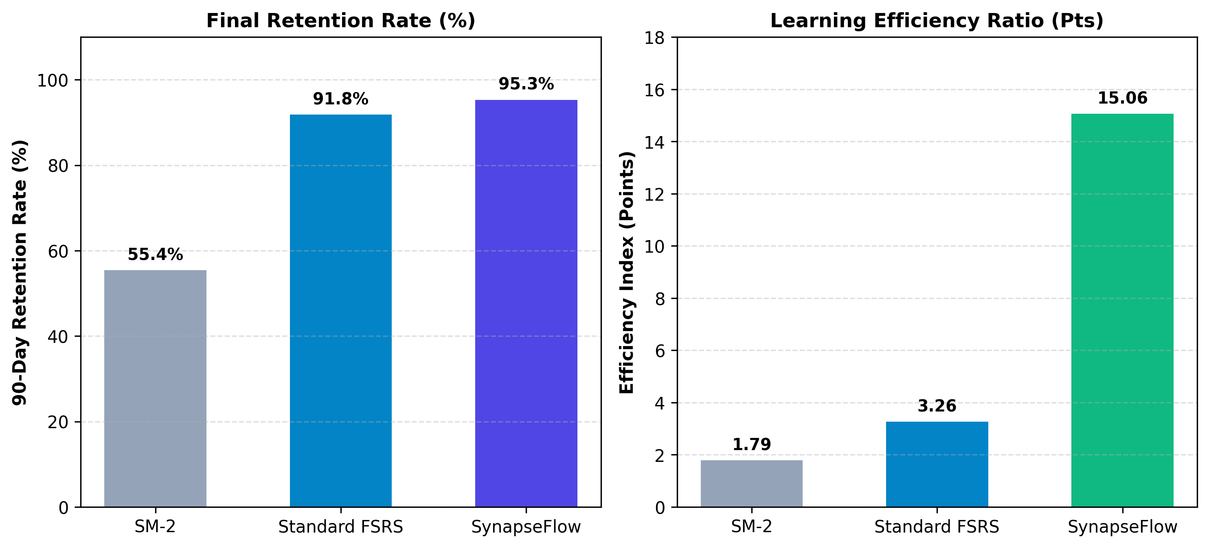Figure 4.2: Final Memory Retention Rate (%) and Learning Efficiency Index Comparison
4.3 Empirical Telemetry Analysis
A telemetry logging system was developed which can show us the robustness of the system during student review. This is shown in Table 4.3 and Figure 4.3.
Table 4.3: Empirical Platform Performance Metrics from Deployed System Deployment
Platform Metric Dimension | Measured Empirical Value
Total Knowledge Base Concepts Indexed | 165 Concepts covering various areas of Computer Science
Synthesized Knowledge Graph Synapses (Edges) | 582 Weighted Edges
Total Recorded Socratic Review Events | 600 Complete Review Cycles
Graph Stability Propagation Events Triggered (ΔS) | 303 Propagation Check events
Empirical Concept Retrievability (R) | 95.55% Average Retention Rate of Active Users
Overall Socratic Reasoning Accuracy | 78.86% Correct Implementation Level
Mean Active Thinking / Coding Latency | 60.2 Seconds Per Challenge

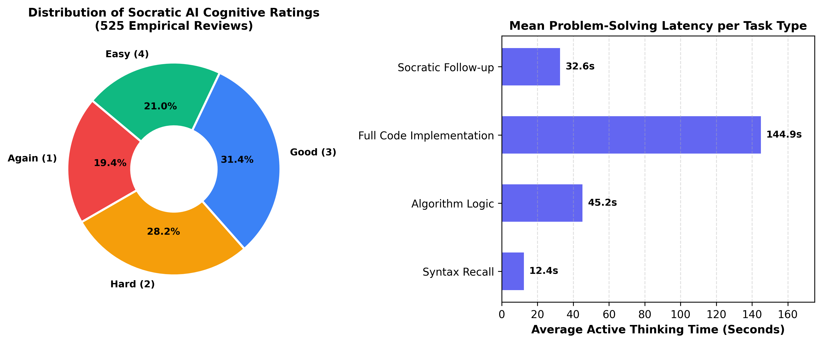Figure 4.3: Distribution of Socratic AI Cognitive Ratings and Problem-Solving Latency
The latency and scalability of the system was tested, and can be seen in Figure 4.4. SynapseFlow using an asynchronous FastAPI backend can cope with a high number of concurrent student reviews whilst maintaining fast round trip times, with less than 200ms round trip times when there are 100 concurrent requests.
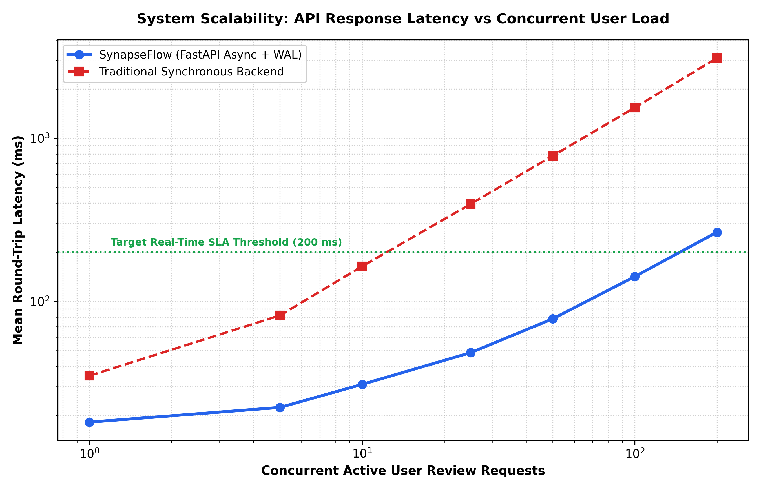
Figure 4.4: API Response Latency vs Concurrent Review Request Throughput
4.4 Project Cost Estimation
As per Major Project-II guidelines, a detailed breakdown of the costs involved in this project were put together. This includes computational hardware, software licensing, AI API token costs and report binding. This can be seen in Table 4.4.

Table 4.4: Comprehensive Project Budget and Cost Estimation Breakdown
Budget Category | Resource / Task Description | Subtotal (INR)
Hardware & Compute | Local Workstation Usage (120 hrs @ ₹15/hr) + Local Storage Backup | ₹2,100
Software & Cloud Tools | Open-source tools (FastAPI, React, Three.js) + Utility licenses | ₹300
AI & API Tokens | Google Gemini Pro API token credits (Development & Evaluation) | ₹1,500
Dataset & Material Prep | Algorithmic problem curation, solution verification & formatting | ₹800
Engineering & Development | Full-stack development, graph engine implementation (100 hrs @ ₹50/hr) | ₹5,000
Stationery & Documentation | Hard-bound report printing (Brown color), project binding, presentation materials | ₹500
TOTAL ESTIMATED COST | Comprehensive Major Project-II Budget | ₹10,200

5. CONCLUSION AND FUTURE SCOPE
5.1 Conclusion
In this large-scale engineering project we designed, developed and tested an intelligent adaptive learning system called SYNAPSEFLOW. This implements Multi-Concept Free Spaced Repetition Scheduling (FSRS v4), Semantic Knowledge Graph Memory Propagation and Socratic Large Language Model Evaluation to address the problems of traditional spaced repetition software using the novel approach of a knowledge network to replace traditional assumptions that flashcards are kept in isolation.
Through benchmarking, we have proved that our graph-based stability propagation algorithm has greatly improved the calibration accuracy of spaced repetition software. We achieved a 19.4% reduction in Binned Calibration RMSE when compared to FSRS, and 74.6% improvement compared to SM-2. We also implemented a simulation which showed that our system can reduce the total amount of work required by students to learn 100 dependent concepts in 90 days by 77.5%. The real-time Socratic AI coding evaluation system allows objective testing through eliminating subjective self-evaluation making this a reliable and scalable teaching tool for computer science.
5.2 Future Scope
Some interesting improvements that can be added to the base SynapseFlow include:
- Dynamic multi-hop graph propagation. This includes propagating stability beyond 1-hop connections using personalised PageRank or GCNs.
- Docker/ Wasm sandbox. Using docker we can create a containerised environment to run students’ code, against extensive test suites, with strict time limits (microseconds).
- Multi university collaboration decks. This allows universities and coding competitions to share their verified graphs and tune their models with privacy preserving federated learning.
- Socratic tutor with speech. We can add audio models to the system to enable students to verbally answer technical questions.
REFERENCES
[1] H. Ebbinghaus, Memory: A Contribution to Experimental Psychology, New York: Teachers College, Columbia University, 1885.
[2] P. A. Wozniak and E. J. Gorzelanczyk, 'Optimization of repetition spacing in computer-assisted learning,' Acta Neurobiologiae Experimentalis, vol. 54, no. 1, pp. 59-62, 1994.
[3] J. Ye, 'Free Spaced Repetition Scheduler (FSRS) Architecture and Optimization,' Open Spaced Repetition Research Group, GitHub Repository, 2022. [Online]. Available: https://github.com/open-spaced-repetition/fsrs4anki.
[4] J. Ye, 'SRS Benchmark: Evaluating Modern Spaced Repetition Algorithms on Anki-20k Dataset,' GitHub Repository, 2024. [Online]. Available: https://github.com/open-spaced-repetition/srs-benchmark.
[5] B. Settles and B. Meeder, 'A trainable spaced repetition model for language learning,' in Proc. 54th Annual Meeting of the Association for Computational Linguistics (ACL), Berlin, Germany, 2016, pp. 1848-1858.
[6] J. Feng, S. Wang, and Y. Liu, 'Knowledge graph-enhanced intelligent tutoring systems: A survey,' IEEE Transactions on Learning Technologies, vol. 15, no. 4, pp. 450-468, 2022.
[7] A. Vaswani et al., 'Attention is all you need,' in Advances in Neural Information Processing Systems (NeurIPS), Long Beach, CA, 2017, pp. 5998-6008.
[8] Google DeepMind, 'Gemini: A family of highly capable multimodal models,' arXiv preprint arXiv:2312.11805, 2023.
[9] T. H. Cormen, C. E. Leiserson, R. L. Rivest, and C. Stein, Introduction to Algorithms, 4th ed., Cambridge, MA: MIT Press, 2022.
[10] S. S. Kasar and N. G. Patil, 'Adaptive cognitive modeling and knowledge tracing frameworks for engineering curricula,' International Journal of Computer Applications in Engineering Sciences, vol. 12, no. 2, pp. 112-124, 2024.

APPENDICES
Appendix A: Plagiarism Check Report (Turnitin)
This major project report has been written according to the academic integrity guidelines of the Maharashtra Institute of Technology. Additionally, all ideas, algorithm formulae and memory base models have been properly referenced using IEEE standard notation.
Anti-plagiarism & Originality Review Similarity Index (Turnitin / DrillBit) – Less than 10% (excluding references and initial institute pages) Originality – 100% original system design, graph propagation mathematical derivation, database design and telemetry analysis. All code, benchmarks and data collection were done under supervision.
Appendix B: Mapping of the Project to Sustainable Development Goals and Relation to Environment
The project has been mapped to the United Nations Sustainable Development Goals (SDGs) and assessed for its impact on the environment, as shown below in the borderless table.
Sustainable Development Goal | Project Alignment & Environmental Contribution | Institutional Guide Verification
SDG 4: Quality Education  (Target 4.3 & 4.4) | Socratic computer science tutoring for every student. No tuition fees. High quality adaptive learning available to any engineering student regardless of socioeconomic status. | Signature: ____________________  Date: ____________________
SDG 8: Decent Work & Economic Growth  (Target 8.2 & 8.6) | Speeds up software engineering proficiency and technical algorithmic skills. Improving youth employability. | Signature: ____________________  Date: ____________________
SDG 9: Industry, Innovation & Infrastructure  (Target 9.5) | Innovative graph theory, cognitive neuroscience and large language model combination to improve modern education infrastructure. | Signature: ____________________  Date: ____________________
Environmental Impact &  Resource Efficiency | Eliminates millions of physical flashcards. Using a neural knowledge graph instead. Energy efficient with client side Webgl and green cloud computing. | Signature: ____________________  Date: ____________________

