**Chapter 1: Introduction**

**1INTRODUCTION**

The internet of things (IOT) concept enables us to connect the normal day to day devices with each other over the internet. The devices connected through IOT concept can be analysed remotely. The IOT concept provides the basic infrastructure and opportunities to form a con- nection between the physical world and computer-based systems. The concept has been gaining importance with more and more wireless devices that are increasing rapidly in the market. hard- ware devices are connected with each other over the internet.

Now-a-days the demand for electricity is increasing at a constant rate in the population and is being utilized for various purposes viz, agriculture, industries, household purposes, hospitals etc., So, it is becoming more and more complicated to handle the electricity maintenance and requirements. Therefore, there is an immediate requirement to save as much electricity as possible. As the demand from the newer generations of population for electricity is increasing so in along with it the technology improvement is needed. The proposed system provides a technical twist to the normal energy meters using the IOT technology. There are issues that we have to address such as penalty charges has been fined to various organizations for using electricity beyond threshold value which in turn generate economic loss to the particular organization.

* 1. **Project Motivation**

Huge amount of energy is used by big institutions such as colleges. State Electricity board has given us certain limit to use electricity. If we use electricity beyond this limit penalty charges are fined. The basic aim of our project is to reduce penalty chares of organizations that are fined by MSEB because of limitless but required use of energy. In our institute also we are facing this problem which generate economic loss to our institute. We are developing device which helps to reduce penalty charges by using concept of load balancing. The basic aim of this system to design an effective and secure technique for load balancing and also deploy this product to monitor and control the energy usage.

* 1. **Objective of the project**
     + To use electricity in amend manner.
     + To provide automated load energy readings on an instant, basis.
     + To monitor energy and managing energy according to data collected.
     + To automate labs to reduce wastage of energy.
  2. **Scope of the Project**

Energy requirement of various organizations is high. There is also wastage of energy. Such negligence may occur due to unconventional methods of monitoring electricity which daily users can’t understand. So proper monitoring is required. Also, by deploying this project we can able to reduce economic loss of organizations.

* 1. **Introduction to Project Topic**
  2. **Block Diagram and Description of the project**

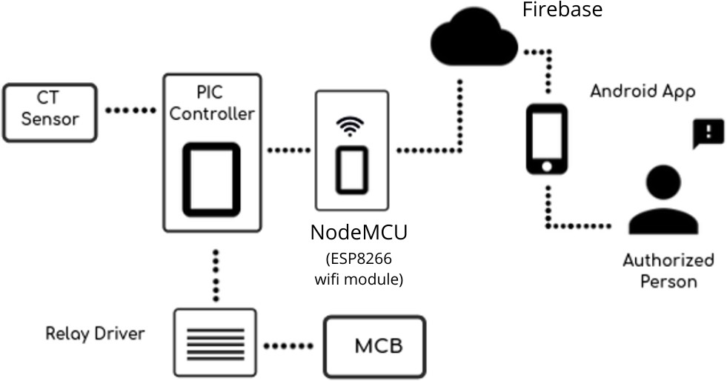

Figure 1: Block diagram for Smart energy monitoring and controlling system Figure 1 Show Block diagram for Smart energy monitoring and controlling system.

**Chapter 2: Literature Survey**

**2Literature Survey**

* 1. Survey from, *”Design and implementation of Bluetooth energy meter”, (2012)* By B. S. Koay, S. S. Cheah, Y. H. Sng, P. H. Chong, P. Shum, Y. C. Tong, X. Y. Wang, Y. X. Zuo and

H. W. Kuek

In above reference entity they described current electronics energy measurement is continu- ously replacing electro-mechanical meters especially in India and China. By the survey we come to know in year 2004, in a Singapore replacement of electro machinal meter by digital meter starts. A wireless digital energy meter would definitely more efficient and convenient to the meter reading task. Bluetooth technology is considered as communication technology in above system. And further they implement it. By using this system user collect data of energy over the Bluetooth network wirelessly.

* 1. Survey from *“IoT Based Energy Meter Reading, Theft Detection and Disconnection using PLC modem and Power optimization”, (Vol. 4, Issue 7, July 2015).*

By “Darshan Iyer N, Dr. KA Radhakrishna Rao M Tech. student, Dept. of ECE, PES College of Engineering, Mandya, Karnataka, India” This paper describes the system consist of PIC18F46k22 Microcontroller. System is design and implementation of smart energy meter using IoT concept. The proposed Energy meter system reduces or nearly eliminates the human involvement in Electricity maintenance. It is also beneficial in term of pay of electricity bill because of central server is there. The user can monitor and controlled energy consumption in units from a web interface by providing IP address of devices. This system also for Theft detection of energy meter and its’ tampering. It is mainly focussing of electricity unit consumes and send theft detect information by using PLC modem. System send alter to user by displaying on the terminal window of the company side. System is based on IoT and usages Wi-Fi unit basically for networking they use ip address so it is giving assurance of security.

* 1. Birendra Kumar Sahani 1, Tejashree Ravi 2, Aqib Javed Tamboli 3, Ranjeet Pisal 4 They published International Research Journal of Engineering and Technology (IRJET) on April 4 2017.

In this paper the idea of smart energy meter using IoT and Arduino have been introduced.

* 1. Gobinath. S, Gunasundari. N and Gowthami. P Worked on *“Internet of Things (IOT) Based Energy Meter”*.PIC-16F877A Microcontroller calculating cost and displayed in LCD and serial communication has been used to interface with the virtual terminal.

**Chapter 3: Introduction to Project domain**

**3Introduction to Internet of Things(IoT)**

The market for Internet application growth is very high today.The IoT is a big technology that enables us to create a range of useful internet applications.Basically, IoT is a network in which all physical objects are linked to the internet through network devices or routers and exchange data.IoT enables artifacts to be remotely operated through existing network infrastructure.IoT is a very effective and insightful strategy that eliminates both human effort and convenient access to physical devices.In addition, this technique has an autonomous management function whereby no human contact will be controlled by any system.

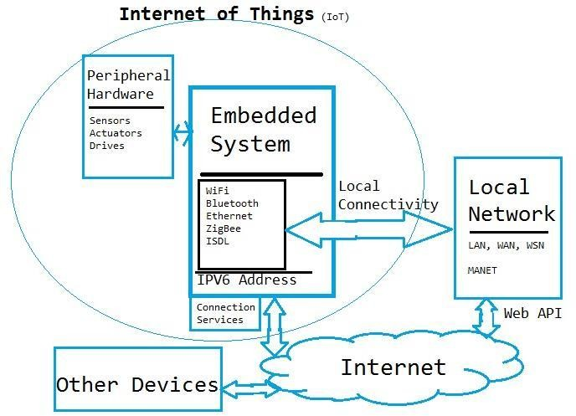

Figure 2: Internet Of thing basic structure Figure 2 Show Internet Of thing basic structure.

The higher than the figure demonstrates the properties of the different web-based tools

and the sharing of information between them.Higher than the number, therefore, is the property of the planet across various current technologies.

”Things” in the IoT context is a mixture of software, hardware, data, and services.”Stuff” will be addressed with a good style of devices such as deoxyribonucleic acid analysis tools for en- vironmental monitoring, electrical clamps in coastal waters, Arduino chips in home automation, and many others.These devices gather useful information with the aid of a variety of existing technologies and share this information between different devices.Examples include the Home

Automation Program, which uses Wi-Fi or Bluetooth to share information between various home devices.

**Features of IOT**

**Connectivity:** Connectivity refers to the determination of the appropriate relation be- tween all IoT and IoT network objects that should be server or cloud.When connecting IoT devices, high-speed electronic communication between devices and the cloud is required to en- able efficient, secure and bi-directional communication.

**Analysing:** After connecting all the relevant items, it takes a period of time to evaluate the information gathered and use it to make business intelligence efficient.When we have an honest view into the information gathered from these issues, then we prefer to agree whether our program features a good system.

**Integrating:** To boost the user experience as well as the IoT incorporated into the dif- ferent models.

**Artificial Intelligence:** IoT makes things sensible and enhances life through the use of technology.For example, if we have a low machine whose beans are meant to be finished, then the low machine itself orders the low beans of your alternative from the supplier.

**Sensing:** Detector devices used in IoT technology notification and live any change within the context of the system and report on their status.IoT technology transforms passive networks into active networks.

**Active Engagement:** The connected technology is created by IOT, or services for active communication with each other.

* 1. **Use of cloud platform and programming languages in Internet of Things**
     1. **Useful programming languages in Internet of Things**

The Internet of Things is today one of the most famous fields in technology.Innovations in this area are too easy to keep up, because more and more devices are being connected to the Internet every single hour.We know that these machines communicate and transfer data to and from other computers over the Internet, but how do they operate internally?How and in what language are these tools configured to work just as they should be?IoT apps should not use any obscure languages that we have never heard of.Usually, they use common languages to function, since they typically use micro-computers such as Raspberry PI. The use of general-purpose programming languages allows more developers to get their hands on IoT science.The survey conducted by the Eclipse Foundation found Java, C, JavaScript, and Python to be the top four programming languages used by IoT-based applications.

**C language**

One of the most important programming languages in the IoT system is the C.This can be a really cheap layer of computer code on the bottom of the hardware.C has been the inspiration of a variety of different languages writing commitments over the year.This makes the knowledge important for everyone inside the IoT to come.The reasoning behind this may be that there is no need for loads of process control.C is on the market for almost any advanced embedded device platform.C is procedural instead of object-oriented since it has no fundamental capabilities.This programming language is compiled to make it easy for IoT to come in.

**Java language**

Java, ever so popular in the programming community because of its ”write once and run ev- erywhere” feature.It’s the same feature that makes Java a great language for IoT projects.Surveys from Eclipse and embedded-computing.com state that Java is the most popular language of IoT developers.Once a Java program is written, it can be run on any system that supports Java Virtual Machine, such as smartphones, desktops and even very small devices.The introduction of the Java ME or the micro edition has boosted the number of developers.The main focus of Java IoT developers as of today is the Java SE Embedded, which is very close to the standard edition.

**Features of JAVA**

**Object Oriented:** Java can be easily extended because it is based on an object model.Almost everything in Java is an object.

**Platform Independent:** Unlike several different programming languages as well as C and C++, once Java is compiled, it is not compiled into a platform-specific machine, but rather into a platform-independent computer memory unit code.This computer memory unit code is distributed online and taken from the Virtual Machine (JVM) on any platform on which it is running.

**Simple:** Java is meant to be easy to find out.If you’re aware of the essential idea of OOP Java, it might be easy to master.

**Secure:** Java’s secure feature enables the development of virus-free, tamper-free sys- tems.Authentication techniques Quadratic measure supported public-key secret writing.

**Architecture-neutral:** Java compiler generates an AN architecture-neutral object file format, which makes the compiled code workable on multiple processors, with the presence of a Java runtime system.

**Portable:** Being architecture-neutral and having no implementation-dependent aspects of the specification makes Java moveable. The Java compiler is written in ANSI C with a clean movability boundary, which may be a POSIX set.

**Robust:** Java makes a trial to eliminate error by accentuating on compile time error checks and runtime checks in the main.

**Javascript:** In 1995, JavaScript emerged as a site-forming artificial language. Brendan

Eich developed JavaScript with syntax like C, but no one believed that JavaScript would play a serious role in the development of economic software. JavaScript was created by ECMA Inter- national in 1997.

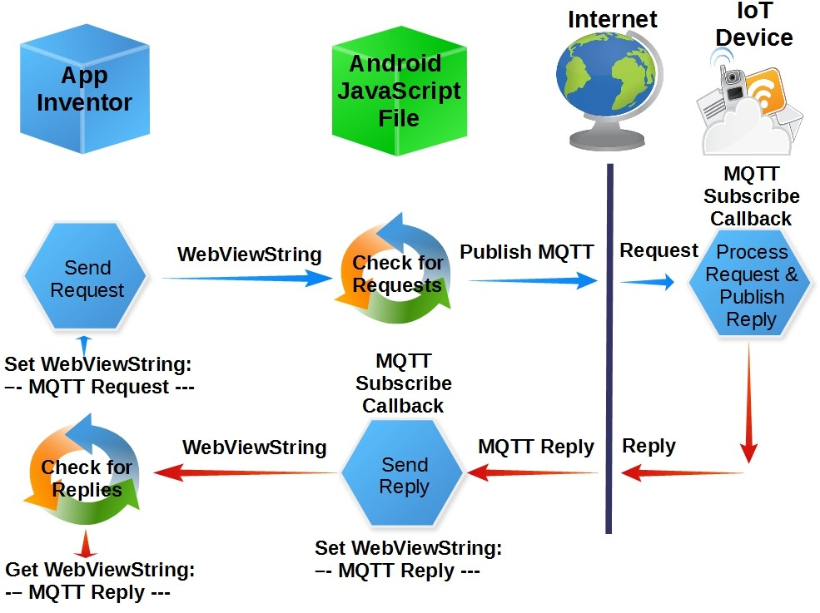

Figure 3: Javascipt for android application Figure 3 Show Javascipt for android application.

* + - * Formation of the Standard Object Notation of JavaScript (JSON).

Introduction of Node.js in 2009 by Ryan Dahl. Node.js played a crucial role in building JavaScript web servers using Google’s super-fast JavaScript V8 engine. JavaScript is now widely used in mobile apps, web pages, web servers, and IoT systems.

*•*

* + 1. **Cloud Platform**

The Internet of Things is starting to rework the daily tasks of square measure completed. The network of objects (IoT) consists of everyday objects – physical devices, vehicles, buildings, etc. with built-in physical science, software, sensors, and network assets, allowing them to gather, send and receive knowledge.The IoT generates an enormous amount of massive knowledge, and this successively places an enormous strain on the net infrastructure. As a result, this forces

corporations to seek solutions to minimize pressure and resolve their downside to transferring massive amounts of knowledge.

Cloud computing has introduced the idea of data technology, providing quantifiability in the delivery of enterprise applications and as a Service (SaaS) package. Corp. square measures are currently migrating their data operations to the cloud. Several cloud providers will leave your knowledge to be transferred either through your ancient network association or through a fervent direct link.The advantage of a direct link to the cloud can make sure that your knowledge is undisputed that the traffic does not cross the net and therefore the quality of service is often controlled.

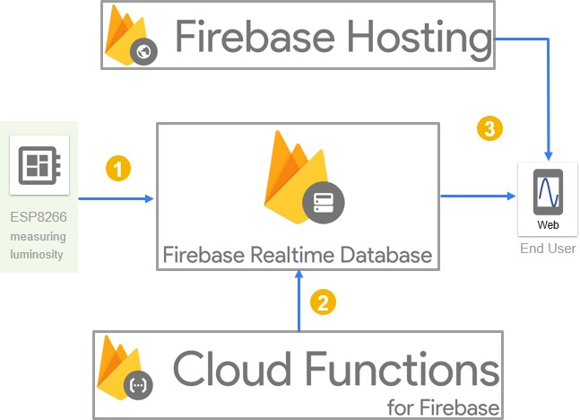

Figure 4: Simple Cloud platform Figure 4 Show Simple Cloud platform.

* 1. **C , C++ and JAVA Language**

Most IoT projects require the use of a microcontroller or a computer device. You need to program this device / microcontroller to achieve the goal / output of your project by performing certain tasks.Now almost all microcontrollers or other computer devices available on the market support C-language programming either exclusively or with support for other languages such as python. Another option to program the device is to use assembly language, but it’s going to

be a very time-consuming task.In a way, C programming unifies all controllers and computing devices on the market. That means, if you know C programming, you can program almost any microcontroller easily.

In recent times, the Internet of Things has become omnipresent and is currently a preferred domain within the developer community. According to Statista’s analysis, half a dozen.21 million IoT developers and five.36 million IoT developers are expected to add IoT in the next half-dozen months.If you want to urge IoT to start and are curious that the artificial language will begin, here may be a list of eleven common programming languages used in IoT. C, the language that was originally developed for the programming of telephone switches, may be a reliable and cheap alternative for the development of embedded systems. It’s spectacular because of its proximity to machine language.

It is a language of procedure and the code is compiled and not taken. The code written in C is very reliable and ascending, and processor independence makes it a strong rival to IoT development. As a result of C not being a freelance platform, it allows IoT developers to reprocess code that can run on most systems.With the help of pointers, accessing and modifying addresses in C is straightforward.

C++ can be an inferior artificial language with imperative, object-oriented, and generic programming options with low-level memory manipulation.

C++ is designed with a bias towards system programming, embedded programming, resource- restricted devices, and large systems. The highlights of C++ are:

* Performance
* Efficiency
* Flexibility of use

C++ may be a common alternative to the secret writing of embedded developers for Linux systems. There are many options that make C++ the preferred alternative among IoT develop- ers:

* Data activity
* Stronger typing / checking
* Multi-peripheral transparency victimization categories
* Templates (as if used continuously)
* Initialization lists

Java is an associated object-oriented language, and there are only a few hardware dependen- cies in the compiler that make it unmovable.Security is the main concern in IoT; with Generic Affiliation Framework 8 (GCF 8), Java’s Access Purpose API provides the latest security stan- dards and also the highest level of networked coding and authentication that ensures privacy. All the Java item references are implicit pointers that can not be manipulated by the applica- tion code.This mechanically excludes the potential risk of operational infringements which may inevitably cause the associated application to prevent all of a sudden. In addition, connectivity at the applicable level of the IoT system is simply handled in Java with a comprehensive set of Apes genes, each of which is customary and freely available through open supply.

* 1. **How IoT works?**

The IoT system consists of web-enabled sensitive devices that use embedded processors, sen- sors and communication hardware to gather, send and act on the information they receive from their environments.IoT devices share the sensing element information they collect by connecting to an associated IoT entryway or a different edge device wherever information is either sent to the cloud to be analyzed or analyzed regionally. Sometimes, these devices communicate with a variety of connected devices and act on the data they get from each other.Devices do most of the work while not human intervention, although people move with devices — for example, line them up, provide directions to them, or access information.

Property, networking and communication protocols used with these web-enabled devices depend, for the most part, on the particular IoT applications deployed.

**Benefits of IoT**

The Internet of Things offers a variety of benefits to organizations, sanctioning them:

* monitoring their business processes;
* improving customer experience;
* saving time and money;
* improving worker productivity;
* combining and adapting business models;
* making higher business decisions; and
* generating a lot of revenue.

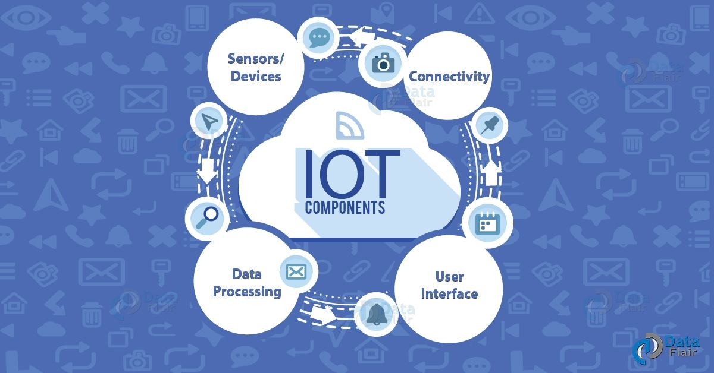

Figure 5: IoT Basic sections Figure 5 Show IoT Basic sections.

* 1. **Introduction to Arduino IDE**

Arduino IDE is an associate degree open-source software package that is primarily used for writing and assembling code into the Arduino module.

*•*

It is a political candidate Arduino software package, creating code compilation too simple that even a typical person with no previous technical data will get their feet wet with the educational method.

*•*

It is well accessible for operative systems like waterproof, Windows, UNIX system and runs on the Java Platform that comes with built-in functions and commands that play a significant role for debugging, piece of writing and assembling the code within the setting.

*•*

A vary of Arduino modules accessible as well as Arduino Uno, Arduino Mega, Arduino carver, Arduino small and plenty of additional.

*•*

Each of them contains a microcontroller on the board that’s really programmed and accepts the data within the variety of code.

*•*

The main code, conjointly called a sketch, created on the IDE platform can ultimately generate a Hex File that is then transferred and uploaded within the controller on the board.

*•*

The IDE setting primarily contains 2 basic parts: Editor and Compiler wherever former is employed for writing the desired code and later is employed for assembling and uploading the code into the given Arduino Module.

*•*

* This setting supports each C and C++ languages.

The IDE environment is mainly distributed into three sections 1.Menu Bar

2.Text Editor 3.Output Pane

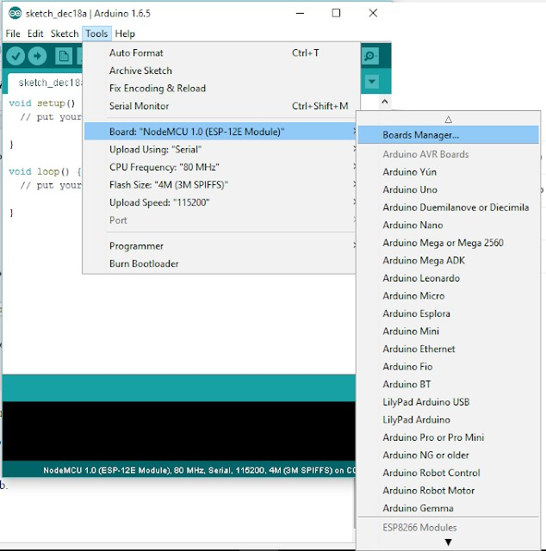

Figure 6: Arduino IDE Editior Figure 6 Show Arduino IDE Editior.

* + 1. **Features of Arduino IDE**
       - Sketchbook;
       - Sketches Management;
       - Sketch Editing Tools;
       - Libraries;
       - Serial Monitor;
       - User Preferences;
       - Project Documentation;
       - Sketches Sharing;
    2. **Adavantages of Arduino IDE**

**Multi-Platform Application**

Arduino IDE works on three preferred operating systems: Windows, Mac OS and Linux. In addition, the appliance is also accessible from the cloud. These choices offer programmers

the choice of making and saving their sketches on the cloud or constructing their programs domestically and transferring them to the board.

**Board Management**

Arduino IDE comes with a board management module, wherever users choose the board they need to work with instantly. If they want to change it, they’re just going to do it from the drop-down menu. Modifying their choice together mechanically updates the PORT info with the information they have on the relevance of the new board.

**Straightforward Sketching**

With Arduino IDE, users will produce programs known as sketches of a text editor- designed area unit. The method may be an easy one, even though it’s a lot of bells and whistles that create a lot of interactive expertise.

**Project Documentation**

Arduino IDE offers programmers the choice to document their comings. This enables them to keep track of their advancements and any changes they make every time they do so. With the exception of this, the documentation allows others to simply use the sketches on their own boards.

**Simple Sketch Sharing**

Apart from saving and archiving sketches and uploading them to the board, Arduino IDE is also capable of sharing sketches (only available in the cloud version). Each sketch has its own distinctive universal resource locator that users will share with their colleagues and fellow Arduino hobbyists.The recipient will then have access to the code; they will either set it aside in the cloud sketch pad or transfer it for their own use.

**Vast Library**

Arduino IDE has over 700 built-in libraries. These have been written and shared by members of the Arduino community who will be used by different users for their own purposes while not having to put in anything. This allows programmers to have a special dimension to their sketches.

**Third-Party Hardware Support**

While Arduino IDE is intended specifically for Arduino boards, it jointly supports third- party hardware connections. This makes the use of the appliance much more in-depth than restricted to proprietary boards.

* 1. **Compilation and Simulation of controller Code**

Step 1- style

When it comes to making Associate Arduino Project your project’s overall style is in- credibly necessary. From the moment you start selecting the parts for your project, you want to have a transparent plan of your conclusion in mind.

For example, if you want to style a sketch that runs on the Arduino Associate Board and illuminates LEDs, you want to supply the foundation with the planning part of your project at intervals. However, the style of your sketches and circuits can confirm the final appearance of your project.

Step 2- Build

When it comes to building your project, this is often where you really give life to your circuit. The ’build process’ is where the Arduino IDE compiles your C++ sketch into a machine language that is then uploaded directly to your Arduino board.

Step 3- using external software Debugging tools

If you check your code manually and still can’t see the matter, it’s time to use a sophisti- cated debugging tool. Whereas several IDEs have their own debugging tool on board, Arduino doesn’t. However, there is a range of external tools that you will be able to use to create positive that your code is running correctly.This area includes a number of the most effective tools to think about if you want advanced debugging and simulation options:

**Visual Micro**

Visual small could be a plugin out there via Microsoft Visual Studio that is used to producing cross-platform programs on Arduino. Any code created in Visual small that adheres to Arduino is accepted. Visual small is nice for Arduino debugging cooperative groups because it allows shared code and library writing. Code is often created across completely different platforms and combined with program code throughout the build method. Visual small jointly offers GDB debugging and Serial, Bluetooth and WiFi debugging.

**Atmel studio**

Atmel Studio IDE could be a free computer code that provides competitive debugging facilities to help solve code errors. A project is often developed, compiled and uploaded to the relevant microchip through Atmel Studio.Like Arduino IDE, Atmel Studio’s IDE uses an equivalent code, which means that you simply don’t have to be forced to learn a brand new programming language to use. Atmel is extremely versatile for the open-source community and supports.ino sketches and C++ supply codes. Atmel Studio jointly provides superb debugging capabilities for DebugWire or JTAG victimization.

**DebugWIRE**

DebugWire could be the Atmel protocol to correct several ATTiny (e.g. ATTiny 13, 85) and ATmegas (e.g. ATmega48/88/168/328) while not JTAG, only via the Reset pin. The De- bugWire protocol is not documented by Atmel, but some guys have built huge components of the protocol and are ready to build some simple debuggers.By victimization debugWIRE one has full browsing and write access to all or any memory and full management of the execution flow. Supports single-step, run-to-cursor, step-out, and computer code break directions.

Step 3- Using Arduino simulators and emulators

More tools that you will use to monitor and debugg the Arduino Emulators and Simulators Unit. Arduino simulators have made it easier than ever for specialists and hobbyists to program and take a look at their ideas until they run efficiently.Hardware simulation could be an advanced method, and while within the field of commerce there is a unit of wonderful tools for hardware debugging these tools area unit quite restricted to manufacturers and hobbyists.

**Debugging**

As mentioned above, the square simulators measure nicely for debugging Arduino, each in terms of syntax and useful errors. What makes the simulators suitable for debugging is that you simply write code and make electronic circuits to check the integrity of your code.Some simulators can give you a limited hardware library to check, while others can allow you to develop advanced virtual environments. You’re even going to use simulators today to render your project in 3D.

**Experimentation**

In terms of experimentation, square simulators and emulators measure laborious to beat. While not a machine, the user is limited to making code based on their theoretical data and has limited opportunities to make new code and new elements available (especially when errors end in broken hardware).With a machine, you will check the code in an extremely virtual setting and take a look at new ideas without any concern about the tip result.

**Chapter 4: Project Design Flow**

**4Overview**

The Internet of things (IOT) concept allows user to connect the conventional day to day devices with one another over the web. The devices connected through IOT conception are often analyzed remotely. The IOT conception provides the fundamental infrastructure and op- portunities to create a connection between the physical world and computer-based systems. The idea has been gaining importance with a lot of and a lot of wireless devices that are increasing speedily within the market. hardware devices are connected with one another over the web. The

E.S.P. 8266 Wi-Fi module utilized in the system provides the connectivity with the web within the system.

This project describes the digitization of load energy usage readings over the web. The planned system design eliminates the involvement of human in electricity maintenance. The user will monitor energy consumption in watts from a webpage by providing a channel id for the load. The Webpage utilizes the Firebase analytics to investigate the energy usage to offer a lot of elaborated description and visualization of the energy usage statistics. Wi-Fi unit per- forms IOT operation by causing energy information of the load to the webpage which might be accessed through the channel id of the device. within the projected system, user will do power management by knowing energy usage time to time. This projected system utilizes an Arduino microcontroller. The unit that is generated will be displayed on the webpage through the Wi-Fi module.

* 1. **Project Architecture**

Project architecture mainly consists of hardware setup (controller, sensor, relay, wifi module), cloud and mobile application. Hardware setup used for collecting sensor data and send it to the cloud and after that mobile application fetch that data and display in systematic format And it is able to send a signal from application to hardware over an internet.



Figure 7: System Architecture Figure 7 Show System Architecture.

* 1. **Project Building blocks**

This project mainly consists of three building block- 1.hardware 2.cloud 3. Mobile appli- cation.We interface sensor, relay and LCD with the controller. ESP module by using serial Communication Send data to the cloud over an internet. And fetch data in android application using a different library.

* + 1. **Functional Descriptions**

This project is divided into three parts namely hardware setup, cloud and mobile application. Hardware setup mainly consists of controller, WiFi module, sensor circuit, relay circuit and LCD. Controller properly interfaced with all other component of circuit. We have used current transformer for sensing current. Relay circuit with ULN 2003 relay driver IC for controlling automatic on/off devices. Communication between Wifi module and controller is established through serial communication. Code is written in NodeMCU controller for power calculation and transferring the data to cloud.

Firebase is open source cloud service where we have created channel. It generates channel ID with read and write API keys. Two fields in the channel are used for power and On/off controlling of device.

Android studio is used for application development. In that Volley, Lecho and Firebase libraries are used. Card view is used to arrange four main activities namely on/off, Readings

and About. Data is fetched in android application with the help of write and read keys.

* 1. **Project (Hw/Sw) Specification**
     1. **NodeMCU H/W**

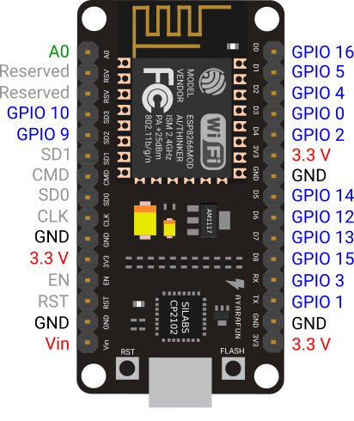

Figure 8: NodeMCU

Figure 8 NodeMCU.

NodeMCU is an open-source firmware and development kit that lets you prototype or build IoT devices. This includes the firmware that runs on the Espressif Systems ESP8266 Wi-Fi SoC and the hardware that is based on theESP-12 board. The software uses the language of the Lua script. This is based on the eLua project and is based on the Espressif Non-OS SDK for ESP8266.

The development board is fitted with an ESP-12E module containing an ESP8266 chip

with Tensilica Xtensa *Ⓧ*R 32-bit LX106 RISC microprocessor, which operates at a clock frequency

of 80 to 160 MHz and supports RTOS. There’s also 128 KB of RAM and 4 MB of Flash memory (for program and data storage) just enough to handle the big strings that make up the web pages, the JSON / XML files, and everything we’re putting on IoT devices today.

The ESP8266 incorporates 802.11b / g / n HT40 Wi-Fi transceiver so that it can not only connect to a WiFi network and communicate with the Internet, but can also set up a network of its own, allowing other devices to connect directly to it. This makes the NodeMCU ESP8266 even more powerful. Since the operating voltage range of ESP8266 is between 3V and 3.6V, the board comes with an LDO voltage regulator to keep the voltage steady at 3.3V.

Power is supplied to the ESP8266 NodeMCU via an on-board MicroB USB connector. Conversely, if you have a controlled 5V voltage source, the VIN pin can be used to supply the ESP8266 and its peripherals directly.

The ESP8266 NodeMCU has a total of 17 GPIO pins broken out to the pin headers on both sides of the development board. Such pins may be delegated to all manner of peripheral tasks.

* + 1. **Relay Module**

Relay is a switch, that opens and closes the circuit electrically. It uses fact of electromag- netism from small voltage to provide higher voltages. It has 2 basic contacts i.e. NO Normally Open and NC Normally Closed. When input voltage is applied across relays coils, Normally Closed changes to Normally Open and Normally Open changes to Normally Closed. When in- put voltage is applied, the relay is energized. Relay has several features e.g. it can be used for switching higher voltage devices to smaller voltage devices. But it must not be used in power consuming devices. It has a large number of applications. It can be utilized in home appliances, electronic circuits where there is a requirement of protection, robotics for controlling its motors from the proper motion and other more.

**Features of relay module**

* + - * Contact current 10A and 250V AC or 30V DC.
      * Each channel has indication LED.
      * Coil voltage 12V per channel.
      * Kit operating voltage 5-12 V
      * Input signal 3-5 V for each channel.
      * Three pins for normally open and closed for each channel.
    1. **Current Transformer**

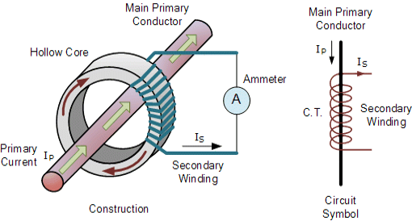

Figure 9: Current Transformer Figure 9 Current Transformer.

The Current Transformer CT is a type of “instrument transformer” which is established

to produce an alternating current in its secondary winding which is proportional to the current being measured in its primary windings. Current transformers reduce the high voltage currents

to a much lower value and provide a efficient way of safely monitoring the actual electrical cur- rent flowing in an AC transmission line using a standard current meter. The principal of working of a basic current transformer is normal different from that of an ordinary voltage transformer.

Current transformers can “step-down” current levels from thousands of amperes down to a standard output of a known ratio to either 5 Amps or 1 Amp for normal operation. So, small and accurate instruments and control devices can be used with CT’s because of this they are insulated away from any high-voltage power lines. There are a number of metering applications and uses for current transformers like with Wattmeter’s, power factor meters, watt-hour meters, protective relays, trip coils in magnetic circuit breakers and MCB’s.

**Features of Current transformer**

Test voltage For Ring (Window) type CT is 4KV 50 Hz for 1 min (except for 50/30 CTtype and 50/50 CTtype where test voltage is 3KV 50 Hz for 1 min) For Wound type CT is 3KV 50 Hz for 1 min.

*•*

* + - * Operating frequency is 50Hz / 60 Hz.
      * Rated primary rating is 1Ato 7500A.
      * Rated secondary output is 5Astandard (1Aon request)
      * Rated burden is 1, 1.25, 1.5, 2.5, 3.75, 5, 7.5, 10, 12.5, 15, 20, 30, 45, 60, 100 VA
    1. **LCD 16x2**

Liquid Crystal Display screen is an electronic display module and find a number of appli- cations. A 16x2 LCD displays are very basic module and are very commonly used in various devices and electronic circuits. These modules are chosen over seven segments and other avial- able multi segment LEDs. The reasons are LCDs are economical, easily programmable, have no limitation of displaying special and even custom characters unlike in seven segments, animations and many more. A 16x2 LCD means it is used to display 16 characters per line and there are 2 such lines available. In this LCD each character is displayed in 5x7 matrixes of pixels. This LCD has two registers that are Command and Data.

**Features of Current transformer**

* + - * Operating Voltage 4.7V to 5.3V
      * Current consumption 1mA without backlight.
      * Alphanumeric LCD display module, means can display alphabets and numbers.
      * Consists of two such rows and each row can print 16 characters
      * Each character is built by a 5 x 8 box pixel
      * It can work 8-bit and 4-bit mode
    1. **Pic Microcontroller**

PIC (usually pronounced as ”pick”) is a family of microcontrollers made by Microchip Tech- nology, derived from the PIC1650 originally developed by General Instrument’s Microelectronics Division. The name PIC initially referred to Peripheral Interface Controller, and is currently expanded as Programmable Intelligent Computer. The first parts of the family were available in 1976; by 2013 the company had shipped more than twelve billion individual parts, used in a wide variety of embedded systems.

* + 1. **PICKIT 3**

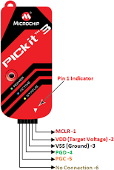

Figure 10: PICKIT 3

Figure 10 PICKIT 3.

The PICkit 3 programmer/debugger (see Figure 1-1) is a simple, low-cost in-circuit debug- ger that is controlled by a PC running MPLAB IDE (v8.20 or greater) software on a Windows R platform. The PICkit 3 programmer/debugger is an integral part of the development engineer’s toolsuite. The application usage can vary from software development to hardware integration.

*Ⓧ*

The PICkit 3 programmer/debugger is a debugger system used for hardware and software de-

velopment of Microchip PIC*Ⓧ*R microcontrollers (MCUs) and dsPIC*Ⓧ*R Digital Signal Controllers

(DSCs) that are based on In-Circuit Serial ProgrammingTM (ICSPTM) and Enhanced In-Circuit Serial Programming 2-wire serial interfaces. In addition to debugger functions, the PICkit 3 programmer/debugger system also may be used as a development programmer.

The debugger system executes code like an actual device because it uses a device with built- in emulation circuitry, instead of a special debugger chip, for emulation. All available features of a given device are accessible interactively, and can be set and modified by the MPLAB IDE interface.

* 1. **Software Specification**
     1. **Android studio**

Android Studio is the well known Integrated Development Environment (IDE) for Android application development, based on IntelliJ IDEA of development . On top of IntelliJ’s powerful code editor and developer tools, Android Studio gives even more features that increase your productivity when building Android apps.

**Features of Android Studio**

* + - * A flexible Gradle-based building system.
      * A fast as well as feature-rich emulator.
      * A unified environment where user can develop for all Android devices.
      * Instant Run to push changes to users running app without building a new APK.

Code templates as well as GitHub integration to help you build common app features and import sample coding.

*•*

* + - * Extensive testing tools or frameworks.
    1. **Arduino programming**

Arduino programs are written in the Arduino Integrated Development Environment (IDE). Arduino IDE is a special software running on your system that allows you to write sketches (synonym for program in Arduino language) for different Arduino boards. The Arduino pro- gramming language is based on a very simple hardware programming language called processing, which is similar to the C language. After the sketch is written in the Arduino IDE, it should be uploaded on the Arduino board for execution.

The first step in programming the Arduino board is downloading and installing the Arduino IDE. The open source Arduino IDE runs on Windows, Mac OS X, and Linux.

The NodeMCU is a development board featuring the popular ESP8266 WiFi chip. As it turns out, you can program the ESP8266 just like any other microcontroller. Its obvious advan- tage over the Arduino or PIC is that it can readily connect to the Internet via WiFi. However, the ESP8266 breakout board has limited pins although the chip itself has a lot of output ports. The NodeMCU solves this problem by featuring 10 GPIO pins each capable of using PWM, I2C and 1-wire interface.

### Proteus Software

The Proteus Design Suite software is a proprietary software tool suite used primarily for elec- tronic design and automation. The software is used mainly by the electronic designers engineers as well as technicians for creating schematics and electronic prints to manufacture printed circuit

boards PCB’s.

Schematic capture in the Proteus Design Suite is used for both the simulation of designs and as the design phase of a PCB layout project. It is therefore a core component and is included with all product configurations.

The PCB Layout module is automatically given connectivity information in the form of a netlist from the schematic capture module. It applies this information, together with the user specified design rules and various design automation tools, to assist with error free board design. PCB’s of up to 16 copper layers can be produced with design size limited by product configura- tion.

### MPLAB Software

The PIC microcontroller programming is performed through ‘MP-Lab’ software. First instal the MP-Lab software, then select and install the compiler like CCS, GCC compiler, etc. Here ‘CCS C compiler’ is used for building the program.

The code loading process of microcontroller is called dumping. The microcontrollers under- stand only the machine level language, which contains ‘0 or 1s’. So we need to load the hex code into the microcontroller. There are many softwares available in the market for loading the code to the microcontroller. Here we have used ‘PICFLSH’ programmer software to dump the code to the PIC microcontroller. The programmer kit comes with the hardware kit along with the software.

This software needs to be installed into the computer. The microcontroller placed in the hardware kit, which comes with the socket. Here are the steps to load the code onto the micro- controller.

The simulation is a decision analysis and support tool, which is used to know the performance of the circuit. The hardware is the cost-effective equipment, so the proposed action cannot be directly observed by the hardware. The simulation software allows you to know the circuit per- formance and find & rectify the errors of the program. There are different types of simulating softwares available in the market for checking the circuit performance. Here Proteous software is used to check the circuit performance.

Open the project in the Proteus software. Click on the ‘Debug’ menu. Select the ‘start debugging’ option. The LED starts blinking, which indicates the circuit is running. After some time, select the ‘stop debugging’ option. The LED will now stop blinking.

**Chapter 5. Project Implementation**

# 5Project Implementation

## Design methodology

By using CT sensor we are going to measure current flowing through a wire from which we can calculate the power consumption by using the formula:

Power = current(Rms) X voltage(Rms)

For that we are need to calibrate CT sensor first , after calibration of sensor it can be interfaced to the microcontroller.We need to convert analog data coming from CT sensor to Digital using ADC (Analog to Digital convertor) microcontroller.

Based upon threshold the microcontroller will priories each electric node and control them so that power consumption will not exceeds. Collected data is displayed on LCD and sent to the cloud for analysis and observation. Later we fetch data in an android application and displayed it.

For monitoring and controlling system by using android app.We are connecting android app with cloud with use of authentication token and api key of cloud.To show Power Consumption.



Figure 11: Design Methodology Figure 11 Show Design Methodology.

### Project requirement

The basic project requirements are a laptop or computer with 8 GB of RAM and an OS installed. Android mobile version 5.0(Lollipop) and above. Android Studio version 3.6 for the development of applications. Arduino IDE version 1.8.10 installed on computer. MP lab x is

installed on your computer. StarUML software for object-oriented design. USB cable A male to B male to dump the code into the pic controller. Diptrace software to be installed for pcb design.

### System Architecture

System architecture’s blocks are shown in figure below and interconnection between them.

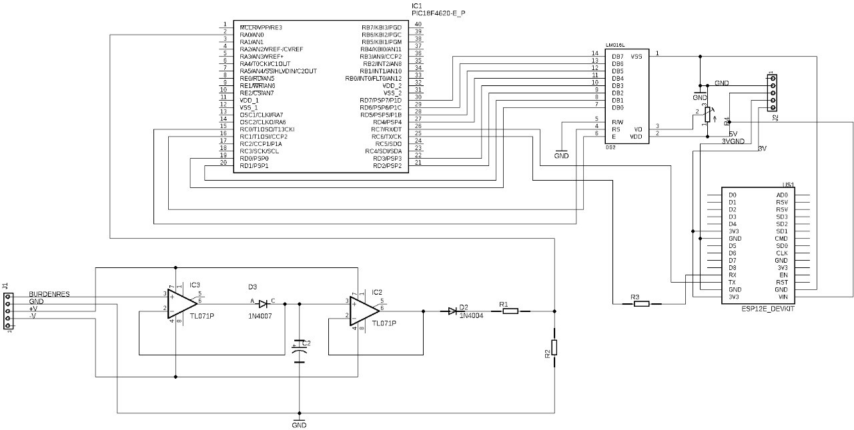

Figure 12: System Architecture Figure 12 Show System Architecture

### Selection of Controller and sensor

* + - * Pic Microcontroller
      * Current Transformer Sensor
      * 1-channel 12V relay module
      * LCD 16 X 2
      * PICKIT 3
      * NodeMCU

### Software Design

* + - * Initialize the input output pin of the pic controller.
      * Initialize SSID and NodeMCU Password.
      * Initialization of Firebase Channel Keys.
      * Initiate the LCD.
      * Sensor calibration (Sensor value= Sensor value/1.5).
      * Transmit your data to Firebase.
      * Serial communication between the NodeMCU and the controller.

### Hardware design

* + - * Interface sensor and LCD to pic controller.
      * Set up serial communication between the NodeMCU and the controller.
      * Design of the circuit of the relay driver.
      * Sensor calibration.
      * Integrating total hardware.

### Hardware and software integration

* + - * Dump the Pic code to the controller.
      * Connect Pic with NodeMCU.
      * Dump firebase connection code in NodeMCU.
      * Create your Firebase channel.
      * Using this write and read API keys date is sent to Firebase.

### Cloud connectivity and Mobile App development

* + - * Retrieve data from the Firebase app that is stored in a real-time database.
      * Use the write key and read key with the proper channel ID.
      * Create the main screen for the application with the logo on the flash screen.
      * Main activity with four options On / Off, power reading, notification, etc.
      * Represent activities in card view.
      * On/Off activity-Two buttons with high and low input API write keys.
      * Reading activity-Calculation of power for every 1 second.

## Project Flowchart

**Project flow is given in below diagram how various activity are carried out and how data is transfer among them.**



Figure 13: Project Flowchart & Serial communication Figure 13 Show Project Flowchart & Serial communication

## Design Specifications

* Use Firebase, liquicrystal, software serial libraries for Pic controller.
* Connect sensors to analog (A1) input pin of controlle.
* Connect Wifi module to Tx and Rx pin of controller.
* Connect LCD pins to digital ouput pins 1 to 5 and 11, 12.
* Digital out pin 13 to ULN IC (Relay driver).
* Use flash screen in android app.
* Card view for activity display.
* Use lecho library and graph view.
* Use volley library and Firebase library.

## Serial communication

Connection of pins from PIC controller to the NodeMCU is as shown in figure.

**Connections:**

| PIC | NodeMCU |
| --- | --- |
| VCC | CHPD |
| GND | GND |
| 3.3V | VCC |
| VCC | Reset |
| Rx | Tx |
| Tx | Rx |

Table 1: Connections

The table 1 Connections

## NodeMCU



Figure 14: NodeMCU

Figure 14 NodeMCU.

NodeMCU is an open-source firmware and development kit that lets you prototype or build IoT devices. This includes the firmware that runs on the Espressif Systems ESP8266 Wi-Fi SoC and the hardware that is based on theESP-12 board. The software uses the language of the Lua script. This is based on the eLua project and is based on the Espressif Non-OS SDK for ESP8266.

The development board is fitted with an ESP-12E module containing an ESP8266 chip

with Tensilica Xtensa *Ⓧ*R 32-bit LX106 RISC microprocessor, which operates at a clock frequency

of 80 to 160 MHz and supports RTOS. There’s also 128 KB of RAM and 4 MB of Flash memory

(for program and data storage) just enough to handle the big strings that make up the web pages, the JSON / XML files, and everything we’re putting on IoT devices today.

The ESP8266 incorporates 802.11b / g / n HT40 Wi-Fi transceiver so that it can not only connect to a WiFi network and communicate with the Internet, but can also set up a network of its own, allowing other devices to connect directly to it. This makes the NodeMCU ESP8266 even more powerful. Since the operating voltage range of ESP8266 is between 3V and 3.6V, the board comes with an LDO voltage regulator to keep the voltage steady at 3.3V.

Power is supplied to the ESP8266 NodeMCU via an on-board MicroB USB connector. Conversely, if you have a controlled 5V voltage source, the VIN pin can be used to supply the ESP8266 and its peripherals directly.

The ESP8266 NodeMCU has a total of 17 GPIO pins broken out to the pin headers on both sides of the development board. Such pins may be delegated to all manner of peripheral tasks, including:

ADC channel – A 10-bit ADC channel.

UART interface – UART interface is used to load code serially. PWM outputs – PWM pins for dimming LEDs or controlling motors.

SPI, I2C & I2S interface – SPI and I2C interface to hook up all sorts of sensors and peripherals. I2S interface – I2S interface if you want to add sound to your project.

The ESP8266 NodeMCU has two buttons. One marked as RST on the top left corner is the Reset button, used to reset the ESP8266 chip, of course. The other FLASH button in the bottom left corner is the download button used to upgrade the firmware.

**Chapter 6. RESULTS AND DISCUSSION**

# 6RESULTS AND DISCUSSION

Once we turn on the mains, the machine will start. All electrical equipment will be on and the current sinter will feel the current in analog form. We can submit it to the picture. Pic has built-in ADC (analog to digital converter). The amount of power is measured and sent to the firebase using NodeMCU. Firebase data is then obtained in the android program and seen in the cart from these readings.

## Firebase results

We create a channel in the Firebase interface and create two fields. According to the data submitted, the results are displayed in the real-time database. Like users data, calculated power & controller nodes.

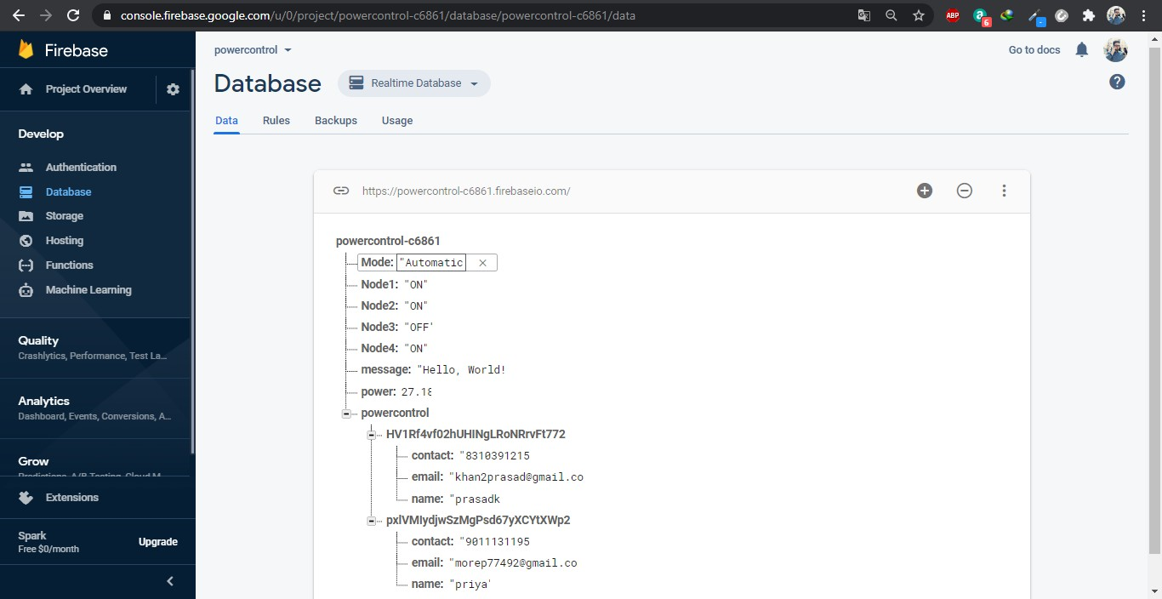

Figure 15: Firebase results Figure 15 Show Firebase results.

## Android application results

The Android application fetches the Firebase data as a read and displays it under the read tab of the Android application. We use read api key to read the data. The following statistics show all the outcomes of the android applications. And we can also controller the power usage by using controller node buttons.

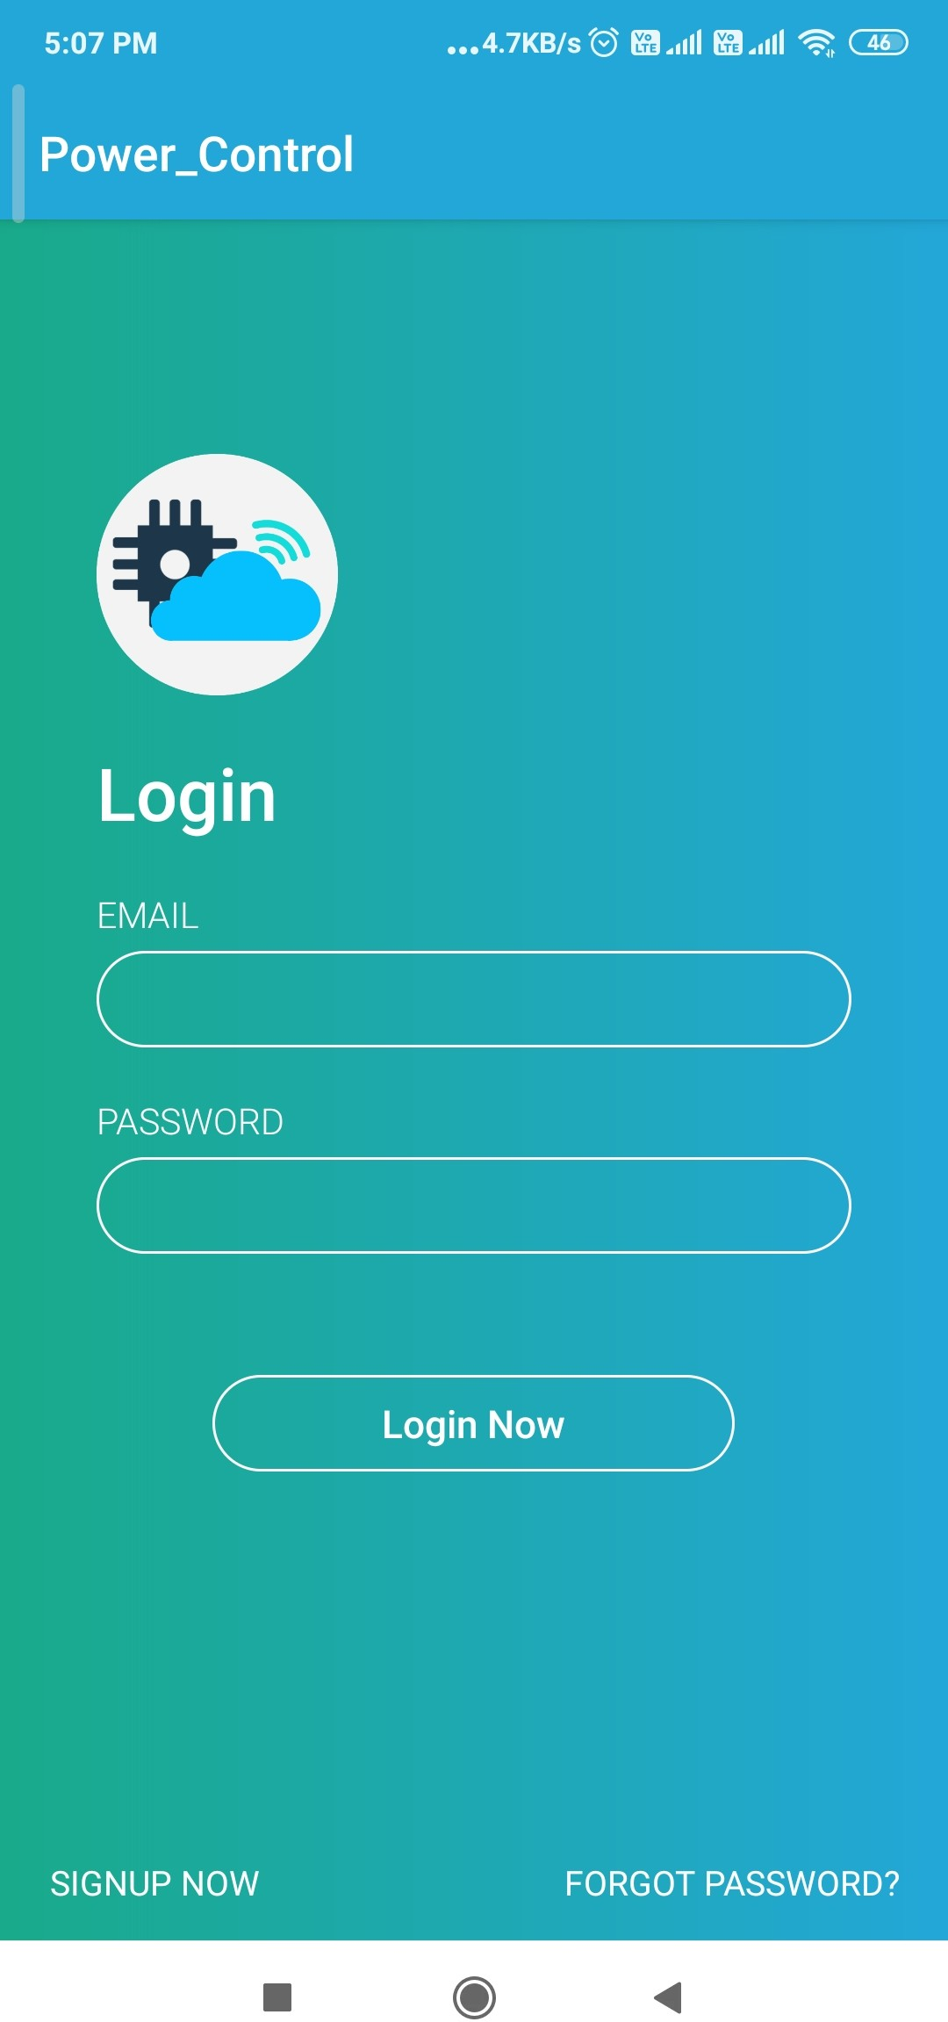

Figure 16: Login Page Figure 16 Show Login Page.

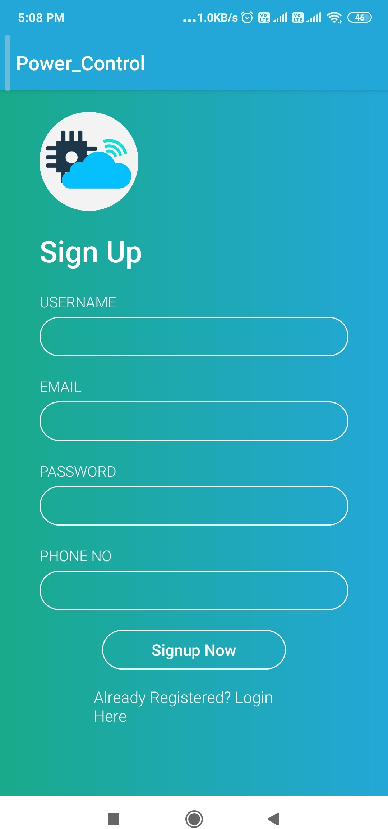

Figure 17: Sign Up Page Figure 17 Show Sign Up Page.

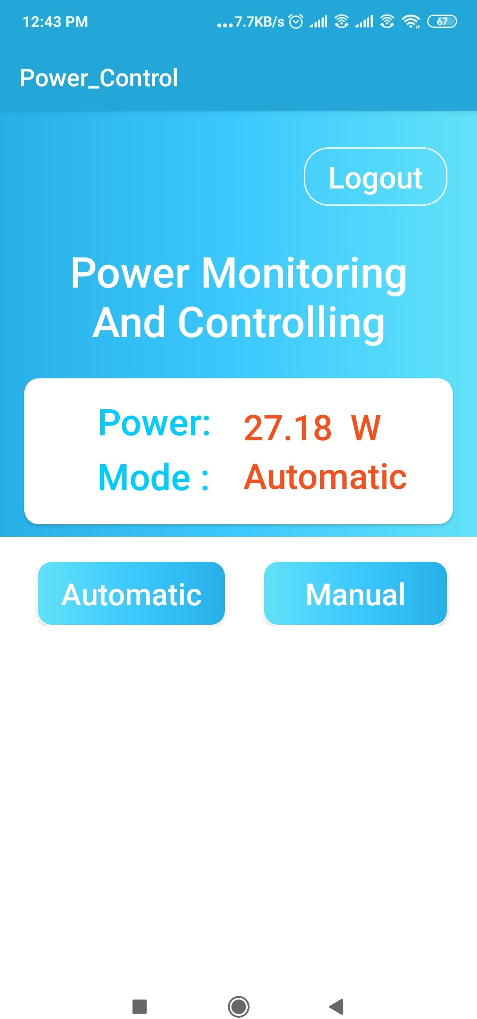

Figure 18: Automatic Mode Figure 18 Show Automatic Mode.

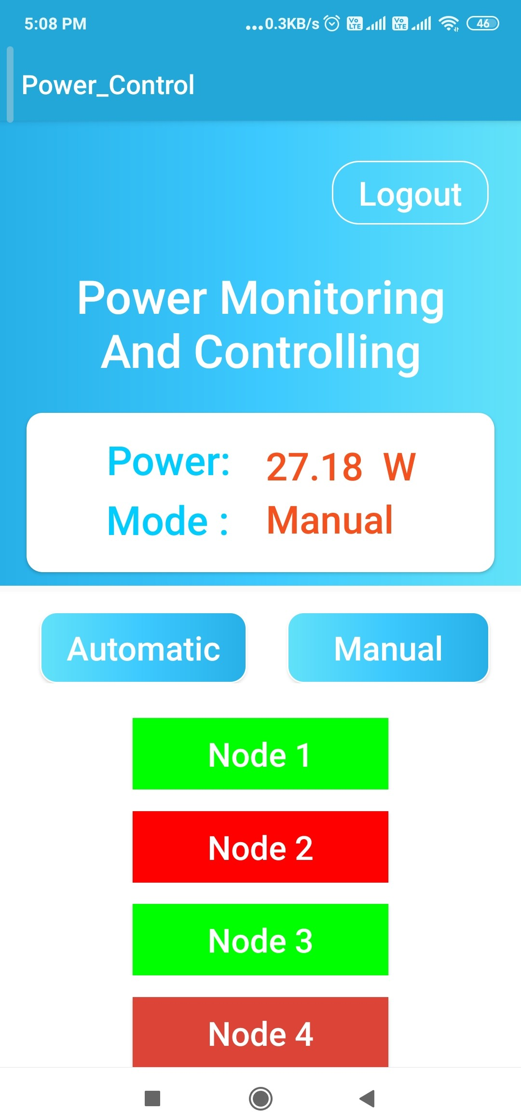

Figure 19: Manual Mode Figure 19 Show Manual Mode.

## Analysis of actual reading

**All above figures shows shows the readings for three days along with error factor.**

**Chapter 7: Conclusion & Future Scope**

# 7Conclusion and future enhancement

Smart energy monitoring and controlling system based on IoT is a contemporary application of this digital era. The developed system provide a instance power calculation along with daily power consumption report along with remote monitoring of electrical appliances and controlling it.

For current sensing we here used Current transformer compare to other devices it efficient and we can transfer data to firebase cloud using NodeMCU.

Firebase cloud provide a best UI also stores data in xsl and json format thus fetching that data in android application become easy by using various different library of android studio(IDE for mobile application development).

Present system notify user about power usage and facility of remotely on/off but future mod- ification make it much efficient and reliable.

## Future scope

* + - Efficiency can be increased using controllers like Texas/ intel gallileo boards.
    - Enhance the system by adding features like payment of bill from android application.

The graphical information regarding the energy usage could be sent to the user in a simpler format with the help of machine learning.

*•*

* + - Use machine and AI and suggest way of power consumption for a particular area.
    - The system could be available for commercial purpose for large scale.

## References

* + 1. Survey from, *”Design and implementation of Bluetooth energy meter”, (2012)* By B.

S. Koay, S. S. Cheah, Y. H. Sng, P. H. Chong, P. Shum, Y. C. Tong, X. Y. Wang, Y. X. Zuo and H. W. Kuek

In above reference entity they described current electronics energy measurement is continu- ously replacing electro-mechanical meters especially in India and China. By the survey we come to know in year 2004, in a Singapore replacement of electro machinal meter by digital meter starts. A wireless digital energy meter would definitely more efficient and convenient to the meter reading task. Bluetooth technology is considered as communication technology in above system. And further they implement it. By using this system user collect data of energy over the Bluetooth network wirelessly.

* + 1. Survey from *“IoT Based Energy Meter Reading, Theft Detection and Disconnection using PLC modem and Power optimization”, (Vol. 4, Issue 7, July 2015).*

By “Darshan Iyer N, Dr. KA Radhakrishna Rao M Tech. student, Dept. of ECE, PES College of Engineering, Mandya, Karnataka, India” This paper describes the system consist of PIC18F46k22 Microcontroller. System is design and implementation of smart energy meter using IoT concept. The proposed Energy meter system reduces or nearly eliminates the human involvement in Electricity maintenance. It is also beneficial in term of pay of electricity bill because of central server is there. The user can monitor and controlled energy consumption in units from a web interface by providing IP address of devices. This system also for Theft detection of energy meter and its’ tampering. It is mainly focussing of electricity unit consumes and send theft detect information by using PLC modem. System send alter to user by displaying on the terminal window of the company side. System is based on IoT and usages Wi-Fi unit basically for networking they use ip address so it is giving assurance of security.

* + 1. Birendra Kumar Sahani 1, Tejashree Ravi 2, Aqib Javed Tamboli 3, Ranjeet Pisal 4 They published International Research Journal of Engineering and Technology (IRJET) on April 4 2017.

In this paper the idea of smart energy meter using IoT and Arduino have been introduced.

* + 1. Gobinath. S, Gunasundari. N and Gowthami. P Worked on *“Internet of Things (IOT) Based Energy Meter”*.PIC-16F877A Microcontroller calculating cost and displayed in LCD and serial communication has been used to interface with the virtual terminal.

## Image Reference links

**Fig 3.1** Internet Of thing basic structure

[*https: // www. researchgate. net/ figure/ Classical-structure-of-IoT-system_ fig1_*](https://www.researchgate.net/figure/Classical-structure-of-IoT-system_fig1_319594914)[*319594914*](https://www.researchgate.net/figure/Classical-structure-of-IoT-system_fig1_319594914)

**Fig 3.2.1** Javascipt for android application

[*https: // internetofhomethings. com/ homethings/ ?tag= app-inventor-javascript*](https://internetofhomethings.com/homethings/?tag=app-inventor-javascript)

**Fig 3.2.2** Simple Cloud platform

[*https: // medium. com/ @o. lourme/ our-iot-journey-through-esp8266-firebase-angular-and-plot*](https://medium.com/@o.lourme/our-iot-journey-through-esp8266-firebase-angular-and-plotly-js-part-1-a07db495ac5f)

**Fig 3.4** IoT Basic sections

[*https: // data-flair. training/ blogs/ how-iot-works/*](https://data-flair.training/blogs/how-iot-works/)

**Fig 3.5** Arduino IDE Editior

[*https: // www. instructables. com/ id/ Quick-Start-to-Nodemcu-ESP8266-on-Arduino-IDE/*](https://www.instructables.com/id/Quick-Start-to-Nodemcu-ESP8266-on-Arduino-IDE/)

**Fig 3.2.1** Javascipt for android application

[*https: // internetofhomethings. com/ homethings/ ?tag= app-inventor-javascript*](https://internetofhomethings.com/homethings/?tag=app-inventor-javascript)

**Fig 3.1** Internet Of thing basic structure

[*https: // www. researchgate. net/ figure/ Classical-structure-of-IoT-system_ fig1_*](https://www.researchgate.net/figure/Classical-structure-of-IoT-system_fig1_319594914)[*319594914*](https://www.researchgate.net/figure/Classical-structure-of-IoT-system_fig1_319594914)

**Fig 3.2.1** Javascipt for android application

[*https: // internetofhomethings. com/ homethings/ ?tag= app-inventor-javascript*](https://internetofhomethings.com/homethings/?tag=app-inventor-javascript)