Deployment of Autotask ASP.NET Web API

# Overview

Autotask ASP.NET Web API wraps Autotask (AT) SOAP API. It helps developers use the Web API from any client (HTML5 web app, AngularJS web app, and so forth). It is RESTful. Using the SOAP API directly is tedious and needs wrapping code in clients like JavaScript/jQuery, web apps and desktop apps. This ASP.NET Web API fulfils this need.

# Pre-requisites

* .NET Framework 4.5.2 Please refer to <https://www.microsoft.com/en-in/download/details.aspx?id=42642>. For .NEt 4.0, please refer to <https://www.microsoft.com/en-in/download/details.aspx?id=17851>.
* IIS 8.0 and above for on-premise deployment of this API package.
* For deploying this API package on cloud hosting providers, please refer to their documentation respectively. For example, the API works fine when I host it on Amazon Web Services (AWS).
* When deploying on IIS, please use t.NET v4.0 as CLR version of the application pool under which the API will run.

# Deployment Guidelines

1. Download the API package (ZIP file which is password protected) from the link on box.com provided on my website <https://d1051qrbmd8m6z.cloudfront.net>.
2. If you have purchased the product already, you must have received the password to open the ZIP file. Extract its contents on a directory of your preference on the server you would like to deploy the API to.
3. For cloud hosting the API, please follow respective documentation. For example, you can choose Microsoft web deploy to deploy the API to AWS EC2 (<http://aws.amazon.com/ec2/>). There is a nice tutorial at <https://martinbuberl.com/blog/deploy-aspnet-mvc-on-amazon-ec2-with-web-deploy/>.
4. This step onwards, I assume that you are deploying to IIS on a Windows Server on your premise. However, please note that steps 5 and 7-11 are still needed for cloud hosting scenario. Please carry out step 5 before you host the API to cloud. For on-premise deployment to IIS, please create a new application on IIS using standard steps. Point to the directory where you extracted the package in the Physical Path field in the create a new application dialog in IIS manager.

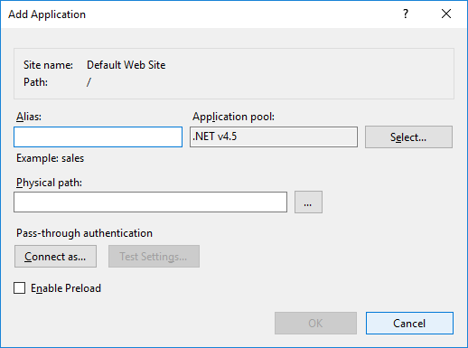

Figure Create a new application and choose the directory where you extracted the API package. Choose an application pool that has CLR version set to 4.0.

1. Update web.config as follows.

Update two keys under the appSettings tag with values as per your Autotask Account. Your account must be enabled for API access to use this ASP.NET Web API and underlying SOAP API.

<add key="APIUsername" value="" />

<add key="APIPassword" value="" />

1. Set the appropriate permissions on the application directory to application pool identity.
2. Done. Browse to the API base URL such as <http://servername/apiappname/apitest.html>.

If you see a page like the following, your deployment is successful.

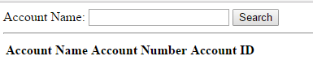

Figure API test page

1. You might want to check the Swagger spec for that API to try all or a few API endpoints. Please navigate to <http://servername/apiappname/swagger>.
2. Your Autotask API account username and password must be correct to correctly use this ASP.NET Web API.
3. In case of any questions or issues, please feel free to email me at [prasad.narwadkar@live.in](mailto:prasad.narwadkar@live.in).
4. The API has a GitHub page at <https://prasadnarwadkar.github.io/AutotaskWebAPI/>. You will find a lot of usage scenarios and other info on that page.