Alfresco Process Services (Activiti) Open-source edition Proof of concept and trial and POC on BonitaSoft (another open-source BPM tool)

Contents

1. Alfresco Activiti 3

1.1 Overview 3

1.2 Installation 3

1.3 Run Apache Tomcat 8.x or higher 4

1.3.1 Create a new Process as per the example at tutorial or run an existing process created for you by the Activiti team 5

1.3.2 Create a new process by going to Activiti app designer 6

1.3.3 An example process 6

1.4 Examples of Business Processes in healthcare 6

1.5 Basics of BPMN 2.0 7

2. BonitaSoft (another BPM tool like Activiti) 7

2.1 Getting Started Tutorial 7

2.2 Prerequisite 7

2.3 Example 7

2.3.1 Draw a BPMN diagram Process automation always starts with a process 8

2.3.2 Define a Business Data Model (BDM)-The data model describes business data handled by processes 8

2.3.3 Declare business variables -Variables are the link between business data and processes 8

2.3.4 Declare contracts -Contracts are interfaces allowing processes and UI to interact 8

2.2.5 Create forms- Forms use data to feed processes through contracts 8

2.3.6 Define who can do what- Actors allow the mapping of organization entities to human tasks 8

2.3.7 Configure an email connector- Most of the processes need email notifications, right? 8

2.3.8 Design an application page- Pages can display more generic information than tasks forms 8

2.3.9 Create an application- Bind all elements together to build a rich, valuable end-user experience 8

# Alfresco Activiti

## 1.1 Overview

Alfresco Process services has an open-source edition known as Activiti community edition. Although you can try it directly, below I have used Alfresco Process Services (Activiti) enterprise trial which is the same as the community edition. Ultimately you can use Activiti community edition (open source) for implementation in production.

## 1.2 Installation

Go to <https://www.alfresco.com/platform/process-services-bpm/trial/download>. Fill up the form and you will receive a link to the download of the exe to install Activiti enterprise (trial). This is similar to the Activiti community edition. Please use appropriate edition for production.

|  |  |  |  |  |  |  |  |  |  |  |
| --- | --- | --- | --- | --- | --- | --- | --- | --- | --- | --- |
| |  |  |  |  |  |  |  |  | | --- | --- | --- | --- | --- | --- | --- | --- | | |  |  |  |  |  |  |  | | --- | --- | --- | --- | --- | --- | --- | | **Step 1: Download the appropriate package for your OS and architecture**   |  |  |  |  | | --- | --- | --- | --- | | |  |  |  | | --- | --- | --- | | **Option 1: Installers (recommended for first install)**   Windows 64: [Download](https://na01.safelinks.protection.outlook.com/?url=https%3A%2F%2Fgo.alfresco.com%2FNDUzLUxJWi03NjIAAAGCAMlcCsXVp7OxX5pu4NEQAtczOyvQDMkX6IQvf8Bjw--yvGB-tpdf2y4hOyCpz0D2U9RYQg0%3D&data=04%7C01%7C%7Cfe74ba1f8d1f4247194f08d9d8c2df55%7C84df9e7fe9f640afb435aaaaaaaaaaaa%7C1%7C0%7C637779153751457466%7CUnknown%7CTWFpbGZsb3d8eyJWIjoiMC4wLjAwMDAiLCJQIjoiV2luMzIiLCJBTiI6Ik1haWwiLCJXVCI6Mn0%3D%7C3000&sdata=cpOKqV2adZszZU1E%2FI4bNefEchpqcdlJ%2BFJkasZqgQg%3D&reserved=0) | [Instructions](https://na01.safelinks.protection.outlook.com/?url=https%3A%2F%2Fgo.alfresco.com%2FNDUzLUxJWi03NjIAAAGCAMlcCuYF7HBu0crTAUr63GxNcl-7L1uviddc3P54x6Akc044nUMtbSqGSRn_vpfq0Zv5EKE%3D&data=04%7C01%7C%7Cfe74ba1f8d1f4247194f08d9d8c2df55%7C84df9e7fe9f640afb435aaaaaaaaaaaa%7C1%7C0%7C637779153751457466%7CUnknown%7CTWFpbGZsb3d8eyJWIjoiMC4wLjAwMDAiLCJQIjoiV2luMzIiLCJBTiI6Ik1haWwiLCJXVCI6Mn0%3D%7C3000&sdata=bHJhXVrzdj40%2B8vL8VdhqTQWfDWR%2FpF3vR%2FHfzVx0oo%3D&reserved=0)   Linux 64: [Download](https://na01.safelinks.protection.outlook.com/?url=https%3A%2F%2Fgo.alfresco.com%2FNDUzLUxJWi03NjIAAAGCAMlcChu5mNz0q7eP1zbahfBbMrrQq-vDhD41yAkzFDUZL9h8_Q6uF4vkA4Ztslt7JEBh6gE%3D&data=04%7C01%7C%7Cfe74ba1f8d1f4247194f08d9d8c2df55%7C84df9e7fe9f640afb435aaaaaaaaaaaa%7C1%7C0%7C637779153751457466%7CUnknown%7CTWFpbGZsb3d8eyJWIjoiMC4wLjAwMDAiLCJQIjoiV2luMzIiLCJBTiI6Ik1haWwiLCJXVCI6Mn0%3D%7C3000&sdata=Tt9xBoPvaqLDxLEMShlY8Fm9ZPeOiOQTgeCToOBKIYw%3D&reserved=0) | [Instructions](https://na01.safelinks.protection.outlook.com/?url=https%3A%2F%2Fgo.alfresco.com%2FNDUzLUxJWi03NjIAAAGCAMlcCgFGxbxYlhsRsdq29K4R0t6OLSmV4Szar1raOcAQndajNpLya9w-T5Uvc74Fq1VxP_k%3D&data=04%7C01%7C%7Cfe74ba1f8d1f4247194f08d9d8c2df55%7C84df9e7fe9f640afb435aaaaaaaaaaaa%7C1%7C0%7C637779153751457466%7CUnknown%7CTWFpbGZsb3d8eyJWIjoiMC4wLjAwMDAiLCJQIjoiV2luMzIiLCJBTiI6Ik1haWwiLCJXVCI6Mn0%3D%7C3000&sdata=B%2F89yvFi0Jq5CkE%2FkNMgymscFut6hJOvk3Vowe%2B4LLA%3D&reserved=0)   |  | | --- | |  |   **Option 2: .war files (requires your own web container)**  Main application ( activiti -app.war): [Download](https://na01.safelinks.protection.outlook.com/?url=https%3A%2F%2Fgo.alfresco.com%2FNDUzLUxJWi03NjIAAAGCAMlcCo-I-AobbTa_nxLYjSErzBkhZK0MNSfyyuCDVM79fWhdZOzFwR_jwIsrOHoRRQ1LsKs%3D&data=04%7C01%7C%7Cfe74ba1f8d1f4247194f08d9d8c2df55%7C84df9e7fe9f640afb435aaaaaaaaaaaa%7C1%7C0%7C637779153751457466%7CUnknown%7CTWFpbGZsb3d8eyJWIjoiMC4wLjAwMDAiLCJQIjoiV2luMzIiLCJBTiI6Ik1haWwiLCJXVCI6Mn0%3D%7C3000&sdata=F9MYEP05NPp1u5AWUOLptwjqGlqbSBGM4f7Wx7ZB9l8%3D&reserved=0) | [Instructions](https://na01.safelinks.protection.outlook.com/?url=https%3A%2F%2Fgo.alfresco.com%2FNDUzLUxJWi03NjIAAAGCAMlcC0Q5k7f8hSWA9qvnm5ufmJ9kKRPJZV_grAAonurICBbOkiPOwwaHNz-VkkC3QPh8NuQ%3D&data=04%7C01%7C%7Cfe74ba1f8d1f4247194f08d9d8c2df55%7C84df9e7fe9f640afb435aaaaaaaaaaaa%7C1%7C0%7C637779153751457466%7CUnknown%7CTWFpbGZsb3d8eyJWIjoiMC4wLjAwMDAiLCJQIjoiV2luMzIiLCJBTiI6Ik1haWwiLCJXVCI6Mn0%3D%7C3000&sdata=%2BcdoDW2jxQnpz78EWi0rIjqxq%2BU%2FNMN7%2BWQ67jlDKQI%3D&reserved=0)  Administration console ( activiti -admin.war): [Download](https://na01.safelinks.protection.outlook.com/?url=https%3A%2F%2Fgo.alfresco.com%2FNDUzLUxJWi03NjIAAAGCAMlcCnmMBopsnNDd8_1GeU5_2oIMZxMzSy1g1dlS_2GU1URwGRp94O58L2Q3CnKz51ga0ag%3D&data=04%7C01%7C%7Cfe74ba1f8d1f4247194f08d9d8c2df55%7C84df9e7fe9f640afb435aaaaaaaaaaaa%7C1%7C0%7C637779153751457466%7CUnknown%7CTWFpbGZsb3d8eyJWIjoiMC4wLjAwMDAiLCJQIjoiV2luMzIiLCJBTiI6Ik1haWwiLCJXVCI6Mn0%3D%7C3000&sdata=GL19l7rFMWtKE8TUEu%2FHlZqtRqwqEXUgqC%2BqR7QuhVg%3D&reserved=0) | [Instructions](https://na01.safelinks.protection.outlook.com/?url=https%3A%2F%2Fgo.alfresco.com%2FNDUzLUxJWi03NjIAAAGCAMlcClpSY5823fDBP_ReCH89Oc5sA16ozFEareIfDP_8ExTMCwn99GlmxfLoyUVehCFKb1s%3D&data=04%7C01%7C%7Cfe74ba1f8d1f4247194f08d9d8c2df55%7C84df9e7fe9f640afb435aaaaaaaaaaaa%7C1%7C0%7C637779153751457466%7CUnknown%7CTWFpbGZsb3d8eyJWIjoiMC4wLjAwMDAiLCJQIjoiV2luMzIiLCJBTiI6Ik1haWwiLCJXVCI6Mn0%3D%7C3000&sdata=nG2wT0RBqPjb%2BDfoYynONK80vDzUS7Ca3W%2FlxcNk%2FOc%3D&reserved=0)  **Option 3: Docker Containers**   Docker: [Instructions](https://na01.safelinks.protection.outlook.com/?url=https%3A%2F%2Fgo.alfresco.com%2FNDUzLUxJWi03NjIAAAGCAMlcCn9lrztuTQIDxMTscom_-TG-w8cGAPJUu8kuT7iEcT8Jn1zLHC1yWIz1731v3slpDTM%3D&data=04%7C01%7C%7Cfe74ba1f8d1f4247194f08d9d8c2df55%7C84df9e7fe9f640afb435aaaaaaaaaaaa%7C1%7C0%7C637779153751457466%7CUnknown%7CTWFpbGZsb3d8eyJWIjoiMC4wLjAwMDAiLCJQIjoiV2luMzIiLCJBTiI6Ik1haWwiLCJXVCI6Mn0%3D%7C3000&sdata=MnSvgUVVrULPkvtZ%2F3IDBse8NuYotVU2fYyWcqIuJE4%3D&reserved=0)   |  | | --- | |  | | |  |  | | --- | |  |  |  | | --- | |  | | |  |  | | --- | |  |  |  | | --- | |  | |

|  |  |  |  |  |  |  |  |  |
| --- | --- | --- | --- | --- | --- | --- | --- | --- |
| |  |  |  |  |  |  | | --- | --- | --- | --- | --- | --- | | |  |  |  |  |  | | --- | --- | --- | --- | --- | | |  | | --- | |  |   **Step 2: Download and install the 30-day trial license**  30-Day Trial License : [Download](https://na01.safelinks.protection.outlook.com/?url=https%3A%2F%2Fgo.alfresco.com%2FNDUzLUxJWi03NjIAAAGCAMlcCthzduTsPg9CLdvDTs7WYVPf9cp62KG0zuaUYR6IlMNzxhIM7XIVe2Ijvy5n_BhFND4%3D&data=04%7C01%7C%7Cfe74ba1f8d1f4247194f08d9d8c2df55%7C84df9e7fe9f640afb435aaaaaaaaaaaa%7C1%7C0%7C637779153751457466%7CUnknown%7CTWFpbGZsb3d8eyJWIjoiMC4wLjAwMDAiLCJQIjoiV2luMzIiLCJBTiI6Ik1haWwiLCJXVCI6Mn0%3D%7C3000&sdata=qxk%2FNbAHkvtBoMukS%2B0myXQhMj1UMNEfKny4VVdx0WM%3D&reserved=0) | [Instructions](https://na01.safelinks.protection.outlook.com/?url=https%3A%2F%2Fgo.alfresco.com%2FNDUzLUxJWi03NjIAAAGCAMlcCo-xN2gV5-vuAdkXVQgL3T4-YabH90umOeZ94qkwiRRzgOgudiUQZlLMlxIKS8ctFc0%3D&data=04%7C01%7C%7Cfe74ba1f8d1f4247194f08d9d8c2df55%7C84df9e7fe9f640afb435aaaaaaaaaaaa%7C1%7C0%7C637779153751457466%7CUnknown%7CTWFpbGZsb3d8eyJWIjoiMC4wLjAwMDAiLCJQIjoiV2luMzIiLCJBTiI6Ik1haWwiLCJXVCI6Mn0%3D%7C3000&sdata=RRWb2IE%2Bnj0I%2FGAQAYi7QE5TZbnuHDljb4Wz1Moknjs%3D&reserved=0)   |  | | --- | |  |  |  | | --- | |  |  |  | | --- | |  | | |  |  | | --- | |  |  |  | | --- | |  | |

|  |  |  |  |
| --- | --- | --- | --- |
| |  |  |  | | --- | --- | --- | | |  |  | | --- | --- | | |  | | --- | |  |   **Step 3: Get Started**  Build your first “Hello world” app in minutes with this [tutorial](https://na01.safelinks.protection.outlook.com/?url=https%3A%2F%2Fgo.alfresco.com%2FNDUzLUxJWi03NjIAAAGCAMlcClYLYfzLvTv3CLqX9iUfbBLEM79V04-iWR_YNeHBbzu8xfyOOcBUwoQdm2duoVed_Oc%3D&data=04%7C01%7C%7Cfe74ba1f8d1f4247194f08d9d8c2df55%7C84df9e7fe9f640afb435aaaaaaaaaaaa%7C1%7C0%7C637779153751457466%7CUnknown%7CTWFpbGZsb3d8eyJWIjoiMC4wLjAwMDAiLCJQIjoiV2luMzIiLCJBTiI6Ik1haWwiLCJXVCI6Mn0%3D%7C3000&sdata=Pno8WPssyL63yrA%2FBMpnimra4dki9YIZH6D%2Fotle8fc%3D&reserved=0)  Join the [Alfresco community](https://na01.safelinks.protection.outlook.com/?url=https%3A%2F%2Fgo.alfresco.com%2FNDUzLUxJWi03NjIAAAGCAMlcC_g-L_EYSQooJkUdaZKJwZg1DdaacYd38D1Mt-rGvrG9WvNVMd-0isqzsg1sX3t1Hyc%3D&data=04%7C01%7C%7Cfe74ba1f8d1f4247194f08d9d8c2df55%7C84df9e7fe9f640afb435aaaaaaaaaaaa%7C1%7C0%7C637779153751457466%7CUnknown%7CTWFpbGZsb3d8eyJWIjoiMC4wLjAwMDAiLCJQIjoiV2luMzIiLCJBTiI6Ik1haWwiLCJXVCI6Mn0%3D%7C3000&sdata=7AEHKObQWnhe9Dwter2LN%2F5feGwrLHdXutLJXelND6E%3D&reserved=0) to find answers and inspiration from other users  Explore more advanced [process examples](https://na01.safelinks.protection.outlook.com/?url=https%3A%2F%2Fgo.alfresco.com%2FNDUzLUxJWi03NjIAAAGCAMlcC61oJHJCLh3Ef1fy_Q8qSVMZoXZOJ-yWoiDNRr7IDryz6JkOvk4ZOK_Gg_ekhUcGE_0%3D&data=04%7C01%7C%7Cfe74ba1f8d1f4247194f08d9d8c2df55%7C84df9e7fe9f640afb435aaaaaaaaaaaa%7C1%7C0%7C637779153751457466%7CUnknown%7CTWFpbGZsb3d8eyJWIjoiMC4wLjAwMDAiLCJQIjoiV2luMzIiLCJBTiI6Ik1haWwiLCJXVCI6Mn0%3D%7C3000&sdata=FQur5AIwhKLuXopLE6gjN3jskt0sWYoaC9ezc8NPm0E%3D&reserved=0) | | |

## 1.3 Run Apache Tomcat 8.x or higher

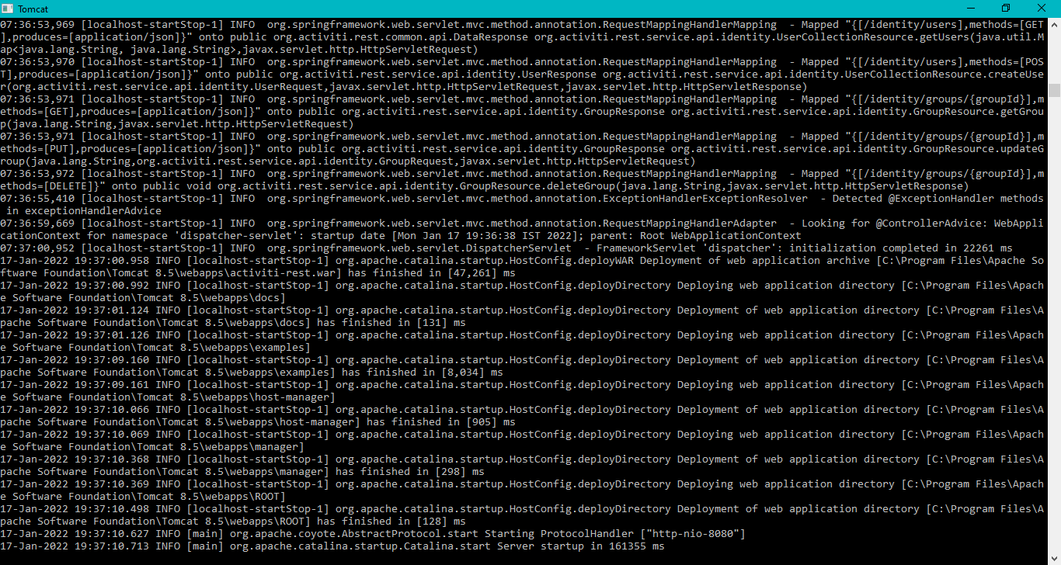

Figure Tomcat 8.x is running

Apache Tomcat is where the Activiti apps run.

The Activiti can run from two apps: 1. Activiti app 2. Activiti explorer. I chose Activiti explorer.

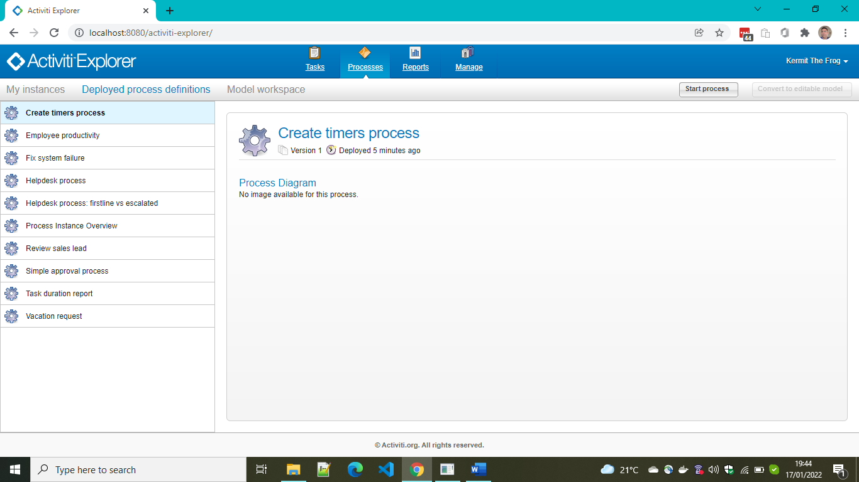

Figure Activiti explorer

### 1.3.1 Create a new Process as per the example at [tutorial](https://na01.safelinks.protection.outlook.com/?url=https%3A%2F%2Fgo.alfresco.com%2FNDUzLUxJWi03NjIAAAGCAMlcClYLYfzLvTv3CLqX9iUfbBLEM79V04-iWR_YNeHBbzu8xfyOOcBUwoQdm2duoVed_Oc%3D&data=04%7C01%7C%7Cfe74ba1f8d1f4247194f08d9d8c2df55%7C84df9e7fe9f640afb435aaaaaaaaaaaa%7C1%7C0%7C637779153751457466%7CUnknown%7CTWFpbGZsb3d8eyJWIjoiMC4wLjAwMDAiLCJQIjoiV2luMzIiLCJBTiI6Ik1haWwiLCJXVCI6Mn0%3D%7C3000&sdata=Pno8WPssyL63yrA%2FBMpnimra4dki9YIZH6D%2Fotle8fc%3D&reserved=0) or run an existing process created for you by the Activiti team

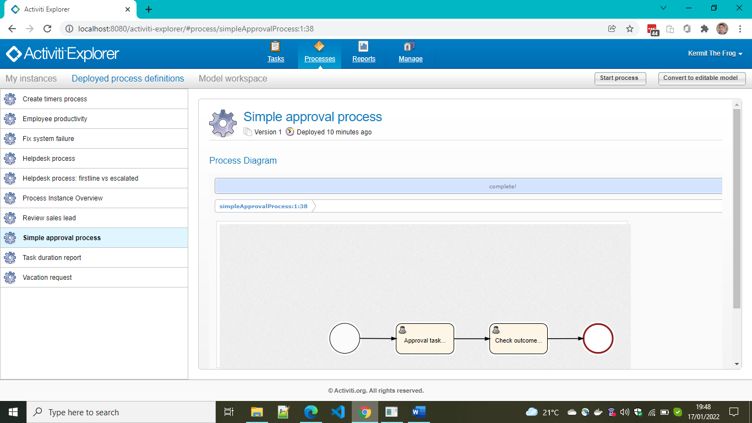

Figure Click on Start process button and you will see the flow. Complete tasks by going to Tasks tab.

### 1.3.2 Create a new process by going to Activiti app designer

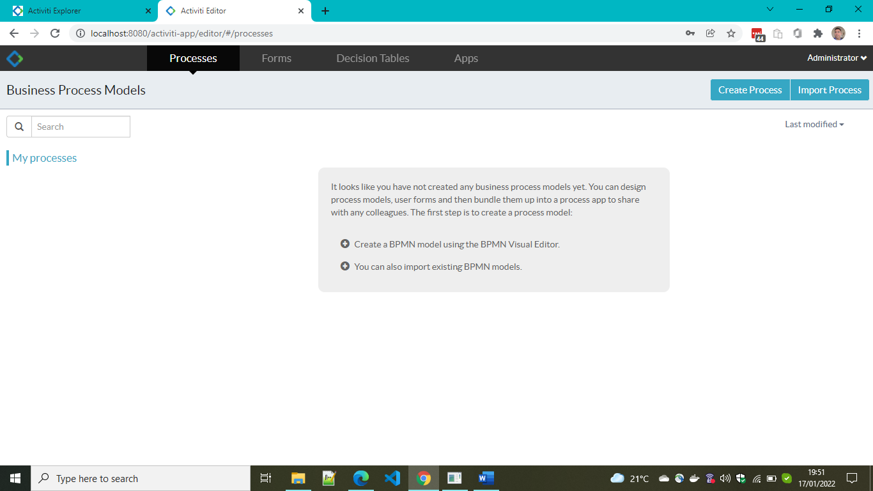

Figure Create a new process by going to Activiti app designer

Please follow the simple instructions in the link to the tutorial and complete the process creation.

### An example process

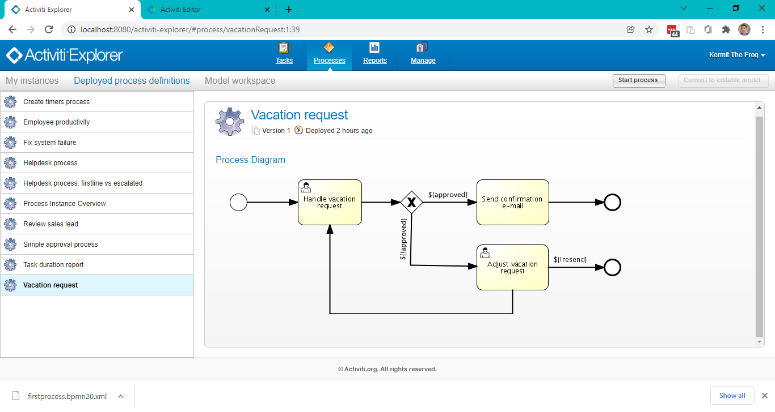

Figure Vacation Request

## Examples of Business Processes in healthcare

* Lab test approval by doctor or lab in-charge
* Appointment acceptance by a doctor
* Clinical Decision Support workflow (Yes or no to a certain drug/medicine)
* Billing decisions based on workflow and task/activity outcomes
* Etc.

## 1.5 Basics of BPMN 2.0

You will mostly use and learn about some basic BPMN elements used in most process diagrams:

* [Pool](https://documentation.bonitasoft.com/bonita/2021.2/process/pools-and-lanes): a pool is a container for a process in a diagram.
* [Lanes](https://documentation.bonitasoft.com/bonita/2021.2/process/pools-and-lanes): a lane is a division of a pool. Typically, a lane contains all the tasks assigned to one actor.
* [Start and end events](https://documentation.bonitasoft.com/bonita/2021.2/process/events): a start event is at the start of a process flow, and an end event is at the end of a flow.
* [Tasks](https://documentation.bonitasoft.com/bonita/2021.2/process/diagram-tasks): a task is a type of activity in a process.
* [Gateways](https://documentation.bonitasoft.com/bonita/2021.2/process/gateways): gateways are used to control how sequence flows interact within a process.

# BonitaSoft (another BPM tool like Activiti)

## 2.1 Getting Started Tutorial

To get started with Bonita, learn how to create your first complete living application.

In this BPM-type *Claim management* example, the application offers customized user interfaces to end-users while standardized processes run in the background, to deliver the full potential of Bonita.  
You will then be able to adapt and extend this example to fit your own needs.

|  |  |
| --- | --- |
|  | If you have any problems while working through this tutorial, you can [ask for help on the Bonita Community web site](https://community.bonitasoft.com/questions-and-answers) and/or open an issue on the Bonita [Community issue tracker](https://bonita.atlassian.net/projects/BBPMC/issues). |

## 2.2 Prerequisite

[Bonita Studio Installation](https://documentation.bonitasoft.com/bonita/2021.2/bonita-studio-download-installation) is the place to go for instruction on how to install BonitaSoft studio on your machine.

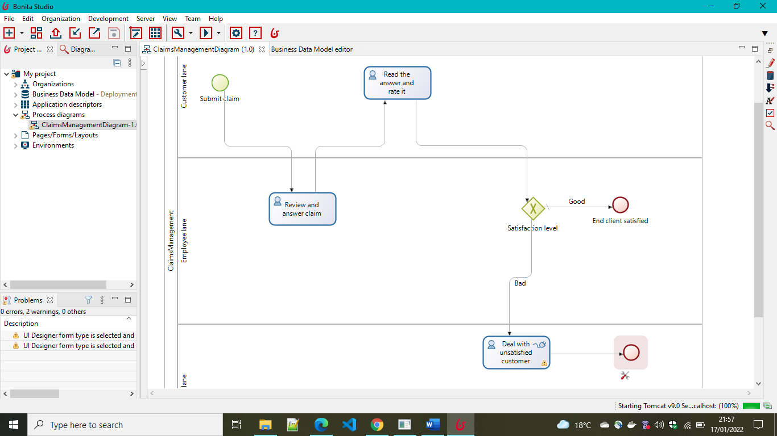

Figure BonitaSoft Studio on Windows 10

## 2.3 Example

The 9-step hands-on journey to your first Bonita Living Application is as follows.

### 2.3.1 [Draw a BPMN diagram Process automation always starts with a process](https://documentation.bonitasoft.com/bonita/2021.2/getting-started/draw-bpmn-diagram)

### 2.3.2 [Define a Business Data Model (BDM)-The data model describes business data handled by processes](https://documentation.bonitasoft.com/bonita/2021.2/getting-started/define-business-data-model)

### 2.3.3 [Declare business variables -Variables are the link between business data and processes](https://documentation.bonitasoft.com/bonita/2021.2/getting-started/declare-business-variables)

### 2.3.4 [Declare contracts -Contracts are interfaces allowing processes and UI to interact](https://documentation.bonitasoft.com/bonita/2021.2/getting-started/declare-contracts)

### [Create forms- Forms use data to feed processes through contracts](https://documentation.bonitasoft.com/bonita/2021.2/getting-started/create-web-user-interfaces)

### 2.3.6 [Define who can do what- Actors allow the mapping of organization entities to human tasks](https://documentation.bonitasoft.com/bonita/2021.2/getting-started/define-who-can-do-what)

### 2.3.7 [Configure an email connector- Most of the processes need email notifications, right?](https://documentation.bonitasoft.com/bonita/2021.2/getting-started/configure-email-connector)

### 2.3.8 [Design an application page- Pages can display more generic information than tasks forms](https://documentation.bonitasoft.com/bonita/2021.2/getting-started/design-application-page)

### 2.3.9 [Create an application- Bind all elements together to build a rich, valuable end-user experience](https://documentation.bonitasoft.com/bonita/2021.2/getting-started/create-application)